BA (Hons) Leadership and Management Skills in the Workplace
LCLM5003
Project Management
A project Portfolio
Ion Magureanu

Part A: Poster
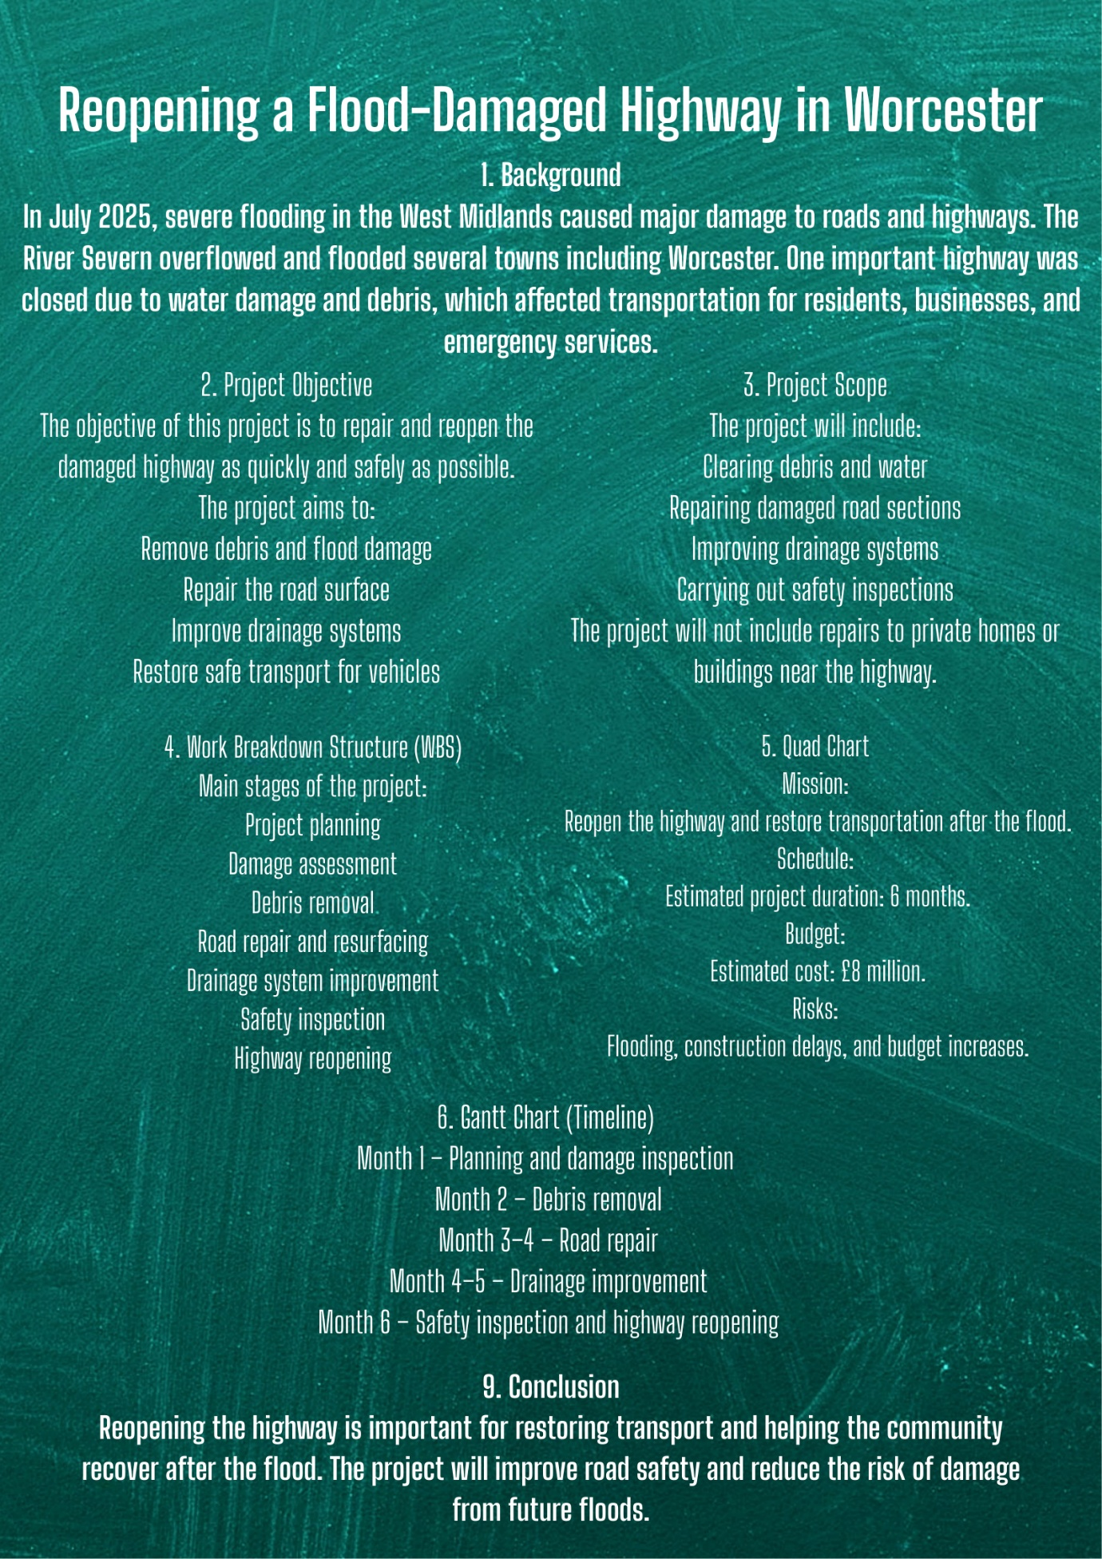

Part B: Reflection from the feedback received from tutor and peers

Peer feedback
This is the feedback I have received from one of my peer:
“As one of your peers, I think you’ve done a really good job creating a clear and well-structured project plan. The layout is easy to follow, and each section (background, objectives, scope, WBS, timeline, etc.) is logically organised. Your objectives are specific and relevant, especially focusing on safety and restoring transport quickly. I also like how you included a Work Breakdown Structure and a timeline—this shows good understanding of project management basics.
However, based on tutor-style expectations, there are a few areas you could improve. First, your project scope could be slightly more detailed—for example, specifying what types of repairs or technologies will be used. Secondly, the risk section is quite brief; you mention risks but don’t explain how they will be managed or mitigated. Adding a risk response plan would strengthen your work. Also, your budget is given as a single figure, but it would be better to break it down into categories (e.g., labour, materials, equipment). Finally, your Gantt chart is written as text—visually presenting it as an actual chart would improve professionalism.”

Reflection:

Based on the feedback from my tutor and peers, I have reflected on both the strengths of my project plan and the areas that require improvement. Overall, my project demonstrates a solid understanding of project management principles, but there are several ways I can enhance the quality and depth of my final submission.
One of the key strengths highlighted in the feedback is the clear structure and organisation of my project plan. I presented the information in a logical order, starting with the background and moving through objectives, scope, work breakdown structure, and timeline. This made the project easy to read and understand. Additionally, my objectives were specific and aligned with the overall goal of reopening the highway quickly and safely. Including elements such as the Work Breakdown Structure (WBS) and a timeline also showed that I understand the importance of planning and sequencing tasks in a project.
Another positive aspect is that my project is realistic and relevant. The scenario of flood damage and infrastructure repair is practical, and I clearly identified key activities such as debris removal, road repair, and drainage improvement. This demonstrates that I can apply theoretical knowledge to a real-world situation.
However, the feedback also identified several areas for improvement. One of the main weaknesses is the lack of detail in certain sections. For example, my project scope is quite general and does not specify the exact methods or technologies that will be used. To improve this, I will add more detailed descriptions of the work involved, such as the types of materials used for road repair or specific drainage solutions.
Another important area for improvement is the risk management section. While I identified some risks, such as flooding and construction delays, I did not explain how these risks would be managed. In my final project plan, I will include a risk mitigation strategy, outlining actions to reduce the likelihood and impact of each risk. This will make my project more comprehensive and realistic.
The budget section also needs further development. Currently, I only provided an estimated total cost. To improve this, I will break down the budget into categories such as labour, materials, equipment, and contingency costs. This will show a deeper level of planning and financial awareness.
Finally, my timeline could be improved by presenting it as a proper Gantt chart rather than a simple list. Creating a visual chart will make it easier to understand task durations and overlaps, and it will improve the overall presentation of my work.
In conclusion, while my project plan has a strong foundation, I will focus on adding more detail, improving risk management, providing a clearer budget breakdown, and enhancing visual presentation in my final submission. These improvements will help me produce a more professional and complete project plan.

Part C: Project Management Plan

Introduction
Infrastructure plays a critical role in supporting economic activity, public safety, and daily life. When major infrastructure such as highways is disrupted, the consequences can be severe, affecting transportation, emergency services, and local businesses. This project management plan focuses on the reopening of a flood-damaged highway in Worcester following severe flooding in July 2025.
The purpose of this plan is to outline how the project will be managed, including its scope, timeline, risks, stakeholders, and resources. The plan applies key project management principles and techniques to ensure that the highway is restored efficiently, safely, and within budget. It also demonstrates structured planning using tools such as Work Breakdown Structure (WBS), Gantt charts, and risk analysis.

Project Description
In July 2025, severe flooding caused by heavy rainfall led to the overflow of the River Severn, resulting in widespread damage across the West Midlands. The flooding caused significant disruption to transport infrastructure, including the closure of a major highway in Worcester due to water damage, debris accumulation, and structural deterioration.
This project aims to repair and reopen the affected highway to restore normal transportation operations. The project includes clearing debris, repairing damaged road surfaces, improving drainage systems, and conducting safety inspections before reopening the road to the public.
The project is expected to be completed within six months and is estimated to cost £8 million. The successful completion of this project will help restore mobility, support economic recovery, and improve resilience against future flooding events.

Scope
The scope of this project focuses on the repair and reopening of the flood-damaged highway in Worcester, ensuring that it is restored to a safe and operational condition as quickly as possible. The project includes all essential activities required to address the damage caused by flooding and to improve the resilience of the highway against future incidents. This begins with the removal of debris and excess water from the affected area, followed by a detailed structural assessment to identify the extent of the damage. Based on this assessment, necessary repair work will be carried out, including resurfacing damaged sections of the road and restoring its structural integrity.
In addition to repairing the visible damage, the project also includes improvements to the existing drainage systems. This is a critical component, as inadequate drainage contributed to the severity of the flooding. Enhancing these systems will help reduce the risk of similar disruptions in the future. The scope also covers the installation of appropriate safety features, such as road signage and barriers, to ensure that the highway meets required safety standards before reopening. A final inspection will be conducted to confirm that all work has been completed to the necessary quality and safety requirements.
However, it is equally important to define what is not included in the project scope to prevent misunderstandings and scope creep. This project does not cover repairs to private properties or buildings located near the highway, even if they were affected by the flooding. It also excludes any form of financial compensation for local residents or businesses impacted by the road closure. Furthermore, large-scale flood prevention infrastructure beyond the immediate highway area is outside the scope of this project, as such initiatives would require separate planning and funding. Ongoing maintenance after the reopening of the highway is also not included, as this will be managed under routine operational responsibilities.
By clearly defining both the inclusions and exclusions, the project scope ensures that all stakeholders have a shared understanding of the project boundaries. This clarity supports effective planning, resource allocation, and project control, ultimately contributing to the successful delivery of the project.

Work breakdown structure
The Work Breakdown Structure (WBS) is used in this project to divide the overall work into smaller, manageable components. This approach ensures that all tasks are clearly defined, organised, and easier to allocate to team members. By breaking the project into structured phases, the WBS supports better planning, coordination, and control throughout the project lifecycle.
The first phase of the project is project planning. This involves defining the project objectives, confirming the scope, developing a detailed schedule, and allocating the necessary resources. During this stage, potential risks are also identified, and initial mitigation strategies are considered. Effective planning is essential as it sets the foundation for all subsequent activities and ensures that the project begins in a structured and controlled manner.
The second phase is damage assessment, which focuses on evaluating the extent of the flood damage. This includes conducting site inspections, carrying out structural analysis of the highway, and assessing any environmental impacts. The information gathered during this stage is critical, as it informs the type and scale of repair work required. Accurate assessment helps prevent delays and unexpected costs later in the project.
The third phase involves debris removal. This includes clearing mud, damaged materials, and other obstructions from the highway, as well as removing any remaining floodwater. Proper waste disposal procedures are followed to ensure environmental compliance. This stage is necessary to create a safe and accessible working environment for the repair teams.
Following this, the project moves into the road repair and resurfacing phase. This stage involves removing damaged road surfaces, repairing the underlying structure, and applying new asphalt to restore the highway. This is one of the most resource-intensive phases and is critical to ensuring the long-term durability and safety of the road.
The next phase is drainage system improvement. In this stage, the existing drainage infrastructure is inspected and upgraded where necessary. New or improved drainage solutions are installed to enhance water flow and reduce the risk of future flooding. The system is then tested to ensure it operates effectively under different conditions.
After construction work is completed, the project enters the safety inspection phase. This involves conducting thorough quality checks, ensuring compliance with safety regulations, and verifying that all work meets required standards. Any identified issues are addressed before moving to the final stage.
The final phase is highway reopening. This includes removing any temporary barriers, communicating with the public and relevant stakeholders, and officially reopening the highway for use. This stage marks the completion of the project and the restoration of normal transport operations.
Overall, the WBS provides a clear and structured breakdown of the project, ensuring that each phase is carefully planned and executed. This helps improve efficiency, accountability, and the likelihood of successful project delivery.

Quad chart
The Quad Chart summarises key elements of the project:
Mission
To repair and reopen the flood-damaged highway in Worcester efficiently and safely, restoring transport connectivity and supporting community recovery.
Schedule
- Total duration: 6 months
- Start date: Month 1
- Completion date: End of Month 6
Budget
- Estimated total cost: £8 million
Risks
- Further flooding
- Construction delays
- Budget overruns
- Resource shortages
The Quad Chart provides a concise overview for stakeholders and decision-makers.

Gantt chart

Month 1: Project planning and damage assessment
Month 2: Debris removal
Month 3–4: Road repair and resurfacing
Month 4–5: Drainage system improvements
Month 6: Safety inspection and highway reopening

Stakeholders involvement
Stakeholder involvement is a critical aspect of this project, as multiple groups are affected by or have an influence on the successful reopening of the flood-damaged highway in Worcester. Effective identification, communication, and engagement with stakeholders will ensure that the project runs smoothly, meets expectations, and minimises conflict.
The primary stakeholders in this project include local government authorities, transport agencies, construction contractors, emergency services, local residents, businesses, and environmental agencies. Each of these stakeholders has a specific role and level of interest in the project. Local government authorities are responsible for providing funding, granting approvals, and overseeing the project to ensure it aligns with public policies and regulations. Transport agencies are involved in coordinating traffic management and ensuring that the highway meets operational standards once reopened.
Construction contractors play a key role in executing the physical work, including debris removal, road repairs, and drainage improvements. Their performance directly impacts the project’s timeline, cost, and quality. Emergency services, such as police and ambulance teams, must remain informed throughout the project to ensure that alternative routes are accessible and that public safety is maintained at all times.
Local residents and businesses are also important stakeholders, as they are directly affected by the highway closure and ongoing construction work. Their concerns may include noise, delays, and access to properties. Engaging with this group through regular updates and clear communication will help maintain public trust and reduce dissatisfaction. Environmental agencies are responsible for ensuring that the project complies with environmental regulations, particularly in relation to waste disposal and drainage improvements.
To manage stakeholder involvement effectively, a structured communication strategy will be implemented. This will include regular progress reports, stakeholder meetings, and public announcements through local media and online platforms. Feedback mechanisms will also be established to allow stakeholders to raise concerns or provide input during the project. High-interest and high-influence stakeholders, such as government authorities and contractors, will be closely managed through frequent communication and collaboration. Meanwhile, lower-influence stakeholders, such as the general public, will be kept informed to ensure transparency.
Overall, effective stakeholder involvement will support better decision-making, reduce risks of conflict, and contribute to the successful delivery of the project.

Allocation of resources
The allocation of resources is a crucial element of this project, as it ensures that all necessary inputs are available and used efficiently to achieve the project objectives within the given timeframe and budget. Effective resource planning helps prevent delays, reduces waste, and ensures that the project is completed to the required quality and safety standards.
Human resources are one of the most important components of the project. A project manager will be responsible for overseeing the entire project, coordinating activities, and ensuring that objectives are met. Engineers and surveyors will carry out technical assessments and design solutions for road repairs and drainage improvements. Construction workers will be responsible for executing the physical tasks, including debris removal, resurfacing, and installation work. In addition, health and safety officers will monitor site conditions and ensure compliance with safety regulations throughout the project. Each team member will be assigned clear roles and responsibilities to ensure accountability and efficiency.
Material resources are also essential for the successful completion of the project. These include construction materials such as asphalt, concrete, drainage pipes, and safety equipment like barriers and signage. Ensuring the timely availability of these materials is critical to avoid interruptions in the construction process. Suppliers will be carefully selected, and procurement will be planned in advance to maintain a steady flow of resources.
In terms of equipment, the project will require various types of machinery to carry out the work efficiently. This includes excavators for debris removal, trucks for transporting materials, road rollers for resurfacing, and specialised drainage equipment for improving water management systems. Proper scheduling and maintenance of equipment will be necessary to maximise productivity and minimise downtime.
Financial resources must also be carefully allocated to ensure that the project remains within its £8 million budget. The budget will be distributed across key areas, with approximately 40% allocated to labour costs, 35% to materials, 15% to equipment, and 10% reserved as a contingency fund. This contingency allocation is important for addressing unexpected costs, such as additional repairs or delays caused by external factors.
Overall, the effective allocation of human, material, equipment, and financial resources will play a vital role in ensuring that the project is delivered on time, within budget, and to the required standard.

Risk analysis
Risk analysis is an essential part of this project, as it helps identify potential issues that could negatively impact the timeline, budget, or quality of the highway reopening. By recognising these risks early, appropriate mitigation strategies can be implemented to reduce their likelihood and impact, ensuring smoother project execution.
One of the most significant risks associated with this project is the possibility of further flooding during the construction period. Given the nature of the initial damage, adverse weather conditions could delay work, damage ongoing repairs, and increase costs. To mitigate this risk, the project team will closely monitor weather forecasts and implement temporary flood protection measures, such as barriers and improved water diversion systems, to protect the site.
Another key risk is construction delays, which may arise due to unforeseen technical challenges, equipment breakdowns, or labour shortages. Delays can affect the overall schedule and lead to increased costs. To address this, the project plan includes buffer time within the schedule, regular progress monitoring, and contingency planning to ensure that any delays are managed effectively without significantly impacting the final completion date.
Budget overruns also represent a critical risk, particularly if additional repairs are required or material costs increase. Poor financial control could lead to the project exceeding its allocated £8 million budget. To reduce this risk, strict financial monitoring will be implemented, along with regular budget reviews and the use of a contingency fund to cover unexpected expenses.
Resource shortages, including limited availability of materials or skilled labour, could also impact the project’s progress. This risk will be mitigated by securing reliable suppliers in advance and ensuring that contracts are in place to guarantee the availability of key resources when needed.
Health and safety risks are another major concern, especially given the hazardous conditions associated with flood-damaged infrastructure and construction work. Accidents or injuries could delay the project and increase costs. To minimise this risk, strict health and safety protocols will be enforced, including regular site inspections, staff training, and the use of appropriate protective equipment.
Overall, a risk register will be maintained and continuously updated throughout the project lifecycle. This will allow the project team to monitor risks, assess their impact, and implement appropriate responses as needed. Effective risk management will play a key role in ensuring that the project is completed successfully, despite potential challenges.

Conclusion
In conclusion, this project management plan provides a structured and comprehensive approach to reopening the flood-damaged highway in Worcester. By applying key project management techniques, including scope definition, Work Breakdown Structure (WBS), scheduling through a Gantt chart, stakeholder engagement, resource allocation, and risk analysis, the project is designed to be delivered efficiently and effectively.
The plan demonstrates a clear understanding of how to manage a real-world infrastructure project by breaking it down into manageable phases and ensuring that each stage is carefully planned and controlled. The inclusion of detailed stakeholder involvement ensures that all relevant parties are considered, while the allocation of resources supports the timely and cost-effective completion of the project. In addition, the risk analysis highlights potential challenges and provides practical strategies to minimise their impact.
Although there are uncertainties, such as weather conditions and possible delays, the use of contingency planning and continuous monitoring will help the project team respond effectively to any issues that arise. This increases the likelihood of completing the project within the six-month timeframe and £8 million budget.
Ultimately, the successful reopening of the highway will restore essential transport links, support local economic recovery, and improve safety for road users. The project also contributes to long-term resilience by incorporating drainage improvements that reduce the risk of future flooding. Overall, this project management plan demonstrates the effective application of project management principles and provides a solid foundation for successful project delivery.

References
Kerzner, H. (2022) Project Management: A Systems Approach to Planning, Scheduling, and Controlling. 13th edn. Hoboken: John Wiley & Sons.
Meredith, J.R., Mantel, S.J. and Shafer, S.M. (2019) Project Management: A Managerial Approach. 10th edn. Hoboken: John Wiley & Sons.
Project Management Institute (PMI) (2021) A Guide to the Project Management Body of Knowledge (PMBOK® Guide). 7th edn. Newtown Square, PA: Project Management Institute.
UK Government (2023) Infrastructure and Projects Authority Annual Report 2022–2023. London: HM Treasury. Available at: https://www.gov.uk (Accessed: 29 March 2026).
Office for National Statistics (ONS) (2024) Transport and infrastructure statistics, UK. Available at: https://www.ons.gov.uk (Accessed: 29 March 2026).
Lock, D. (2020) Project Management. 11th edn. London: Routledge.
Turner, J.R. (2016) Gower Handbook of Project Management. 5th edn. London: Routledge.
Burke, R. (2013) Project Management: Planning and Control Techniques. 5th edn. Chichester: Wiley.

