EMPLOYBILITY AND ACADEMIC SKILLS

STUDENT NAME: UGOCHI PRECIOUS EMEJURU
STUDENT NUMBER: 1908381
LECTURE’S NAME: RITA UKACHI-LOIS
MODULE CODE: BMSW4001
MODULE NAME: ACADEMIC AND EMPLOYEBILITY SKILLS
LEVEL: 4
GROUP NUMBER: 10

TABLE OF CONTENT
Introduction ………………………………….pg. 3
Term 1 topics ………………………………..pg. 3
Time Management………………………….pg. 3-4
Paraphrasing ……………………………….pg. 4-5
Summarising ……………………………….pg. 5
Term 2 Topics ……………………………...pg. 5
CV Writing ………………………………….pg. 6
Cover Letter Writing ………………………pg. 6
Conclusion ………………………………...pg. 7
Reference List ……………………………pg. 8
In-class Exercises ………………………..pg. 9

INTRODUCTION
Reflection is the process of understanding something that is being thought in your own way. To make „meaning‟ means to make sense of an experience, we make an interpretation of it. When we subsequently use this interpretation to guide decision-making or action, then making „meaning‟ becomes „learning‟. (Mezirow, 2017) The purpose of this report is to analyse all my various impressions on the academic and employability unites I undertook during the last two semesters. To express the impact this module had on me I will be mentioning 5 topics that have influenced not only my academics but also my personal and professional life. Also, in this report different references extracted from in class exercises and other valuable and reliable informants will be presented. Lastly these will all be listed at the end of this article.
TERM 1 TOPICS
Throughout the duration of this term a lot of concepts were assimilated. The main topics were the various skills that can be applied both in the university and in a workplace. A skill is the capacity to practice or execute something in an appropriate way. In my understanding, there are four types of skill that hold a significant meaning for most individuals. The first group of skills are the Basic skills, these comprehends: listening, writing, and speaking. The second set of skills are named the Thinking skills, which are usually used in complex situation such as when difficult decision is required. These are: Critical Thinking, Problem Solving and Decision Making. In addition, there are the so-called People Skills, these are mainly required when making human interactions. These are: Teamwork, Leadership, Negotiation and Communication, furthermore, these are the skills that enables everyone to enhance their personality helping them to achieve self-mastery, build self-confidence and determination. Lastly, there are the Personal qualities, like cooking and punctuality, in other word, these are the attributes that differentiates a person from another. From this term I will present the 3 topics that impacted my daily life the most.
TIME MANAGEMENT
Time management is the topic that made me reflect the most, thanks to this unit I have learnt how to manage my time better not only when it comes to my academics but especially in my daily life. To my understanding Time management is an essential ability that humanity cannot do without. This is the ability to organize one’s time by programming and equally dividing the various tasks that needs to completed daily. Understanding and consequently mastering this skill enables each person to be determined and self-reliant, it also permits them to acknowledge their priorities and focus. Thanks to this skill the percentage of stress has increasingly dropped.
There are three methods which can help to manage the time and give the right priorities at the appointed thing needed in that moment. The first method is called the Pareto 80-20 Rules, this is a process that helps you to prioritize the principal activities which need to be done in a day. “The Pareto principle, states that in many events, 80% of the effects come from 20% of the causes.” (Naoum, 2016)
The RAC method (Record, Analyse and Change) allows you to record your daily activities analyse them and then isolate the major sources of time wasting and lastly, it enables you to set your priorities right.
The process with which we can recognize the level relevance and urgency the numerous activities have by putting them in a is called, the Eisenhower method; “what is important is seldom urgent and what is urgent is seldom important”. (Coninck, 2016).
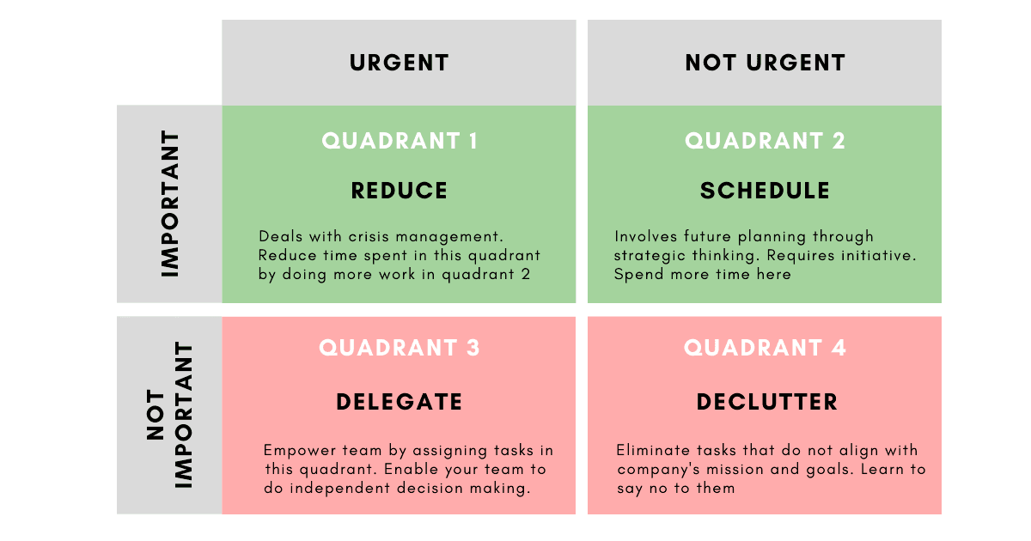
Before the lesson about this skill I was aware of it, but I was never able to apply this ability in my daily life. Thanks to these different methods I have been able to acquire and master this skill and now I have improved my efficiency at work by contributing more and working faster offering and optimal and excellent customer service. Not only at work but also academically speaking I have been able to deliver all my assignments and school project on time unlike when I did not have this capacity and I was always stressed and frustrated.
PARAPHRASING
Another topic that was approached is paraphrasing. This skill is one of the most important capacities used in written and verbal communication. This comprises on the replacement of a sentence, hypothesis or a passage from a source and rearrange it alternative words and by doing so, avoiding plagiarism. “The importance of providing explicit, proactive instruction of paraphrasing skills is endorsed in recent research as a way to help students avoid committing cases of plagiarism.” (Setsuko Oda, 2007)
This is a skill can be used environment, but it is must vital in academics for all scholars the mastering of this capacity is also equal to the number of opportunities they will have in future and also, it is very important because it can boost their grades and sense of reasoning.
Before I began my year in this university I was quite unsure of what paraphrasing was all about but as I started my academic year I understood the not only the meaning and what paraphrasing included but I also started putting it in practice by doing exercises at home in preparation of the in-class exercise. In this in-class exercise, according to the lecturer I possessed some good ideas of what paraphrasing was but also had to improve my skills and most importantly I had to improve my grammar. Now I am quite confident that I have improved this skill and I now I can also debate with my colleagues about competent subject by mentioning and paraphrasing different sources. Therefore, thanks to this skill I can now be consistent and fluent with my speaking and writing.
SUMMARISING
This topic likewise paraphrasing is part of academic writing the difference between the topics is that when summarising you have to not only substituting the sentence but also identifying the main point of text, passage or report and give a brief statement of it by always being coherent and maintaining the same content. This an ability that helps each person to challenge his or her intellectual capacities.
This as well known is used mostly in academics and as it may seem easy, I am of the opinion that it is one of the most difficult skills a student can ever achieve but holds the same relevance as other topics taken during the last term. To have this attribute is an excellent virtue academically speaking for the simple reason that it allows scholars to self-assess themselves to know how good their memory is. As it known that when summarising they tend to forget what was written in the main passage and by forgetting vital information, they might make grievous mistake in the case of an oral examination.
Like in other topics mention earlier at the beginning of the academic year my idea of summarising was just to eliminate the less significant sentences and rewrite the story with the remaining sentences and by doing so making the passage incoherent and full of grammatical errors. After the lesson on this topic I understood better what summarising is all about and after the in-class exercise, in which the lecturer acknowledged me for my good use of the skill but also informed me to try reduce the number of language errors. I know can proudly say that I am quite convinced that I can confidently use this skill because before summarising I always read the source twice if possible, underline the points that I deem relevant and lastly, put them together by paraphrasing them where necessary and always trying to keep the text coherent. This is the result of an excellent work with commitment and devotion.
TERM 2 TOPICS
During this term we have experienced a lot of turbulence caused by the Covid-19 pandemic. This unexpected event interrupted our onsite lessons and to be honest those were the lessons I preferred for various reasons. Few topics were taught during this semester and I am going to present the two major units undertaken in class.
CV WRITING
“A CV also known as Curriculum vitae (course of life) is a detailed document highlighting one’s professional and academic history. CVs typically include information like your work experience, achievements and awards, scholarships or grants you have earned, coursework, research projects and publication of your work.” (Guide, 2020)
A CV is one of the most important documents one can possess as it is a pass card to the career world. It is vital to learn how to write a perfect CV and to always keep it up to date. when writing a curriculum vitae, it is important to always adapt it to the specific role you are applying for. For example, if you had numerous and diverse job experience but your applying for a costumer advisor role, then, on the CV you should exclusively and only include job experiences that relate to the one you are applying for.
Before my academic year, I always had difficulties applying for job and on securing one. I always wondered what the problem might have been. At that time, I did not know what a CV was all about and how to write it. I personally think that the only reason I could secure my first job was because I let someone else structure my CV. As time went by, I began to understand what was required to write a CV but still was not enough. After the lessons we had in class I finally understood where I was mistaking and what where my errors. I was never adapting the curriculum vitae to the job role I was applying for and was never updating some key points and making my application less interesting for the employers. Now I receive offers from different companies. Thanks to the lecturer, who made me understand how to really structure an adequate CV through practice and an in-class exercise, I do not need to go to agencies for help anymore.

COVER LETTER WRITING
The last topic I am going to present is the cover letter. This letter is a key document that will introduce you to your prospective employer and, if well-written, it will also pave the way to that important job interview. It is an essential part of your overall job-hunting campaign, and it can build you up or if not incisive, involving and well-written, it can sadly also destroy your image. (Beatty, 2004)
A cover letter likewise the CV has the purpose of selling you to the employers. To my understanding this is a document that completes your curriculum vitae. The advantage of creating this document is that you can really express in your own word and the best professional and formal way possible, your desire and determination of obtaining the role you applied for.
Before this term this was one of the most difficult documents I had to write. To be honest I did not know what a cover letter was about so, whenever there was a job application where it was compulsory to write a cover letter, I would interrupt the application. Fortunately, after the in-class exercise conducted during this semester I now hold I full understanding of what a cover letter is and how to write it.

CONCLUSION
Before this journey I was insecure of everything I do stressed and frustrated because I could not achieve much in life as I wanted to. Thanks to this academic year, I have enhanced my knowledge on so many aspects that I would have never deemed necessary or relevant before. I am extremely grateful to have been part of this program because without it I would have not been able to secure a position not only my job but in the society. I can now confidently take part to project and continue my journey with more experiences both academically and professionally.

REFERENCES
- Indeed, Career Guide (2020) What Is a CV? Curriculum Vitae Definition and Examples [online]. Available from: https://www.indeed.com/career-advice/resumes-cover-letters/what-is-a-cv (Accessed: 2 May 2020).

- Jack Mezirow (2017) Fostering Critical Reflection in Adulthood: How critical reflection triggers transformative learning [online]. Available from: https://my.liberatedleaders.com.au/wp-content/uploads/2017/02/How-Critical-Reflection-triggers-Transformative-Learning-Mezirow.pdf (Accessed: 30 April 2020).

- Nathan De Coninck (2016) Eisenhower method explained [online]. Available from: https://www.youtube.com/watch?v=OJPZWOXkg18 (Accessed: 1 May 2020).

- Naoum, V, Kiriopoulos, D, Charonis, A, Athanasakis, K (2016) PHS82 - The Pareto Principle ("80−20 Rule") In Healthcare Services In Greece Vol 19 Iss. 7 [online]. Available from: https://www.sciencedirect.com/science/article/pii/S1098301516329291 (Accessed: 30 April 2020).

- Richard H. Beatty (2004) The Perfect Cover Letter, 3rd edn. Hoboken: John Wiley & Sons [online]. Available from: https://whel-primo.hosted.exlibrisgroup.com/primo-explore/search?query=creator,exact,Richard%20H.%20Beatty%201939-&vid=44WHELF_UWTSD_VU1&lang=en_US
(Accessed: 2 May 2020).

- Setsuko Oda, Yukako Yamamoto (2007) Paraphrasing: an Essential Tool for EAP [online]. Available from: http://citeseerx.ist.psu.edu/viewdoc/download?doi=10.1.1.594.8247&rep=rep1&type=pdf (Accessed: 30 April 2020).

IN-CLASS EXERCISES
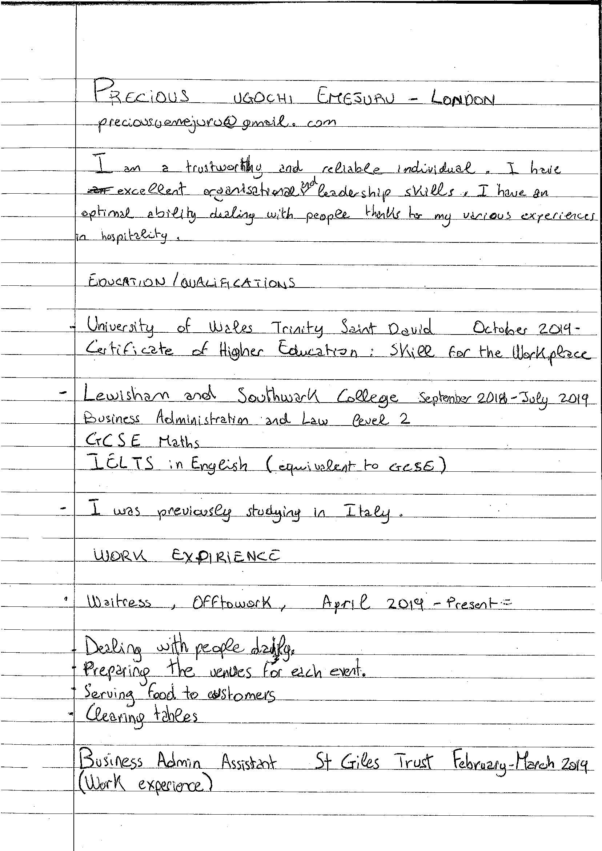
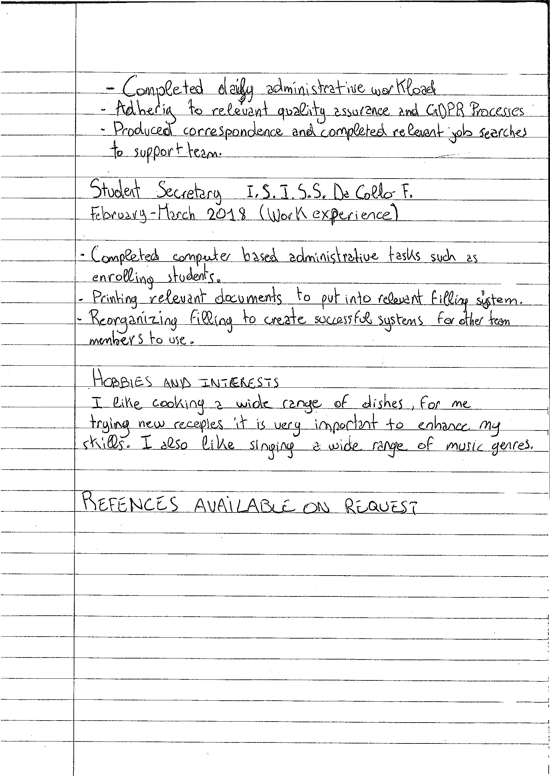
[Hiring manager's name]
[Hiring manager's company name]

[Company address] _b)YÅoA—
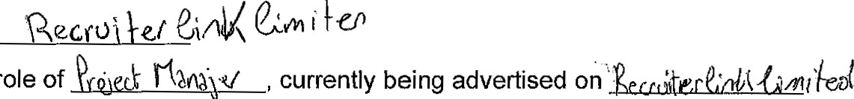
[Today's Datel 2020
Dear Mr/Mrs/Miss/Ms
I wish to apply for the role of
Please find enclosed my CV for your consideration.
As you can see from my attached CV, I have over
[Address]
(for this ex please leave blank)
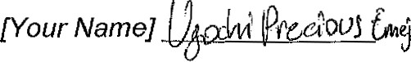
experience in the ee.pa.bee

during this time make me the right/perfect candidate for the role.
In my current role as a 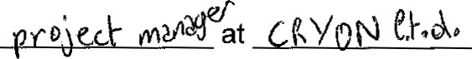, I have been responsible for

[Now write about what you leamt during this experience — relevant to the role you are applying for)

All of this, coupled with my enthusiasm and dedication, [insert skills relevant to the role],
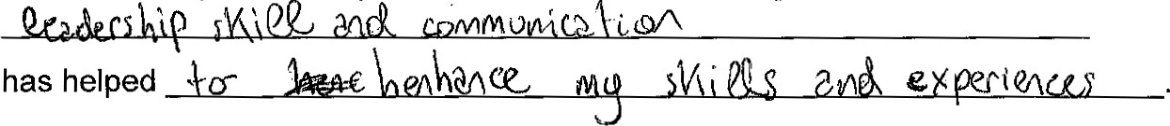
I am confident that I can bring this level of success with me to your organisation and help build upon their reputation as [state their position in market — learned through your research). With my previous experience and expertise, I believe my contribution will have
• |  | sync,e_
Thank you for 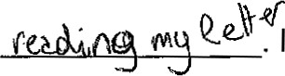 look forward to

Yours sincerely/Yours faithfully,
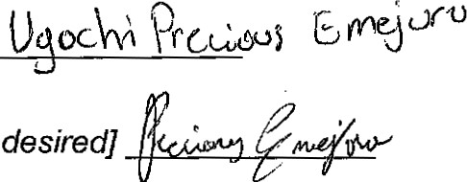
[Your
Name]
[Signature
-
if

