Katie lewis 2204029
ECAD5010 Assignment- What are staff and pupils perceptions of self assessment in a year 5 classroom?

Appendices
Appendices 1- Ethics form
APPLICATION FOR ETHICAL APPROVAL

RESEARCH STUDENTS
This form is to be completed by the student within SIX months for full-time students and TWELVE months for part time students, after the commencement of the research degree or following progression to Part Two of your course.

Once complete, submit this form via the MyTSD Doctoral College Portal at (https://mytsd.uwtsd.ac.uk).

This document is also available in Welsh.

RESEARCH STAFF ONLY
All communications relating to this application during its processing must be in writing and emailed to pgresearch@uwtsd.ac.uk , with the title ‘Ethical Approval’ followed by your name.

STUDENTS ON UNDERGRADUATE OR TAUGHT MASTERS PROGRAMMES should submit this form (and receive the outcome) via systems explained to you by the supervisor/module leader.

In order for research to result in benefit and minimise risk of harm, it must be conducted ethically. A researcher may not be covered by the University’s insurance if ethical approval has not been obtained prior to commencement.

The University follows the OECD Frascati manual definition of research activity: “creative work undertaken on a systematic basis in order to increase the stock of knowledge, including knowledge of man, culture and society, and the use of this stock of knowledge to devise new applications”. As such this covers activities undertaken by members of staff, postgraduate research students, and both taught postgraduate and undergraduate students working on dissertations/projects.

The individual undertaking the research activity is known as the “principal researcher”.

Ethical approval is not required for routine audits, performance reviews, quality assurance studies, testing within normal educational requirements, and literary or artistic criticism.

Please read the notes for guidance before completing ALL sections of the form.

This form must be completed and approved prior to undertaking any research activity. Please see Checklist for details of process for different categories of application.

SECTION A: About You (Principal Researcher)
1 | Full Name: |  | Katie Lewis
2 | Tick all boxes that apply: |  | Member of staff: | ☐ | Honorary research fellow: | ☐
 | Undergraduate Student | ​​☒​ | Taught Postgraduate Student | ​​☐​ | Postgraduate Research Student | ​​☐​

3 | Institute/Academic Discipline/Centre: |  | Initial Teacher Education, Yr Athrofa
4 | Campus: |  | Carmarthen
5 | E-mail address: |  | 2204029@student.uwtsd.ac.uk
6 |  | Contact Telephone Number: |  | 07871135953
 |  | For students:
7 |  | Student Number: |  | 2204029
8 |  | Programme of Study: |  | BA Primary Education with QTS
9 |  | Director of Studies/Supervisor: |  | Dr Julia Holloway

SECTION B: Approval for Research Activity
1 | Has the research activity received approval in principle?  (please check the Guidance Notes as to the appropriate approval process for different levels of research by different categories of individual) |  | YES | ​​☒​ | NO | ​​☐​
 |  |  |  |  | Date
2 | If Yes, please indicate source of approval (and date where known): Approval in principle must be obtained from the relevant source prior to seeking ethical approval | Research Degrees Committee |  | ​​☐​
2 |  | Institute Research Committee |  | ​​☐​
2 |  | Other (write in) ECAD5010 Module lead Sioned Hughes |  | ​​☒​ | 18.01.24

SECTION C: Internal and External Ethical Guidance Materials
 | Please list the core ethical guidance documents that have been referred to during the completion of this form (including any discipline-specific codes of research ethics, location-specific codes of research ethics, and also any specific ethical guidance relating to the proposed methodology). Please tick to confirm that your research proposal adheres to these codes and guidelines. You may add rows to this table if needed.
1 | UWTSD Research Ethics & Integrity Code of Practice | ​​☒​
2 | UWTSD Research Data Management Policy | ​​☐​
3 | [List any other relevant documents here] Bera guidelines 2018 and EWC code of conduct | ​​☒​

SECTION D: External Collaborative Research Activity
If there are external collaborators then you should gain consent from the contact persons to share their personal data with the university. If there are no external collaborators then leave this section blank and continue to section E.
1 | Institution |  | Yr Arotha
2 | Contact person name |  | Julia Holloway
3 | Contact person e-mail address |  | j.holloway@uwtsd.ac.uk
4 | Is your research externally funded? |  |  |  | YES |  | ​​☐​ |  | NO |  | ​​☐​
5 | Are you in receipt of a KESS scholarship? |  |  |  | YES |  | ​​☐​ |  | NO |  | ​​☐​
6 |  | Are you specifically employed to undertake this research in either a paid or voluntary capacity? |  | Voluntary |  | YES |  | ​​☐​ |  | NO |  | ​​☐​
7 |  |  |  | Employed |  | YES |  | ​​☐​ |  | NO |  | ​​☐​
8 |  | Is the research being undertaken within an existing UWTSD Athrofa Professional Learning Partnership (APLP)? |  | If YES then the permission question below does not need to be answered. |  | YES |  | ​​☒​ |  | NO |  |  | ​​☐​
9 |  | Has permission to undertake the research has been provided by the partner organisation? |  | (If YES attach copy)  If NO the application cannot continue |  | YES |  | ​​☐​ |  | NO |  |  | ​​☐​

Where research activity is carried out in collaboration with an external organisation
10 | Does this organisation have its own ethics approval system? | YES | ​​☒​ | NO | ​​☒​
 | If Yes, please attach a copy of any final approval (or interim approval) from the organisation (this may be a copy of an email if appropriate).

SECTION E: Details of Research Activity
1 | Indicative title: |  | What are staff and pupils perception of Self assessment in a year 5 classroom?
2 | Proposed start date: |  | 24.01.24 | Proposed end date: | 19.02.24
Introduction to the Research (maximum 300 words per section)
Ensure that you write for a Non-Specialist Audience when outlining your response to the points below:
- Purpose of Research Activity
- Proposed Research Question
- Aims of Research Activity
- Objectives of Research Activity
Demonstrate, briefly, how Existing Research has informed the proposed activity and explain
- What the research activity will add to the body of knowledge
- How it addresses an area of importance.
3 | Purpose of Research Activity  - To investigate self assessment to improve my practice.  - To trial and evaluate research methods in investigating self assessment  (this box should expand as you type)
4 | Research Question  What are staff and pupils perceptions of self assessment in a year 5 classroom?  (this box should expand as you type)
5 |  | Aims of Research Activity  - To explore staff and learners’ perceptions of self assessment.  - To critically evaluate the different research tools.  - To further develop personal knowledge and understanding of self assessment to improve professional practice  (this box should expand as you type)
6 |  | Objectives of Research Activity  Conduct a research study using the mosaic approach.  Collect data by interviewing children.  Collect data by conducting a questionnaire for staff.  (this box should expand as you type)
Proposed methods (maximum 600 words)
Provide a brief summary of all the methods that may be used in the research activity, making it clear what specific techniques may be used. If methods other than those listed in this section are deemed appropriate later, additional ethical approval for those methods will be needed. You do not need to justify the methods here, but should instead describe how you intend to collect the data necessary for you to complete your project.
7 |  | Interviews –Six 9-10 year old pupils from year 5 in my placement school will be involved in a semi-structured interview where they will be invited to respond to key questions in order for me to collect data for my research. These questions include: Do you know what self-assessment means? Do you mark your own work? How do this make you feel? Do you enjoy marking your own work? include These interviews will be conducted in an informal setting and I will make notes in my notepad and audio record their responses on the class ipad. The pupils will have a choice on whether they would like to participate and will be made aware that they do not have to answer any questions and that they can stop at any time. No real names will be used.  Questionnaire: My questionnaire will be emailed to staff members in the school. I am hoping it will reach 60 staff members including teachers and teacher assistants. Some key questions on this questionnaire include: How often do you use self assessment? Do you use self assessment in your classroom? Do you agree that self assessment boosts pupils self confidence? The staff will have a choice on whether they want to fill out the questionnaire and will not be pressured. They will be informed that it is being used to conduct research for my assignment.  Existing research done by NFER has inspired me to research self-assessment. They conclude that pupils assessing their own work can deepen their understanding of the success criteria and learning objective. (NFER,2012)  (this box should expand as you type)
Location of research activity
Identify all locations where research activity will take place.
8 |  | Placement school. It is a large school in South Wales, in a semi-rural area. There are roughly 600 pupils in the school age 3-11 with 33 percent of pupils eligible for free school meals. There are roughly 25% ALN pupils.  (this box should expand as you type)
Research activity outside of the UK
If research activity will take place overseas, you are responsible for ensuring that local ethical considerations are complied with and that the relevant permissions are sought. Specify any local guidelines (e.g. from local professional associations/learned societies/universities) that exist and whether these involve any ethical stipulations beyond those usual in the UK (provide details of any licenses or permissions required). Also specify whether there are any specific ethical issues raised by the local context in which the research activity is taking place, for example, particular cultural and/or legal sensitivities or vulnerabilities of participants. If you live in the country where you will do the research then please state this.
9 |  | N/A  (this box should expand as you type)

10 | Use of documentation not in the public domain: Are any documents NOT publicly available? | NO | ​​☒​
10 |  | YES | ​​☐​
11 | If Yes, please provide details here of how you will gain access to specific documentation that is not in the public domain and that this is in accordance with the current data protection law of the country in question and that of England and Wales.  (this box should expand as you type)

 | Does your research relate to one or more of the seven aims of the Well-being of Future Generations (Wales) Act 2015? | YES | NO
12 | A prosperous Wales | ​​☐​ | ​​☒​
13 | A resilient Wales | ​​☐​ | ​​☒​
14 | A healthier Wales | ​​☐​ | ​​☒​
15 | A more equal Wales | ​​☐​ | ​​☒​
16 | A Wales of cohesive communities | ​​☐​ | ​​☒​
17 | A Wales of vibrant culture and thriving Welsh language | ​​☐​ | ​​☒​
18 | A globally responsible Wales | ​​☐​ | ​​☒​
19 | If YES to any of the above, please give details:
 | (this box should expand as you type)

SECTION F: Scope of Research Activity TICK ALL RELEVANT BOXES HERE
 | Will the research activity include: | YES | NO
1 | Use of a questionnaire or similar research instrument? | ​​☒​ | ​​☐​
2 | Use of interviews? | ​​☒​ | ​​☐​
3 | Use of focus groups? | ​​☒​ | ​​☐​
4 | Use of participant diaries? | ​​☐​ | ​​☒​
5 | Use of video or audio recording? | ​​☒​ | ​​☐​
6 | Use of computer-generated log files? | ​​☐​ | ​​☒​
7 | Participant observation with their knowledge? | ​​☐​ | ​​☒​
8 | Participant observation without their knowledge? | ​​☐​ | ​​☒​
9 | Access to personal or confidential information without the participants’ specific consent? | ​​☐​ | ​​☒​
10 | Administration of any questions, test stimuli, presentation that may be experienced as physically, mentally or emotionally harmful / offensive? | ​​☐​ | ​​☒​
11 | Performance of any acts which may cause embarrassment or affect self-esteem? | ​​☐​ | ​​☒​
12 | Investigation of participants involved in illegal activities? | ​​☐​ | ​​☒​
13 | Use of procedures that involve deception? | ​​☐​ | ​​☒​
14 | Administration of any substance, agent or placebo? | ​​☐​ | ​​☒​
15 | Working with live vertebrate animals? | ​​☐​ | ​​☒​
16 | Procedures that may have a negative impact on the environment? | ​​☐​ | ​​☒​
17 | Other primary data collection methods. Please indicate the type of data collection method(s) below. | ​​☐​ | ​​☒​
 | Details of any other primary data collection method:  (this box should expand as you type) | ​​☐​ | ​​☒​
If NO to every question, then the research activity is (ethically) low risk and may be exempt from some of the following sections (please refer to Guidance Notes).

If YES to any question, then no research activity should be undertaken until full ethical approval has been obtained.

SECTION G: Intended Participants TICK ALL RELEVANT BOXES HERE
If there are no participants then do not complete this section, but go directly to section H.

 | Who are the intended participants: | YES | NO
1 | Students or staff at the University? | ​​☐​ | ​​☒​
2 | Adults (over the age of 18 and competent to give consent)? | ​​☒​ | ​​☐​
3 | Vulnerable adults? | ​​☐​ | ​​☒​
4 | Children and Young People under the age of 18? (Consent from Parent, Carer or Guardian will be required) | ​​☒​ | ​​☐​
5 | Prisoners? | ​​☐​ | ​​☒​
6 | Young offenders? | ​​☐​ | ​​☒​
7 | Those who could be considered to have a particularly dependent relationship with the investigator or a gatekeeper? | ​​☐​ | ​​☒​
8 | People engaged in illegal activities? | ​​☐​ | ​​☒​
9 | Others. Please indicate the participants below, and specifically any group who may be unable to give consent. | ​​☐​ | ​​☒​
 | Details of any other participant groups:  (this box should expand as you type) | ​​☐​ | ​​☒​

Participant numbers and source
Provide an estimate of the expected number of participants. How will you identify participants and how will they be recruited?
10 | How many participants are expected? | Roughly 16  (this box should expand as you type)
11 | Who will the participants be? | 10 staff members (teachers, teacher assistants and LSAs) and 6 year 5 pupils age 9-10.  (this box should expand as you type)
12 | How will you identify the participants? | I will select a random sample with support from the class teacher.  (this box should expand as you type)

 | Information for participants: | YES | NO | N/A
13 | Will you describe the main research procedures to participants in advance, so that they are informed about what to expect? | ​​☒​ | ​​☐​ | ​​☐​
14 | Will you tell participants that their participation is voluntary? | ​​☒​ | ​​☐​ | ​​☐​
15 | Will you obtain written consent for participation? | ​​☐​ | ​​☐​ | ​​☒​
16 | Will you explain to participants that refusal to participate in the research will not affect their treatment or education (if relevant)? | ​​☒​ | ​​☐​ | ​​☐​
17 | If the research is observational, will you ask participants for their consent to being observed? | ​​☐​ | ​​☐​ | ​​☒​
18 | Will you tell participants that they may withdraw from the research at any time and for any reason? | ​​☒​ | ​​☐​ | ​​☐​
19 | With questionnaires, will you give participants the option of omitting questions they do not want to answer? | ​​☒​ | ​​☐​ | ​​☐​
20 | Will you tell participants that their data will be treated with full confidentiality and that, if published, it will not be identifiable as theirs? | ​​☒​ | ​​☐​ | ​​☐​
21 | Will you debrief participants at the end of their participation, in a way appropriate to the type of research undertaken? | ​​☒​ | ​​☐​ | ​​☐​
22 | If NO to any of above questions, please give an explanation
 | (this box should expand as you type)

 | Information for participants: | YES | NO | N/A
24 | Will participants be paid? | ​​☐​ | ​​☒​ | ​​☐​
25 | Is specialist electrical or other equipment to be used with participants? | ​​☐​ | ​​☒​ | ​​☐​
26 | Are there any financial or other interests to the investigator or University arising from this study? | ​​☐​ | ​​☒​ | ​​☐​
27 | Will the research activity involve deliberately misleading participants in any way, or the partial or full concealment of the specific study aims? | ​​☐​ | ​​☒​ | ​​☐​
28 | If YES to any question, please provide full details
 | (this box should expand as you type)

SECTION H: Anticipated Risks

Outline any anticipated risks that may adversely affect any of the participants, the researchers and/or the University, and the steps that will be taken to address them.

If you have completed a full risk assessment (for example as required by a laboratory, or external research collaborator) you may append that to this form.
1 | Full risk assessment completed and appended? |  | Yes | ​​☐​
1 |  |  | No | ​​☒​
2 | Risks to participants  For example: sector-specific health & safety, emotional distress, financial disclosure, physical harm, transfer of personal data, sensitive organisational information
 | Risk to participants:  Participants may feel obliged to take part in the study due to a power dynamic. | How you will mitigate the risk to participants:  I will have a welcoming and comforting body language. I will introduce myself and make it clear they’re not obliged to answer. I will talk about assent and descent
3 | If research activity may include sensitive, embarrassing or upsetting topics (e.g. sexual activity, drug use) or issues likely to disclose information requiring further action (e.g. criminal activity), give details of the procedures to deal with these issues, including any support/advice (e.g. helpline numbers) to be offered to participants. Note that where applicable, consent procedures should make it clear that if something potentially or actually illegal is discovered in the course of a project, it may need to be disclosed to the proper authorities
N/A

(this box should expand as you type)
4 | Risks to the investigator  For example: personal health & safety, physical harm, emotional distress, risk of accusation of harm/impropriety, conflict of interest
 | Risk to the investigator:  There is a risk of accusations of favouritism when choosing pupils.  (this box should expand as you type) | How you will mitigate the risk to the investigator:  I will randomly select my pupils using the teachers lollipop sticks in order to collect a random sample and to avoid any accusations of favouritism.  (this box should expand as you type)
5 | University/institutional risks  For example: adverse publicity, financial loss, data protection
 | Risk to the University:  I must uphold the universities good reputation and conduct myself and research professionally, ethically and appropriately.  (this box should expand as you type) | How you will mitigate the risk to the University:  - I will act in a professional manor and ensure that all data is accurate and not fabricated in any way, shape or form.  (this box should expand as you type)
6 | Environmental risks  For example: accidental spillage of pollutants, damage to local ecosystems
 | Risk to the environment:  (this box should expand as you type) | How you will mitigate the risk to environment:  (this box should expand as you type)

 | Disclosure and Barring Service
 | If the research activity involves children or vulnerable adults, a Disclosure and Barring Service (DBS) certificate must be obtained before any contact with such participants. | YES | NO | N/A
7 | Does your research require you to hold a current DBS Certificate? | ​​☒​ | ​​☐​ | ​​☐​
8 | If YES, please give the certificate number. If the certificate number is not available please write “Pending”; in this case any ethical approval will be subject to providing the appropriate certificate number. | 001814780160

SECTION I: Feedback, Consent and Confidentiality

1 | Feedback  What de-briefing and feedback will be provided to participants, how will this be done and when?
This will be a summary of discussion at the end of the interview.
(this box should expand as you type)
2 | Informed consent  Describe the arrangements to inform potential participants, before providing consent, of what is involved in participating. Describe the arrangements for participants to provide full consent before data collection begins. If gaining consent in this way is inappropriate, explain how consent will be obtained and recorded in accordance with prevailing data protection legislation.
I will converse with my Julia (my lecturer) and inform her of the research I will be undertaking, providing reason and rationale behind the research. I will email the head teacher to ask for consent .A letter will be send to the head teacher to sign.

(this box should expand as you type)
3 | Confidentiality / Anonymity  Set out how anonymity of participants and confidentiality will be ensured in any outputs. If anonymity is not being offered, explain why this is the case.
 | There will be full confidentiality, no names will be shared or used. I will be the only person who has the data.(this box should expand as you type)

SECTION J: Data Protection and Storage NO NEED TO COMPLETE SECTION J

 | Does the research activity involve personal data (as defined by the General Data Protection Regulation 2016 “GDPR” and the Data Protection Act 2018 “DPA”)? | YES | NO
1 | “Personal data” means any information relating to an identified or identifiable natural person (‘data subject’). An identifiable natural person is one who can be identified, directly or indirectly, in particular by reference to an identifier such as a name, an identification number, location data, an online identifier or to one or more factors specific to the physical, physiological, genetic, mental, economic, cultural or social identity of that natural person. Any video or audio recordings of participants is considered to be personal data. | ☐ | ☐
 | If YES, provide a description of the data and explain why this data needs to be collected:
2 | (this box should expand as you type)
 | Does it involve special category data (as defined by the GDPR)? | YES | NO
3 | “Special category data” means sensitive personal data consisting of information as to the data subjects’ –  (a) racial or ethnic origin,  (b) political opinions,  (c ) religious beliefs or other beliefs of a similar nature,  (d) membership of a trade union (within the meaning of the Trade Union and Labour Relations (Consolidation) Act 1992),  (e) physical or mental health or condition,  (f) sexual life,  (g) genetics,  (h) biometric data (as used for ID purposes), | ☐ | ☐
 | If YES, provide a description of the special category data and explain why this data needs to be collected:
4 | (this box should expand as you type)

 | Will data from the research activity (collected data, drafts of the thesis, or materials for publication) be stored in any of the following ways? | YES | NO
5 | Manual files (i.e. in paper form)? | ​​☐​ | ​​☐​
6 | University computers? | ​​☐​ | ​​☐​
7 | Private company computers? | ​​☐​ | ​​☐​
8 | Home or other personal computers? | ​​☐​ | ​​☐​
9 | Laptop computers/ CDs/ Portable disk-drives/ memory sticks? | ​​☐​ | ​​☐​
10 | “Cloud” storage or websites? | ​​☐​ | ​​☐​
11 | Other – specify: | ​​☐​ | ​​☐​
12 | For all stored data, explain the measures in place to ensure the security of the data collected, data confidentiality, including details of backup procedures, password protection, encryption, anonymisation and pseudonymisation:
 | (this box should expand as you type)

 | Data Protection
 | Will the research activity involve any of the following activities: | YES | NO
13 | Electronic transfer of data in any form? | ​​☐​ | ​​☐​
14 | Sharing of data with others at the University outside of the immediate research team? | ​​☐​ | ​​☐​
15 | Sharing of data with other organisations? | ​​☐​ | ​​☐​
16 | Export of data outside the UK or importing of data from outside the UK? | ​​☐​ | ​​☐​
17 | Use of personal addresses, postcodes, faxes, emails or telephone numbers? | ​​☐​ | ​​☐​
18 | Publication of data that might allow identification of individuals? | ​​☐​ | ​​☐​
19 | Use of data management system? | ​​☐​ | ​​☒​
20 | Data archiving? | ​​☐​ | ​​☐​
21 | If YES to any question, please provide full details, explaining how this will be conducted in accordance with the GDPR and Data Protection Act (2018) (and any international equivalents, where appropriate):
N/A

(this box should expand as you type)
22 | List all who will have access to the data generated by the research activity:
 | (this box should expand as you type)
23 | List who will have control of, and act as custodian(s) for, data generated by the research activity:
 | (this box should expand as you type)
24 | Give details of data storage arrangements, including security measures in place to protect the data, where data will be stored, how long for, and in what form. Will data be archived – if so how and if not why not.
 | (this box should expand as you type)
25 | Please indicate if your data will be stored in the UWTSD Research Data Repository (see https://researchdata.uwtsd.ac.uk/ ). If so please explain. (Most relevant to academic staff)
N/A

(this box should expand as you type)
26 | Confirm that you have read the UWTSD guidance on data management (see https://www.uwtsd.ac.uk/library/research-data-management/) | YES | ​​☐​
27 | Confirm that you are aware that you need to keep all data until after your research has completed or the end of your funding | YES | ​​☐​

SECTION K: Declaration
The information which I have provided is correct and complete to the best of my knowledge. I have attempted to identify any risks and issues related to the research activity and acknowledge my obligations and the rights of the participants.

In submitting this application I hereby confirm that I undertake to ensure that the above named research activity will meet the University’s Research Ethics and Integrity Code of Practice which is published on the website: https://www.uwtsd.ac.uk/research/research-ethics/
1 | Signature of applicant: |  | Date: 18/01/23

For STUDENT Submissions:
2 | Director of Studies/Supervisor: | Dr Julia Holloway | Date: 18/1/24
3 | Signature: | Julia Holloway | Date: 18/1/24

For STAFF Submissions:
4 | Academic Director/ Assistant Dean: |  | Date:
5 | Signature: |  | Date:

Checklist: Please complete the checklist below to ensure that you have completed the form according to the guidelines and attached any required documentation:
​​☒​ | I have read the guidance notes supplied before completing the form.
​​☒​ | I have completed ALL RELEVANT sections of the form in full.
​​☐​ | I confirm that the research activity has received approval in principle
​​☐​ | I have attached a copy of final/interim approval from external organisation (where appropriate)
​​☐​ | I have attached a full risk assessment (where appropriate) ONLY TICK IF YOU HAVE ATTACHED A FULL RISK ASSESSMENT
​​☒​ | I understand that it is my responsibility to ensure that the above named research activity will meet the University’s Research Ethics and Integrity Code of Practice.
​​☒​ | I understand that before commencing data collection all documents aimed at respondents (including information sheets, consent forms, questionnaires, interview schedules etc.) must be confirmed by the DoS/Supervisor, module tutor or Academic Director.

RESEARCH STUDENTS ONLY
Once complete, submit this form via the MyTSD Doctoral College Portal at (https://mytsd.uwtsd.ac.uk).

RESEARCH STAFF ONLY
All communications relating to this application during its processing must be in writing and emailed to pgresearch@uwtsd.ac.uk , with the title ‘Ethical Approval’ followed by your name.

STUDENTS ON UNDERGRADUATE OR TAUGHT MASTERS PROGRAMMES should submit this form (and receive the outcome) via systems explained to you by the supervisor/module leader.

Appendices 2- Letter to school
Dear Mrs Thomas

I’m looking forward to returning to your school and to my PTE2 class on Wednesday, 24.01.

As you know, the purpose of the visit is to trial research tools using Assessment for Learning as a theme, as part of the ECAD5010C research module.

Please find attached a copy of the blanket consent form, and a parental consent form, should you wish to seek parental consent on my behalf before the research day.

During the day, I will need to conduct a short interview with staff and / or learners in my PTE2 class and share an online questionnaire with staff and / or learners in my PTE2 class.

The whole day has been devoted to piloting the research tools so you, as a school, have flexibility in deciding on convenient times for me to distribute the questionnaires and conduct the interviews. If you wish, I can send you the online questionnaire link in advance.

In the meantime, I look forward to seeing you next Wednesday.

Many thanks and best wishes,

Katie Lewis.

………………

Appendices 3- Questionnaire
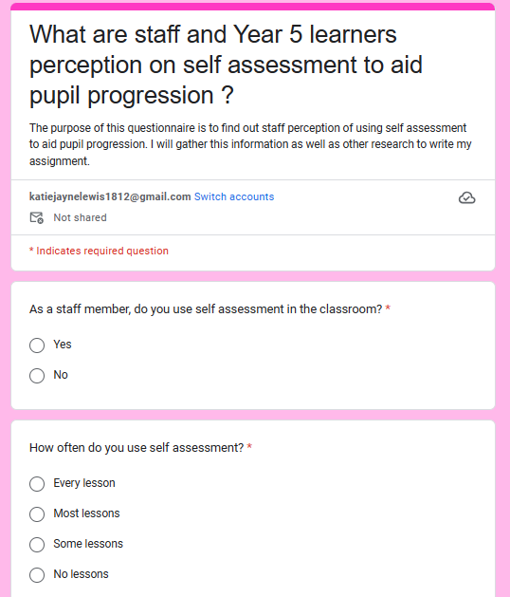
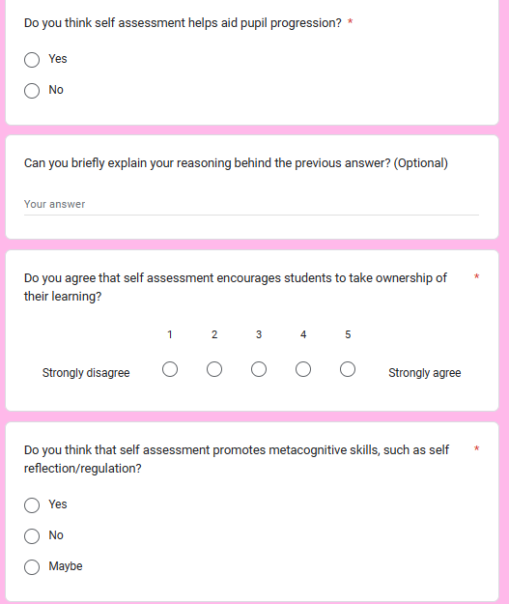
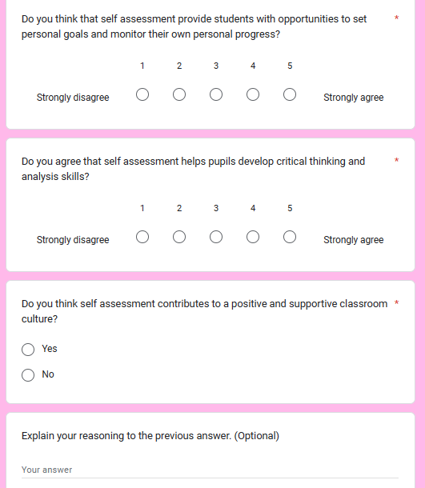

Appendices 4- Questionnaire results
Appendices 4a
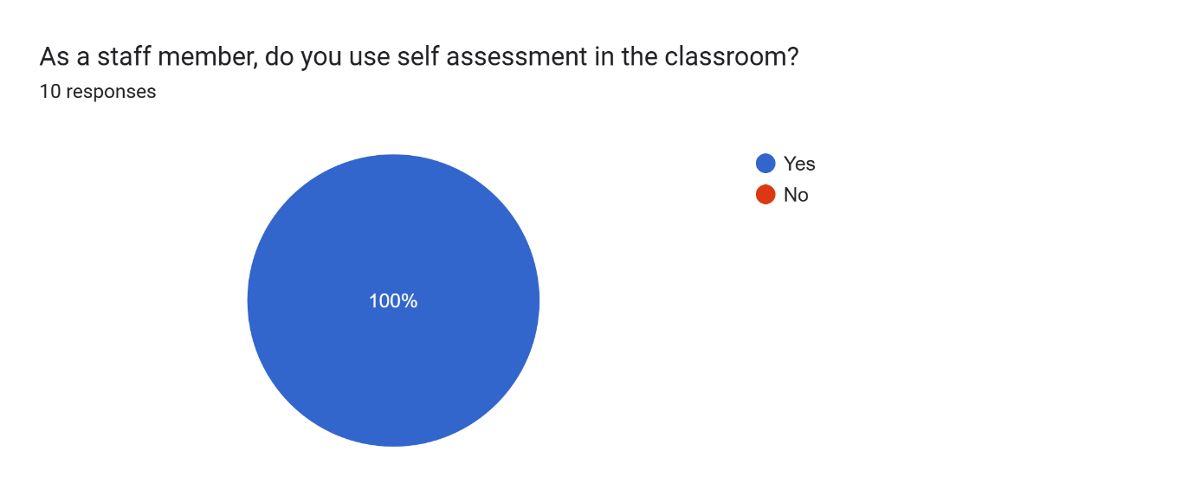
Appendices 4b
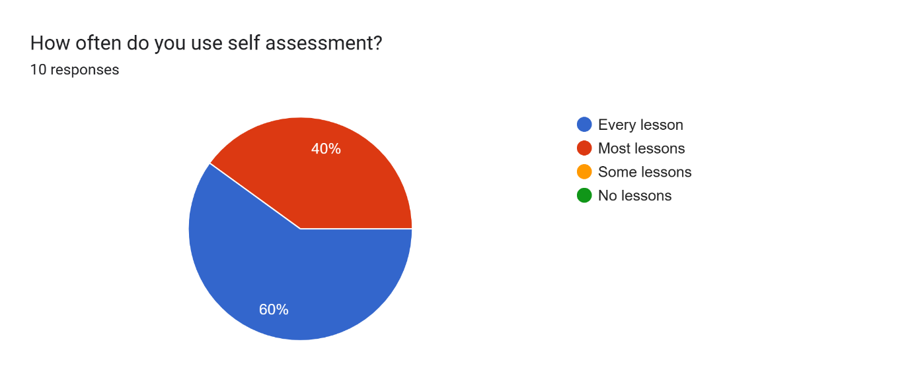
Appendices 4c
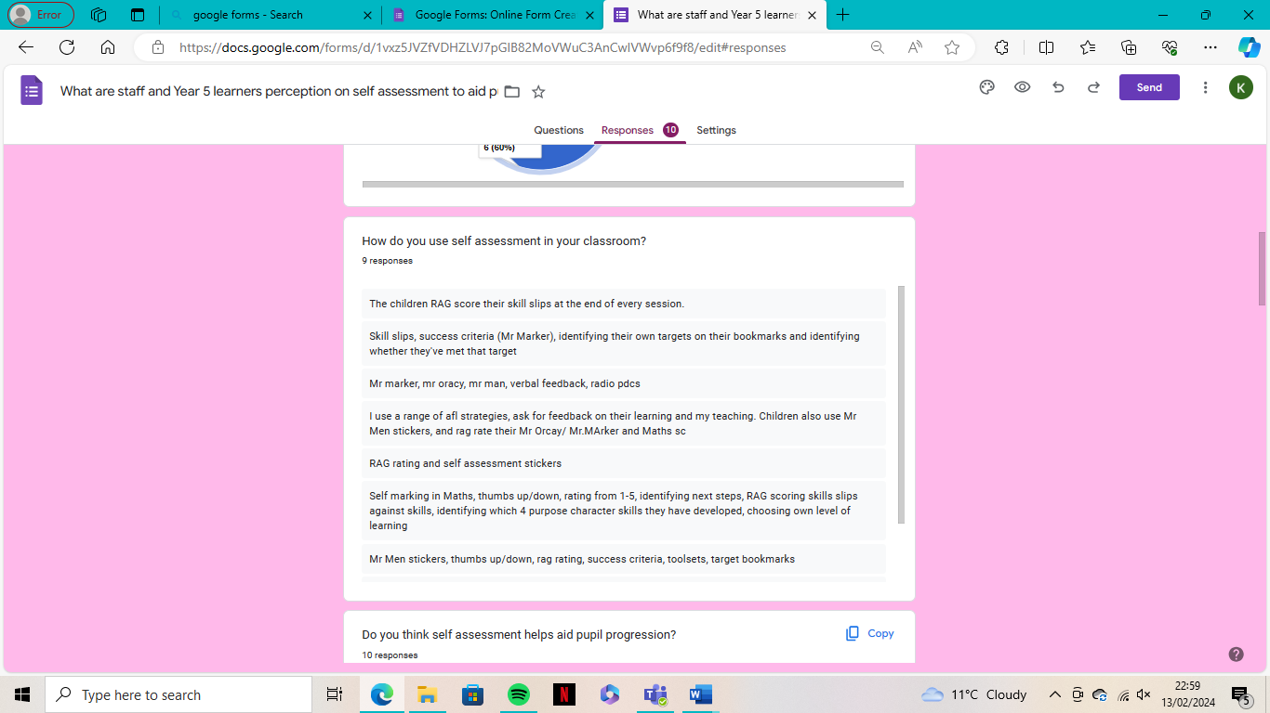
Appendices 4d
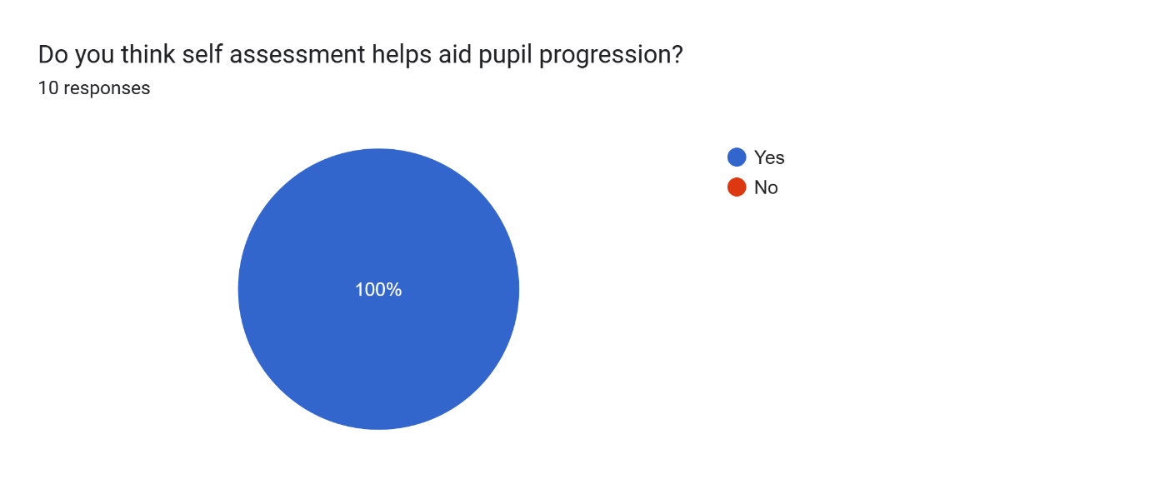
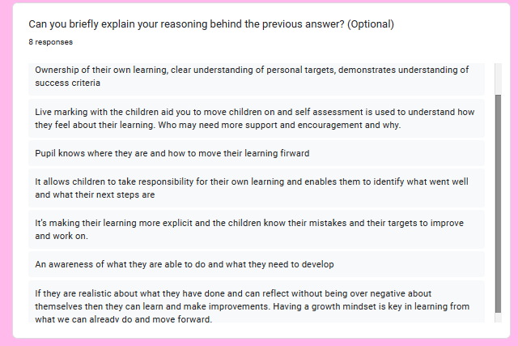
Appendices 4e
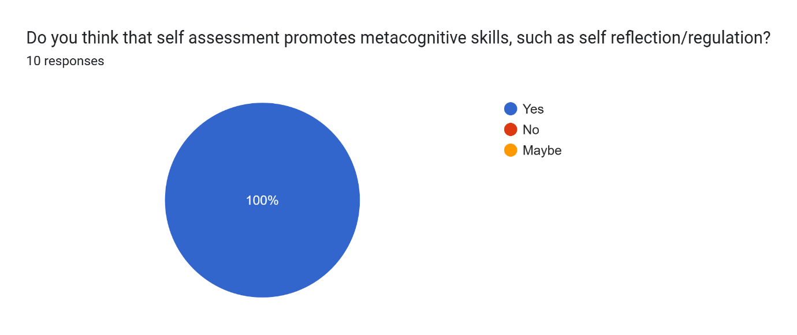
Appendices 4f
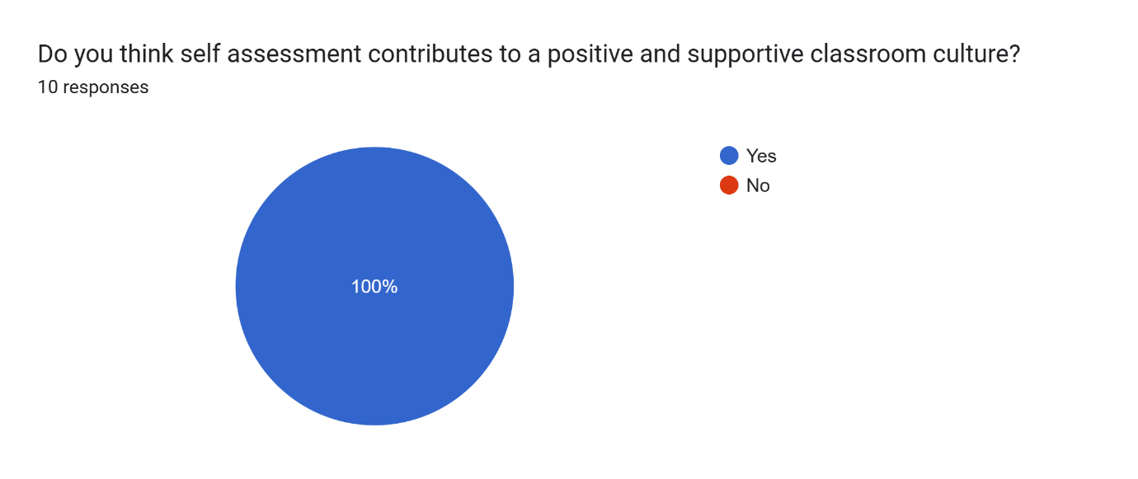
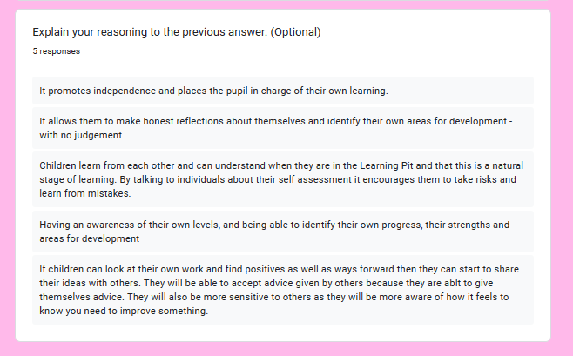
Appendices 5- Interview transcription
Interview conducted with 6 Year 5 pupils.

Me: Boys and girls does anyone know what ‘self-assessment’ means?
Pupil A,B and C: No.
Pupil D: Does it mean you self-check your work?
Me: Yes, it does, good job. Do you use self-assessment in your class?
All pupils: Yes!
Me: So.. How do you do this?
Pupil E: We got skill slips.
Pupil A: We mark it.
Pupil F: yeah, we mark it.
Pupil C: Yeah, so we got like skill slips and little text things in them and we have got green,orange and red for if we have done it, if we haven’t done it and if we have kind of done it.
Me: Okay, So how often do you self-assess your work in class?
All pupils: Every day.
Me: Do you like self assessing your own work?
Pupils A,B,C,E,F: Yeah.
Pupil D: Eh, actually it’s a bit fun.
Pupil A: Yeah, it's kind of fun.
Me: How does it make you feel, when you mark your own work?
Pupil C: Independent.
Pupil E:Normal.
Pupil A: Confident.
Pupil D: I don’t know, meh.
Pupil B: it is brave.
Me: Okay, interesting so how does it make you feel towards your work?
Pupil A: happy.
Me: Why is that?
Pupil A: Uh… because um.. because then I don’t know.
Me: Is there anything you don’t like about self assessment?
Pupil B: Ugh, if you loose your coloured pens and then we don’t know what to do.
Me: What do you mean by coloured pens?
Pupil B: Like my pens. We got felt pens in our pencil cases.
Me:Okay.
Pupil B: That we use.
Me: What colours do you use and what do they mean?
Pupil B: Um so red means didn’t do it. Oranges means kind of did it and green means didn’t.
Me: Okay.
Pupil D: Also, we do it after we finish something that miss told us to mark.
Pupil C: Like with maths,topic… practically anything!
Me: So… all subjects?
Pupil A: Yes, every lesson. Like English or maths.
Pupil C: We don’t even do English? All we do is speak English. Hello.
Pupil A: Hello.
Me: So would you rather self assess your work or peer assess? Peer assessing is when someone else, like a friend marks your work.
Pupil B: Easy, Peer!
Pupil E: Peer assess.
Pupil A: Well…
Pupil C: Self… because no one else sees if you got anything wrong.
Pupil E: And also, with the peer, then we can do them like …. we can literally just do nothing, sit back, start getting ready for break or next lesson.
Pupil B: And it is good to see what they put down for you.. the work you did.
Pupil A: And you don’t have to work. So I put down I independent, they might say I was actually ‘H”.
Me: What does H mean?
Pupil A: It means you need a lot of help. ‘I’ means independent and ‘M’ means medium help.
Pupil E: It is kind of like with the colours.
Me: Okay, thank you guys! That is all.

