BMIH5007 Financial Management for the Hotel Industry
Assignment Title: Comparison of Two
Hospitality Organisations

Student : Adrian Marian Oprea
Student id: 1714749

Executive Summary
This report has discussed the essential components associated with revenue management for Travelodge and Shangri-La Hotels along with highlighting the impact of various marketing initiatives in the business growth aspects. The comparison of the revenue among these two hotel businesses has been analysed along with mentioning the most suitable target customer base through creating a customer persona. The financial commitments towards CSR initiatives have been discussed along with highlighting the impact of effective CSR initiatives on the potential growth of the business. The market position of Travelodge and Shangri-La has been evaluated through a positioning map which highlighted the impact of the strategies adopted by these businesses.

Table of Contents
Introduction 4
Discussion on the Organisations 4
Comparison of Revenue 4
Market Position 6
Potential Growth of the Organisations 8
Financial Commitment to CSR of the Organisations 10
Recommendations 10
Conclusion 11
References 12

Introduction
This report aims to acknowledge the diverse business strategies adopted by Travelodge and Shangri-La Hotels along with highlighting the ability to incorporate enhanced financial planning to generate better revenue. The market position of these hotel businesses will be evaluated through a positioning map along with reflecting the characteristics of the target consumer base through customer persona. The potential growth factors associated with these hotel businesses will be discussed in this report along with highlighting the impact of brand awareness on the business growth.

Discussion on the Organisations
The sustainability of business organisations operating in the hospitality sector greatly depends on the appropriate evaluation of the essential factors of the business environment. It enables them to formulate effective strategies based on the fluctuations associated with the needs and expectations of the consumer base. This leads to a better scope for business growth in the competitive market (Jagels, 2007). Brexit and the epidemic devastated the UK economy, affecting hotel finances. To combat the economic slump, good marketing and revenue management are needed. Travelodge, a popular UK hotel chain, succeeds in the competitive hospitality sector by providing guests with the best comfort and convenience and concentrating on the business process (Travelodge, 2024). Travelodge prioritises improving services by understanding customer concerns and queries and making appropriate changes to business policies to improve customer satisfaction and the hotel's reputation. Shangri-La is an international hospitality company that succeeds in the UK hospitality industry by providing guests with high-quality services and superior digital marketing (Shangri-La, 2024). Shangri-La Hotels and Resorts may improve financial planning by using a revenue structure that optimises resource use. The hotel company can better handle business volatility. Shangri-La's marketing department evaluates its rivals' pricing strategies. It improves comprehension of the best company strategy for development and customer service..

Comparison of Revenue
The initiatives adopted by a business organisation towards achieving enhanced stability in the overall business process require the incorporation of an effective revenue management system for the appropriate allocation of resources. This enables the business to manage essential components based on the evaluation of their priority resulting in proactive efforts towards any unforeseen challenges or issues associated with financial aspects (Drury, 2021). The effectiveness of the finance function of the hotel business promotes better alignment of the other crucial business segments with the goals and objectives associated with the business purpose. It leads to enhanced scope for arranging suitable services for the guests that result in better customer loyalty which is highly essential for accomplishing sustainable business growth (Prasad, 2020). The ability of both Travelodge and Shangri-La Hotel to understand the significance of change management along with engaging in identifying the most suitable strategies and technological advancements in their existing business process resulted in achieving enhanced competitive advantage. It leads to a better scope for sustainability in the revenue collection aspects.
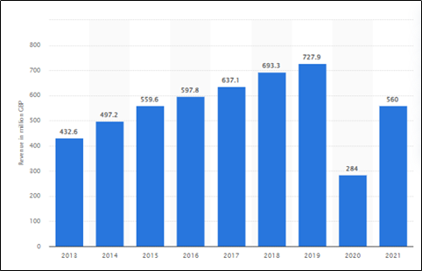
Figure 1: Revenue of Travelodge in the United Kingdom
(Source: Statista, 2024)
The graph highlights the potential of Travelodge to incorporate effective strategies associated with financial management which resulted in an increment in the revenue collection till 2019. The economic slowdown in the UK due to the pandemic along with the increase in the corporate tax rates by the British government led to a sharp decline in the annual revenue in 2020 (Statista, 2024). The analysis of the external business environment resulted in the identification of the diverse opportunities associated with business growth for Travelodge promoted enhanced revenue in 2021. It paved the way for the fulfilment of the vision of the hotel business which aims to accomplish enhanced market share in the hospitality sector of the UK. The marketing initiatives by Shangri-La which comprises a social media marketing strategy for obtaining the attention of a large audience base resulted in better brand awareness which is essential for sustainable finance function along with ensuring better scope for increasing revenue collection in the competitive hospitality sector.
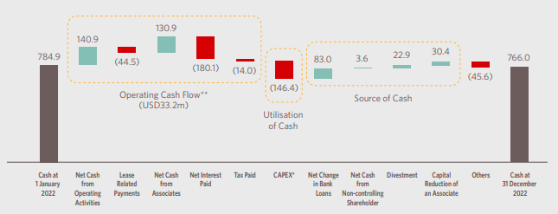
Figure 2: Movement of cash flow at Shangri-La
(Source: Shangri-La, 2022)
The proper financial management at Shangri-La can be seen in the approach of the hotel business towards the finance function (Shangri-La, 2022). The annual revenue of any business organisation greatly depends on the ability to manage the financial aspects resulting in enhanced stability in the business process.

Market Position
The sustainability of the business organisation in the intensely competitive hospitality market is greatly dependent on the evaluation of the key factors of the business environment (Walker, 2021). It requires a proper understanding of the role of the marketing function and its impact on the overall business process which is correlated with the ability of the business to achieve better market position. The promotional strategy adopted by Shangri-La is focused on understanding the needs and expectations of the consumer base enabling them to understand their perspectives regarding convenient services. This approach highlighted the requirement for the incorporation of suitable changes in the operational functions for better alignment with the effectiveness of customer service.
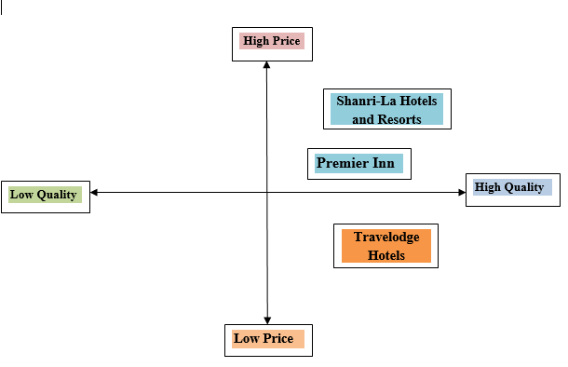
Figure 3: Positioning Map
(Source: Created by the learner)
The market positioning map highlights the focus of both the hotel businesses towards their business strategies. The business strategy of Travelodge is focused towards offering high-quality services at affordable pricing ranges. This approach promotes better attention of a large consumer base leading to enhanced business growth. This pricing strategy is adopted with utmost focus towards the comfort and convenience of the guest which cannot compromise with the essential services. The strategy adopted by Shangri-La is focused towards offering high-quality premium services with a high pricing range that reflects the ability of the business to incorporate enhanced policies. This approach resulted in highlighting the market presence of the hotel business among the finest organisations that have the potential to provide great experiences to its guests (Atrill and McLaney, 2021).

Necessary aspects | Required criteria
Age | 15 to 65 years
Gender | Male, Female and Transgender
Occupation | Businessmen, Govt. employees and private-sector employees
Segmentation | Psychographic
Social status | From any background
Table 1: Customer persona for Travelodge
(Source: Created by the learner)
The customer persona for Travelodge highlights the various characteristics associated with suitable guests. This information promotes a better understanding of the relevant needs and expectations along with ensuring enhanced customer satisfaction.

Necessary aspects | Required criteria
Age | 25 to 66 years
Gender | Male, Female
Occupation | Businessmen, Govt. employees and private-sector employees
Segmentation | Psychographic
Social status | Upper class
Table 2: Customer persona for Shangri-La
(Source: Self-created)
The customer persona for Shangri-La highlights the services offered by the business are suitable for the upper-class segment of the population due to high price ranges.

Potential Growth of the Organisations
The ability of the hotel business to evaluate the effectiveness of the strategies incorporated into the business process through monitoring the performance of each segment promotes enhanced growth (Griffin, 2022). The alignment of the business policies with the needs and expectations of the consumer base is also considered a significant factor for the betterment of the organisation. The understanding of the essential changes that need to be incorporated into the existing business process for addressing the potential challenges and threats associated with fluctuations in the business environment. This aspect resulted in great success for both Travelodge and Shangri-La Hotels in the hospitality sector of the UK. The business growth of hotel businesses significantly depends on the ability to communicate with the target consumer base. This aspect requires adopting effective marketing initiatives that have the potential to communicate the efforts of the business towards the comfort and convenience of the customers (Park, 2020). The challenges associated with the inefficiency in the process associated with customer service can be addressed with the incorporation of digital technology. Digital technology promotes better analysis of the performance of the business functions along with ensuring suitable changes that can resolve the present issues. The key principles associated with the Ansoff’s Model are utilised to understand the most suitable business strategy that will promote potential growth in the future (Zugay and Zakaria, 2023). This factor also ensures enhanced sustainability regarding brand awareness and annual revenue which is essential for the accomplishment of the goals and objectives of the business.
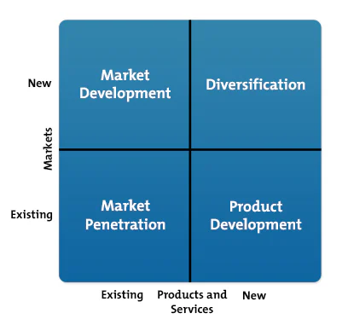
Figure 4: Ansoff’s Matrix Model
(Source: Zugay and Zakaria, 2023)
The incorporation of a product development approach into the business strategy by Travelodge resulted in affordable prices (Seal et al., 2008). This aspect enabled the marketing team of Travelodge to promote a wide range of services that do not compromise the comfort and convenience of the guests. The adoption of the product development approach by Travelodge has paved the way for better potential growth in the competitive market (Bhimani, 2006). The market penetration strategy by Shangri-La Hotels and Resorts enabled them to prioritise the premium services that will highlight their ability to incorporate enhanced policies towards the customer’s experience.

Financial Commitment to CSR of the Organisations
The reputation of the business organisation among the consumer base significantly influences the sustainability of the growth aspects. The incorporation of suitable CSR initiatives that aim to address the key challenges associated with societal and environmental issues promotes enhanced brand awareness. This factor highlights the voluntary efforts of the business organisation which requires the allocation of additional funds in the CSR initiatives. This scenario enables the business to focus on the finance function to prevent any negative impact on the operational process that can be compromised due to diversifying the business expenditure (Bhimani, 2006). The CSR programs of Shangri-La comprise achieving a net zero carbon emissions along with providing food to the NGOs that help the weaker section of society. The transformation of the supply chain management of Shangri-La requires additional financial resources for the effective implementation of sustainable business practices. The incorporation of change management into the existing business process is a challenging task due to the resistance from the workforce that is concerned regarding job insecurity (Crawford, 2021). The ability of the leadership to ensure their career development through the proposed change along with the appropriate implementation of the CSR initiative which is focused towards minimising the carbon footprint results in better employee engagement in adopting sustainable practices. The HRM of Travelodge is focused towards incorporating digital technology into the training and development initiatives that aim to enhance the skills and knowledge regarding the changing needs and expectations of the consumer base (Ozbilgin, 2020). The suitable allocation of funds into this initiative promotes better career development for the workforce which significantly enhances the employee engagement at Travelodge resulting in better scope for enhanced productivity and customer satisfaction. The incorporation of social inclusion at the workplace by both the hotel businesses resulted in better formulation of business strategies due to the presence of employees from diverse backgrounds.

Recommendations
The diversification of the service segment of Shangri-La which comprises separate offers associated with the pricing range of the rooms will promote better revenue (Seal, 2019). This aspect requires proper analysis of the perspectives of the target consumer base through various social media platforms enabling the marketing team to formulate effective promotional initiatives. The separate target consumer base that prefers affordable rooms needs to be addressed with a better strategy to shift their customer loyalty from the leading hotel businesses that offer affordable hotel rooms.
The incorporation of an effective revenue management system by Travelodge will prevent the financial aspects from any unforeseen crisis that can impact the sustainability of the business growth (Tranter et al., 2014). The economic slowdown in the UK due to the pandemic along with the higher corporate tax rates need to be addressed with proactive strategies. The monitoring of the performance of the key business components which is preventing from optimum utilisation of the resources needs suitable measures.

Conclusion
This report has discussed the significance of proper revenue management in the hospitality market along with highlighting the essential components of the business environment. The overview of the Travelodge and Shangri-La Hotels has acknowledged the focus of the business process along with their strategies towards enhanced growth aspects. The market position of the hotel businesses has been highlighted through a positioning map along with discussing the characteristics of the target consumer base. The impact of CSR initiatives on brand awareness has been discussed in this report along with highlighting the financial commitments by Travelodge and Shangri-La Hotels.

References
Atrill P, McLaney E 2021. Management Accounting for Decision Makers, FT Prentice Hall
Bhimani A, (Ed) 2006. Contemporary Issues in Management Accounting, Oxford
Crawford, J.K., 2021. Project management maturity model. Auerbach Publications.
Drury, C 2021. (11th Ed) Management and Cost Accounting, London, Prentice Hall
Griffin, R.W., 2022. Fundamentals of management. Cengage Learning, Inc..
Jagels, M. 2007. Hospitality Management Accounting, London, Wiley.
Ozbilgin, M., 2020. International human resource management: Theory and practice. Bloomsbury Publishing.
Park, S., 2020. Marketing management (Vol. 3). Seohee Academy.
Prasad, L.M., 2020. Principles and practice of management. Sultan Chand & Sons.
Seal W, Garrison RH, Noreen E 2008. Management Accounting, McGraw Hill
Seal, W 2019. (6th Ed) Management Accounting, London, McGraw Hill
Shangri-La, 2022. Annual Report [Online] Available at: <https://sitecore-cd.shangri-la.com/-/media/Project/Shangri-La-Group/Investor/Files/Public-Disclosures/Latest-Top-Publications/e0069_230418_AR.pdf
Shangri-La, 2024. Luxury Hotel in London | Shangri-La Hotel, At The Shard, London. [online] Available at: <https://www.shangri-la.com/en/london/shangrila/
Statista, 2024. Annual revenue of Travelodge UK from 2013 to 2021 [Online] Available at: <https://www.statista.com/statistics/429089/travelodge-total-revenue-united-kingdom-uk/#:~:text=Travelodge%20revenues%202013%2D2021&text=Travelodge%20UK%20generated%20revenues%20of,year's%20total%20of%20284%20million.> [Accessed on: 8th May 2024]
Tranter, K. Stuart-Hill, T. Parker, J. 2014. Introduction to Revenue Management for the Hospitality Industry, London, Pearson
Travelodge, 2024. Travelodge | Great value hotels throughout the UK & Ireland. [online] Travelodge. Available at: <https://www.travelodge.co.uk/>
Walker, J 2021. Introduction to Hospitality, Harlow, Pearson
Zugay, B. and Zakaria, R., 2023. Ansoff matrix. SAGE Publications, Inc.

