Mr. Liam Howells

Submitted in partial fulfilment of the requirements for the degree of

MMusTech Creative Music Technology
University of Wales Trinity Saint David

Analysing the influence that technological and socioeconomic forces have on the creativity and disparity of popular music

Word count: 5,198



Table of Contents:

Summary of topic...............................................................................................3

Introduction........................................................................................................4

Chapter One Influential technology
Technological influences on popular music..............................................................................7
Accessibility to music technology.............................................................................................8

Chapter Two Society, the industry and popular music
Homogenisation of popular music..........................................................................................11
Societal trends and industry adaptation.................................................................................13

Chapter Three Political and Economic Forces
Economic commodification of popular music.........................................................................16
Generating profit and technological enchancement..............................................................17

Conclusion...........................................................................................................................19

Reference Bibliography...................................................................................................23

Summary of topic

This paper analyses and discusses the music industry as an entity that is being influenced and altered by the waves of innovation in consumer technology and commercial activity. The idea behind the statement proposed by this paper is that the music industry has developed a structure capable of withstanding the demands of a society that is constantly connected through means of the internet and social media.
The technology that is now readily available to consumers and content creators allows for sophisticated and abundant creation techniques and this has allowed for a plethora of new sounds and ideas to be heard, as well as an undesired emergence of copyright infringement that devastated the revenue streams for the global music industry. The music industry had to assimilate and adjust to the digital era following the unwelcomed torrent of digital copyright infringement, this paper intends to investigate the redevelopment of the global music industry and it may have influenced the music and the artists we listen to.

Introduction

This dissertation will discuss the correlation between the current socioeconomic system and the technology that empowers it, for the ways in which they may be affecting creative disparity and diversity within contemporary popular music. Popular music is defined here as music that is widely received by mass culture on a global and commercial scale. Pop music status can be attributed to multiple genres, however there are sources that suggest a perceived lack of harmonic and timbral disparity between most of the music on commercial charts, that there is not much to differ between each song in terms of lyrical content, melodic structure and topic diversity. Mauch. M, MacCallum. R. M, Levy. and M, Leroi. (2015) carried out research on set definable properties of popular music in commercial charts between 1960 and 2010, summarising the idea presented by this paper of a correlating influence from technological, social and economic forces on popular music over time.
1.1 Influential technology will discuss historic details concerning listening habits and the gradual development and implementation of music technology. P, Schaeffer whose findings and literature have been highlighted for their fundamental stance in the development of electronic music are important for understanding the technological origins of contemporary popular music. As with most contemporary popular music now consisting mainly of synthetic and unnatural sounds and rhythms generated by samplers, synthesisers, sequencers, these forms of electronic music production along with a newly introduced means of digital audio recording and editing, became more and more accessible along with innovations in consumer-based technology and personal computers – enabling everyone from the young and prospected to the professional and well-established to communicate and operate in an enhanced digital environment. Musicians have been strengthened by the contemporary technological era both creatively and in terms of self-promotion capabilities, along with having access to fully revised recording studio facilities in a compact digital environment.
2.2 Society, the industry and popular music analyses a period of creative stagnation within popular music that occurred from the early 90’s to around the mid 2000’s; which can in part be attributed to the formalities of an oligopoly within the production cycle of popular music. Furthermore, as detailed within the information presented by the aforementioned research journal, the set definable properties of popular music will break down in chronological format this period of creative stagnation which corelates to how major corporations of the music industry assimilated to a new and effervescent online digital marketplace. This rollout of the world wide web and the eventual introduction of social media enabled society to share digital information on a global scale. Societies ability to freely distribute information online had initially incurred some troublesome scenarios – affecting the traditional commercial practices of the music industry. Proceeding to examine the fundamental properties of new digital music formats, such as MP3 – and how this new electronic media contributed to the disruption of traditional music industry practises.
3. Political and economic forces. As the industry has matured to a new digital hyperreality, the elements that form popular music’s commodity status were distorted in a way that popular music became less about what can be offered to the listener for its intrinsic qualities and artistic values – but more for how the music can be a vehicle for the promotion of economic and commercial development instead, and how this behaviour from influential commercial practitioners can result in promoting music that can be considered below the standards set by popular music recorded around the periods of the 60’s and 80’s. Contemporary means of online marketing and media provide the music industry with renewed strategic possibilities to ensure financial sustainability and growth, through paid subscription services to online music streaming platforms – which still is a relatively new concept that has surged in popularity in recent years. Music streaming platforms seemingly restored the void left by the depleted physical sales market, with profits rising each year.

Chapter One
1.1 Influential Technology: Technological influences on popular music.
Acousmatic sound and electroacoustic music are two key terms that define the underlying sonic mechanics formulating the majority of contemporary popular music. The term ‘acousmatic sound’ defines what is heard without the main visual source being seen by the listener, Schaeffer and Peignot (1948) used the term to describe the listening experience of their compositional work and research within their book In search of a concrete music
Schaeffer derived the term from Greek word ‘akousmatikoi’ – originating from Ionian Greek Philosopher Pythagoras, who used the term to label the preliminary stages of his teachings where he would try and enforce a deeper concentrated listening onto his pupils by delivering his lectures from behind a curtain or a veil.

Behind these contradictions and paradoxes lie fundamental shifts in listening habits. Shifts not revolutions: Christopher Small has recently pointed out (Small, 1998) that what we perceive as the decline of undistracted and concentrated listening, allied to music becoming a more integrated part of social exchange, is but a return to a behaviour quite common before the late romantic era in Europe. (Emmerson, 2000, p.1)

In modern society, listening to music on smartphones through wireless earphones or other devices such as a car stereo system, can carry the characteristics of acousmatic sound – but as is the case with concentrated and undistracted listening, the majority of the popular music being played does not require an attuned concentration for it to be comprehended. However, popular music somewhat has to justify the technical standards set by the technology that is used by the consumer to play it, stereo field and the acoustic properties of the listening space is important, but not so accessible to all consumers. Innovations are tending to lean toward active speaker technology, frequency response and high-fidelity audio.
With the current technological prowess of the modern era, music has seen new levels of popularity as technology becomes more intrinsically valued by musicians and consumers, this means the digital audio product will be a lot more relatable for consumers and ultimately more profitable for companies like for example Apple, who are offering online music streaming platform Apple Music along with the HomePod entertainment system.
1.2 Influential Technology: Accessibility to musical technology
“The noughties saw a huge increase of consumer technology and before long, home computing was no longer a luxury. Affordable software allowed for anyone to try their hand at music production and the old guard were understandably concerned.
Over in America, names like Puff Daddy and Dr Dre were also disrupting the status quo. Hip hop had opened up a new avenue to stardom - producing your own beats.”
(Terzeon, J, 2017)
With affordable prices and a relatively easy approach to general use and maintenance, personal computers at home were fast becoming the norm from the 90’s era. Exponential growth in the performance of CPU and microchip technology saw the personal computer expand its processing capabilities. This allowed for more complex and extensive software-based applications to be developed and relatively inexpensively. This access to affordable and relatively powerful consumer-based technology lay the foundations for a new generation of electroacoustic sound exploration.
This transition in accessibility to technological means of productivity, provided the general populace with new ways of expressing their inspired ideas. As detailed in the article by Terzeon, J (2017), this had an effect on popular music and cultural trends, for example in the UK, many styles of electronic music gained loyal followers (of trance, techno and drum & bass respectively). While in the US, hip hop, rap and R&B music was rapidly gaining dominance and claiming multiple positions in the charts. These forms of electronic music and the technology empowering them inspired a generation, the wave of creation and social embrace ignited a relationship between creativity and technology that had only been realised by a select few prior to the modern era. Pretty much every process within a professional recording studio has been decoded and embedded into software called Digital Audio Workstations (DAW).
Through free promotional evaluations of DAWs offered by developers and considering how easy it is for these applications to be retained, along with the depth of creative functionality they offer - not all users of these applications can get the most out of them – but with considering the sheer scale of creative utilisation they offer – from signal flow, dynamics processing, and rhythm or melodic sequencing. Finding out how to take advantage of these new facilities along with promoting new material meant connecting with other like-minded creatives and the most convenient way of doing this was through the Internet.
For a topic as broad as the Internet and its influence on electronic and popular music, it is necessary to refer an important key point to summarize this observation – communication.
Artists and enthusiasts began using the internet as a platform for discussion, self-promotion and exploration of new ideas and networking opportunities through online forums that later evolve into a larger form of social media such as MySpace at around the mid to late 2000’s. As discussed in an interview conducted by Daswani, K, (2015) with electronic dance music artist Calvin Harris, Calvin explains how he proceeded to interact with profiles of people he found to be working in the industry.
[Interviewer] And everything happened for you on MySpace.
[C. Harris] This was in 2006, when people were still looking for music on MySpace, and enjoying it. I would search for names that I would recognise from record liner notes – songwriters, DJs – and I would send them a message to check out my music. I was basically spamming them. One of them was a promoter named Mark Gillespie who used to book DJs and run festivals, and another was Felix Howard who had just started a job at EMI and was looking for music. They both got back to me. Mark knew two managers who looked after DJs and suggested we all have a meeting, and Felix signed me to EMI. Mark is still my manager and EMI is still my publisher. Everything happened in that one week. It was crazy. I was literally on the shop floor at Marks & Spencer and got a call that EMI was offering me £30,000 for three years. I put the phone down and remember thinking, “What am I going to do?” I was earning £20,000 a year and I was thinking if I should really leave. Thank God I did. (Daswani, K, 2015)

The internet had bridged a sizeable void between global exposure and confinement within local society, as is portrayed by the case and of timing of Calvin Harris’ discovery. With an extremely vast platform for self-promotion and self-expression, societies and different cultures around the world could now connect through the internet to share resources, discuss ideas and pursue new artistic concepts.

Chapter Two
2.1 Society, Industry and the Art: Homogenization of popular music
“Just as palaeontologists have discussed the tempo and mode of evolutionary change in the fossil record, historians of music have discussed musical change and the processes that drive it. Some have argued that oligopoly in the media industries has caused a relentless decline in the cultural diversity of new music, whereas others suggest that such homogenizing trends are periodically interrupted by small competitors offering novel and varied content resulting in ‘cycles of symbol production”
(Mauch. M, MacCallum. R. M, Levy. M, Leroi. A. M, 2015, p. 5).
Analysing the research presented by this journal, researchers have utilised music information retrieval and text-mining tools, analysing approximately 17,000 recordings that appeared in the US Billboard Hot 100 Charts between 1960 and 2010, for the purpose of observing and studying the quantitative trends in their respective harmonic and timbral structures.
The text makes a reference to oligopoly within the media industry, as in the case with song writing and the production of popular music - oligopoly has manifested itself within this field to a certain degree as well. For example, Martin Sandberg, known professionally as Max Martin together with Lukasz Sebastian Gottwald, also referred to as Dr. Luke – somewhat have a lion’s share of the market with songs dominating official charts all over the globe; working with well-known names such as Rihanna, Miley Cyrus, Taylor Swift, Katy Perry and Nicki Minaj.
The songs and the recordings these producers write for the aforementioned names are also extremely catchy – a trend that can be perceived as a form of homogenization. This can be observed by analysing the results from case study: Evolution of musical diversity in the Billboard Hot 100.
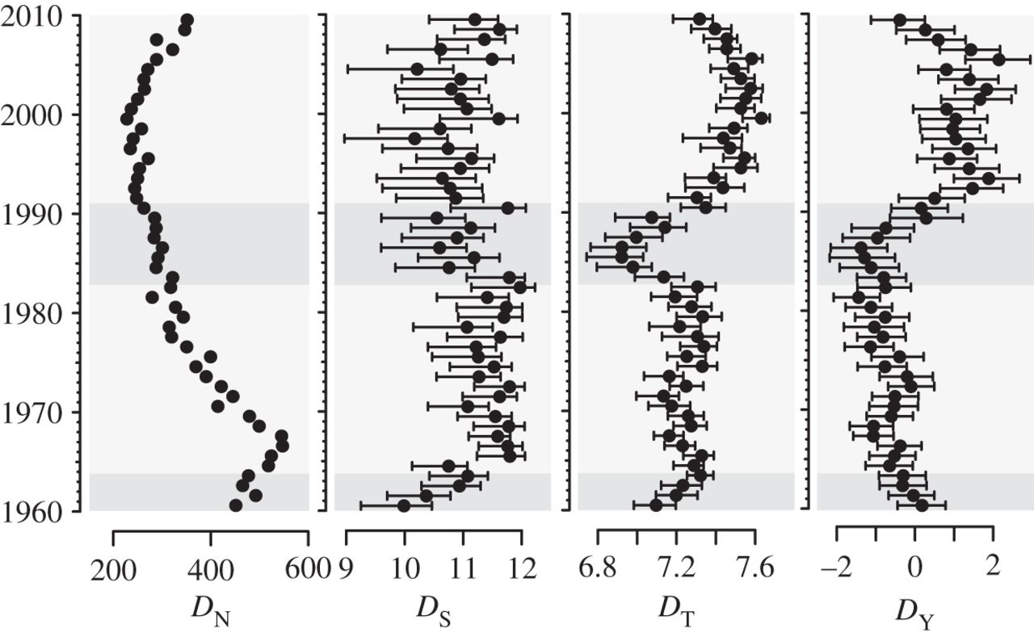

From left to right: song number in the charts, DN, depends only on the rate of turnover of unique entities (songs), and takes no account of their phenotypic similarity. Class diversity, DS, is the effective number of styles and captures functional diversity. Topic diversity, DT, is the effective number of musical topics used each year, averaged across the harmonic and timbral topics. Disparity, DY, or phenotypic range is estimated as the total standard deviation within a year.

Fig.1. Case Study: Evolution of musical diversity in the Billboard Hot 100, Mauch. M, MacCallum. R. M, Levy. M, Leroi. A. M (2015)

Upon studying the data presented, the disparity [DY] within popular music shows an exponential rise from the early 90’s before stagnating and declining around the mid 2000’s; a suggestive behaviour in the trend of popular music that, as discussed in the previous chapter of this writing - could be attributed to innovations in computing capabilities and affordable consumer electronics alongside new industry practices.
With the music industry adapting to the demands of an effervescent technological industry, what can be perceived as the manifestation of homogeneity in popular music could be attributed to ways in which a profit driven industry seeks to reduce risks of any major financial losses when investing in and promoting new artists - as understandably with the costs of worldwide promotion being substantial and the risk of a low return remaining likely - one method in reducing the risk of such financial loss, is to ensure that the records being released have an essence of familiarity about them which correlates to the behavioural trends of the popular music being promoted commercially, as reflected in Fig. 1.

2.2 Society, Industry and the Art: Societal trends and industry adaptation
The recent disruption of the music industry can be traced back to the arrival of online peer-to-peer technologies such as Napster. The key to the disruption were two characteristics of music: the ‘information goods’ nature of the product and that it is an ‘experience good’. The fact that songs are information goods makes them shareable, free, and able to be distributed unbundled from the album. (Dewan, S. and Ramaprasad, J, 2014 p. 101)
Dewan, S. and Ramaprasad, J. (2014) examine the relationship between new digital media formats, along with their impact on physical media sales in the industry and the growing importance of social media. The article summarizes two key characteristics of the digital audio product that have been proven to be fundamental elements allowing for the exploitation and disruption of the traditional methods of media distribution such vinyl and CD sales for example - that were initially maintaining a consistently high level of revenue year after year.
The information goods nature of the digital audio product exposed a new avenue for consumers to share and listen to their favourite music. As good for promotion as this may have been, the profit-driven music industry was not procuring the prospected profits that reflected the exponential development of online marketplaces.
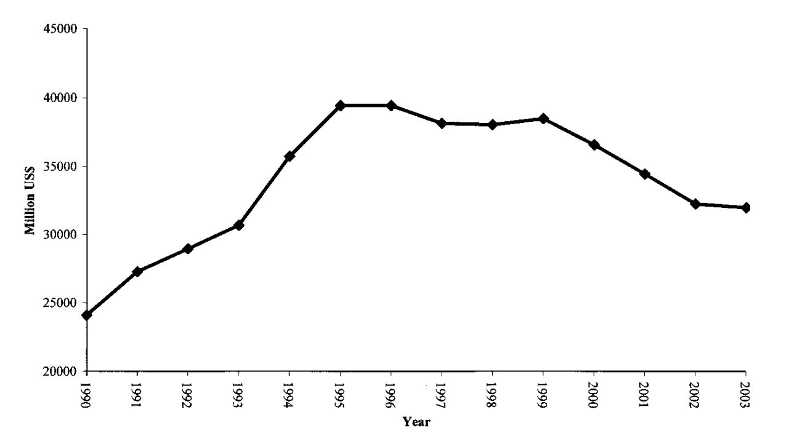
The RIAA has presented research online, in the form of a journal written Zentner, (2006) presenting statistics that support the analysis previously highlighted in this paper, concerning digital media and how it has disrupted global record sales as can be seen in the following image:

Fig. 2 Global music sales in million US$ (IFPI 2004a). Local currency values are converted to dollars at the exchange rate of each year. Music videos are included since 2001. (Zentner, A, 2006a p.2);

The music industry evidently had initial teething problems when colliding with the emergence of such technologies as peer-to-peer file sharing. As pointed out by Zentner,
This downturn coincides with the proliferation of online music file sharing. In June 1999, Napster was created, making the work of many artists available for free. Its popularity was immediate. According to Mediametrix, a company that provides Internet rankings and measurement, Napster was the fastest software adoption in history. (Zentner, A, 2006b p.2)
The fact that works of musical art that traditionally would have been purchased over the counter at retail stores were rendered completely free to acquire, damaging record sales significantly, did not halt or diminish the popularity of popular music artists or live performance events. If anything, the availability of free commercial and copyrighted content only exacerbated the desire for more live music events and festivals.
Worldwide communication made possible by the internet generated a convergence between music followers which in part facilitated a revitalising surge in popular music festivals. Naveed, K. Watanabe, C. and Neittaanmäki, P. (2017) indicate two key points for discussion:
- (i) the co-evolution between streaming and live music industries has functioned well over the last few years
- (ii) the live music industry has incorporated a self-propagating function by assimilating to innovations previously initiated by digital music (Naveed, K. Watanabe, C. and Neittaanmäki, P. 2017a)

With heightened levels of communication and the capabilities for distribution of content online, society is celebrating the art of music in a new modern facility. Naveed, K. Watanabe, C. and Neittaanmäki, P. explain how the music industry,
‘incorporated a self-propagating function by assimilating to innovations previously initiated by digital music. (Naveed, K. Watanabe, C. and Neittaanmäki, P. 2017b)
This action of adaptation or assimilation by the music industry ensures that sustainability within the context of a new online driven marketplace can be achieved.

Chapter Three

3.1 Political and economic forces: Economic commodification of popular music
Art and music are an integral part of cultures across the world, music has been the means for celebration, unity and togetherness - created by artists from various disciplines who intend to emit positive social energy. The commodification of music by commercially driven forces such as record labels and artist agencies, can also be perceived as the fundamental element that formulates popular music, for what is promoted to mass culture most frequently and intensely, is in part intended to serve the interests and targets set by corporate executives and investors.
León (2014) discusses how artistic expression in music is increasingly valued for the ways in which the art or content created can be expended for economic or commercial development, over what can be provided from any of the intended artistic values.
“Forms of cultural or artistic expression like music are increasingly valued for their ability to serve as vehicles for different forms of economic development, rather than for their assumed intrinsic aesthetic qualities. They are contested sites, where multiple constituencies (artists, audiences, granting agencies, urban developers, politicians, activists) compete with one another for more effective management control, simultaneously generating strategies that challenge and reinforce the current social and economic order.

(León. J 2014) suggests that the intrinsic and aesthetic qualities are essentially of lesser value to commercially driven entities when compared to what can be achieved by utilising the medium can serve as a possible tactic for the appropriation and dictation of cultural trends. This often leads to the manufacturing of cultural role models that are then promoted at the forefront of entertainment, consequently adding motion to more potential new trends and collective ideologies based upon the relevance of the product or personality and for what they may portray aesthetically and morally; this approach can initiate more frequent shifts in societal trends along with regulations tending to conserve and protect advantageous economic values instead of the intrinsic and morally inspiring aspects of music.
The stronghold of the pursuit for commercial development continues to hold an influence on the behaviour of commercial practises, which in turn influences the decision making of popular music artists and agencies, as what genre of music or topic is most relevant tend to be where many artists and/or agency promoters go. This mechanic of investment procurement in the corporate structure is decisive in that depending on what agreements or decisions have been made, could determine the longevity of an artist’s career along with how and what source material is selected for promotion before a cycle of production is initiated.
3.2 Political and Economic forces: Generating profit and technological enhancement
Art and music are an integral part of cultures across the world, music has been the means for celebration, unity and togetherness - created by artists from various disciplines who intend to emit a positive social energy. However, the continuous access to music online did not serve the industry well initially, with music becoming free to attain at any desired time through illicit means. As Christman explains:
Within 2017's $8.72 billion total, streaming overall remains the dominant growth vehicle, with the various channels growing a whopping 43 percent to $5.66 billion, up from 2016’s total of $3.96 billion. Looking at it another way, streaming last year generated 65 percent of revenue, or nearly two-thirds of all recorded-music revenue for the year. (Christman, 2018)
Christman’s article details the fluctuations in revenue growth of the US music industry, revenue that has been generated predominantly by paid monthly subscriptions to online music streaming platforms. As is the case with music being a fundamental form of cultural celebration, the possibility of generating a substantial profit within the current technological socioeconomic construct is consistently present. Ensuring that high profits are procured can be attributed to the studies carried out in the previous chapter, the disparity in popular music fell considerably around 2007 and 2010 and this could potentially be down to online streaming platforms and the freedom of choice that it imposes onto listeners. This new digital transportation of media can be perceived as a consumer controlled digital radio service, in the sense that the end consumer is in control of what content is being played or stored for consumption. The smartphone offers the consumer improved versatility and freedom of choice for digital music, while also offering the music industry a new platform for promotion and advertising. While commercial entities continue to dominate the mass awareness of popular music – music recorded and published by the dominant corporate figures will more than likely continue to dominate popular music charts.

Conclusion

The research carried by this dissertation serves to add to the understanding and other related research in this field, that along with how the information age has altered contemporary forms of social and economic systems, this greatly affects the consumption and practice of music and media production at a fundamental level; aiming to observe and discuss a selection of key topics that intend on summarizing the idea of a creative disparity in popular music, that is seemingly now only an object of perspective in the grand scheme of events. The music industry seems to be recovering well from the turbulent emergence of digital formats, the piracy and illegal distribution of copyrighted works made a sizeable impact on the global music industry, forcing the hand of commercial practitioners into devising a new digital music platform that is profitable yet affordable and easily accessible.
One argument here is that mass culture could be said to have exploited the art of popular music, the same way that the music industry exploited popular music. Where mass culture ravaged online digital content through piracy, critically damaging the traditional formats of music sales, the music industry had been appearing to release and promote music that was seemingly not abundant with emotional truth and was too repetitive or with not enough lyrical content. The trends in perception of contemporary popular music suggests that it all sounds the same becomes more apparent when undertaking general research of popular opinion and reviews from members of the public on social media or blogs.
The contemporary socioeconomic construct eventually aided in the development of a revised approach to the commercial practises in the music industry, formulating new and innovative entertainment services that are offered at little to no cost to the end consumer, while offering substantially more content. As the listener of popular music continues to enjoy the virtually endless libraries of playlists and albums from their smartphones or smart speakers at home, the music producer is indulging in the enhanced and fully integrated recording studio software.
As a final observation based on the topics discussed - while the art of popular music has been subject to alteration in various formats by society and the industry, individuals of all disciplines will continue to celebrate, create, write and enjoy the music that they truly enjoy creating and playing. The emergence of electronic music and music composed by means of electronic devices meant that producers could experiment with digital sampling, effectively using any sound that could be recorded as raw material (fitting into the electroacoustic soundscape as described by Schaeffer, 1952) even if the source material were copyrighted works, as it could be processed beyond recognition. Sampling, remixing – these techniques pushed the limits of what is considered ethically and morally accepted due to encounters with claims of plagiarism as records were being sampled by producers all over the world – in the hope of finding that perfect drum fill, vocal phrase or hook.
But alongside the music, fans can now for example connect with and stay updated on the progress of works of their favourite acts, binding together artists and music lovers. But is this binding together of musicians and followers really all that positive?

Social media has created an ideal platform for self-promotion but also seems to have ignited a light that cannot be turned off, after a while the light naturally becomes uncomfortable for those who have been exposed to it for long enough, the light in this discussion being social media of course, Facebook, Instagram and Snapchat for example. Social media tore down the curtains and illuminated the once mysterious lore a composer and music producer instilled with their otherworldly productions. There are also new demands and standards that correlate with the implementation of social media, such as those promotional demands from artist agencies who require artists to basically check-in on social media to remain engaged with the followers. Ultimately, popular music will continue to evolve and reflect contemporary states of cultural expression – for at least that can be said for the future of popular music; as there is no predicting what formalities modern society and the state of popular music may encounter in the future.

Reference Bibliography

McAlpine, F. (2018). Has pop music lost its fun? - BBC Music. [online] BBC.co.uk. Available at: https://www.bbc.co.uk/music/articles/fb84bf19-29c9-4ed3-b6b6-953e8a083334 [Accessed 9 Nov. 2018].
Mauch. M, MacCallum. R. M, Levy. M, Leroi. A. M (2015) present their findings in research journal ‘The Evolution of Popular Music: USA 1960-2010’. The research carried out within this journal enables us to see in chronological format the shifts and stagnations in topic diversity, harmonics and timbre of commercial popular music.
Apple’s HomePod houses a well-crafted speaker that is capable of detecting the acoustic space that it is situated in before producing any sound, ensuring that the most accurate and clear reproduction of the audio is emitted into the room.
Highlighted text from The rise of the producer: How nerds took over the charts (Terzeon, J, 2017) online article. Published by VT News & Entertainment: October 2017. http://vt.co/entertainment/music/rise-producer-nerds-took-charts/
A prime example of a digital audio workstation and a completely integrated recording studio is Live, from German manufacturer Ableton. Live 10 features audio and MIDI recording, an unlimited amount of audio and MIDI tracks for arrangement with 12 send and return tracks for mixing, along with 256 channels of mono in and out signal path for the implementation of outboard gear and external instruments.
Martin Sandberg also known as Max Martin is an award-winning Swedish born Record Producer and Songwriter
Lukasz Sebastian Gottwald is an award-winning American record producer, popularly known as Dr. Luke. Lukasz has also co-written records with Martin Sandberg.
Evolution of musical diversity in the Billboard Hot 100 is a case study presented in the research journal ‘The evolution of popular music: USA 1960–2010’ (Fig.4 Page No. 6) analysing the data of various key elements of popular music.
Dewan, S. and Ramaprasad, J. (2014). Social Media, Traditional Media, and Music Sales. MIS Quarterly, 38(1), pp.101-121.
RIAA. Measuring the Effect of File Sharing on Music Purchases | University of Texas at Dallas - Available at: https://www.riaa.com/reports/measuring-the-effect-of-file-sharing-on-music-purchases/.
The Evolution of Music Technology [Parts 1, 2 & 3]. (2009). [video] Directed by D. Jones and J. Kerfoot. USA: Deliberate Soul Productions.
Tan, D. (2013). Music Industry - Oligopoly Market. [online] Economicallyinclined.blogspot.com. Available at: http://economicallyinclined.blogspot.com/2013/07/music-industry-oligopoly-market.html [Accessed 9 Nov. 2018].
Hong, S. (2007). Measuring the Effect of Digital Technology on the Sales of Copyrighted Goods: Evidence from Napster. SSRN Electronic Journal.
Butler, S. (2018). Digital streaming behind biggest rise in UK music sales for two decades. The Guardian. [online] Available at: https://www.theguardian.com/business/2018/jan/03/digital-streaming-behind-biggest-rise-in-uk-music-sales-for-two-decades [Accessed 9 Nov. 2018].
Schaeffer, P. (1952). A la recherche d'une musique concrète. Paris: Éditions du Seuil.
Emmerson, S. (2016). Music, electronic media, and culture. London: Routledge.
Rosenblatt, B. (2015). High-Res Audio Makes Slow Progress as Sony and Neil Young Show Off New Products at CES 2015. Forbes. [online] Available at: https://www.forbes.com/sites/billrosenblatt/2015/01/08/high-res-audio-makes-slow-progress-as-sony-and-neil-young-show-off-new-products-at-ces-2015/#cb3cfb97113f [Accessed 9 Nov. 2018].
Computer Ownership Up Sharply in the 1990s. (1999). [Bureau of Labor Statistics, U.S. Department of Labor, Issues in Labor Statistics. https://www.bls.gov/opub/btn/archive/computer-ownership-up-sharply-in-the-1990s.pdf
Daswani K. (2015). ON YOUR MARKS - Calvin Harris talks about electronic music, MySpace, and why he’s the best person to take grocery shopping..
Mauch, M., MacCallum, R., Levy, M. and Leroi, A. (2015). The evolution of popular music: USA 1960-2010. Royal Society Open Science
Zentner, A. (2006). Measuring the Effect of File Sharing on Music Purchases. The Journal of Law and Economics, 49(1), pp.63-90.
Naveed, K., Watanabe, C. and Neittaanmäki, P. (2017). Co-evolution between streaming and live music leads a way to the sustainable growth of music industry – Lessons from the US experiences. Technology in Society, 50, pp.1-19.
U.S. Music Industry Hits Highest Revenue Mark in a Decade, Fuelled by Paid Subscriptions – Ed Christman, Billboard.com (2018) https://www.billboard.com/articles/business/8257558/us-music-industry-2017-highest-revenue-in-decade-fueled-paid-subscriptions

