‘Berlin, June 28.- The Pan German Deutsche Zeitung prints the following across it’s front page:’ “German honor today will be carried to its grave in the Hall of Mirrors, in which, in the glorious year of ’71 the German empire was resurrected in all its former splendor. Lest we forget! In restless labor the German people will again strive to attain that place among the nations of the world to which it is entitled. Then vengeance for the disgrace of 1919!”

- https://www.rarenewspapers.com/view/585516 , ‘A final yelp for militarism’, The Detroit Sunday News, 29th June 1919, p. 1

This article was written by Deutsche Zeitung (German Newspaper), a Pan German newspaper often abbreviated to DAZ, and became a conservative highlight of German media outlets during its production. Its intention was to become an equivalent conservative newspaper to that of The Times in Britain therefore providing a more democratic outlook on the government. In 1921 the newspaper went on an aggressive campaign against Armenia by denying their involvement but also justifying the Armenian genocide during the First World War and subsequently stated that murder and backstabbing was the true Armenian manner after the assassination of Taalat Masha in Berlin, a Turkish politician who ordered the arrest and deportation of Armenian intellectuals in Constantinople. The motive behind the publication or copy of this article was simply to display the media coverage from Germany news outlets to the American public on the day the Treaty of Versailles was signed during the year 1919. The intention behind the publication would possibly be intended as a display of German humiliation by America or patriotism from Americans for ending the biggest war at the time. Even though the American Newspaper didn’t say anything about this German article its clear to see that no words were necessary for what was said by the German media. From the German point of view, it is clear to see a mixture of emotion including anger, patriotism and sorrow, the resembling feeling of a lot of Germans after the armistice was signed ending the war. The German newspaper talks about how their honour will be destroyed and humiliated by the allied nations and their demands in the treaty of Versailles, for example the war guilt clause. It’s content also acknowledges the ironic element of the location where their pride and honour will be ultimately lost being held in Versailles where the unification of Germany took place in 1871 uniting multiple German states into one German Empire after the Franco-Prussian war. The final part of this article also foreshadows the future feelings of the German people during the period of the Weimer Republic being in control of Germany after its defeat in the First World War. “…vengeance for the disgrace of 1919!”highlights the German feeling about the terms given to them within the treaty of Versailles designed to humiliate them for their part in the war with vengeance a key word placed at the end of its article that obviously resulted in the creation of the Second World War under the third Reich.

This would appeal towards the right-wing members of the public mostly by creating a line that would include a sense of national pride and a promise of revenge that many Germans, both public and soldiers felt at the conclusion of the war. When we compare this publication to that of a media outlet on the side of the central power, for example Austria who first declared war, it leaves an obvious bias to the treaty of Versailles siding with German feelings. Their own newspaper ‘Neuigkeits Welt-Blatt’ printed a title stating, “The signature that brings us peace”: “Can the state that needs to sign this peace live?” indicating their own scepticism towards the allies demands in support of Germanys stance. The fact that they were worried about the survival of their state shows how, in the eyes of the central powers, these demands were not reasonable or even able to be met by any state, in particularly the reparation payments after 4 years of war. If Austrians or any of their allies needed further confirmation of this fact, then France made it clear to them with the Austrian newspaper writing it’s reply to their own question by quoting French newspaper ‘Ouvere’ which said “Today Austria signs its death sentence”. All these examples of the media from both allied and axis countries show the feelings and uncertainty in some cases facing them at the time. Germany was already out for vengeance both within their own country, an example of this being the ‘Stab in the back’ theory, and against their enemies after their military and monarchy was humiliated and defeated, some historians agreeing that this humiliation was unnecessary and a catalyst for the Second World War. Austria was uncertain of their future pending the signing of the treaty in Versailles whilst America was arguably basking in the victory by further displaying the humiliated Germany in their newspapers and maybe even antagonist them at some points. This gobbet captures the overall mood during the day of the signing of the Treaty of Versailles in 1919 and the humiliation both the politicians and military felt on the side of the axis powers when the demands were being drawn up.

Gobbet Two: ‘Liberty leading the People’

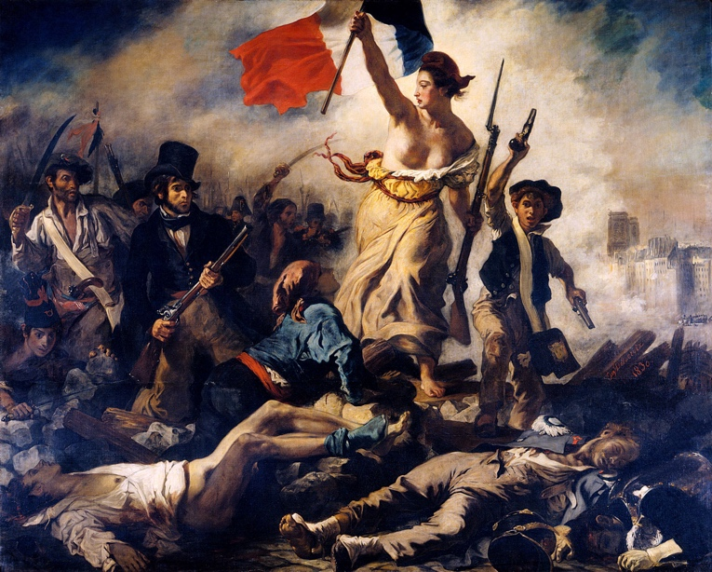
- Eugene Delacroix, Liberty Leading the People, c. 1830, oil on canvas, 260 x 325cm, Louvre Museum, Paris

The painting ‘Liberty Leading the people’ was painted by French artist Eugene Delacroix in 1830 in Paris during the July revolution. Delacroix’s motivation for this work was dominated by the previously mentioned July revolution that aimed to remove Charles X from the throne after he attempted to restrict the liberty of the French people through a constitutional takeover. The result of this was obviously another revolution once again to fight for their personal rights, taking siege of cities and aggressive fighting ensuing through France. Charles X would eventually abdicate and a new constitutional monarchy, often called the July Monarchy, took control of France in 1830. This painting is considered his most memorable work with Delacroix conveying the will and determination of the French people instead of glorifying the actual reason of the revolution, the removal of Charles X from the throne. Historians theorize that because Delacroix depended on royal commissions for his portraits, he never outright joined the revolution even though he was still moved and intrigued when the rebels raised the flag on the Notre Dame marking the turning point of the revolution. He would often call himself a “simple stroller” through the now volatile French society. In a letter to his brother, he would tell him “A simple stroller like myself ran the same risk of stopping a bullet as the impromptu heroes who advanced on the enemy with pieces of iron fixed to broom handles.” His focus on the emotional aspect of the revolution may be due to the romanticism era that he lived through and embraced. The painting showcases the French warriors lying dead on the floor with the symbolic lady standing resolute surrounded by smoke waving the French flag rallying the other warriors forward. The figures in the background also represent the different classes in French society from the third estate. The man on the left holding a musket or shotgun, wearing a finely tailored suit and a top hat represents the bourgeoise (middle class) whilst behind him we can see a man who looks like a factory worker due to the white apron we can see around his uniform. Finally, on the right side of the female figure we can clearly see a young boy, a student indicated by his black beret called a faluche, raising his pistol seemingly shouting something to those behind him as if he was rallying them forward. It is also worth noting that in the background surrounded by the smoke we can just about see Notre Dame being the only building featured in Delacroix’s painting. The woman is the centrepiece of this painting embodying the symbol of liberty during the revolutionary era of France. Delacroix would display liberty as a goddess like figure using the dead as a pedestal, possibly the dead as her pedestal representing liberty striding through the image towards the viewers. She is also wearing a red Phrygian cap that is like the stocking cap symbolizing the working class and was made popular during the initial French revolution (1787-1799) often referred to as the ‘liberty cap’. Delacroix also paints her holding a musket in her left hand possibly symbolizing equality within the working class that was created during the 1787-1799 revolution to topple the class system that dominated French society. This female figure also bares a resemblance to the statue of liberty that would be designed in 1886 and gifted to America as a sign of freedom so it’s understandable to reason that the pose of the female in the painting is often referred to as the symbol of liberty throughout the enlightenment era of France. This painting is seemed to be the symbolism of the end of the Age of Enlightenment, this may be as the end of the French Revolution was deemed to be when the Romantic era began.

The initial reception of this artwork within France was positive with the July Monarchy purchasing his work and displaying it in the Musee du Luxembourg located in Paris. It was moved to a museum for living artists but began to lose favour of the government and was taken down and within a few years was returned to Delacroix never to be seen again until he displayed it in Luxembourg once again. By 1874 ‘Liberty Leading the People’ was transferred to the Louvre where it slowly became one of Delacroix’s most celebrated works. It’s been acknowledged throughout history, most recently being used by Coldplay, a British rock-band, as it’s cover art for its album ‘Viva la Vida’ (Long Live Life) in 2008. Their song ‘Viva la Vida’ also focuses on the events of the French Revolution and the death of King Louis XVI. This is further proof that Delacroix’s ‘Liberty Leading the People’ is simply a piece of art that will survive for centuries, either through song or images, to come as a symbol of liberty and freedom for the people whether it be through politics or through war.

Gobbet 3

"We knew the world would not be the same. A few people laughed, a few people cried. Most people were silent. I remembered the line from the Hindu scripture, the Bhagavad-Gita. Vishnu is trying to persuade the Prince that he should do his duty, and, to impress him, takes on his multi-armed form and says, 'Now I am become Death, the destroyer of worlds.' I suppose we all thought that, one way or another."

- J. Robert Oppenheimer, ‘Now I am become death’, < https://www.atomicarchive.com/media/videos/oppenheimer.html#:~:text=I%20remembered%20the%20line%20from,that%20one%20way%20or%20another. >, [Accessed 21/5/2022]

J. Robert Oppenheimer is known for the creation of the atom bomb being a part of the Manhattan Project with other scientist such as Enrico Fermi and Leo Szilard. He is often referred to as the ‘father of the atomic bomb’. The personnel involved in the creation of the atomic bomb is vast, yet Oppenheimer is arguably the most well-known member of the project. Is it because he was the director of the project and therefore the de-facto leader of the project or was it because of his reaction to his own creation shown above? Personally, the latter is the more believable as a man who contradicts his own work, something as big as the atomic bomb, is worth exploring in more detail. The first line of his speech highlights how today we live under the term mutually assured destruction against almost every superpower in the world, Russia and USA are considered the main threats. By creating the atomic bomb, it did more for the future of society than it did for the current society. The atomic bomb was a means to an end for the Second World War, or the war between America and Japan specifically, and whilst its use is ethically questionable Oppenheimer seems to have understood the future implications of this breakthrough in warfare which ultimately led to the cold war between Russia and USA and the future threats of nuclear power in society. Oppenheimer’s speech was broadcasted out nationally when news broke of the use of his atomic bomb and his speech was not a joyous mood after the end of the war but more a sombre realisation of how it had ended turning to religion for his answers. Oppenheimer’s moral code is known to be complex and not controlled by one singular religion although he did hold an interest in Hinduism. He looks to Hinduism specifically possibly because of their focus on belief in the soul and karma (simple cause and effect). The explosion ended the war and saved millions of lives, yet it also killed thousands of innocent Japanese lives as well as soldiers. The advancement of nuclear warfare has led to an increase in potential nuclear threats although but has also ensured no nuclear warfare has been attempted due to mutually assured destruction. In the years to come Oppenheimer would use Hinduism as a structure in his life although he never fully converted to its ideology. Throughout his entire life after the atomic bomb, he looked for absolution through religion but then also felt pride for serving his country despite his own acceptance on how he changed the world even after he dies. One Hindu scripture influenced him most at this time telling the live audience “'Now I am become Death, the destroyer of worlds” taken from the Bhagavad-Gita, considered one of the holy scriptures of Hinduism. It’s interesting how he seems to place the creation of the atomic bomb on himself rather than as a team. The project was worked on by not just America but Canada and Britain as well where all scientists played a part in its development. True Oppenheimer was the director of the project and maybe he was assuming it was his responsibility as such but in the hegemony of command he was not in charge completely. The other members of the Manhattan Project had mixed feelings as well over its development. Leo Szilard desired to create nuclear weapons before the Nazi’s did but expressed his refusal to use it in warfare as he was a pacifist but also regarded himself as a contrarian. He would begin a petition to oppose the use of the atomic bomb in Japan due to possible future geopolitical issues, he wasn’t alone either with many scientists signing his petition believing that a peaceful demonstration would be of better use to show the Japanese their threat rather than moving straight to direct warfare. This gobbet highlights the internal conflict of one of the greatest events in the history of warfare and the potential future implications of this act from Oppenheimer’s point of view.

The use of the atomic bomb and the notion that Oppenheimer had become death itself carries through today with warfare often seeming a common theme through the decades. After the demonstration of the atomic bomb Russia began its own nuclear development programme and created their own nuclear bomb by 1949 thus creating the warfare methodology of ‘Mutually Assured Destruction’. The Cold War was a stark reminder of the power that Oppenheimer had introduced to warfare and that the world would never be the same again when it came to warfare. We can use the current situation in Ukraine as an example of the power nuclear warfare holds with governments. Russia’s threat of a nuclear deterrent against western allies of Ukraine has been able to hold any possible direct reinforcements from other global superpowers in aid of Ukraine. This is the true power of nuclear warfare and mutually assured destruction that Oppenheimer had created in 1945.

The Detroit Sunday News, ‘A final yelp for militarism’, < https://www.rarenewspapers.com/view/585516 >, [Accessed 11/5/2022]
Europeana Newspapers, ‘WWI in historic newspapers: Treaty of Versailles’, < http://www.europeana-newspapers.eu/wwi-in-historic-newspapers-treaty-of-versailles/ >, [Accessed 9/5/2022]
Europeana Newspapers, ‘WWI in historic newspapers: Treaty of Versailles’, < http://www.europeana-newspapers.eu/wwi-in-historic-newspapers-treaty-of-versailles/ >, [Accessed 9/5/2022]
Artsper Magazine, ‘Art Analysis: Liberty Leading the People by Eugene Delacroix’, < https://blog.artsper.com/en/a-closer-look/art-analysis-liberty-leading-the-people-by-eugene-delacroix/ >, [Accessed 19/05/2022]
- J. Robert Oppenheimer, ‘Now I am become death’, < https://www.atomicarchive.com/media/videos/oppenheimer.html#:~:text=I%20remembered%20the%20line%20from,that%20one%20way%20or%20another. >, [Accessed 21/5/2022]

