The Architectural Transformation of The Royal Welsh College of Music and Drama Building

Introduction
The Royal Welsh College of Music and Drama stands as an impressive example of contemporary architecture within Wales. The new and improved college by BFLS architects was completed in 2011 and is a modern extension of the preexisting Raymond Edwards building designed by John Dryburgh and officially opened in 1977 (cardiffparks.org, Royal Welsh College of Music and drama). Situated in Cathays Park; a civic centre with a rich heritage of early 20th-century governmental and cultural buildings, the college occupies a prominent location in Cardiff, Wales.
The college was originally founded in 1949 as ‘The Cardiff College of Music’ within the main range of Cardiff Castle (cardiffparks.org, Royal Welsh College of Music and drama) but due to a growing number of students, it was decided to construct a new college building on the outskirts of Bute Park. By this time, it had been renamed the ‘Welsh College of Music and Drama’, but it wasn’t until 2002 that it was awarded its royal title, officially making it the ‘Royal Welsh College of Music and Drama.
The contract for the project was won by BFLS architects in 2007 through an international design competition organised by the college. (Flanagan Lawrence, Royal Welsh College of Music and drama) The £2.5 million expansion allowed the college to modernise its facilities, improve its performance spaces and create a friendly environment where students and staff are more than just attendees in an academic setting; they are active members of a close and vibrant community of various talents.

Design Philosophy
The architects adopted a design philosophy that was centred around an inside-out approach (Flanagan Lawrence, Royal Welsh College of Music and drama), which allowed for the design of the interior to influence the shape of the building, rather than having the exterior walls restrain the potential of the internal spaces. Simultaneously, great care was taken to seamlessly integrate the building into its urban context.
The college looked to blur the boundaries between different departments and for the new building to facilitate integration among these departments to create a collaborative atmosphere (Flanagan Lawrence, Royal Welsh College of Music and drama). The physical layout of the spaces was carefully considered to encourage interactions among the students and staff from different courses, potentially leading to the sharing of ideas and possibly increasing diversity within the college.
The architect’s vision centred around the creation of 3 ‘individual units’; the ‘drama’ unit which houses the 200-seat Richard Burton Theatre and sits parallel to the original Raymond Edwards Building, a canteen facility with a rehearsal studio just above on the 1st floor, and the Dora Stoutzker music hall capable of seating 450 people. These 3 units, as well as the original building, are tied together with glass curtain walling and are all united as one entity under a singular, metal floating roof. The roof includes a metallic soffit which creates the visual illusion of a floating roof due to its reflective surface, making the building appear ‘lighter’ and more innovative.

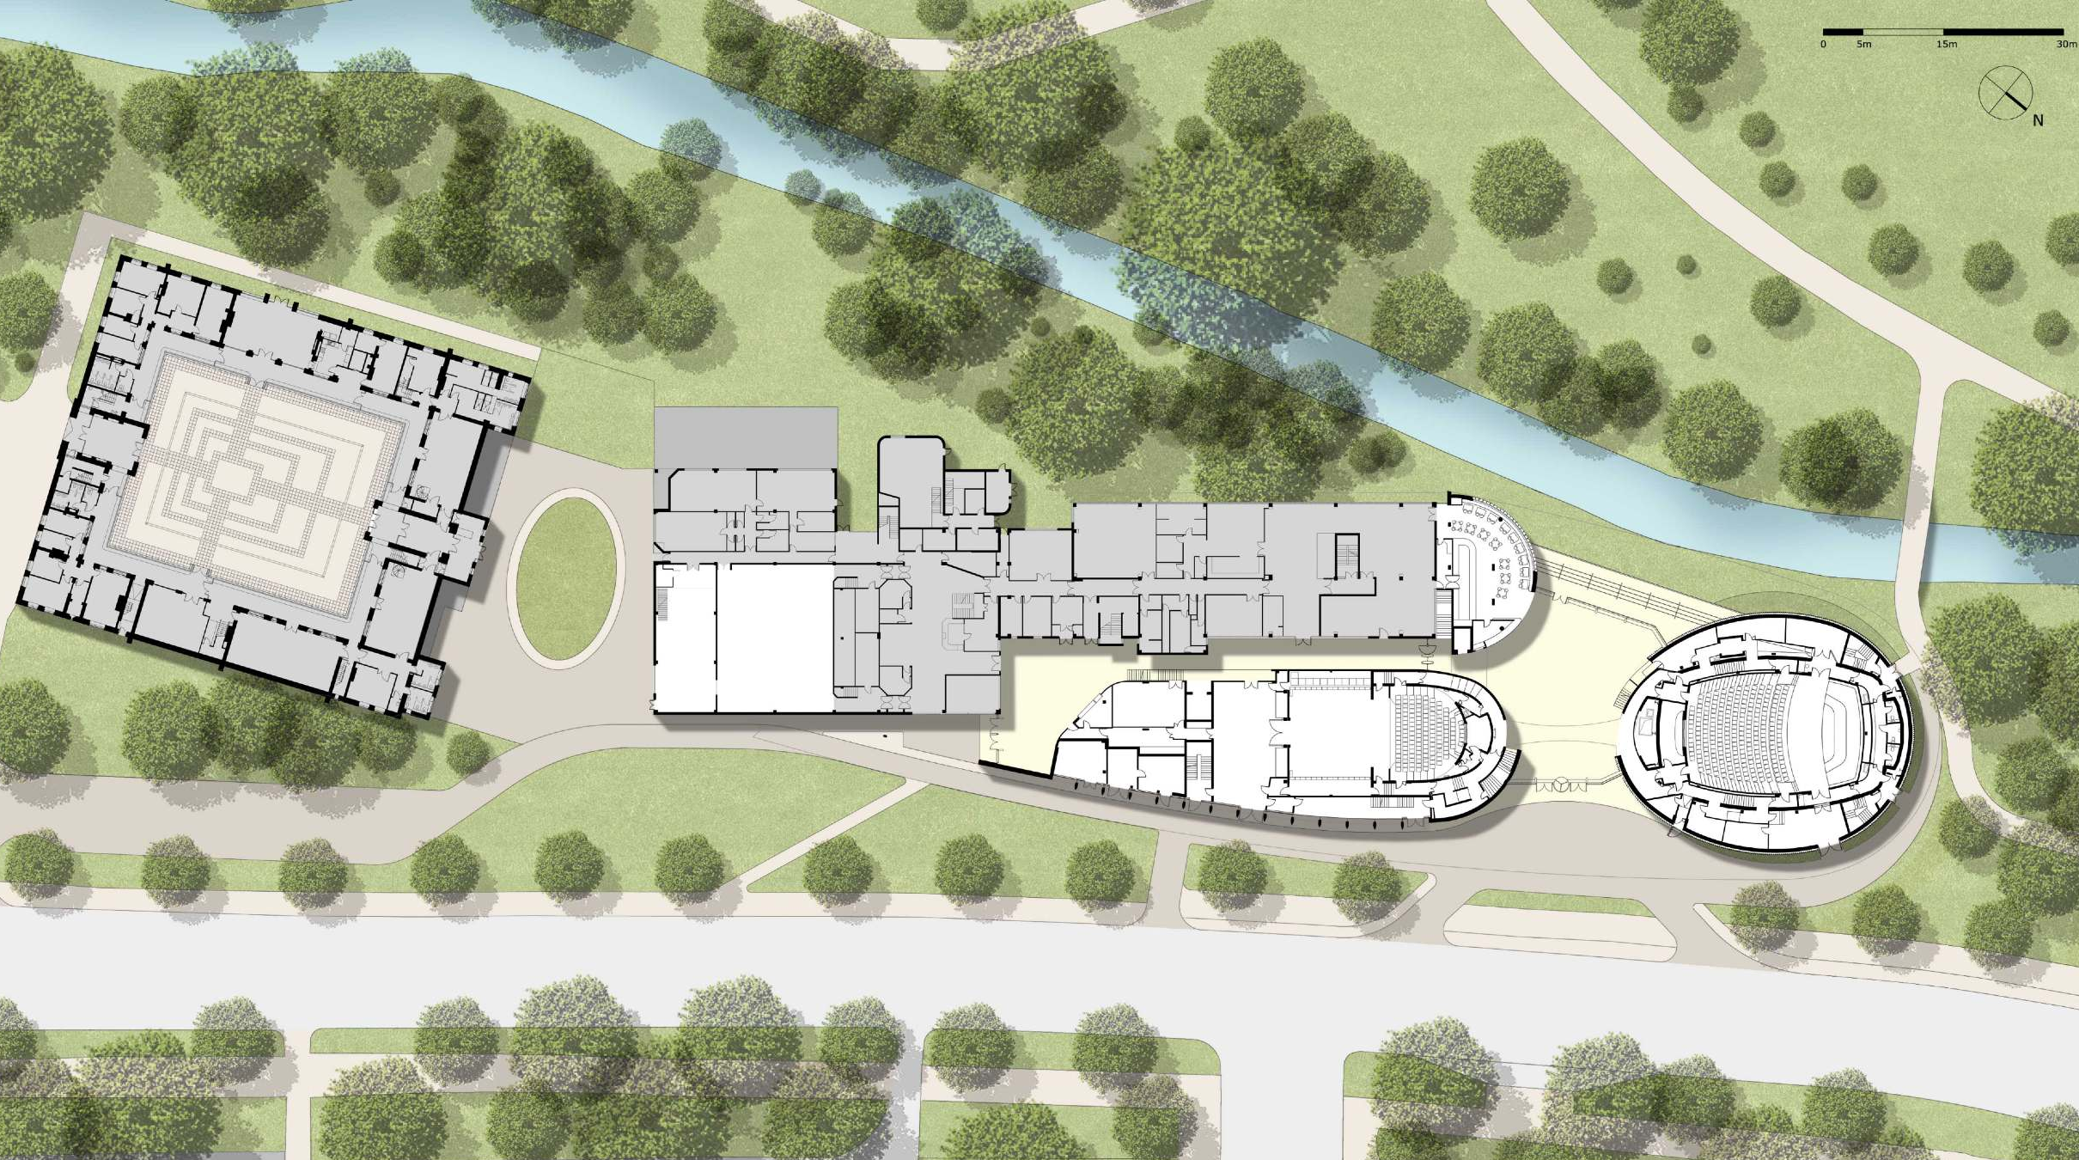
Main Entrance
Figure 1 – Site Plan of College

Design
The design of the college utilises many subtle elements that together, significantly contribute to the overall impressive functionality and aesthetic design of the building. The use of gently curving curtain walls at the main entrance serves as a practical way to welcome people in from the roadside and seamlessly guide them into the foyer area.
As shown in Figure 1, the foyer strategically opens up to Bute Park at the West side of the building, allowing in a great quantity of natural light and providing panoramic views of the natural landscape. The connection to the park is strengthened by the installation of the terrace which runs parallel to the canal and acts as a transitional space between the internal and external spaces, embracing the natural landscape and allowing for uninterrupted views of the park and canal.

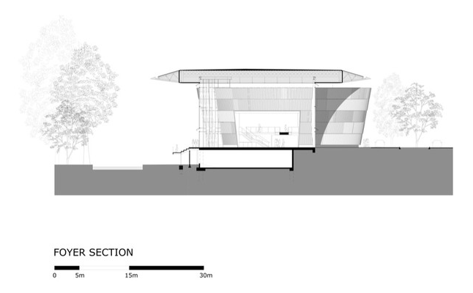

Figure 2 - Section Through Foyer

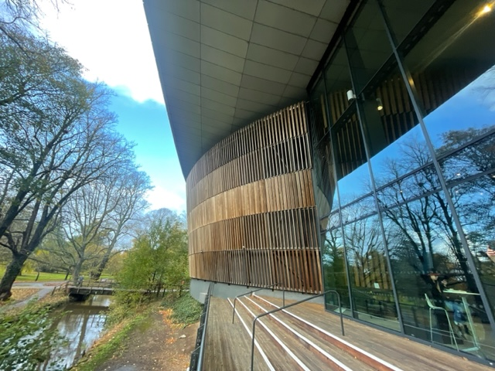
Figure 3 – The terrace opening up onto Bute Park

One of the key elements of the college is undoubtedly the Dora Stoutzker Hall; the large, drum-like feature at the North end of the building. Instead of a structure that would otherwise impose itself on the landscape, the music theatre seamlessly integrates itself into the park, acting as a bond that brings the college building into the natural environment of the park. This is achieved through the western red cedar wood (Jordana, 2010) that clads the exterior walls of the music theatre, resulting in a softer edge facing onto the park and creating a sense of harmony between the contemporary architecture and the intrinsic qualities of the listed park, allowing for the college to be a complement to the park rather than an obstruction.
The ‘drama’ unit serves as the new façade along North Road, consisting of stone and glass, and making up one side of the curving elements that guide people through the main entrance. The music hall, nestled within the park makes up the adjacent curved element. The curtain walls of the foyer physically connect and highlight the contrast between the industrial section of the college and the more ‘organic’ timber-clad music hall, (as portrayed in Figure 3).

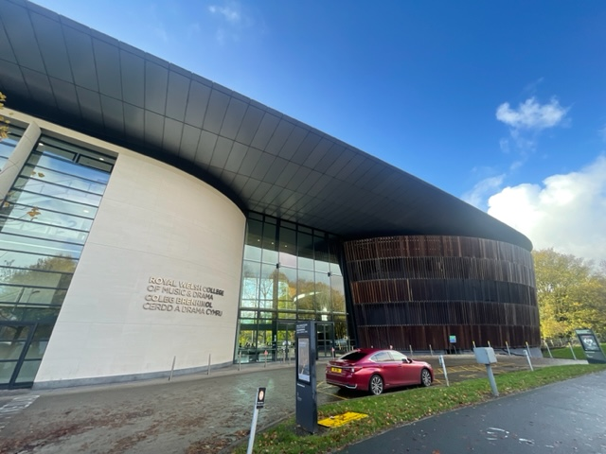
Figure 4 – The main entrance leading into the foyer

The intermediate space between the old Raymond Edwards Building and the new Richard Burton Theatre unit makes up the Linbury Gallery, a treble-height space that hosts exhibitions and special events (RWCMD, Linbury Gallery) and most importantly, functions as the main artery, linking the old college building with the additional facilities. The ‘negative space’ that makes up the area between the 3 new units is what makes up the foyer area and acts as a junction with direct routes leading to the Linbury Gallery, the canteen, the terrace, the Dora Stoutzker Hall, the Richard Burton theatre, and the main entrance.
The inward-curving walls from the foyer into the gallery play a crucial role in guiding individuals seamlessly through the space. This design choice not only ensures a fluid transition but also acts as a visual guide, directing individuals through the gallery in a funnel-like fashion, enhancing the overall navigational experience.
Furthermore, the bridge connecting the drama building and the music hall symbolises the relationship between the music and drama departments, emphasising the college's collaborative character.

Acoustics
The decision to acoustically close off the building from the adjacent road signifies a thoughtful understanding of the institution's function. To prioritise the quality of the acoustics, the design ensures that the performance spaces, notably the 450-seat chamber concert hall, remain insulated from external noise, mainly from the busy road. This strategic measure creates an environment finely tuned for musical and theatrical activities, aligning with the core requirements of the college.
The design of the performance rooms primarily focused on optimising the acoustic and theatrical elements to enhance the functionality of the spaces, this ensured that the core needs of the college were met (Flanagan Lawrence, Royal Welsh College of Music and drama) and that these spaces provided the best learning and performing environments possible for the students.
Internally, the concert hall features birch ply with a clear lacquer finish, chosen not only for its aesthetics but also for its acoustic properties. The material contributes not only to the visual appeal but also to the acoustic performance of the space ensuring that the performers and audience experience a harmonious and acoustically optimal setting, reinforcing the commitment to excellence in architectural acoustics. Judging from the many positive reviews on the college website regarding the Dora Stoutzker Hall (RWCMD, Dora Stoutzker hall), it is clear that the space is a success and achieved what it was designed to.

Conclusion
In conclusion, the Royal Welsh College of Music and Drama has undergone an impressive architectural evolution since its beginnings in 1949. The current building stands as an innovative example of how an old building can be extended and transformed within a modern context without sacrificing the heritage of the surrounding area. The transformation of the college demonstrates how a building can be suitably adapted to meet the evolving needs of its community.
The design philosophy, characterized by an inside-out approach and a dedication to seamless urban integration, serves as the foundation for the college's architectural success. This approach prioritses the functional needs of the college without sacrificing the aesthetic design of the building. The creation of the three distinct units which are united under one continuous roof symbolises the theme of ‘collaboration’ and demonstrates a vision that prioritizes both functionality and aesthetic appeal.
Looking closely at the design elements reveals a cleverly organised arrangement of spaces that encourage interaction and embrace the natural surroundings; from the foyer's deliberate opening up to Bute Park to the softly curved walls that welcome and direct guests. The acoustically closed-off design showcases a deep understanding of the institution's function. The emphasis on the acoustic quality aligns with the core requirements of the college, providing optimal settings for musical and theatrical performances.
Overall, this project has demonstrated how an old building can be transformed and extended in a modern context without sacrificing its heritage. The Royal Welsh College stands as a testament to the successful fusion of historical elements and contemporary design principles. By adopting an inside-out approach, prioritizing collaboration, and integrating seamlessly with the surroundings, the college has not only met modern functional needs but has become a vibrant hub for diverse talents.

Reference List

Figure 1 - Lawrence, F. (no date b) RWCMD Site Plan, Flanagan Lawrence. Available at: https://www.flanaganlawrence.com/royal-welsh-college-of-music-and-drama (Accessed: 15 December 2023).
Figure 2 - ArchDaily (no date) Section Through Foyer, ArchDaily. ArchDaily. Available at: https://www.archdaily.com/178785/royal-welsh-college-of-music-drama-bfls (Accessed: 15 December 2023).
Jordana, S. (2010) Royal Welsh College of Music and drama / BFLS, ArchDaily. Available at: https://www.archdaily.com/69695/royal-welsh-college-of-music-and-drama-bfls (Accessed: 15 December 2023).
Lawrence, F. (no date) Royal Welsh College of Music and drama, Flanagan Lawrence. Available at: https://www.flanaganlawrence.com/royal-welsh-college-of-music-and-drama (Accessed: 15 December 2023).
Royal Welsh College of Music and drama (no date) Bute Park - Royal Welsh College of Music and Drama. Available at: https://www.cardiffparks.org.uk/bute/info/rwcmd.shtml (Accessed: 15 December 2023).
RWCMD (no date a) Dora Stoutzker hall, Royal Welsh College of Music & Drama. Available at: https://www.rwcmd.ac.uk/our-campus/dora-stoutzker-hall (Accessed: 15 December 2023).
RWCMD (no date) Linbury Gallery, Royal Welsh College of Music & Drama. Available at: https://www.rwcmd.ac.uk/our-campus/linbury-gallery (Accessed: 15 December 2023).

