Student Name: Charlie Treasure- Coates
P Number: 1802990
Programme of Study: Surface Pattern Design (for interiors)
Module: ADAD4010
Lectures: Julia Lockheart and Gwenllian Beynon
Word count: 1542

We are in the age of the Anthropocene, an era where humans have only lived 0.1% of the entire universe’s existence, yet in that time we have left profound marks, which is subsequently throwing our earth off balance, along with those who live in it- we are losing sight of which path to take (The Prince of Wales (HRH), Juniper and Skelly, 2010)
Humans are the only species to have a multiplying culture, we are undertaking that of remodelling the physical and biological world, we have the power to alter the future of every species, including our own (Vince, 2014). The notion behind culture, has often made us believe that we are on this theoretical pedal stool against other animals and the natural world, thus leading to a common view of animals being objectified as ‘things’ or ‘other’ in relation to humans (Hurn, 2012).
Exploring the ideas of John Burger’s work of why we look at animals, this exhibition delves into the complex relationship of man and animal and how the age of the Anthropocene has had effect on this perpetual connection with non-human species.
This exhibition will be held in an animal enclosure, influences originating from London zoo, particularly the Snowden aviary (see fig. 1a). This is one of an intimate exhibition, it’ll engage those who view it through provoking their senses and thoughts. It will allow the audience to walk through, causing them to be submersed in the enclosed environment, the smaller pieces included, will be shown within glass domes as glass will enable the viewers to constantly be in some contact with the surroundings. The curvature of these domes will add to the already intimate space curated from the enclosure, thus causing the audience to feel more aware of themselves and the space they are in. (see fig. 1b)
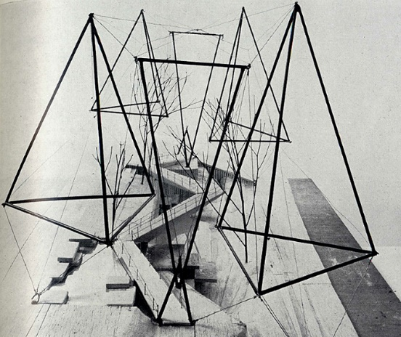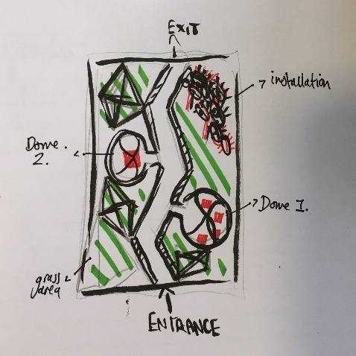
Fig.1a: Snowden Aviary (Price, C. 1965) Fig.1b: exhibition layout (Treasure-Coates, C. (2019)
The zoo is a metaphorically important element to this exhibition, as it reflects that of Berger’s ideologies, to how we and the animal are in relation, and the perplexing perspective that lies between the ‘spaces of the bars, the visibility through the glass or the empty air above the moat’ (Berger, 2009, p. 34). The mere innocent act of this, relates back to species free or bred, who have been heavily conditioned to meet that of human actions, which subsequently resulted in the way we perceive and hold animals against us. (Ramos, 2016)
Emitting a sense of uncertainty and uneasiness, contradicted to that from a conventional gallery, the enclosure enables the audience to experience that of an animal’s perspective, their life cut off from others, stricken from their independence, their life held by a frame. (Ramos, 2016). Through the façade of this, however, the solidarity of the enclosure, causes the audience to feel an aware consciousness of themselves, which ultimately allows the coexistence of each piece that revolve within the intimate space, curated by the individual. (Bachelard, 1994)
When looking into a cage, between the bars, we always try and establish an intimate connection through the unease of our beady eyes, boring into that of which is like a distorted image (Ramos, 2016). Exploring the connectivity of humans and non-humans, Jenny Kendler’s piece Birds watching (fig. 2.), it’s a 40- foot long sculpture, comprised of 1oo reflective bird’s eyes, all of which depict birds that are endangered and threatened by climate change.
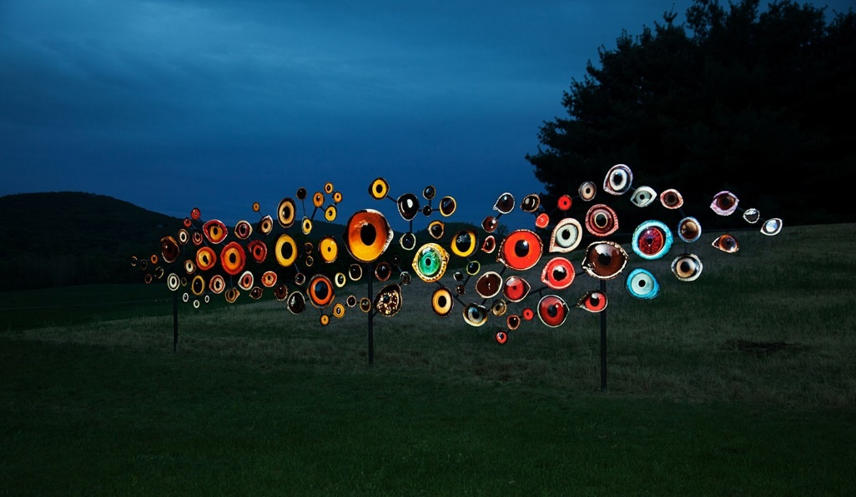
Fig.2. Birds Watching (Kendler, J. 2018)
Hidden amongst the artificial landscape, iridescent eyes travel through the enclosure, the feeling of restlessness can be evoked from the audience, however the audience are made marginal, due to the ironic twist of feeling the emotions that an animal experiences- the gaze of 100 eyes, hopelessly trapped in a cage. We are blinded by that of modern culture, we have been directed into a sense of illusions and gained a sense of disregard for non-human as a consequence (Kendler, 2019). Enabling the audience to gaze into eyes truly looking back, although the iridescent of their eyes are non-humans, there is a human- like attribute that lingers within theirs and resonates in ours. It allows them to reflect upon our relationship and responsibility we have for creatures, coexisting with us.
Following on from Birds Watching, whose piece causes the audience to rethink our relationship and unveil what it, Kate MacDowell’s piece solastalgia (fig.3), explores further into our relationship, through expressing our power yet vulnerability, by juxta positioning elements of culture and myth. (MacDowell, 2019).
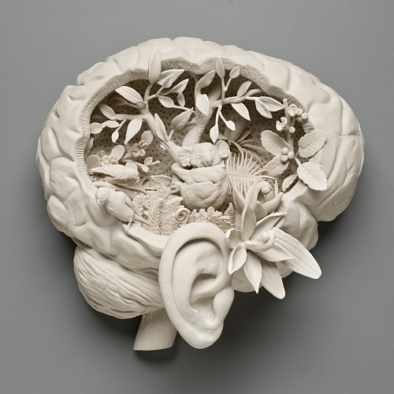
Fig, 3. Solastalgia (MacDowell, 2010)
Contrasting to that of its surroundings in the enclosure, this piece embodies our direct connection with the natural world, and though intricately beautiful, this piece evokes that of distress and vulnerability. Solastalgia defines and describes physical or psychological pain caused by the loss of inhabitation or home sickness, even though one is still home (Glenn, 2006). This word applies context to the piece, by the exploration of human-induced impacts regarding the deforestation and destruction of animal’s homes.
The brain in solastalgia, metaphorically symbolises a vessel for the species and environments that have been effected by human actions, thus resulting in a sense of power and dominance that humans hold against animals. Furthermore, this consecutively relates to that of the enclosure and how zoos are a ‘symbolic representation of conquest over species and distant land’ (Berger, 2009)
On the contrary the use of porcelain, expresses the fragility of nature and humans in this dying ego system because of the ghost-like appearance it holds. The transparency and almost elegant stance porcelain has, historically correlates to that of higher status within culture, alongside value, which causes the audience to reconsider our status among animals, (MacDowell, 2019) like Birds Watching, it enables us to truly see what is and that animals and us alike share an element of vulnerability and fragility.
Through the notion of solastalgia, positivity can be unearthed, firstly from the recognition of the distress within our environment, then from looking and considering, acknowledging the message portrayed from Solastalgia, will result in an empowering experience within the viewers. (Glenn, 2006) It gives us reason to reconsider, to understand the responsibility we have and accept that through our destruction towards animals, we are ultimately losing a part of our self - ’We are intimately connected’ (The Prince of Wales (HRH), Juniper and Skelly, 2010, pg. 312)
Delving into the fragility, Crystal Morey explores the connections we have with the natural world. Like the previous 2 artists, Morey’s work indulges into the effects of human activity and how this has had impacts on the world today, as well as exploring how we are all interweaved through land and time, by expressing that over historical visual language.
Sharing that of MacDowell’s piece solastilgia, Morey captures the interconnectedness we share with animals, and explores this notion through the elemental hybridity of human and animal/plant attributes. Her series, Habitats Collide (2014) (fig 4a,4b,4c), looks into the issue of endangered and exstinct animals, caused by that of humans. (Morey, 2019)
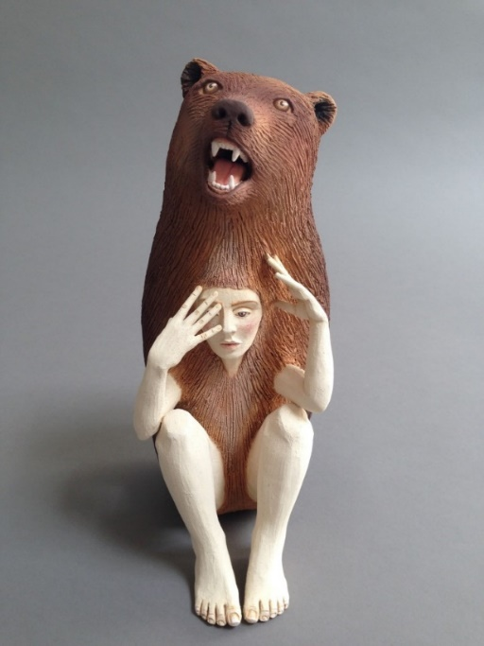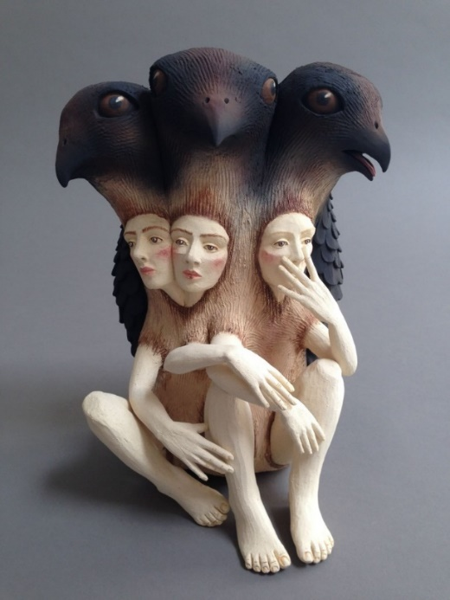
Fig. 4a. Habitats Collide (Morey, 2014) Fig. 4b. Habitats Collide ( Morey, 2014)
Although comparitvely small agaisnt the backdrop of the encloure, this series will be arranged in a collective manor by surrounding the dome they are in, resulting in an intimacy between object and spectator. The intimate space that is curated, reflects the way in which the human bodies are engolfed by that of the animals, to the audience this expresses our connection with animals and the ever changing boundries humanity has with nature and animals (Antler Gallery, 2019)
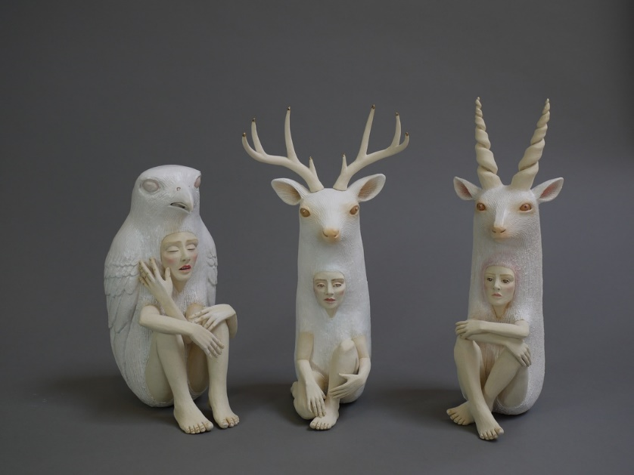
Fig. 4c. Habitats Collide (Morey, 2014)
The faces that Morey portrays in each piece, have a certain speculative and emapthetic quality to them, symbolising the similarity of animal to man. Linking to that of Birds Watching, the audience reconsider and look closer, the boundries of man and animal blurr, because of the parallels between the human eyes, to that of the animals, resulting in a sense of familarity amid the two. Ultimately this refers to Berger’s theories of how we see animals, an animals look is observant and wary , just like a humans, however we have always been looking through fear and ignorance, thus resulting in animals seeing us as we see our surroundings. The accecptance of this, is what makes the look between familiar (Berger, 2009)
Conclusively, this exhibition engages with those who view it, by provoking their senses and thoughts revolving around the issues of human-induced issues that have contributed and altered the way we see animals. The artworks and installation, bring these issue central to that of the audience within the enclosure. Although exploring the negative inflictions on animals there is an underlining meaning which touches upon how we as a society should reconsider and reflect upon our relationship with animals, because the harm to them only brings it us and the inner destructiveness that we provoke and hold will only contribute to the harm of more species, including the well-being of our own (The Prince of Wales (HRH), Juniper and Skelly, 2010)
This exhibition brings the audience back down to earth, and through the dissolve of our connection with the species around us, it’ll evoke a new perspective (literally and theoretically), which in turn, will empower a generation to rekindle our rooted relationship with animals.

Bibliography
Physical texts:
Bachelard, G. (1994) Poetics of space. Boston: Beacon press.
Berger, J. (2009) Why Look At Animals? London: Penguin Books Ltd.
Hurn, Samantha. (2012) Humans and other animals: Cross- cultural perspectives on human- animal interactions. London: Pluto press.
Prince of Wales (the), HRH, Juniper, T, Skelly, I. (2010) Harmony: A new way of looking at our world. London: Harper Collins Publishers.
Ramos, F. (2016) Animals: Documents of contemporary art. London: Whitechapel Gallery Ventures Limited.
Vince, G. (2014) Adventures in the Anthropocene: A journey to the heart of the planet we made. London: Chatto and Windus Publishers.

Online Text:
Antler Gallery (2014) Habitats Collide: Antler Gallery. Available at:
http://crystalmoreystudio.com/2014/07/01/habitats-collide-antler-gallery/ (accessed: 28.04.2019)
Kendler, J. (2019) Jenny Kendler: Environmental artist and activist. Available at:
https://jennykendler.com/home.html (accessed: 25.04.2019)
MacDowell, K. (2019) Kate MacDowell. Available at:
http://www.katemacdowell.com/statement.html (accessed: 27.05.2019)

Morey, C. (2019) Crystal Morey. Available at:
https://www.crystalmorey.com/habitats-collide-single-fate.html (accessed: 03.05.2019)
Glenn, A. (2006) ‘Solastalgia’, Social sciences: comprehensive works, environmental studies, 32(4/5), pp. 34-36. Available at: https://search.proquest.com/docview/218765167?accountid=130472 (accessed: 05.05.2019)

Image Bibliography:
Kendler, J. (2018) Birds Watching. Available at: https://jennykendler.com/section/466865-Birds-Watching.html (accessed: 25.04.2019).
Price, C. (1965) Snowden Aviary [drawn model] available at: https://rndrd.com/n/177#c (accessed: 04.05.2019)
MacDowell, K. (2010) Solastalgia. Available at: http://www.katemacdowell.com/solastalgia.html (Accessed: 27.04.2019)
Morey, C. (2014) Habitats Collide. Available at:
https://www.crystalmorey.com/habitats-collide-single-fate.html
(Accessed: 04.05.2019)
Treasure- Coates, C. (2019) Exhibition Layout. Available at: https://moodle.uwtsd.ac.uk/blog/index.php?userid=12211 (accessed: 05.05.2019)

.

