

Assessment 1 – Reading Task Template
Upload your photo of your A3 in-class notes here:
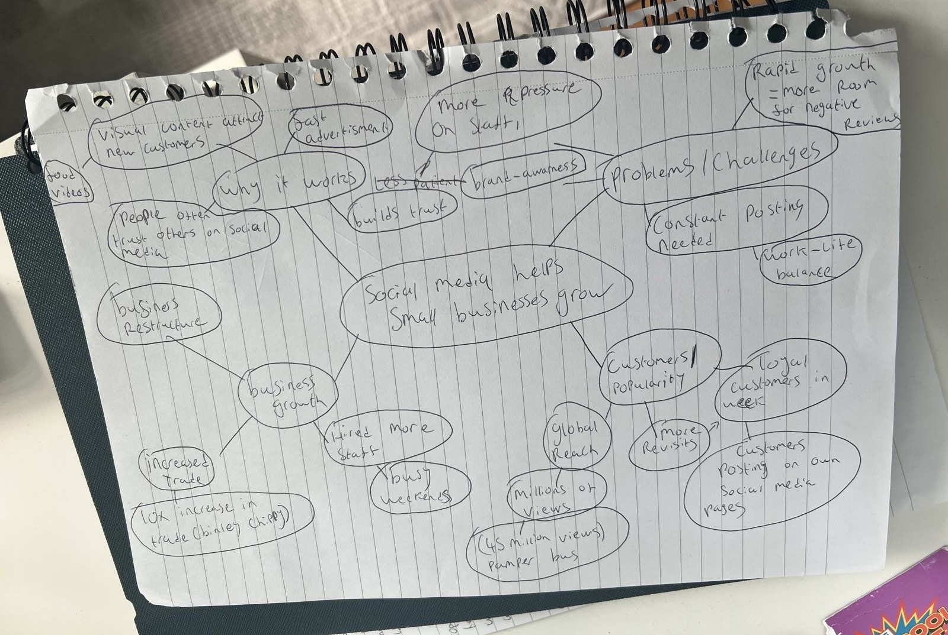

1. Answer these questions using the sentence starters below
a. What is the main idea of the text?
The main idea is that Social media greatly helps small business grow
b. What are two key points?
One key point is social media can positively influence your business is more ways then one , bringing on good customer reviews and good popularity ,with 200 Million businesses worldwide using the social media platform Instagram
Another key point is Most of the younger generation do not prefer standard advertising as they are not catchy enough, But with the use of social media posts and videos it could build the brands awareness and exponentially increase sales for the company
c. What part of the text did you find most important? Why?
The most important part of this text is that social media has transformed how businesses can grow allowing even small companies to reach huge audiences which could bring in more revenue for the company, This is important because it explains how social media platforms and content creation is much more favoured around the world rather then your typical billboard / advert which does not catch the eye of the younger generation .
d. Was anything unclear or difficult to understand?
in the beginning i found it difficult creating my mind map and actually understanding the text but by reading the text again underlining the key points i found it easier to finish my work and the task
e. How did your group help you understand the text better?
My group helped me understand how to properly draw a mind map making sure my points and ideas was correct helping me find and highlight key points which helped me find what i needed quicker instead of having to keep on re reading the text
2. One sentence reflection
Question: What did you find challenging about this task?
The hardest part of this task for me personally is that because of unfortunate circumstances I was not able to be inside the classroom with my piers doing the work so I found it difficult to start my mind map having to ask my teacher for some extra help which I am very thankful for as she replied to me on a Sunday which she usually does not do .

