Student’s name: Diana Zabrac
Student`s Id: 2030656
Effective Team Working and Communication (BMSW4002)
Teacher name: Joanna Walsh

COMMUNICATION MODEL

Introduction
Communication is referred to as the exchange of information from one person to another or between groups of persons. Communication can be verbal, non-verbal, visual, written, or listening. Individuals and businesses use various communication models in the workplace (van der Vleuten, et al., 2019). Communication models are conceptual models used to explain the communication process with this model developed in different years and use of different perspectives. These communication models can include Berol’s S-M-C- R model of communication, helical model of communication, Shannon and Weaver, Aristotle, Schramm’s, Westley and Maclean, and Barnlund’s transactional, and lastly, Lasswell’s model. However, these are grouped as linear, interactive, and transactional (Avena-Koenigsberger et al., 2018). The report aims to discuss and demonstrate an understanding of these models. Secondly, the report will discuss communication skills through the literature used in class.
Further, the reports will refer to a case study of these and give examples of poor communication in the workplace and how it could be improved. These will be through published literature that will include journals, books, articles, and newspapers to provide intensive and extensive findings. Lastly, the report will provide a conclusion, which will entail a summary of all the elements of this report.

Communication model
As noted, before, communication models are grouped as linear, interactive, or transactional.
The linear models only look at one–way communication, the transactional models look at the two–way communication models with the massage more complex, lastly, the interactive model is simply two-way communication.
Aristotle's model of communication.
This is the oldest model of communication. This model was created to create better ways to convince the communicators; it aims to improve communication abilities by underpinning the situations in the communications. Aristotle's communication models argue that five elements should be considered for the best communication. This includes the speech, speaker, effect, target audience, and the occasion (Bumb et al., 2017). The model also considers the elements that should be used to improve communication, including logical arguments, connecting ability, and credibility. These are also known as logos, pathos, and ethos, respectively. In this model, the speakers and the speech are the most important in any communication. Most of the speeches, lectures, and seminars use this communication model as it is very straight and forward. The audience in this model of communication is massively influenced. The process of this model of communication can be shown as in the diagram below:
Figure 1: Aristotle model of communication
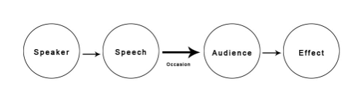
Lasswell’s model
This communication model has five main questions that are identified and answered. These five questions are who, said what, to whom, through which or what channels, and lastly, what effects. The who is these model focuses on the message that is not biased. The channel focuses on channels of communication through which the receiver receives the messages. This can include televisions, blogs, radio, letters, emails, and other channels. Using the five important elements of communication in this model, it can critique the message practically and explain the events of the communication through analysis. This communication model is influential and has been used by many organizations with the key elements or questions identified as the focus. However, this communication model is used in mass communication; the model was developed in 1948 and was meant to spread media propaganda (Horan et al., 2021). It is a linear model of communication. The three functions of communication recognized by this communication model are surveillance of the environment, cultural transmission between generations, and correlation of components of society. The main advantages of this model are that it is easy and simple; it suits almost all types of communication and has the concept of the effects. However, it has several disadvantages that include not mentioning the feedback, barriers such as noise not being mentioned in this communication model, and lastly, the linear communication model (Ferrer-i-Cancho, 2018). This communication model can be shown as in the figure below:
Figure 2: Lasswell’s model
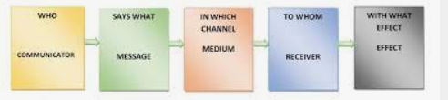
Shannon- weaver communication model
This model of communication has five key parts in which the communication occurs. These parts of communication include sender, channel, encoder, receiver, and decoder. The models focus on decoding and encoding the messages by the receivers and the senders (Khan et al., 2017). During this process, noise is identified that ends to disruption or could of the information aimed to be passed. An example is a mishearing of the conversation passed through the verbal. Misspelling the letters or the emails and even noise such as the static on the radio broadcast. The communication process there must assess the noise as a factor. This model was the first to bring noise into the communication process. Additionally, the introduction of the feedback idea is also introduced retroactively in this communication model. This model of communication can be shown as below:
Figure 3: Shannon- weaver communication model

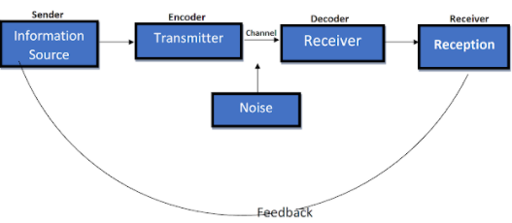
Berol’s S-M-C- R model
As the name suggests, this model encompasses four steps (S-M-C-R). These four steps are the source, message, channel, and receiver. This model accounts for these steps and shows how best the information is communicated. These source steps, however, have different elements these are. Sources - this includes the attitudes of the senders, culture, and skills. Messages elements include code, structure, and code (Horan et al., 2021). The channel elements include smelling, touching, seeing, and hearing. Lastly, the receiver elements include knowledge, attitude, and culture. a summary of this communication model can be shown in the figure below:
Figure 4: Berol’s S-M-C- R model
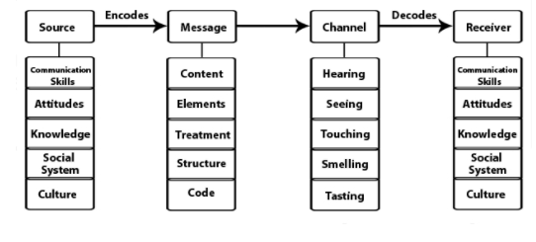
Osgood – Schramm model
This is an interactive model of communication. It explains the impersonal two–way communication process. It explores the communication that is reciprocal and equal. The communication model doesn’t differentiate the receivers and the senders and regards that both have an equal position in encoding or decoding the messages. In communication where immediate feedback is needed, this model is very effective (Jha,2021). It can easily be implemented in communication, such as face-to-face discussion. In the process where feedback is immediate, noise is reduced through message clarifications. This model can be shown and summarized in the diagram below:
Figure 5: Osgood – Schramm model

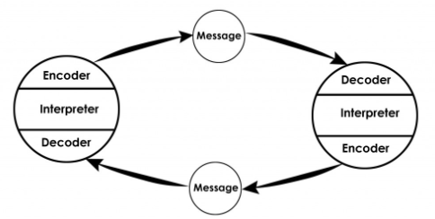
Dance’s helical model
This is a transactional model of communication. Through feedback, these models explain how to improve the communication message. Feedback influences the statement and interaction of the message (Jha, 2021). The communication process is regarded as a circular process and does not follow a perfect repeat. The broader circular aims to meet wider knowledge about communication.
Barnlund’s model of communication
This is also a transactional communication model. It explores immediate feedback communication and interpersonal. In this model, feedback for the sender is the reply for the receiver. It also explores how the cues affect the messages in the communication process (Fan and Wu, 2019). The model further identifies different public cues that include environmental and private cues, including the receiver and sender's background and personal thoughts.
The westly and Maclean model of communication
This model explains that personal factors and environmental factors influence communication. Communication feedback is also embraced in this model of communication. The message we send or the feedback depends on both the cultural background and the cultural background (Ferrer-i-Cancho, 2018). In short, it includes the beliefs, culture, and background of both the receivers and the senders. The social context of the needs of the broader social context is needed to understand and know the messages. While this is complex, it encompasses a greater scope: this can be demonstrated as below:
Figure 6: Westly and Maclean model
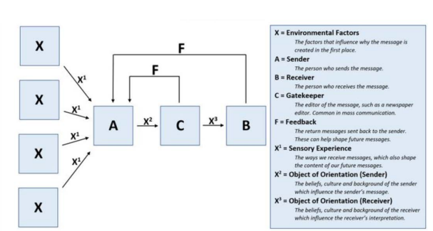
Communication skills
These are abilities of the information senders or receivers to share or convey ideas and feelings effectively. These are abilities used when giving or receiving the information by the senders and the receivers (Fan and Wu, 2019). These can be used by both the business in various modes of communication such as face to face, digital communication, e.g., social media, and emails. These communication skills can be discussed as below:
Active listening
This is the ability to pay attention to both the sender and the receiver. Understanding both by the coworkers and generally at the workplace can be increased through active listening. For example, where face-to-face is done, Distractions such as the cell phone can be avoided. Asking questions may also lead to clarification, therefore, avoiding miscommunication. Active listening also entails paying attention to other people’s body language, tone, or facial expression.
Confidence
Communication and giving feedback on the messages’ confidence is another communication skill. This skill is vital both in the workplace and in daily life communication. For example, during face-to-face conversation or addressing some, eye contact should be maintained. Even in writings, emails, thoughts must be clearly polished and have the ability to answer related questions in case of any.
Empathy
This can be defined as the ability to share in emotions of others in the communication process. It is important in– on one setting and also in teams. For an appropriate response or feedback, individuals must clearly understand other people’s feelings (Ferrer-i-Cancho, 2018). An example is an email sent that expresses anger or frustration. To diffuse the emotions of the senders, empathy could be used by first acknowledging how they feel before sending feedback.
Respect
Respect in communication is the ability to know when to initiate the feedback, response or when to send a message. It is also allowing others to give their thoughts without interrupting them. The topic being communicated to the person should also be relevant, and they feel respectful to be expressed to. Additionally, the respects skills entail giving clear questions, responding fully or giving feedback, and understanding others.
Responsiveness
Responsiveness is being fast in responding to the sender of the message. The communication messages need to be addressed by the reconversion at the possible soonest time. This does not only entail giving a response; acknowledging that the message has been received and replied to later is an idea of this skill. Besides these discussed communication skills, other communication skills can include having good volume and clarity, sharing feedback, friendliness, and choosing the right communication method.
Examples of poor communication in friend’s workplace
one of the poor verbal communications at my friend’s workplace is gossip. Most of the employees in the company / the workplace have been involved in this. Often, the gossips are exaggerations and inaccurate, leading to constantly misleading the employees in my friend’s workplace. At one point, co-workers speeded the rumors of the cut of employees' salaries. As a result, most of the employees left the job. The second example of poor communication at my friend’s workplace is communicating where there are distractions, and the communication is made to the employees where the machines make a loud noise, this makes such information not be gotten fully by the employees leading to failure in the execution of the process laid or communicated. It is prudent for such a workplace to have halls where the employees can assemble information that needs to be conveyed. The third poor communication at my friend’s workplace is the use of vernacular language, which some of the employees cannot understand; this means that they will be left out on what changes the communicated idea aims. Language acts as a barrier to most employees at this workplace as most of the communication is done in vernacular that they cannot understand. Unfortunately, no translator is also provided in such a situation, which is poor communication. Often, the formal language is not used to pass the communication; mixed language has generally hindered the effectiveness of the information being conveyed (Fan and Wu, 2019). Information passed through the team leaders also loses some meaning or the key parts as they give information according to their understanding.
Ways to improve communication at the workplace.
Schedule weekly meetings with the employees
Transparency and effectiveness are factors that must be considered if the communication barriers are to be eliminated and communication improved (Avena-Koenigsberger et al., 2018). with these questions, feedback, complaints, and compliments can be gathered from the employees
Use formal language
Every employee at the workplace can understand formal language. Making communication through a formal path will also maintain the chain of command, and the employees will address the issues covered in the information (Bumb et al., 2017). The employees can easily follow instructions, rules, and regulations where formal communication is done.
Regular face-to-face communication between the management should also be emphasized to reduce misunderstandings. Other ways include using notes for effective communication, digital communication channels, constructive feedback, and lastly, communication with the employees at a personal level.
Conclusion
Communication is vital both at the workplace and to the individuals. The communication models include the Shannon- weaver model, the berlos S-M-C-R model, dance’s helical model, and the lass wells model. Communication skills are abilities needed for effective communication, and these include confidence, empathy, active listening, responsiveness, and respect. To improve communication, there is a need to use the formal language, regular face-to-face communication, and schedule weekly meetings with the employees at the workplace.

References
Avena-Koenigsberger, A., Misic, B. and Sporns, O., 2018. Communication dynamics in complex brain networks. Nature Reviews Neuroscience, 19(1), pp.17-33.
Bumb, M., Keefe, J., Miller, L. and Overcash, J., 2017. Breaking bad news: An evidence-based review of communication models for oncology nurses. Clinical journal of oncology nursing, 21(5), pp.573-580.
Fan, N. and Wu, C.Q., 2019. On trust models for communication security in vehicular ad-hoc networks. Ad Hoc Networks, 90, p.101740.
Ferrer-i-Cancho, R., 2018. Optimization models of natural communication. Journal of Quantitative Linguistics, 25(3), pp.207-237.
Horan, S.M., Chory, R.M., Craw, E.S. and Jones, H.E., 2021. Blended Work/Life Relationships: Organizational Communication Involving Workplace Peers, Friends, and Lovers. Communication Research Trends, 40(2).
Khan, A., Khan, S., Zia-Ul-Islam, S. and Khan, M., 2017. Communication Skills of a Teacher and Its Role in the Development of the Students' Academic Success. Journal of Education and Practice, 8(1), pp.18-21.
Jha, S.K., 2021. Verbal Communication at Workplace: A Pragmatic Approach. Turkish Journal of Computer and Mathematics Education (TURCOMAT), 12(10), pp.7053-7057.
van der Vleuten, C., van den Eertwegh, V. and Giroldi, E., 2019. Assessment of communication skills. Patient education and counseling, 102(11), pp.2110-2113.

