The Structure and Culture of Matthews House.
The purpose of this essay is to describe the structure and culture of Matthew’s House.
Culture has many different meanings, which often makes it hard for people to understand as it can be viewed in a number of different ways depending on the person. One of the common definitions is “the values and behaviours that contribute to the unique social and psychological environment of an organisation” - (BusinessDictionary , 2017 ).
In business, strategy and structure are very similar. The overall structure of an organisation is the key factor for an effective management system. The structure of an organisation affects the overall performance, morale and the job satisfaction of the employees within. Choosing an appropriate structure allows the organisation to achieve and maintain their goals and objectives. According to Mullins, organisation structure is “the pattern of relationships amongst position in the organisation and amongst members of the organisations. It defines tasks and responsibilities, work roles and relationships and channels communication” - (J.Mullins, 2016) The organisation I will be writing about is Matthew’s House. They are a not for profit organization which aim to provide hospitality and hope within the heart of Swansea.
There are numerous types of culture, there being three overall main types which are more commonly known. National culture is a set of beliefs and customs which are held by members of a national group. Integrational culture is when individuals adapt to the ways of another culture, such as their beliefs. Another form of integrational culture is when members of a certain culture introduce their own culture into another one. (Arnold, n.d.)
There are many different kinds of organisation culture. However, there are four main ones which are commonly known. These are person culture, power culture, role culture and task culture. Power culture is when an organisation has the power held by a small group of people who influences the organisation. So, those with power decide what happens within that organisation. Organisations which have a role culture, are highly controlled and everyone within that organisation know their roles and responsibilities. Role cultures are based upon a tall structure such as a hierarchy. Task culture is formed within a team is put together to overcome certain problems. The task is the main focus so the team is orientated around the problem identified. There is no single power source and the team develops their own objectives. When an organisation adapts a person culture, some team members believe that they are superior to the business. The team of the organisation is usually made up of people with a similar background and similar skills from training. This type of culture is most common in professional firms such as accountants or law firms. (Riley, 2016)
Culture is important to an organisation as it keeps both employees, as well as volunteer’s active as well as engaged. The type of culture which an organisation has an impact on the organisations growth, communication as well as innovation. The culture is what establishes exactly what the customers of an organisation expect from them. Culture is also important as it aids organisations to promote healthy competition within the workplace which motivates employees to do their job roles more effectively and efficiently. The overall culture of an organisation is important as it aids the organisation to create the commonly known brand image and the culture then brings all employees onto the same platform. (Axiong, 2012)
The main reason behind structure is dividing the work tasks up between members of the organisation. This enables the different members to be steered towards the overall goals and objectives of the organisation. The structure of an organisation should be constantly reviewed in order to ensure that it is in the most appropriate form to encourage business growth and development. (J.Mullins, 2016).
According to Edgard Schein, there are three different levels of culture. The first is artefacts. These are at the top of the organisation and can be easily spotted, so are visible things such as clothing and appearance. The second level is the values which contain strategies, goals and the philosophies of the business which reflect the original values of the organisation. The final level is basic assumptions and values. These are the core of the culture which gets overall represented by the assumptions which are not visible. The final level is seen as the most important. (Value Based Management , 2016)
The culture of Matthews House follows the Cultural Web designed by Gerry Johnson and Kevan Scholes in 1992. The Web has distinguished 6 elements which make up the model of the working environment. As shown in figure 1 below, these elements are usually characterised using 6 over lapped circles, which then influence the overall cultural paradigm. Within the Cultural Web, if one of the original elements changes, it has a knock-on effect on all of the other elements. (Mind Tools, 2017). The Cultural Web can help businesses, such as Matthews House to create effective strategies for applying change.
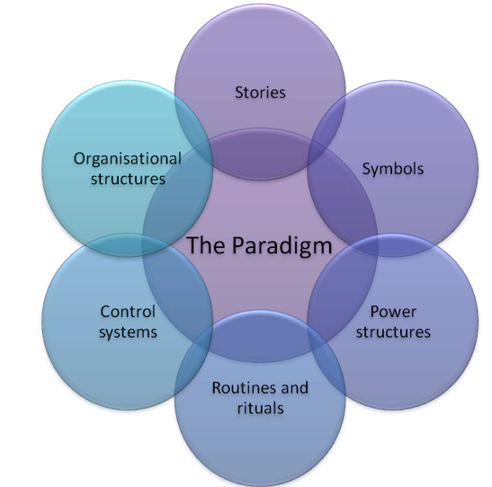
Figure 1 The Cultural Web designed by Gerry Johnson and Kevan Scholes. - (Smith, 2013)
One of the most common stories behind Matthews House is the history behind the building, which is located in the High Street in Swansea. During 2014, St Matthews Centre was known as a community building and was used as a drop-in centre, focusing on the homeless. It was run by a charity named Cyrenians Cymru. Unfortunately, they were put into administration and had no choice but to close. In April 2015, it became common knowledge that the building was due to be sold to a business. The Hill Church aimed to save the building for the homeless and anyone who is in need of extra support. A group of 30 people came together and raised the money in order to buy the building, who then went on and renamed it Matthews House. The group had the aim of providing hospitality and hope within the centre of Swansea.
As one of the main facilities of Matthews House is a café with a fully functioning café, named Matts Café, the two both have separate logos. They have interpreted the initials from ‘Matthews House’ and created a design, which is easy to recognise.

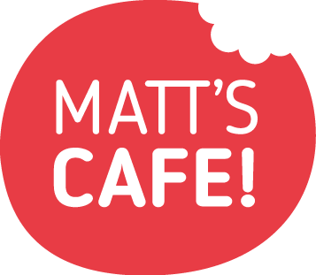
Within Matthews House there are a range of power structures. The power sources of Matthews House are both internal and external. The leadership of Matthew’s House and the direction in which it runs is all down to the project manager, Thom Lynch and his manager who is the overall leader, Robin Vincent. They then have a team of trustees that support, educate and guide the project with the safest, most trustworthy and legal way possible. The team of trustees is made up of five people, one being external to the project for the purpose of accountability. Other than Thom Lynch all other ‘employees’ are completely unpaid and volunteer their time into Matthew’s House.
Some of the measures which are put in place within Matthew’s House. The measures which are recorded are entirely down to the individual projects. Overall, Matt’s Café alone has over 6,000 hours donated purely by their volunteers, which has over 80 volunteers coming ‘in and out’ of the organisation. Since Matt’s Café opened they have served over 7000 meals.
The Café has specific routines within the overall set up and set down of the project. They have regular servicing from the Lift service, as well as the fire systems to the security and utilities. They also have monthly trustee meetings, as well as regular leadership meetings in order to discuss any issues, as well as ideas for Matthew’s House.
There are three main common types of structure. These are hierarchy, flat and matrix structure. A hierarchy structure is when the employees are classified at different levels within their organisation. Each one of these levels is one below the other. Within each level, one person has a numerous number of workers below them, this is known as their span of control. The chain of command is organised in a pyramid shape. There are many disadvantages to having a hierarchy structure within an organisation. Having a hierarchy structure can cause a business to respond to change slowly and the communication across all elements of the organisation to be poor. This can cause departments to make decisions which benefit their department as opposed to the business. However, this type of structure allows authority and responsibility to be clearly defined within each level. As well as the promotion path being clearly defined. The below diagram is a standard lay out of a hierarchy structure.
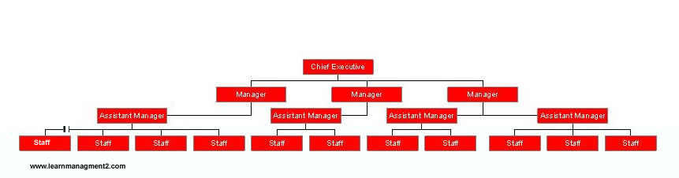
Figure 2 hierarchy structure. (LearnerManagement2, 2016).
Another type of structure is flat. This is when the organisation organises the employees into certain levels. Those who have gained more authority (power) will be within the top levels and those without much or no power at all will be in the lower levels. These levels are distinguished in a certain way. The advantages of a flat structure include that there is a greater communication method between both management teams and their workers. This also enables the organisation to have better team spirit and have easier decision making. Also, by having a reduced number of managers within the top layers this reduces costs as managers cost more to employ than those who aren’t managers. However, this may slow down the growth of the organisation, specifically if managers have a wider span of control. A flat structure has a lack of layers which may cut down the amount of opportunities for promotion.
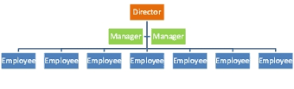
Figure 3 flat structure diagram. (LearnerManagement2, 2016)
The third common type of structure is a mixture of traditional departments with the project teams within an organisation. All individual employees work across the teams and projects as well as across their own department. These teams could be either permanent or temporary, this depends on the task in hand. The advantage of a matrix structure is that it allows an organisation to break down any barriers, which improves communications across all aspects of the organisation. It also allows individuals within that organisation to use specific skills and avoid the need for several departments to meet on a regular basis which overall reduces costs. However, the members in the project teams’ loyalties may lie in different places as they have to report to more than one manager. It also may encourage the team members to avoid their overall responsibilities.
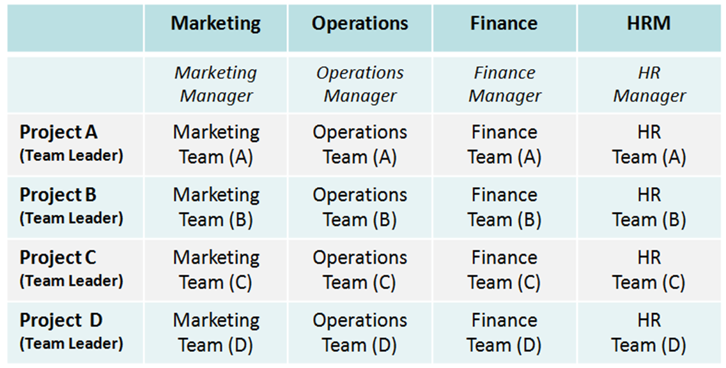
Figure 4 a matrix structure. (Tutor2u, 2016)

Matthew’s House adapt a flat structure as do most common not for profit organisations. They have the overall leader of Matthew’s House, Robin Vincent. There is then the project manager Thom Lynch who is one of the people who originally set up Matthew’s House and then the rest of the employees are completely voluntary. Matthew’s House having a flat structure allows the volunteers to have more overall responsibility as it removes any unnecessary managers and improves the speed of the communication within Matthew’s House. Once there is an idea for a project within Matthew’s House, it is quickly discussed as there is no need for it to go through levels, upon levels of employees with different powers. Also, by there not being many paid roles in the organisation, this allows the funds which are raised by Matthew’s House to be paid right back into the organisation rather than being spent on employing different staff at different levels.
In order for a business to be constantly competitive an organisation must be careful and constantly review its effectiveness and development. An important feature is the ability to change to a different culture. In order for an organisation to both perform and develop well, the changing process must work well with the culture. (J.Mullins, 2016)
An increase in size of an organisation means that there is more need for a more formal structure. In comparison, in smaller organisations such as Matthew’s House there can be more personal and informal organisational structures. Matthew’s House have designed their structure based on encouraging their employees to participate in order to give a more effective and efficient performance.
The structure however, can differ for a range of influences such as the business strategy, organisation size, technology, the business environment and the global implications.
After researching the contribution of culture and structure effecting the performance of a business, I have found that it Matthew’s House performs well for these reasons. As, they have the ten typical characteristics of a strong organisational culture, as well as following a strong business structure so all roles and responsibilities are clearly outlined.
In conclusion, it is important for Matthew’s House to have a strong culture and structure, as without the employees, Matthew’s House wouldn’t be able to run the way they do. “when an organisation has a strong culture, it keeps employees actively and passionately engaged. (Axiong, 2012). Therefore, in order for the employees of the organisation to be constantly engaged, the organisational culture and structure must be clearly outlined.

Bibliography
Arnold, G., n.d. Cultural Intergration - definion and examples. [Online]
Available at: https://study.com/academy/lesson/cultural-integration-definition-examples.html
Axiong, A., 2012. The importance of a strong organisational culture.. [Online]
Available at: http://www.mediaspacesolutions.com/blog/bid/122890/The-importance-of-a-strong-organizational-culture
[Accessed 01 12 2017].
Axiong, A., 2012. The importane of a strong organisational culture. [Online]
Available at: http://www.mediaspacesolutions.com/blog/bid/122890/The-importance-of-a-strong-organizational-culture
[Accessed 23 November 2017].
BusinessDictionary , 2017 . What is organisational culture? definition and meaning. [Online]
Available at: http://www.businessdictionary.com/definition/organizational-culture.html
[Accessed 20 11 2017].
BusinessDictionary.com, 2017. What is business structure? definition and meaning. [Online]
Available at: http://www.businessdictionary.com/definition/business-structure.html
[Accessed 01 12 2017].
BusinessDictionary, 2017. national culture? definition and meaning. [Online]
Available at: http://www.businessdictionary.com/definition/national-culture.html
[Accessed 15 11 2017].
J.Mullins, L., 2016. Management & Organisational Behaviour. 11th Edition ed. Harlow : Pearson Education Limited.
Ke, n.d. Flat organsational structure. [Online]
Available at: http://www.learnmanagement2.com/flat%20structure.htm
LearnerManagement2, 2016. Flat organsational structure. [Online]
Available at: http://www.learnmanagement2.com/flat%20structure.htm
[Accessed 23 November 2017].
LearnerManagement2, 2016. Hierarchical Organisation/Structure. [Online]
Available at: http://www.learnmanagement2.com/hierarchical%20structure.htm
[Accessed 27 November 2017].
Mind Tools Ltd 1996-2017, 2017. The Cultural Web - Strategy Tools from MindTools.. [Online]
Available at: https://www.mindtools.com/pages/article/newSTR_90.htm
[Accessed Novemeber 2017].
Mind Tools, 2017. The Cultural Web Aligning Your Organisation's Culture With Strategy. [Online]
Available at: https://www.mindtools.com/pages/article/newSTR_90.htm
[Accessed 01 December 2017].
Riley, J., 2016. Models of Organisational Culture. [Online]
Available at: https://www.tutor2u.net/business/reference/models-of-organisational-culture-handy
[Accessed 20 11 2017].
Smith, A., 2013. Organisational culture, CSR strategies & ethics. [Online]
Available at: http://thepurchasingcoach.blogspot.co.uk/2013/09/organisational-culture-csr-strategies.html
[Accessed 2017 November 15].
Tutor2u, 2016. [Online]
Available at: https://www.tutor2u.net/business/reference/matrix-structures
[Accessed 22 November 2017].
Value Based Management , 2016. Summary of Culture Levels. [Online]
Available at: http://www.valuebasedmanagement.net/methods_schein_three_levels_culture.html
[Accessed 16 November 2017].

