Jess Eardley (2217994)

Abstract
The following contains a lab report investigating the hypothesis that ATR-FT-IR spectroscopy is suitable for analysing and identifying functional groups within organic compounds. The results and discussion are concluded and support the hypothesis however it is explained there are limitations to the FTIR method which could be further supported using other analytical techniques such as Raman spectroscopy.

Lab Report 1
Analysis of Organic Compounds Using FT-IR Spectroscopy

Table of Contents
Introduction 2
Purpose of Experiment 2
Hypothesis 2
Variables 2
Theory 2
Equipment 3
Equipment list 3
Instrument settings 3
Hazards 3
Procedure 4
Observations and Data 6
Results and Discussion 7
Conclusion 10
References 11
Appendices 12

Introduction

Purpose of Experiment
Demonstrating how effective Fourier Transform Infrared (FTIR) spectroscopy is at identifying key functional groups and substituents present in organic compounds by using an Attenuated Total Reflectance (ATR) spectrometer.

Hypothesis
If a ATR-FT-IR spectroscopy technique is applied to organic compounds with diverse functional groups (such as: carboxylic acids, esters, amides and aldehydes) it will effectively identify these groups through their characteristic absorption bands, which will demonstrate the technique’s reliability in functional group analysis.

Variables
Control variables: IPA cleaner, pressure/contact on sample, instrument settings.
Independent variable: Sample (A, B, C, D).
Dependant variable: Absorbance frequencies

Theory
ATR-FTIR spectroscopy is a non-destructive analytical technique that combines infrared (IR) spectroscopy with ATR sampling to identify chemical bonds and functional groups present in a sample for identification [1] [2].

An ATR spectrometer uses a laser beam aimed at a high refractive index crystal to create an effervescent wave. Some of this effervescent wave is absorbed by the sample at the crystal-sample interface and the rest is reflected. The resulting IR spectrum, which displays the sample’s absorption frequencies, is analysed to identify characteristic functional groups [1].

Equipment

Equipment list
- PerkinElmer UATR 2 with UATR Single reflection Diamond accessory [3]
- PerkinElmer Spectrum software [3]
- PC
- IPA solution in a wash bottle
- Blue roll
- 4 X Sample reference powders labelled A, B, C, D, see Appendix 1
- 4 X Sample trays
- 4 X Spatulas (1 for each sample)
- PPE
  - Safety goggles
  - Nitrile gloves
  - Lab coat

Instrument settings

Table 1 Acquisition parameter settings for the PerkinElmer Spectrum 2 software.
Acquisition Parameters
Spectral Range | 4000 – 400 cm⁻¹
Resolution | 4cm⁻¹
Background Scans | 15 scans
Sample Scans | 15 scans
Apodization | Strong

Hazards

Table 2 Hazards identified in experiment.
Hazards
Class 1 Laser | Optical radiation hazard [3]
Samples (A, B, C, D) | Oxidising agent
IPA | COSHH

Procedure

- Safety & Sample Handling

  - Adorn PPE listed in the equipment section of this report.
  - Identify and follow the lab procedures such as wate disposal routes, sample handling methods and general safe lab practices.
  - Label samples trays A, B, C, D and assign 1 spatula per sample to prevent cross contamination.
  - Turn on the PerkinElmer UTAR 2 spectrometer and run the PerkinElmer spectrum software. Follow the PerkinElmer Spectrum 2 User Guide [3] for the initial set-up of the instrument and software.

- ATR Instrument and Software Set-up

  - Set the instruments parameters in the PerkinElmer Spectrum software using the values in Table 1 and PerkinElmer User Guide [3].
  - Identify the sample arm and sample plate on the FTIR spectrometer [3]. Using the ratchet handle on the sample arm remove the sample arm from the sample plate. Swing the arm away from the plate and remove the detachable foot.
  - Using the IPA cleaner and blue roll, remove all contaminants and residues from the foot, sample plate and ATR crystal which for this spectrometer is a diamond. The IPA cleaner should be added to the blue roll and wiped on the plate starting from the middle and working out to the edge of the plate using a circular motion. The excess IPA residue can be dried with another clean and dry piece of blue roll. Attach the cleaned foot back to the sample arm.
  - Add the IPA solution as the cleaner type in the instruments set-up settings, see Table 1.
  - Take a background measurement using the ‘Scan background’ function on the software which is saved automatically

- Measurement procedure

  - Type an identifier, such as ‘Sample A’ in the “Sample ID’” box.
  - Using a spatula, place a small amount of the solid sample on the ATR crystal in the centre on the sample plate.
  - Position the sample arm above the sample plate, in line with the ATR crystal. Lower the arm by turning the ratcheted handle clockwise and ensure it has good contact with the sample for a good spectra result.
  - Select the “Scan” command on the program. This opens a preview mode.
  - Select the “Scan” command again, to collect the full spectra for the sample.
  - Save the spectra as CSV file.

- Data Processing & Interpretation

  - The data can be processed using ATR correction, smoothing and baseline corrections. For this experiment, none of these were applied to the data.
  - Add data labels to the spectra manually, not using the “Auto Label” function, to aid in manually analysing the samples absorbance frequencies.
  - To identify the sample computationally, use the “Library Search” function. This function compares the samples ATR-IR spectra to known ATR-IR spectra within the PerkinElmer spectra library to give an answer with a confidence value between 0 - 1 and. 1 means sample is identical to identified spectra.
  - If this threshold is not in the analyst’s acceptable range, then the sample spectra should be run again.
  - If satisfied with the spectra and all data is saved, follow step 1.c in this procedure, to clean the sample from the spectrometer.
  - To analyse the the other samples in the experiment, repeat all steps in part 2 and 3 of this procedure.

Observations and Data

Figure 5 shows the identified peaks in each sample’s spectra. The frequencies in the spectra were compared to characteristic absorbency regions [4] [5].
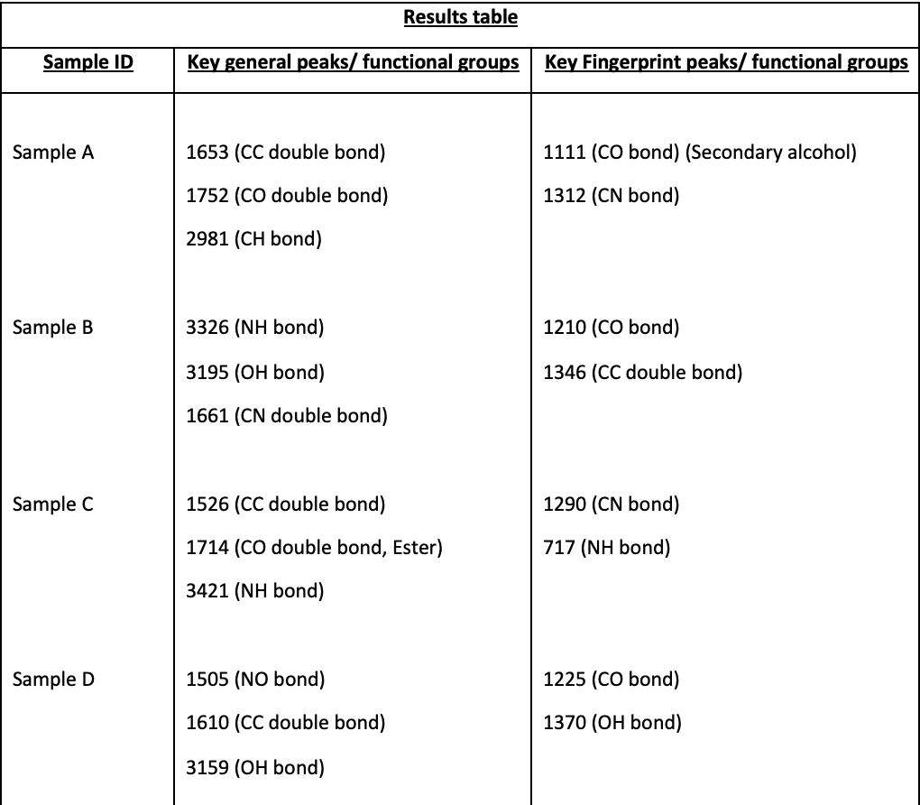
Figure 5 Identified absorbance frequencies from the samples ATR-FTIR spectra.

Results and Discussion

Figure 1, shows the ATR- IR spectra for Sample A. There is a strong sharp spike at 1022 cm⁻¹. This spectrum shows a strong similarity to the IR spectra of Guanidine [6].

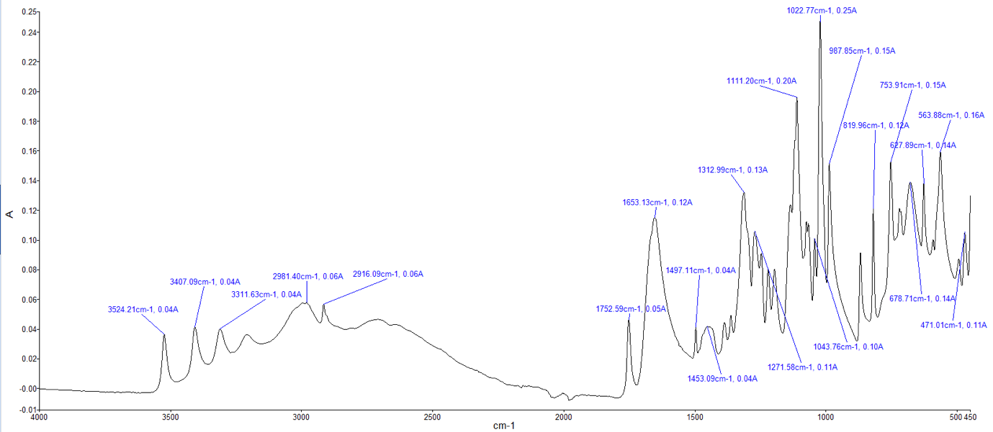
Figure 1 Sample A absorbance frequency spectra

Figure 2, shows the ATR- IR spectra for Sample B. There is a strong sharp spike at 1661 cm⁻¹. A weaker but broad peak at 2820cm⁻¹. This spectrum shows a strong similarity to the IR spectra of Ascorbic acid [7].

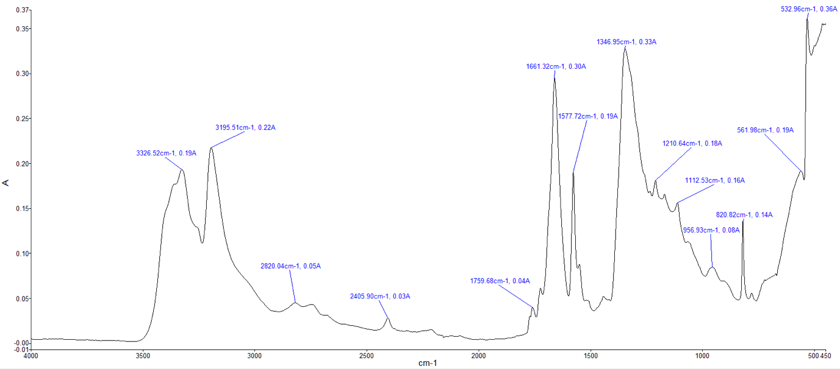
Figure 2. Sample B absorbance frequency spectra.

Figure 3, shows the ATR- IR spectra for Sample C. There is a strong sharp peak at 717 cm⁻¹. The rest are weaker sharp peaks. This spectrum shows a strong similarity to the IR spectra of Methyl 3-nitrobenzoate [8].
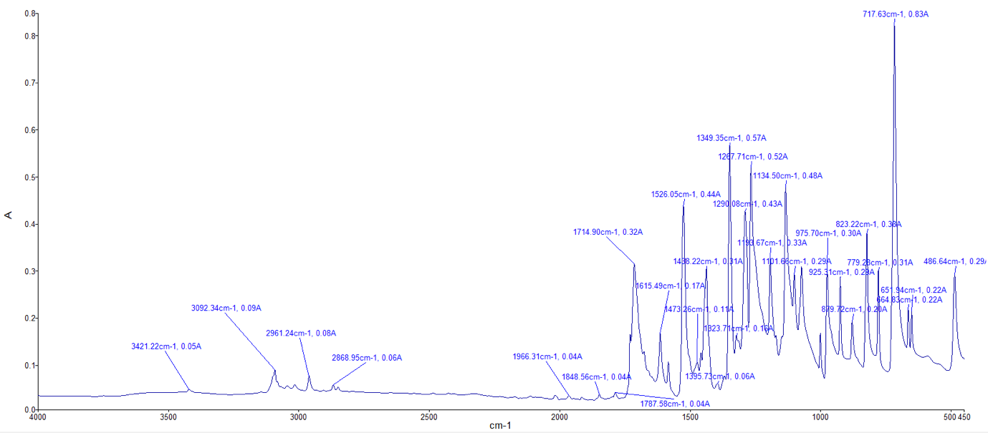
Figure 3 Sample C absorbance frequency spectra.

Figure 4, shows the ATR- IR spectra for Sample D. There are many strong sharp peask such as at 1225 cm⁻¹. A weak broad peak at 3159 cm⁻¹. This spectrum shows a strong similarity to the IR spectra of Acetaminophen [9].

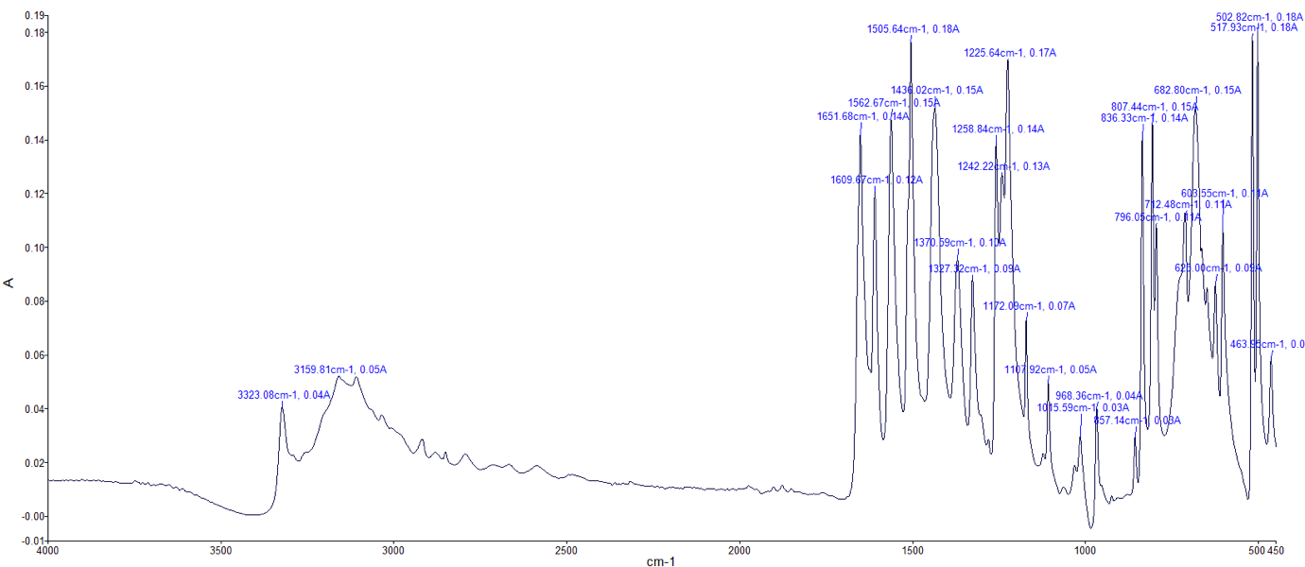
Figure 4 Sample D absorbance frequency spectra.

During the ATR analysis, Sample C was miss identified when using the ATR software’s library search function. It was theorised that the sample contained some impurities, and these effected the system’s ability to correctly identify the sample when using the library function.

The spectra results show that ATR-FTIR spectroscopy is a useful technique for identifying functional groups within organic compounds.

The functional groups identified in the compounds such as amide, arene, esters and amine are also present in some energetic compounds. An example is Tetryl, also known as N-methyl-N-nitro-2,4,6-trinitroaniline [10]. This explosive compound is a nitramine and contains a nitro amino group and a nitro group. Acetaminophen has a phenol structure and phenol is an explosive pre-cursor as it can be nitrated with acids to form tetryl [10] [11].

FTIR and Raman spectroscopy techniques are used with in the energetic industry such as in-field operations to identify unknown toxic chemicals used in the manufacture explosives, explosive stabilisers and energetic pre-cursors. The “TruDefender” [12] device uses FTIR spectroscopy where as the “FirstDefender” [13] device uses Raman spectroscopy. Both Spectroscopy methods have their limitations. FTIR struggles to identify samples that contain a lot of water and requires the sample to be indirect contact with the ATR crystal sampler. While Raman can identify samples indirectly and through some transparent containers it struggles to identify compounds with strong fluorescence [13] [12] [14].

Conclusion

The ATR- FTIR method produced a clear spectrum of the characteristic absorbance regions of specific functional groups supporting the hypothesis that this method is suitable for analysis of organic compounds.

Furthermore, most energetic compounds are organic and contain nitro-groups which can be easily identified using the FTIR-ATR analytical method. The FTIR and Raman spectroscopy methods can be used together to obtain a confirmatory result or used in place of one another to overcome the limitations of the singular methods.

The FTIR and Raman spectroscopy methods are widely used in the energetic industry by the military and/or police such as, to rapidly identify materials present for in field analysis of manufacturing/storage/use of toxic warfare agents or Improvise Explosive Devices (IEDs) in terrorism offences.

References

[1] | Specac, “Everything You Need to Know About ATR-FTIR Spectroscopy,” [Online]. Available: https://specac.com/everything-you-need-to-know-about-atr-ftir-spectroscopy/#:~:text=What%20is%20ATR%2DFTIR%20spectroscopy,high%20sensitivity%2C%20and%20broad%20applicability..
[2] | Agilent, “Fourier Transform Infrared Spectroscopy (FTIR) Overview,” [Online]. Available: https://www.agilent.com/en/support/molecular-spectroscopy/ftir-spectroscopy/ftir-spectroscopy-basics-faqs?srsltid=AfmBOoqDHUiIz4DCCN9F_gmIPbf8rIuUJwIlfoqrmqJFXDEQwdiAPTq2.
[3] | PerkinElmer, “Spectrum 2 User Guide PerkinElmer,” 04 2015. [Online]. Available: https://www.s4science.at/wordpress/wp-content/uploads/2019/04/L1050228-Spectrum-Two-Users-Guide-en-US.pdf.
[4] | LibreTexts, “Infrared Spectroscopy Absorption Table,” [Online]. Available: https://chem.libretexts.org/@go/page/22645.
[5] | O. Ali, “How to Interpret FTIR Results: A Beginner's Guide,” AZO Optics, 21 03 2025. [Online]. Available: https://www.azooptics.com/Article.aspx?ArticleID=2756.
[6] | 2. *. ,. M. K. 1. S. I. 1. M. M. 3. S. 1. 2. *. Hironori Izawa 1, “Guanidinylation of Chitooligosaccharides InvolvingInternal Cyclization of the Guanidino Group on theReducing End and Eﬀect of Guanidinylation onProtein Binding Ability,” Biomolocules, 2019.
[7] | Chemical Book, “Ascorbic Acid(50-81-7) IR1,” [Online]. Available: https://www.chemicalbook.com/SpectrumEN_50-81-7_IR1.htm.
[8] | NIH, “Methyl 3-nitrobenzoate,” PubChem, [Online]. Available: https://pubchem.ncbi.nlm.nih.gov/compound/Methyl-3-nitrobenzoate#section=Computed-Properties.
[9] | Chemical Book, “Acetaminophen(103-90-2) IR1,” [Online]. Available: https://www.chemicalbook.com/SpectrumEN_103-90-2_IR1.htm.
[10] | NIH, “Nitramine,” PubChem, [Online]. Available: https://pubchem.ncbi.nlm.nih.gov/compound/Nitramine.
[11] | J. Akhavan, The Chemistry of Explosives, Croydon: The Royal Society of Chemistry, 2022.
[12] | Thermo Scientific, “Thermo Scientific TruDefender FT,” 2010. [Online]. Available: https://tools.thermofisher.com/content/sfs/brochures/TruDefender-FT-SpecSheet.pdf.
[13] | Thero scientific, “Downrange Chemical and Explosives Identification,” 2024. [Online]. Available: https://documents.thermofisher.com/TFS-Assets/CAD/brochures/firstdefender-brochure.pdf.
[14] | M. D. H. a. C. D. B. Robert L. Green, “Handheld FT-IR and Raman as Tools in the Analysis of Improvised Explosive Materials,” Spectroscopy Supplements, vol. 0, no. Special Issue, 2010.

Appendices

Appendix 1- Table of labelled reference powders requiring conformation analysis.

Sample ID | Compound | Relevance / functional features
A | Guanidine  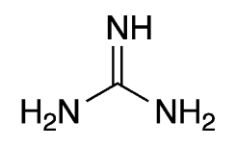 | Models nitrogen-rich ionic species common in energetic salts and precursor chemistry; shows salt/ionisation spectral effects.
B | Ascorbic acid  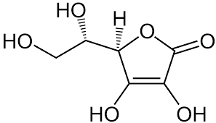 | Poly-hydroxy lactone; models oxidation-sensitive species and ageing studies.
C | Methyl 3-nitrobenzoate  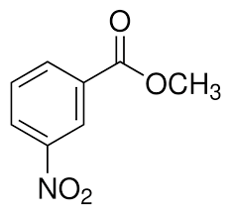 | Aromatic nitro-ester; analogue for nitrated aromatic intermediates.
D | Acetaminophen  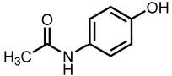 | Represents an amide / phenol structure; analogue for stabilisers, binders or organic contaminants.

