

Student ID: 2221255
Course Name: BSc Applied Computing
Module: Usability Engineering Component 2
Full Interface & Testing
Module Code: ACCB6017
Institution Name: University Of Wales Trinity Saint
David
Date of Submission: 14th November 2025, 14:00 (2 PM)
Module Tutor: Nasir Ibrahim


​​
Table of Contents
1.0: Cover Page: 3
2.0: Table of Contents: 4
3.0: Table of Figures: 4
4.0: Abstract: 4
5.0: Introduction: 4
6.0: Full colour design storyboards: 4
Design Optimisation from Wireframe Prototypes to Persona-Informed Storyboard Execution: 4
1.0: Main menu interface of the game: 4
2.0: Interactive Tutorial Interface: 4
3.0: Character Selection and Player Profile Interface: 5
4.0: Interactive Campus Map Interface: 6
5.0: Accusation and Interrogation Interface: 8
8
7.0: Feedback collected from Users for Prototype: 9
7.1: Storyboard Feedback and Testing Approach: 9
7.2: Participant Feedback: Usability and Emotional Engagement: 10
Usability: 10
Emotional Engagement: 10
Alignment with User Expectations: 10
Overview of Persona-Based Positive and Negative Feedback: 10
8.0: Information collected from users for working version of Mobile App to be potentially built and released: 11
8.1: Data Collection Plan for the Working Version: 11
8.2: Basic User Information: 11
8.3: Gameplay Behaviour Data: 12
8.4: System Performance Data: 12
8.5: Emotional Response & Satisfaction Data: 12
8.6: Accessibility Interaction Data: 12
8.7: Consent and Privacy Acknowledgement 13
8.8: How This Data Will Help Improve the Next Version of the Game: 13
9.0: Additional Usability Considerations: 13
9.1: How the Storyboards Would Differ with a Pure Usability Approach 13
1. Minimal Visual Design: 13
2. Reduced Thematic Elements: 13
3. Text-Based Instructions: 14
9.2: Conflicts Between Usability and User Experience (UX): 14
1. Visual Engagement vs. Cognitive Load: 14
2. Reward & Penalty Screens: 14
3. Tutorial Complexity vs. Emotional Comfort: 14
9.3: Examples from the Design Process: 15
Example 1: Character Selection Screen: 15
Example 2: Map Screen: 15
Example 3: Tutorial Screen 15
9.4: Additional Conflicts Between Usability and UX in Game Development 15
10.0: Conclusion: 16
11.0: References: 17
​​12.0: Appendices: 19

3.0: Table of Figures:
Figure 1: Coloured storyboard of the Start Screen for The Vice-Chancellor’s Murder game, showing an accessible, high-contrast interface with thematic campus imagery, warm colour tones, and clearly labelled navigation buttons designed to enhance usability and focus. 6
Figure 2: “How to Play” storyboard screen illustrating step-by-step guidance and accessible design features added to support diverse user needs and enhance gameplay comprehension. 7
Figure 3: Combined Character Selection screen showing all characters with instant profiles, redesigned for accessibility, lower cognitive load, and better engagement. 8
Figure 4: Redesigned Campus Map screen showing colour-coded rooms, icons, and visual cues to enhance recognition, accessibility, and spatial awareness. The warm maroon, gold, and navy palette supports thematic immersion and visual clarity, while bottom navigation buttons ensure consistent, user-friendly interaction. 9
Figure 5: Accusation and Interrogation Interface, enhanced with colour-coded icons, numbered steps, and an accessible layout to support clarity, focus, and inclusive interaction for diverse user personas. 10
Figure 6: Accessibility-enhanced home screen showcasing integrated features such as text resizing, language selection, voice input, audio control, search tool, and toggle mode, designed to support diverse user needs including dyslexia, ESL users, low vision, and 22
Figure 7: Accessibility Settings screen illustrating key customisation features, including Vision Enhancement, Hearing Enhancements, TalkBack, Text Size, Game Mode, Toggle Options, and Advanced Settings. These tools support users with visual, auditory, and cognitive needs, promoting inclusive, flexible, and user-centred gameplay. 23
Figure 8: Improved Clue Screen storyboard showing enhanced colour contrast, clearer icon grouping, and character-based hints to support accessibility and reduce cognitive load based on persona feedback. 24
Figure 9: Redesigned reward screen showing enhanced visual feedback, clearer scoring, and accessible layout based on persona requirements and usability principles. 25
Figure 10: Redesigned penalty screen, showing improved emotional feedback, clearer visual cues, and accessible navigation driven by persona insights and usability best practices 26
Figure 11: Full game flow illustrating key user interactions, decision points, and accessibility features across the gameplay sequence. 27
Figure 12:Feedback responses from personas on the coloured storyboard design. 28
Figure 13: Feedback responses from personas on the coloured storyboard design. 28

4.0: Abstract:

This report presents the user-centred design process for a mobile mystery game inspired by Cluedo and set across two UWTSD campuses. Four personas representing varied accessibility needs ADHD, dyslexia, anxiety, and visual impairments—guided the design approach. Initial wireframes were produced and progressively refined into coloured storyboards using Nielsen’s heuristics, Schneiderman’s rules, and iterative user feedback. The final interface enhances clarity, accessibility, and engagement through simplified layouts, legible typography, structured navigation, and an inclusive colour scheme. Overall, the project illustrates how user research and iterative testing contribute to creating an accessible and engaging game experience.

5.0: Introduction:

This report outlines the design and evaluation of a mobile Cluedo-style mystery game adapted to the UWTSD campus setting. Using a user-centred design approach, the project incorporates accessibility and usability principles to accommodate a broad range of players. Four personas—developed through questionnaires and interviews—represented key user groups, including neurodiverse learners, anxious users, international students, and players with visual sensitivities. These personas guided choices around layout simplicity, readability, colour contrast, iconography, and navigation structure.
Low-fidelity wireframes were first produced to map core gameplay stages such as character selection, campus exploration, clue discovery, and the accusation process. These were then refined into coloured storyboards informed by user feedback to enhance clarity, emotional comfort, and engagement. Overall, the report highlights how inclusive design and usability principles support the development of an intuitive and accessible game interface.

6.0: Full colour design storyboards:

The following section presents the full-colour design storyboards for the UWTSD version of the Cluedo computer game. In response to wireframe feedback from four distinct personas, the full-colour storyboards were refined to enhance usability, streamline navigation, and improve visual clarity across key app functions, visual hierarchy, and user flow, in accordance with established interaction design principles.

Design Optimisation from Wireframe Prototypes to Persona-Informed Storyboard Execution:

1.0: Main menu interface of the game:

The coloured storyboard for the main page successfully implements the improvements identified during wireframe testing feedback, as shown in Figure 1. The updated interface replaces the plain grey layout with a warm, engaging campus background that reflects the mystery theme and enhances user immersion. Incorporating navy and amber tones enhances visual hierarchy [1][2] and fosters emotional warmth, effectively responding to participant concerns that the initial wireframe felt “sterile.” High-contrast button design improves legibility for users with dyslexia and visual impairments, while accessibility and settings icons strengthen inclusivity [3] and user control [4]. The dark background and simplified layout also support users with ADHD, reducing distractions and maintaining focus. Overall, the design aligns with user-centred principles of aesthetic consistency, accessibility, and engagement as recommended in UX research.

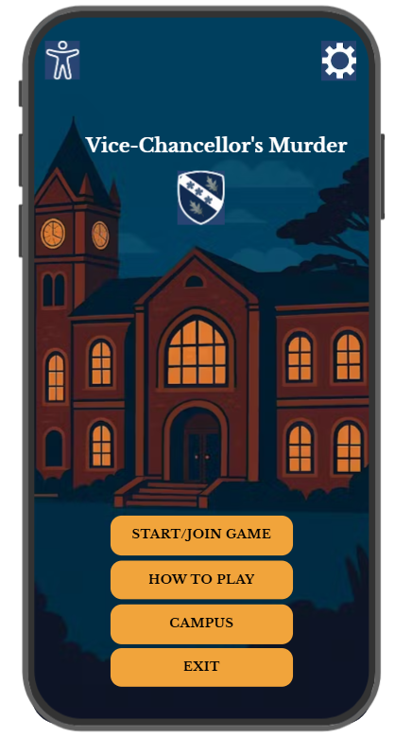

Figure 1: Coloured storyboard of the Start Screen for The Vice-Chancellor’s Murder game, showing an accessible, high-contrast interface with thematic campus imagery, warm colour tones, and clearly labelled navigation buttons designed to enhance usability and focus.

2.0: Interactive Tutorial Interface:

The “How to Play” user guidance screen has been introduced in response to persona feedback, addressing the need for clearer instructions, improved accessibility, and reduced cognitive load [5]. This screen was not part of the original wireframe but was added later to enhance user orientation and comfort, especially for those unfamiliar with the app’s format or gameplay style. Minimal text supported by numbered icons aids dyslexic [6] and international players by improving comprehension, as shown below in Figure 2. Friendly, narrative text (“Welcome, Detective…”) boosts engagement, while consistent button placement and accessibility icons support intuitive, inclusive navigation.

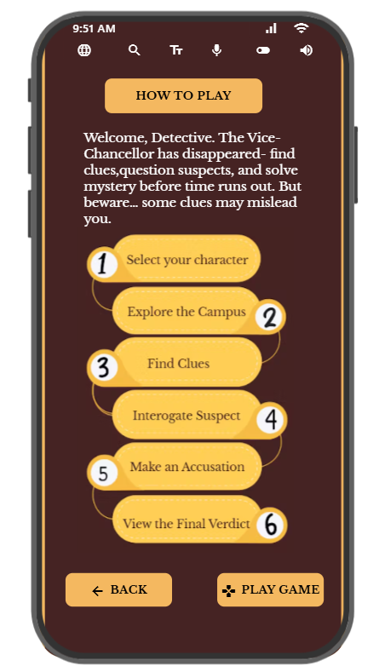
Figure 2: “How to Play” storyboard screen illustrating step-by-step guidance and accessible design features added to support diverse user needs and enhance gameplay comprehension.

3.0: Character Selection and Player Profile Interface:

The Character Selection screen, as shown in Figure 3, was redesigned by merging three wireframes into a single, dynamic interface for greater simplicity and accessibility. Feedback from users with ADHD, dyslexia, and limited gaming experience showed that switching screens was confusing. The new layout displays all characters together, showing each profile instantly to reduce cognitive load and improve recognition. Large icons, bold fonts, and a high-contrast navy, maroon, and gold palette enhance readability for neurodiverse users. Humorous taglines boost engagement, while consistent buttons and Talkback support improve accessibility. The redesign promotes efficiency, visibility, and universal usability for a more inclusive player experience, aligning with Nielsen’s and Schneiderman’s usability principles [7] [8].
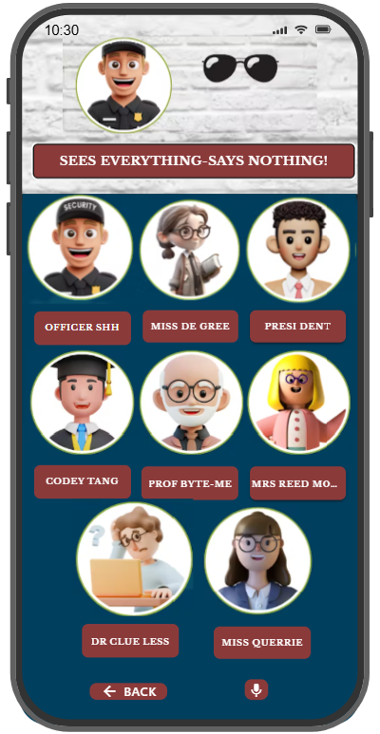

Figure 3: Combined Character Selection screen showing all characters with instant profiles, redesigned for accessibility, lower cognitive load, and better engagement.

4.0: Interactive Campus Map Interface:

The Campus Map screen in Figure 4 was redesigned to enhance usability, accessibility, and engagement based on persona feedback. Users with ADHD and dyslexia found the original layout overly text-heavy and visually dull, making navigation difficult. The new design introduces colour-coded rooms, clear icons, and visual cues to aid recognition and reduce cognitive effort, following Nielsen’s “Recognition rather than Recall” principle. Interactive elements like Hint and Clue buttons provide clear feedback, supporting Schneiderman’s guidelines [9] for informative and consistent interaction. A warm maroon, gold, and navy palette adds thematic depth while ensuring high contrast for visually impaired users [10]. Simplified navigation buttons at the bottom promote predictability and inclusivity. Overall, the redesign transforms the static layout into a visually intuitive, accessible, and engaging map experience.

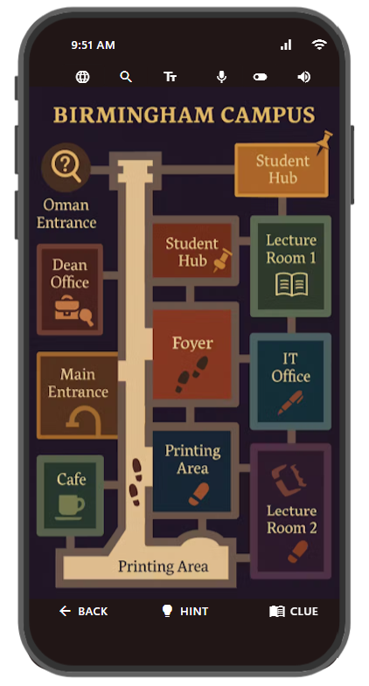
Figure 4: Redesigned Campus Map screen showing colour-coded rooms, icons, and visual cues to enhance recognition, accessibility, and spatial awareness. The warm maroon, gold, and navy palette supports thematic immersion and visual clarity, while bottom navigation buttons ensure consistent, user-friendly interaction.

5.0: Accusation and Interrogation Interface:

The Accusation Card screen, as shown in Figure 5, was redesigned to enhance clarity, engagement, and accessibility based on persona feedback. Users with ADHD and dyslexia found the original version text-heavy and difficult to follow, prompting the introduction of colour-coded icons, numbered steps, and a warm palette to aid focus and recognition. The new design applies Nielsen’s “Recognition rather than Recall” and Schneiderman’s principle of reducing memory load, guiding players clearly through the “Who,” “Where,” and “Weapon” selections [11]. Icon-based interactions replace long text for easier comprehension by dyslexic and ESL users, while a single, prominent “Confirm” button ensures consistency and accessibility. Overall, the redesign improves usability, understanding, and emotional engagement in line with inclusive game design standards.

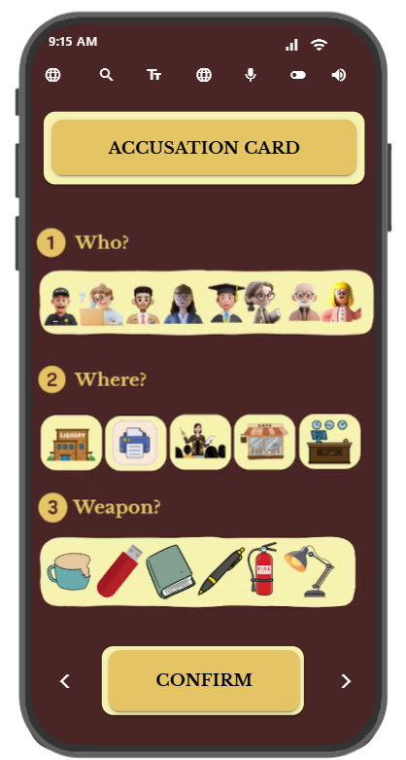
Figure 5: Accusation and Interrogation Interface, enhanced with colour-coded icons, numbered steps, and an accessible layout to support clarity, focus, and inclusive interaction for diverse user personas.

All screens include a top accessibility bar shown in Appendix 1 to ensure a consistent, user-friendly experience for diverse users.
Additional interfaces, including the Reward, Penalty, Accessibility, and Clue Log screens, are documented in Appendices 2 through 5. The complete game flow is provided in Appendix 6.

Across all storyboard screens, Norman’s principles [12], Nielsen’s heuristics [13], and Schneiderman’s rules [14] were applied to improve clarity, consistency, and ease of use. Colour coding, icons, and simplified layouts reduce cognitive load, while consistent navigation and clear feedback support users with dyslexia, ADHD, anxiety, and language barriers. These combined principles create a more intuitive, accessible, and user-friendly mystery game interface.

7.0: Feedback collected from Users for Prototype:

7.1: Storyboard Feedback and Testing Approach:

Survey feedback on the coloured storyboard prototype was gathered from the same participants who previously evaluated the wireframe and early gameplay, ensuring continuity in user experience assessment. These individuals were carefully selected to authentically represent the defined personas an ADHD student, a dyslexic international student, a mature learner with anxiety, and a colour-blind user based on their real-life accessibility needs. Initial gameplay requirements were shared with this group to inform persona development, and the coloured prototype was later tested by the same participants to capture consistent, experience-based insights into usability, accessibility, visual clarity, and emotional engagement. The survey link was shared with three testers, and one participant was additionally interviewed in a one-to-one session.
The feedback survey link is provided in Appendix 6, with completed survey responses documented in Appendix 7.

7.2: Participant Feedback: Usability and Emotional Engagement:

Usability:
Users found the coloured storyboard much clearer and easier to navigate than the wireframes. High-contrast colours, larger icons, and well-grouped information improved readability for dyslexic [15] and visually impaired participants. ADHD and anxious users reported that the simplified layout, consistent buttons, and numbered steps reduced cognitive load and confusion. Users also appreciated the icon-based cues and reduced text, which made interactions clearer and easier to follow for a wider range of users [16].

Emotional Engagement:
Participants reacted positively to the friendly colour palette [17], supportive wording, and more engaging visual style. The reward screen encouraged a sense of achievement, while the updated penalty screen felt less discouraging and more motivational. Anxious users described the design as “calm,” “encouraging,” and “less overwhelming” compared to typical game interfaces. A few users suggested slightly reducing the visual intensity of the reward screen an unexpected but valuable insight for future refinement.

Alignment with User Expectations:
Most feedback closely matched persona-based expectations, particularly around clarity, readability, and emotional comfort. The only unexpected insight was that some users found certain celebratory elements overly stimulating, emphasizing the need for optional low-sensory modes. Overall, the feedback confirmed that the coloured storyboard successfully met the accessibility and usability requirements identified during earlier stages.

Overview of Persona-Based Positive and Negative Feedback:

Aspect | Positive Feedback | Negative Feedback
Visual design | Clear, high-contrast colours improve readability; warm palette feels welcoming. | Some screens (reward screen) felt slightly overstimulating for sensitive users.
Navigation | Easy-to-follow layout; consistent button placement reduces confusion. | Icons on some screens could be clearer or more descriptive.
Accessibility | Text size options, icon cues, and simplified instructions support dyslexic and ADHD users. | Colour-blind users suggested an alternative palette for better differentiation.
Engagement | More immersive and motivating than the wireframe; friendly tone helps anxious users. | A few users wanted even calmer designs with fewer bright elements.
Understanding of tasks | Numbered steps and grouped elements reduce cognitive load. | Some participants requested more tooltips or audio explanations.

8.0: Information collected from users for working version of Mobile App to be potentially built and released:

8.1: Data Collection Plan for the Working Version:

In the working version of the game, both usage data and emotional-response data will be collected to evaluate usability, accessibility, and player engagement. This approach is based on Nielsen’s principle of iterative evaluation [18] and Schneiderman’s rule of continuous feedback, which emphasise monitoring real user behaviour to improve interface design.

8.2: Basic User Information:

The app will gather only essential onboarding details, such as username, preferred language, and selected accessibility options like text size, colour contrast, and audio settings. This information allows the interface to tailor itself to individual user needs, promoting a personalised and accessible experience without collecting any sensitive personal data.

8.3: Gameplay Behaviour Data:

The app will automatically track gameplay behaviours, including navigation flows, clue interactions, character choices, and points where users disengage. This data will be used to pinpoint usability challenges, areas of cognitive strain, and the overall effectiveness of the interface, enabling iterative refinements based on established usability principles.

8.4: System Performance Data:

The app will automatically monitor technical metrics including crash reports, loading durations, and button responsiveness. This data helps maintain stability and performance across devices, ensuring a smooth user experience while allowing developers to identify and resolve issues efficiently

8.5: Emotional Response & Satisfaction Data:

Emotional and subjective feedback will be gathered through optional in-app surveys and quick ratings. This data captures player feelings such as enjoyment, frustration, or confusion elements that cannot be detected automatically but are essential for understanding user comfort and motivation.

8.6: Accessibility Interaction Data:

The app will track the frequency of player interactions with accessibility tools such as text resizing, colour-blind mode, and text-to-speech. This data will help determine which features are most beneficial and highlight areas where further support may be needed to accommodate diverse user needs.

8.7: Consent and Privacy Acknowledgement

At the initial launch of the app, users will be prompted to provide consent for data collection. This approach promotes transparency, aligns with GDPR requirements, and ensures ethical management of user information while empowering players with full control over how their data is utilized.

8.8: Differences Between Usage Data and Emotional Response Data
Usage data and emotional response data differ in purpose and how they are collected. Usage data is automatically recorded by the app and shows what users do, helping identify usability and navigation issues. Emotional response data is gathered manually through surveys or feedback and reveals how users feel, such as comfort, confusion, or engagement. Together, they offer a fuller understanding of the overall user experience.

8..9: How This Data Will Help Improve the Next Version of the Game:
Insights from the working version will guide the next release by revealing user interaction patterns, usability challenges, and accessibility needs [19]. Usage analytics will highlight confusing screens and drop-off points, while emotional feedback will inform adjustments to visual and reward elements. Accessibility and technical data will support feature refinement and performance stability, ensuring a more intuitive, inclusive, and user-centred experience.

9.0: Additional Usability Considerations:

9.1: How the Storyboards Would Differ with a Pure Usability Approach

1. Minimal Visual Design:
If the app were designed purely from a usability viewpoint, the screens would prioritise efficiency over aesthetics. Background illustrations, thematic colours, and decorative elements would be removed. For example, the home screen would use plain, high-contrast colours and simple rectangular buttons, following Nielsen’s principles of visibility, simplicity, and consistency.

2. Reduced Thematic Elements:
A usability-focused design would exclude mystery-themed visuals, icons, and stylised maps. For example, the campus map would be presented as a simple grid rather than a decorative 2D illustration, and character selection would display roles in plain text instead of illustrated avatars. While this approach enhances clarity and functional efficiency, it reduces emotional engagement and thematic immersion.

3. Text-Based Instructions:
Tutorial and clue screens would contain straightforward text without storytelling elements. While highly efficient, this could overwhelm dyslexic or ADHD users, contradicting the needs identified in the persona research.

9.2: Conflicts Between Usability and User Experience (UX):

1. Visual Engagement vs. Cognitive Load:
Introducing thematic colours and character illustrations aimed to enhance immersion from a UX standpoint. However, usability principles prioritised minimal visual distraction. This tension was resolved by applying warm, low-saturation colours and streamlined layouts, striking a balance between emotional engagement and visual clarity.

2. Reward & Penalty Screens:
Usability guidelines advocate for direct, immediate feedback (e.g., “Correct” or “Incorrect”). In contrast, UX design calls for emotionally supportive visuals to sustain player motivation. The final interface combined clear icons with subtle animations, adhering to Schneiderman’s principle of informative feedback while remaining sensitive to overstimulation.

3. Tutorial Complexity vs. Emotional Comfort:
A purely usability-driven tutorial would deliver compact, instruction-heavy content. UX needs particularly for users with dyslexia, anxiety, or limited English proficiency required simplified, step-by-step guidance with visual aids. The final design incorporated numbered steps and icons, reducing cognitive load (Schneiderman) and enhancing emotional comfort (Norman’s Emotional Design).

9.3: Examples from the Design Process:

Example 1: Character Selection Screen:
- Usability-only version: Plain list of characters.
- Final UX-integrated version: Illustrated character icons, short playful descriptions, and a profile box.
This improved emotional connection while maintaining clarity.

Example 2: Map Screen:
- Usability-only version: Simple black-and-white grid.
- Final version: Themed 2D campus map using high contrast and labelled icons.
This supports immersion without compromising navigability.

Example 3: Tutorial Screen
- Usability-only version: Dense instructional text.
- Final version: Six short steps with numbered circles and minimal wording.
This aligns with the needs of ADHD, dyslexic, and anxious personas.

9.4: Additional Conflicts Between Usability and UX in Game Development
The table below outlines further recurring tensions between usability and user experience (UX) that commonly surfaced during the game design process.

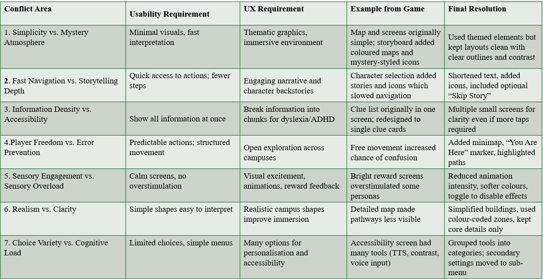

10.0: Conclusion:
This project demonstrates the effectiveness of a user-centred and accessibility-focused design methodology in transforming a traditional Cluedo concept into an inclusive mobile game tailored to the UWTSD campus context. By developing personas representing ADHD, dyslexia, anxiety, and visual sensitivities, the design process remained grounded in the needs of diverse user groups. The application of Nielsen’s heuristics, Schneiderman’s principles, and iterative user evaluation enabled systematic improvements in clarity, navigation, emotional comfort, and overall usability.
The progression from low-fidelity wireframes to fully coloured storyboards illustrate how iterative refinement can significantly enhance both functional accessibility and narrative engagement. The final designs support a wide spectrum of players by incorporating readable typography, high-contrast colour palettes, intuitive iconography, and simplified interaction flows.
While the prototype successfully addresses the primary accessibility and usability goals, further work could explore advanced accessibility configurations, adaptive interfaces, and expanded game interactivity. Overall, this project reinforces the value of inclusive, research-informed design practices in creating meaningful, engaging, and accessible mobile game experiences.

11.0: References:
[1] J. J. Saw and L. P. Gatzke, "Designing visual hierarchies for the communication of health data," Journal of the American Medical Informatics Association, vol. 31, no. 11, pp.2722–2729, 2024.
[2] C. Chang and T. Johnson, "Integrating heuristics and think-aloud approach to evaluate the usability of game-based learning material," Journal of Computers in Education, vol. 8, no. 1, pp.137–157, 2021.
[3] V. Cozlov and M. Zadorojnii, "Inclusivity and accessibility in UX design," Conferinţa tehnico-ştiinţifică a studenţilor, masteranzilor şi doctoranzilor, 2022.
[4] N. Chandarana and T. Gada, "Accessibility Challenges in Current Mobile Applications: A Comprehensive Overview," International Journal of Innovative Research in Computer and Communication Engineering, vol. 12, pp.8401–8406, 2024.
[5] A. J. Seyderhelm and K. L. Blackmore, "How hard is it really? Assessing game-task difficulty through real-time measures of performance and cognitive load," Simulation & Gaming, vol. 54, no. 3, pp.294–321, 2023.
[6] P. Otermans, et al., "How do adults with neurodevelopmental disorders prefer information being presented?" Educational Media International, pp.1–22, 2025.
[7] H. Kusuma, et al., "Usability evaluation of Ruangguru online learning mobile application using heuristic method," Procedia Computer Science, vol. 245, pp.176–184, 2024.
[8] M. Ahmad Faudzi, et al., "Investigating the user interface design frameworks of current mobile learning applications: A systematic review," Education Sciences, vol. 13, no. 1, pp.94, 2023.
[9] W. F. Algashmari and W. Aljedebi, "Evaluation of mobile applications user interfaces: a case study of children’s mobile applications," Communications in Mathematics and Applications, vol. 13, no. 1, pp.417, 2022.
[10] J. Laine, "Impact of dark mode on user experience and eye comfort," 2025.
[11] L. Chitrakar, et al., "User-centric design of ui for mobile banking apps: Improving ui and features for better customer experience," Available at SSRN 5056829, 2024.
[12] S. A. Ariffin, et al., "Review on Cultural Design Elements for Mobile Applications User Interface." Int.J.Interact.Mob.Technol., vol. 16, no. 15, pp.78–92, 2022.
[13] M. Muhanna, A. Masoud and A. Qusef, "Usability heuristics for evaluating Arabic mobile games," International Journal of Computer Games Technology, vol. 2022, no. 1, pp.5641486, 2022.
[14] S. Subedi, et al., "Designing for Ease: Usability-Driven Redesign of Nepal's Immigration Portal," Authorea Preprints, 2025.
[15] L. Kurman and J. Cohen, "Dyslexia-Friendly Design in Infographics: An Experimental Study on Information Retention and Recall from Dyslexia-Friendly and Non Dyslexia-Friendly Designed Infographics," 2025.
[16] K. Majrashi, "Performance of mobile users with text-only and text-and-icon menus in seated and walking situations," Behaviour & Information Technology, vol. 41, no. 1, pp.32–50, 2022.
[17] L. Hegemann and A. Oulasvirta, "Palette, purpose, prototype: The three ps of color design and how designers navigate them," Proceedings of the 2024 CHI Conference on Human Factors in Computing Systems, 2024.
[18] E. R. Oliveira, et al., "An iterative process for the evaluation of a mobile application prototype," SN Computer Science, vol. 3, no. 4, pp.262, 2022.
[19] M. A. Rahman and S. N. Jyoti, "A Systematic Literature Review of User-Centric Design In Digital Business Systems: Enhancing Accessibility, Adoption, And Organizational Impact," Review of Applied Science and Technology, vol. 1, no. 04, pp.1, 2022.
[20] C. Petroff, J. Fenton, and L. Malik, “Inclusive Design in Mobile Game Interfaces: Improving Accessibility for Neurodiverse Users,” International Journal of Human–Computer Interaction, vol. 37, no. 11, pp. 1052–1065, 2021.
[21] M. Kumar and R. Singh, “Designing Accessible Mobile Interfaces for Users with Visual and Cognitive Impairments,” Journal of Usability Studies, vol. 17, no. 4, pp. 185–198, 2022.
[22] Interaction Design Foundation, “Colour Accessibility in UX Design: Best Practices for Inclusivity,” Interaction Design Foundation, 2021. [Online]. Available: https://www.interaction-design.org/literature/article/color-accessibility-in-ux-design
[23] G. Golubović, et al., "UI/UX design and usage effectiveness of mHealth applications," Universal Access in the Information Society, pp.1–14, 2025.
[24] W. M. Ayada and M. A. E. E. Hammad, "Design quality criteria for smartphone applications interface and its impact on user experience and usability," International Design Journal, vol. 13, no. 4, pp.339–354, 2023.

[25] E. P. Goodman, "The Stakes of User Interface Design for Democracy," Available at SSRN 3882012, 2021

​​12.0: Appendices:

​Appendix 1:
Brief Feature Explanations of the top accessibility bar can be seen in Figure 6.

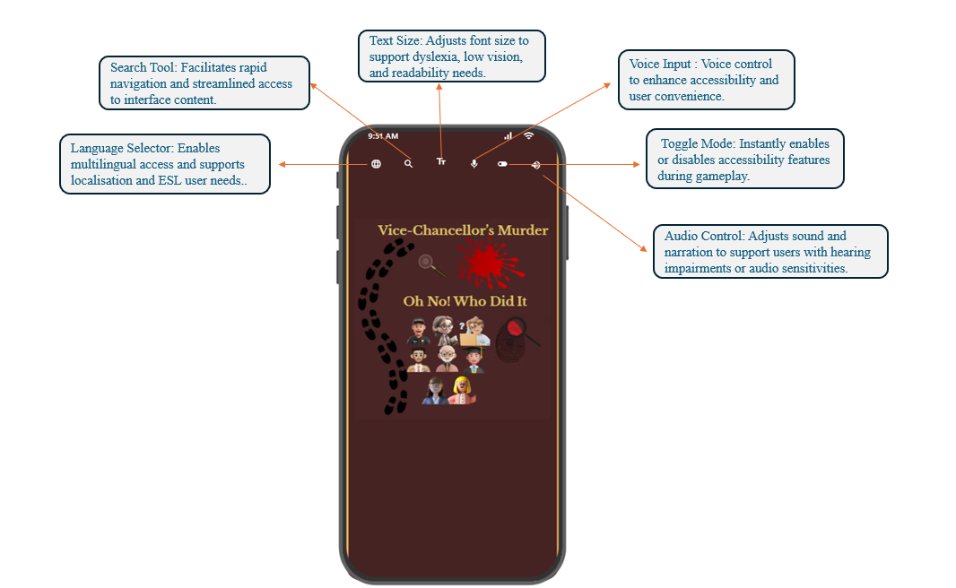
Figure 6: Accessibility-enhanced home screen showcasing integrated features such as text resizing, language selection, voice input, audio control, search tool, and toggle mode, designed to support diverse user needs including dyslexia, ESL users, low vision, and

Appendix 2:
​​​The Accessibility Settings screen in Figure 7 supports diverse user needs with a clear layout and customisable options [20]. Features such as Vision Enhancement, Text Size, Talkback, and Hearing Enhancements improve usability for users with sensory impairments [21], while Game Mode and toggle controls aid focus and flexibility. Overall, the design promotes inclusive, user-centred interaction.
The accessibility features have been significantly enhanced to meet the diverse needs of personas, including users with visual impairments, hearing difficulties, ADHD, dyslexia, and anxiety, by offering customisable controls that improve visibility, clarity, and interaction comfort [22].

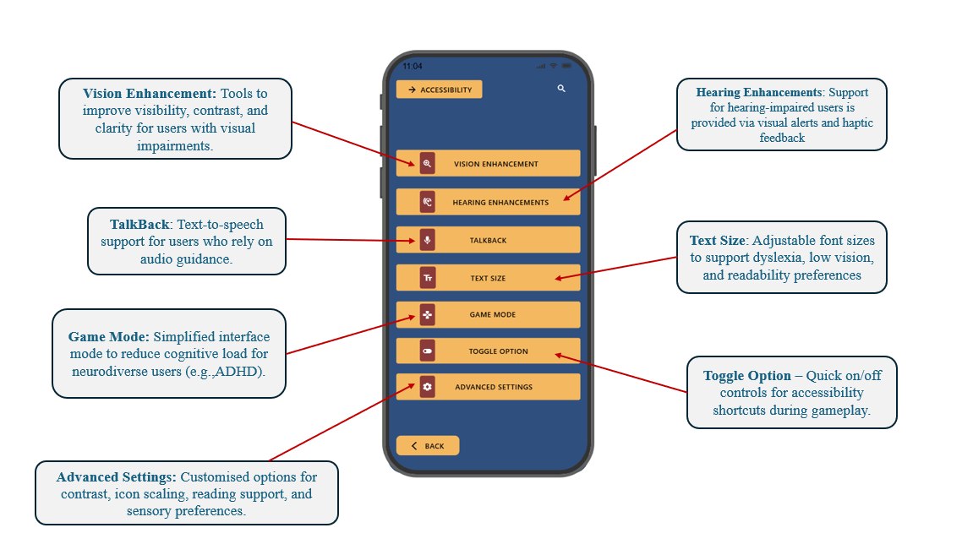

Figure 7: Accessibility Settings screen illustrating key customisation features, including Vision Enhancement, Hearing Enhancements, TalkBack, Text Size, Game Mode, Toggle Options, and Advanced Settings. These tools support users with visual, auditory, and cognitive needs, promoting inclusive, flexible, and user-centred gameplay.

Appendix 3:
The coloured Clue Screen as can be seen in Figure 8, was redesigned to improve clarity, accessibility, and reduce cognitive load. High-contrast navy and gold enhance visibility for dyslexic and colour-blind users, while enlarged, grouped icons support quicker processing for ADHD users. Warm tones and character illustrations increase comfort and engagement, and the new speech-bubble hint with clear action buttons provides immediate feedback aligning with Nielsen’s principle [23]. Overall, the redesign strengthens inclusivity and usability in line with persona feedback and modern interaction-design principles.

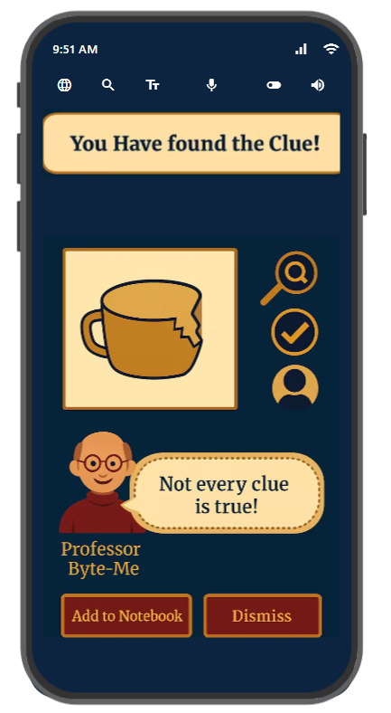

Figure 8: Improved Clue Screen storyboard showing enhanced colour contrast, clearer icon grouping, and character-based hints to support accessibility and reduce cognitive load based on persona feedback.

Appendix 4:

The reward screen in Figure 9 was redesigned to increase motivation and accessibility based on persona feedback. Bright colours, visual rewards, and clearer scoring enhance engagement for ADHD and anxious users, while high contrast and larger text support dyslexic and low-vision players. Clear navigation improves consistency and readability, resulting in more positive feedback and a more accessible user experience [24].
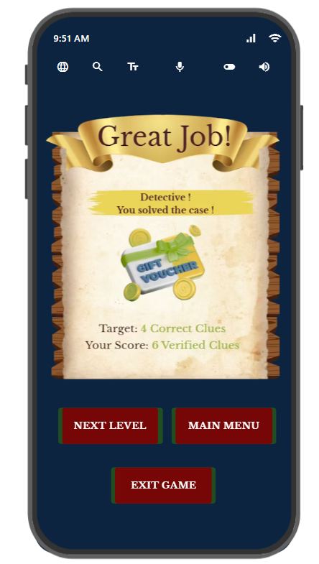

Figure 9: Redesigned reward screen showing enhanced visual feedback, clearer scoring, and accessible layout based on persona requirements and usability principles.

Appendix 5:

The new penalty notification panel as shown in Figure 10 introduces supportive language, high-contrast visuals, and clear icons to reduce anxiety and improve comprehension for neurodiverse and low-vision users. It aligns with Nielsen’s feedback and visibility heuristics and Schneiderman’s rules [25] for supportive error handling, making the experience more motivating and accessible while maintaining gameplay flow.
.
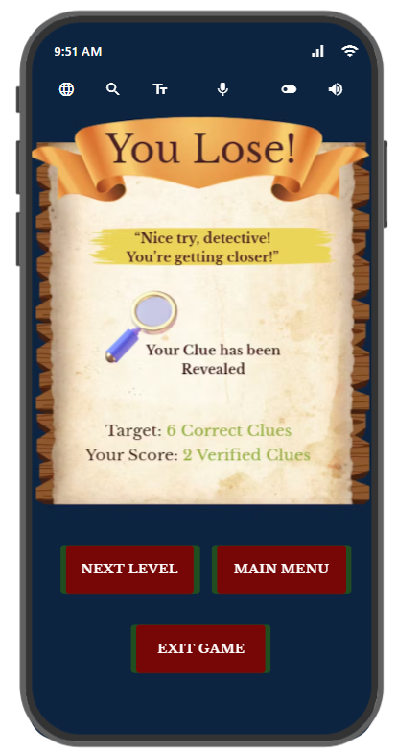

Figure 10: Redesigned penalty screen, showing improved emotional feedback, clearer visual cues, and accessible navigation driven by persona insights and usability best practices

Appendix 6:

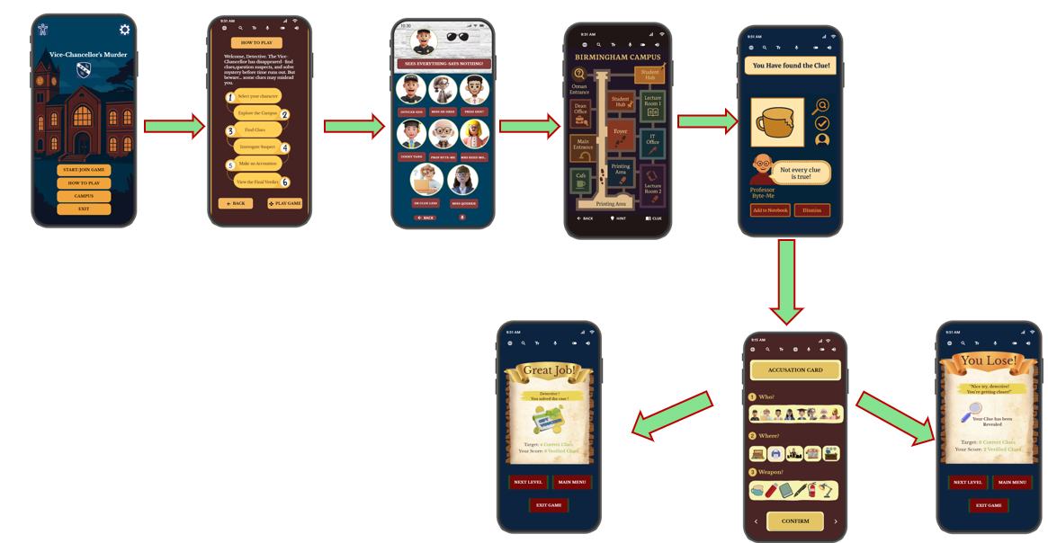
Figure 11: Full game flow illustrating key user interactions, decision points, and accessibility features across the gameplay sequence.

Appendix 7:

https://forms.gle/MrNC3yBTrT5fKBZj9

Appendix 8:
The survey response summary is presented in Figures 12 and 13.
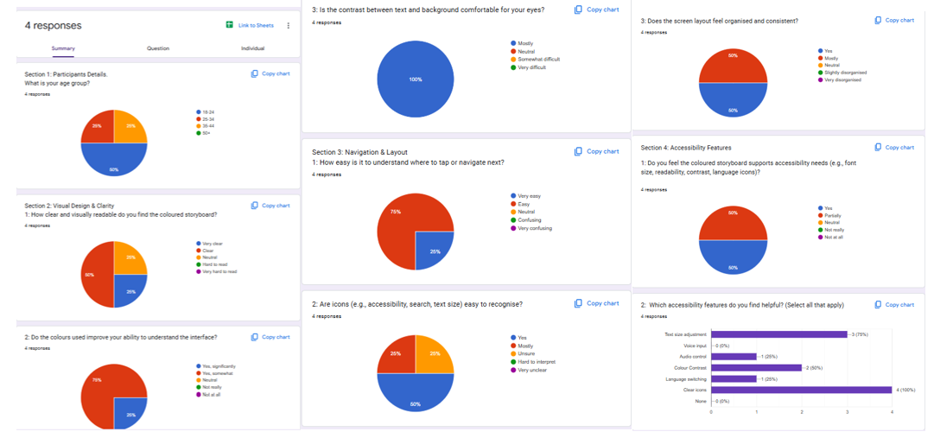

Figure 12:Feedback responses from personas on the coloured storyboard design.

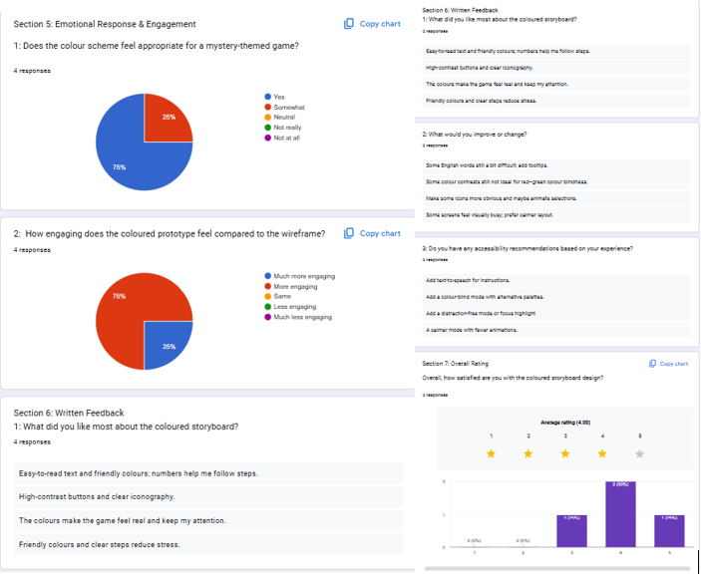
Figure 13: Feedback responses from personas on the coloured storyboard design.

