An Analysis of Quality Assurance in East Kent Maternity Services (2022)

Assignment Title: Component 2 Service Improvement Report
Lecturer: Dr Fahad Khan
Programme: MSc Public Health and Social Care in Practice
Module: Quality Assurance and Service Improvements
Module code: LCHS7006
Submitted by

Student name: Abdullah Nana
Student ID number: 2526419

Executive Summary
The report reflects on the gaps in Quality Assurance and Quality Improvement identified in the East Kent Maternity Services investigation (2022), while taking a critical approach. An investigation found that there were weaknesses across governance, leadership, communication and patient safety across the organisation, as well as avoidable neonatal and maternal harm. The report adopts a variety of recognised frameworks for quality improvement such as the Donabedian Model, Fishbone Analysis, Five Whys, SWOT Analysis, the Plan-Do-Study-Act (PDSA) Cycle and Kurt Lewin's Three-Stage Change Model to explore the reasons why services are failing and then presents evidence-based strategies for improvement.

Table of Contents
Executive Summary 2
1. Introduction 4
1.1 Definition of Quality Assurance 4
1.2 Definition of Quality Improvement 4
1.3 Aim of the Report 4
1.4 Importance of Quality Assurance and Quality Improvement 4
1.5 Brief Description of the East Kent Case 5
2. Main Body 6
2.1 Case Study Analysis: East Kent Maternity Services Incident 6
2.2 Application of Donabedian Model 7
2.3 Fishbone (Cause-and-Effect) Diagram Analysis 8
2.4 Five Whys Analysis 9
2.5 SWOT Analysis 11
2.6 Kurt Lewin's Three-Stage Change Model 13
3. Recommendations 14
Recommendation 1: Strengthen Clinical Governance 14
Recommendation 2: Benchmarking Against High-Performing NHS Trusts 14
Recommendation 3: Workforce Development 15
Recommendation 4: Improve Patient Safety Culture 15
Recommendation 5: Digital Quality Monitoring 15
Recommendation 6: PDSA Cycle Implementation 16
Benchmarking 17
4. Conclusion 18
References 19

1. Introduction

1.1 Definition of Quality Assurance
Quality assurance (QA) is a planned and systematic process of work that ensures healthcare services are consistently compliant with the requirements of the regulatory bodies and clinical standards/thresholds for the patient. QA in the NHS is comprised of governance, audits, performance monitoring and risk management to make sure safe and effective care is provided. Critics responded, though, that QA often takes too much of an adherence to standards and not enough education, development, and innovation. Organisations can fulfil inspection requirements and do not need to address fundamental issues of cultural and leadership issues.

1.2 Definition of Quality Improvement
Quality improvement (QI) is an ongoing and systematic process of making improvements to healthcare processes, products and experiences, based on evidence and a learning process. Quality improvement is not a process to ensure a set of predetermined standards but rather a process that encourages continuing change and innovation to improve performance (Haggar et al., 2024). Good quality improvement requires identifying areas for improvement in services, making changes, tracking the impact of the change and sustaining the change. In this sense, the work of quality assurance and quality improvement go hand in hand and serve to promote excellence in health care systems in the modern world. Some criticise the over-inspection and regulation approach as being more likely to lead organisations to achieve the minimum standards rather than stimulate innovation and learning.

1.3 Aim of the Report
This report critically analyses the quality assurance system within East Kent Maternity Services (2022) and assesses the reasons for the failure of the system, using frameworks and theories of systems to improve the system, before making recommendations based on evidence to ensure safer delivery of maternity care.

1.4 Importance of Quality Assurance and Quality Improvement
Both Quality assurance and Quality improvement are essential components of safe, effective and patient centred healthcare, and will be key to helping Healthcare organisations identify potential risks, measure clinical performance and put in place evidence-based improvements. In some cases, an abortions procedure and quality assurance process failed to prevent avoidable harm, as happened at East Kent Maternity Services, and they need to be improved. National guidance and regulatory checks and balances were in place, but these failed to function effectively due to the lack of strong leadership, checking and accountability, and poor organisational cultures. During the following years there was no evidence of learning organisation that followed unattractive clinical practices (Lethbridge, 2024).
Critics have replied that perhaps a quality assurance process could be set up to trace and certify to standards, but it is rather uncertain what this would mean to the quality of outcomes of the provision of care. This was evidenced in the EAST Kent case where it failed to be investigated and acted upon in a timely manner. So, it is important that the quality assurance process be coupled with practice of quality enhancement process.

1.5 Brief Description of the East Kent Case
The East Kent Maternity Services investigation (2022) was in relation to the serious failure to safeguard mothers and babies at East Kent Hospitals NHS Trust resulting in a few avoidable deaths, stillbirths and serious birth injuries. The investigation revealed that there were continued leadership deficiencies, organisational culture, multi-disciplinary communication, clinical decision making and governance issues, and a lack of listening to women and families on repeat (Bennett-Weston et al., 2026). These deficiencies were indicative of important shortcomings in quality assurance systems and patient safety practices. This report therefore critically explores the reasons for these failures in the light of the quality improvement frameworks accepted and the evidence-based models of service improvement.
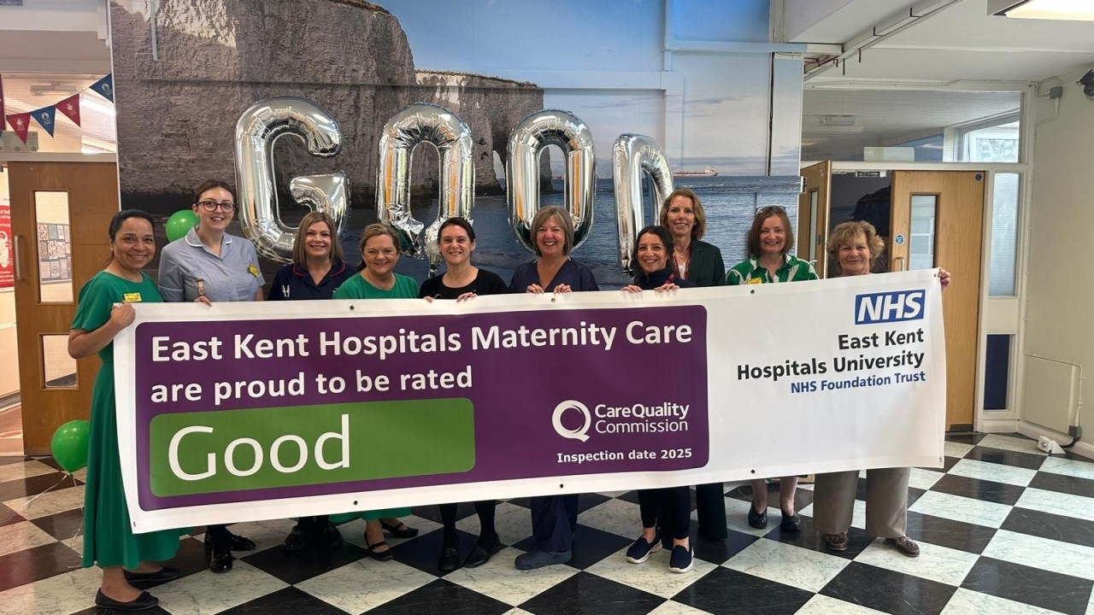
Figure 1: East Kent Maternity Services investigation 2022 maternity care NHS
(Source: Bennett-Weston et al., 2026)
In the East Kent case it is good to see how QA and QI are included. System level leadership, communication and poor culture despite governance and national quality standards preventing quality systems to protect mothers and babies. For this reason, preventable deaths and major injuries to babies went on for several years. This means in addition to compliance, the accountability, learning and continuous improvement circles need to be established within the healthcare organisations.

2. Main Part

2.1 Case Study Analysis: East Kent Maternity Services Incident
In the East Kent Maternity investigation, the investigation revealed that quality assurance systems are not enough to guarantee the safety of patients. While there were some policies and regulatory requirements in place within the NHS, unsafe practices continued for several years for a variety of reasons relating to leadership, governance and organisational culture (Bennett-Weston et al., 2025). This means that the quality assurance mechanisms were not effective, and compliance rather than learning from incidents was a focus.


Figure 2: East Kent Hospitals NHS Trust maternity ward healthcare staff
(Source: Oyugi et al., 2024)
In addition, there was a lack of a good learning culture among the organisational leaders, leading to reoccurring incidents with no meaningful service improvement. All the above issues are highlighted in the Ockenden Review which identified poor leadership, insufficient accountability and failure to learn from past maternity incidents in NHS organisations (Oyugi et al., 2024). The Care Quality Commission also found that governance, patient safety monitoring and regulatory compliance were all weaker and NHS England highlighted the need to improve safety culture, staff training and multidisciplinary working.

2.2 Application of Donabedian Model
The Donabedian Model is an evaluation of quality of healthcare that looks at three interrelated elements: Structure, Process, and Outcomes. It provides a framework to acknowledge the influence of organisational factors on patient safety and service quality. At East Kent Maternity Services structural weaknesses included lack of staff, lack of professional training, lack of leadership, lack of clinical resources and lack of governance systems (Felker et al., 2025). These limitations limited the number of workers, affected clinical supervision, and limited compliance with evidence-based standards of maternity. These process failures then became evident, such as delayed diagnosis, inadequate fetal monitoring, inadequate documentation, ineffective communication between multi-disciplinary teams and repeated inappropriate escalating of deterioration of the mother or foetus. Such weaknesses were evident in poor clinical judgements and poor patient-centred care.
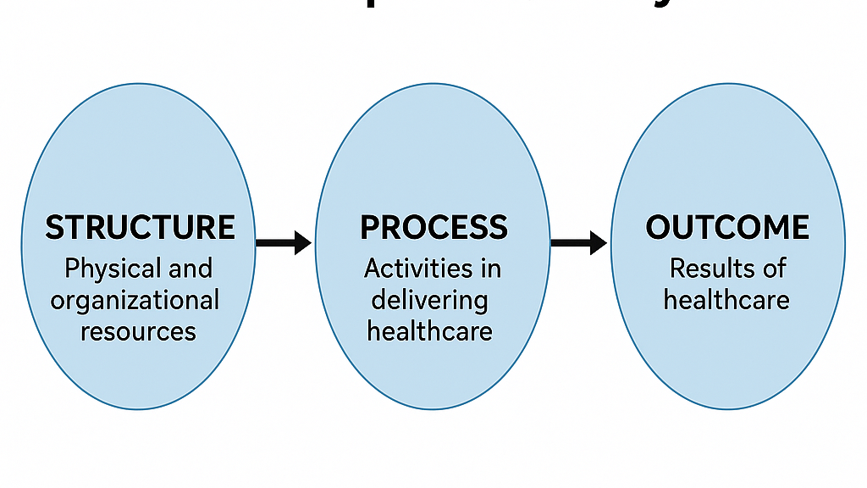
Figure 3: Donabedian Model Structure Process Outcome healthcare
(Source: Felker et al., 2025)

The negative consequences were unnecessary maternal mortality, neonatal mortality, unnecessary brain injury, psychological trauma for families, decreased patient satisfaction, and loss of trust in maternity services. The Donabedian Model is a great example of the relationship between the structure of an organisation, the nature of care offered and the outcomes of care and thus can be used to fully identify quality issues (Tompkins et al., 2025). The model, however, which did a systematic analysis of performance of the healthcare system, has relatively little focus on external factors such as organisational culture, behavioural factors and political pressures that also had a significant role in the failures of the East Kent maternity service. The Donabedian Model suggests that better organisation leads to better outcomes for patients, but there is not always a relationship between these in the complex healthcare system. Moreover, the model does not place adequate emphasis on the importance of organisational culture, the attitudes of employees, and the attitudes of management, all of which played an important part in the East Kent's failures. Therefore, the Donabedian framework can be used to measure the quality of healthcare, but it must be combined with other frameworks of organisational change to increase the quality of healthcare in the long term. In East Kent delayed clinical decision making and poor maternity outcomes were related to inadequate staffing, poor governance and ineffective leadership. The model assumes however that there is a linear relationship between structure, process and outcomes and concludes with a sparse focus on organisational culture and behaviours. Therefore, it needs to be backed with more wide-ranging organisational change frameworks.

2.3 Fishbone (Cause-and-Effect) Diagram Analysis
The Fishbone Diagram revealed that there were multiple factors that led to the failure of quality assurance in East Kent Maternity Services and that the consequences of this failure were the result of a chain of interrelated organisational weaknesses.
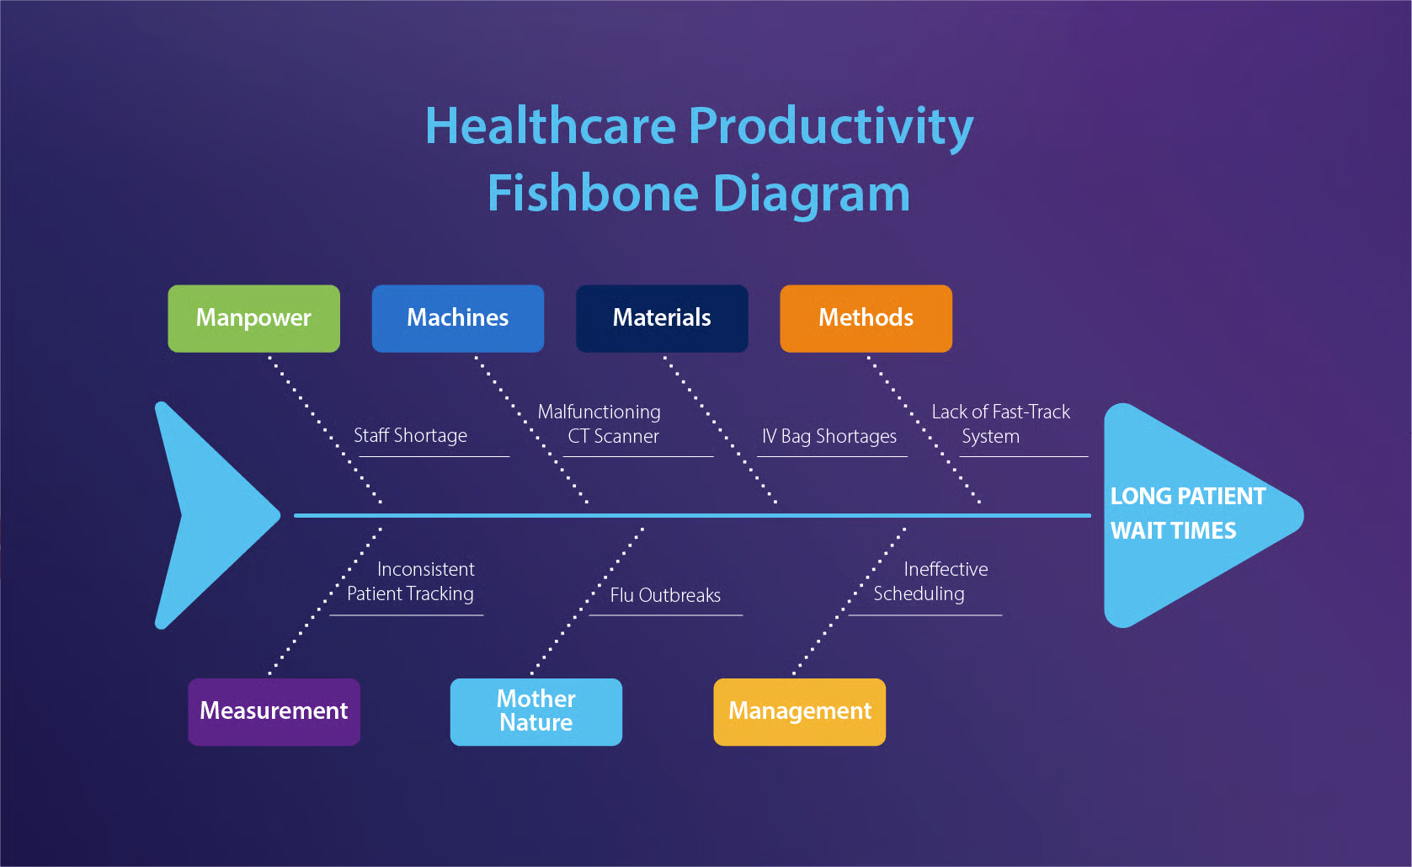
Figure 4: Fishbone diagram healthcare quality
(Source: Norman et al., 2022)

Category | Critical causes identified
People | Poor leadership, staff shortages, poor clinical training and limited supervision resulted in poor decision making for safety.
Methods | The lack of proper escalation procedures, risk assessment and inadequate governance meant timely interventions were not taking place (Lewis, 2025).
Environment | Poor workloads and pressures on the workforce, along with a culture that was ‘defensive’, were barriers to learning and reporting concerns.
Equipment | Fetal monitoring equipment was inadequate, and information technology systems were not efficient, resulting in delays in making accurate clinical assessments (Norman et al., 2022).
Management | Organisational learning was constrained by weak accountability, ineffective quality assurance systems and a lack of incident investigations.
Policies | Poor implementation of national maternity standards and not following NICE guidance led to inconsistent clinical practice (Saleh, 2024).
Table 1: Fishbone (Cause-and-Effect)
All these factors added to each other and led to unsafe care and repeated avoidable harms by midwifes. The Fishbone Diagram is useful because it enables identification of root causes of a problem in the health care system rather than finger pointing. However, the framework only provides an explanation of the possible causes and does not prioritise these nor look at causal relations over time. The Fishbone Diagram, however, does not reveal who the most important causes are that impact organisational performance. Furthermore, there is not always a clear explanation of the relationship between various causes. So, it should be used in conjunction with root cause analysis and continuous improvement approaches like PDSA. The Fishbone Diagram in turn list all the interconnections of service failures at the leadership, staffing, policies, management and clinical resources level. It does not show the significance of various causes, nor the time relationships between the causes themselves, however, and in particular does not show causation in detail. Similarly, by asking Why five times, the Five Whys technique discovers the root causes of failures, in an organisational setting. However, many times it can reduce potentially complex health issues with multiple contributing factors down to a single factor and can rely on investigator discretion.

2.4 Five Whys Analysis
The Five Whys technique is used to uncover the root causes of preventable maternal and neonatal harm, rather than just the fault of the health care worker, by repeatedly asking the question 'why'.
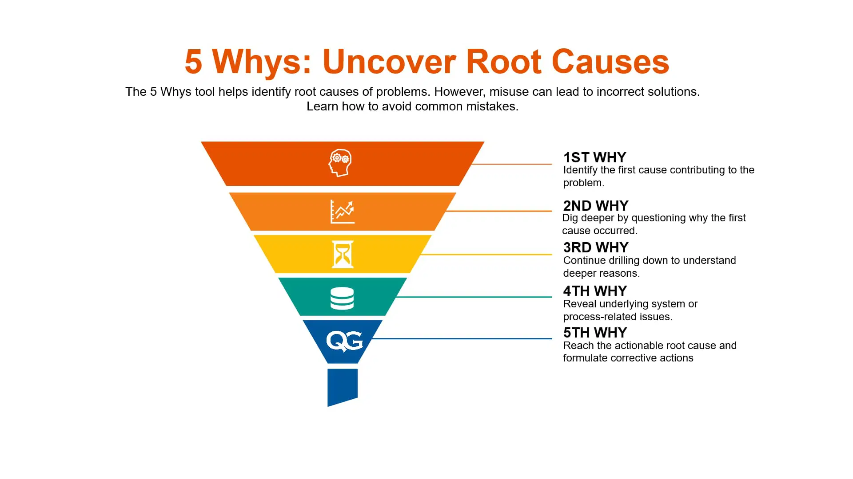
Figure 5: Five Whys root cause analysis
(Source: Cox et al., 2024)
Problem | Critical explanation
Avoidable maternal and neonatal harm | The investigation revealed preventable repeated deaths due to unsafe maternity care and serious birth injuries.
Why 1: Poor clinical decision-making | Clinicians did not identify maternal and foetal deterioration in time, and were not able to act appropriately (Dasgupta et al., 2026).
Why 2: Poor communication | Poor information sharing between health professionals caused delays and led to poor coordination of care.
Why 3: Inadequate multidisciplinary teamwork | Limited collaboration reduced coordinated decision-making and weakened continuity of care (Timothy et al., 2025).
Why 4: Weak leadership | Leaders failed to promote accountability, supervision, and effective governance across maternity services.
Why 5: Poor organisational culture and ineffective quality assurance systems | A defensive culture discouraged learning from incidents, allowing unsafe practices to continue without sustainable improvement initiatives repeatedly (Fleetwood-Smith, 2024).

Table 2: Five Whys Analysis
While the Five Why technique may be useful, it can cause issues because there can be numerous root causes at the same time in situations involving health issues. In addition, outcome is dependent on the experience of the analyst. Therefore, it must be used in connection to the wider organisational analysis to help develop better improvement strategies.

2.5 SWOT Analysis
SWOT analysis is a system to analyse and evaluate an organisation's strengths, weaknesses, opportunities and threats. It is, however, subjective, it does not take strategic questions into consideration and only performs a one-off organisational evaluation. Thus, it should be related to continuous quality improvement and the performance monitoring system.
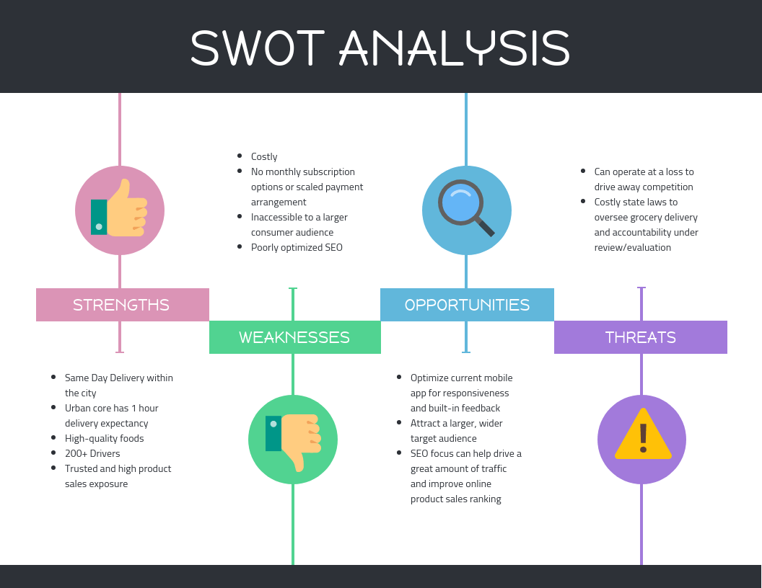
Figure 6: SWOT analysis healthcare organisation
(Source: O'Carroll et al., 2022)
Element | Critical Analysis
Strengths | Safe care was well supported by maternity strategies and good practice within the NHS, skilled healthcare practitioners and clinical guidance (O'Carroll et al., 2022). But they were not effective in their implementation due to weak leadership and governance, which reduced their positive impact.
Weaknesses | Unsafe clinical environments were caused by leadership failures, governance deficiencies, staff shortages, poor communication and a defensive organisational culture (Wilson et al., 2022). These weaknesses compounded, making it difficult to hold people to account and to learn from serious incidents within the organisation.
Opportunities | There are opportunities to improve quality assurance, multi-disciplinary working and evidence-based decision making across services through digital maternity records, improved staff education, improved governance, improved safety culture and national maternity reforms (Newman et al., 2026).
Threats | Sustainability is at risk from litigation, burnout, recruitment challenges, financial pressures and loss of public trust (Callander et al., 2026). These external pressures will continue to impact workforce resiliency, patient trust in the system and ongoing efforts to improve quality of care, unless organisational change is fully realised.

Table 3: SWOT Analysis

SWOT analysis, however, has its subjectivity as different stakeholders may see different strengths and weaknesses. Further, SWOT does not rank the items by significance, and this makes it more difficult to make strategic decisions. Besides that, SWOT is only a static assessment, not an explanation of the changes of the organizational factors through time. Hence, SWOT need to be supplemented with others quality improvement frameworks for evidence-based decision making.

2.6 Kurt Lewin's Three-Stage Change Model
This is a detailed model of sustainable improvement in East Kent Maternity Services using Kurt Lewin's Three Stage Change Model. Leaders need to identify issues with service, ensure that staff are aware of these issues and establish a commitment to change within the organisation in the Unfreeze stage (Callander et al., 2025). The Change stage should include training for staff, governance changes, better incident reporting processes and increased patient involvement to enhance the safety of maternity care. The Refreeze stage consists of ongoing audits, quality assurance procedures, performance monitoring and ongoing patient feedback and reinforcement of a positive safety culture. Easy and simple, but perhaps too simplistic for the modern health care organization, Lewin's model.
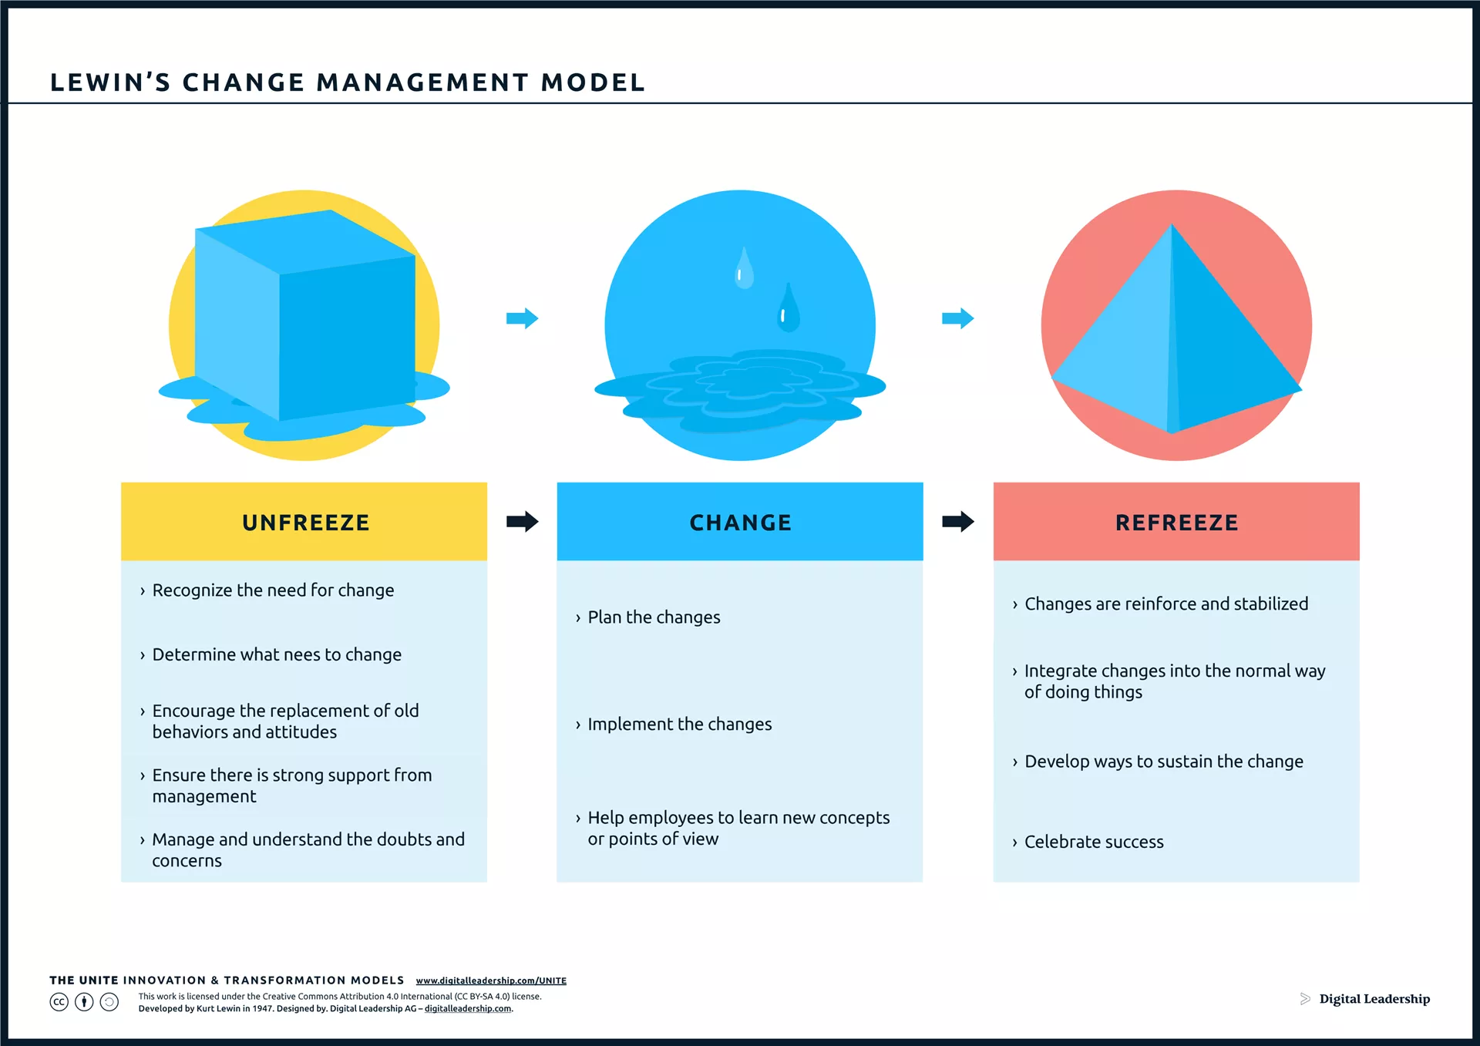
Figure 7: Lewin Change Model Unfreeze Change Refreeze healthcare (Source: Callander et al., 2025)

3. Recommendations

Recommendation 1: Strengthen Clinical Governance
East Kent Hospitals NHS Trust should improve its clinical governance, with a reorganisation of clinical governance committees to monitor the safety of the maternity service, review adverse events and ensure that national standards are met by a multidisciplinary committee (Lewis, 2025). Compliance with NICE guidance should be assessed in regular clinical audits, gaps in performance identified and monitoring of implementation of corrective actions should take place (Mills et al., 2022). Good governance will facilitate the improvement and transparency of maternity services, will help reduce avoidable harm, improve patient safety and will ensure continuous quality improvement.

Recommendation 2: Benchmarking Against High-Performing NHS Trusts
The focus is that East Kent Maternity Services use high performing NHS maternity services with excellent patient safety outcomes as a benchmark. Measures of performance should reflect NHS Resolution Maternity Incentive Scheme, guidance from the NICE and the Better Births strategy. Comparisons of clinical outcomes, governance arrangements, workforce practices and patient experience helps find interventions that have been successful and will be appropriate for local implementation (van der Scheer et al., 2025). Benchmarking enables East Kent Hospitals NHS Trust to learn from high-performing NHS maternity services regarding levels of clinical performance, patient safety indicators and governance, through identification of areas for improvement (van der Scheer et al., 2025). There are reasons to believe that benchmarking prompts organisations to follow best practice, minimize unnecessary variation and enhance patient care outcomes through lifelong learning.

Recommendation 3: Workforce Development
Enhancing patient safety and clinical competence of staff in the maternity service should be the priority for workforce development, across the services. Responsibility to keep all staff colleagues updated with national clinical practice guidelines, risk assessment and emergency obstetric care. Leadership development programs should improve senior professionals to make better decisions, take responsibility and become more efficient in the organization (Fula et al., 2025). Human factors training can improve team collaboration and communication, as well as situational awareness, in challenging clinical situations. Multi-disciplinary teams to be trained in obstetric emergencies regularly in simulated realistic scenarios. The recruitment and retention policy should work on dealing with staffing issues, the staff burden and continuity of safe quality maternity care.

Recommendation 4: Improve Patient Safety Culture
A strategic priority must be set for East Kent Maternity Services to improve patient safety culture to help avoid future incidents and regain public trust. Tackling the systemic issue of healthcare professionals' fear of blame or action against them for reports of safety concerns would be a significant improvement to the Freedom to Speak Up initiative. Risks are identified as early as possible and transparency created within organisations by building psychological safety (Kent et al., 2024). Good communication decreases misunderstandings, ensures that concerns are escalated at a suitable time and enhances the continuity of maternity care.
The organisation needs to promote a culture of learning, making incidents learning opportunities but not faulting a particular person. Feedback on learning, reflective practice and frequent incident reviews can improve organisation learning and minimise re-occurrence of failures. (Dixon et al., 2022). Together, they would create higher levels of trust, accountability, working in teams and continuous quality improvement, and help to make a maternity service safer and more responsive, just as the national expectations are for patients' safety and what is expected by regulators.

Recommendation 5: Digital Quality Monitoring
Digital quality monitoring needs to be broadened to enhance quality assurance, through evidence-based decision making across East Kent Maternity Services. A holistic electronic patient record system should be available to all health care providers instantly, enabling them to access the clinical information they need, and eliminating disjointed documentation systems and any associated errors in information. Multidisciplinary communication and safer decisions in emergency situations are also enabled through digital records (Whybrow et al., 2026). A second early-warning system should also be integrated into the maternity services system so that it can alert the team that something has changed, either in the mother's or the baby's condition, at an early stage. These systems can help to ensure patient safety by enabling clinicians to respond in a timely manner and prevent unnecessary adverse events (Haggar et al., 2024). Finally, real-time audits should be continuous, not regular tests to make sure NICE guidance, governance principles and organisational policies are being followed. Combined, these technologies help to reinforce governance, improve patient safety and facilitate efficient data-informed maternity care throughout the organisation.

Recommendation 6: PDSA Cycle Implementation
Plan-Do-Study-Act (PDSA) is a systematic process of continuous quality improvement in the maternity services. In the Plan stage there are incident reporting, audit, patient feedback and clinical performance indicators that reveal areas of maternity safety issues to enable organisations to develop targeted plans for action that will improve the safety of mothers and their babies (Lethbridge, 2024). The Do or implementation phase involves implementation of staff training, Governance changes, communication changes and of evidence based clinical interventions, all implemented on a controlled scale.
The model has, however, been criticized for its linear perspective of organisational change when in a healthcare improvement process, change is often continuous and dynamic. Also, the model does not seem to be so useful if it comes to resistance to change within large healthcare organizations. It should therefore be used in conjunction with other ongoing quality enhancement techniques such as the PDSA cycle.

Benchmarking
Benchmark Area | High-Performing NHS Trust Practice | Current East Kent Issue | Improvement for East Kent
Clinical Governance | Monthly governance reviews with multidisciplinary oversight (Norman, Stock and Harmer, 2022; Felker et al., 2025) | Weak governance and poor accountability (Norman, Stock and Harmer, 2022) | Introduce regular multidisciplinary governance meetings (Felker et al., 2025)
Patient Safety | Continuous incident reporting and learning culture (Felker et al., 2025) | Under-reporting and poor organisational learning (Timothy, Lloyd and Bradshaw, 2025) | Develop open reporting culture and learning systems (Felker et al., 2025)
Staff Training | Mandatory simulation training and competency assessments (Whybrow et al., 2026) | Inconsistent clinical training. (Lewis, 2025) | Regular competency-based maternity training. (Whybrow et al., 2026)
Digital Monitoring | Real-time electronic maternity dashboards. (van der Scheer et al., 2025) | Limited performance monitoring. (Felker et al., 2025) | Implement digital quality dashboards. (van der Scheer et al., 2025)
Patient Engagement | Family involvement in care planning and feedback. (Haggar et al., 2024) | Women not consistently listened to. (Tompkins et al., 2025) | Strengthen patient engagement programmes. (Haggar et al., 2024; Tompkins et al., 2025)
Quality Audits | Continuous benchmarking against NHS maternity standards. (Felker et al., 2025) | Irregular quality monitoring. (Norman, Stock and Harmer, 2022) | Quarterly benchmarking and external peer review. (Felker et al., 2025)

4. Conclusion
This report considers how the failures in quality control in East Kent Maternity Services occurred as a critique and shows the crucial importance of quality assurance to safeguard patient safety and enhance outcomes of care. To conclude its investigation, the Commission concluded that avoidable damage to mothers and babies was caused by poor leadership, weak governance, lack of communication, poor organisational culture and failure to implement quality assurance. Using the Donabedian Model led to findings of connections between organizational structures, clinical processes and adverse outcomes; the Fishbone Diagram, Five Whys, and SWOT analysis identified interconnected root causes and their need for comprehensive intervention.
The Change Model (Kurt Lewin) and the PDSA cycle provided a method for initiating service changes, and for sustaining service improvements through continuous testing and learning in the organisation. Overall, good governance, evidence-driven governance and workforce development are key in providing safer maternity services. The overall story of East Kent has been that there is no way to improve the quality sustainably by being compliant. Rather, it is crucial for delivering safer maternity services to have effective leadership, organisational learning, evidence-based practice and continuous monitoring.

References
- Bennett-Weston, A., Ward, A., Burnett, D., Hogg, J., Knight, R. and Howick, J. (2026) ‘Complex intervention to improve empathy within maternity services: a mixed methods feasibility study with pilot evaluation’, BMJ Open Quality, 15(2), p. e004013. Available at: https://bmjopenquality.bmj.com/content/15/2/e004013
- Bennett-Weston, A., Ward, A., Burnett, D., Hogg, J., Knight, R. and Howick, J. (2025) A complex intervention to introduce a culture of empathy within maternity services: Addressing individual, team, and system-level factors. SSRN Preprint. Available at: https://papers.ssrn.com/sol3/papers.cfm?abstract_id=5185426
- Callander, E.J., Enticott, J., Mol, B.W., Thangaratinam, S., Gamble, J., Robson, S. and Teede, H. (2026) ‘Maternal and Neonatal Outcomes and Health System Costs in Standard Public Maternity Care Compared to Private Obstetric‐Led Care: A Population‐Level Matched Cohort Study’, BJOG: An International Journal of Obstetrics & Gynaecology, 133(1), pp. 72–82. Available at: https://obgyn.onlinelibrary.wiley.com/doi/abs/10.1111/1471-0528.18286
- Callander, E.J., Enticott, J., Mol, B.W., Thangaratinam, S., Gamble, J., Robson, S. and Teede, H. (2025) ‘The principle of universality and value-based maternity care: a population-level matched study of costs and outcomes for private obstetric and public models of care’, medRxiv [Preprint]. Available at: https://www.medrxiv.org/content/10.1101/2025.03.04.25323379.abstract
- Cox, A., Ip, A., Watkin, S., Matuska, G., Bunford, S., Gallagher, A. and Taylor, C. (2024) ‘Implementing and evaluating resources to support good maternity care for parents with learning disabilities: A qualitative feasibility study in England’, Midwifery, 133, p. 104001. Available at: https://www.sciencedirect.com/science/article/pii/S0266613824000858
- Dasgupta, T., Rowell, L., Boulding, H., Easter, A., Horgan, G., Mistry, H.D., Begum, Y., Peter, M., Sutedja, T., Van Citters, A. and Nelson, E.C. (2026) ‘Experiences of seeking and receiving maternity care during a health-system shock: a qualitative study with women and partners in the UK with a focus on marginalised groups’, BMJ Public Health, 4(1), p. e004303. Available at: https://bmjpublichealth.bmj.com/content/4/1/e004303
- Dixon, P.H., Levine, A.P., Cebola, I., Chan, M.M., Amin, A.S., Aich, A., Mozere, M., Maude, H., Mitchell, A.L. and Zhang, J. (2022) ‘GWAS meta-analysis of intrahepatic cholestasis of pregnancy implicates multiple hepatic genes and regulatory elements’, Nature Communications, 13(1), p. 4840. Available at: https://www.nature.com/articles/s41467-022-29931-z
- Felker, A., Patel, R., Kotnis, R., Kenyon, S. and Knight, M. (2025) Saving Lives, Improving Mothers’ Care: Lessons learned to inform maternity care from the UK and Ireland Confidential Enquiries into Maternal Deaths and Morbidity 2021–23. Oxford: National Perinatal Epidemiology Unit, University of Oxford. Available at: https://ora.ox.ac.uk/objects/uuid:5d6c56bc-17ee-49d8-8702-8f235102479b/files/s3197xp79p
- Fleetwood-Smith, R. (2024) ‘Sensing maternity spaces: using creative approaches to explore sensory experiences within a maternity department’, Design for Health, 8(3), pp. 367–389. Available at: https://www.tandfonline.com/doi/abs/10.1080/24735132.2024.2433840
- Fula, F.M., Ngbolua, J.P.K.T.N., Amuli, J.P.J. and Mukandu, B.L.B. (2025) ‘Use of maternity services by adolescents in the Bandundu Urban-Rural Health Zone in the context of free care: Lived experiences, challenges, and perspectives of pregnant adolescents and adolescent mothers’, Orapuh Journal, 6(4), p. e1231. Available at: https://www.orapuh.org/ojs/index.php/orapj/article/view/e1231
- Haggar, T., Boulding, H., Pow, R., Dasgupta, T., Silverio, S.A., Nelson, E.C., Van Citters, A., Mistry, H., von Dadelszen, P. and Magee, L. (2024) Advancing co-production in local maternity services. London: King’s College London Policy Institute. Available at: https://www.kcl.ac.uk/policy-institute/assets/resilient-policy-lab-report.pdf
- Kent, L., McGirr, M. and Eastwood, K.A. (2024) ‘Global trends in prevalence of maternal overweight and obesity: a systematic review and meta-analysis of routinely collected data retrospective cohorts’, International Journal of Population Data Science, 9(2), p. 2401. Available at: https://pmc.ncbi.nlm.nih.gov/articles/PMC12045326/
- Lethbridge, J. (2024) Public values and the search for ‘informed choice’ in maternity services during the period 1991–2022 in England. University of Greenwich. Available at: https://gala.gre.ac.uk/id/eprint/45255/
- Lewis, M. (2025) ‘Midwifery leadership in a changing world—Why Is This So Challenging? A Reflective Commentary’, Healthcare, 13(19), p. 2473. Available at: https://www.mdpi.com/2227-9032/13/19/2473
- Lewis, M. (2025) Midwifery Leadership in a changing world-Why is this so challenging. A narrative review. Preprints. Available at: https://www.preprints.org/frontend/manuscript/44755d48a32e814ccfb82a37478adfb2/download_pub
- Mills, T.A., Roberts, S.A., Camacho, E., Heazell, A.E., Massey, R.N., Melvin, C., Newport, R., Smith, D.M., Storey, C.O., Taylor, W. and Lavender, T. (2022) ‘Better maternity care pathways in pregnancies after stillbirth or neonatal death: a feasibility study’, BMC Pregnancy and Childbirth, 22(1), p. 634. Available at: https://link.springer.com/article/10.1186/s12884-022-04925-3
- Newman, T., Dennis, R., Fitzpatrick, K., Heazell, A.E., Kenyon, S., Sanders, J. and Rowe, R. (2026) ‘Numbers and proportions of women giving birth in UK midwifery units since 2016: a secondary analysis of data reported to the UK Midwifery Study System (UKMidSS)’, Midwifery, 148, p. 104776. Available at: https://www.sciencedirect.com/science/article/pii/S026661382600080X
- Norman, J.E., Stock, S.J. and Harmer, C. (2022) ‘After the Ockenden review: a chance to reset maternal and perinatal care in the UK?’, The Lancet, 399(10344), pp. 2331–2333. Available at: https://www.thelancet.com/journals/lancet/article/PIIS0140-6736(22)00823-6/abstract
- O’Carroll, J.E., Zucco, L., Warwick, E., Arbane, G., Moonesinghe, R., El-Boghdadly, K., Guo, N., Carvalho, B., Sultan, P. and ObsQoR Collaborators (2022) ‘Obstetric services in the UK during the COVID-19 pandemic: A national survey’, Anaesthesia Critical Care & Pain Medicine, 41(5), p. 101137. Available at: https://www.sciencedirect.com/science/article/pii/S2352556822001187
- Oyugi, B., Audi-Poquillon, Z., Kendall, S. and Peckham, S. (2024) ‘Examining the quality of care across the continuum of maternal care (antenatal, perinatal and postnatal care) under the expanded free maternity policy (Linda Mama Policy) in Kenya: A mixed-methods study’, BMJ Open, 14(5), p. e082011. Available at: https://bmjopen.bmj.com/content/14/5/e082011.abstract
- Saleh, M. (2024) ‘Safer National Maternity Care: Prospects and Challenges’, Journal of Medical and Clinical Case Reports, 1, p. 12. Available at: https://www.medvixpublications.org/get/1-JMCCR2024091591A1%20Galley%20Proof-1733322886.pdf
- Timothy, K., Lloyd, B. and Bradshaw, C. (2025) ‘Healthcare professionals’ perceptions of risk management on pregnancy and childbirth: An integrative review’, Midwifery, 145, p. 104376. Available at: https://www.sciencedirect.com/science/article/pii/S0266613825000956
- Tompkins, L., Hodge, G., Shawe, J., Burrows, L., Bogaerts, A. and Pearce, S. (2025) ‘A scoping review of personalised UK maternity care: where are we now?’, British Journal of Midwifery, 33(7), pp. 398–407. Available at: https://www.magonlinelibrary.com/doi/abs/10.12968/bjom.2025.0024
- van der Scheer, J.W., Blott, M., Dixon-Woods, M., Olsson, A., Moxey, J., Kelly, S., Woodward, M., Maistrello, G., Randall, W., Blackwell, S. and Hughes, C. (2025) ‘Detecting and responding to deterioration of a baby during labour: surveys of maternity professionals to inform co-design and implementation of a new standardised approach’, BMJ Open, 15(3), p. e084578. Available at: https://bmjopen.bmj.com/content/15/3/e084578.abstract
- Whybrow, R., Robert, G., Dagustun, J., Ahuja, S., Brown, H., Bassett, S., Parr, M., Adeyinka, T., Glenday, S., Cross, S. and Sharma, E. (2026) ‘Improving maternity and neonatal care in England: protocol for a formative evaluation of the implementation of the core competency framework to enhance multi-professional practice’, BMC Pregnancy and Childbirth, 26, Article 885. Available at: https://link.springer.com/article/10.1186/s12884-026-08855-2
- Wilson, A.N., Melepia, P., Suruka, R., Hezeri, P., Kabiu, D., Babona, D., Wapi, P., Spotswood, N., Bohren, M.A., Vogel, J.P. and Kelly-Hanku, A. (2022) ‘Quality newborn care in East New Britain, Papua New Guinea: measuring early newborn care practices and identifying opportunities for improvement’, BMC Pregnancy and Childbirth, 22(1), p. 462. Available at: https://link.springer.com/article/10.1186/s12884-022-04735-7

