Database Management Systems

Henry COBBOLD
P149234
Database Management Systems – M5X01130
Dr. Kemi Ademoye

Table of Contents:
1. Abstract 1
2. Performance Tuning 1
2.1 Database Query Requirements 1
2.2 Analysing Query Transactions 2
3. Identifying Additional Secondary Indexes 5
4. Distributed Database 7
3.1 Suitable Schema Fragmentation 7
3.2 Reconstruction of Global Relations Using Fragments 12
5. Conclusion 13
6. References and Cited Work(s) 13

Abstract

This paper explores the design of distributed database systems in the context of ‘Book & Ride’, a local taxi company based in South Wales. To aid their expanding operations the use of a server-based database systems is key and with the use of performance enhancements, is a necessity to provide a suitable base for increasing data storage and interrogation.
Performance enhancements discussed include appropriate querying of the system, the use of transactions and additional de-centralisation on both a region and city level.
It is assumed for the purposes of this scenario ‘Book&Ride’ are running a homogenous cross-site DBMS architecture [1],[2] and the underlying integral operation of the database management system is consistent across all sites.

Performance Tuning

2.1 Database Query Requirements

Concurrency can be controlled by interleaved query execution and the handling of queries across the database simultaneously [2],[3]. Given the distributed nature of the database scenario for ‘Book&Ride’ there are an array of queries that could be performed across the system [4] at different physical locations. Swansea for example specialise in the storage and processing of certain aspects of database records.
The queries shown below are designed to cover several queries integral for the taxi business. Fig. 1-4 show queries that are likely to be executed at City offices and at the Swansea office where finance and HR will require queries such as those shown in Fig. 3 and 4.

Figure 1: Aggregated field to sum Driver Mileage

Figure 2: Finding inter-city bookings

Figure 3: Cancelled bookings

Figure 4: Bookings with no payment data

2.2 Analysing Query Transactions

‘Book&Ride’ enforce a rule whereby the shift hours worked for each driver must not exceed 40 per week with all drivers working to a 3-week cyclical roster. To impose this rule a transaction checks ‘INSERT INTO’ statements for ‘DriverSchedule’ to not tip the driver over the allotted hours [5].
As can be seen in ‘Driver’ ‘D00001’, is considerably under his hours, Fig. 5. below shows the number of entries currently in his week.

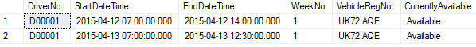
Figure 5: 'D00001' week 1 schedule

To sum the total hours partial execution of the transaction (see below) produces the single column illustrating the ‘SUM’ statement. The use of no column name is due to no alias fieldname, this is only an aspect of the transaction statement.
It is therefore possible to allocate more driver hours to ‘D00001’ for this week. Fig. 7. totals up the hours as 12.

Figure 6: 'SUM' totalling the 'DATEDIFF' function


Figure 7: 12hrs currently allocated to 'D00001' this week

In contrast, Driver ‘D00003’ is near his limit in terms of hours and in-validates the 40hr per week rule. The ‘INSERT INTO’ query is subsequently rolled-back to abandon the statement [2]. The fore-mentioned statements have been executed again. There are 5 entries with hours totalling 39, another long shift is added (see below) which tips the hours over the threshold.

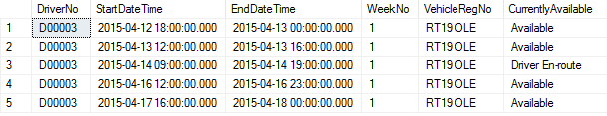
Figure 8: 'D00003' has 5 entries

Figure 9: Executing the 'SUM'

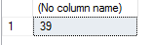
Figure 10: Only 1hr under maximum hours

Running the transaction to allocate for than 5 hours to ‘D00003’ will throw an error and the schedule will not be updated. His hours must be covered by another driver with the necessary scope for more work during week 1.
Shown below is the generic transaction format using the ‘IF’ as the validation check. The statement used above to create the calculated field forms the Condition field.

Figure 11: Transaction format

Figure 12: Check Schedule input with Transaction

As can be seen above, the transaction opens up with an ‘INSERT INTO’ [2],[6] statement to append the following record to the ‘DriverSchedule’ table. The subsequent ‘IF’ contains a ‘SUM’ [7], which calculates the ‘DATE DIFFERENCE’ (‘DATEDIFF’) [8] between the shift start time and finish time for that driver number and week number, hence checking his weekly schedule [9]. Should this total less than 40 hours the transaction, named ‘AllocateDriverSchedule’, is committed to the database table correctly.
However, if a driver is near the limit, and a new shift tips him over this threshold the ‘IF’ fails and the transaction is rolled-back, its execution is aborted [10]. The desired changes are not fulfilled on the destination table, as can be seen below when attempting to execute the ‘INSERT INTO’ statement above.

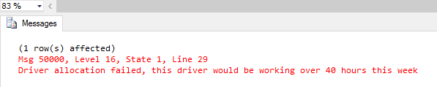
Figure 13: Resulting error message for > 40hrs

However, given the potential need to cover for shortfalls a shift could be less than one hour, allowing the driver to work a job-by-job basis. As seen below the ‘INSERT INTO’ has now been edited, the changes can therefore be committed to the database as it passes the business rule validation in situ.

Figure 14: Revised hours being input

The altered statement, passing validation is now appended to table ‘DriverSchedule’.

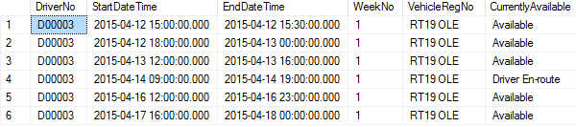
Figure 15: Committed changes on 'DriverSchedule'

Identifying Additional Secondary Indexes

To enhance the performance attributes of the database the use of table Indexes is advised [2],[13]. They are designed to provide greater performance in instances of multiple column aggregation [11], despite the limited number of tables for which this would be suitable in the ‘Book&Ride’ scenario.
The three small definition tables (‘Region’, ‘City’, ‘Office’) can be indexed simply by the primary key, as this field is the most likely to be used in queries and transactions [11]. This can be seen below:

Figure 16: Indexing small tables by PK
The indexing of schema tables depends on the types of query being ran on the system. The SQL illustrated above represents primary Indexing on several table’s primary key field.
The ‘Driver’ table can be subjected to cluster indexing, but with ‘DriverID’ unlikely to be used as the query field, as only the single result would be returned, indexing ‘City’ would be more beneficial. If an office managed an entire region, and not just a city, the indexing techniques used could be altered appropriately.

Figure 17: 'Driver' indexed by 'City' field

‘Member’ can be handled as per ‘Driver’, however it is more likely a database user will wish to view their ‘AddressRegion’ as this will be used in more queries than the PK field. Numerous tables use an ‘Address’ field and indexes placed on this field would see benefits in ‘JOIN’ queries ran.

Figure 18: Indexing the Members by their PostCode

‘Booking’ table presents several options to the database designer. Using a combination of ‘PickupCityID’ and ‘DestinationCityID’ would allow the origin and destination of journeys to be more handled quicker. Alternatively, indexing options exist on fields such as ‘AssignedDriverNo’ or ‘BookingDateTime’ where their retrieval could be in cross-table queries and transactions.

Figure 19: Options for indexing 'Booking' table

Although the use of indexing in streamlining cross-table queries the performance can be seen in a single table where the ability to read data both regularly and rapidly is paramount. ‘DriverSchedule’ could be subject to clustered indexing on the ‘CurrentlyAvailable’ field as a city is likely to often run queries incorporating this field to view the status of their drivers.

Figure 20: Clustering multiple columns

Indexes can be created and dropped as operational database requirements deem fit, so the ability to alter indexes is advantageous where future changes could occur, an important factor for ‘Book&Ride’.

Distributed Database

With the expansion of Book & Ride beyond the reach of South Wales the scope of the database becomes less compact. Server based databases are designed to de-centralise the system and increase performance of the database at each physical location of the business to streamline the processing of interactions undertaken at the location [4]. There are a range of benefits that fragmentation provides including speed, security and these factors on system rigidity and durability [14], [1].
Fragmentation speeds up data access as the storage of information is as closely aligned to the physical location where it is used as possible [15]. This configuration will see each location handle its own aspects of the database, but to keep the database ‘distributional’ each site has the connection to the globally accessible database structure [15].
For Book & Ride staff the ‘Distributed Database Management System’ (DDBMS) [14],[1],[2] the distributed nature of the database is not obvious to anyone accessing its different elements, some of which will be fragmented and stored in the database topology at another site [1],[4],[15].
The use of a single DBMS system could be fragmented as outlined in Section 3.1 and 3.2.

3.1 Suitable Schema Fragmentation

The centralisation of several smaller tables is advised due to their equal requirements at each physical location.
Several tables are small and contain information that is likely to be equally used throughout the entire ‘Book&Ride’ system. The ‘Region’, ‘City’ and ‘Office’ tables have equal weighting and will likely be infrequently accessed from each location, when this is the case it is likely to be a read operation executed and not the writing of new information performed on other tables. To reflect the operational use of these tables and their limited size in the database model it has been decided to centralise these tables and undertake no fragmentation [1],[15].
Fig. 21-23. Shows these tables and the generic, widely required information regarding operations needed across ‘Book&Ride’.

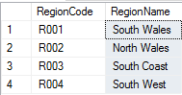
Fig. 21: 'Region' table

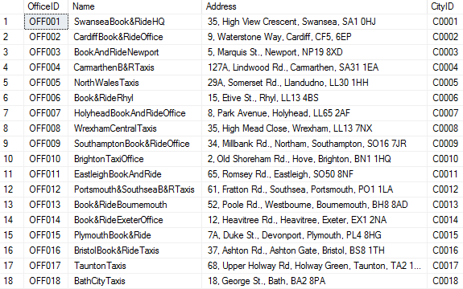
Fig. 22: Office table can be left un-fragmented

If the database had been constructed in such a way that each office controlled all cities within the given region performing horizontal fragmentation by region would show its cities. As is currently the design this would not be appropriate.

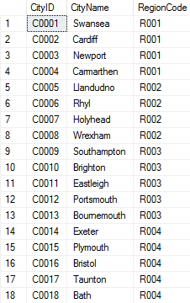
Fig. 23: The 'City' table is small and is un-suited to fragmentation

Fragmentation can be performed on the ‘Drivers’ table to enhance the way each ‘City’ views drivers that live in the city. It can be assumed that each office will want to the see the drivers that live within the confines the city boundary on a regular basis, or to view a driver’s ‘home’ city when they enter a new city. Horizontal fragmentation can be performed which sees each ‘City’ store the information relevant to it at its own location. This provides performance and execution benefits whilst (as outlined in section 3.) whilst still providing the list of drivers that live in all-of the other cities.
‘Driver’ table is split horizontally by the field ‘OfficeID’ (some fields have been omitted from ‘Driver’ for clarity purposes) on the field ‘CityID’ with the ‘WHERE’ clause being the unique identifier in the ‘OfficeID’ field [11],[12]. Fig. 24. shows how all drivers that live in Swansea can be fragmented to the Swansea city office.
Data currently entered in the database sees just the single drivers based in both Cardiff and Newport which will see D00005 allocated to the Cardiff City Office and D00006 to the Newport Office.

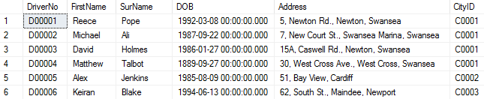
Fig. 24: South Wales’ driver’s belonging to their ‘base’ city

There are 18 rows currently in the ‘Driver’ table, and these can be see listed below (intermediate rows are omitted for clarity purposes)

D₁: σ _{OfficeID = ‘OFF001’} (Driver)
D₂: σ _{OfficeID = ‘OFF002’} (Driver)
D₃: σ _{OfficeID = ‘OFF003’} (Driver)
D₄: σ _{OfficeID = ‘OFF004’} (Driver)
D₅: σ _{OfficeID = ‘OFF005’} (Driver)
…
D₁₄: σ _{OfficeID = ‘OFF014’} (Driver)
D₁₅: σ _{OfficeID = ‘OFF015’} (Driver)
D₁₆: σ _{OfficeID = ‘OFF016’} (Driver)
D₁₇: σ _{OfficeID = ‘OFF017’} (Driver)
D₁₈: σ _{OfficeID = ‘OFF018’} (Driver)

‘Member’ table fragmentation. To cater for the business rule that the HR and Finance is processed at Swansea the Member table can be broken up using either vertical or mixed fragmentation as desired [14]. Because of the information handling at Swansea, the HR and payment information for the customers will also need viewing. Additionally, the HR aspect of this vertical split of ‘Members’ could be fragmented horizontally so the HR details are also stored at the location of the ‘Region’ too [14].
The financial split of this table is likely to be viewed on a regular basis by the finance dept. based in Swansea. Fragmentation does not mean however that this information cannot be viewed elsewhere within the scope of the DDBMS [14].
Firstly, perform a vertical [14] split of the ‘Members’ table, as seen in Fig. 25 and Fig. 26.

M₁ Π MemberNo, CardNo, CardCVV, CardExpiryDate(Member)
M₂ Π MemberNo, FirstName, SurName, DOB, AddressRegionCode, PhoneNo, EmailAddress(Member)

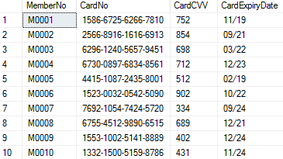
Figure 25: Fragment M1 from Member table

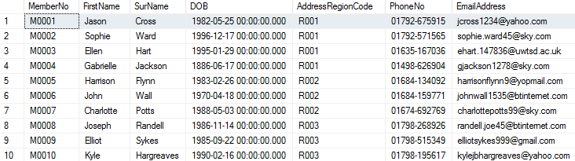
Figure 26: M2 comprised of HR records from the Member table

M₂ can then be split to view drivers in their own address region as shown below, this will then be stored at all the cities belonging to that region.

M₂₁ Π _{AddressRegionCode = ‘R001’} (M₂)
M₂₂ Π _{AddressRegionCode = ‘R002’} (M₂)
M₂₃ Π _{AddressRegionCode = ‘R003’} (M₂)
M₂₄ Π _{AddressRegionCode = ‘R004’} (M₂)

The ‘Booking’ table can be fragmented for efficiency by taking 3 vertical splits and then horizontally splitting 1 of these partitions. ‘Booking’ contains driver payment details and so can be vertically separated as the Finance department will want to see financial information on a journey-by-journey basis. The HR department, also based in Swansea, will want to see the HR aspect of booking and the fields used are shown in fragment B₂. However, HR are likely to want to split the HR partition again for the driver and the client and so to reflect this ‘Member’ information is allocated to fragment B₃.

B₁ Π BookingNo, FareAmount, CancellationDateTime, CancellationCharge, PaymentDetails (Booking)
B₂ Π BookingNo, BookingDateTime, PickupDateTime, JourneyMileage, CarSize, DeliveredDateTime, AssignedDriverNo (Booking)
B₃ Π BookingNo, MemberNo, PickupAddress, PickupCityID, PickupPostCode, DestinationAddress, DesinationCityID, DesinationPostCode (Booking)

Each region can then store the bookings originating from that City, achieved by horizontally splitting B₃ by ‘PickupCityID’. Performing this split will keep simplified records, given the reduced table complexity, for each booking at their own location. All of the table will still be viewable at this location, but still streamlines the read process.
Given the precise use of fragmentation to achieve performance boosts the ‘Book&Ride’ company distributed database could be categorised as deploying a selective replication model. Some tables have been fragmented appropriately and those unprocessed have been clearly categorised as replicated or centrally located.

3.2 Reconstruction of Global Relations Using Fragments

The ‘Region’, ‘Office’, and ‘City’ table have not been fragmented and will not require rebuilding
As outlined in the company scenario the processing of financial and HR information is carried out at the Swansea branch for both ‘Drivers’ and ‘Members’. As such, performance enhancements can be made to improve the viewing and processing. The table ‘Driver’ is only subject to a horizontal fragmentation and can be rebuilt using the following UNION statement for each tuple [11]:

Original Driver Relation = (D₁ υ D₂ υ D₃ υ D₄ υ D₅ υ D₆ υ D₇ υ D₈ υ D₉ υ D₁₀ υ D₁₁ υ D₁₂ υ D₁₃ υ D₁₄ υ D₁₅ υ D₁₆ υ D₁₇ υ D₁₈)

The success of fragmented tables can be categorised against the following parameters and by effectively meeting these regulations the tables can be reconstructed correctly.
- ‘Completeness’ implies the original table structure must be rebuilt to the same state from which it was decomposed [14].
- ‘Reconstruction’ suggests that the data querying attributes from the given fragment can still be seen and performed following re-building [14].
- ‘Disjointness’ says that elements must not be repeated across fragments of a table. The single exception being that of the ‘Primary Key’ [11] field for a simple vertical fragment [14].
The reconstruction of the ‘Driver’ table above is valid as the table is complete once the reconstruction is executed, meeting ‘Completeness’ regulations. The statement meets the ‘Reconstruction’ guidelines as the queries performed on the table, such as viewing ‘CarSize’ or ‘OfficeID’ result, can be performed suitably when the table is reassembled. All the fields, due to the horizontal split performed, are naturally lossless and so meet disjoint guidelines.
The ‘Member’ table has been exposed to mixed fragmentation. As outlined in section 3.1 M₂ has been horizontally split. The statement below JOINS vertically fragmented sub-table M₁ against the ‘UNION’ of the second half of the vertical split M₂.

Original Member Relation: M1 ⋈ (M₂₁ υ M₂₂ υ M₂₃ υ M₂₄)

Successfully constructing the table relation shows the fragmentation techniques used on this table meet the key aspects of fragmentation. All fields in the table appear in either M₁ or M₂, meaning tables elements will be present following the vertical reconstruction of ‘Member’. The horizontal split on M₂ returns all ‘Members’ for each of the four regions.

Conclusion

For a local business looking to expand its scope the use of a ‘Distributed Database System’ can enhance both the definition and manipulation of their records. The de-centralisation of the system can offer performance enhancements across the system and make the retrieval of data more efficient. Whilst considering the enhancements the database development caters for expansion into new regions.

References and Cited Work(s)

[1] C. S. Kumar, J. Seetha, and S. R. Vinotha, “Security Implications of Distributed Database Management System Models - University of Wales Trinity Saint David,” Int. J. Soft Comput. Softw. Eng., vol. 2, no. 11, 2012.
[2] C. M. Ricardo and S. D. Urban, Databases Illuminated, 3rd ed. Burlington, MA: Jones & Bartlett Learning, 2017.
[3] J. L. Harrington, SQL Clearly Explained, 3rd ed. Burlington, MA: Morgan Kaufmann, 2010.
[4] P. Helland, “The Singular Success of SQL,” Commun. ACM, vol. 59, no. 8, pp. 38–41, 2016.
[5] Microsoft, “BEGIN TRANSACTION : MSDN,” webpage, 2018. [Online]. Available: https://msdn.microsoft.com/en-us/library/ms188929(v=sql.100).aspx. [Accessed: 18-Mar-2018].
[6] Microsoft, “INSERT : MSDN,” webpage, 2018. [Online]. Available: https://msdn.microsoft.com/en-us/library/ms174335(v=sql.100).aspx. [Accessed: 18-Mar-2018].
[7] Microsoft, “SUM : MSDN,” webpage, 2018. [Online]. Available: https://msdn.microsoft.com/en-us/library/ms187810(v=sql.90).aspx. [Accessed: 18-Mar-2018].
[8] Microsoft, “DATEDIFF : MSDN,” webpage, 2018. [Online]. Available: https://msdn.microsoft.com/pl-pl/library/ms189794(v=sql.110).aspx. [Accessed: 18-Mar-2018].
[9] M. J. Hernandez, Database Design for Mere Mortals: A Hands-On Guide to Relational Database Design, 3rd ed. Addison-Wesley, 2013.
[10] Microsoft, “ROLLBACK TRANSACTION : MSDN,” webpage, 2018. [Online]. Available: https://msdn.microsoft.com/pl-pl/library/ms181299(v=sql.110).aspx. [Accessed: 18-Mar-2018].
[11] T. Connolly and C. Begg, Database Systems - A Practical Approach to Design, Implementation and Management, 6th ed. Harlow, Essex: Pearson Education, 2015.
[12] N. Mercioiu and V. Vladucu, “Improving SQL Server Performance,” Inf. Econ., vol. 14, no. 2, pp. 55–60, 2010.
[13] Microsoft, “Reorganize and Rebuild Indexes : Microsoft Docs,” webpage, 2018. [Online]. Available: https://docs.microsoft.com/en-us/sql/relational-databases/indexes/reorganize-and-rebuild-indexes. [Accessed: 18-Mar-2018].
[14] L. Wiese, “Clustering-based fragmentation and data replication for flexible query answering in distributed databases,” J. Cloud Comput., vol. 3, no. 1, p. 18, Dec. 2014.
[15] C. S. Pan and M. L. Zymbler, “Encapsulation of Partitioned Parallelism into Open-Source Database Management Systems,” Program. Comput. Softw., vol. 41, no. 6, pp. 350–360, 2015.

