Student Name: Sadia Odud  Student ID: 2130037  Module Title: Foreign Languages & Cultural Awareness  Module Code: BMIH5003  Lecturer: Lisa Bassler  Date: 1st March 2024 | 
ASSIGNMENT 1: PORTFOLIO
(4 Components)

Component 1: Professional Reflection (500 words +/- 10%)

Weighting: 25%
[I recently assisted a French guest at a luxury hotel that serves foreign clients. The guest approached the front desk with a leaflet, appearing confused and in need of help. My French was inadequate, but I tried to say the lift had the information. However, the guest's growing uncertainty suggested a cultural misunderstanding, emphasising the need of good communication and cultural awareness in guest happiness (Christiansen, Branch and Karmowska, 2020). The leaflet turned out to be a hotel service guide, suggesting the passenger was looking for information on spa or dining possibilities. Since the leaflet didn't have an English translation and I couldn't speak French, the linguistic barrier became clear. I used hand signals and bad English to send the guest to the lift in hopes that he would understand that important information was there. However, the guest's developing displeasure with my approach showed the need for a more sophisticated understanding of cross-cultural communication. This incident illustrates the difficulties of language, communication, and expectations. His cultural heritage shows in his expectation of French knowledge. My failure to meet this expectation caused a language barrier and guest discomfort. It emphasises that cultural service requirements go beyond linguistic competency and demand a thorough awareness of the guest's culture to customise an experience (Hampden-Turner and Hampden-Turner, 2020). Recognising the issue's complexity, I must develop personally and professionally. This project began with the recognition that I needed to improve my language skills, especially in languages spoken by our various foreign guests. Language courses and applications will improve my communication and make conversations clearer. I also recognise the importance of cultural sensitivity training to better comprehend varied norms and expectations. Such programmes will provide me cultural intelligence to avoid mistakes and offence. This commitment recognises that guest satisfaction goes beyond physical amenities and includes culturally tailored service. I understand the limitations of traditional communication methods. I'm exploring alternate techniques in response. Visual aids, multilingual materials, and translation apps can help guests from different cultures understand information (Torres, Fu and Lehto, 2016). Adaptability improves communication and shows a commitment to inclusion and guest happiness (Torres, Fu and Lehto, 2016). Proactive cross-cultural awareness is crucial to my behavioural progress. It's crucial to understand our frequent guests' cultures, especially those from high-traffic areas. This information helps us anticipate and comprehend our various clientele's wants and expectations. Prevention can improve the guest experience and build a sense of connection and cultural resonance. The goal of adopting these skills and behaviours is to prevent cultural misunderstandings rather than just fix them (Armstrong et al., 2018). A comprehensive approach to hospitality that spans language and cultural barriers includes linguistic diversity, cultural sensitivity, improved communication, and cross-cultural knowledge. By doing so, I hope to create a warm and inclusive hotel where every visitor feels welcomed, understood, and cherished. This commitment goes beyond personal development to improve service in a globally diversified hospitality setting, matching with the concept of a high-end hotel serving foreign clients. I strive to prevent future cultural misunderstandings and create an environment where cultural diversity is acknowledged and weaved into great guest care via continual learning and adaptation.
References:
Armstrong, R.W., Mok, C., Go, F.M. and Chan, A. (2018). The importance of cross-cultural expectations in the measurement of service quality perceptions in the hotel industry. International Journal of Hospitality Management, [online] 16(2), pp.181–190. doi:https://doi.org/10.1016/S0278-4319(97)00004-2.
Christiansen, B., Branch, J.D. and Karmowska, J. (2020). Cultural Factors and Performance in 21st Century Businesses. [online] www.igi-global.com. IGI Global. Available at: https://www.igi-global.com/book/cultural-factors-performance-21st-century/244227 [Accessed 20 Feb. 2024].
Hampden-Turner, C. and Hampden-Turner, F.T., Charles (2020). Riding the Waves of Culture: Understanding Diversity in Global Business. [online] Google Books. John Murray Press. Available at: https://books.google.com.bd/books/about/Riding_the_Waves_of_Culture.html?id=9boLEAAAQBAJandredir_esc=y [Accessed 19 Feb. 2024].
Torres, E.N., Fu, X. and Lehto, X. (2016). Examining key drivers of customer delight in a hotel experience: A cross-cultural perspective. International Journal of Hospitality Management, 36, pp.255–262. doi:https://doi.org/10.1016/j.ijhm.2013.09.007.

Component 2: Presentation

Weighting: 25%

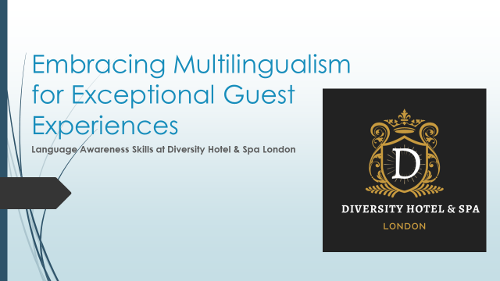
Multilingualism Benefits

Language Diversity
Diversity Hotel and Spa London's ethnic environment boosts guest pleasure through multilingualism (Zlatko and Maciej, 2019). Language Diversity is about interacting with
guests on a human level, not just communicating. Multilingualism honours our different clients and creates a more inclusive culture.
Enhanced Communication
Enhanced Communication goes beyond commerce (Žerajić, 2020). Staff who speak the guest's language make transactions feel warm and friendly. Positive communication makes guests feel at home.
Cultural Sensitivity
Additionally, cultural sensitivity is essential to excellent service. Language is crucial to understanding and appreciating diverse cultures (Manoharan and Singal, 2017). By paying attention to linguistic differences, the hotel team communicates well and demonstrates their dedication to a culturally aware and compassionate atmosphere for our guests.

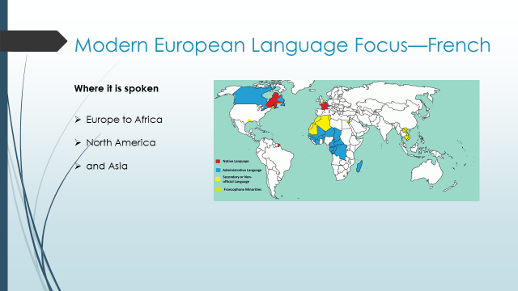
Modern European Language Focus—French

Where it's Spoken
French is a Romance language with a rich cultural heritage beyond Europe. Spoken Where: A map of French-speaking countries shows its global reach, from Europe to Africa, North America, and Asia. French is practical as a widely spoken language, especially for Diversity Hotel and Spa London's multinational clientele.

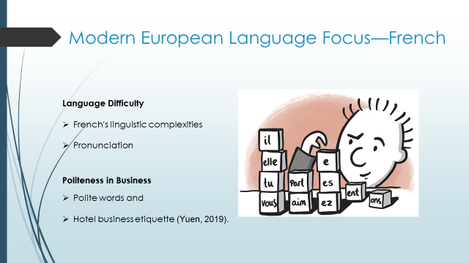
Language Difficulty
Our staff's French language acquisition relies on understanding its language Difficulty. While each learner's experience is different, understanding French's linguistic complexities and problems will help language training efforts.
Politeness in Business
Business politeness is essential for guest satisfaction (Yuen, 2019). Providing examples of polite words and explaining hotel business etiquette helps our personnel create a friendly and respectful atmosphere, improving the visitor experience.

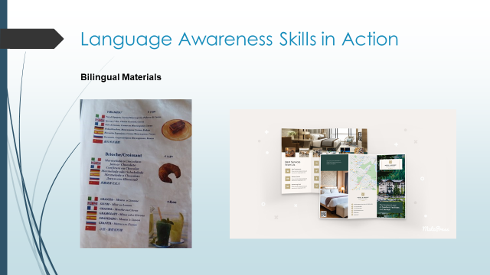
Language Awareness Skills in Action
Real-world Examples at Diversity Hotel and Spa London:
Bilingual Materials
The act on language awareness at Diversity Hotel and Spa London. Brochures, menus, and signs in many languages show our dedication. A French-speaking guest could easily navigate our hotel with language-specific brochures.

Overview of Ongoing Staff Language Training Programs
An Overview of Ongoing Staff Language Training Programmes** shows our proactiveness. Staff taking French language classes demonstrate our dedication to building a staff that can smoothly help French-speaking clients.
Cultural Sensitivity Practices
Our employees recently addressed a French-speaking guest in French, demonstrating cultural sensitivity and linguistic skill. This extends beyond communication, creating a respectful environment that improves service guest pleasure (Yu and Huat, 2017).
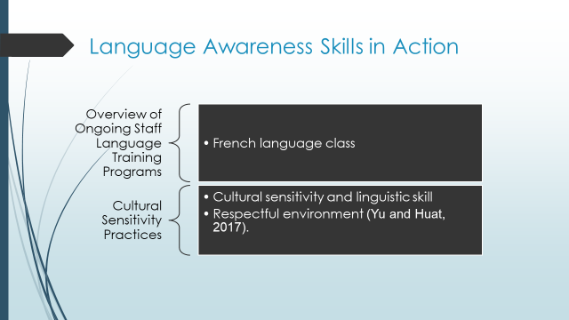
References (no screenshots):
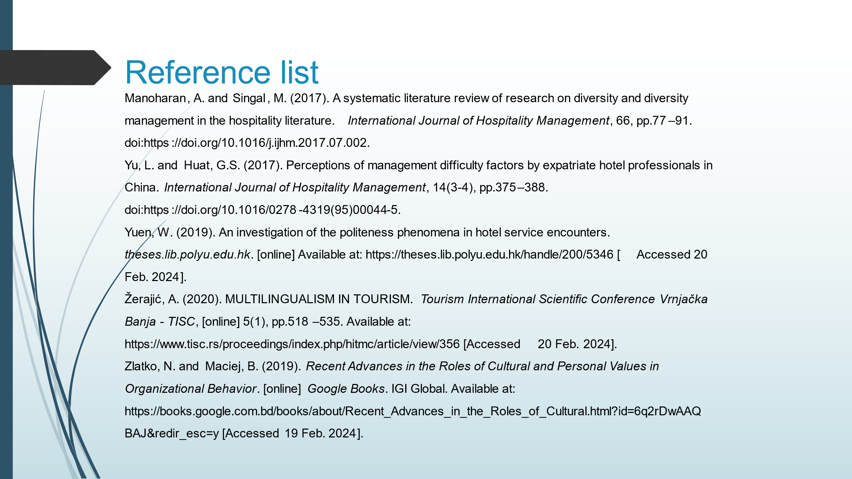
Manoharan, A. and Singal, M. (2017). A systematic literature review of research on diversity and diversity management in the hospitality literature. International Journal of Hospitality Management, 66, pp.77–91. doi:https://doi.org/10.1016/j.ijhm.2017.07.002.
Yu, L. and Huat, G.S. (2017). Perceptions of management difficulty factors by expatriate hotel professionals in China. International Journal of Hospitality Management, 14(3-4), pp.375–388. doi:https://doi.org/10.1016/0278-4319(95)00044-5.
Yuen, W. (2019). An investigation of the politeness phenomena in hotel service encounters. theses.lib.polyu.edu.hk. [online] Available at: https://theses.lib.polyu.edu.hk/handle/200/5346 [Accessed 20 Feb. 2024].
Žerajić, A. (2020). MULTILINGUALISM IN TOURISM. Tourism International Scientific Conference Vrnjačka Banja - TISC, [online] 5(1), pp.518–535. Available at: https://www.tisc.rs/proceedings/index.php/hitmc/article/view/356 [Accessed 20 Feb. 2024].
Zlatko, N. and Maciej, B. (2019). Recent Advances in the Roles of Cultural and Personal Values in Organizational Behavior. [online] Google Books. IGI Global. Available at: https://books.google.com.bd/books/about/Recent_Advances_in_the_Roles_of_Cultural.html?id=6q2rDwAAQBAJ&redir_esc=y [Accessed 19 Feb. 2024].

Component 3:

LIVE PRESENTATION (no links need to be submitted here)
Component 4: Student Self-Reflection (500 words +/- 10%)

Weighting: 25%
Reflection helps a student to analyse his or her experience on events, skills or other activities to identify good and bad points that can help the student to increase productiveness in future. I will use ‘ERA Cycle’ as a reflective model to evaluate my experience and learning while making the presentation that will help me to understand the importance of foreign language and cultural awareness (University of Hull, 2013). Experience, reflection and action are the three stages of ‘ERA Cycle’ that may help to analyse the situation and make improvement in future in case of same situations.
Experience: My experience was not good as I had not properly communicated with the French Guest at Diversity Hotel and Spa London as I don’t speak properly in French language. The guest came to me with a leaflet that has no English translation so he asked me to tell about the information written in the leaflet but I had failed to provide adequate information. I had used hand sign and weak English to provide information that was written in the leaflet but this gesture made the guest unhappy. The guest was not satisfied with my approach that made the guest discomfort and he may won’t think about take service from the hotel.
Reflection: I felt very bed in that situation as I couldn’t deliver better service due to language barrier that made the guest unhappy and this could lead to lower customer satisfaction and decrease guest number (Byram, 2012). I have to improve my skill to deal with foreign guests and need to improve my language skill so that I can deal with such situation in properly that won’t create discomfort of guests. I have to increase my awareness about foreign languages and different cultures to deal with foreign guests and people come from different cultures as expectations of guests from different language and culture is different. I have to enrol in different courses to learn different language as I have to deal with many foreign tourists.
Action: I will enrol myself in courses to learn multilingualism that can enhance language diversity and increase communication skill (Abramson and Moran, 2017). I will also join in cultural sensitivity training provided by Diversity Hotel and Spa London to understand importance of cultural awareness and to deal with different cultures. I can use translation apps to understand foreign language that helps to provide adequate information to the foreign guests and they will become happy that may increase their interest to take service from the hotel. Management should use English translation so that guests can understand the services. I will also try to learn visual signs and English language properly so that such incident won’t occur in future. I will take suggestion from my colleagues and seniors who will help me to improve my skill to deal with such incident.

References:
Abramson, N.R. and Moran, R.T. (2017). Managing Cultural Differences : Global Leadership for the 21st Century. Milton: Taylor and Francis.
Byram, M. (2012). Language awareness and (critical) cultural awareness – relationships, comparisons and contrasts. Language Awareness, 21(1-2), pp.5–13. doi:https://doi.org/10.1080/09658416.2011.639887.
University of Hull (2013). LibGuides: Reflective writing: ERA. [online] Hull.ac.uk. Availableat:https://libguides.hull.ac.uk/reflectivewriting/era#:~:text=The%20ERA%20Cycle.

