Contents

1.0 Introductory Matters and Background - Page 4.

2.0 Outline Description of Construction and Discussion on overall condition – Page,,,,,,.

2.1 Building Form

2.2 Main Teaching Blocks, Hall, Kitchen etc.

2.3 Boiler House

2.4 Sports Hall

2.5 Temporary Buildings

2.6 Grounds, Roads, Car parking and Coach Park.

3.0 Summary Description of the Construction and Condition of Specific Elements – Page 10.

This section is to be read in conjunction with the associated plates, comments and more detailed Excel spreadsheets See Appendices.

3.1 Exterior

3.1.1 Eaves, Verge/Fascia and Soffits

3.1.2 Windows

3.1.3 Doors

3.1.4 Walls

3.1.5 Thermal Insulation.

3.1.6 Interior Ceilings

3.1.7 Walls

3.1.8 Floors

3.1.9 Fire safety

3.2 Acoustics

3.3 Inclusivity

3.4 Landscaping

3.5 Penetrating and Rising Dampness

3.6 Condensation

3.7 Mains Services

3.7.1 Gas

3.7.2 Electricity

3.7.3 Heating Systems

3.7.4 Water

3.7.5 Drainage

3.7.6 Broadband and IT Services

3.7,7 Fire Safety Systems

3.8 Decoration

4.0 Conclusion - Page.

5.0 Appendices

5.1.1 Excel Spreadsheets.

5.2 Annotated photographic Plates.

5.3 Plans, Sections and Elevations if available. .

1.0 Introductory Matters and Background

  - Client:

Text based

Excel
Blocks:

School
Building Condition Report
Block One:
Reception, Administration, Main Hall, Refrectory/Kitchen, Sixth form centre the associated linking corridors, stairs etc.
ELEMENT | Element No. | Description of Construction | Description of Condition | Condition Rating  In accord with provided rating system. |  |  | Risk Rating |  | Suggested Remedial Repair/Investigation |  | Costings |  | Alternative Recommended Option |  | Comments
Roof | 1 |  |  | Condition Rating | Priority | Weighting
Roof structure | 1.1 | Woodwool slab with felt coverings | Visible only in limited areas of the Hall, stores etc. | D | 1 |  |  |  |  | Health and Safety Issue. Deleterious material.
Coverings (incl. glazed roof lights) | 1.2 | Broken and cracked roof-lights are contributing to water penetration internally that is damaging the interior finishes. Green mineral finished felt roof coverings. | Not seen due to access. Assume that it is in similar condition generally to the felt to that of the library. Water penetration arising. | D | 1
Insulation Drainage (including rainwater goods and pipes) | 1.3 | Assumed that some PIR Insulation added when last recovered as per the Library roof. The felt is likely to be aged. |  | D | 1
Parapets, | 1.4 | Not Applicable.
Handrails etc. | 1.5 | There are no handrails apparent. | Consider maintenance access. | D | 1 |  |  |  |  | Hand-rail or a fall arrest system should be added to aid maintenance repairs.
Frame Other (including chimneys) | 1.6 | Extract ventilation from Kitchen | Service and clean. | B-C | 1
Boiler Flues and Extract | 1.7 | Not applicable.
Eaves (Fascia/Soffit/Barge). | 1.8 | These were originally of timber with asbestos boarded soffits. In many areas the timber fascia has since been over-clad with now badly deteriorated paint coated galvanised steel sheets or PVC boards. | Peeling paint, concealed asbestos containing materials and deteriorating timber work, especially at exposed corners where wind eddies arise. | D | 1
Rainwater gutters and downpipes | 1.9 | Aluminium gutters and cast aluminium and cast-iron rainwater downpipes. | Many gutters are now blocked or leaking. Down-pipes are damaged or missing. | D
Tank Room | 1.1 | Colour-coated trapezoidal steel wall cladding | Water leaks? | C |  |  |  |  |  | Reclad as part of refit.
Building Structure | 2

Powerpoint/Word/ Paint etc.

Defective asbestos sheet roof coverings. There is also debris that has fallen from above, or been thrown by vandals onto the roof.
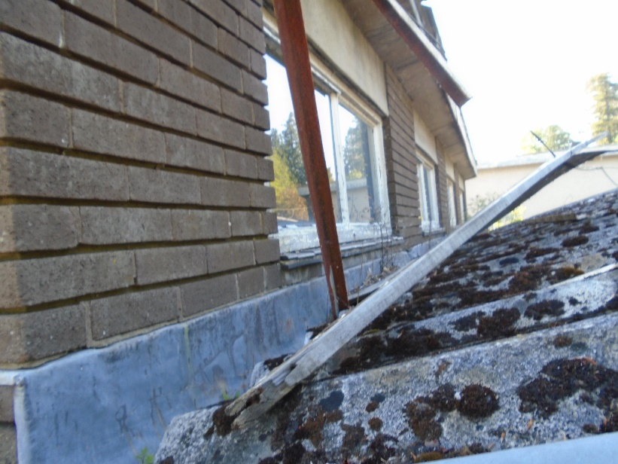

Safe maintenance access to these areas was always almost impossible.


