Martin Dunn (1705105)
1705105@student.uwtsd.ac.uk
Application Development
ACCA5012

Table of Contents
- Introduction
- Application Development Concepts
- About the Game
  - Software Requirements
  - How to Play
- Software Design
- Implementation
- Conclusion
- References

- Introduction
The content provided within this report will document the progress and completion of a 2D game developed in Unity using scripts in C#. Main areas that are covered are application development concepts regarding current trends in the industry, requirements for the game that has been created, design and implementation and an evaluation. The game that has been developed is short and takes place over 3 levels. It was largely inspired by the previously viral game ‘Flappy Bird’.

- Application Development Concepts
There are many different application development trends in the current time period, some are stated below [reference(s)]:

- Virtual Reality
- Augmented Reality
- Cloud Based Games
- Battle Royale
- Cross Platform Play
The trends of application development are not just limited to the above list, this is a small example of some of the current trends.
Augmented reality is a very interesting trend within games and apps where it combines virtual and real world aspects to create a high level of immersion that would otherwise not be possible [1]. Not to be confused with Virtual Reality (VR) that is when the 3D environment is totally computer developed that the user can interact with and create immersion in artificial worlds. [2]
There are different components required to make AR possible. Firstly, a scene generator, the device or software that is used to render the AR scene, is required. this is not usually an issue as rendering is not usually an issue with AR as there are not many objects that need to be rendered and done necessarily need to be ‘Realistic’.
Secondly, as tracking system, this is by far one of the most important problems on an AR system as all virtual objects have to be placed correctly aligned in the real environment, and in relation to each other for it to create the illusion of it actually being there. This is specifically an issue in some applications that need an accurate representation of the object, for example in medical or military training.
Finally, a display is required. a large portion of AR displays are head mounted displays (HMD) but this does not mean it is the only solution out there [2]. There are several mobile applications that use Augmented Reality on smartphones for many different reasons, including entertainment and games.
- About the Game
This section will go into detail about the implementation of the application developed in the worksheet provided during lectures, this includes requirements and how to play the game.

  - Software Requirements
There are a small number of requirements that needed to be met to create the game that has been made for this module, they are listed below:
- At least 3 Levels
- Player can move in both directions
- Randomly generate enemies or collectibles or obstacles
- Have an objective
- Have a HUD
These are the main essential components that are needed in the implementation of the game that will be created to complete the Application Development module.
  - How to Play
The main aim of the created game is to avoid hitting enemies and collect the coins dropping onto the screen without losing all the players lives in the process. The player starts with 3 lives at the beginning of level 1. They must use the A key to move left and the D key to move right and the Spacebar to move upwards. Using these controls, they must dodge the other flying birds and soldiers in the scene, as these are the enemies, whilst trying to collect the coins dropping onto the scene. Each time an enemy is hit a life will be lost and the level will be reset, but the coin collection progress will remain.
15 coins are required to complete Level 1 with this number increasing by 5 coins per level to slightly increase difficulty, also enemy speed and positions can also change on different levels for changes to play style and difficulty for the player. Once a level is completed the player is granted and extra life as a small reward to help them on their journey to complete all 3 levels.
Once the desired number of coins have been collected for completion of the level, either ‘Level Completed’ or ‘Game Completed’ will display on the screen to indicate that the player was successful. Alternatively, if all lives are lost ‘Game Over’ will display to the player and they will be required to restart the game with all progress being reset to 0.

- Software Design
The design process for this implementation was a very short process and a lot of inspiration was taken from the previously viral mobile game ‘Flappy Bird’ [3] as the concept of this game was a very simple and basic one, but also very addictive and created fun competition among users and desire to have the highest possible score they could have. This same level of fun and excitement has been the main goad for the design and development of this project.
The design of the background was created using the free assets provided and has no real inspiration or comparability to previous known work. It was created using the developers on the spot creative intuition. There are 2 assets that were taken from the internet as they fit the theme of the development for the game, these are the flying enemy and the collectible coin.

- Implementation

The game has been created using Unity and Visual Studio, using scripts coded in the C# language.
There are 8 scripts, written using Visual Studio 2019, in total enabling the functionality of the created project with the 3 main scripts are titled:

- Player
- Enemy
- GameController

The player script, as the title states, contains all the code that enables the players usability from the user including movement in each direction, including jumping. It also includes lines of code for detecting when the player has collided with either a player or a collectible and takes the correct action that is required for each object.
The Enemy script, much like the Player script, controls the enemy objects within the game world, including detecting collisions with off screen triggers to reset the enemy position after the enemy has left the play area enabling them the cycle across the game area again to challenge the player.
The GameController script contains the main functions controlling the level changes and user interface (UI) elements of the game, making them available for other scripts to call them when needed.
The remaining 5 scripts are much smaller scripts mostly containing individual elements of the UI such as, lives or score counter that is displayed on the screen to enable the user to be aware of their current progress in the game. They also control the spawn rate and random spawn location of the collectible coins above the screen and enable them to drop onto the screen for the player to go and collect. There are many different functions within the scripts that have been implemented to enable functionality of the game.
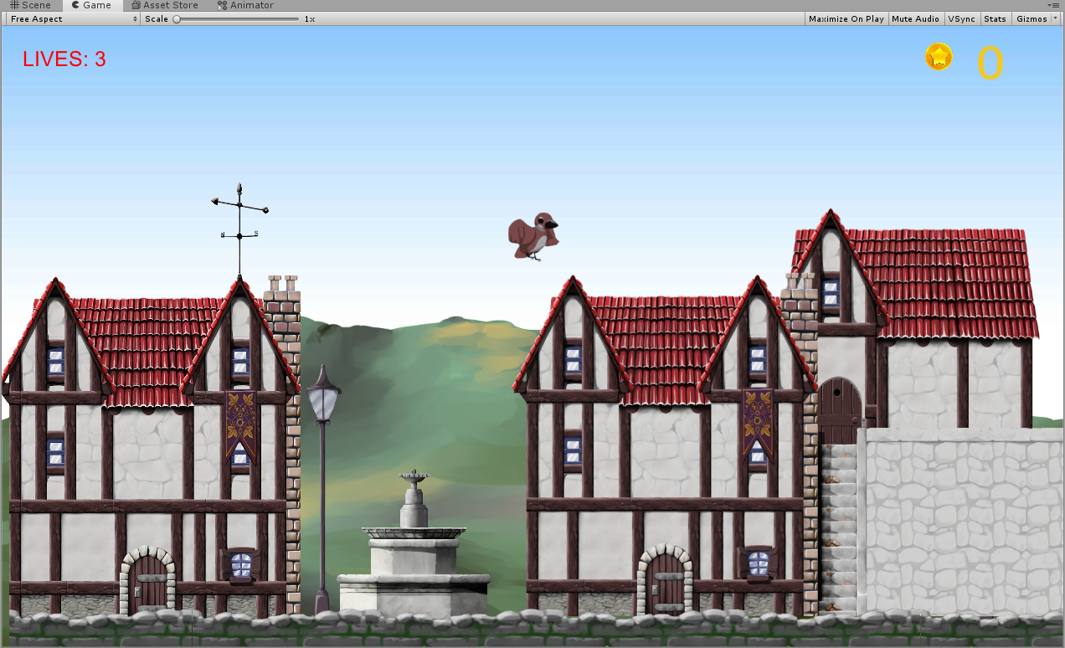
Unity has been used to create the different Scenes/Levels where the game will take place, also applying physics to game and different components to game objects such as triggers and colliders for the previously mentioned scripts to control the functionality of. See images of all 3 levels below.
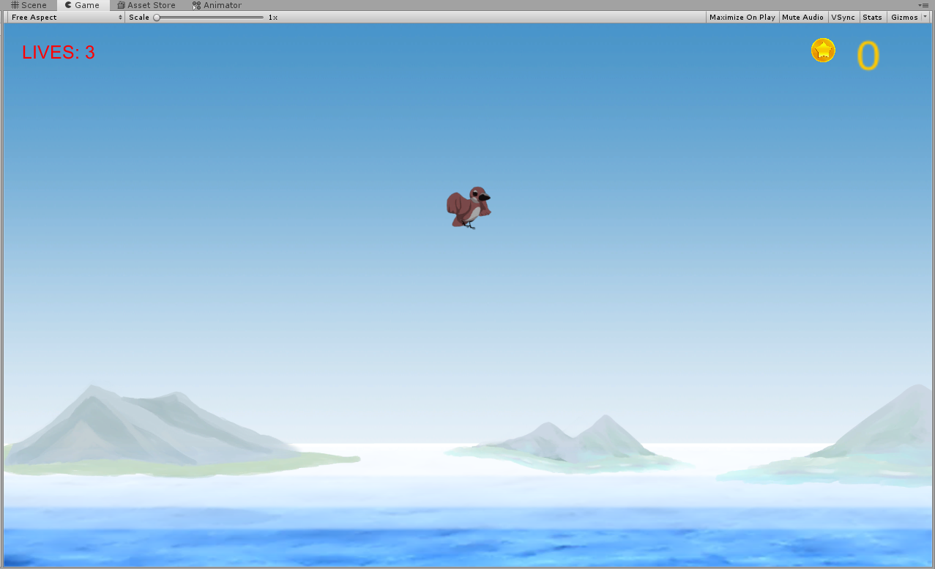
Figure 1 – Level1
Figure 1 – Level2

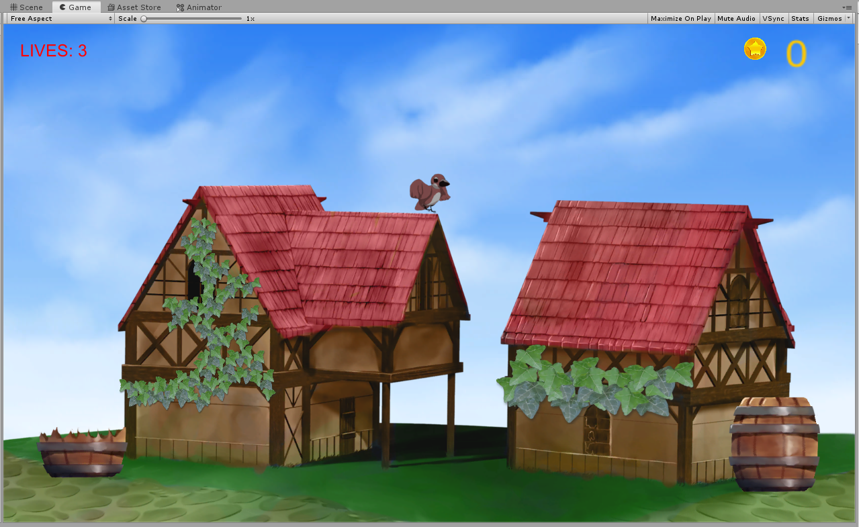
Figure 1 – Level3

There has been a large amount of verification of the functionality of the game through testing from various users to ensure there are no bugs or unexpected responses from the functionality that has been implemented. New test were carried out every time a new feature was implemented or even a change to and existing feature as it is very important within software to ensure functionality is working how it is expected, it is very easy to make small errors withing lines of code to create unexpected outcomes, this happened many times within the development period.
There some known issues with the game that if development were to continue would need implementation to correct. One of these issues is the Scene does not rescale to any scene size that the game would be launched on. For example, if the game view window is to be resized to make it bigger the game does not also scale up to fit this area and instead shows off screen spawn points for enemies and collectibles. The player can not use this play area as the dedicated play area has ‘bounds’ to prevent the player from flying off the screen and not being able to get back to the play area. If the development were to continue the developer would need to research how to implement this into the game as the knowledge is currently unknown to make this happen.
It has been attempted to ensure that each element of the game has been thoroughly tested to the best of the developer’s ability and many hours have been spent correcting unexpected results to the expected outcome. For example, when the player collects the required amount of coins for the level and animation appears stating that the level is completed and then executes a function to load the next level. As this animation was being displayed to the user the game would still be functioning in the background, if the player was to collide with an enemy this animation would be overridden by the player collision function with an enemy to restart the level, and would also make it impossible to make any more progress within the game as the player would have already exceeded the maximum collectibles needed so the next level function would never be called.
This was corrected by creating a static bool ‘GameIsOver’ being default set to ‘false’. This would be then set to ‘true’ whenever the level complete animation is playing, this variable would then be the condition for an ‘if’ statement containing the trigger collision code for the player with the enemy ensuring that the collisions would never be detected and the game can progress as normal. Upon the loading of the new level the variable would be reset to ‘false’ so the game will play the same across all the levels withing the game.

- Conclusion

In conclusion, the functionality of the game is believed to be at an acceptable standard for a first attempt using at application development and using Unity and C#. It is not believed in any way to be perfect and there are a large amount of areas that could receive a large amount of improvement to make this game much better, such improvements come with experience and knowledge of the software and the language that are being used. There were many times an idea was created but never implemented due to time constraints and lack of experience with Unity and C#. The developer has stated they are happy with the functionality of the game in its current state and feels it is easy to use and understand by anyone that would happen to play this game. One recommendation comes within the coding/scripting in visual studio. It could be slightly cleaner in places and possibly reduced the amount of scripts used by including more into the ‘GameController’ script and calling then from other scripts.

When it comes to some of the possibilities of future improvements there are so many possibilities limited only by imagination and experience. See the list below for some good future improvements if development were to continue:

- Starting menu (Play, Options, Quit etc)
- Pause menu
- Difficulty setting
- More levels
- Different playable characters
- Challenges
- Scoreboard
- Survival mode
- Side scrolling version combining all background prefabs transitioning randomly into each other
- Different enemy types
- ‘Bad’ collectibles that subtract from the score/take a life

These are just some of the improvements that can be implemented to create a better gaming experience for all users. There are many more changes and additions could be made, especially with the rate that technology advances more is possible each year.
There were many different online sources consulted for information/tutorials on various aspects of the development process. One main source that was regularly used is a Youtube tutorial creator by the name of ‘Brackeys’ [4] who is a game developer who makes regular videos using unity and C# to help teach millions of people how to develop. One playlist in particularly useful for this project is ‘How to make a 2D Platformer’ [5]. Unity also has its own informative tutorials on how its engine works and the different functions and lines of code can be used to implement different features. Finally, A large amount of information was taken from university lecture content made accessible online by the lecturer to enable the developer with the basic skills to begin using the software and the language.

References

[1] | D. S. Zlatanova, "Augmented Reality Technology," GIS Technology, no. 17, p. 7, 2002.
[2] | J. C. O. G. A. G. R. Silva, "Introduction to Augmented Reality," Introduction to Augmented Reality, pp. 1-7.
[3] | R. Rigney, "Wired," 02 December 2014. [Online]. Available: https://www.wired.com/2014/02/flappy-bird/#. [Accessed 07 12 2019].
[4] | Brackeys, "Brackeys," [Online]. Available: http://brackeys.com/. [Accessed 08 December 2019].
[5] | Brackeys, "Youtube," [Online]. Available: https://www.youtube.com/user/Brackeys/playlists. [Accessed 08 December 2019].

marking criteria and Student FEEDBACK

This section details the extent to which the assessment criteria are demonstrated by you, which in turn determines your mark. The marks available for each category of skill are shown. Lecturers will use the space provided to comment on the achievement of the task(s), including those areas in which you have performed well and areas that would benefit from development/improvement.

Common Assessment Criteria Applied (Assignment 1) | Marks available | Marks  awarded
1. Engagement with Literature Skills

A good, though brief, summary overview of the chosen application trend. Generally, a more in-depth discussion is required and the required background from a relevant peer-reviewed study is missing. Expand the scope of references to further improve your research work. (Grade mark: 56.00%) | 25 | 14
2. Knowledge and Understanding Skills

3. Cognitive and Intellectual Skills

Although you have identified problems with the game, you have not actually documented the test cases. You were given a template for this in the assignment brief. A very good evaluation with some relevant recommendations has been provided. (Grade mark: 60.00%) | 20 | 12
4. Practical Application Skills

A good attempt featuring a simple game. The main area for improvement is the implementation of the code and not just relying on and copying tutorial code from online/other sources. Generally, learn how to use script to dynamically generate the game world - this was a requirement for the assignment. Learn how to use object-oriented coding practices and know when and how to expose fields and also when you should make your methods public. Most of your fields and methods have been made public and static. If you need to make fields accessible to the Inspector, then use the SerializeField attribute, if you need to make them accessible to other classes, then make use of properties and not all methods need to be made public. Also, avoid hard-coding game tags and game object names. Yes a lot of sample scripts you see would do this, but there are better ways to implement this and note that some of the Unity Find functions are resource intensive too. Learn how to use the Event system too. In terms of game play, there really should have been some more variation beyond the background between the levels and I would consider using different speeds as well. The game would also have benefitted from a menu to start the game. (Grade mark: 58.00%) | 50 | 29
5. Transferable Skills for Life and Professional Practice

The report is of a good standard. See your report for some suggested improvements. (Grade mark: 60.00%) | 5 | 3

Assignment Mark (Assessment marks are subject to ratification at the Exam Board. These comments and marks are to give feedback on module work and are for guidance only until they are confirmed. ) | Late Submission Penalties (tick if appropriate) |  | 58%
 | Up to 1 week late (40% Max) |  | 58%
 | Over 1 week late (0%) |  | 58%

