

Project Management
  - Cloud Computing
ACCC5005

Marius-Catalin

Bobitiu

Project Management
Project management practices aim, as expected, to complete the project. Getting things achieved more effectively by reducing the cost and meeting consumer needs-related external priorities. Objectives seem simple and realistic, but projects continue to run late, surpass their budgets, or fail to meet project goals. In the early 50's, modern project management was implemented during the Manhattan project. (Assem Al-Hajj, 2018)

Integrated System
An integrated management system is a single process developed in conjunction with diverse concepts to handle various facets of the activities of an entity. In this case, the values are the method of reservation, payment and selling of spare parts.

Rapid Prototyping Methodology
Rapid prototyping has become a pattern of recreating difficult architecture for a potential field of implementations since the last decade. Since the Cold War, numerous ways of rapid prototyping have been presented for the improvement of innovative defense and space posts. It is usually going to be introduced based on the intent. (Sharda Gupta, 2018)

Tables:
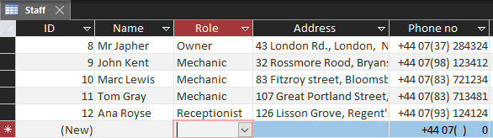

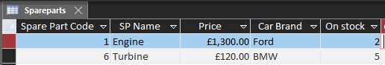
-------------------------------------------------------------------------------------------------------------------------------------------------------------------------------------

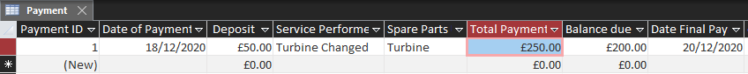
-------------------------------------------------------------------------------------------------------------------------------------------------------------------------------------
-------------------------------------------------------------------------------------------------------------------------------------------------------------------------------------
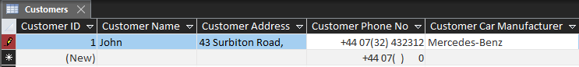
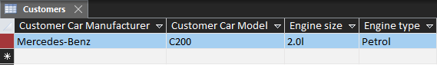

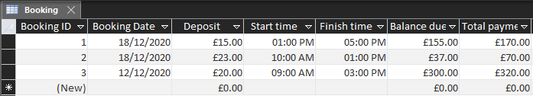
-------------------------------------------------------------------------------------------------------------------------------------------------------------------------------------

-------------------------------------------------------------------------------------------------------------------------------------------------------------------------------------0

Forms:
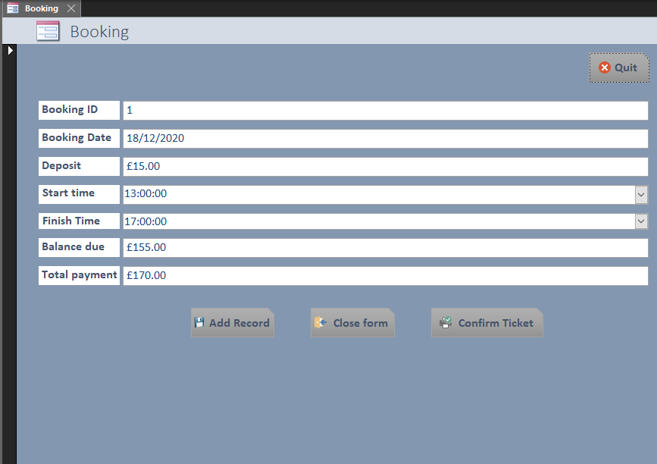
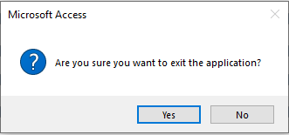
This will pop-up when you press the “Quit” button. It is a good way to make sure the application will not be closed by mistake.

Print Confirmation ticket

The next screenshot shows the Confirmation ticket which will be printed out just by one press of a button. Easy to use, very practical , and will help people know everything, from when they need to come pick the car, to how much money they already deposited, and the money they need to bring.

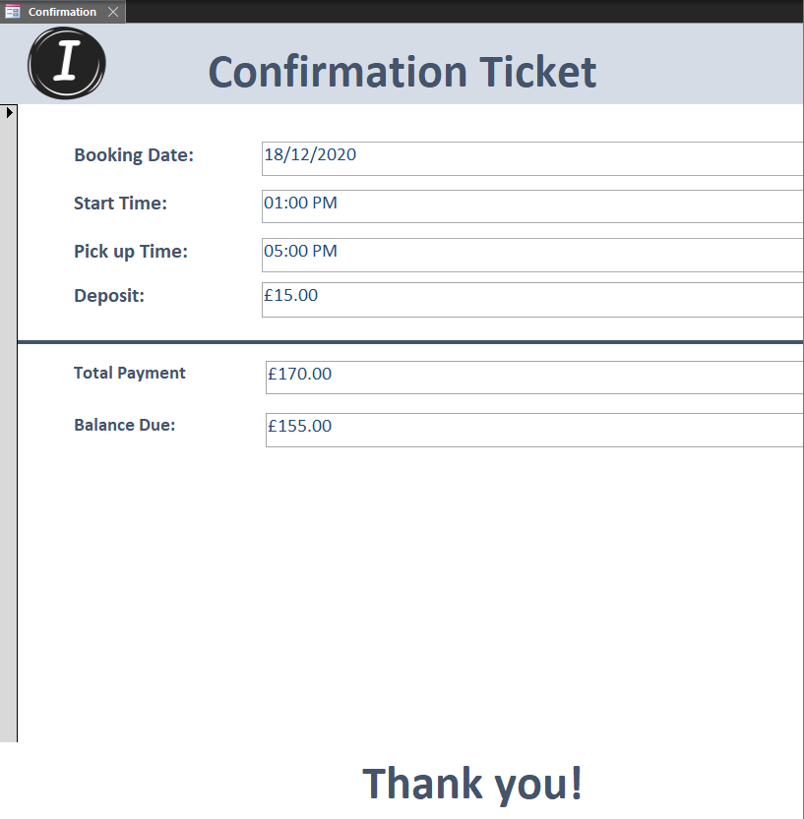

Work-breakdown Structure (WBS)
The deliverable-oriented breakup of a project into smaller parts is a work-breakdown structure (WBS) in project management. It is a main deliverable initiative that organizes the work of the team into manageable parts.
This is the work-breakdown structure for this project:
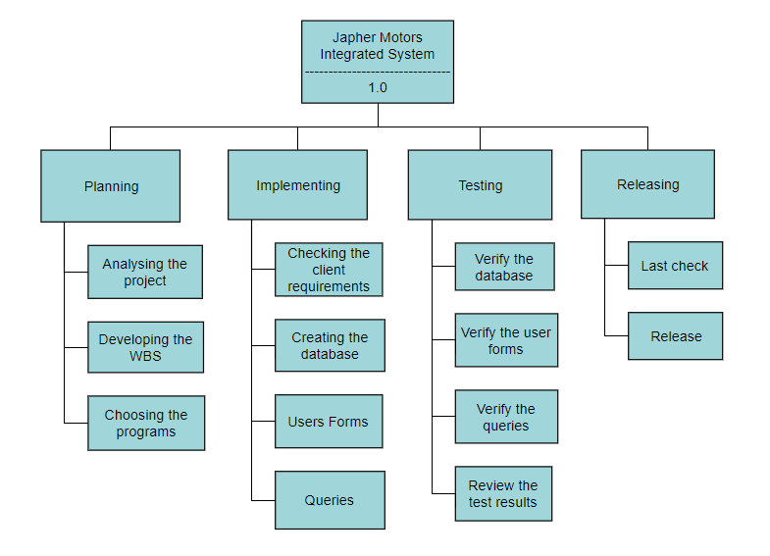

Communication plan
A communications strategy helps you to distribute data to suitable partners efficiently. The strategy would describe the messages that you need to spread, who you are targeting, and which platform(s) you are targeting. (Carmicheal, 2019)
Stakeholder Name | Engagement Action | Owner | Channel | Frequency
Marius Bobitiu | Manage Closely | Project Manager | Personal check-in meetings, email notifications from software | Daily

Stakeholder Management Plan
Put easily, the notion of handling the parties participating with any major project is stakeholder management. The project manager has to meet the demands of key stakeholders with finesse, regardless of how much influence they hold. (Blackburn, 2019)
Stakeholder name | Title | Role | Power (H/L) | Interest (H/L) | Requirements | Concerns
Marius Bobitiu | Project Manager | Developer, Tester | H | H | Finish implementing the database and testing it. | Finishing the project in time.

Gantt Chart
A Gantt Chart is an easy-to-use framework that provides a graphic representation of complex initiatives, with each of these tasks spread out over time, split into smaller activities. A Gantt Chart shows what the different tasks are when if there is any overlap in activities and how the project should be done within a given time period, when it can start and end. (Stanley, 2015)
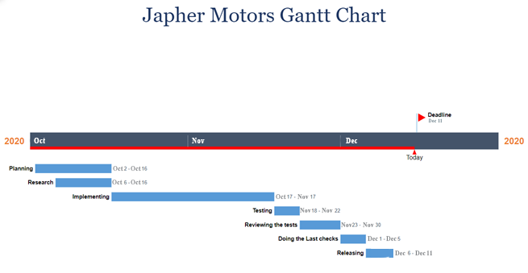

References
Assem Al-Hajj, M. M. Z., 2018. The impact of Project Management Implementation on the Succesful Completion Of Projects in Construction.. International Journal of Innovation, Management and Technology., 9(1), p. 21.
Blackburn, M., 2019. How to make a Stakeholder Management Plan. [Online]
Available at: https://www.projectmanager.com/blog/stakeholder-management-plan
[Accessed 22 November 2020].
Carmicheal, K., 2019. How to Write an Effective Communication Plan. [Online]
Available at: https://blog.hubspot.com/marketing/communications-plan
[Accessed 24 November 2020].
Sharda Gupta, A. B., 2018. Rapid Prototyping for Polymeric Gels. Polimeryc Gels.
Stanley, L., 2015. Gantt Chart In Project Management: Definition & Examples. [Online]
Available at: https://study.com/academy/lesson/gantt-chart-in-project-management-definition-examples.html#lesson
[Accessed 25 November 2020].

