

Certificate of Higher Education in Skills for the Workplace

Task 2
Professional career development report

Student name: Dimitrichka Dimitrova
Student ID:2123033

Module name: Professional Career Development
Module code: (BMSW4005_LON)
Lecturer name: Bianca Sanfilippo
Submission date:

Table of Contents
Introduction 3
Recruitment and Selection: Personal reflection on the role play applying KOLB’s (1984) LEARNING Cycle 3
The experience: 3
Reflective observation: 3
Abstract conceptualisation: 4
Active experimentation 4
Skills which contribute toward working effectively 4
The knowledge which contributes toward working effectively 6
SWOT Analysis 8
Personal career action plan/development plan 9
My short - medium – long term targets for the development of my own professional career plan (using SMART targets) 11
Conclusion 13
References 14

Introduction

To achieve personal and career development that contribute towards the achievement of one’s goals and aspirations, one should possess a wide variety of different skills and abilities (Vondracek, Lerner and Schulenberg, 2017). The current paper would comprise a personal evaluation of my current competencies, expertise and experience, to enable an accurate assessment of my current employability situation and develop a well-structured plan for further improvement that would facilitate the accomplishment of my career ambitions.

Recruitment and Selection: Personal reflection on the role play applying Kolb’s Reflective Cycle

Reflection can be defined as a process whereby one examines an event, to self-evaluate and assess one’s experience and consequently consider the pursuit of an attitudinal or behavioural change (Bulman, 2013).
It has been associated with multiple benefits. For instance, reflection has been recognised as improving the quality and depth of learning (Roebuck, 2007). Moreover, it has been identified as facilitating professional development (Jayatilleke and Mackie, 2012).

In recognition of the importance of reflection, a reflective account of my experience as a participant in a role-play with another student would be presented.

There are several frameworks that could be used in the conduction of reflectional practices. Among them, Kolb’s learning cycle (1984) has been recognised as especially helpful in providing the ability to effectively reflect on experience and develop strategies for future self-improvement and development (Vince, 1998). Given that, I would apply the model when exploring my role-play experience.

As per the model, effective reflection is to be pursued through four different stages:

The experience:
The event took place during week 8 of my university course and required me to perform two roles: one of a job interviewer and another one of a job applicant. For my interviewer role, I impersonated a HR specialist of a cleaning company.

Subsequently, I took the role of a job applicant, whereby I imagined to be a cleaning manager job applicant, as this corresponds to my actual career aspirations. In view of that, I evaluate that the experience has been contributory to my preparation for future actual job interviews.

Reflective observation:
To prepare for the role of a HR specialist, I conducted some research on the qualities and skills that are demanded from such individuals, as well as on the professional conduct that a job interviewer should demonstrate. I acknowledge this as having facilitated my ability to accurately pretend to be an interviewer.
The experience of taking the role of an interviewer also enabled me to derive a better understanding of how such a person feels whilst conducting a job interview and what specific details pertaining to the behaviour of the applicant could be noticed. I believe that I can use this knowledge to improve my job application performance.

I assess that my second role as a job applicant was also highly beneficial for me and my professional development as I was put in a highly realistic situation whereby, I had to present my skills and qualities in the best manner in order to ensure my good performance before the interviewer.

During the interview, I endeavoured to act with confidence and provide comprehensive answers to the questions. Despite my attempt to endorse a confident appearance, however, I still experienced some anxiety which led to my avoiding frequent eye contact with the interviewer and playing with my hair.

Abstract conceptualisation:
In reviewing the experience, I have recognised several mistakes when attending a job interview. For instance, the other role-play participant did not smile during the interview which I assess as diminishing her friendly appearance. Moreover, I also identified several aspects of my behaviour that were problematic such as my body language and my low speaking tone. I evaluate that these issues were caused by our anxiety and thus, additional practice on feeling more relaxed during the interview is needed.

Other areas for development regard the need to put a greater emphasis on our strengths. I noticed that my partner seldom mentioned what qualities make her a highly suitable candidate for the job role. Upon inquiring whether she has made the same observation during my role-play interview, she confirmed my allegation.

Active experimentation:
Drawing from the experience, I will take note of the problematic aspects that I identified during the two interviews and work on their overcoming. In particular, I will practice improving my body language and speaking in a clearer manner, as well as focusing more on the presentation of my strengths vs. In doing that, I would endeavour to ensure that such drawbacks do not impede my performance in actual job interviews.

Skills which contribute toward working effectively

Considering my desire to pursue a cleaning company’s manager career, I consider it essential to develop a good awareness of the skills and competencies that have been identified as facilitating the achievement of efficient management, both on an overall business management level, as well as specifically in the cleaning services provision sector.

The managerial skills that enable an effective management of a company’s operations could be divided into three categories (Katz, 2009).

Conceptual Skills
Such abilities pertain to the capacity to analyse situations, solve problems and construct viable working strategies.

There are multiple occasions whereby a well-skilled manager would have to interfere to solve a certain issue. For instance, a client might not be satisfied with the service’s quality. For such cases, a good manager should be able to develop a highly effective problem-resolution strategy.

Moreover, planning is also a very important aspect of management, to be able to set achievable goals, construct optimal task completion schedules and thus, contribute to the high efficiency of the business.

Furthermore, creative thought can facilitate the development of unconventional strategies that provide the company with a competitive advantage in the cleaning business market.
Human Relations Skills
A manager should be able to establish effective communication practices with the company’s employees, as it can be identified as a crucial prerequisite for the accomplishment of a highly effective work process, whereby employees work with motivation and satisfaction (Dozier, Grunig and Grunig, 2013).

Through communication, managers can convey the organization’s aims, as well as provide their employees with helpful feedback that facilitates their most optimal performance (Froschheiser, 2008).

Good listening skills are also to be assessed as essential not only in communicating with employees but also to understand the needs, requirements and preferences of clients (Zugaro and Zugaro, 2017).

Furthermore, a manager should interact with staff and clients with honesty and integrity, to establish trust and contribute to the positive nature of the work environment (Verma, 2013).

An integral part of the Human Resources management aspect of management pertains to the good awareness and application of employment legislation politics. There are several legal policies that provide for the protection of human rights and the provision of fair work conditions and are to be followed by all people involved in a company’s function.

Amongst them, The Human Rights Act 1998 and The Equality Act 2010 constitute acts which aim to protect people from being discriminated against (Hepple, 2010). In particular, as per the Equality Act 2010, there are 9 ‘protected characteristics’ which should not have an effect on the manner in which an individual is treated. It is important to consider these legalizations, to ensure that a manager recruits and treats the company’s employees in a legally and ethically appropriate manner.
Technical Skills
These skills concern managers’ industry awareness and their competency regarding the business sector’s market, trends, consumer expectations and behaviour and legal policies.

Such knowledge is vital for the construction of highly effective work strategies (Hrebiniak, 2013). Moreover, as work monitoring and control are important to ensure the efficient completion of the workforce’s tasks, a manager must be well aware of the work standards that are to be met.

Some essential business skills such as handling financial data and interpreting market trends are also necessary so that a manager can undertake well-informed decisions about the company.

The knowledge which contributes toward working effectively

As mentioned, several legal policies govern the protection of human rights in the workplace.

In addition to them, there are several other legal acts that should be considered by a company’s management.

For instance, data protection and its corresponding legislation are to be recognised as a crucial aspect of every business that involves dealing with employees’ and customers’ information. All personal data that is handled by a UK-based business should be protected and remain strictly confidential, in accordance with The Data Protection Act (1998). To ensure that, a cleaning manager should be cognizant of this legal policy.

Another important duty of a cleaning manager regards the ensuring of the health and safety of the company’s working personnel. The UK’s legal structure defines the regulations that govern workplace health and safety in its Health and Safety at Work Act (1974). Therefore, cleaning companies’ management should be aware of this act’s clauses.

Moreover, a worldwide recognized work safety and quality certification is the ISO accreditation which comprises a confirmation from an independent party that an organization operates in accordance with the standards of the International Organization for Standardization (ISO). Such a certification is an indicator of the quality of services of a cleaning company. For that reason, it is to be assessed as beneficial for a cleaning company’s manager to possess knowledge about the ISO accreditation requirements and processes (Sanyal and Martin, 2007).

Furthermore, a manager should be aware of the workplace rules that are to be imposed, such as attendance and absenteeism, work violation policies, sick or holiday leave policies and others, to preserve consistent work efficiency. In addition, the individual should be cognizant of the wage and hour legislation as per the UK’s Employment and Labour Law.

My personal strengths and areas for further development

Overall, I recognise myself as possessing multiple skills that are prerequisites for my accomplishment of a successful career in cleaning management.

First, I evaluate that I am a highly ambitious and motivated person that strives to achieve high and is ready to exert herself towards the accomplishment of her goals.

Furthermore, I believe that I have a creative mind that is capable of coming up with innovative and unconventional ideas and problem solutions.

I am also very flexible and adaptive to changes, as I have a lot of experience in changing my circumstances.

Lastly, I consider that I am an efficient communicator that is able to establish good communication practices with a broad variety of people, treat people with respect and dignity and convey her ideas in an effective manner. Moreover, I can easily resolve conflicts with people.

In spite of these positive qualities of mine, I also assess that I still have some areas whereby I should seek to improve myself.

For instance, I evaluate as necessary to expand my knowledge regarding the legal regulations that are relevant to the cleaning companies’ management, as well as learn more about how to handle financial data and analyse market trends.

I can also achieve an improvement in my organisation and task and time management skills. Currently, in most cases, I am able to effectively schedule my duties but given the importance of being well-skilled in organising, to be able to effectively distribute a cleaning company’s time, tasks and resources, I would like to explore more strategies for effective organizing and thus, contribute to my amelioration of such skills.

Furthermore, sometimes due to my high ambitions, I pursue too many projects and objectives and get overwhelmed with the amount of work that I have to do. As a result, I also get stressed. Therefore, this is another field which I would like to develop.

SWOT Analysis

SWOT ANALYSIS

STRENGHTS  - Excellent communication skills  - Creativity  - Flexibility  - Resourcefulness  - High motivation  - Experience in the cleaning field  - Knowledge acquired during the module and the course | WEAKNESSES  - Lack of certain knowledge and expertise  - Occasional difficulties in time and task management  - Disorganization  - Inability to say no to people and projects  - Proneness to stress
OPPORTUNITIES  - Opportunities to acquire more relevant skills and competencies  - Being able to pusue a successful career whereby I actively employ my strengths  - Strategies to effectively combat my weaknesses  - Identification of other strengths and weaknesses of mine and seeking to develop them | THREATS  - Competitors  - Not being able to develop the full skill set that is needed to be a prosperous manager  - Allowing bad organization to impact my work  - Being overwhelmed by the number of projects that I undertake  - Being negatively affected by stress and other emotions

Personal career action plan/development plan

I am on achieving my learning and development objectives by continuing to apply reflective learning as per the Kolb’s learning development plan (Kolb, 1984).
Moreover, Kolb identifies four learning styles (shown on Figure 1).

Figure 1
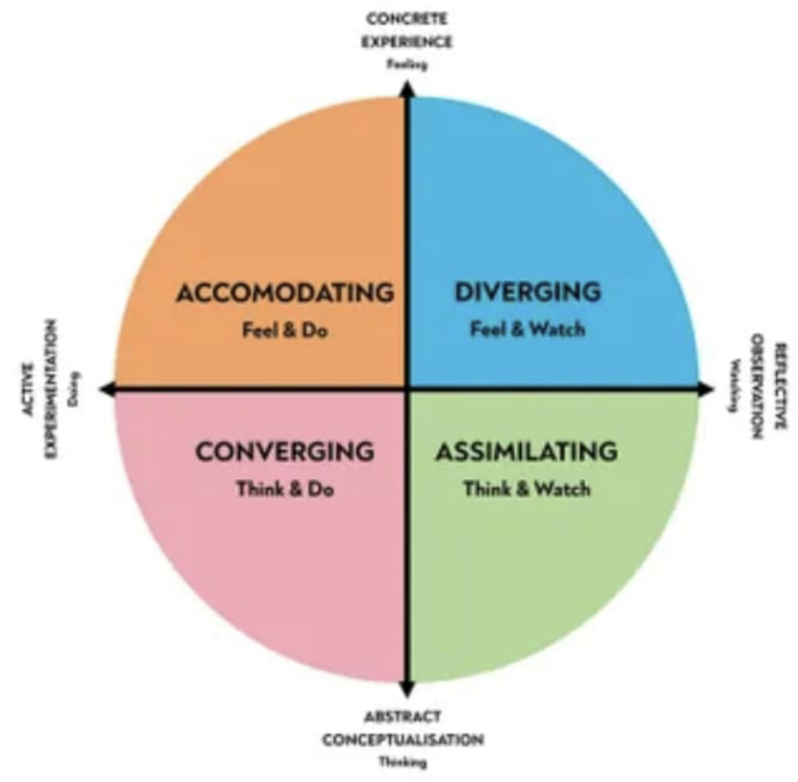

I evaluate the converging learning style as the one that is most appropriate for me and my objectives. Therefore, I would endeavour to actively apply it.
My professional career pathway is:
My career aspirations regard my becoming a prosperous cleaning company manager that is in charge of the management of a cleaning business that has a broad operational range.

What are my current strengths?
My current strengths pertain to my high ambition and strive for self-development and improvement, my adaptability to change and resourcefulness, my good communication skills, my creative mind and the experience and education that I have gathered.

What are my achievements and areas of success since the beginning of the module/programme?
Since the beginning of the module, I have acquired knowledge about several effective strategies and methods that I can use to evaluate my career performance and planning and maximize my employability. Moreover, I have expanded my understanding of the factors that facilitate the pursuing of a successful career.

I have achieved a significant improvement in my skill set and expertise and am now more able to effectively use my strengths, combat my weaknesses and develop optimal self-development strategies.

In what areas do I need to develop?
I would like to further expand my knowledge regarding different frameworks and methodologies that can be used in personal and career development.

Moreover, upon my identification of my weaknesses, I consider it essential to develop strategies to minimize their impact on me.

Why is it important to improve in these areas?
My improvement in these areas would benefit my ability to pursue my desired career pathway and goals, as well as would positively impact my overall skill set and thus, contribute to my self-improvement.

Who will help me? What resources will I need?
I believe that my personal ambitions and motivation would be my main drives in my endeavor to improve myself. Using them, I would seek to identify the best resources that would enable the accomplishment of my personal development plans. I would incorporate a wide variety of resources- from literature to personal testimonials by professionals and enrollment in practicals, trainings and courses.

What are the constraints/ barriers to achieving these key areas and how I will manage these– e.g., time, resources.
I evaluate my shortage of time to be my main barrier as I have a very busy schedule, as well as have many responsibilities pertaining to my family. Nonetheless, I plan on mitigating the impact of this barrier by developing a highly effective time and task management plan and not losing focus on my goals.

What further action do I need to take now?
Actions to be taken – things to do, people to see.
I need to continue to develop my career plan by identifying more strengths and weaknesses that I have. Furthermore, I should explore on how to best take advantage of my positive attributes and combat my negative ones. To do so, I would continue to analyse myself and my current situation, reflect on feedback that I receive and resort to a broad range of resources that could expand my knowledge and skills.

Time scale – by when
Although I would like to achieve improvement in the shortest timespan possible, to ensure the quality of my self-development and minimize the stress and pressure that I put on myself, I would refrain from setting specific time targets.

My short - medium – long term targets for the development of my own professional career plan (using SMART targets)

Short-term plan (3 - 6 months)
Specific | Perform well during the module and course and acquire a wide range of knowledge
Measurable | My grades and feedback from my teachers and student peers would reflect my performance during the module and course
Agreed | The course and module are well-structured and aim to facilitate the achievement of self- and career advancements. Moreover, I have high aspirations that drive me to actively work towards my high performance.
Realistic | Many students have been positively impacted by career development courses and have used them to acquire skills and competencies that aid them to accomplish their goals.
Time-Bound | The duration of my goal commences from my date of enrollment in the course and would last until its ending.
Medium-term plan (1-2 years)
Specific | Better manage my time, tasks and stress levels.
Measurable | I will track the amount of time that I spend to complete different tasks, projects and assignments, as well as do stress questionnaires that measure my stress levels.
Agreed | I have the needed motivation and drive to conduct elaborate research regarding good time and stress management strategies, as well as resort to the module’s material in order to be able to develop a good plan on how to achieve an improvement in these fields.
Realistic | Multiple strategies have been developed and are effectively being used by people to organize their schedules and diminish their stress.
Time-Bound | I would endeavor to observe an improvement as soon as possible. Nevertheless, my aim is to recognize a significant development prior to the beginning of the next study year.
Long-term plan (2-5 years)
Specific | Be in charge of the management of a cleaning company
Measurable | My successful hiring would mark my successful accomplishment of this goal
Agreed | Given my experience, the expertise and skills that I aim on continuously developing and my strong motivation to exert myself towards the achievement of my ambitions, I consider that I would manage to be hired as a cleaning company’s manager.
Realistic | I will ensure to gather all necessary skills and expertise and have an outstanding performance during job interviews. I will actively apply all the knowledge that I have gathered to maximize my potential to be hired at the position.
Time-Bound | I aim on achieving this goal after the completion of my university course.

Conclusion

The current paper regarded my reflection on a job recruitment role play interview, as well as my evaluation of my current skills and abilities. Based on them, a plan for further career and personal development was constructed. In following it, I aim on achieving my career ambitions.

References
Bulman, C. (2008) 'An introduction to reflection', Reflective practice in nursing, pp. 1-24.
Dozier, D. M., Grunig, L. A. and Grunig, J. E. (2013) Manager's guide to excellence in public relations and communication management. Routledge.
Froschheiser, L. (2008) 'Communication, communication, communication: The most important key to success in business leadership', SuperVision, 69, pp. 9-11.
Hansen, R. S. and Hansen, K. 2007. Using a SWOT analysis in your career planning.
Holt, A. S. J. and Allen, J. (2015) Principles of health and safety at work. Routledge.
Hrebiniak, L. G. (2013) Making strategy work: Leading effective execution and change. FT Press.
Jayatilleke, N. and Mackie, A. (2013) 'Reflection as part of continuous professional development for public health professionals: a literature review', Journal of Public Health,35(2), pp. 308-312.
Katz, R. L. (2009) Skills of an effective administrator. Harvard Business Review Press.
Roebuck, J. (2007) 'Reflexive practice: To enhance student learning', Journal of Learning Design, 2, pp. 77-91.
Sanyal, B. C. and Martin, M. (2007) 'Quality assurance and the role of accreditation: An overview', Report: Higher Education in the World 2007: Accreditation for Quality Assurance: What is at Stake?
Verma, D. (2013) 'Communication: A necessary leadership skill', Management Guru: Journal of Management Research, 2, pp. 95-101.
Vince, R. (1998) 'Behind and beyond Kolb's learning cycle', Journal of management education, 22(3), pp. 304-319.
Vondracek, F. W., Lerner, R. M. and Schulenberg, J. E. (2019) Career development: A life-span developmental approach. Routledge.
Zugaro, E. G. and Zugaro, C. G. (2017) The listening leader: how to drive performance by using communicative leadership. Pearson UK.

