Cai Perry (2304930)
University of Wales Trinity Saint David
Network Operating systems and services
Coursework 1 Report

Table of Contents
Abstract 2
Task 1 – Research 2
Hypervisors 2
IP Addressing 3
Routing 4
Network services 5
Task 2 – Technical Documentation 5
Choosing the Hypervisor 6
Windows download 6
Linux download 7
Testing connectivity – Windows 8
Testing connectivity – Linux 9
Testing connectivity – Server to server 9
Task 3 - Reflection 10
Bibliography 10

Abstract
This report will be split into three sections, each detailing the parts of coursework 1 that required the deployment and testing of a virtual network following a set topology. Section 1 will detail research that covers the foundational knowledge of networking which was carried out prior to deployment of the virtual network. This research covers topics that were needed to be understood in order to know how the network operates
Section 2 details the process of deploying the network and testing the connection between both clients, servers and from server to server. This section will contain screenshots showing what has been achieved, with accompanying captions displaying the objective.
The final section is a reflection on both the process of making the virtual network, and what problems were faced during the time, and also a personal reflection on how my understanding of the topic and process developed.

Task 1 – Research
Before deploying and testing my network, the basic topics needed to be researched so that there was some understanding of the theory behind the networks. Here there is research on hypervisors, IP addressing routing and other network services.

Hypervisors
Hypervisors are crucial piece of software that makes virtualisation possible [1]. It can be a piece of software or hardware that manages virtual machines, that acts as an intermediate layer between the physical hardware of the host machine and the VMs. The hypervisor also allows multiple VM’s to run on one host machine.
There are two types of hypervisors. Type 1 is known as a ‘Bare Metal Hypervisor’ [2]. These are hypervisors that run directly on the host machine without the need to run through an operating system. Advantages of using a type 1 hypervisor include quicker load times as there is no need to go through the OS [3]. Type 1 hypervisors also have much higher scalability, meaning that they can scale to visualise networks over multiple terabytes of RAM and hundreds of CPU cores [3], because of this, type 1 hypervisors are favoured by larger organisations because of their ability to manage larger workloads. However, one disadvantage of a hypervisor would be that it would typically require a separate, dedicated machine for it to work [4].
The second type of hypervisor is known as a (Hosted Hypervisor). This will normally be installed on top of a host OS, and this is where the name is derived from as it is reliant on the host OS for it to manage the hardware resources for the creation of VM’s. Type 2 hypervisors typically are better for projects that prioritise ease of use over maximum performance as they allow developers to create environments quickly and efficiently [5]. One problem with a type 2 hypervisor is that there are higher security issues compared to a type 1 hypervisor, because of the reliance on the host OS a type 2 hypervisor has an increased attack surface [5] as if the host OS has any underlying vulnerability issues, it will carry over and effect the hypervisor.
Choosing the correct hypervisor depends on what the project requires, if you require an enterprise that needs hundreds of VM’s, a type 1 would be the best choice because of its high scalability and better security properties [6]. Alternatively, if admins have a less demanding workload or require a testing environment, type 2 would be best due to its simple nature and smaller price.

IP Addressing
In our groups we discussed how important that IP addressing is to the overall network. This is because it allows devices to communicate with each other and to share resources. Every device on a network needs a unique identifier so that it can be recognised, an IP address can provide this no matter what the device is. IP addressing also adopts a hierarchal structure that divides larger networks into more manageable, smaller networks, this is a process called subnetting and it helps scale networks avoiding congestion and simplifying the routing process.
There are two main versions of IP being used currently. IPv4 is the most used version of IP addressing and had been the backbone of communication throughout the internet since its creation. IPv4 uses 32 bit addresses which are dived into four octets. This will be written in a decimal format like this (192.168.1.1). IPv4 has approximately 4.3 billion addresses [7] that are unique, however one main problem with IPv4 is that with the rapid growth of the internet and the increase of devices that can connect to a network, IPv4 can no longer satisfy the global demand.
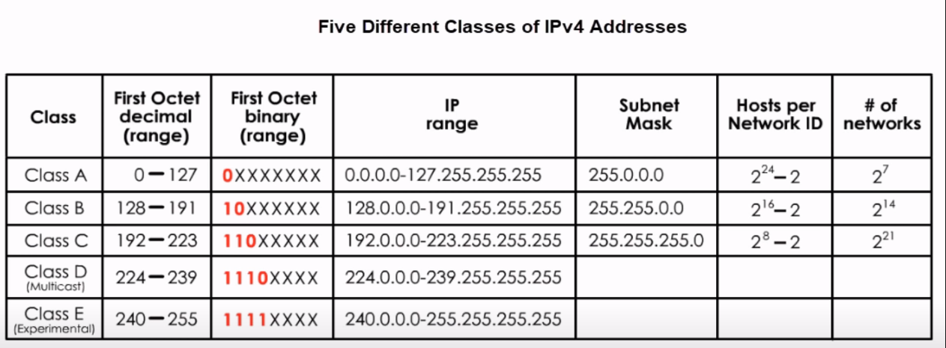
Figure 1- IPv4 Classes and their properties [11]
IPv4 addresses are divided into different classes to organise how they are used. These classes are range from class A to class E and serve different networks. Class A, B and Care used for normal IP addressing on networks, with A being for larger networks and C being for smaller networks [8]. Class D is used for multicasting networks, which allows a single host to send data to thousands of hosts across the internet. Class E addresses are not given to hosts or available for general use, these addresses are reserved for research purposes.
IPv6 was developed to solve the limitations of IPv4, as it uses 128 bit addressing. This means that IPv6 has around 340 undecillion addresses, more than enough to satisfy demand for the foreseeable future. Because of the large amount of addresses, there is no need for NAT, which was a workaround in IPv4 [9], this allows for more direct communication. IPv6 was also built with security as the foundation [9], as IPv6 requires the use of IPsec [10]. IPsec is a group of protocols which helps secure the communication between devices and works by encrypting IP packets and authentication the source where the packets have been sent from.

Routing
Routing is described as the process of how data can be directed from a starting point to an end destination [12]. This process is handled by a piece of hardware called ‘routers’ and involves making routing decisions which makes sure the shortest and most efficient path is to the destination IP address. To find the destination IP address, it analyses the address that is on the packet of data that is being routed.
Within networks, the process of routing can be carried out with two different methods, static routing and dynamic routing. Static routing is a type of routing where the packets of data that get sent through the routers have a pre-determined path to send data through that have been manually configured by a network administrator [13]. This path will not change unless adjusted manually. Because of the complex work that is required for static routing, it is typically used for much smaller networks. They are also better for security purposes, as they do not require the use of any external routing protocols, therefore making them less vulnerable to router attacks such as unauthorised route updates, or route poisoning [14]. Static networks provide poor scalability, as the network grows and the pathing becomes more complex, managing it will eventually become cumbersome. For the same reason, static networks are also vulnerable to human error, misconfiguration of any router can lead to network wide problems.
Compared to static, dynamic routing is a more advanced way of networking, where routers will automatically adjust their routing tables based on the condition of the network, this allows for the best path to the destination to always be taken. Routers will also use routing protocols to discover routes and exchange routing information. Some popular routing protocols involve Routing Information Protocol, which uses a distance vector algorithm [15] which sends its routing table to neighbouring routers. This is used for smaller scale networks that prioritise simplicity over scalability. OSPF is a link-state protocol, which will operate in a hierarchy by dividing the network into areas [15]. It is used for larger scale networks where complex routing is required. BGP is path vector routing protocol which is normally used for routing between anonymous networks, such as the internet.

Network services
A network service can be described as various functions that support the operation of a network.
A virtual Private Network (VPN) is a security tool that creates an encrypted connection over a less secure network, such as the internet. It will hide your IP address and will replace it with one from the VPN server, this will make your online activity harder to trace. VPN’s will also encrypt the data that is being sent so that third parties cannot intrude on your activity [16]. A VPN will route data traffic through a server in a different geological location, so it would appear that you were browsing in a different country, this is a way to pass through any region locked content some website may impose.
A Dynamic Host Configuration Protocol (DHCP) is a network protocol that can automatically assign IP addresses to and other configuration settings to devices, this way IP management is simplified by eliminating the need for manual configuration [17]. This works when a device connects to the network, it will broadcast a request for an IP address. A DHCP server will send an IP address to the device from a pool of IP’s, along with additional configuration information such as the default gateway DNS address and subnet mask.
An ADDS is used in windows networks that provides a centralized directory [18] that will store and organise objects like computers and network resources. It can control the access throughout the network by limiting who can access what. It also helps administrators and users to find and use information. It is built on a centralised management scheme which allows one point of control for users, devices and security policies, which streamlines the configuration and management of a large network [18].

Task 2 – Technical Documentation
In this section there will be documenting screenshots and accompanying commentary to display my understanding of the task and network topology.

Choosing the Hypervisor
I have chosen to use a type 2 hypervisor for this project because compared to type 1, its features fit the requirements of my project better. This is because they’re more user friendly, and easier to install and are great for development environments, which is what I need for testing my virtual networks connectivity between the servers and clients.
Because this is only a small project with a small network, I have no need to take advantage of the type 1 hypervisors great scalability and higher performance. This project will be using OracleBoxVM as its hypervisor.

Windows download
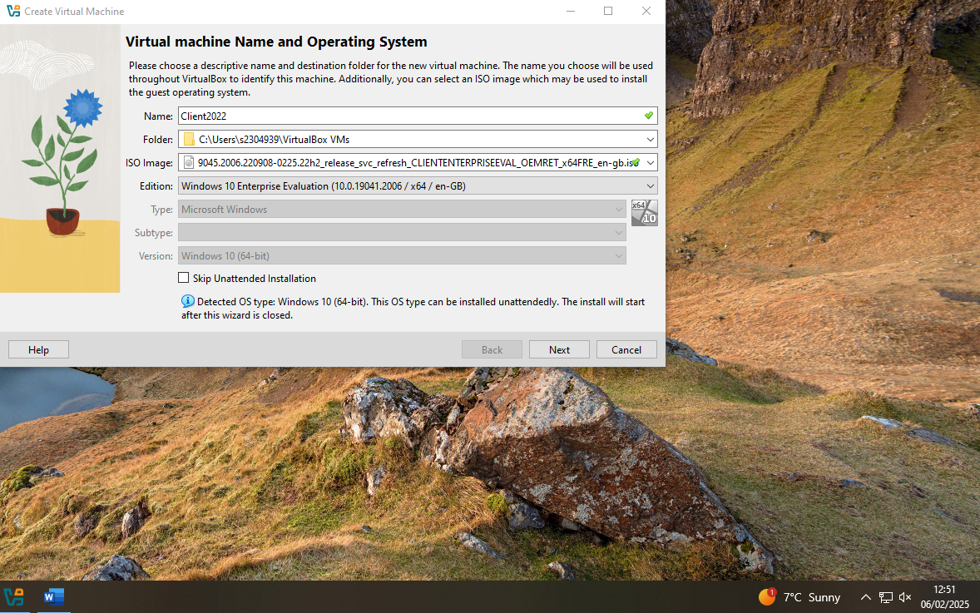
This is the download of the windows client, here, the downloaded ISO is selected, and the windows edition has to be selected.
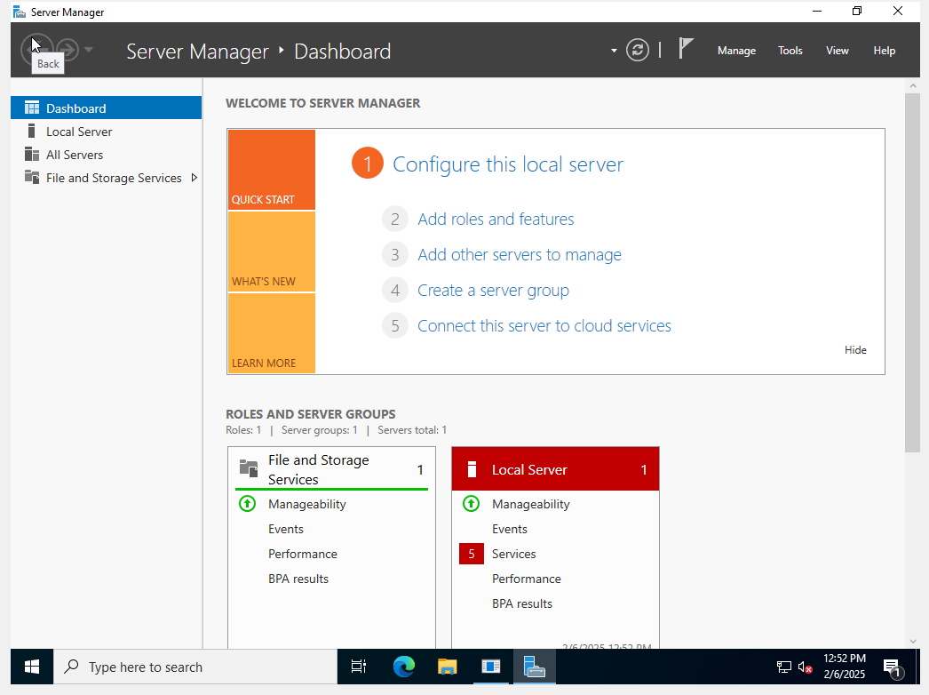
This is the installation of the windows server, after the installation, the server manager is where you can manage the connectivity and configuration of the server.

Linux download
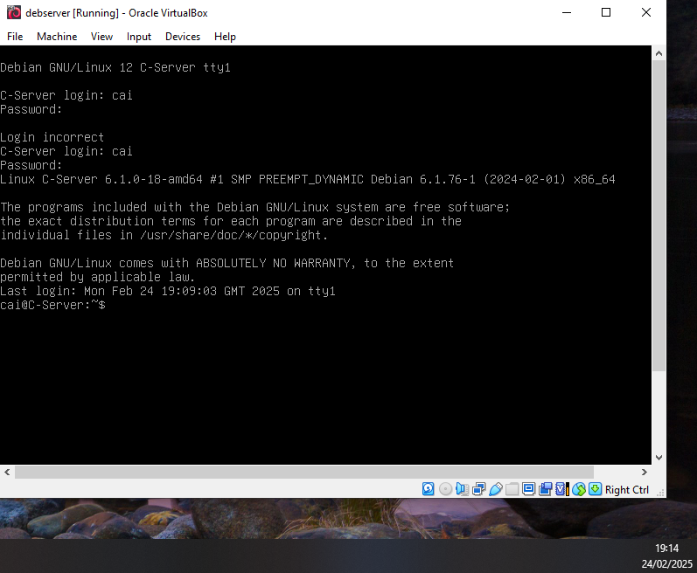
Here I have downloaded the Debian server for Linux, I have set the c-server login as my name, and I have also set a password.

Testing connectivity – Windows
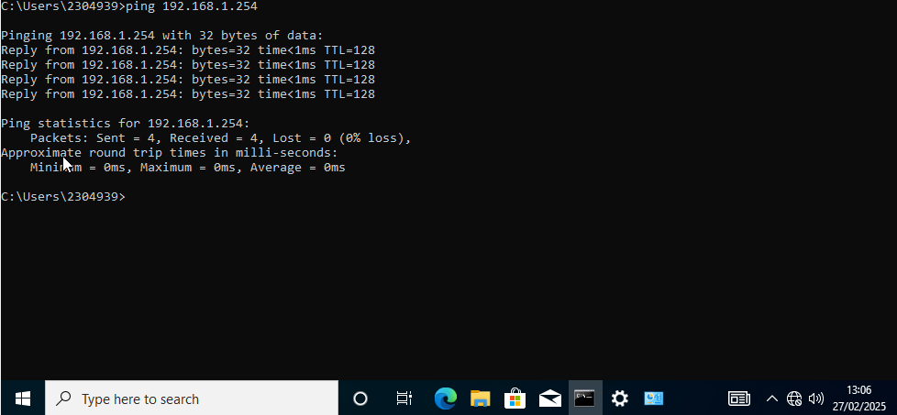
Here, this screenshot shows a successful ping from the client to the server, here I have 0% packet loss meaning the ping was successful. To make sure the pings were successful, the firewall on both the server and client had to be disabled.

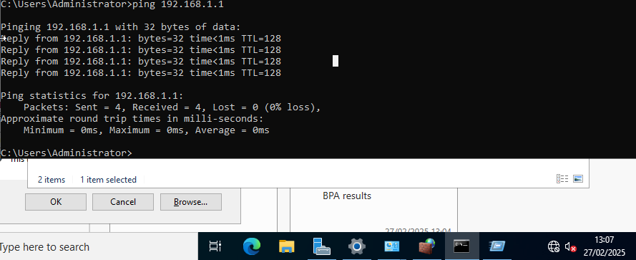
This is the server client ping; here you can again see that there is 0% packet loss meaning the ping was successful.

Testing connectivity – Linux
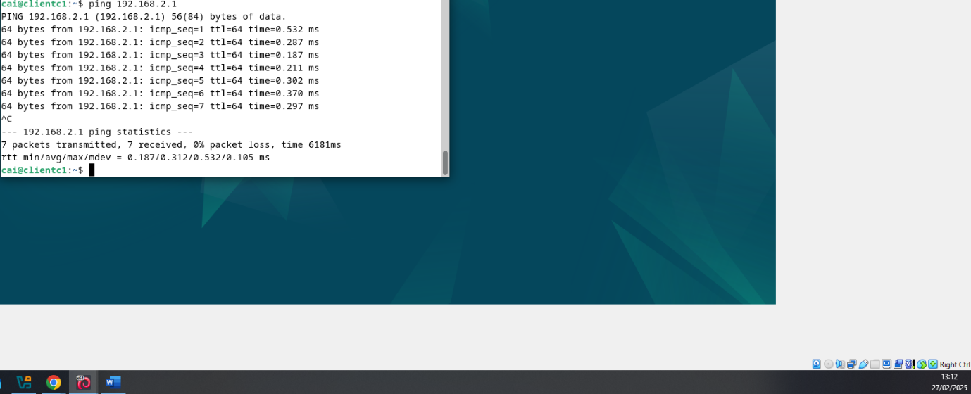
Here is the Linux client pinging the server
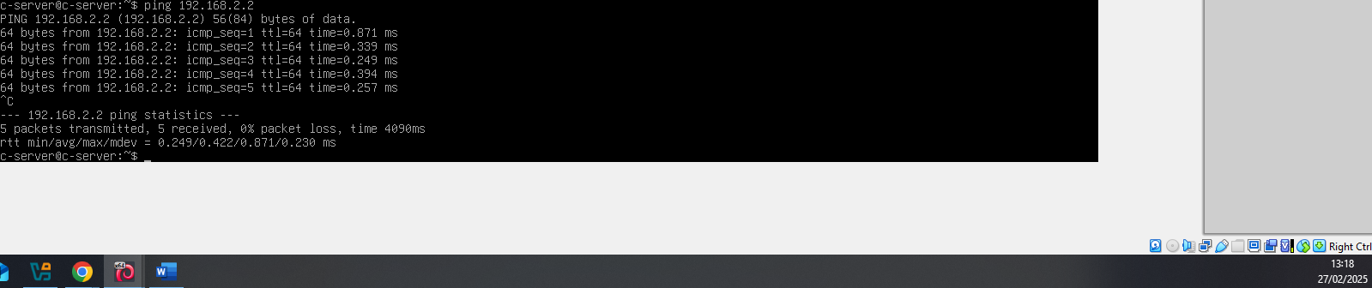
This is the Linux server pinging the client

Testing connectivity – Server to server
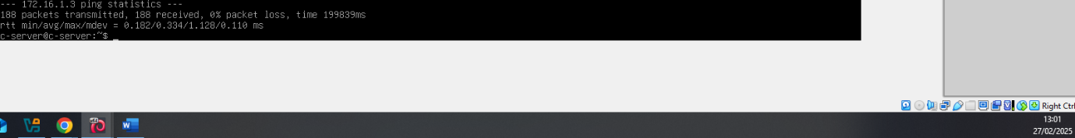
To complete testing connectivity in my network, I had to ping the two servers, here, the Linux server is pinging the windows server
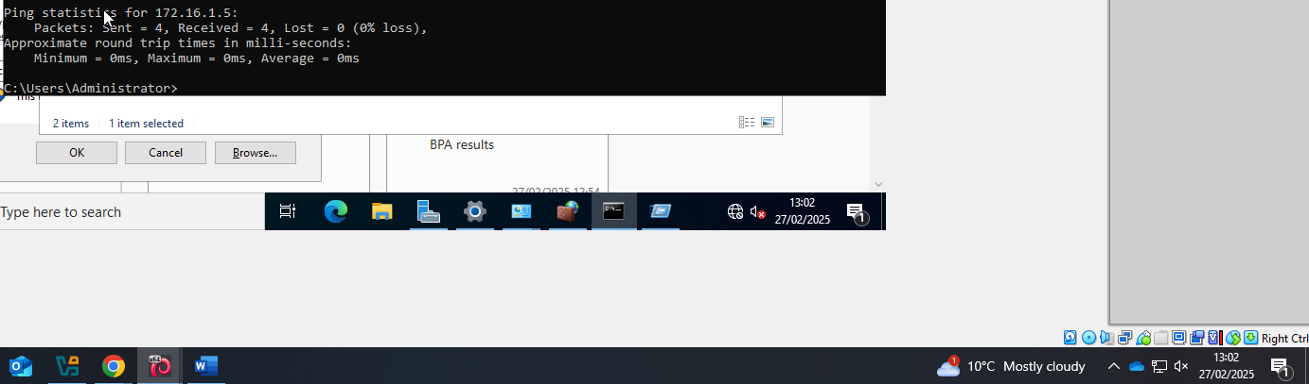
This is the windows server pinging the Linux server, both servers have no packet loss when pinging, therefore are fully connected and the network is working.

Task 3 - Reflection
When deploying my network, initially the connectivity between my windows server and client wouldn’t connect even though the IP addresses were correct and configured properly. This was because of the firewall, to solve this problem I had to disable the firewall on both the server and client, this however is a security issue, so in further coursework I will be configuring the firewall to accept data from established IP’s, instead of turning it off completely.
My ability and understanding of configuring networks have grown substantially over the time of this coursework, I found the beginning to be difficult as I had little understanding of how networks operate, but after my understanding grew, I found it to get easier.

Bibliography
[1] S. Simic, “How to Implement Validation for Restful Services with Spring,” Knowledge Base by phoenixNAP, Jan. 24, 2019. https://phoenixnap.com/kb/what-is-hypervisor-type-1-2 (accessed Feb. 18, 2025).
[2] V. Yfantis, “Hypervisor, what is it and its benefits. | Parallels Explains,” Parallels Remote Application Server Blog - Application virtualization, mobility and VDI, Apr. 30, 2020. https://www.parallels.com/blogs/ras/hypervisor/ (accessed Feb. 18, 2025).
[3] jean lou, “What is a Hypervisor? Understanding Types, Benefits, and Their Role in Virtualization,” MonoVM.com, Jan. 05, 2025. https://monovm.com/blog/what-is-a-hypervisor/#What-is-a-Hypervisor? (accessed Feb. 18, 2025).
[4] S. Bigelow and B. Kirsch, “What’s the difference between Type 1 vs. Type 2 hypervisor?,” Techtarget, Jan. 13, 2021. https://www.techtarget.com/searchitoperations/tip/Whats-the-difference-between-Type-1-vs-Type-2-hypervisor (accessed Feb. 18, 2025).
[5] N. Bisht, “Hypervisor,” GeeksforGeeks, Jul. 23, 2018. https://www.geeksforgeeks.org/hypervisor/ (accessed Feb. 18, 2025).
[6] UMATechnology, “Type 1 Vs Type 2 Hypervisor - What’s The Difference? - UMA Technology,” UMA Technology, Jan. 20, 2025. https://umatechnology.org/type-1-vs-type-2-hypervisor-whats-the-difference/ (accessed Feb. 18, 2025).
[7] “IPv4 Address Report,” ipv4.potaroo.net. https://ipv4.potaroo.net/ (accessed Feb. 25, 2025).
[8] Meridian Outpost, “5 Classes of IPv4 Addresses [Class A, B, C, D and E],” www.meridianoutpost.com, 2024. https://www.meridianoutpost.com/resources/articles/IP-classes.php (accessed Feb. 25, 2025).
[9] “Structure and Types of IP Address,” GeeksforGeeks, Mar. 01, 2021. https://www.geeksforgeeks.org/structure-and-types-of-ip-address/ (accessed Feb. 25, 2025).
[10] Cloudflare, “What is IPsec? | How IPsec VPNs work | Cloudflare UK,” Cloudflare, 2022. Available: https://www.cloudflare.com/en-gb/learning/network-layer/what-is-ipsec/ (accessed Feb. 25, 2025).
[11] G. much !, “Tricks to remember five classes of IPv4,” Networks & Security, Jun. 19, 2021. https://medium.com/networks-security/tricks-to-remember-five-classes-of-ipv4-484c191678fb (accessed Feb. 25, 2025).
[12] “What is Routing?,” GeeksforGeeks, Dec. 11, 2023. https://www.geeksforgeeks.org/what-is-routing/
[13] “What is Static Routing? | Static Routes | Cisco Static Routes ⋆ IpCisco,” IPCisco. https://ipcisco.com/lesson/static-routes/
[14] M. Hamza, “Common Attacks On Routing Protocols And How To Mitigate Them,” Medium, Nov. 08, 2020. https://hamzamhirsi.medium.com/common-attacks-on-routing-protocols-and-how-to-mitigate-them-11ec0cad08d7
[15] T. Keary, “Routing Protocol Types - The Ultimate Guide (The Essentials!),” Comparitech.com, 2018. https://www.comparitech.com/net-admin/routing-protocol-types-guide/
[16] C. Hoffman and N. Lewis, “What Is a VPN, and Why Would I Need One?,” How-To Geek, Apr. 19, 2018. https://www.howtogeek.com/133680/htg-explains-what-is-a-vpn/
[17] GeeksforGeeks, “Dynamic Host Configuration Protocol (DHCP) - GeeksforGeeks,” GeeksforGeeks, Jul. 01, 2024. https://www.geeksforgeeks.org/dynamic-host-configuration-protocol-dhcp/
[18] Microsoft, “Active Directory Domain Services Overview,” learn.microsoft.com, Aug. 16, 2022. https://learn.microsoft.com/en-us/windows-server/identity/ad-ds/get-started/virtual-dc/active-directory-domain-services-overview

