An Analysis of the Noise Resistance of Analogue Modulation Techniques __________________________________________________
And other fun topics to bring up at a party: Volume II


Jack Lonsdale
Embedded Electronic Systems Year 3
October 2023
Word Count: 2181

Contents
Introduction 3
Background Research 3
Literature Review 6
Task 1: AM Modulation 7
Receiver and Transmitter Architecture 7
Block Diagram 7
Circuit Diagram 8
Results and Analysis: 8
AM in time and frequency Domain: 8
Varying Modulation Index: 9
Comparison of Message Signal and Demodulated Message: 9
Task 2: DSB-SC 12
Receiver and Transmitter Architecture 12
Block Diagram 12
Circuit Diagram 13
Results and Analysis 14
DSBSC Modulation and Demodulation 14
The effects of increasing noise 15
Task 3: FM Modulation 19
Receiver and Transmitter Architecture 19
Block Diagram 19
Circuit Diagram 20
Results and Analysis 21
Conclusion 23
Recommendations on Future Work 24
Appendices 24
Appendix A: AM Components Selection 24
Appendix B: FM modulation and demodulation maths 25
Appendix C: DSB-SC Component Justification 26
Appendix D: FM Modulator component selection 27
Appendix E: Maths of FM Modulation 27
References 28

Introduction
Communications technology has changed the world significantly. Allowing information to be transferred from one side of the planet to the other, and even into space, it forms the infrastructure that is relied upon by everyone.
One key aspect of this domain is analogue communications, the means by which analogue signals are encoded onto sine waves, and transmitted. Upon reception, these signals have inherited noise, reducing the clarity of what was transmitted, potentially even to the point of erroneous replication.
There are many techniques for doing this, the two main types are Amplitude Modulation (AM) and Frequency Modulation (FM). These different methods both have different levels of resistance to noise.
In this assignment, the noise resistance of both these techniques will be investigated by constructing models of each in MATLAB’s Simulink, and observing the effects of increasing noise.

Background Research
Most electrical signals we wish to transmit cannot easily be transmitted directly. They often widely differ in frequency, resulting in two main problems:
- Many different antennas would be needed to transmit and receive due to the different frequencies.
- A large portion of the electromagnetic spectrum would be required for just a single transmission.
The first solution discovered for this problem was to modulate the amplitude of a carrier wave with the signal to be transmitted, (Amplitude Modulation, AM). This allows for the use of a single antenna, and conserves the EM spectrum.
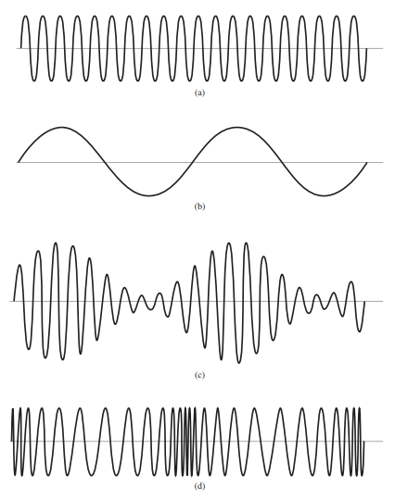
Above: Fig. 1.1, A diagram showing: a carrier wave (a), a message signal (b), AM modulated carrier wave (c), and FM modulated carrier wave(d) . [2]
Consider the carrier wave c(t) and message signal m(t):
$$c\left(t\right)= A_{c}sinω_{c}t m\left(t\right)= A_{m}sinω_{m}t$$
Above: Equations 1.1 (left) and 1.2 (right), mathematically categorizing the carrier wave and message signal [4]

Our modulated wave is given by:
$$V_{AM}Sin(ω_{c}t)$$
Above: Equation 1.3, Equation of modulated wave [4].
With some substitution and simplification, we come to:
$$V_{AM}=\left[A_{C}+m\left(t\right)\right]Sin(ω_{c}t)$$
$$V_{AM}=\left[A_{C}+A_{m}sin⁡(ω_{m}t)\right] Sin(ω_{c}t)$$
$$V_{AM}= A_{C}\sin\left(ω_{c}t\right)+ \frac{1}{2}mA_{C}\left[\cos\left(ω_{c}-ω_{m}\right)t- \cos\left(ω_{c}+ω_{m}\right)t\right]$$
Above: Equation 1.4, Equation of AM wave [4].
DSB-SC (dual side-band, suppressed carrier) is a technique for amplitude modulation that reduces the power wasted transmitting the carrier wave [3]
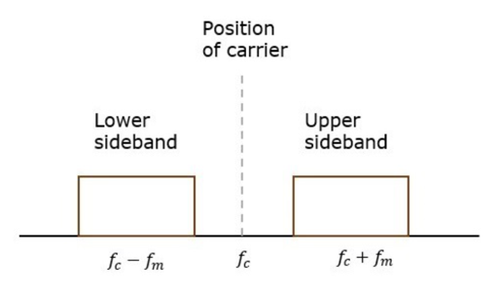
Above: Fig. 1.2, Frequency domain of DSB-SC AM Signal [3].
However, AM is prone to disruption from noise. The solution to this was a more robust modulation technique: Frequency Modulation (FM). A technique where the frequency of the carrier wave is altered (modulated) by the message signal (Fig. 1.1) improving immunity to noise. The signal to noise (SNR) performance of AM is 4.8dB worse than an unmodulated signal, and FM is 15.7dB better than unmodulated signals [1].
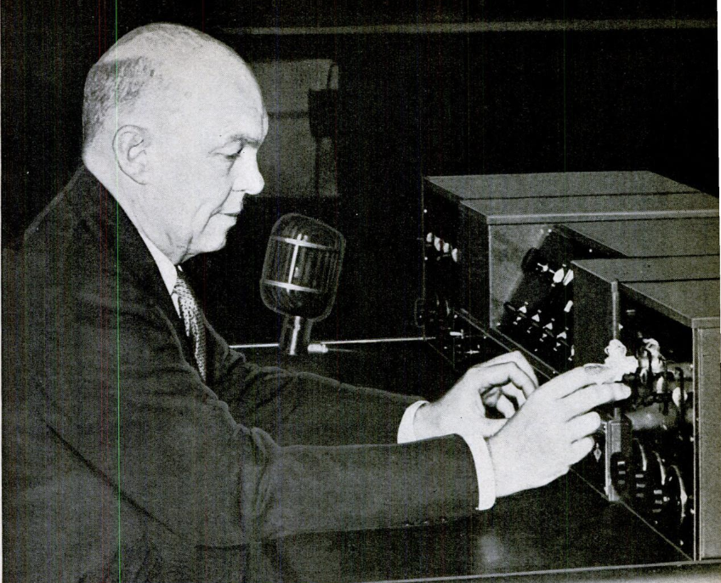
Above: Fig. 1.3, Major Edwin H. Armstrong, inventor of FM radio, tending to his creation [6]
For a breakdown of the maths of FM, please refer to Appendix E.

Literature Review
Analogue communications are important for all industries (directly or indirectly). Much research has been conducted on the effects of noise, and its ability to degrade the strength of a signal. Finding modulation techniques that have a higher resistance to noise allows signals to travel further before losing the information they encode. Increasing the distance of communications, reducing hardware costs and complexity, and increasing signal fidelity are natural goals of engineers everywhere.
AM and FM are techniques that have been utilized for several decades, as such there is not much recent research into their respective noise resistance, however it is well documented within academic literature that FM has significantly better noise resistance than AM. Due to its nature, noise changes the amplitude of a signal, but has a much smaller effect on its frequency.
Several techniques exist to reduce the impact of noise on electronics systems and specifically AM and FM systems, including [8]:
- Bandwidth Limiting
- Using Low Noise Amplifiers
- Noise Filtering
It is also well documented that significant noise exists at twice the frequency of national power grids (50Hz in UK) [9].

Task 1: AM Modulation

Receiver and Transmitter Architecture

Block Diagram
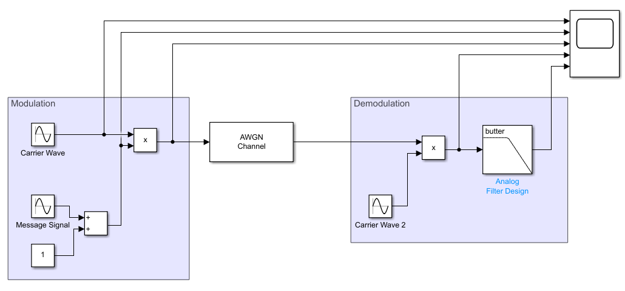
Above: Fig. 2.1, A simple AM modulator
The AM modem shown above in Fig.2.1 can be broken down into three main stages:
- The modulator applies a bias voltage to the message signal, ensure all of the waveform is positive. This is then multiplied by the carrier wave, producing the modulated signal.
- The signal is transmitted, passing through an AWGN (additive white gaussian noise) channel, simulating the atmospheric noise between transmitter and receiver.
- The demodulator multiplies the signal by an identical copy of the carrier wave and is passed through a low-pass filter, removing the carrier wave through a technique known as envelope detection [10].

Circuit Diagram
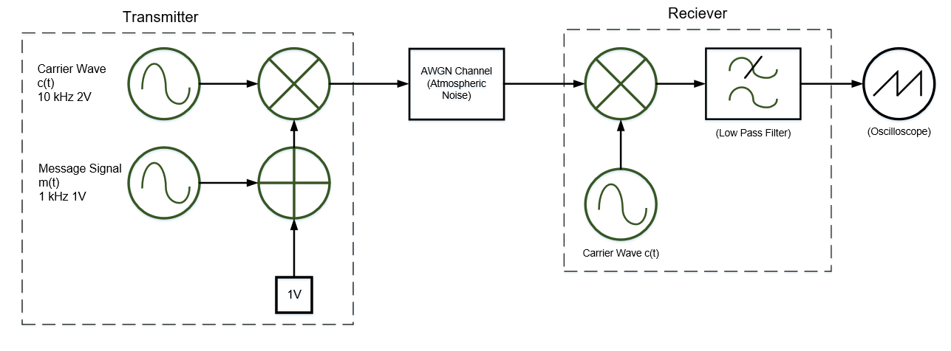
Above: Fig. 2.2, Circuit Diagram for A simple AM modem.
Key Components used:
For a greater explanation on the rational of the following selections, please refer to appendix A: AM Component selection.
- The carrier wave was selected to have a 10KHz frequency, significantly greater than message frequency, removing the possibility of aliasing.
- The message signal had an amplitude varying from 0.5 to 1.5 to observe the effects of under-modulation, critical modulation, and over-modulation.

Results and Analysis:

AM in time and frequency Domain:
Starting with a modulation index of 1:
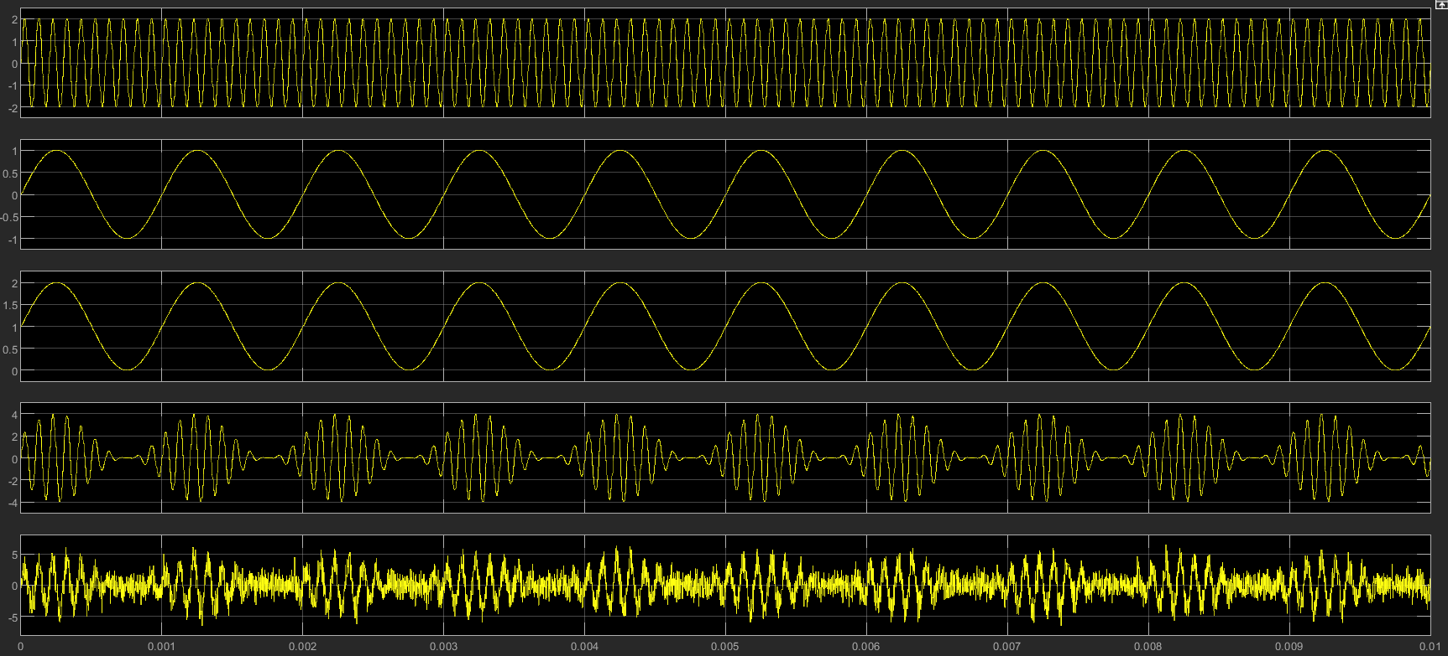
Above: Fig. 2.3, Oscilloscope trace showing the output of the different stages of the AM modulator.
The traces shown above in fig. 2.3 show (respectively):
- The Carrier Wave
- The Message Signal
- The message signal with DC bias applied
- The modulated wave (product of the carrier wave and message signal)
- Modulated wave with Gaussian noise (Signal to Noise Ratio (SNR) of 0)

Varying Modulation Index:
When the modulation index is changed, then over-damping and under-damping can be observed in Fig. 2.4 and Fig. 2.5 below:
Above: Fig. 2.4 AM modulation: Over-Modulation with a modulating factor of 1.5
When compared to (critically modulated) trace 4 of Fig.2.3, it is seen that the ripples begin to increase in magnitude when the message signal is at its lowest value(over-modulation).
Above: Fig. 2.5 AM Modulation: Under-Modulation with a modulating factor of 0.5
When compared to trace 4 of Fig. 2.3, it can be seen that the ripples never reduce to 0, even when the message signal is at its lowest value (under-modulation).

Comparison of Message Signal and Demodulated Message:
Time Domain:
You can see the comparison of the original message signal to a demodulated signal in Fig. 2.6 below:
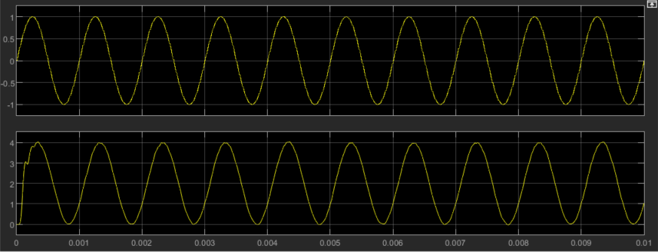
Above: Fig. 2.6, Message Signal fed to the modem (top trace), and respective output signal (bottom trace).
The demodulated signal represents the message signal accurately with two minor changes:
- The negative phase shift caused by the delay of the circuit. Most of this delay is caused by the low-pass filter, as the output signal takes time to settle.
- The jagged shape of the rising edge of the first wave, this is caused by the initial charging and discharging of the RLC components in the low-pass filter.
Frequency Domain:
Looking at the EM spectrum for the signals, we see the following picture in Fig. 2.7, below:
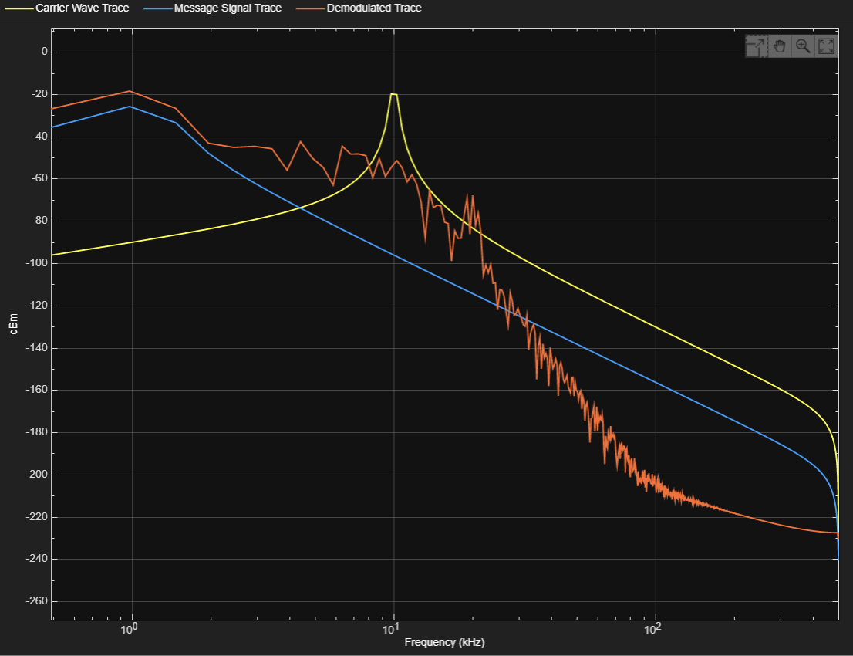
Above: Fig. 2.7, Frequency Response of the AM modem, showing the Carrier wave, Message signal, and demodulated signal.
Carrier Wave:
The trace of the carrier wave displays exactly as expected: a peak-shape centered around the carrier frequency: 10 kHz.
Message Signal:
Similarly, the message signal is another peak centered at the message frequency: 1 kHz.
Demodulated Signal:
The frequency response of the demodulated trace has a ripple caused by the gaussian noise. It is observed that these ripples increase in magnitude as frequency decreases. The exact cause of this would require further investigation.
The trace shown was for an SNR of 0. As the SNR reduces further, the ripples increase in size slightly, as shown in figures 2.8, 2.9, and 2.10 below:
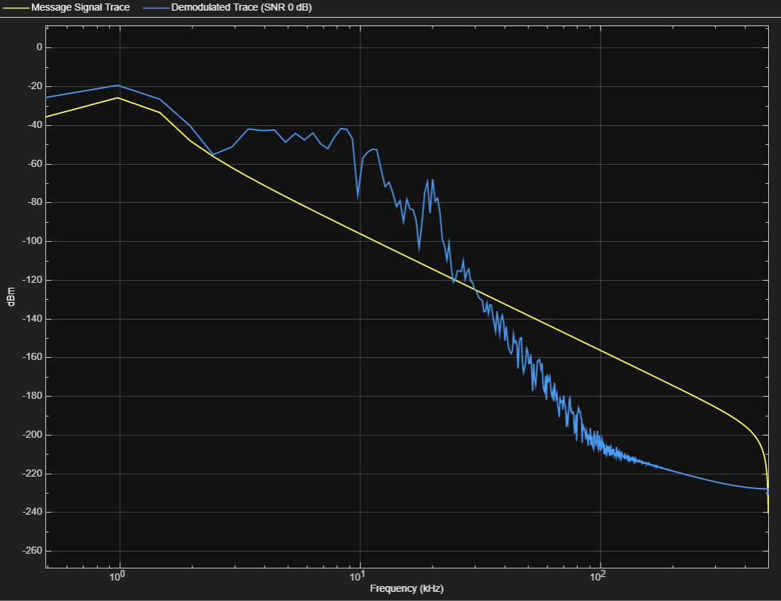
Above: Fig. 2.8, A frequency response showing the difference between the message signal, and demodulated message signal (SNR = 0).

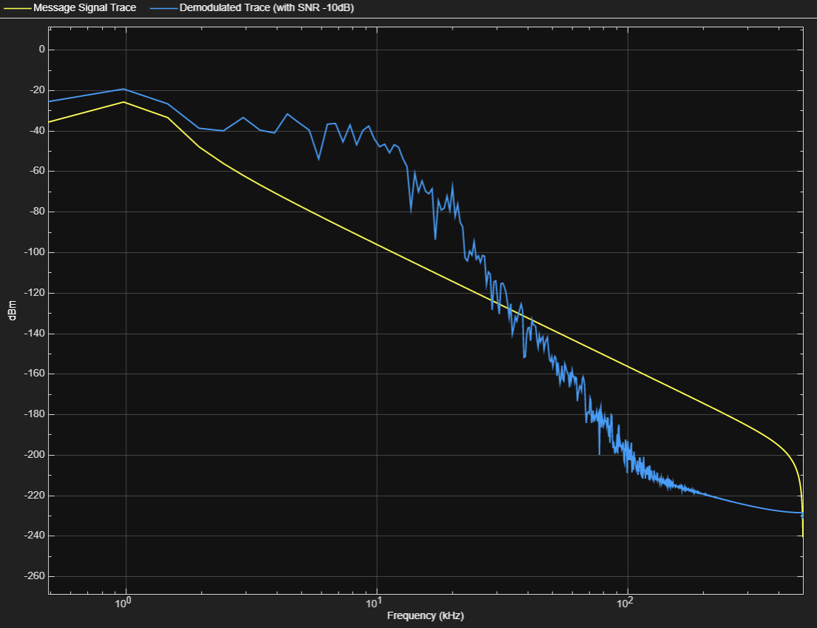
Above: Fig. 2.9, A frequency response showing the difference between the message signal, and demodulated message signal (SNR = -10).
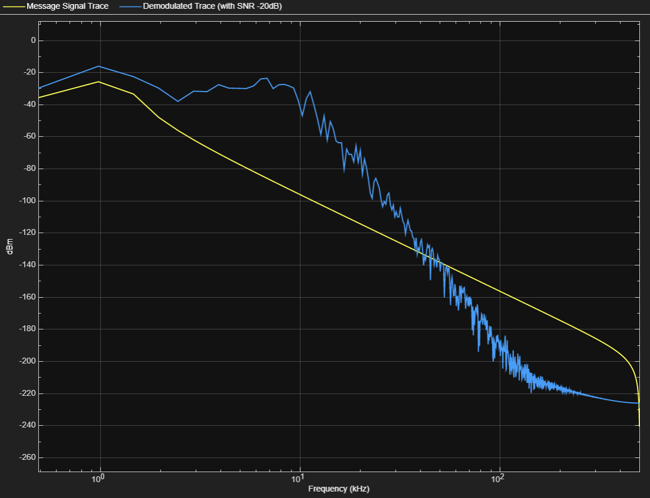
Above: Fig. 2.10, A frequency response showing the difference between the message signal, and demodulated message signal (SNR = -20).

Task 2: DSB-SC

Receiver and Transmitter Architecture

Block Diagram
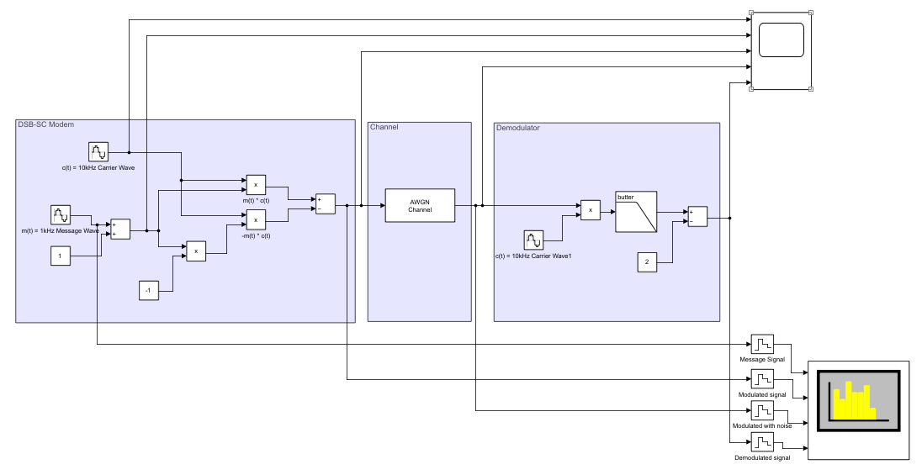
Above: Fig. 3.1, Block Diagram of DSB-SC Modulator
The DSB-SC (Dual Sideband, Suppressed Carrier) modem operates similarly to the AM modulator. The modulator adds a DC bias voltage to the message signal and multiplies by the carrier wave. The demodulator is the same, filtering the carrier wave out, and subtracting the DC bias voltage.
However, as a balanced DSB-SC, the carrier wave c(t) is multiplied by the message signal m(t) [11]:
$$S_{1}\left(t\right)=m\left(t\right) ×c(t)$$
And the same is done for a reflection of m(t):
$$S_{2}\left(t\right)= -m\left(t\right)×c(t)$$
Then S₂(t) is subtracted from S₁(t):
$$S\left(t\right)= S_{1}\left(t\right)- S_{2}\left(t\right)$$
This acts to suppress the carrier wave from the transmitted signal, saving power.

Circuit Diagram
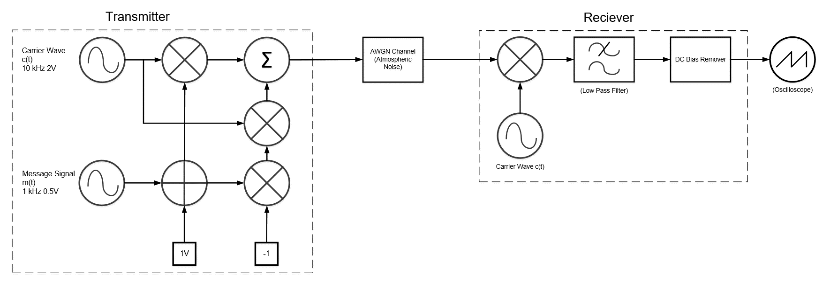
Above: Fig. 3.2, Circuit Diagram of DSB-SC Modem
Components involved:
For a more in-depth explanation into the justification for component specification, please refer to Appendix C: DSB-SC Component Justification
- Carrier wave and message signals:
  - Same frequencies as AM Modulator
  - Since the modulation index of the carrier is set to be 0.5, the amplitude of the message signal was set to 0.5.
- DC Bias remover: subtracts the bias voltage from the demodulated signal.

Results and Analysis

DSBSC Modulation and Demodulation
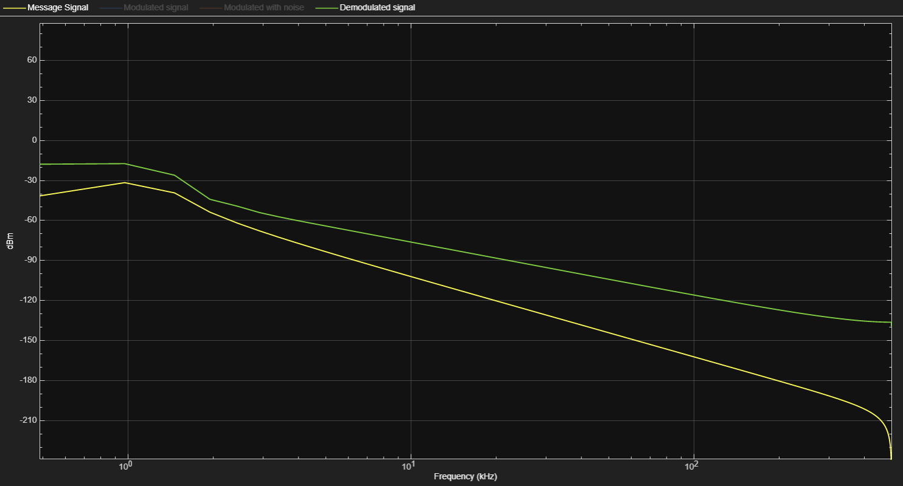
Above: Fig. 3.3, The frequency response for the message signal (yellow) and Demodulated signal (green).
As expected, the demodulated signal is a similar shape to the original message signal, with the same peak at 1 kHz. The vertical difference can be explained by amplification of the signal in the demodulator.
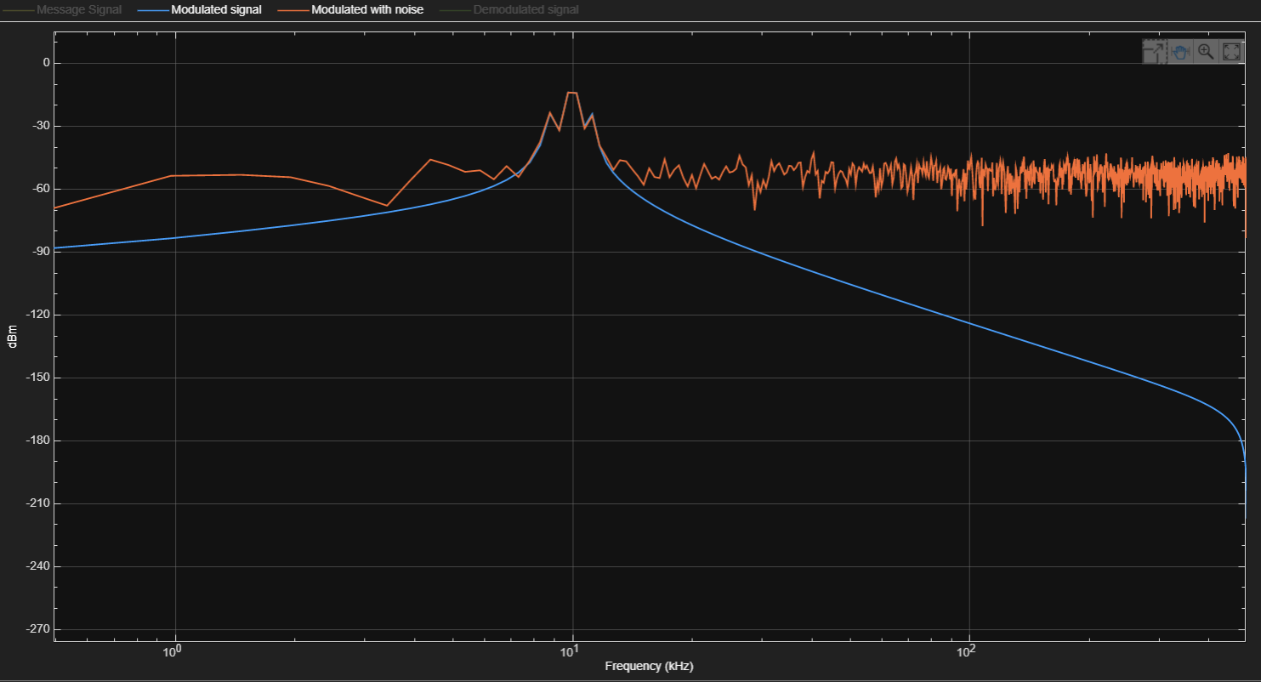
Above: Fig. 3.4, The frequency response for the transmitted signal (blue) and received signal (with noise added).
When looking at the transmitted signals, you can see a flat top to the peak, with two peaks at either side. This is slightly different to the expected behavior, shown below:
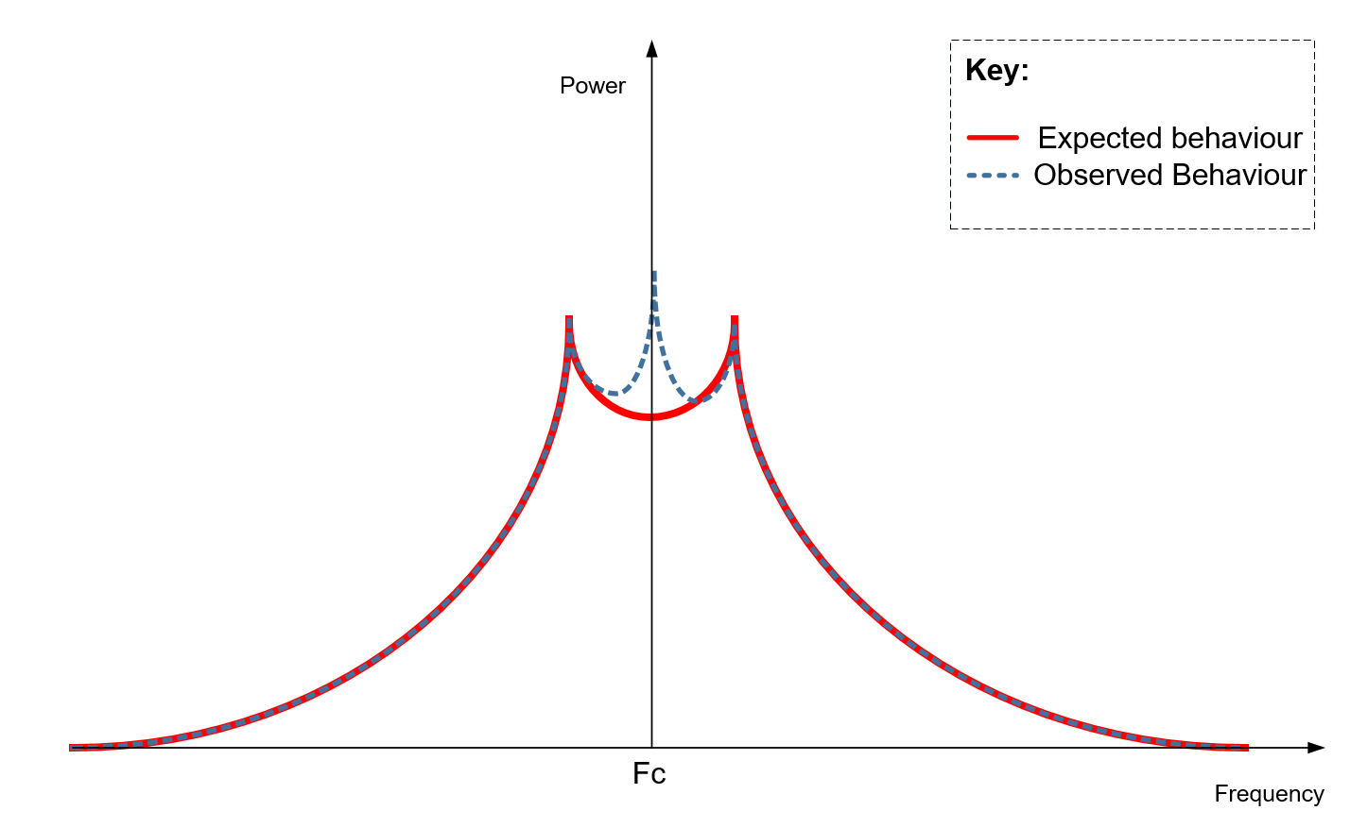
Above: Fig. 3.5, The expected and observed frequency response from the DSB-SC modulator.
The expected behavior would be for a trough at the carrier frequency (10 kHz) rather than slightly either side of the peak. To find why this isn’t the case would require further investigation.

The effects of increasing noise
The multimedia block in Simulink isn’t working, so instead of playing audio, I’ll continue to use sinusoidal waves as input.
Frequency domain
There is seemingly little change in the frequency domain of the demodulated signal with increasing noise, as shown below by figures 3.6, 3.7, and 3.8 with respective SNRs of 0dB, -6dB, and -12dB. This may seem to suggest that the frequency domain has a greater noise resistance that the time domain.
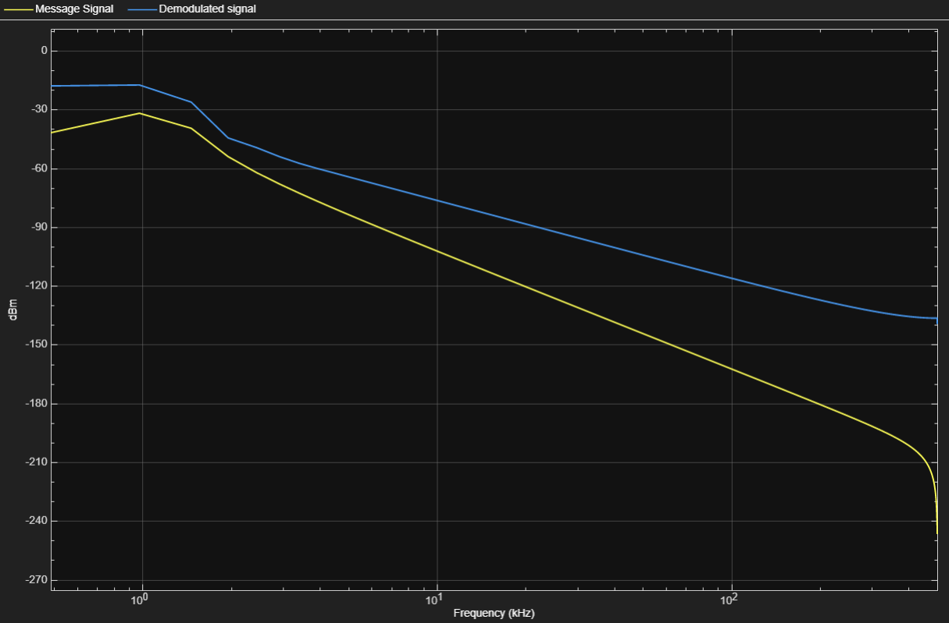
Above: Fig. 3.6, Frequency response of the message and demodulated signals with a SNR of 0dB.

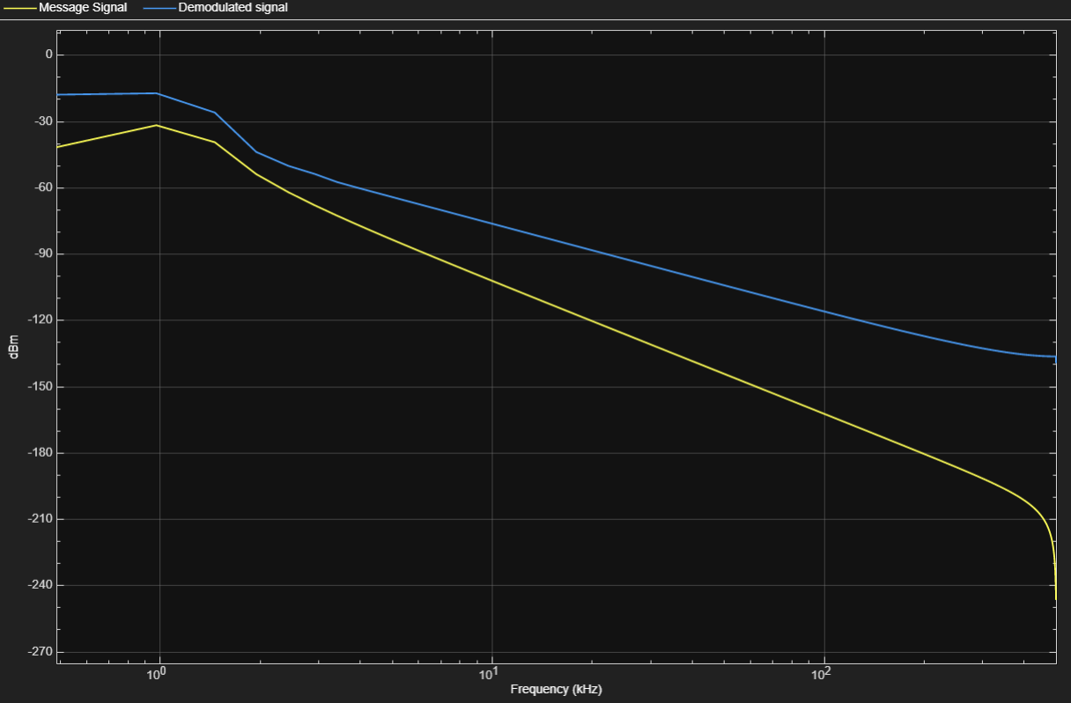
Above: Fig. 3.7, Frequency response of the message and demodulated signals with a SNR of -6dB.
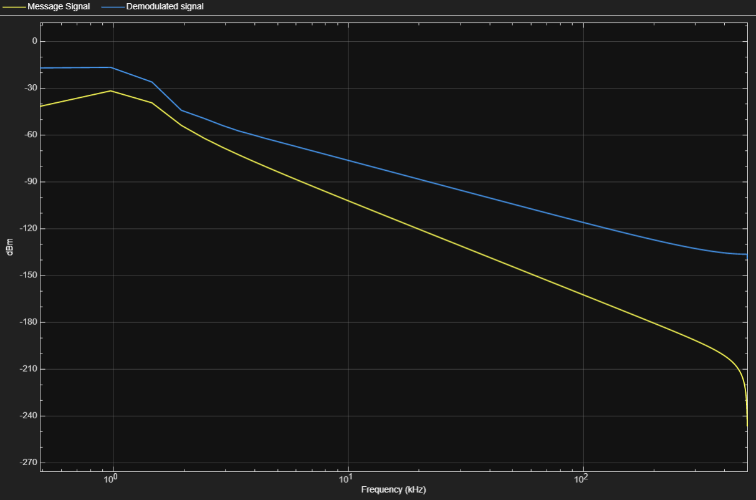
Above: Fig. 3.8, Frequency response of the message and demodulated signals with a SNR of -12dB.
However, FM can still be fallible to noise in sufficient quantity, as shown below in Fig. 3.9:
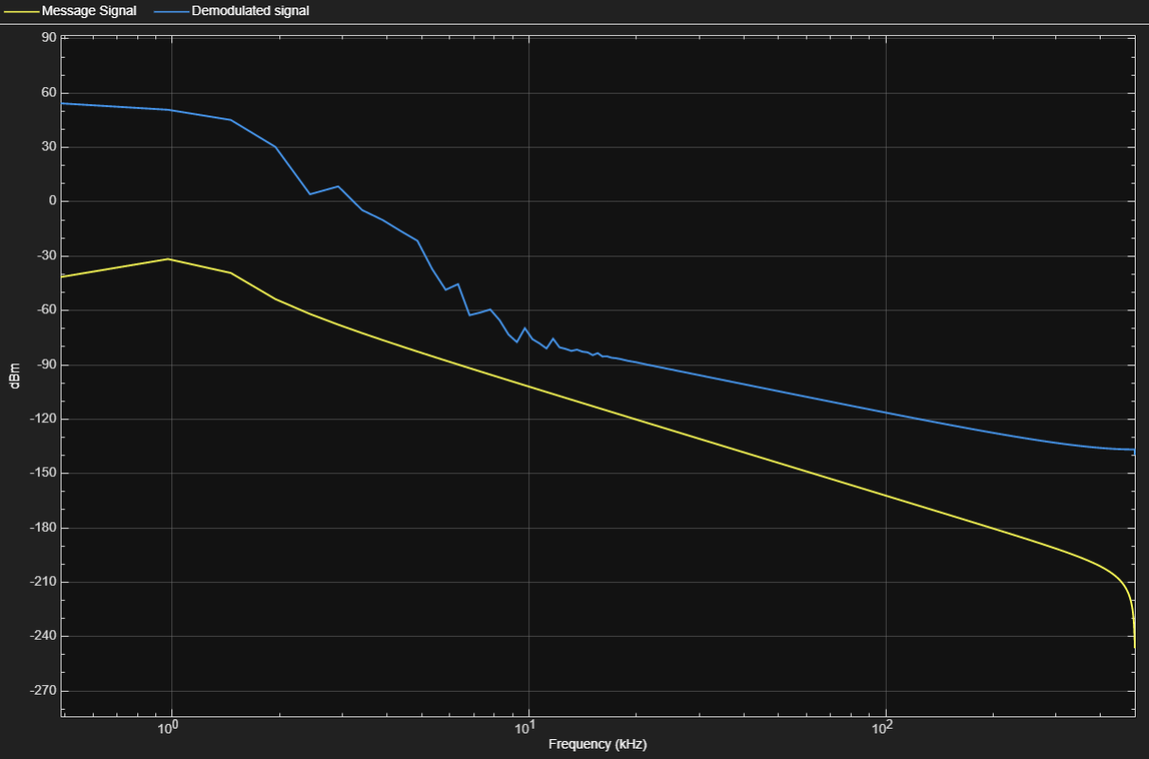
Above: Fig. 3.9, Frequency response of the message and demodulated signals with a SNR of -100dB.

Time Domain
In the time domain, the signal was clearly distorted with increasing levels of noise. With an SNR of 0 (Fig. 3.10, below) we can see a sine wave of roughly constant amplitude after T=0.04:
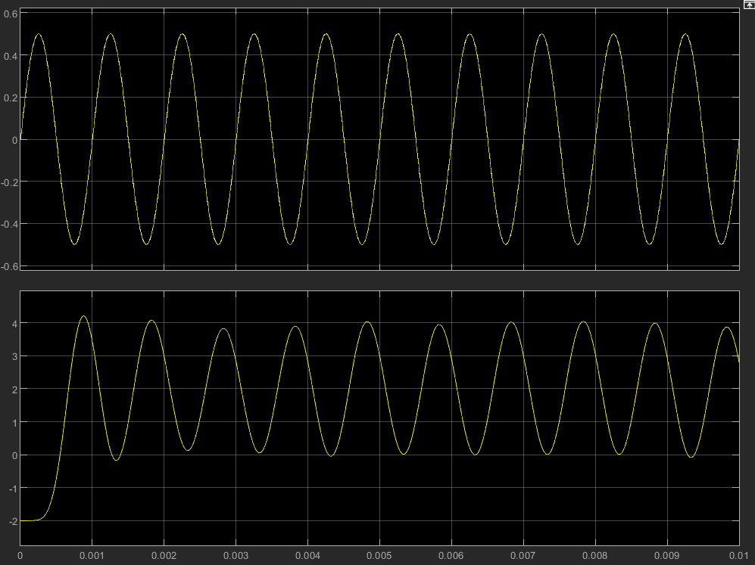
Above: Fig. 3.10, Oscilloscope trace showing the message signal (top), and demodulated signal (bottom) at an SNR of 0 dB
At an SNR of -6dB (shown below in Fig. 3.11), we can see the peaks and troughs of the received signal changing slightly between cycles:
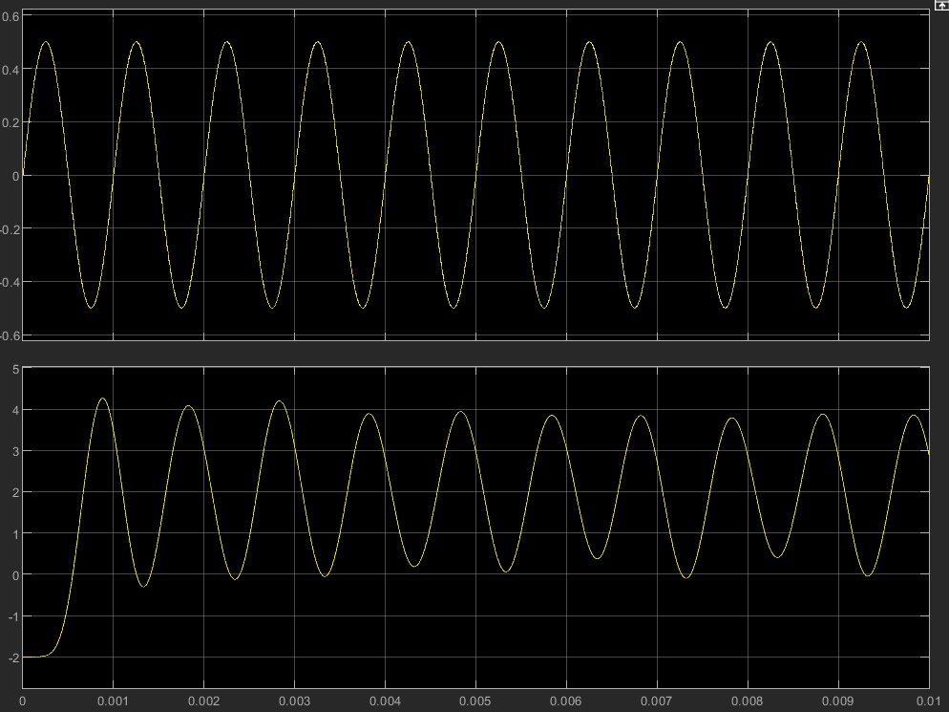
Above: Fig. 3.11, Oscilloscope trace showing the message signal (top), and demodulated signal (bottom) at an SNR of -6 dB
At -12dB SNR (shown below in Fig. 3.12), the demodulated signal isn’t even recognizable as a single sine wave, with constantly changing amplitude:
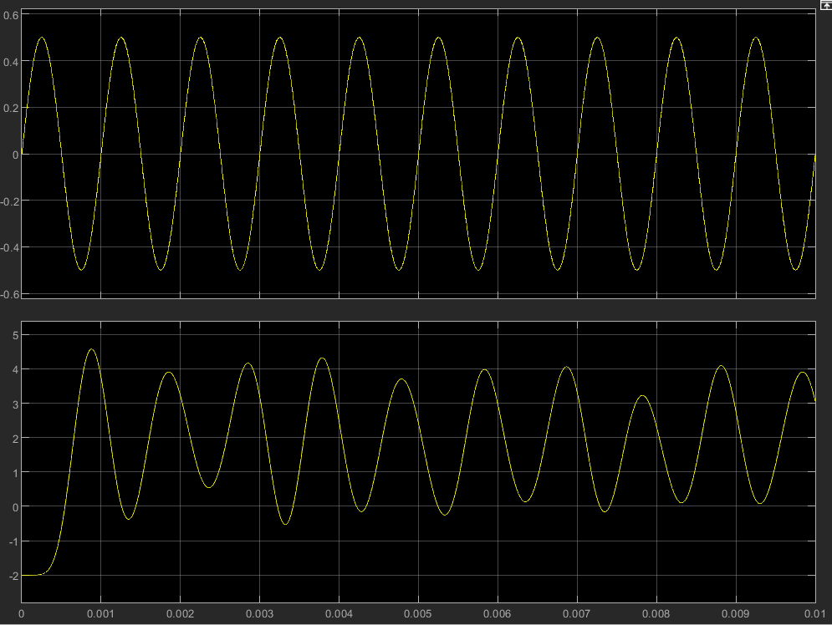
Above: Fig. 3.12, Oscilloscope trace showing the message signal (top), and demodulated signal (bottom) at an SNR of -12 dB

Task 3: FM Modulation

Receiver and Transmitter Architecture
For a breakdown of the maths involved, please refer to Appendix B.

Block Diagram
The hardware implementation of FM modulation follows the equations in Appendix B, shown below in figure 4.1:
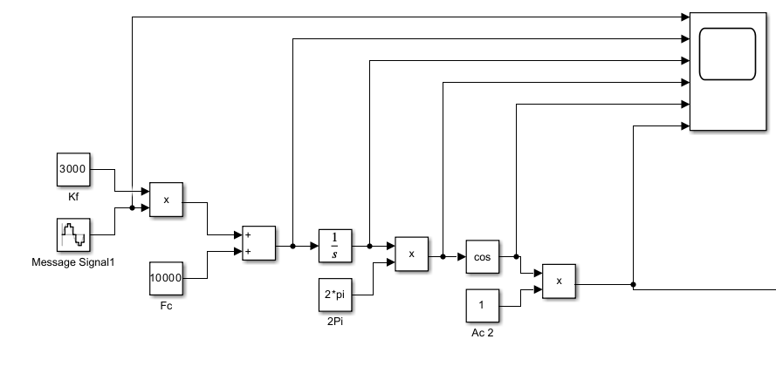
Above: Fig. 4.1, Block diagram of FM modulator. For an explanation on the selected constant values, please refer to “Circuit Diagram” section.
- The message signal is first multiplied by K_{f}, then summed with the desired carrier frequency (10 kHz).
- The result is integrated, and multiplied by 2π
- The cosine block is employed to carry out the trigonometric function on our signal
- The signal is amplified to change the carrier amplitude
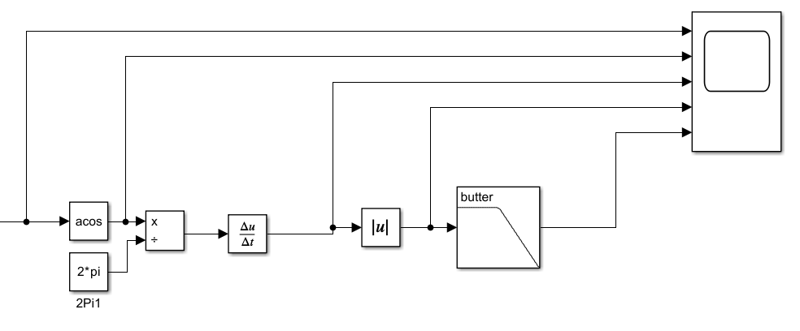
Above: Fig. 4.2, Block diagram of FM demodulator.
- The inverse cosine block is used to apply the trigonometric function, revealing $θ_{i}$.
- $θ_{i}$ is divided by 2π and differentiated, producing a scaled version of the message signal.
- The absolute block and low pass filter act as an envelope detector, producing the output.

Circuit Diagram
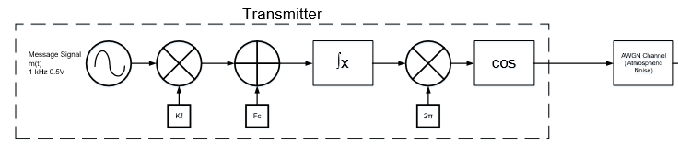
Above: Fig. 4.3, Circuit Diagram of FM Modulator.
For a breakdown of why each component and constant was selected, please refer to Appendix D.

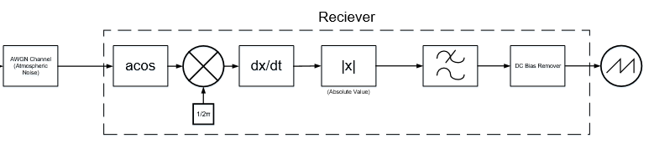
Above: Fig. 4.4, Circuit Diagram of FM Demodulator.
The low pass filter was a Butterworth design, with an edge-passing frequency of 10kHz (a value selected after an estimated process of trial and error).

Results and Analysis
Modulator
Upon completion of a simulation, the following output of the FM modulator is shown below, in Fig. 4.5:
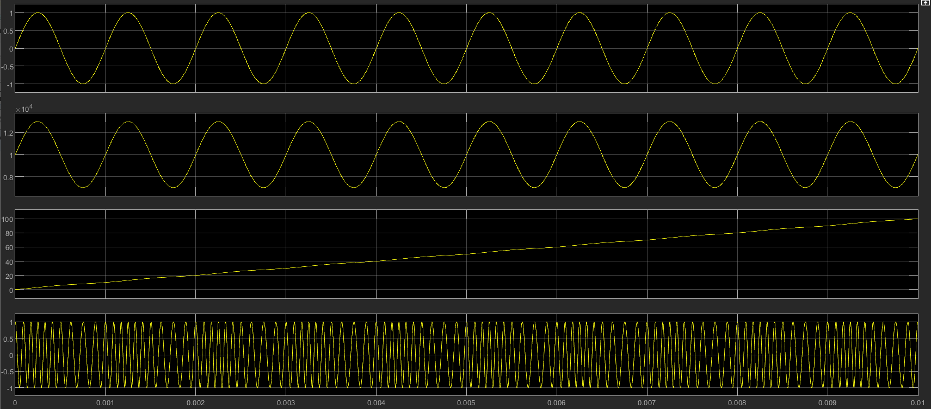
Above: Fig. 4.5, Oscilloscope trace showing output of various stages of the modulator.
Each trace (top to bottom) shows:
- The message signal
- The scaled message signal after multiplied by the frequency sensitivity, and the carrier frequency is added.
- The integration of the scaled message signal.
- The modulated signal (cosine of previous trace).
The demodulated waveform can also be seen (below, figure 4.6):
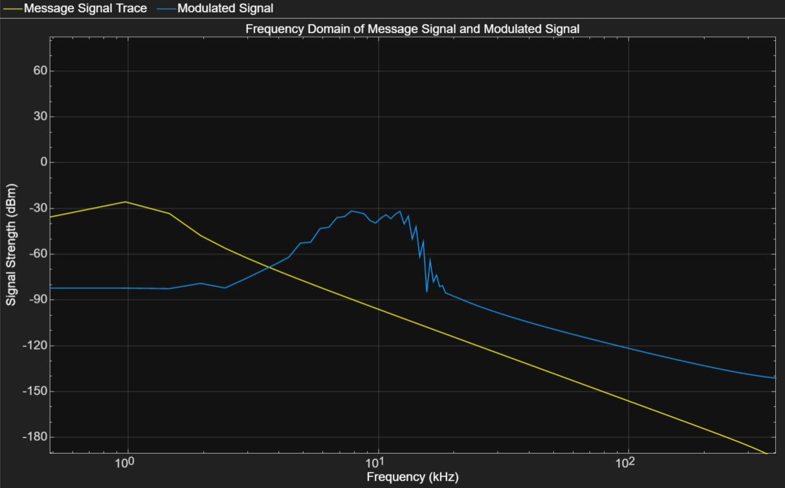
Above: Fig. 4.6, Frequency Response of the message signal, and modulated signal.
As the frequency response in figure XXX shows, the message signal is centered around 1 kHz. The modulated signal is centered around the carrier frequency of 10 kHz. The jagged edges either side are where the frequency of the signal has been altered to encode the message onto it.
Demodulator
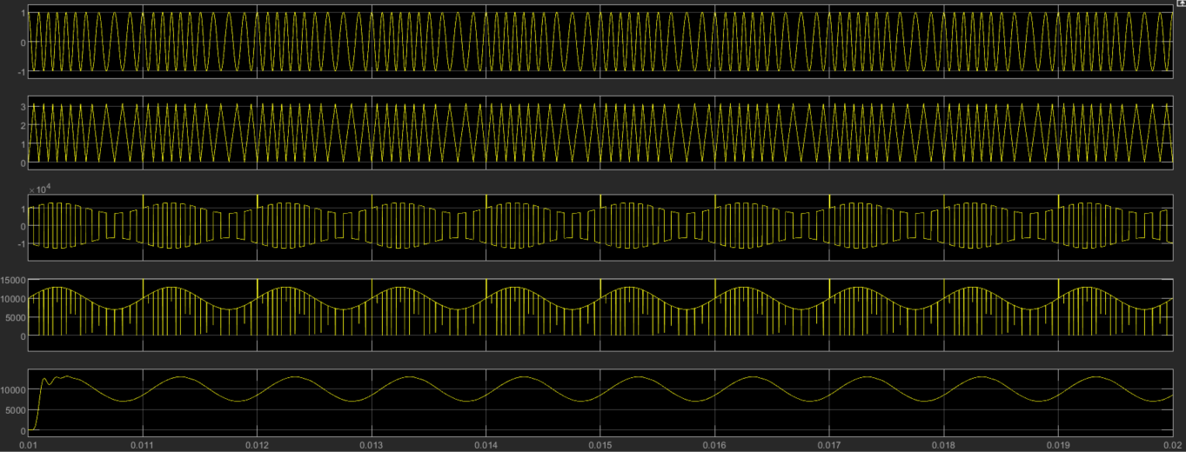
Above: Fig. 4.7, Oscilloscope trace showing output of various stages of the demodulator.
Each trace (top to bottom) shows:
- The received signal
- The inverse cosine function of the received signal
- The derivative of the previous trace
- The absolute value of the previous trace (removing values below 0)
- The message signal
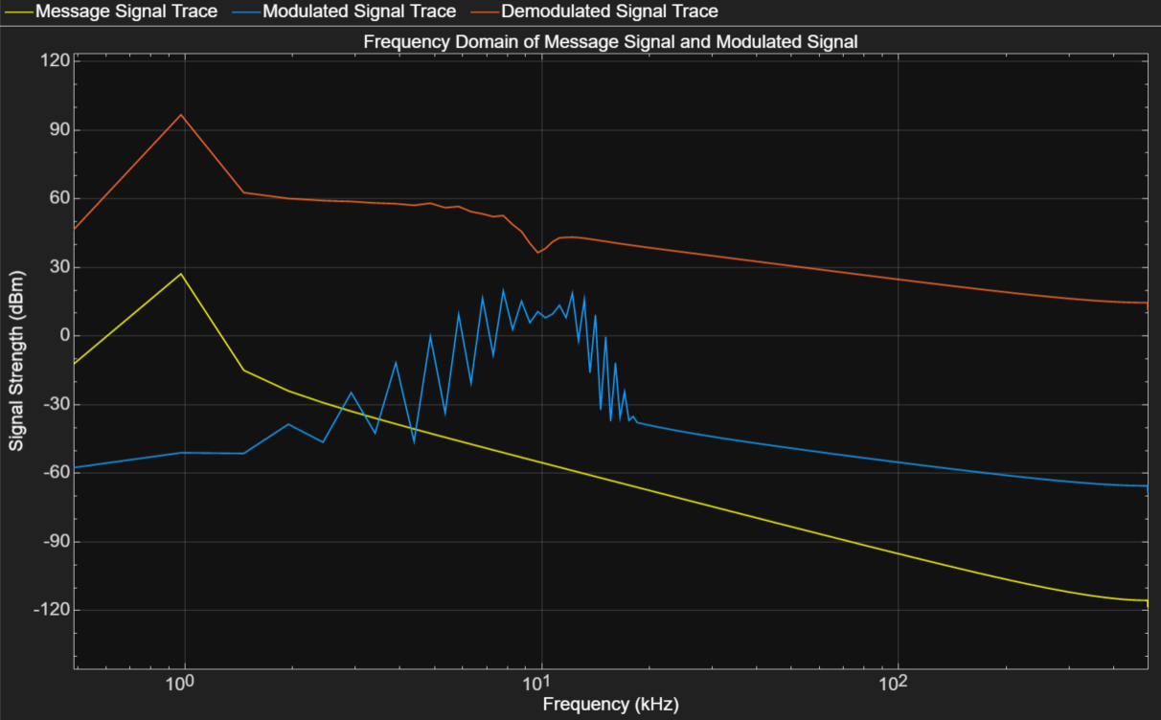
Above: Fig. 4.8, Frequency Response of the message signal, modulated signal, and demodulated signal.
As you can see in Fig. 4.8 above, the demodulated signal matches the message signal closely. Two differences are:
- A local minimum at the carrier frequency of 10 kHz. Further research would be required to figure out why this occurs.
- A higher signal strength. This can be explained by the amplification that happens when the signal is demodulated. Attenuation deemed unnecessary here.
Adding noise to the signal
After an AWGN channel is added between the modulator and demodulator, Simulink begins to struggle processing the simulation. As noise is increased, this problem becomes worse. A low noise (SNR < 0) will crash the simulation entirely. Regrettably, this means it will not be possible to analyze the noise resistance of FM modulation. For more details, please refer to the conclusion of this report.
Above: Fig. 4.9, Warning showing Simulink’s difficulty processing the model with noise added.

Conclusion
Two main issues reduced the effectiveness of this assignment significantly:
- The incorrect setup of the FM modulation model meant that Simulink was unable to process the demodulated output of the modem when an AWGN channel was added. It is suspected this is due to the mathematical operations carried out on the increasingly complicated noisy signals.
- Inability to use the multimedia block in Simulink. This reduced the ability to observe the effects of noise on a signal slightly. Although compensated for by an increased number of oscilloscope traces, it did become more difficult to observe the effect of noise.
To reduce the risk of similar issues cropping up in the future, it is vital to ensure more experience in the software used, and significant effort is undertaken to achieve the “minimum viable solution” as quickly as possible, to allow for scope flexibility.

Recommendations on Future Work
Moving forwards with this research, it is recommended to repeat this investigation with more time and expertise available. This would ensure valid data can be captured and analysed. Providing greater clarity on the effective noise resistance of analogue modulation techniques, the research would be a useful reference to engineers in several fields.
Additional verification of the results with physical components would significantly improve confidence in any conclusions drawn, and would reduce the risk of software issues stopping the research.
It is also important to consider that much research has already been conducted in this area. Although the results of this study aren’t especially useful, the superiority of FM’s noise resistance is a widely acknowledged fact, and resources studying this further could better be used in other areas.

Appendices

Appendix A: AM Components Selection
- Carrier Wave:
  - The carrier wave is a sine wave with frequency ($f_{c}$) of 10KHz (as specified in the assignment brief). This ensures that the carrier frequency is significantly greater than the frequency of the message signal ($f_{m}$), reducing the chance of error being introduced due to aliasing. Although the theoretical limit for carrier frequency (given by the Nyquist theorem [12]) is $f_{c}≥2f_{m}$, ensuring that $f_{c}$ is significantly greater than $2f_{m}$ accounts for real-world error.
  - The amplitude of the carrier is 2V. This ensures that when a DC bias voltage is applied to the message signal, their amplitude is still the same (assuming $f_{m}$ for critical modulation).
- Message Signal:
  - The message signal is a sine wave with a frequency of 1KHz (as specified in the assignment brief).
  - To change the modulation index of the transmitter, the amplitude of the message signal changes from 0.5V to 1.5V. When a 1V DC bias voltage is applied, this ranges from 1.5V to 2.5V, allowing the effects of over-modulation, critical modulation, and over-modulation to be observed.
- Low Pass Filter:
  - The low pass filter used is a “Butterworth” design, and has a filter order of 8. This was chosen after a process of trial and error, balancing the Q factor (steepness of frequency response) against the settling time for the output signal.
  - A passband frequency of 10kHz was selected to match the carrier frequency.

Appendix B: FM modulation and demodulation maths
The modulation architecture follows the maths laid out here [13]:
We start by finding the frequency of the modulated wave (instantaneous frequency, given below):
$$f_{i}= f_{c}+ k_{f}∙m(t)$$
Above: Equation 2.1, Equation for Instantaneous Frequency
Where:
$$f_{i}=Instantaneous Frequency \\ f_{c}=The frequency of the carrier wave \\ k_{f}=The frequency Sensitivity \\ m\left(t\right)=The message Signal$$

Remembering that angular frequency is the rate of change of angle:
$$ω_{i}= \frac{dθ_{i}(t)}{dt}$$
Above: Equation 2.2, Instantaneous Angular Frequency
Where:
$$ω_{i}=Instantaneous frequency \\ θ_{i}=Instantaneous angle$$Integrating gives:
$$θ_{i}(t)= 2π\int{f_{i}}dt$$
After substituting in the value for instantaneous frequency:
$$θ_{i}\left(t\right)=2π\int{f_{c}+k_{f}m\left(t\right)}dt$$
After substituting into the standard equation for an analogue wave and simplifying, the following is achieved:
$$s(t)=A_{C}Cos[ 2πf_{c}t+2π k_{f}\int{m\left(t\right)dt}]$$
Above: Equation 2.3, Equation of FM Modulated wave

Demodulation:
For the demodulation of these transmitted signal, the same maths can be employed in the reverse direction. We start by rearranging equation XXX to find instantaneous angle ($θ_{i}$) in terms of s(t), to get equation XXX, below:
$$θ_{i}= acos⁡(\frac{s(t)}{A_{c}})$$
Above: Equation XXX, [Description here]
Next, equation XXX is re-arranged to give the message signal (m(t)) in terms of instantaneous angle ($θ_{i}$), producing equation XXX, below:
$$m\left(t\right)= \frac{{\left(\frac{θ_{i}}{2π}\right)}^{'}- f_{c}}{k_{f}}$$
Above: Equation XXX, [Description here]
Using these equations, the design for the demodulator can be realised.

Appendix C: DSB-SC Component Justification
Components involved:
- Carrier wave and message signals:
  - The frequency of the carrier wave and message signal were set to 10 kHz and 1 kHz respectively, as with the first AM modulator.
  - The amplitude of the carrier wave was set to 2V.
  - Since the modulation index of the carrier is set to be 0.5, the amplitude of the message signal was set to 0.5. After a 1V DC offset was applied, this would ensure the signal ranged from 1.5V to 0.5V (50% the range of the carrier wave: 2V to 0V).
- Low-Pass filter:
  - The low-pass filter is a Butterworth design, of order 8 (as with previous AM modulator).
  - The passband frequency was set to 1.5 kHz. This value was found through a short-process of trial and error, allowing the lower-frequency 1 kHz message signal to pass, but greatly attenuating the 10 kHz carrier wave.
- DC Bias remover: subtracts the bias voltage from the demodulated signal. In reality this would be implemented with a capacitor or transformer, but in Simulink it was easiest to simply subtract the value.

Appendix D: FM Modulator component selection
Key Components and constants:
- The message signal for FM was kept as a 1 kHz sine wave for the sake of continuity.
- The frequency sensitivity for most FM modulators typically ranges from 0.1 to 5 [14]. Upon experimentation, it was found that a significantly larger number would be required to provide the modulator with the required sensitivity.
- F_{c}, the required frequency of the carrier wave was set as 10 kHz.

Appendix E: Maths of FM Modulation
Categorized by the following equations [7], FM is described with:

$$m\left(t\right)= A_{m}cos⁡(2πf_{m}t)$$
Above: Equation 3.1, Equation of a sinusoidal message signal
And the frequency of the wave at any given instant is given by [7]:

$$f_{i}\left(t\right)=f_{c}k_{f}A_{m}\cos\left(2πf_{m}t\right)$$
Above: Equation 3.3, Instantaneous frequency definition
We create our own term: “frequency deviation” (Δf), simplifying to:
$$f_{i}\left(t\right)=f_{c}Δf\cos\left(2πf_{m}t\right) where: Δf= k_{f}A_{m}$$
Above: Equation 3.2, Frequency Deviation
The comparison between the modulation frequency and frequency deviation is known as “modulation index”, given by [7]:
$$β= \frac{Δf}{f_{m}}$$

References
Number: | Reference:
[1] | [1] Kin K. Leung, "Lecture 5: Effects of Noise on FM," Slide 32, presented at EEE and Computing Departments, Imperial College London, London, 2009. [Online] Available: https://www.commsp.ee.ic.ac.uk/~kkleung/communications2_2009/Lecture5.pdf
[2] | [2] S. Haykin, M. Moher, “4.2 Properties of Angle-Modulated Waves,” in Book “Introduction to Analog & Digital Communications”, Second edition, p.155.
[3] | [3] J.P. Devaraj, "Radio Frequency Systems", Slide 3, presented at UWTSD, Swansea, September 2023.
[4] | [4] J.P. Devaraj, "Radio Frequency Systems", Slide 4, presented at UWTSD, Swansea, September 2023.
[5] | [5] J.P. Devaraj, "Angle Modulation- FM", Slides 5-6, presented at UWTSD, Swansea, September 2023.
[6] | [6] E. W. Murtfeldt, “Popular Science” magazine, November 1940, p.59
[7] | [7] S. Haykin, M. Moher, “4.4 Narrow-Band Frequency Modulation,” in Book “Introduction to Analog & Digital Communications”, Second edition, p.161.
[8] | [8] P. Horowitz, W. Hill, “EIGHT: Low-Noise Techniques” in Book “The Art of Electronics”, third edition, Cambridge University Press, Cambridge, 2015, p.473-590.
[9] | [9] The Open University, “6.2 Mains Hum”, Recording Music and Sound, [Online] Available: https://www.open.edu/openlearn/history-the-arts/recording-music-and-sound/content-section-6.2, Accessed: 01/12/2023
[10] | [10] J.P. Devaraj, "Angle Modulation- FM", Slides 18, presented at UWTSD, Swansea, September 2023.
[11] | [11] J.P. Devaraj, "Radio Frequency Systems", Slide 6, presented at UWTSD, Swansea, September 2023.
[12] | [12] Science Direct, “Nyquist Theorem”, [Online] Available: https://www.sciencedirect.com/topics/engineering/nyquist-theorem#:~:text=Nyquist's%20theorem%20states%20that%20a,oscilloscope%20bandwidth%20would%20be%20typical., Accessed: 01/12/223
[13] | [13] J.P. Devaraj, "Angle Modulation- FM", Slides 5-6, presented at UWTSD, Swansea, September 2023.
[14] | [14] Science Direct, “Frequency Modulation”, [Online] Available: https://www.sciencedirect.com/topics/nursing-and-health-professions/frequency-modulation Accessed: 01/12/223

