8a Using loops (2) – For

1. Write a for loop that counts from 0 to 12 (print the counter on the screen).

Note: only two lines of code are required

Sample output:

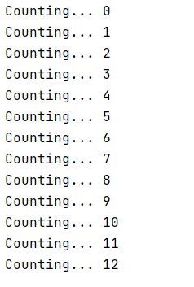

2. Write a for loop that counts from 4 to 16 and goes up in increments of 2:

Sample output:

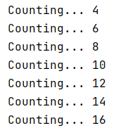

3a. Write a for loop that counts from 1 to 12 and goes up in increments of 1.

Sample output:

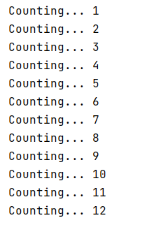

3b Adapt your for loop to do some simple calculations to reproduce the 7 times table.

Multiple myCounter by 7 each time around the loop, store the result, and then print the result.

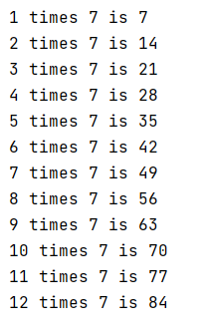

3c Adapt your solution to allow the user to choose the times table they want.

Sample output:

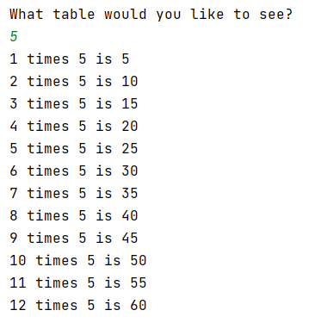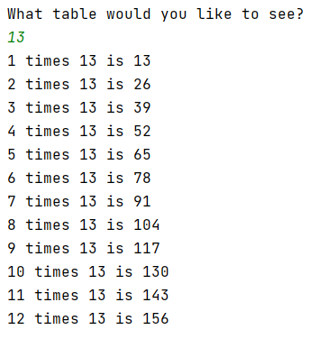

4a. Print "XXXXX" on the screen. This is the width (5) of a rectangle.

Using a for loop, repeat this down the screen so that you achieve a 5 x 7 rectangle. You can do this in the two lines of code

Sample output:

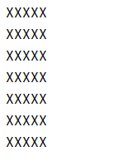

4b Extend your solution to allow the user to choose the height of their rectangle (but the width stays as XXXXX)

Sample output:

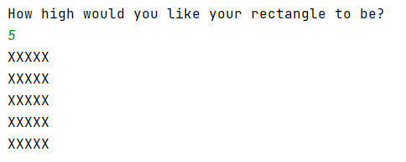

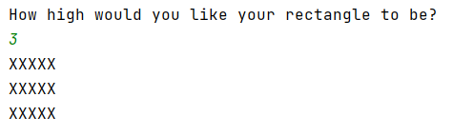

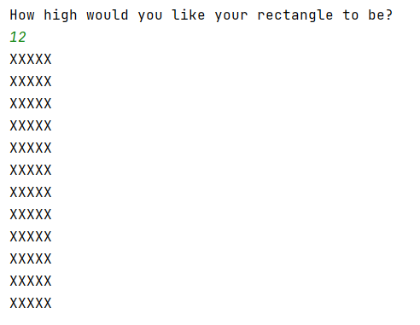
4c (Harder) For the adventurous among you, write a program to allow the user to enter both the width and length. You will need to print just one X - print("X") and use a nested loop.

Sample output:

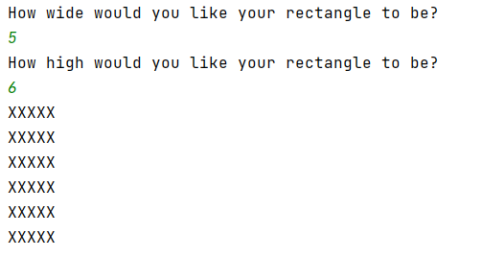

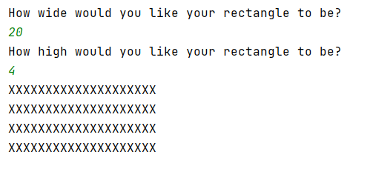

5. Write a for loop to print out the traditional children's rhyme "One potato, two potato" (if you don't know the rhyme, see the sample output below)

Most lines are similar, apart from "4" so you will need to stop it printing "potato" on that line only.

Sample output:

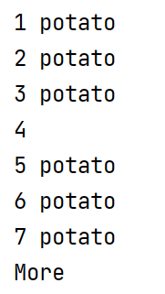

6. Write a child's program to simulate a rocket blasting off. Use a for loop for the countdown.

Note: You do not have to draw the rocket (but it is fun )



