Manufacturing Systems engineering
Manufacturing Design and Technology
Ben Leach
2020
Contents
1.0 Introduction. 2
2.0 Appraisal of the Original System. 3
2.1 The basics of FMEA. 3
2.2 When to use FMEA. 3
2.3 How to use FMEA. 3
2.4 FMEA for current design with new improvements recommended. 4
2.5 Appraisal of the original system. 5
3.0 Manufacturing Process Proposal. 6
3.1 Jaws 6
3.2 Drive plate. 7
3.3 Bolts holding jaws to cylinder. 8
3.4 Worm and shaft. 8
4.0 Design and Development Work Undertaken. 9
4.1 What changes have been made? 9
4.2 Updated FMEA spreadsheet. 11
5.0 Manufacturing Process Design 12
5.1 Flow chart of manufacturing process. 12
6.0 Conclusion. 14
7.0 Work Cited. 15
8.0 Table of figures. 16

Introduction.

For this report, we been tasked to undertake a design study to develop a 3-jaw gripper. This is intended to use on a robotic system. The end effector will need to be flexible and adaptable to pick and place a range of objects. We are given a basic designed as shown in figure 1 and are required to undertake a further development to consider and optimise the manufacturability of the system.

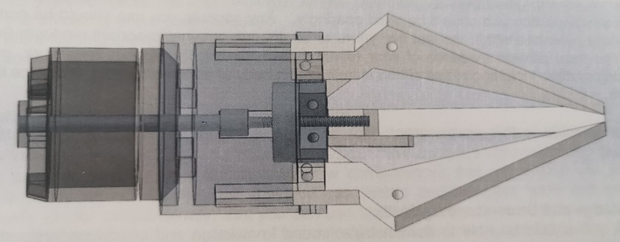
Figure 1 Side view of 3 jaw gripper assembly.

Using FMEA we were able to detect several faults in key areas to resolve, using CAD software like solid works gave us the opportunity to improve the overall design to make it more efficient. Several manufacturing process would be needed to create the parts required ranging from CNC machining to waterjet cutting but not everything will need to made on site, some parts can be sourced from local and online supplies for generic items like bolts and motors.
Flow chart was created to show how the manufacturing process is done, from ordering the materials required to quality checks. This was the easiest way of describing how the part is created to being dispatched to customers.

Appraisal of the Original System.

To give an appraisal of the original system we are going to use a system called FMEA (Failure mode and effects analysis). This process analysis tool was developed in the 1940s to do a step-by-step approach for identifying all possible failures in the design, manufacturing and the final assembly process for a product or service.

  - The basics of FMEA.
Failure mode – this means the possible ways and mode in which something might fail. These failures could occur with possible errors or defects, especially the errors that can affect the potential customer.
Effect analysis – This refers to the study of consequences of those possible failures.
(The quality toolbox, 2020)
The failures will be prioritized according to how serious the consequence are, the frequency it will occur and how easily they are detected. FMEA will also allow you to document current knowledge and actions about the risk of failures for further use in CI (continuous improvement). This process tool will help you during design to prevent failures and further along it will then be used for control. To reduce to prevent failures you would need to use FMEA from the beginning of the design stage and continuing using it throughout the life of the product.

When to use FMEA.

- When in the design/redesigning process of developing a product or service.
- When the product or service is being used in a different way then intended.
- Before developing control plans for a new or modified process.
- When improvement goals are planned for an existing process, service, or product.
- Periodically throughout the life of the product, service, or process to make further improvements on the produce or process.
(Rewaj, 2020)

How to use FMEA.

A typical process of using a FMEA is usually a 10-step process as follows:
- Review the process, you need to identify each process component.
- Brainstorm potential failure modes review all existing documentation on each component for clues on what can fail.
- List potential effects of each failure, the effect will be the impact it has on the product or process. There may likely be more than one effect for each failure.
- Assign severity ranking, this shows the severity of the consequence of failure.
- Assign occurrence ranking, what are chances and how often it occurs.
- Assign detection ranking, the chances of failure will be detected before it occurs.
- Calculate RPN, Severity X Occurrence X Detection.
- Develop action plan, this is where you decide which failures will be worked on based on the RPN (Risk priority numbers) Focus on the highest RPNs.
- Act and implement improvements identified by the FMEA.
- Calculate the resulting RPN, re-evaluate each of the potential failures once improvements have been made to determine the risk of failure with the improvements.
(FMEA Training, 2018)

FMEA for current design with new improvements recommended.
Figure 2 FMEA of current design.
(Quality one, 2017)

Appraisal of the original system.

First thought of the basic design of the original system, we were able to detect several severe issues, the major one being the joiners connecting the jaws to the drive plate, if designed and left alone the joiners would rub against each other or possible prevent jaw movement as shown in figure 3.
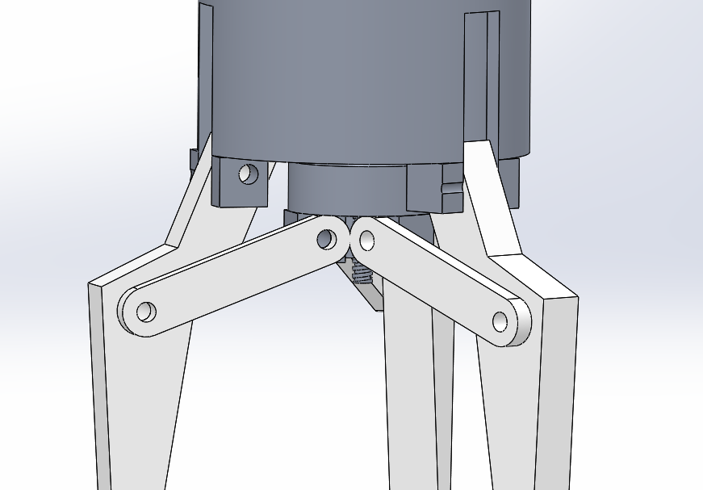
Figure 3 Joiners on initial design.
Another major issue is the mass of the robot end effector, to reduce load of the robotic system, we need to reduce as much mass as possible to allow movement but without compromising the end effector for example as you can see from figure 4 there is room to make adjustments to the design to reduce mass.
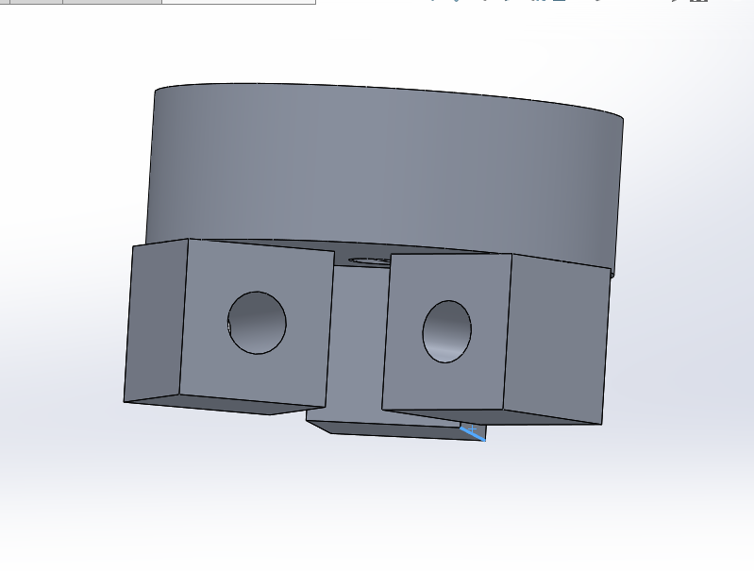
Figure 4 Drive plate.
The final major design change that is needed is for the jaws, currently looks like it needs a redesign to better pick and place objects. It needs to be able to hold the product through the entire moving and placing process which currently it will struggle to do with many components out. See figure 5 to show initial plan for jaws.
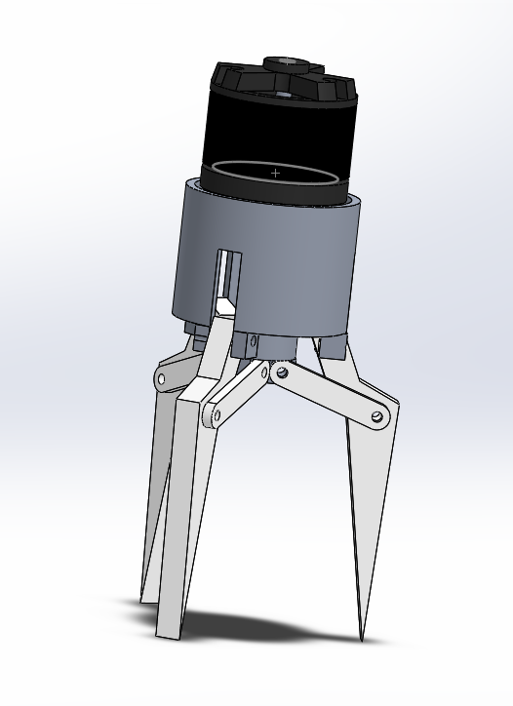
Figure 5 Initial design of jaws.

Manufacturing Process Proposal.

Here we discuss the different manufacturing methods for each of the critical components for the end effector, the first redesign is on the actual pick up jaw. The original design was not useful or practical. As you can see from figure 6, we redesigned it a lip, this will better assist with picking up parts. The claw can be designed many ways and used for different components; you never build a jaw set that be good for every component.
Figure 6 Redesigned claw.

Jaws

To manufacture the jaws, we choose to do waterjet cutting, this process involves cutting the steel plate with high pressure water, the water can be also mixed with abrasive material to enhance the cutting properties. Water jet cutting requires a high pressure, which can be anything between 5000 to 6200 bar depending on the material being cut. The waterjet machine is CNC-controlled, once the designed has been inputted into the computer the nozzle with follow along the path of the program producing a jaw. Once the part has been made and removed from the waterjet the edges can be rubbed down with emery cloth to remove all sharp edges before assembling. Due to the CNC software and design package, we can produce a range of different designed jaw’s using this equipment which can meet customer demand.
(Donath, 2019)
A typical CNC waterjet is shown in figure 7:
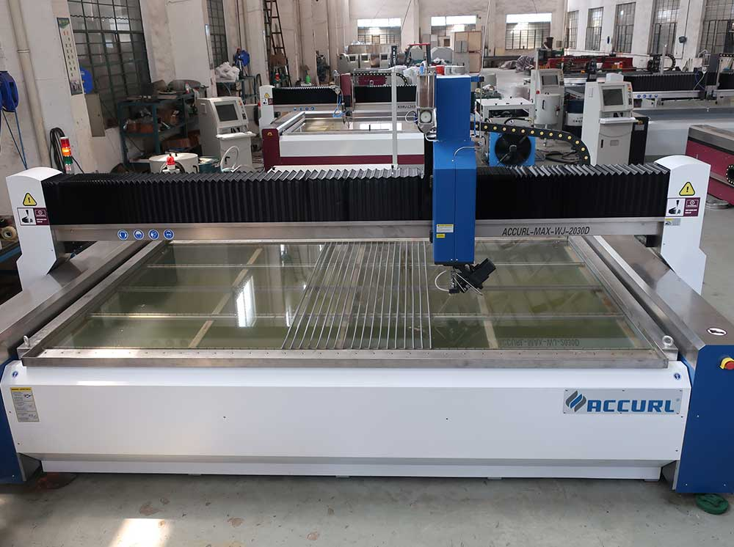
Figure 7 CNC waterjet machine.
(ACCURL, 2020)

Drive plate.

The drive plate has been redesigned so it has reduced mass while maintaining its structural integrity, the three original blocks which held the joiners has now been redone so it’s a rounded surface instead of a block, this reduces the size and also makes it more aesthetically pleasing as shown in figure 8.
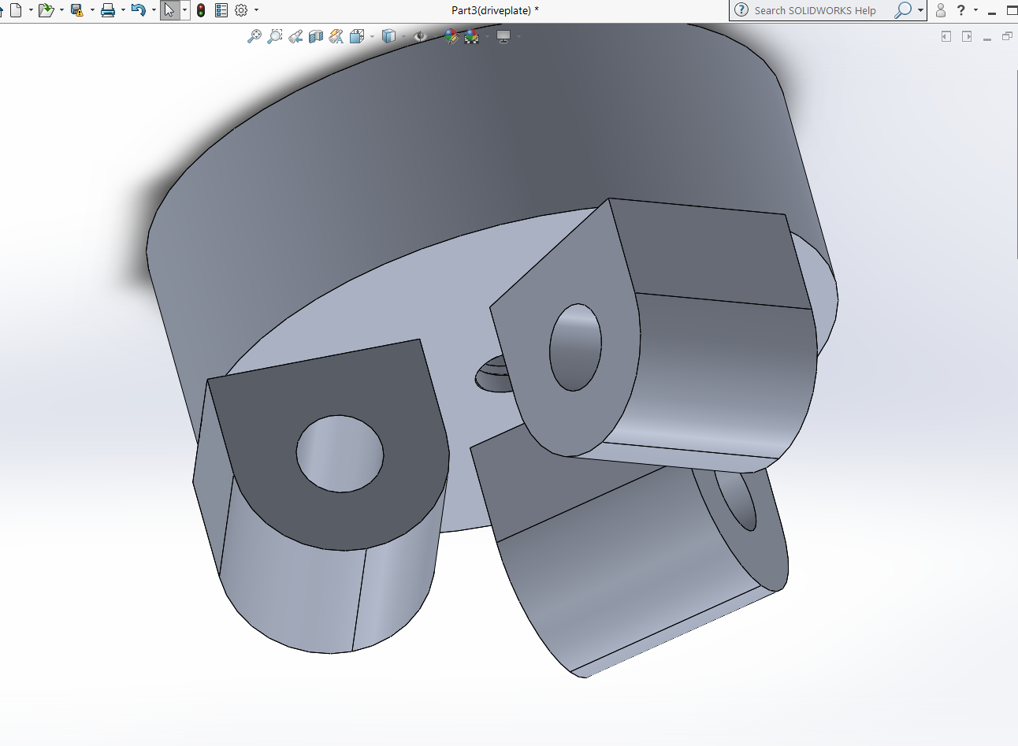
Figure 8 Drive plate.
The manufacturing process that was chosen for this component would be a CNC miller, with several sets of cutting and drilling pieces it can achieve the results required to produce the piece. Milling is a process of cutting and drilling material, it uses a rotating cylindrical tool called a milling cutter which is held in by a spindle, this can vary in size from machine to machine. Once the program is created and inputted in the computer the various tooling for example cutters and drill sizes will cut away excess material as required until the component is completed. Having several machines at once with a single operator can mass produce parts in a relativity short time. A typical CNC miller is shown in figure 9.
Several parts can be created using this process such as the cylinder and joiners, with additional modifications to reduce the overall mass of it, the CNC miller is able to create the components to the desired specification. This process was chosen as it can produce a wide range of parts in the future, for example if the company wants to produce a new product or redesign the 3-jaw gripper even further.
( All3DP, 2020)
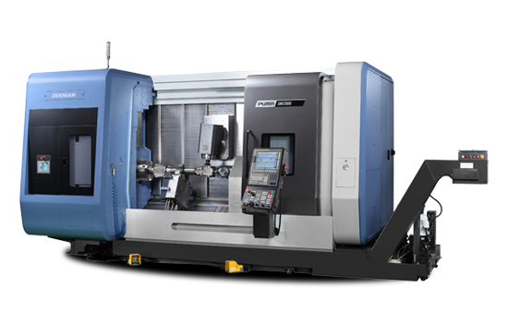
Figure 9 5 Axis CNC milling machine.
(Millscnc, 2020)

Bolts holding jaws to cylinder.

To hold the jaw, we would use shouldered bolts made from stainless steel, this material is best suited for long operations without maintenance. This will also allow engineers to remove the jaws easily if one were to become damaged. These will not need to be made and can be easily sourced from a range of manufactures and sellers like RS components.
(RS Components, 2020)

Worm and shaft.

To produce the worm and shaft, we used a CNC lathe, like the miller but instead it rotates the material instead of the tooling, this is ideal when making circular parts quickly and effectively. The material will be held by a chuck which holds the material and can rotate up to 12,000RPM depending on the model of lathe. As you can see from figure 10, this shows a typical CNC lathe on the insides.
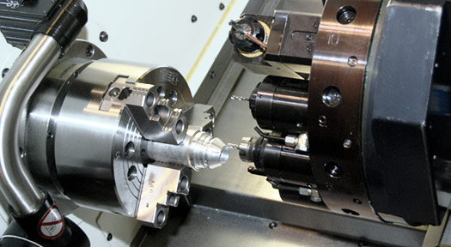
Figure 10 CNC lathe.
(CNC Hurco, 2018)
The program created will use the tools programmed in the designated tooling wheel like the miller, once the part is created it will use a tool for parting it off the remaining material and deposit it below before moving on to creating the next piece.

Design and Development Work Undertaken.

What changes have been made?

Several pieces of the 3-jaw gripper have been redesigned to reduce the overall mass of the system; this will reduce power usage by the system due to the reduced load it is carrying. You can see from figures 11 and 12 on the new redesigned drive plate and cylinder. You can see that original design was just a solid square block, a radius has been added which makes it more aesthetic and most importantly reduced the mass for each one.
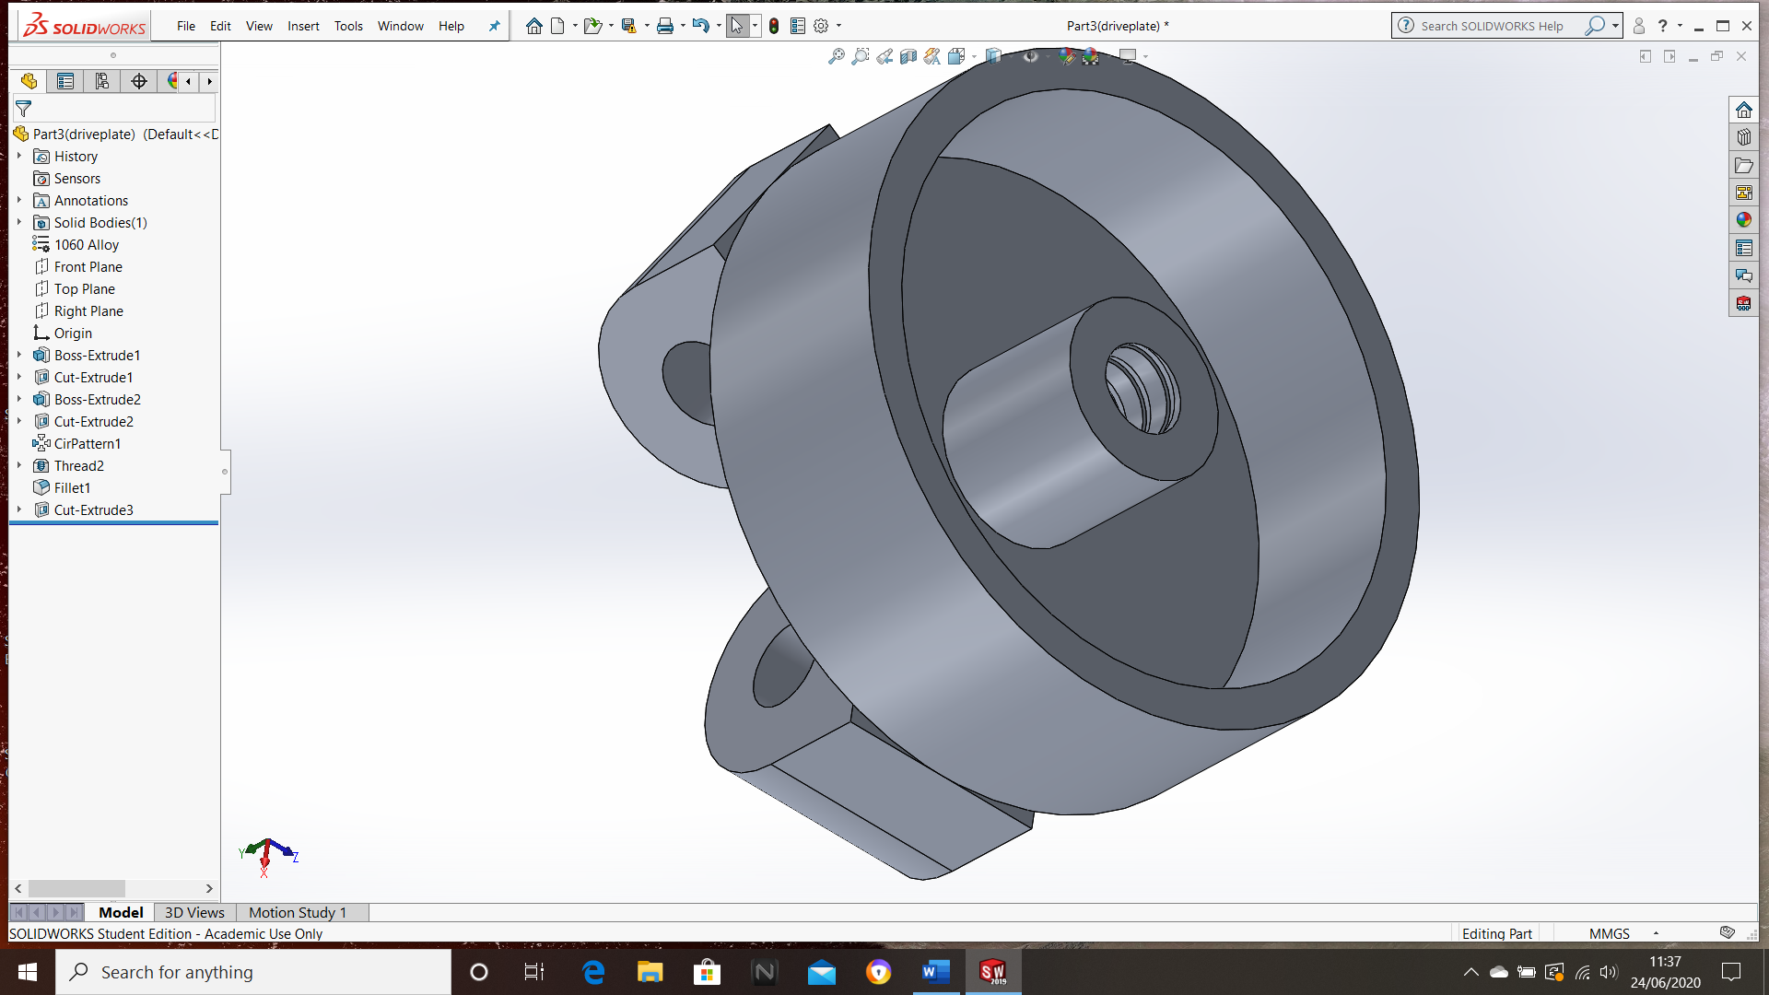
Figure 11 Redesigned Drive plate.
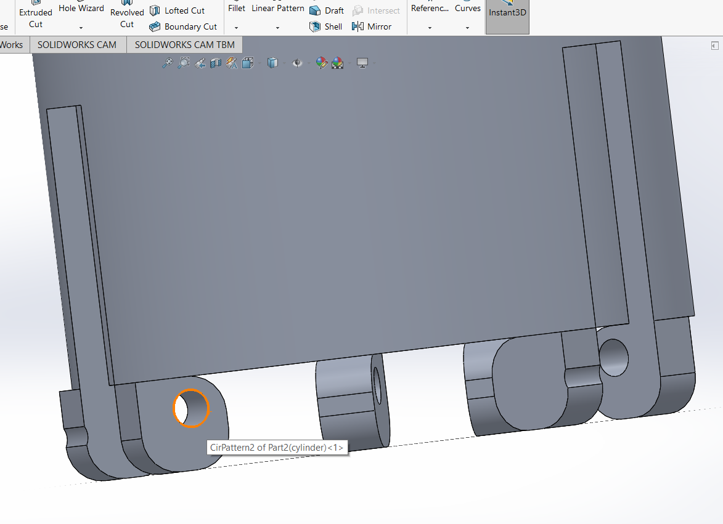
Figure 12 Redesigned cylinder.
The topside of the drive plate as shown in figure 13 has been carved out, this allows additional mass to be removed to make it lighter. This does not cause any structural integrity issues for the drive plate.
Figure 13 New Drive plate.
The jaw has been redesigned so it is better able to pick up objects with have a lip allowing it to better pick up objects as shown in figure 14. This will not work for every type of product but depending on the customers, they can request additional jaws of different design to allow the system to pick up more complex or difficult to grab products without losing its function.
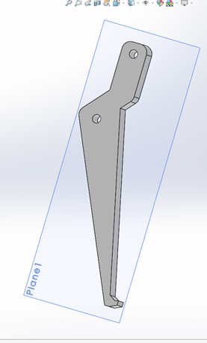
Figure 14 Redesigned Jaw.
The worm has been redesigned, a stopper has been added to the end of the worm to prevent the jaws from overextending which will cause the drive plate to come off the worm, as shown in figure 15, you can see the added stopper to prevent it from happening.
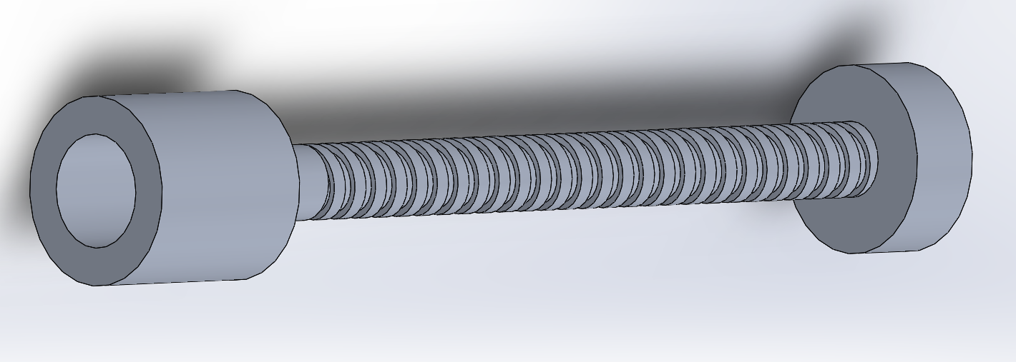
Figure 15 Redesigned worm.
The final part that been redesigned is the joiner, currently the connection holding the jaws to the drive plate will collide and rub against each other possible wearing the joint or worse prevent the jaw from opening or closing, the end where the bolts would go through has been redone to prevent contact as shown in figure 16.
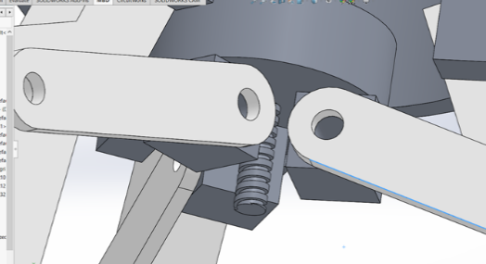
Figure 16 Redesigned joiner.

Updated FMEA spreadsheet.

Figure 17 Updated FMEA.
After the modifications to the designed it almost eliminated the design flaws entirely, especially if the customers maintain the robot system which should prevent the issues which cannot be resolved entirely. Customers can also request additional designed jaws for different products they run.

Manufacturing Process Design

Due to the variety of products that the manufacturer of the robotic gripper will face, the product will use the MTA strategy (Make-to-assemble). It is based on a hybrid of MTS (Make to stock) and (Make to order) this means that the company will stock basic parts based on demand predictions, but will not assemble until the customers place their order. This main advantage of this strategy is that it allows fast customization of the product based on consumer demand, but the negative side of this strategy is that the company may receive too many orders to handle causing delays to get assembled component to the customer.
(Kenton, 2020)
Due to the range of possible jaws that can be designed and used, customers can decide which jaw is best for their work environment.

Flow chart of manufacturing process.

Surface cleaning, deburring sharp edges.
Machining the parts required.
Obtaining Raw Materials required.

Scrapped and Reworked.

Parts to assembly stores.
Quality inspection for all parts.
Pass QC or Fail QC

Final Quality check of finished product.
Components assembled.
Customer orders confirmed.

Pass.
Fail.
Quarantine.
Dispatched to customer.

Figure 18 Flowchart of manufacturing process.
Figure 18 shows the basic flowchart on how the part is created from obtaining the raw materials to dispatching the final product to the customers.
Most parts required for this product would be part of REM (Repetitive manufacturing), this means that production would often repeat for a specific production rate. The process is made up from dedicated production lines that would continuously create the same product or set of parts year-round. The advantage of this is set up requirements are kept to a minimal and there are little change over so production speeds can be adjusted to meet customer demands using predictive forecasts.
(Searcherp techtarget, 2020)
Several sections we discuss is the process for quality checks, QC is a procedure or a group of procedures which is intended to ensure that the product quality is maintained or possible improved. Another major aspect of this process is to establish a set of well-defined controls. These controls will assist production standardize both production and reactions to quality issues. It’s aim is to reduce waste by removing as many errors in production as possible, this will help reduce waste but also increase profits margin.
(Investopedia, Adam Hayes)
These types of manufacturing process are useful for the following industries:
- Automotive.
- Food and drink.
- Household electronics e.g. bulbs.
(Bragg, 2018)

Conclusion.

To conclude this report, we talk about the initially design and what problems it can possible face using FMEA, currently the robotic 3-jaw wouldn’t work and would need extensive overhaul in the design to function properly and last longer. Using software called Solidworks we were able to redesign several key components for example drive plate, to make it lighter and to also prevent the jaws from falling apart or jamming in place completely.
The parts for the robotic system can be created using many different manufacturing methods from CNC machining to waterjet cutting for the jaws, the reason these methods was chosen as it allows little operator intervention once set up correctly and can just keep producing parts until the production target is hit, but these processes also allow to customize parts to suit the consumers like different jaw designs. Once the product has been redesigned a new FMEA sheet was produced to show areas which would still produce issues in the future and recommendations on how to improve life of the product.

Work Cited.

All3DP, 2020. What Is CNC Milling? – Simply Explained. [Online]
Available at: https://all3dp.com/2/what-is-cnc-milling-simply-explained/
[Accessed 10 June 2020].
ACCURL, 2020. ACCURL 3D Waterjet Cutting Machine with 5 Axis Waterjet CNC Cutting price for sale. [Online]
Available at: https://www.accurl.com/machine-stock/accurl-3dwaterjet-cutting-machine-with-5-axis-waterjet-cnc-cutting-price-for-sale/
[Accessed 10 June 2020].
Bragg, S., 2018. Repetitive manufacturing. [Online]
Available at: https://www.accountingtools.com/articles/2017/7/27/repetitive-manufacturing
[Accessed 20 June 2020].
CNC Hurco, 2018. CNC mill turn. [Online]
Available at: http://cnc.hurco.com/sg/cnc-machine-tools/turning-centers/mill-turn/pages/tmx.aspx
[Accessed 16 June 2020].
Donath, S., 2019. Water jet cutting - Function, methods and application examples. [Online]
Available at: https://www.etmm-online.com/water-jet-cutting--function-methods-and-application-examples-a-834966/
[Accessed 10 June 2020].
FMEA Training, 2018. 10 steps tp do a process FMEA. [Online]
Available at: https://fmea-training.com/10-steps-process-failure-mode-and-effects-analysis/
[Accessed 30 May 2020].
Investopedia, Adam Hayes. Quality control. [Online]
Available at: https://www.investopedia.com/terms/q/quality-control.asp
[Accessed 20 2020 2019].
Kenton, W., 2020. Manufacturing Production. [Online]
Available at: https://www.investopedia.com/terms/m/manufacturing-production.asp
[Accessed 19 June 2020].
Millscnc, 2020. Doosan SMX mill-turn machines. [Online]
Available at: https://www.millscnc.co.uk/product/doosan-smx-mill-turn-machines/
[Accessed 10 June 2020].
Quality one, 2017. FMEA. [Online]
Available at: https://quality-one.com/fmea/
[Accessed 04 June 2020].
Rewaj, M., 2020. Why should you do an FMEA?. [Online]
Available at: https://www.innovaltec.com/fmea-blog/
[Accessed 30 May 2020].
RS Components, 2020. Bolts and screws. [Online]
Available at: https://uk.rs-online.com/web/c/fasteners-fixings/screws-bolts/socket-screws/2
[Accessed 16 June 2020].
Searcherp techtarget, 2020. Process manufacturing. [Online]
Available at: https://searcherp.techtarget.com/definition/process-manufacturing#:~:text=Hand%20lotions%20are%20an%20example,broken%20apart%20at%20the%20end.
[Accessed 20 June 2020].
The quality toolbox, 2020. Failure mode and effects analysis (FMEA). [Online]
Available at: https://asq.org/quality-resources/fmea
[Accessed 30 May 2020].

Table of figures.

Figure 1 Side view of 3 jaw gripper assembly. 2
Figure 2 FMEA of current design. 4
Figure 3 Joiners on initial design. 5
Figure 4 Drive plate. 5
Figure 5 Initial design of jaws. 5
Figure 6 Redesigned claw. 6
Figure 7 CNC waterjet machine. 6
Figure 8 Drive plate. 7
Figure 10 5 Axis CNC milling machine. 7
Figure 11 CNC lathe. 8
Figure 12 Redesigned Drive plate. 9
Figure 13 Redesigned cylinder. 9
Figure 14 New Drive plate. 9
Figure 15 Redesigned Jaw. 10
Figure 16 Redesigned worm. 10
Figure 17 Redesigned joiner. 10
Figure 18 Updated FMEA. 11
Figure 19 Flowchart of manufacturing process. 12

