Jonathan Jones, ‘History and all its grisly facts are worth more than the illusion of memory,’ The Guardian, October 31 2014 (http://www.theguardian.com/commentisfree/2014/oct/31/world-war-one-poppies-memorial-cameron; accessed January 30 2015)

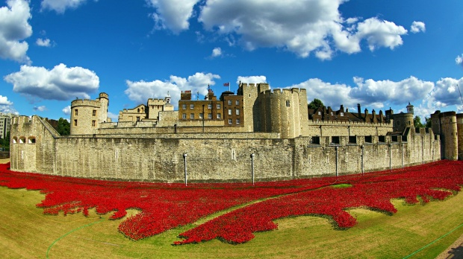
Red ceramic poppies fill the moat of the Tower of London. Photograph: Paul Brown/Demotix/Corbis

In 1924 the German artist Otto Dix depicted a skull, lying on the ground, a home to worms. They crawl out of its eye sockets, nasal opening and mouth, and wriggle among patches of hair and a black moustache – or are they growths of grass? – that still cling to the raw bone.
This horror comes from Der Krieg, a series of etchings in which Dix recorded his memories of fighting in the first world war. He was a machine gunner at the Somme, among other battles, and won the Iron Cross, second class. But he remembered it all as pure horror, as did other participants who happened to be artists or writers such as George Grosz, Siegfried Sassoon, Ernst Jünger and Robert Graves.
I was thinking of that death’s head by Dix when I wrote in an online Guardian article earlier this week (http://www.theguardian.com/artanddesign/jonathanjonesblog/2014/oct/28/tower-of-london-poppies-ukip-remembrance-day) that I would rather see the moat of the Tower of London filled with “barbed wire and bones” than the red ceramic poppies currently drawing huge crowds to see what has become the defining popular artwork in this centenary of the Great War’s outbreak. I called the sea of poppies now surrounding the Tower “toothless” as art and a “Ukip-style memorial” – to quote my words not in their original context but as they have since been republished in angry articles in the Mail, Telegraph and Times, with the Mail in particular denouncing me as a “sneering leftwing critic” and the Guardian for publishing my wicked words. Even the prime minister got drawn in at question time in the Commons. “Cameron defends ‘toothless’ poppy tribute,” reported Thursday’s edition of the Times.
But my criticism of this work of art was and is reasonable, honest and founded not in some kind of trendy cynicism but a belief that we need to look harder, and keep looking, at the terrible truths of the war that smashed the modern world off the rails and started a cycle of murderous extremism that ended only in 1945. If it did end.
I strongly believe that an adequate work of art about the war has to show its horror, not sweep the grisly facts under a red carpet of artificial flowers.
Otto Dix told the truth about this war that killed more than 8 million men from many nations and left many more disfigured and disabled when he drew that worm-infested skull. Their deaths and injuries were not beautiful. But the installation at the Tower is spuriously beautiful: it allows us to mourn without seeing anything to cause visceral distress. It muffles the terrible facts. It is so tasteful, so decorous.
What a feeble contrast not just with Dix but with the photographs that show this war as it was. On a bookcase when I was a child I remember finding AJP Taylor’s The First World War: An Illustrated History. On its cover was a photograph of a skeleton in a dugout still wearing a uniform on its fleshless bones. That was the historical reality of this war, which Taylor brilliantly chose to show visually in his classic book.
This war has always been there, for me, in the background of family life. As it happens I quite possibly owe the Daily Mail my existence, for it helped get the Jones genes through to 1918. As my great-grandparents in their farmhouse on the edge of Snowdonia faced the threat of their teenage son’s call-up in the Great War, my great-grandmother saw an advert in the Mail for volunteers for the new Naval Air Service. So my grandfather worked as a joiner keeping wood-framed flying machines going, and as he said when asked what he did in the war: “I survived.”
My other grandfather also survived, but with scars on his memory. He was a runner on the western front. He would never speak about what he experienced, except to once tell my dad he had been trapped for days in a pothole in no man’s land. Hearing of that I have always believed the photo on Taylor’s book, the drawing by Dix. And I don’t believe the Tower of London’s floral tribute.
These experiences were real, this war was real, and it means absolutely nothing to reduce it all to vague feelings of universal grief. What we owe the youth of that generation is to attend to the details of the history that caught them in its hungry jaws. We need to smell the rotting earth and gunpowder, feel the boots falling apart in muddy water, the pounding in the chest as the guns started up. The installation at the Tower is abstract, and tells nothing about that history. It is instead a representation of grief as such – a second-hand evocation of feelings about the dead.
It does not matter now, a century after it started, how sad we are about those the first world war killed. Our soulfulness won’t bring back a single slaughtered soldier. What can make a difference is our historical understanding of the Great War, its causes and consequence. History is worth far more than the illusion of memory, when none of us today actually have a memory of being soldiers in 1914-18.
That brings me to my “sneering” remark that something about this memorial nurtures the world view of Ukip. Out of the millions who died, this installation is very specific about who it mourns. It does not include the French, who lost a tenth of their young men, or Russia, where the war precipitated revolution, civil war and famine. And of course it does not include a single German. Instead it is accumulating 888,246 ceramic poppies each of which – explains the Tower of London website – “represents a British military fatality during the war.”
If we can only picture the Great War as a British tragedy we have not learned very much about it. Yet some historians today glibly encourage that blinkered vision. It sells books. Popular history has been invaded by revisionists who tell us that far from being lions led by donkeys in a futile bloodbath, the British soldiers who fought from 1914-18 were fighting, as the propaganda at the time claimed, to defend democracy from militarist authoritarian Germany.
I believe this fashionable view of the first world war to be historically unjustified. I’ve been interested in its history ever since I spent too many hours as an 18-year-old reading up to win a history entrance scholarship at Cambridge – no, before that, since seeing that photo of an unburied corpse on the cover of Taylor’s book. The best current work on the origins of the first world war, Christopher Clark’s The Sleepwalkers, is a 562-page analysis that does not pander to instant explanations. He demonstrates the absurdity of seeing Germany as the unique culprit and reveals the complex process of diplomatic folly that started the war. So as I asked Lord West on The World at One, why not mourn German soldiers at the Tower?
In so explicitly recording only the British dead of world war one, this work of art in its tasteful way confirms the illusion that we are an island of heroes with no debt to anyone else, no fraternity for anyone else.
The war poet Wilfred Owen did not want us to remember him and his contemporaries with the bland sentimentality of this installation. He wished instead we could witness what he witnessed, a young man dying in a gas attack:
If you could hear, at every jolt, the blood Come gargling from the froth-corrupted lungs, Obscene as cancer … My friend, you would not tell with such high zest To children ardent for some desperate glory, The old Lie; Dulce et Decorum est Pro patria mori.
A true work of art about the first world war would need to be as obscene as cancer. But Owen, who died soon after writing this, is “represented” by one of those ceramic flowers now, his bitter truth smoothed away by the potter’s decorous hand.

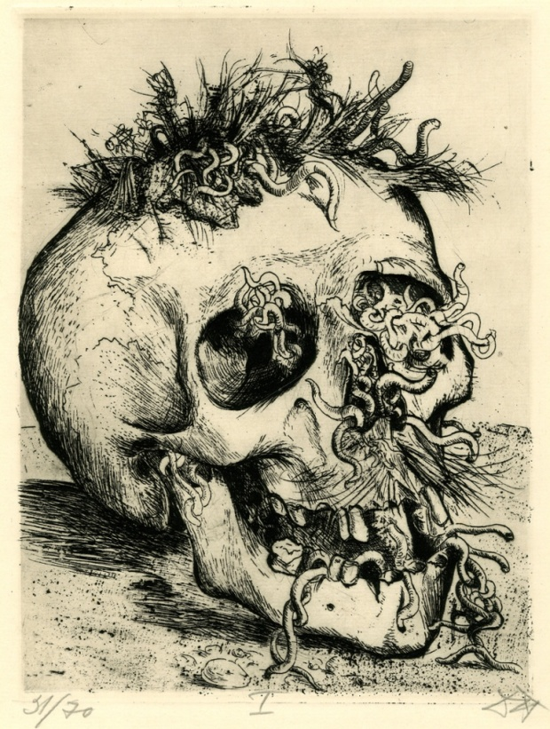
Skull 1924 by Otto Dix. Photograph: The British Museum

