Understanding and Engaging in the Customer Experience

Programme: BA (Hons) Leadership and Management Skills for the Workplace
Module: Understanding and Engaging in the Customer Experience
Module code: BMSW5103
Student Name: Andreea-Cristina Iliescu
Student Number: 2009203
Level 5 Term 1 Group 1
Module lecturer: Zainab Atta
Assignment Title: Organisation’s quality systems and customer relationship management.

Table of Contents
Executive Summary 3
Introduction 4
Company Context 5
SWOT Analysis 5
PESTLE Analysis 6
Marketing Mix 7
Ansoff Matrix 7
Communication Mix 8
Porter’s Five Forces: 8
Stakeholder’s Map 9
Models Review 10
IDIC Model 10
Payne's Five Process Model 11
The Value Chain Model 12
Model Selection 14
Application 15
Recommendations 17
Conclusion 18
References 19

Executive Summary
Nestlé is a well-known brand that offers a variety of items to its clients. The company works in several nations, which necessitates a significant amount of effort to maintain a solid client relationship. The company has strengths and limitations that must be considered. While maintaining quality and customer relationships, the company's external environment contains political, social, environmental, economic, and technological characteristics that the organization must analyse. For quality assurance, the company can use a market penetration plan. There are different techniques for different types of firm stakeholders. Finally, the company communicates with its consumers and stakeholders through a variety of methods. For customer relationship management, the organization can utilize the IDIC Model, Payne's Five Process Model, and the value chain model. The value chain method is more efficient, and it allows for internal strategic alignment. To achieve this strategy, the organization needs to train its personnel and develop a proper plan.

Introduction
Quality of performance in the business in many ways leads to effective customer experience. Therefore, Nestlé is highly concerned about the quality of its products and service. Besides, the firm puts focus on quality promotion and content to attract the target customers. Experience of the consumers in a company is crucially needed. A firm need to be concerned about the process of providing an effective experience to the customers along with the necessary strategies to continue it. This report would review the operations, organisational culture and strategies of Nestlé concerning quality assurance and customer experience. The context of the company would be discussed. Then a model would be selected based on the external and internal factors of the company with proper justification behind it. Finally, the guidance of applying the model along with some relative recommendations would be provided to the company.

Company Context
Nestlé was founded in Switzerland in 1866. It is one of the most successful brands in the world that has reached millions of customers across many countries. Nestlé mainly produces food items. The firm has a famous line of different types of coffee. Nestlé knows very well how maintaining quality can only benefit the firm in many ways even though it requires much effort and investment for it. One of the core strategies followed by Nestlé is diversified service. The firm focuses on building a diversified product line with diversified operations in different locations. Nestlé is also concerned about the efficiency of its activities. The firm puts a lot of investment in product development, brand growth, digitalisation and sustainability assurance. Nestlé also tries to provide organic and healthy foods to the customers helping them to maintain a healthy lifecycle

SWOT Analysis
The internal factors of Nestlé can be understood by analysing the SWOT model. This model identifies the capabilities and potential challenges of the firm.
Strengths: The most important strength held by Nestlé is its fame around the globe. The firm has managed to deliver its products and brand equity to people through an effective marketing strategy. Also, the firm is famous for its product development efforts. It launches new items every year based on market research analysis and demand evaluation (Light, 2020). The research and development of the company are very rich and gets high attention from the upper management. Finally, the proper distribution strategy of the company has made the firm visible to millions of customers.
Weaknesses: As Nestlé has different categories of food items, there sometimes arises criticisms regarding some of their products. The firm needs to maintain a price limit that does not always allow to focus on the ingredients. There are also some scandals regarding the products including baby milk offered by Nestlé. Moreover, the firm has yet to learn about embracing diversity in order to create a more effective customer relationship.
Opportunities: The company has the capability to enter new markets easily through its year-long experience and brand recognition. The firm can also get their activities in economically rich and growing countries like China, India and Brazil. It also can enrich its supply chain management and gain a competitive advantage in the market.
Threats: Many buyers are emerging in the marketing with many brands to serve them which puts the loyalty of customers at risk. Increased globalisation is generating a lot of new dimensions that the company needs to maintain. The price of raw materials is fluctuating in the market. Finally, the generation of workforce and target customers is ageing which requires a shift in attention for the firm.

PESTLE Analysis
The external factors of the company can be analysed through PESTEL Analysis.
Political Factors: The standards set by the government regarding food quality and ingredients is changing. As Nestlé is entering new countries, it has to face diverse political backgrounds and regulations. The international relationship between different countries holds a significant role in the quality maintenance of Nestlé.
Economic Factors: The assurance of quality requires stable financial and economic conditions surrounding a company. The growth of the economy in the countries where Nestlé operates must be evaluated. Again, the payment system along with the banking setting of the countries also hold an important role for the business. Moreover, the income, saving and purchase path of the customers also affect the decisions and quality of the firm.
Social Factors: The customers are following different lifestyles and changing their habits due to globalisation. The festivals and cultural functions of target people are observed and utilised by Nestlé in promoting their brand (Camillus, 2014). People are also adapting to a new culture which can be utilised by the company in delivering generalised promotion.
Technological Factors: A lot of customers of Nestlé are spending time on social media. The company, therefore, uses digital marketing to expand its customer base. Technology offers different innovative aspects which are used by the firm in production, development and quality assurance. E-commerce has also become a strong platform for the company to perform its sale and communication activities with customers.
Environmental Factors: Nestlé has to be aware of the ecological impacts it has through its operations. The firm has included the concern for environmental solutions in its Corporate Social Responsibilities strategy. This matter is hugely considered in the packaging and recycling procedure in the firm/.
Legal Factors: The regulations related to intellectual property, industrial norms and employee relationships are highly concerned by Nestlé. The different laws and regulations in countries where Nestlé operates also influence the quality of the company.

Marketing Mix
Product: The firm currently has seven different product categories. It focuses on consistent delivery of beverages, packaged foods, baby foods and others. The firm also invests in developing the products as part of marketing.
Price: Nestlé is known for its affordable price offerings for its products. The company must maintain the price so that the customers do not develop any doubt about the quality of the products.
Promotion: Nestlé uses traditional and digital methods of promotion. It utilises a relationship marketing strategy to engage customers (Dominici, 2019). It also sponsors roadshows or shopping mall events for promotion.
Placement: The firm maintains an effective supply chain to distribute its items in more than sixty countries. Supermarkets, groceries, online businesses and e-commerce platforms are some of the places where the products of the company can be found.

Ansoff Matrix
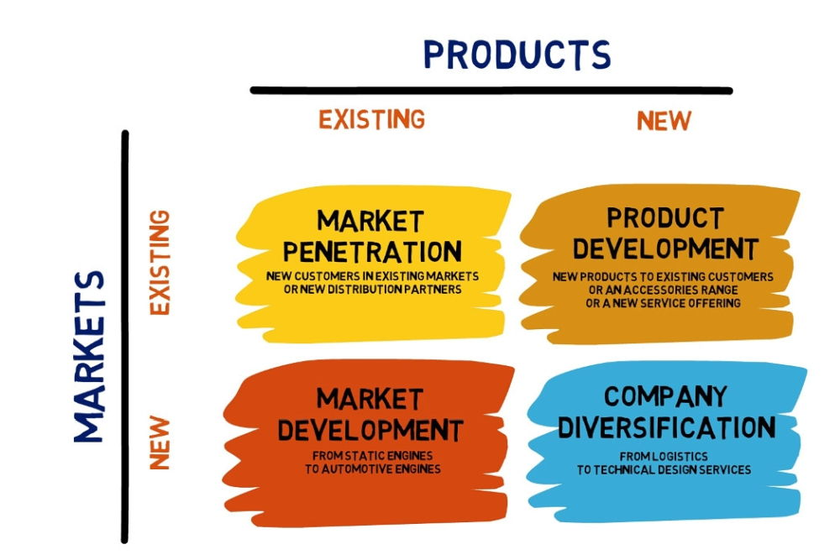
Figure 1: Ansoff Matrix; Source: (Shaw, 2020)
The Ansoff matrix of marketing helps the managers of a company to find the right strategy of promotion based on the market and product condition. Market penetration is inspired to push existing items in the existing markets. Market development is followed in introducing products in a new market. The firms can use product development to ensure better competency in the current market (Shaw, 2020). Finally, diversification is used in introducing new products in new markets. Nestlé must use a market penetration strategy. It can assist the firm in embracing relationship marketing campaigns. Through the use of social media and other platforms, the firm would be able to enhance customer relationships.

Communication Mix
The communication mix helps draw the design for making a strong relationship with the customers. This mix is comprised of many different strategies. They are advertising which gives the customers some reason to buy items. Sale promotion works as an incentive for customers to buy items. The Direct marketing strategy only focuses on the target customers of the company (Todorova, 2015). Another communication strategy is personal selling which requires the firms to set an arrangement to sell products to the persons directly. Finally, the public relation of the firm is concerned about the public image of the company that is developed by the firm. Nestlé can use public promotion, advertising and sales promotion to communicate with the customers and build better relationships.

Porter’s Five Forces:
The competition of Nestlé with its rival brands is quite high as the demand for their products is increasing. The threat of new entry would be low for Nestlé as the customer food industry requires diverse activities. The threat of substitutes for Nestlé is also very high as people have access to organic milk or food items. The power of the buyers is also high as the competition in the market is at its peak. Buyers have more options to choose from. The suppliers of the company enjoy a low power over Nestlé as the firm has many options to explore when it comes to procurement and logistics.

Stakeholder’s Map
Based on the interest of the stakeholder in the matters of the company and the power they hold in the decision-making process; a company can categorise stakeholders in four different ways. Nestlé should keep the Blockers from the map satisfied. The standards are monitored by the firm. The drivers of the firm who have both high power and interest must be managed closely by the company. Finally, Nestlé needs to keep the defenders of the company informed about the activities of the firm.
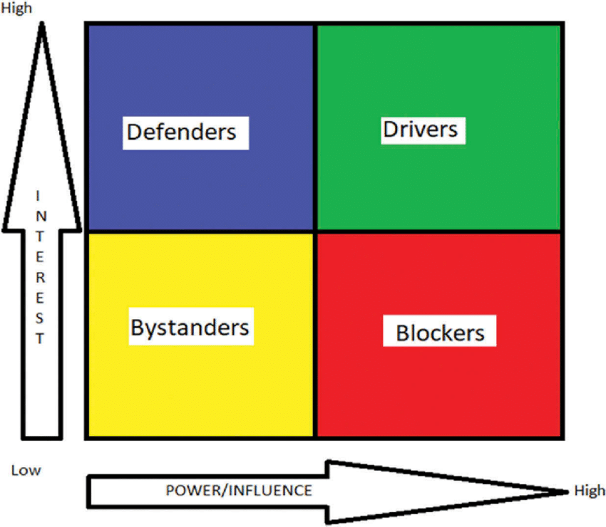
Figure 2: Stakeholders Map; Source: (McMullan, Ajay and Srinivas, 2018)

Models Review
CRM is the short form of Customer Relationship Management in a company. This holds a significant role in providing a quality experience to the customers. The customers of a firm would only become loyal and sustained buyers of the products when they get proper treatment from the firm’s end. To apply CRM, a company has to focus on the quality of its service and products. Quality and marketing have a close relationship in enhancing customer experience. Nestlé has to understand what its customers expect from its products. This expectation might come from natural wants or can be generated through the marketing campaign of the firm. Then, the company has to determine the service that the customers are getting. The gap between expectation and reality should be closed through quality management. There are some effective models of CRM that companies can explore.

IDIC Model
The Peppers and Rogers Group proposed the IDIC model as a basic framework for establishing CRM in a range of settings. IDIC stands for identity, differentiate, interact, and customise, which are considered to be the four steps of CRM deployment.
Identify: The first goal is to define the consumers, which may be done by obtaining information such as a customer's name, purchase history, interest at each customer interface throughout the organisation. The purpose is to conduct as much research as possible about each customer so that you can better understand their needs, desires, and buying patterns. Nestlé might use the buyer profile strategy in this matter. The general and unique identities of the buyers would be included in the profile (Kumar and Petersen, 2012). The common traits in the profile would be used for setting marketing decisions. Also, the cycle of purchase of the customers including the time between repeated purchases and the value held by the customers must be perceived in this stage. However, this stage can be difficult to conduct s there are many customers buying from physical stores and tracking them can be a difficult task.
Differentiate: The last stage is to segment or differentiate your customers depending on their present and predicted lifetime value. Nestlé should keep in mind that not all users are equal in terms of company value. The company may direct customer relationship efforts on the most valuable clients who buy products regularly from the business and adjust the interactions to best fit each category for optimal profitability. It can be done by segmenting your customers depending on their worth to the organisation. This process highly depends on the previous step as without identifying the traits of the customer, it would be difficult to segment the customers.
Interact: The segmentation of the customers makes it easier for the company to have an idea of how to approach them properly. The customers who prefer to stay online might be approached through social media and other online forms. Again, the users of the company who expects rewards for their loyal engagement with the company might want to get discounts or benefits from the company. Thus, based on the value the customers hold, Nestlé can apply different strategies.
Customisation: The last stage of this model of creating a customer relationship concerns the individual approach of the customers. The customers who might like to know about the health benefits of the food items of Nestlé products should be informed about that. This process might require constant analysis of the feedback and responses from the customers regarding the products. This stag focuses on meeting the needs and expectations of the target groups of customers.

Payne's Five Process Model
Another effective and used model for customer management in a business is called Payne’s Five process model which is discussed in the following.
Strategy Development Process: Strategy in a business denotes the process of developing a long-term plan that would help to face different challenges that might come in future. Strategy in CRM would be related to the approach that the firm might use in dealing with the customers. Nestlé has a big customer base (Best, 2013). Therefore, the company can build a strategy and deliver the plan to the employees to make sure the regular customers are staying loyal to the firm. The strategy should also include the decisions on how to change the approach of customer management in the future in face of different changes.
Value Creation Process: The second stage after creating a strategy for customer management is creating value for the customers. There can be different levels of customers holding different depths of value for the company. The firm needs to identify the valuable customers who are loyal and express positive reviews about the products of the company. Nestlé has many rivals in the market. However, with the creation of value for the customers, it can demonstrate its efforts for the users. This might provide a competitive advantage to the company. This process would also be concerned about the possible scope for developing value for the customers in the coming days.
Multichannel Integration Process: The social factors in PESTEL analysis has helped to understand that Nestlé has a diverse customer base and they hold different customs and culture within them. Thus, the use of a single channel or a few challenges might not be effective in creating a strong bond and value for the customers (Thakur and Chetty, 2022). This stage would focus on improving the integration among different channels used by the firm. The feedback from different channels regarding customer value creation can be hugely helpful to decide on further strategy establishment and value creation.
Information Management: This stage is basically important for all other stages on this model. It concerns the collection of relative information about the strategy and customer feedback. This information can be both quantitative and qualitative. The analysis of gathered data can be crucial in developing the right tone for marketing in Nestlé. To make the process more effective and responsive, Nestlé can utilise its technological factors and create a system that generates and analyses data promptly. This process can make the CRM strategy more comprehensive for managers and concerned parties.
Performance Assessment: This stage of the model is focused on evaluating the performance of the company regarding value creation and implementation. The customers are the main centre of this model and their insight regarding the business must be taken into consideration by the company. Thus, the engagement of the customer before and after the value proposition must be assessed. Then, the profit margin of the company, the value of shareholders, return on investment and other aspects can easily help to understand whether the process has succeeded in customer relationship management.

The Value Chain Model
The value chain model mainly has four different stages on creating value among the customers. Nestlé has to be careful about its value proposition towards the customers through this chain. The stages of this process include:
Customer Segmentation: A company like Nestlé that produces different types of products in different categories needs to identify which group of people would be interested to buy the products. The baby food category must be bought be by mothers, fathers and other close relatives of babies. In this way, this stage would help Nestlé to identify the customer base. As different customers have different types of needs and expectations, it would be easier for the company to offer proper value to them.
Customer Intimacy: Once the customer segments are identified, Nestlé must need to learn more about them in order to sustain the competition. The company should know its customers more than its competitors so that it can develop the right design to attract customers. The buying habit of the customers, their preferences about the products and other aspects must be learned by the company to increase intimacy with customers.
Value Proposition: Nestlé has learned about the customers and now it is time to serve them according to their needs which would be done in this section. The value that the company might offer to its customers might be effective and useful (Stevenson, 2022). The firm can also ensure individual approach customised on the traits of the customers if it specialises in this stage.
Customer Lifecycle Management: The previous three stages help the company approach delivering value to the customers. In the last stage, the firm should maintain these processes and understand the lifecycle of the customers. To ensure effective lifecycle management, the firm needs to gather data regularly from the customer relationship management process. An automation system can go a long way to make the process more useful for the company.
To support this model, there is also a support stage where the internal management of the company is facilitated to make the value proposition and customer management more useful. The activities in this stage include the HR management process, procurement process, leadership process, data management and others.

Model Selection
Nestlé has to maintain customer relationships to perform better in the competitive market. However, there are some issues that might bar the process of customer management implementation. Firstly, there are many established models for this purpose and it might be hard for the company to select a specific model. The previous analysis of the three models shows different models have different processes but all of them wants to create value for the firm. Therefore, it can be better for the company to utilise the value chain model for its CRM. This model precisely explores the processes of the other two models.
Another issue that Nestlé might face is the cost of implementing the CRM models. The use of the Value Chain Model also requires some costs. It requires the firm to gather information about the customers. Based on the segmentation, the firms are needed to develop an intimacy plan for the customers (Campbell, 2016). Again, it also requires collection and analysis of customer data which adds to the spending of the company. However, these stages are common in all other models as well. This cannot stop the company from obtaining a specific model. But the value chain model can be integrated with the internal management of the company. This can help the company to balance the costs. This aspect also mitigates the issue of not having a centralised customer relationship model. Because, the value chai model allows the company to connect its HR, procurement, leadership, IT and other sections to the value chain model. Finally, the Value Chain Model is also a set of activities that keep coming back in a cycle for the firm. Thus, the company should not be worried about the model being a one-time investment. Rather, Nestlé can be able to use the model constantly with a proper balance and distribution of the investment.
There can arise some challenges while implementing this model for the company. This includes a lack of support from the departments. Each department has some specific tasks that they have to be concerned about. Thus, an extra project like Value Chain Model implementation can increase their workload and hamper their strategy. Thus, there can arise a lack of support. Again, the adoption rate among the departments and other employees can decline due to a lack of guidance and information about the application of this strategy (Romain, 2020). This can lead to the ineffective outcome of the process. This might crash the project. Therefore, clear directions and improved leadership should be ensured before assigning employees and departments to the tasks of this model.

Application
Nestlé is a big company with a diversified product line. The firm has thousands of employees. It also has millions of employees all over the world. The diversity of the backgrounds of the customers makes it difficult for the company to ensure a proper customer management system. The CRM Value Chain model can be aligned with the current strategies of the firm and can help the company in mitigating the challenges.
Defining Customer Segmentation: Nestlé has identified its target customers through its years of operations in the market. Thus it would be easier for the company to start the value chain model for better customer relationships (Haines, 2019). There is much data stored in the company relating to the behaviour and preferences of the customers.
Creating Customer Intimacy: This stage of the model requires Nestlé to gather more information to understand people in target segmentation. Nestlé cares about its customers and thus it wants to gather feedback from the customer regarding their experience and insights about the products. This should be done to retain the customers more effectively. Data management and collection of information can come in handy in this stage of the model. Nestlé manages customer data and therefore, it would be easy for the company to maintain this process.
Proposing Value: This stage of the model of the value chain helps the company to offer its values and services to each group of target customers. Thus, Nestlé would have to plan what values it can offer to the customers in different segments. The customers have different expectations which are learned in the previous section (Bhatia, 2012). Now, Nestlé should ensure meeting those expectations. Nestlé has a system to value its loyal customers. Again, the firm tries to develop its product quality and packaging constantly based on customer feedback.
Managing Customer Lifecycle: This stage would take care of the previous three stages through constant monitoring of the customer behaviour and lifecycle. Nestlé has to rebuild its organisational structure and culture to maintain the customer lifecycle. Nestlé has moved towards digital marketing E-commerce which can assist in approaching customers in different stages of their lifecycle and buying procedure.
Nestlé is concerned about transparency and governance within the company. The value chain model requires the company to integrate its different departments for better support. This would allow the company to make a better bond between the members of the member of the firm.
However, there can arise the challenge of complexity in the company. Nestlé is a brand that has been operating on some specific set of strategies for customer management. The adoption of the new model can hamper its smooth flow that is being practised for a long time. Vague direction about the strategy can lead to ineffective outcomes. Thus, the firm needs to develop proper plans and directions before implementing this model.

Recommendations
To apply the CRM model properly in the company and avoid any class in the process, Nestlé can follow the given suggestions,
- The company should generate a proper utilisation strategy for the model. The resources that the company might need to ensure the steps are followed properly should be identified and collected before starting the project. Once the firm has all the necessary plans and resources to proceed with the model implementation, it can confidently face any challenges in the procedure.
- Training the employees of the firm on customer relationships can lead a long way. Employees should know the value behind putting much effort into the customer relationship. Once they realise the depth of this matter, they should be educated on how to ensure better customer management (Luenendonk, 2015). The stages of the model should be taught to them so they can know how to mitigate challenges and issues for proper implementation.
- The current tasks and operations of the company should be aligned with the stages of this model. The value chain model can be implemented with the participation of other departments. Therefore, the company must consider demonstrating a connection of the model with the tasks of each department.

Conclusion
Nestlé is a famous brand for different products for the customers. The firm operates in different countries which requires much effort to manage a strong customer relationship. The firm has its strengths and weaknesses that it needs to consider. The external environment of the company holds political, social, environmental, economic and technological features that the firm must analyse while maintaining quality and customer relationships. The firm can utilise a market penetration strategy for its quality assurance. There are different approaches for different sets of stakeholders in the company. Finally, the firm uses multi-channels to communicate with its customers and stakeholders. There is IDIC Model, Payne’s Five process model and value chain model that the company can use for customer relationship management. The value chain process is more effective and it allows internal connection with the strategy. The company must train its employees and make a proper plan to implement this strategy.

References
Best, R. (2013). Market-based management : strategies for growing customer value and profitability. Upper Saddle River, N.J.: Pearson Education.
Bhatia, S. (2012). Customer Relationship Management. [online] Available at: https://www.slideshare.net/shveta_bhatia/customer-relationship-management-2955032 [Accessed 11 Mar. 2022].
Camillus, J.C. (2014). Organisational identity and the business environment: the strategic connection. International Journal of Business Environment, 4(4), p.306.
Campbell, A. (2016). 3 Biggest Problems Implementing a CRM System, and What to Do About Them. [online] 3 Biggest Problems Implementing a CRM System, and What to Do About Them. Available at: https://www.sba.gov/blog/3-biggest-problems-implementing-crm-system-what-do-about-them [Accessed 11 Mar. 2022].
Dominici, G. (2019). From Marketing Mix to e-Marketing Mix: a literature overview and classification. International Journal of Business and Management, 4(9).
Haines, D. (2019). The CRM implementation process: a six step plan for success. [online] Discovercrm.com. Available at: https://www.discovercrm.com/crm-implementation-process.html [Accessed 11 Mar. 2022].
Kumar, V. and Petersen, J.A. (2012). Statistical methods in customer relationship management. Chichester: J. Wiley.
Light, L. (2020). Nestlé’s Trademark Confusion May Cost The Company Credibility. [online] Forbes. Available at: https://www.forbes.com/sites/larrylight/2020/06/04/nestls-trademark-confusion-may-cost-the-company-credibility/?sh=71e10ff72395 [Accessed 11 Mar. 2022].
Luenendonk, M. (2015). Better Targeting your Customers with CRM Value Chain Model | Cleverism. [online] Cleverism. Available at: https://www.cleverism.com/crm-value-chain-model-better-targeting-customers/ [Accessed 11 Mar. 2022].
McMullan, P., Ajay, V.S. and Srinivas, K.R. (2018). Improving access to medicines via the Health Impact Fund in India: a stakeholder analysis. [online] Available at: https://www.researchgate.net/figure/Stakeholder-analysis-matrix-comparing-the-interest-of-each-actor-with-their-perceived_fig1_323519219.
Romain, J.K. (2020). 10 common CRM problems and how to fix them. [online] Zendesk. Available at: https://www.zendesk.com/blog/10-common-crm-problems-fix/ [Accessed 11 Mar. 2022].
Shaw, A. (2020). PESTLE Analysis of Nestlé. [online] SWOT & PESTLE Analysis. Available at: https://swotandpestleanalysis.com/pestle-analysis-of-Nestlé/ [Accessed 10 Mar. 2022].
Stevenson, J. (2022). The CRM Value Chain. [online] Toolbox.com. Available at: https://www.toolbox.com/tech/enterprise-software/blogs/the-crm-value-chain-111807/ [Accessed 11 Mar. 2022].
Thakur, S. and Chetty, P. (2022). How Payne’s Five Process model can help to improve CRM? [online] Project Guru. Available at: https://www.projectguru.in/paynes-five-process-model-crm-strategy/#:~:text=The%20value%20creation%20process%20of%20Payne%E2%80%99s%20Five%20Processes [Accessed 11 Mar. 2022].
Todorova, G. (2015). Marketing communication mix. Trakia Journal of Science, [online] 13(Suppl.1), pp.368–374. Available at: https://www.researchgate.net/publication/304418915_Marketing_communication_mix.

