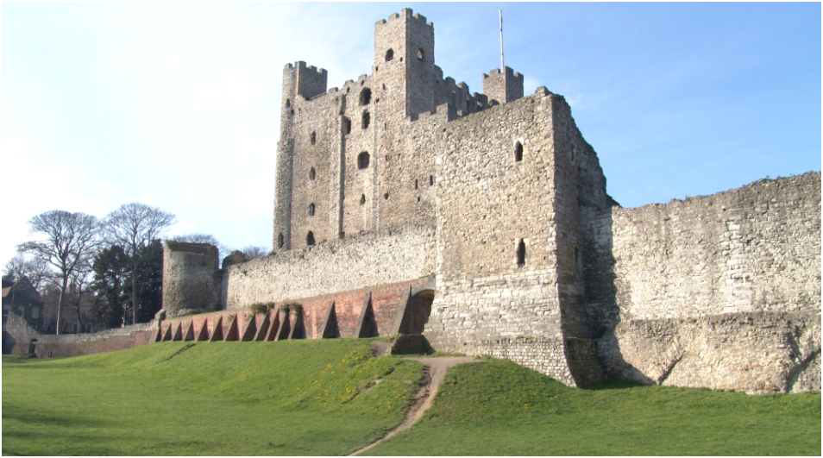
Though not on its original site, Rochester castle commands the point that Watling Street crosses the navigable River Medway towards London. Its location on a route between the Kentish ports and London ensured that it remained under Crown control with custodianship entrusted to the Archbishop of Canterbury. The site was particularly important to the Norman and Angevin kings because it protected access to the capital and provided royal lodgings en-route to the king’s possessions in France. Another function was administration, both for local and, when the king was in residence, national governance. Typical of Norman planning of secular and ecclesiastical powerbases, the castle is close to Rochester cathedral. The earlier castle was built by Bishop Gundulf in 1087 at a cost of £66, suggesting that the Bishop was able to incorporate Roman masonry within a less imposing structure. Since the appearance of Gundulf’s castle is unknown, I shall restrict discussion to the extant keep.

The castle is an imposing structure, formed of a massive keep now measuring 113 foot high, 70 foot square with walls up to 12 foot thick. It is surrounded by a banked, curtain wall, partly using Roman and Gundulf’s masonry. Its visual impact cannot be underestimated: before 1066, castles were virtually unknown in England thus, with the exception of churches, the local populace would not have seen a stone building before, and not on this scale. Henry I directed William de Corbeil, Archbishop of Canterbury to build an egregiam turrim (great tower): the tower was begun in 1127 and finished either before William’s death in 1138 or certainly before 1141. The resulting tower was the largest of its type in Europe (other four-storey keeps were of more modest dimensions) and, according to contemporaries, ‘outstanding’ and ‘noble’.

The tower is made from Kentish ragstone, with occasional use of imported Caen stone for corners and arched windows. It consists of three floors and a basement with a protruding fore-building with its own set of defences which allows access to the keep itself. Originally it had square turrets on all four corners, but the south-eastern turret was re-built in circular Poitevin design after King John’s siege of 1215. The keep incorporates many features of the typical Norman donjon: it has two internal spiral staircases located in the east and west turrets, internal cross-walls to produce two rooms per floor, internal well for water supply, pilaster buttresses and a first-floor entrance. The keep would have been serviced by other buildings: the lack of an integral kitchen suggests further buildings in the bailey. Similar arrangements exist in early Norman castles of Ivry-la-Bataille, Domfront and the Tower of London. Rochester is slightly unusual in possessing two, possibly three, chapels, but that could be related to its close relationship with the archbishopric. Internal arrangements are conjectural, but there is sufficient remaining to indicate multiple garde-robes, a grand two-storey-high principal floor surrounded by a mural gallery, and fire-places on the first, second and third floors. Various configurations for the utilisation of space for domestic arrangements have been discussed in a conservation document for Rochester castle in 2009. Flooring has not survived within the donjon, but there is sufficient extant material for researchers to propose a range of configurations. Interpretation of Rochester is complicated by its unique features: the central arcade on the principal floor and chambers of roughly the same size, and later reconstruction of the south-east corner. Little information exists regarding 12th century royal domestic arrangements (the complex hierarchy associated with later periods had yet to develop), however presence of finely-worked Romanesque arches and elaborate windows with chevron carving on the second and third floors indicate a high status royal building.

Essentially, the function of a castle is four-fold: to defend, impress, govern and live in thus castles combine military, ceremonial, administrative and domestic functions. Ostensibly, its prime functions would be control of the river and outlying areas and garrisoning troops. The third incarnation of Rochester castle (there was an earlier wooden structure of unknown location preceding Gundulf’s) was built only fifty years after the displacement of virtually all of the indigenous elite by foreigners: the Normans could not be assured of loyalty from their new subjects. Thus Norman kings in England dealt ruthlessly with anyone suspected of disloyalty. The main function of the castle therefore was to display Norman power and impregnability: Rochester castle is the visible projection of Norman might and, paradoxically, their insecurity. The desire to produce a strong statement of power, an imposing, externally symmetrical building, is probably why there is an unusual internal arrangement of two equally-sized main rooms on each floor. Rochester castle is an image of both external and internal grandeur, the size of the rooms indicating a public, probably ceremonial, function. The fourth element, administration, is crucially important. Rochester castle was an important administrative centre – the principal rooms are large, but contained timber screening, some undoubtedly used to screen administrative staff.

There has been debate on just how defensive castles actually were, with some revisionist historians arguing that they served almost no military function at all. Rochester castle was captured three times in its history: outer defences were quickly breached with the defenders retreating to the upper floors of the keep. Accounts survive of the sieges of 1215 and 1264, and the conventional interpretation of the great tower as the ‘last resort’ during siege owes much to the story of Rochester, including the use of the spine wall as a final barrier by defenders. In 1215, the defenders lasted days, in 1264, better-manned and provisioned, they lasted little more. This highlighted the inherent weaknesses of the donjon: susceptibility to mining and no opportunity to attack after retreat inside. After 1215, a chronicler commented: ‘after it few cared to put their trust in castles’. Stone castles could be starved or undermined to submission by a determined, professional force but protection in times of national conflict was possibly not their prime raison-d’ětre. Kings and nobility still continued to fund massively expensive castle-building in stone, even in areas well away from the Marches and the Scottish borders; the Crown very quickly repaired damage to Rochester keep. Collection of revenue was vital for king, church and nobleman; timber constructions could be burnt down by a mob reluctant to pay taxes and they do not give the same aura of impregnability as large stone walls. The argument that the castle was all form does not really hold: it successfully protected the business interests of the medieval elite. Rochester castle is therefore an outward display of power dedicated to display, subjugation and cash-flow.

Bibliography:

C. Gravett and D. Nicolle, The Normans: Warrior Knights and their Castles (Oxford: Osprey Press, 2006)
D. Stenton, English Society in the Early Middle Ages (Harmondsworth: Penguin Press, 1981)
J.A. Goodall, ‘The Great Tower of Rochester Castle’, Medieval Art, architecture and archaeology of Rochester, ed. Tim Ayers and Tim Tatton-Brown (British Archaeological Association: Conference Transactions Volume 28, 2006)
M. Chibnall, The Debate on the Norman Conquest (Manchester: Manchester University Press, 1999)
P Dixon, ‘The myth of the keep’, in The Seigneurial Residence in Western Europe, AD 800–1600, ed G Meirion-Jones and E Impey (Oxford, 2002)
R.A. Brown, ‘Royal Castle-building in England, 1154-1216’, Anglo-Norman Castles, ed. by Robert Liddiard (Oxford: Boydell and Brewer, 2002)
R.H.C. Davis, The Normans and their Myth (London: Thames and Hudson, 1976)
The Paul Drury Partnership (October 2009a), Rochester Castle Conservation Plan Part 1: Understanding and Significance (pp. 1–53) (PDF), Teddington: The Paul Drury Partnership, archived from the original (PDF) on 2 April 2012

Important ancient trackway then paved Roman road that links present-day Kent to Wroxeter, continuing in one direction to Anglesea and the other up to Scotland
The Paul Drury Partnership (October 2009a), Rochester Castle Conservation Plan Part 1: Understanding and Significance (pp. 1–53) (PDF), Teddington: The Paul Drury Partnership, archived from the original (PDF) on 2 April 2012
In comparison, and allowing for inflation, Henry II spent £6400 on Dover castle. R.A. Brown, ‘Royal Castle-building in England, 1154-1216’, Anglo-Norman Castles, ed. by Robert Liddiard (Oxford: Boydell and Brewer, 2002), p. 134.
These stone towers were called donjon, ‘keep’ is a later Elizabethan term. C. Gravett and D. Nicolle, The Normans: Warrior Knights and their Castles (Oxford: Osprey Press, 2006), p. 114.
The Paul Drury Partnership (October 2009a), Rochester Castle Conservation Plan Part 1: Understanding and Significance (pp. 1–53) (PDF), Teddington: The Paul Drury Partnership, archived from the original (PDF) on 2 April 2012
R.H.C. Davis, The Normans and their Myth (London: Thames and Hudson, 1976), p. 110.
Saxon defensive structures, burhs, were essentially earthworks.
When the tower was used as a prison for Robert of Gloucester. The Paul Drury Partnership (October 2009a), Rochester Castle Conservation Plan Part 1: Understanding and Significance (pp. 1–53) p. 26.
The Paul Drury Partnership, p.79.
J.A. Goodall, ‘The Great Tower of Rochester Castle’, Medieval Art, architecture and archaeology of Rochester, ed. Tim Ayers and Tim Tatton-Brown (British Archaeological Association: Conference Transactions Volume 28, 2006), pp. 265–99.
Hard, gray limestone, most likely sourced from quarries at near-by Maidstone.
The Paul Drury Partnership, ibid., p. 29.
www.engligh-heritage.org.uk
Gravett and Nicolle, The Normans: Warrior Knights and their Castles (Oxford: Osprey Press, 2006) p. 214.
The Paul Drury Partnership (October 2009a), Rochester Castle Conservation Plan Part 2: Understanding and Significance (pp. 54-102), p. 82.
Gravett and Nicolle, The Normans: Warrior Knights and their Castles, p. 196.
The Paul Drury Partnership (October 2009a), Rochester Castle Conservation Plan Part 1: Understanding and Significance (pp. 1–53) (PDF), Teddington: The Paul Drury Partnership, archived from the original (PDF) on 2 April 2012
The Paul Drury Partnership, Rochester Castle Conservation Plan Part 2: Understanding and Significance (pp. 54-102).
The Paul Drury Partnership, ibid., p. 87.
Within a radius of about 10 miles, a comfortable ride out and back in a day. Gravett and Nicolle, The Normans: Warrior Knights and their Castles, p. 204.
M. Chibnall, The Debate on the Norman Conquest (Manchester: Manchester University Press, 1999), p. 14.
Interestingly, Robert Curthose who succeeded William as Duke of Normandy was much more lenient. Davis, The Normans and their Myth, p. 123.
The norm was for one principle and one smaller room.
The Paul Drury Partnership, Rochester Castle Conservation Plan Part 2), p. 80.
The word chancellor is derived from cancella (a screen), behind which the king’s scribes would sit. D. Stenton, English Society in the Early Middle Ages (Harmondsworth: Penguin Press, 1981), p. 24.
For arguments, see M. Morris, Castles of the Conqueror, BBC History Magazine, 11 October 2016.
For example P Dixon, ‘The myth of the keep’, in The Seigneurial Residence in Western Europe, AD 800–1600, ed G Meirion-Jones and E Impey (Oxford, 2002), 9–14.
The Barnswell chronicler, a monk associated with Barnswell Priory. Gravett and Nicolle, The Normans: Warrior Knights and their Castles, p. 214.

