Contents
Abstract 2
1 Introduction 2
2 Security framework and model(Task 1) 2
2.1 ISO 27000 2
2.2 COBIT 6
2.3 NIST 8
2.4 Discussion 9
3 Application on a specific scenario(Task 2) 9
3.1 Case scenario introduction 9
3.2 Risk management 10
3.2.1 Risk Analysis 10
3.2.2 Risk management 10
3.3 System architecture 11
3.3.1 Physical layer 11
3.3.2 Security layer 11
3.3.3 Application layer 12
4 Conclusion 13
Reference 13
Background reading 13

Abstract
With the development of society, the importance of information is increasing day by day. At the same time, information security is also facing various risks. In such a big environment, information security management framework/standard gradually emerged, and gradually paid attention to by various organizations. This paper introduces three information security management models/standards and applies one of them in practical scenarios.
Key word: Information security management, ISO 27000, COBIT, NIST

1 Introduction
Information technology has been integrated into every corner of human society, and constantly promotes social progress and development. However, the ubiquitous information is accompanied by the wind at any time, information security incidents occur from time to time, information security problem has been called the common concern of the whole society, information system security, management, risk and control problems are increasingly prominent. The field of information security research institute design is quite extensive, the construction of information security is a system engineering. In the construction of information security, the correct way is to follow the international relevant information security standards and best practices, consider the needs of the organization for information security at all levels, introduce reasonable control measures on the basis of risk assessment, establish information security management system to ensure the security of information attributes. The vast majority of information security problems are from the defects of management, information security management is a very important topic, in solving the problem of information security occupies an important position, its development of information security practitioners put forward higher requirements. Risk assessment is the basis of information security management system and information security risk management, is the necessary premise to establish information security guarantee system, through risk assessment can focus on the important issues of information security activities.

2 Security framework and model(Task 1)

2.1 ISO 27000
ISO 27000[1] series of standards originated from the British Standards Institute 1995 developed BS 7799 standard, and after the adoption of ISO standards formed after the improvement of ISO 17799 standard.
ISO 27000 series standards by the International Standardization Association (ISO) and the International Association of Electronic Technology (IEC) jointly formulated to provide information security management system (ISMS) construction guidance. The standard covers issues such as information protection, confidentiality, and IT technology security, and is applicable to organizations of all sizes. The standard system develops new standards related to information security management every year. At present, it mainly includes the following published standards:

Table 2.1 Documents in ISO27000 series
Standard Document | Content
ISO/IEC 27000 | Information security management system basis and terminology
ISO/IEC 27001 | Information security management system requirements
ISO/IEC 27002 | Information security control practice guide
ISO/IEC 27003 | Guide to information Security management system
ISO/IEC 27004 | Information security management monitoring, measurement, analysis and evaluation
ISO/IEC 27005 | Information security risk management
ISO/IEC 27006 | Information security management system audit and certification body requirements
ISO/IEC 27007 | Information security management system audit guide
ISO/IEC 27008 | Information security control audit guide
ISO/IEC 27010 | Information security manages communications across industries and organizations
ISO/IEC 27011 | ISO 27002 - based information security management guide for telecommunications organizations
Among many standards, ISO 27001 standard was the first to put forward the concept of information security management system, is the core of the whole ISO standard series, which describes in detail the establishment, implementation and maintenance of information security system requirements, used to guide the development of information security management system construction, information security management is divided into 14 security control domain(Figure 2.1), Specifically, it includes 35 control objectives and 114 security control measures, basically covering all fields of enterprise information security management. Therefore, information security construction based on ISO 27001 standard can effectively avoid the blind area of enterprise information security management. ISO 27002 provides reference for the implementation of information security management system based on ISO 27001 as a reference guide for the implementation of general information security control measures based on ISO27001.
Security policy
Organizing information security
Human resources security | Asset management
Human resources security | Access control
Human resources security | Cryptography
Human resources security | Physical and environmental security | Operations security | Communications security | Information systems acquisition, development and maintenance
Human resources security | Supplier relationships
Information security incident management
Information security aspects of business continuity management
Compliance
Fig 2.1 ISO 27001 standard 14 control domains
The construction of information security system is mainly based on risk management. By identifying, evaluating and analysing information security risks, the probability and influence of risk occurrence are reduced to an acceptable level, and corresponding measures are taken to ensure that business will not be interrupted or lost due to the occurrence of security events. ISO 27001 standard requires the development of information security strategy, determine the scope of the management system, clear management responsibilities, and through risk assessment, determine control objectives and select control measures. Once the system is established, the organization shall continue to maintain and improve the information security management system to maintain the effectiveness of the system. Similar to the ISO 9001 quality management standard in the ISO 9000 series, ISO 27001 provides a PDCA reference model for the establishment, implementation, operation, monitoring, evaluation and improvement of information security system, emphasizing that the construction and operation of the system is based on the continuous cycle improvement of the PDCA model (Figure 2.2). The construction and operation mechanism of information security system based on PDCA cycle model can effectively improve the initiative of enterprise information security management.

Fig 2.2 Schematic diagram of PDCA model
The PDCA diagram can vividly illustrate that the improvement activities of the system are a continuous process that goes round and round. PDCA stands for:
P(Plan)——Define policy and goals, define activity plans
D(Do)——Take practical steps to implement the contents of the plan
C(Check)——Review and summarize the results of the implementation plan, evaluate the effectiveness and identify problems
A(Action)——The results of the inspection summary should be processed, and the successful experience should be confirmed and appropriately promoted and standardized; To summarize the lessons of failure so as not to recur; Unsolved problems go to the next PDCA cycle.
With each cycle completed, the effectiveness of the management system is on a higher level. The organization continues to improve its management by implementing the PDCA process, as shown in Figure 2.3.
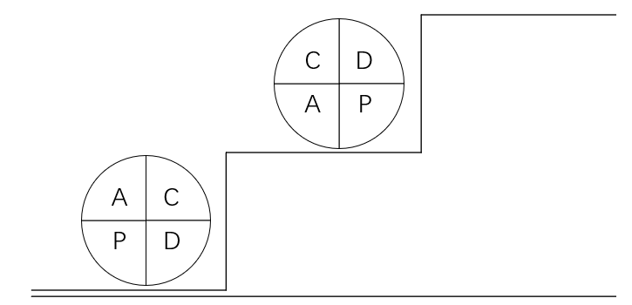
Fig 2.3 PDCA model of continuous improvement
The four stages of the PDCA cycle can be broken down into eight steps, each of which is detailed as follows:
Planning stage: formulate specific work plans and propose general objectives. The planning phase can be further divided into the following four steps:
(1) Analyse the current situation and find out the existing problems
(2) Analyse the causes and influencing factors of the problem
(3) Analyse and identify the main problems in management
(4) Make management plan and identify management key points
According to the main problems in management, formulate management measures, plans, clear management focus. When formulating the management plan, we should pay attention to the completeness, multi-choice and comprehensiveness of the whole
(5) Implementation phase: implement according to the formulated plan
Implement the plan in management. The implementation of the formulated management plan in the management work directly affects the whole process. So in the implementation stage to firmly in accordance with the formulation of the plan to carry out.
(6) Review phase: Review the results of the implementation plan
Check the work, investigate the results. This stage is a more important stage, which can be checked whether the implementation plan is reasonable and feasible. It is the inspection period to examine the work of the previous stage and provide conditions for the work of the next stage.
Treatment phase: according to the investigation results. The processing phase can be further divided into the following two steps :
(7) Standardization of solved problems. The successful and feasible provisions should be standardized and incorporated into the system and regulations to prevent similar problems in the future.
(8) Identify any unresolved problems and move on to the next loop for resolution.
In quality management, PDCA cycle has been widely used and achieved good results, so some people say that PDCA cycle is the basic method of quality management. The PDCA cycle is called the PDCA cycle because the four processes do not run once, but repeatedly. It is a spiral and development, each cycle, the demand for improvement. ISO/IEC 27001 is generally considered to be a PDCA cycle, which itself is a nesting of many cycles, as shown in Figure 2.4.
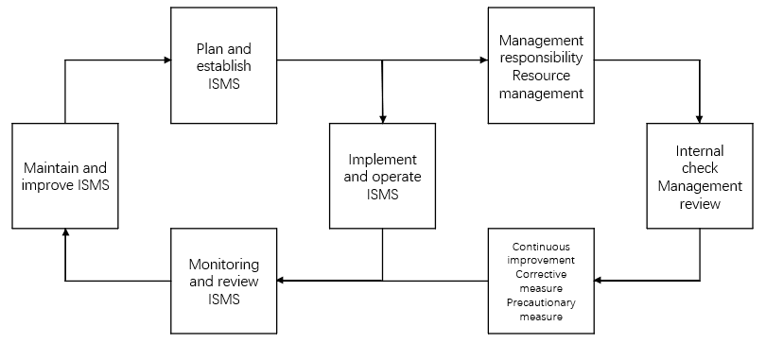
Fig 2.4 Two PDCA cycles

2.2 COBIT
The system has undergone six updates and improvements since its first release. IT has gradually evolved into the most advanced and authoritative standard system for security and information technology management and control recognized by global scholars, as well as the international IT audit standard. The latest version is COBIT 2019[2], released in December 2018. COBIT 2019 core content is a reference model for governance and management objectives, which summarizes 40 core governance and management objectives based on COBIT 5 and a series of other authoritative standards and frameworks (Figure 3.1) and describes the processes involved in them in detail.
Governance objectives are included in the assessment, guidance and Monitoring (EDM) area. In this area, the board of directors and executive management are responsible for evaluating strategic options, guiding senior management in implementing the selected options, and overseeing the implementation of the strategies. The management objectives are responsible for by senior and middle management, which are divided into four areas, respectively representing Plan, Build, Run and Monitoring, running through the entire life cycle of information system. Alignment, Planning, and Organization (APO) is the overall organization, strategy, and support activities for IT; Build, Purchase, and Implementation (BAI) is the definition, acquisition, and implementation of IT solutions and their integration into business processes. Delivery, Service and Support (DSS) is the operational delivery and support of IT services, including security. Monitor, evaluate, and evaluate (MEA) performance monitoring for IT and its consistency with internal performance objectives, internal control objectives, and external requirements. According to the COBIT framework, whether an enterprise can achieve the highest value from IT by maintaining the balance among profit, optimizing risk level and resource use depends on the realization of IT goals, and the decisive factor for the realization of IT goals is the realization of effective control of IT processes. Therefore, in the process of information system audit, auditors should pay attention to the execution of each IT process, so as to ensure the security, reliability and economy of information system.
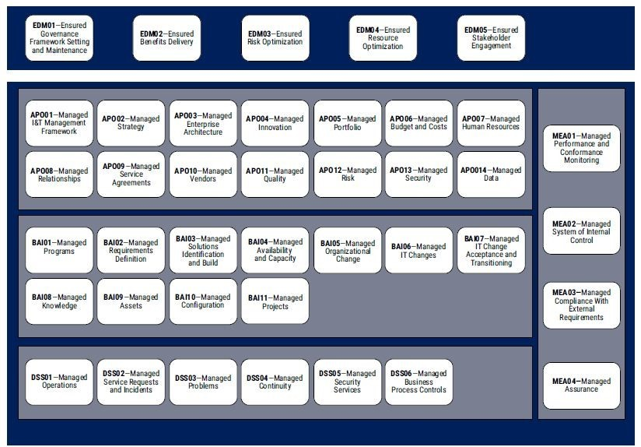
Fig 2.5 COBIT 2019 core model
The COBIT 2019 update has improved in several ways:
First, IT better illustrates the importance of IT governance to the enterprise. With the support of the board of directors and executive management, develop IT governance plans in order to achieve benefits, risk optimization, resource allocation optimization, business and IT adjustment. Keep governance solutions on a continual basis for improvement. This will be a major advantage for the enterprise, and it leads to new trends in technology. For example, added development business and agile development concepts; Off-market business was considered; The impact of third party suppliers is discussed.
Second, it uses the latest standards and working methods to improve and update. The COBIT model allows technical standards, specifications and regulations to reference and align other information with concepts from other sources. The concept of key areas is introduced. A focus area describes a specific governance topic, area, or problem that can be addressed by combining a set of governance and management goals and their combinations. Such as smes, cybersecurity, digital transformation and cloud computing. Areas of focus can contain a combination of common governance components and bodies of change. The number of areas of focus is virtually unlimited, and new areas can be added as needed.
Finally, it is more prescriptive. Frameworks such as COBIT can be descriptive and prescriptive. Instantiate the COBIT conceptual model, where custom COBIT components are considered a way of dealing with how to build custom governance systems for IT. IT is a high-performance tool for IT governance. COBIT performance structure that integrates the NCE management model into the conceptual model. In order to better align with the capability Maturity Model integration, the concepts of maturity and capability are introduced. It adds new online collaboration capabilities. Future updates will be recommended by COBIT users and reviewed by the COBIT Steering Committee to ensure the quality of COBIT's core framework and the timeliness of updates.
By using the COBIT framework, IT governance can be better realized in the following aspects:
(1) Identify information needs Before delving into technical solutions and technologies, fully identify the information needs of the organization. The first principle of applying COBIT 5 is to meet the needs of stakeholders: understand what the information needs are, what the key to the information is, and why and how to manage it. This can be done appropriately, subject to additional regulatory and policy constraints. It is important to understand the different levels of information quality goals in an organization. When an enterprise achieves necessary quality goals, information is an asset or resource that brings benefits to the enterprise.
(2) COBIT 5 uses target cascades to analyse and illustrate the dependencies of information resources and to show how information contributes to achieving enterprise goals. By doing all the above, stakeholders are more inclined to use relevant governance.
(3) Defining stakeholder roles Roles and responsibilities should be defined through extensive consultation across stakeholder groups throughout the information life cycle. Determine whether there is an information model and who plays what role in each stage of the information life cycle. Some of the roles suggested in COBIT include: information producer, information consumer, information owner, information getter, information planner, information user, and information custodian.

2.3 NIST
NIST SP800-30[3] is a guide for information Technology system risk management published by National Institute of Standards and Technology (NIST) in 2002.
It believes that risk management is "the process by which information system managers weigh the operational and economic costs of security measures to protect and improve the security capabilities of information systems and data that support an organization's business". Meanwhile, risk management is defined as "risk assessment, risk mitigation and risk continuous assessment", as shown in Figure 2.6.
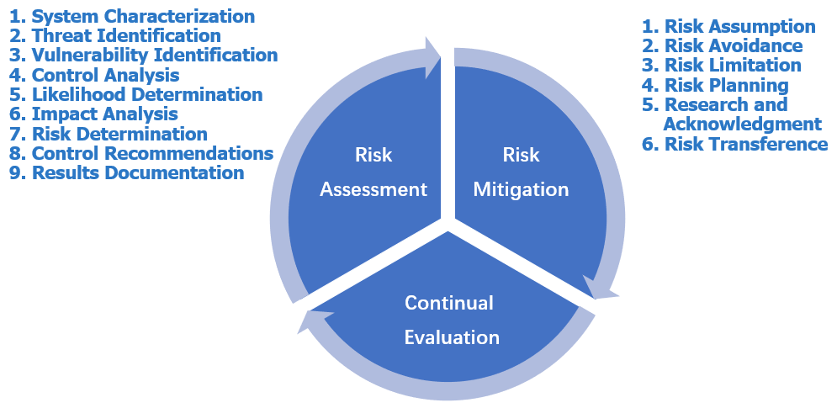
Fig 2.6 Risk Management
(1) Risk Assessment
NIST SP800-30 regards risk assessment as the first process of risk management. The organization determines potential threats and risks through risk assessment during the life cycle of the system, and provides a basis for the safety control selection for the next step of risk mitigation. It consists of nine steps: description of system characteristics, threat identification, vulnerability identification, analysis of existing security controls, identification of possibilities, impact analysis, risk identification, control recommendations and documentation of the results.
(2) Risk Mitigation
Risk mitigation is the second process of risk management, which includes risk acceptance, risk avoidance, risk suppression, risk planning, risk reduction and risk transfer. It is the process of optimizing, selecting and implementing risk control measures, including prioritizing risk control, selecting risk control methods, cost-benefit analysis of risk control, selecting risk control, assigning responsibility, formulating risk control implementation plan and implementing risk control measures.
(3) Continual Evaluation
The network and information systems of most organizations are constantly expanding and upgrading, so the corresponding software, hardware, and information of the system need to be updated to the new version, so that the corresponding system components, policies, and personnel need to be updated and upgraded. In other words, risk management is an ongoing management process.

2.4 Discussion
NIST standard series, released by the U.S. national institute of standards and technology graduate with critical infrastructure related network communication architecture and equipment as the object of management, it with identification, protection, detection, and the corresponding, restore five stages to describe the information security requirements, dynamic testing security issues as the main ideas, but it is only in view of the specific requirements of the network system, Such as energy, power and other key enterprises. Published by ISACA(Information System Audit and Control Federation), COBIT takes information system as the management object. It is process-oriented and focuses on information system audit, but it is only suitable for information system security audit. ISO27001 issued by ISO(International Organization for Standardization), used to manage the information security of the organization, focusing on the continuity of enterprise business and the integrity of the management system, although it has more management system establishment requirements, but for different architectures of enterprises have good adaptability. Compared with other security standards, ISO27001 standard focuses more on describing the role of management in information systems, and describes more management related scenarios.

3 Application on a specific scenario(Task 2)

3.1 Case scenario introduction
CoffeeBlue sells Blue Mountain Peak coffee from Jamaica, one of the best and most sought-after blends in the world. CoffeeBlue has extensive presence around the globe. The company uses cloud services to deliver IT services to its staff and clients. It is estimated that almost 95% of the company's network is wireless based. The company also has a massive online presence and social media presence to promote its activities. Owing to its large staff and international customer base, the company has recently come under immense pressure to allow both its staff and customers to use their personal devices to access the company's network/resources. Security of personal staff's data and client's data is the company's major concern. The company is also concerned about protecting its intellectual properties, which is worth billions. Information Security is a priority to the company, but everything is in disarray. There is no established policy covering their security need.

3.2 Risk management
Through the research of various methods, this paper adopts the COBIT framework to protect the security of the company. Based on the COBIT frame, risks are identified, risks are analyzed and risks are dealt with, and the system architecture and function are designed specifically, which has a strong guiding significance for the information construction of the company, especially for the security protection of sensitive data.

3.2.1 Risk Analysis
Risk analysis is the systematic use of information to identify sources of risk and estimate risk.By referring to the COBIT model and combining with the actual situation of CoffeeBlue, this paper divides the risk of sensitive data leakage into two categories: external risk and internal risk as shown in Table 3.1.
No. | type | Risk
1 | External  risk | Through network attack, Trojan virus and other ways to directly obtain sensitive data information.
2 | External  risk | By attacking various application systems of enterprises, unauthorized authorization of the system is obtained, so as to obtain sensitive data.
3 | External  risk | Obtain sensitive data information by means of data interception, eavesdropping and so on.
4 | External  risk | Access to sensitive data through theft or other means
5 | External  risk | Loss of sensitive data due to force majeure factors such as earthquake, fire and power failure.
1 | Internal  risk | Loss of sensitive data files or storage media by mistake.
2 | Internal  risk | Disclosure of sensitive data on the Internet.
3 | Internal  risk | Data center system administrators have too much authority and take the initiative to disclose sensitive data information.
4 | Internal  risk | System permission control is not strict, and internal personnel are not authorized to obtain sensitive data.
5 | Internal  risk | The lack of a reasonable audit supervision mechanism leads to the failure to timely detect the loss or loss of sensitive data.
6 | Internal  risk | System design defects or configuration defects lead to theft or loss of sensitive data.
7 | Internal  risk | Data loss caused by static electricity, electromagnetic, hardware and software failure, etc.

3.2.2 Risk management
Risk management is to develop and implement a plan to control risks, determine the methods to reduce the possibility of risk occurrence and reduce its adverse effects. The first principle is to reduce the risk to an acceptable level, or completely eliminate the internal and external risks. According to enterprise sensitive data analysis results reveal that the main risk, sensitive data protection system architecture and function design enterprises, the overall goal of overall risk to sensitive data leakage prevention and control, make the enterprise have a certain sensitive data leakage risk prevention capacity, system carried out in accordance with the modular elements design, which play a role of independent functional, and each other as a whole, display system and the system function.

3.3 System architecture
According to the hierarchical model design, the system architecture is divided into three layers: physical layer, security layer and application layer. The physical layer component provides protection capability for all kinds of physical infrastructure, the security layer component provides special security prevention capability for IT network equipment, computing equipment, storage equipment and IT application operation, and the application layer component provides secure application service for sensitive data storage, processing and transmission.

3.3.1 Physical layer
The physical architecture "refers to the optical fiber, cable, or the real physical media, such as electromagnetic wave of these media can transfer physical signals, such as voltage, brightness or amplitude, mainly include the power equipment backup, backup, disaster backup, security protection, electromagnetic interference shielding, natural disaster prevention and environment in seven aspects such as equipment monitoring.
(1) Equipment backup: establish cold/hot backup mechanism for key computing, storage and network equipment, such as Jamaica Blue Peak Coffee recipe, employee data, customer data and intellectual property information, keep key equipment online 24 hours a day.
(2) Power backup: set up UPS battery pack and uninterruptible power supply to provide redundant backup mechanism for safe and stable power supply of data center of CoffeeBlue.
(3) Disaster backup: the disaster backup mechanism of the remote data center is established far away from the headquarters to deal with the impact of data loss caused by natural disasters such as earthquake and fire.
(4) Security protection: comprehensively adopt civil air defense, physical defense and technical defense mechanisms to protect the company's data center, key parts and key equipment.
(5) Electromagnetic interference protection: in the company's research and development center, key information storage and other key areas, adopt electromagnetic shielding, electromagnetic radiation interference, power filter and other measures to effectively protect electromagnetic interference, electromagnetic leakage and other risks.
(6) Natural disaster prevention: consider comprehensively the impact of earthquake, fire or flood on key parts and equipment facilities such as data center machine room. The impact of the headquarters building and other aspects to do a good job to enhance protection measures.
(7) Monitoring of environmental equipment: use sensors, network monitoring and other means to run data center room and all kinds of hardware equipment. Comprehensive monitoring of the situation, with emergency warning and disposal functions.

3.3.2 Security layer
Security layer architecture mainly refers to general infrastructure, security defense infrastructure, security operation and maintenance infrastructure, security tools and technologies, security components and support systems, including identity authentication, access control, intrusion detection, access control, virus protection, terminal protection and operation and maintenance management and other seven aspects.
(1) Authentication: When using cloud services, employees and customers of CoffeeBlue shall use fingerprint + authentication gateway and other strong authentication methods to log in, and make mandatory authentication of user identity to ensure that users can log in legally; When accessing sensitive data, personnel or devices can be authenticated by using temporary random passwords and issuing device digital certificates.
(2) Access control: control the user's access to resources at the network layer or application layer to ensure that only the company's employees, customers and the corresponding devices can access the corresponding resources, and prevent the risk caused by untrustworthy or unsafe devices, especially those infected with viruses or Trojans.
(3) Intrusion detection: the establishment of network attack prevention machine including security audit, monitoring, attack identification and response, etc. System to realize the intrusion alarm, in order to trigger the emergency response;
(4) Access control: establish an access control mechanism at the network layer, and authorize and control terminals that access the network by controlling the number of terminal access, authorization of terminal access, strengthening terminal security inspection and policy management, Internet behaviour management and violation audit, etc.
(5) Virus protection: the establishment of terminal virus protection system, mandatory virus protection for the whole network equipment, can protect the host. Avoid the infection of conventional virus, Trojan horse and worm, and keep the real-time update of the virus library.
(6) Terminal protection: for all kinds of desktop computers, notebook computers, mobile storage media and other terminals that access the computer input and output of the terminal equipment are protected to prevent illegal data input and output.
(7) Operation and maintenance management: promote the standardization of operation and maintenance processes, regulate the operation of data center administrators, and reasonably authorize them.

3.3.3 Application layer
The application layer architecture mainly includes five aspects: sensitive data collection and generation, sensitive data identification and encryption, sensitive data use and tracking, sensitive data flow and exit, sensitive data ledger and management.
(1) Collection and generation of sensitive data: sensitive data received shall be reasonably classified and graded according to the protection level, and corresponding measures shall be taken to protect it.
(2) Identification and encryption of sensitive data: identify sensitive data specifications, and encrypt and protect the storage, transmission and processing of sensitive data.
(3) Use and tracking of sensitive data: in the process of using, retaining and storing sensitive data, safety control measures such as two-dimensional code, watermarking and data label are adopted comprehensively to track and manage all kinds of carriers of sensitive data in the whole process.
(4) Sensitive data flow and exit: establish sensitive data import and export mechanism, standardize data import and export operation, form operation records, and define the flow and exit of different types of sensitive data. If it is really necessary to transfer to the company, it shall undergo more strict evaluation and consult the legal department of the enterprise.
(5) Sensitive data ledger and management: Establish sensitive data carrier ledger, strengthen data management, including setting sensitive data security responsible person, retention period, authority grant, destruction measures, etc., and comprehensively standardize the life cycle management of sensitive data carrier.

4 Conclusion
Information security management depends on the information security management system. Relying on the information security management framework mentioned above, CoffeeBlue can establish a relatively perfect information protection barrier. To a large extent, CoffeeBlue can reduce/avoid the impact of various external and internal risks to achieve the purpose of protecting information security.

Reference
- Disterer, and Georg. "ISO/IEC 27000, 27001 and 27002 for Information Security Management." Journal of Information Security 04.2(2013):92-100.
- Kasma, Vira Septiyana , S. Sutikno , and K. Surendro . "Design of e-Government Security Governance System Using COBIT 2019 : (Trial Implementation in Badan XYZ)." 2019 International Conference on ICT for Smart Society (ICISS) 2019.
- US Department of Commerce, NIST. "Recommended Security Controls for Federal Information Systems and Organizations (NIST SP 800-53, Revision 3 [including updates as of 5/1/2010]).".

Background reading
- Roy, Prameet P. . "A High-Level Comparison between the NIST Cyber Security Framework and the ISO 27001 Information Security Standard." 2020 National Conference on Emerging Trends on Sustainable Technology and Engineering Applications (NCETSTEA) 2020.
- El-Sayed, M. , M. Saber , and R. Arnous . "An Integrated Framework to Ensure Information Security Over the Internet." International Journal of Computer Applications 178.29(2019):13-15.
- Obama, Barack H."Statement on the Release of the "Framework for Improving Critical Infrastructure Cybersecurity" by the National Institute of Standards and Technology." Daily Compilation of Presidential Documents .(2014): doi:

