BMSW4004
Problem Solving and Decision Making
Student name: Francesco pio Gennarelli
Student ID:2027591
lecturer Name: Rexon Nting

Table of contents
- Introduction pag 3
- Problem analysis pag 3
- Problem-solving pag 4
- Plus, Minus, Interesting (PMI) pag 6
- How to implement the solution pag 7
- Stakeholders Analysis and Communication pag 9
- monitor the implementation plan pag 10
- Conclusion pag 10
- References pag 11
- appendix pag 12

1. Introduction
In this report, I will talk about my past work experience and how you will have managed today a work situation that is not at all optimal with serious consequences on my lifestyle so that I can help you readers.
The example I would like to analyze is the following:
During high school in Italy, I worked in a small clothing store to pay for my daily expenses and to become more independent, but with very little results. The shop in question was looking for a shop assistant who could help customers, stand at the checkout and arrange the clothes, which as a first work experience, I thought was more than enough.
Initially, everything was going well but after the second month of work the hours had intensified even though my contract was part-time and the salary if it arrived was late. Not being able to leave my job because I needed the money I had to stay, as there was not much demand for workers in my area.
After about 4 months the business started to deteriorate with the opening of a shopping centre, and this did not help the clothing sector

2. Problem analysis
The low salary, the hours that increased without respecting the extras, and the worry of the shopping centre made me anxious about being fired, I must be forced to fire myself.
At that time, I was 17 and I was studying music and I needed that money to pay for my studies so I don't know how I would have done it.
Luckily, I still had my parents helping me, but they couldn't afford my music expenses when I had to find a solution. I didn't want to throw away 8 years of sacrifices dedicated to music.
In Italy, there has always been a crisis, especially in the south. Some statistics suggest that in 7 years the salary has dropped by 4.3%.
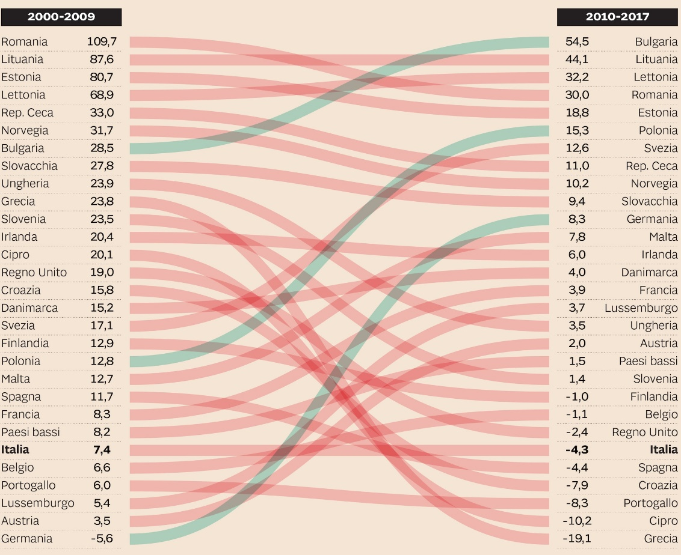
scheme of percentages of the world wage crisis in Europe
source: ilsole24

3. Problem-solving
In this section I will explain how to find solutions if you have the following problems:
- Underpaid
- Work / Life Balance
- Unsupportive Boss
I would first like to analyze the cause-and-effect Analysis with the “fishbone diagram or Ishikawa”

Underpaid work / life balance

anxiety about the future

job dissatisfaction

feedback helps
worker to be decrease in productivity
satisfied with
their work

Unsupportive Boss
Work / Life Balance

the second point to analyze is the economy of one's own country to find an effective solution, for example if a country is more involved in the tertiary sector or primary or secondary if it is developed in the tourism sector.

the second point that I would like to analyze is the clothing market and its effects on the country to understand the legislation and environmental factors with a Pestle Analysis

P | E | S | T | L | E
in Italy, taxes on clothes are 22% of VAT | in Italy the fashion sector dropped a lot after the covid, with 38% unemployed in this job | fashion is much discussed in Italy thanks to Milan Fashion Week. And the news reports talk about it as well thanks to the vastness of famous fashion models and manufacturers in Italy.  The population is inclined to buy high-priced clothes | technological development is not the best, but the artisanship of the sector is one of the best in the world, considered the main source of the Italian economy with its craftsmen | The consumer is almost always provided with a receipt protected by the law both in returns and in product exchange | In Italy, the development for new environmental sources of production and the recycling of materials such as plastic in clothing is on the rise

now having analyzed both my problems and my country's economy and clothing sector I have come up with optimal solutions.
First solution:
Italy being very influenced by the environment and the demand is increasingly asking for sustainability to remove semi-leather garments and start selling recycled clothes.

Second solution:
Create partnerships with clothing artisans, to bring the best quality. that not all large companies have. To create competition.

third solution:
Being able to have advertising space for some show so that it has a lot of shares.

4. Plus, Minus, Interesting (PMI)
First solution PMI
Plus | Minus | Interesting/implication
being a small niche, it is easier to satisfy it 5 | prices will be higher 3 | Increase the impact on the sector 2
we will be eco-sustainable for the planet 3 | being a small niche, a strategic point must be found 5
buyers will be very happy with the recycling 5
Total 13 | Total 8 | Total 2

Second Solution PMI
Plus | Minus | Interesting/implication
greater product quality 4 | create partnerships 3
help small craftsmen 3 | a limited and slow production 5
have original products 3 | high prices 5
Total 10 | Total 13 | Total 0

Third solution PMI
Plus | Minus | Interesting/implication
a lot of visibility 4 | expensive advertising space 6 | attract new customers 2
probably increased earnings 3
Total 7 | Total 6 | Total 2

as shown in the totals, the winning idea is the first.
Initially it may be difficult to enter the ecological sector but thanks to bonuses that Italy releases in this period of change it will be easier.
And the second point of the minus for the difficulty of finding a strategic point is not that relevant.
being able to sell online these days.

5. How to implement the solution

In this fifth part, we will analyze how to implement our idea previously analyzed with the PMI.
there are various implementation methods but today we will see only one, but there are some fundamental points that all the implementation plan has in common, which are the following:
Define Goals:
Schedule Milestones
Allocate resources
Designate a team member if necessary
Define adaptation methods if anything changes
monitor the change.
as an implementation plan, we will use the Gantt chart,
but first I want to give you more information about this Gannt.
Henry Gantt (1861-1919), an American mechanical engineer, designed the Gantt chart.

A Gantt chart is a commonly used graphical depiction of a project schedule. It's a type of bar chart showing the start and finish dates of a project's elements such as resources, planning and dependencies.

some of the benefits of this diagram are:
it can be used for all kinds of projects.
they can be used in the construction world or for software programmers or to set the times for a book for each activity and very modular.
There are certain more specific diagrams for each activity.

Project name: Eco-Shop | Client name: Francesco Gennarelli | Start date: 6/1/2022 | End Date: 9/10/2022

Task Name | Start Date | End Date | Duration (In Days) | 6/1/2022 |  | 6/20/2022 |  | 7/1/2022 |  |  |  | 8/9/2022 |  |  |  | 9/10/2022
shop renovation | 6/1/2022 | 7/1/2022
interior design | 6/20/2022 | 7/1/2022
eco supply for clothes | 7/1/2022 | 8/9/2022
personal research | 8/9/2022 | 9/10/2022
template created by me

this is an example of a Gantt chart as you can see the one in blue are timelines to indicate about the time dedicated to each task

I would like to analyze more in detail how I would like to proceed with the implementation for the opening of the ecological shop.
for the first months that is from 6/1/2022
I would renovate the shop with a refurbishment of the interiors without paying attention to the design but more to the real size
then towards the middle of the renovation I would focus on the design to be captivating and modern and reflective on the environment.
Then of course I would look for suppliers of recycled clothes to buy in bulk.
finally, after opening from 8/9/2022 to 9/10/2022, I would look for staff to help customers.
6. Stakeholders Analysis and Communication
definition of a stakeholders
“…any group or individual who can affect or is affected by the achievement of an organisation’s objectives.” (Freeman, 1984)
- A stakeholder is any group or individual with an interest or a stake in the operations of a company or organisation - anyone who can affect or be affected by its activities.

Stakeholder analysis is the process of identifying an organization's stakeholders and evaluating their influence, or how they are affected, to manage relationships with them.

The purpose of stakeholder analysis is to provide decision-makers with information about individuals and groups that may influence whether or not their goals are achieved.

This makes it easier to anticipate problems, gain the support of the most influential stakeholders, and improve what the organization offers to different groups and individuals and how it communicates with them.
Stakeholders can be internal, such as employees, managers, members of trade unions or departments, or external such as customers or suppliers.
there are also primary and secondary stakeholders which are the following:
Primary stakeholders define the business and are vital to its continued existence

Customers, Suppliers, Employees, Shareholders and / or investors, The community.

Secondary stakeholders are those who may affect relationships with primary stakeholders. For example, an environmental pressure group may influence customers by suggesting that your products fail to meet eco-standards
for an analysis of the stakeholders, it is necessary to identify and think about their needs
Interest  Of  Stakeholders | Keep Completely informed  inform of the partnership with recycled clothes | Manage most Thoroughly  better manage assistants for a good reputation
Interest  Of  Stakeholders | Regular Minimal contact  increase advertising | Anticipate and meet needs  decrease the waiting time for payments
 | Influence of stakeholder

graphic created by me

there are methods to communicate your plan to stakeholders, the most effective is certainly:
Two-way communication, which involves dialogue and negotiation with stakeholders, can be more difficult, but can lead to a better understanding of stakeholders' perspectives.

7. monitor the implementation plan
in this penultimate chapter of this essay, you will be able to see the effects of our choices on the company.
if we have taken the decisions with caution and reflection, we could expect a positive profit or if it were the opposite we would expect to fail.
Being all that uses simulation we cannot simply expect but we must evaluate the success rate.
we should measure the Financial Measures of Performance.
first, we establish the standard performance, i.e., the profit trend in the shop and compare them with new standards after the change.
then We measure the actual performance
for example, how workers and customers behave.
measures the peak performance for example when it is earned in a total day after the makeover and change of clothes.
and finally, if the results are positive, it means that the change has occurred successfully.
probably if the shop I worked in in the past had made these choices I wouldn't have lost my job.
Since recycling is a much-discussed subject in Italy and it is also taught to child pupils, therefore the market was very large and both parents and children learn to recycle from birth.
So, for these reasons a niche would certainly have been created of people who would have chosen a store of this kind rather than a large chain of clothes.

8. Conclusion
in conclusion, I hope this report will help you in the future or now if you want to open a business. The key word for not failing is change.
this is a difficult process but if you use all means provided in this report, I am sure you will succeed.
always use problem-solving and decision-making methods like PMI if you don't know what to do
have optimal communication with the stakeholders and monitored meticulously.

9. References
Magnani A. (2019) Retribuzioni, calo del 4,3% in 7 anni. Perché il problema dell’Italia sono gli stipendi Available at: https://www.ilsole24ore.com/art/retribuzioni--calo-43percento-7-anni-perche-problema-dell-italia-sono-stipendi--ABWtwpSB?refresh_ce=1
on 19/04/2022

Musino C. (2021) sustainable fashion: the Italian fashion effort in a changing world Available at: https://www.visititaly.eu/art-and-culture/sustainable-fashion-the-italian-fashion-effort-in-a-changing-world- on 19/04/2022

Freeman R. E. (1984) Strategic Management: A Stakeholder Approach
Cambridge university press

Straus, DA 2002, How to Make Collaboration Work: Powerful Ways to Build Consensus, Solve Problems, and Make Decisions, Berrett-Koehler Publishers, Incorporated, Oakland. Available from: ProQuest Ebook Central. [17 April 2022].

Ziegenfuss, JTJ 2001, Organization and Management Problem Solving: A Systems and Consulting Approach, SAGE Publications, Thousand Oaks. Available from: ProQuest Ebook Central. [17 April 2022].

10. appendix
role play question problem
1)I have a problem with my salary
is not in accordance with my needs and does not reflect my responsibilities. can you help me?

2)the company is asking me to do too many hours and I don't have enough time to dedicate it to me.

3)The manager of my department does not give me feedback on my work and
I cannot understand if it is an optimal result. And we're having trouble understanding his deliveries

4)I would like to take more time for my vacation and difficult to work interrupted

5)I have been in this company for 1 year now, I would like you to grow up professionally

