UNIVERSITY OF WALES
TRINITY SAINT DAVID

BA BUSINESS MANAGEMENT

Student name: GEORGE EDUARD VODISLAV

Student ID : 1917506

Module Title: MARKETING FUNDAMENTALS

Assignment Title: MARKETING FUNDAMENTALS ANALYSIS AND EVALUATION- ASSESSMENT 1

Module Lecturer’s Name: TUSHARA BALENDRAN

Table of Contents
1.0 Introduction 3
2.0Analysis 4
2.1 Mission statement of Unilever 4
2.2 Marketing process of Unilever (marketing mix) 4
2.3 Situational analysis (SWOT analysis) 6
2.4 Marketing strategy of the company 7
2.5 PESTLE analysis and analyzing the impact (favourable or unfavourable) 9
3.0 Recommendations 10
Recommendation 1 10
Recommendation 2 10
4.0 Conclusion 10
Reference list 11

1.0 Introduction
Marketing is considered as the activities and strategies utilized by organizations to develop the concept of communication. It is the process which allows companies to develop their product for attracting consumers.
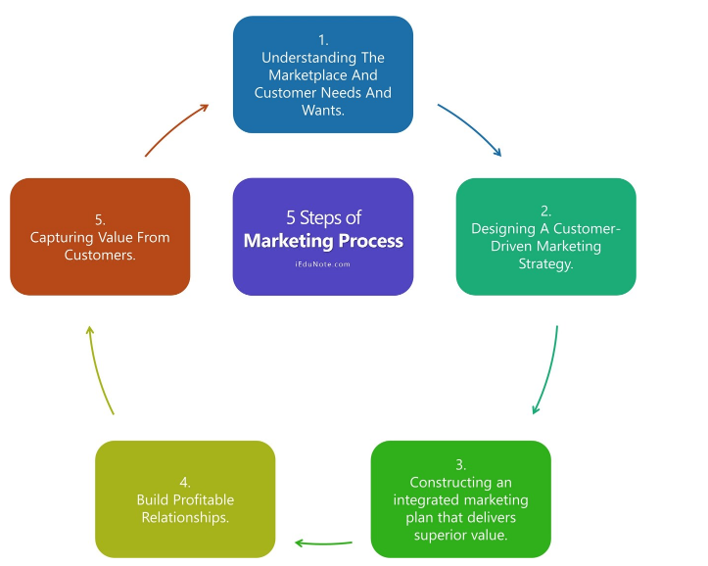
Fig 1: Steps in the marketing process
(Source: insider, 2020)
All the steps displayed in the above picture are indicating the marketing process of companies. Organizations go through multiple market research processes to find out the trends and requirements of the market. However, some internal, as well as external forces, influence the company's marketing strategy. This study will analyze multiple factors of the marketing mix and marketing process of the Unilever Company. To evaluate the internal and external influencing forces, a SWOT and PESTLE analysis will be done on the company's background. Apart from that, this study also will delve into the marketing strategy of the organization. Lastly, some recommendations will be provided to the company which will help Unilever to enhance its marketing process competitively.

2.0 Analysis

2.1 Mission statement of Unilever
Unilever's mission is to "add vitality to life”. The statement means meeting the everyday needs of hygiene, personal care, and nutrition via brands that satisfy people and make them look good and feel good. It's about how Unilever satisfies its consumers in many aspects of life. Also, the company's corporate vision provides direction for the development of the company (Unilever, 2020).

2.2 Marketing process of Unilever (marketing mix)
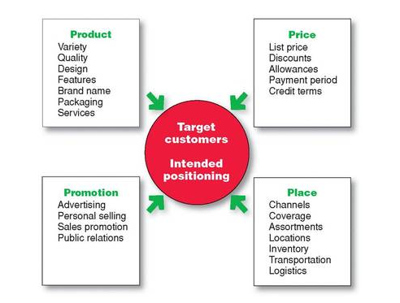
Fig 2: 4P's of the marketing mix
(Source: company website)
Unilever uses a complex process of the marketing mix that considers different variations of products among the global market. Unilever being one of the leading MNC needs to maintain its marketing mix in a way that addresses all the challenges in the market.
Four P's of the marketing mix are product, place, promotion, and price. Unilever's significance of product and place elements is much more than promotion and price but still, the other two elements also contribute to the company's profitability.
- Product Mix - Unilever has a wide range of products and brands, it has almost 400 brands, which produces many goods and products, and maximum brands out of these enjoy a loyal consumer base and high popularity (Išoraitė, 2018). The sales rate of 13 brands out of these 400 is more than 1 billion euros, like Lux, Magnum, and more. There are four chief food categories of Unilever, food, refreshment, Personal care, and home care. The largest out of these categories is the personal care category which has the most products and sales. The company regularly checks it's a portfolio to make sure its product mix balance is accurate. Also, the brand that doesn't fit the company's strategies is disposed of (Unilever, 2020).
- Place: Unilever uses both the modern and traditional systems of product sales and distribution. The direct sale to consumers has led to quick fragmentation of the old traditional method. Unilever has a proper established distribution process in the urban market as well. However, in the urban areas, the big retailers enjoy the dominant over small retailers, yet the online market like Amazon has taken a higher position for the sales (Kotler et al., 2008). Unilever has gone very deep in the rural market of developing countries like India, through a project called Shakti, the company has tried to overcome all the issues that stop the expansion of its business in the rural market.
- Promotion: Unilever uses both ways for promotion be its traditional way of giving ads on (tv and newspaper or hoardings and billboards) or modern way of promotion through (social media through Google ads, using other social media platforms like Facebook and more). With time, Unilever has come up with a difficult and unique campaign for its brand promotion to build brand recognition. One of its campaigns for Dove where they stated how self-esteem is important, it was made for women to realise their potential. They also made a bold campaign for Axe where they talked to men saying "find your magic", this campaign was led by mostly digital channels. Unilever has always been spending high on its promotional activities to not just push sales but also to give high recognition to brands.
- Price: The FMCG market is highly competitive in today's world, to maintain and be a part of the market, Unilever maintains a pricing strategy where they keep their prices but higher for their premium products than its competitors to maintain the premium image and quality (Kwon and GUAN, 2020). Also, they offer discounts from time to time to help push sales. Unilever's pricing strategy is competition oriented for most of its products.

2.3 Situational analysis (SWOT analysis)
Situational analysis can help to understand a company's “strengths, weaknesses, opportunities, and threats". Organizations utilize this analytical process to understand their potential opportunities and disadvantages, which is necessary for developing any new marketing strategy. So, the SWOT matrix can be utilized to understand Unilever's current situation:

Strengths  - Unilever servers in almost 190 countries and hence it has an international footprint (fortune, 2020).  - Unilever holds a broad and deep brand portfolio as well as a diversified service range. It helps this company to fulfill the demands of a diverse range of consumers.  - This organization combines international thinking with domestic execution.  - A heavily financed R&D department. | Weaknesses  - Unilever operates within a mega competitive market. In such a situation competitor like Nestle and P&G directly challenge Unilever’s dominance.  - The products Unilever can be easily replaced with some substitutes.
Opportunities  - Capturing the “Trillion Dollar Consumer market" in India and China can enhance the profit margin for the company.  - Emerging and rapidly changing trends in the market after global media proliferation and globalization have opened multiple doors of advantage for the company. For instance, consumers in developing markets are very much influenced by the western lifestyle. It means that this organization has a big opportunity to grasp this growing and huge consumer base. | Threats  - Often, consumers in some countries like China like to utilize products based on their home country. Such a situation can create a major threat to Unilever in the global market.  - The global economy is shrinking, and consumers are spending comparatively less than before. Apart from that, consumers now demand more value within a low price, which can hamper the overall operational and production procedures of organizations like Unilever.  - In recent time, some multinational companies from Asia have emerged as a global brand. It means this company must face threats from not only existing bigger brands but also from the new emerging companies.
Table 1: SWOT analysis of Unilever
(Source: Self-created)

2.4 Marketing strategy of the company
The description of the marketing strategy of Unilever Plc. can be described through the STP strategy used by the organization as follows:
Segmentation
The brand Unilever has operations in more than 50 countries and over 400 products. Therefore, the range of the products is diverse and different target audiences. For example, the audience of the Clinic plus shampoos is between the ages of 12-50 but food products like Kissan and Knorr are used quite extensively by almost all the people. The detergent named Surf Excel is used by women and people between 16 to 60. Therefore, the segmentation of the organization is quite complex and there are many people within the different target groups (Kotler et al., 2008). Still, the segmentation based on demographic, geographic, psychographic, and behavioral aspects can be done. In demographics, the people generally aged between 15-50 years, low and middle income, men and women, and different stages of life are there. on a geographic basis, the segmentation has been done in North America, Europe, Middle East, South, and South Asia markets mainly. In psychographic, the people between thinkers, non-thinkers, believers, and makers are equally used for segmentation. The benefits, usage rate, and patterns are used by Unilever to segment (Sarti, Darnall, and Testa, 2018).

Targeting
As said earlier, the market of the products of Unilever is quite diverse and a commodity can have an almost opposite market. For example, the target audience of Knorr Soups is never the same as Surf Excel users. Therefore, their target market is of quite various types. According to a survey, the demand for sustainable products among the customers of Unilever has been 30%. Therefore, to reach these customers, Unilever has started to make its products more sustainable (Morgan, Whitler, Feng, and Chari, 2018). if the age, income, and demands of the people are used for their different products, as patterns can be understood. For example, the home care range has the target market of people within 14-45 years and medium to high income. Similarly, the food products of the organization generally start from the age of 5 and go based on the needs and nutritional value.
Positioning
If the positioning of the organization Unilever sees carefully, it can be seen that the main position of the brand has been in Asia, Europe, and North America. The main reason behind it has been easy and cheap labor availability and the huge market. Almost 1/3rd of the population in the whole world is based in Asia and undoubtedly it has a lucrative market here. for positioning, the broad differentiation has been used by the organization where the products are of diverse specifications and the positioning within those countries has been between the people of different ages, income, and status (Kotler et al., 2008).
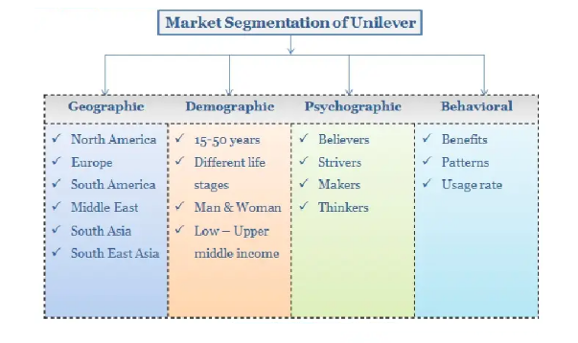
Figure 3: Market Segmentation of Unilever Plc
(Source: Tasnim et al. 2015)

2.5 PESTLE analysis and analyzing the impact (favorable or unfavorable)
To understand the external environment of Unilever, PESTEL analysis can be used as follows:
Political: the range of the goods of Unilever has been diverse ranging between home care to food products and others. Most of the revenue of the brand comes from fast-moving consumer goods which are mainly food items (Vlados and Chatzinikolaou, 2019). therefore, the drug and food standards of the different countries where they operate should be aided by. Besides, the political party in the USA may make the food standards stricter which can affect their business which is not favorable.
Economic: the economic factor has been very important for Unilever as it is based mainly on fast-moving consumer goods. The huge market of India and China can generate huge profit but there are some risks. On the contrary, the possibility in the European market is less but is less risky. Employment is another important factor, in the countries where income and employment are high; the purchasers would also purchase more making favorable benefits for Unilever (Team, 2020).
Social factor: the social factor has been another important factor in the market. For example, Unilever has to launch different products in its different country operations with different strategies and different languages. Besides, the different language and socio-economic status of the people and the general desire to look attractive has been common (Vlados and Chatzinikolaou, 2019). Therefore, Unilever has to market its products, especially beauty and personal care with the care that will be favorable.
Technological factor: the development of different production technology and operations management technology, there has been a lot of improvement in the operations process. To combat this issue, investment in the automated operations process and R&D so that new products can be developed is necessary and it is favorable. (Pdfs.semanticscholar.org. 2020)
Environmental factors: the environmental changes and changing environmental legislation in different countries can affect the operations of Unilever. for example, the stricter laws regarding carbon emission, plastic usage, and others (Team, 2020). Therefore, environmental factors such as low carbon emission and 100% reusable plastic use should be initiated which is not fully favorable.
Legal: with more than 400 products under their belt, Unilever must take care of the patents and regulations in the countries in which they are operating. a strong and vigilant legal department and patent protection therefore should be taken care of for favorability.

3.0 Recommendations

Recommendation 1
Unilever needs to keep track of their increasing price so that they can compete in the market. Apart from that, Unilever should quickly execute its new advertising style where they will not show ads of foods and drinks to children of certain ages, giving the choices to parents to select these items for children.

Recommendation 2
From the discussions made above in the study, it can be recommended that the organization should use an environment-friendly operations process with 100% reusable plastic for environmental concerns. Besides, more investment in technology and R&D is recommended to develop new product lines to get a competitive advantage.

4.0 Conclusion
From Unilever in the discussion, it can be seen that the marketing process has been thoroughly investigated. Unilever has its operations in almost 200 countries and 400 products. To understand the process, the vision and mission statement has been described. If the marketing process of Unilever is seen through 4Ps' it can be seen that the organization has placed its products among the lower-middle-income people within Europe, North America, South Asia, and other countries. To support the description, the use of the STP strategy of Unilever has been properly described in its target markets and positioning. PESTEL analysis has been done to determine the favorability of the macro environment with situational analysis through SWOT. At last, two recommendations are also presented based on the study.

Reference list
Book
Kotler, P., Keller, K., Ang, S., Tan, C., and Leong, S., 2008. Marketing Management: An Asian Perspective. 5th ed. The UK: Pearson.
Journals
Išoraitė, M., 2018. Brand Image Theoretical Aspects. Integrated Journal of Business and Economics, 2(1), p.116. DOI: 10.33019/ijbe.v2i1.64
Kwon, J., and GUAN, L., 2020. Mapping research on competitive strategy in international business journals: a co-citation analysis. International Journal of Business and Emerging Markets, 12(1), p.1. DOI: 10.1504/ijbem.2020.10028553
Morgan, N., Whitler, K., Feng, H., and Chari, S., 2018. Research in marketing strategy. Journal of the Academy of Marketing Science, [online] 47(1), pp.4-29. Available at: <https://link.springer.com/article/10.1007/s11747-018-0598-1> [Accessed 14 August 2020].
Sarti, S., Darnall, N., and Testa, F., 2018. Market segmentation of consumers based on their actual sustainability and health-related purchases. Journal of Cleaner Production, [online] 192, pp.270-280. Available at: <https://www.sciencedirect.com/science/article/pii/S0959652618312241> [Accessed 14 August 2020].
Vlados, C., and Chatzinikolaou, D., 2019. Methodological Redirections for an Evolutionary Approach of the External Business Environment. Journal of Management and Sustainability, [online] 9(2), pp.25-46. Available at: <https://www.researchgate.net/profile/Charis_Vlados/publication/335491630_Methodological_redirections_for_an_evolutionary_approach_of_the_external_business_environment/links/5d690550a6fdccadeae4c1d0/Methodological-redirections-for-an-evolutionary-approach-of-the-external-business-environment.pdf> [Accessed 14 August 2020].
Online articles
Pdfs.semanticscholar.org. 2020. [online] Available at: <https://pdfs.semanticscholar.org/486b/56f34dc6629d7ed74f054b857b56f74a52d6.pdf> [Accessed 14 August 2020].
Websites
fortune, 2020. Unilever CEO Paul Polman’S Plan To Save The World. [online] Fortune. Available at: <https://fortune.com/2017/02/17/unilever-paul-polman-responsibility-growth/> [Accessed 24 August 2020].
insider, 2020. The Marketing Process - Marketing-Insider. [online] Marketing-Insider. Available at: <https://marketing-insider.eu/marketing-process/> [Accessed 24 August 2020].
Team, M., 2020. Unilever PESTLE Analysis | PESTEL Analysis Of Unilever | MBA Skool-Study.Learn.Share.. [online] MBA Skool-Study.Learn.Share. Available at: <https://www.mbaskool.com/pestle-analysis/companies/17992-unilever.html#:~:text=Unilever%20PESTLE%20Analysis%20examines%20the,the%20business%20of%20the%20brand.> [Accessed 14 August 2020].
Unilever, 2020. All Brands. [online] Unilever global company website. Available at: <https://www.unilever.com/brands/> [Accessed 24 August 2020].
Unilever, 2020. Unilever Puts Vitality At Core Of New Mission. [online] Unilever global company website. Available at: <https://www.unilever.com/news/press-releases/2004/04-02-12-Unilever-puts-vitality-at-core-of-new-mission.html> [Accessed 24 August 2020].

