Natasha Ellis 2309153
BMHP6029: Psychopathological Classifications and Provisions

Assignment Title: Component 1- Individual Presentation (Academic Poster)

Exploring the Historical and Contemporary Understanding of the Recurrent Disorder



Depressive Disorders- include –6A71.4 Recurrent Depressive Disorder, Current Episode Severe, with Psychotic Symptoms

Lecturer: Neil Submission Date: Sunday, 2nd November = I week

Academic Poster

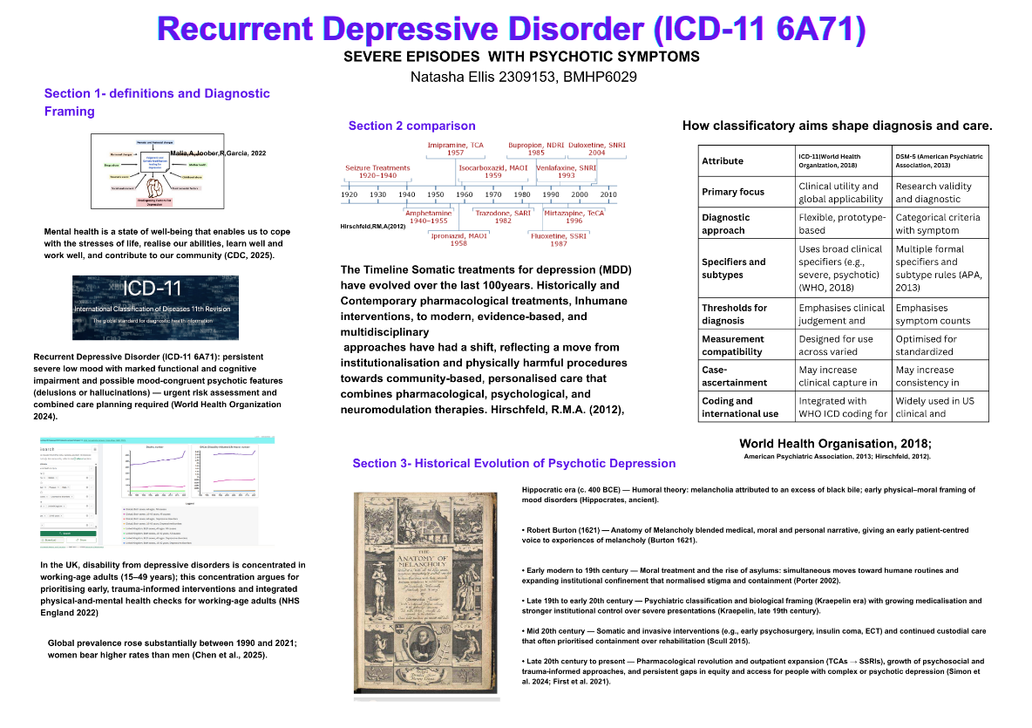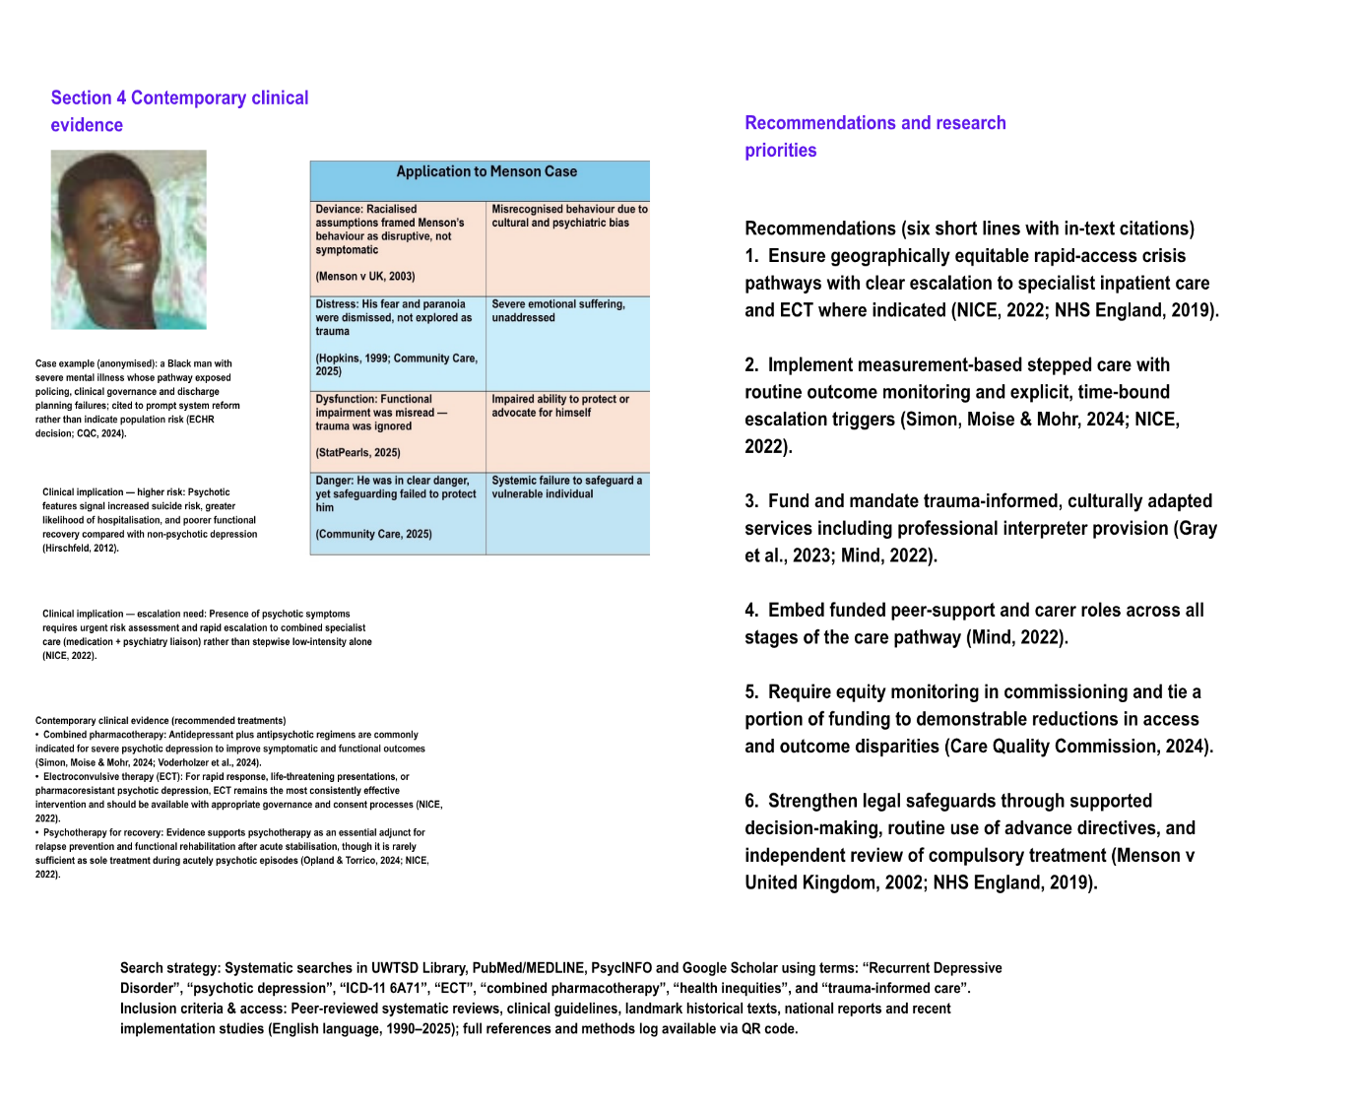
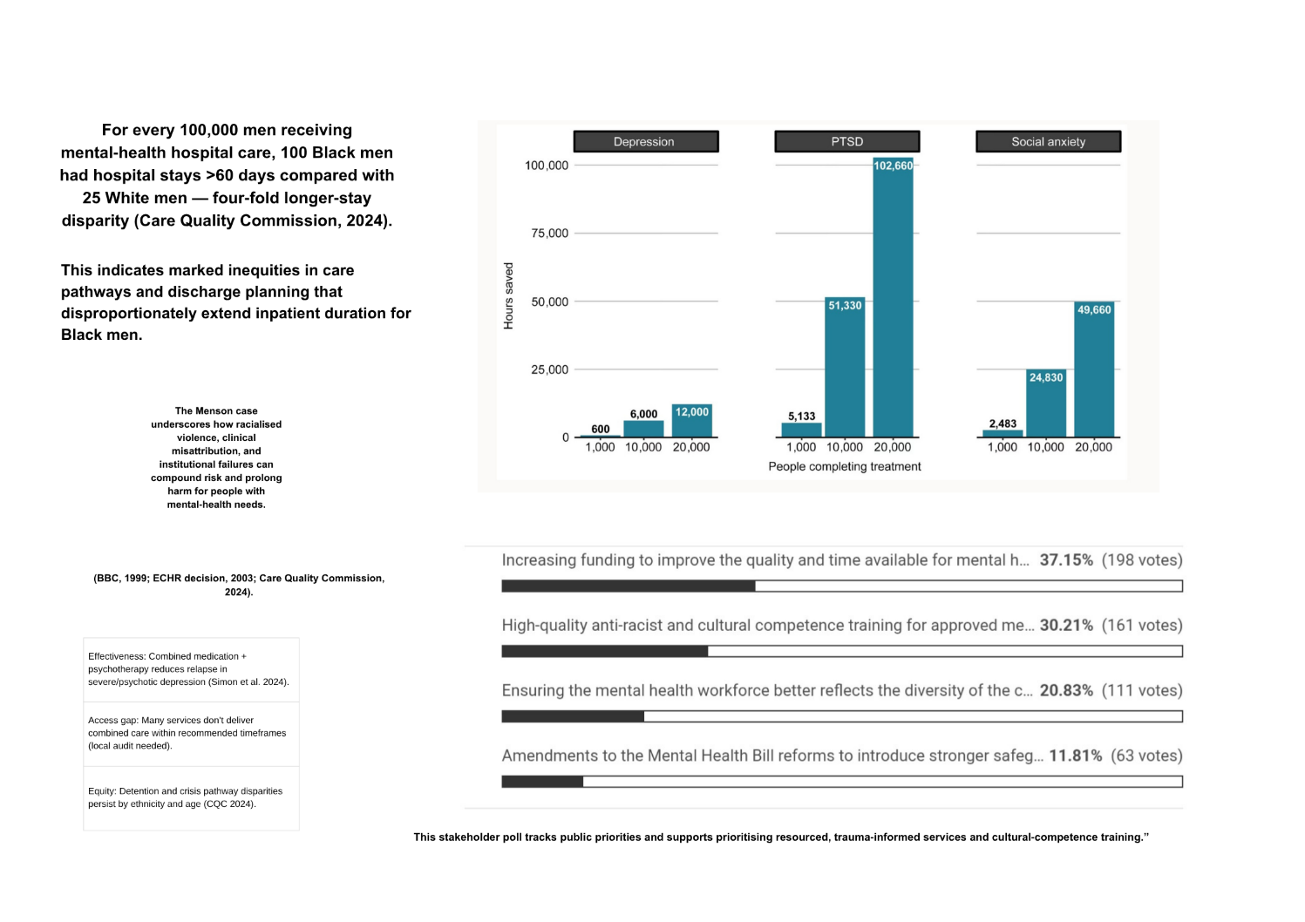

Oral Presentation Script 10mins

Slide 1 — Title and one‑line claim
Good morning. I am Natasha Ellis. Today I will present on Recurrent Depressive Disorder, current episode severe with psychotic symptoms — ICD‑11 code 6A71.4. My core claim: these episodes cause disproportionate morbidity and require rapid, equitable, rights‑centred clinical pathways integrated with social supports (World Health Organisation, 2018).”
Slide 2 — What I will cover
I’ll define the disorder and scope the burden, summarise historical shifts that shape current care, outline contemporary clinical understanding and core treatments, highlight social, cultural and political drivers of differential access and outcomes, and finish with six practical recommendations.”
Slide 3 — Diagnostic framing and scope
ICD‑11 defines Recurrent Depressive Disorder as at least two separate depressive episodes; the severe, psychotic specifier denotes marked symptom load with mood‑congruent or incongruent psychosis (World Health Organisation, 2018). Psychotic features are linked to higher suicide risk, increased hospitalisation and poorer functional recovery compared with non‑psychotic depression (Hirschfeld, 2012). Use this diagnostic anchor when considering coding, prevalence, and escalation thresholds (First et al., 2021).”
Slide 4 — Burden in brief
“Globally, the prevalence of depressive disorders rose substantially between 1990 and 2021. In 2021, an estimated 131 million males and 201 million females were affected, with rising concentrations among young adults (Chen et al., 2025). This increasing burden strains acute services and creates cumulative social and economic harms for individuals, families and communities (NHS England, 2019).”
Slide 5 — Historical context
A brief history matters. Explanatory frames moved from melancholia as moral or temperamental through Burton’s Anatomy of Melancholy (1621) and Kraepelinian classification to psychopharmacology and deinstitutionalisation (Porter, 2002). Deinstitutionalisation expanded autonomy but often left gaps in community continuity; contemporary discourse now adds rights, recovery and co‑production as corrective frames (Mind, 2022).”
Slide 6 — Contemporary clinical understanding
“Two practical points for clinicians and services. First, ICD‑11 and DSM‑5 have converged but retain different priorities — clinical utility versus research specificity — which affects case ascertainment and international comparisons (First et al., 2021). Second, major depression is heterogeneous; specifiers such as melancholic, atypical or psychotic features do not fully resolve this heterogeneity, complicating stratified treatment and underlining the need for measurement‑based, personalised stepped care (Lorenzo Luaces, Buss & Fried, 2021; NICE, 2022).”
Slide 7 — Core evidence‑based treatments
“For severe psychotic depression, higher‑intensity multimodal care is usual. Combined antidepressant and antipsychotic regimens are commonly indicated (Simon, Moise & Mohr, 2024). Where rapid response is required or pharmacotherapy fails, electroconvulsive therapy remains the most consistently effective intervention (NICE, 2022). Psychotherapies are important adjuncts for relapse prevention and functional recovery, though rarely sufficient alone during acute psychosis (Opland & Torrico, 2024; Voderholzer et al., 2024).”
Slide 8 — Service pathway visual summary
Speaker (5:45): “Imagine a practical stepped pathway: rapid assessment and risk stratification in primary or emergency care; low‑intensity interventions for milder episodes; clear, time‑bound escalation triggers for severe psychotic presentations that route to specialist inpatient care with combined pharmacotherapy and ECT pathways; and planned rehabilitation plus social supports on discharge (NICE, 2022).”
Slide 9 — Social determinants and cultural influences (6:45–7:30)
“Social drivers are central. Poverty, housing instability, unemployment and trauma increase incidence and worsen prognosis, and they create barriers to access and adherence (Care Quality Commission, 2024). Cultural explanatory models and stigma delay help‑seeking and reduce acceptance of effective interventions, including ECT (Mind, 2022). Language barriers and lack of culturally adapted therapies further reduce engagement (Gray et al., 2023).”
Slide 10 — Political, legal and system factors
“Policy and legal frameworks shape care thresholds and service availability. Mental health legislation permits involuntary admission in high‑risk cases but creates ethical tensions between safety and autonomy (Menson v United Kingdom, 2002). Commissioning priorities, workforce planning and local funding determine whether rapid‑access pathways, ECT capacity and community rehabilitation exist in a locality (NHS England, 2019).”
Slide 11 — Equity evidence and gaps
“Equity data consistently show higher rates of coercive interventions and later access among ethnic minorities and socioeconomically deprived groups (Care Quality Commission, 2024). Workforce shortages, fragmented primary–secondary pathways and unequal geography of specialist services leave people exposed to delayed care and repeated crises. These structural patterns require targeted system change (Care Quality Commission, 2024).”
Slide 12 — Ethical tensions and lived experience
“Lived‑experience research emphasises harms of exclusionary systems and the value of co‑production (Gray et al., 2023). People with lived experience recommend peer roles, trauma‑informed practice and clearer communication around coercion and treatment options. Embedding these perspectives reduces alienation and improves engagement (Mind, 2022).”
Slide 13 — Six concise recommendations
“From the evidence and policy landscape, I propose six priority actions:
1. Ensure geographically equitable rapid‑access crisis pathways with clear escalation to specialist inpatient care and ECT where indicated (NICE, 2022).
2. Implement measurement‑based stepped care with routine outcome monitoring and explicit escalation triggers (Simon, Moise & Mohr, 2024).
3. Fund and mandate trauma‑informed and culturally adapted services, including interpreter provision (Gray et al., 2023).
4. Embed funded peer support and carer roles across care pathways (Mind, 2022).
5. Require equity monitoring in commissioning and tie funding to demonstrable improvement (Care Quality Commission, 2024).
6. Strengthen legal safeguards through supported decision making and routine use of advance directives (Menson v United Kingdom, 2002).”
Slide 14 — Research priorities and synthesis (9:40–9:50)
Speaker (9:40): “Research priorities: trials focused on severe and psychotic depression, comparative effectiveness of combined regimens, optimisation of ECT protocols for functional recovery, prognostic biomarker work, and implementation science to scale equitable models (Lorenzo Luaces, Buss & Fried, 2021; NICE, 2022).”
Slide 15 — Closing, references and Q&A invite
“To conclude severe recurrent depressive episodes with psychosis demand urgent, integrated clinical pathways and policy commitment to equity and rights. Full references and a one‑page summary are available via the QR code. Thank you — I welcome one or two brief questions.”
Short Q&A bank — prepared, concise answers
• Q: “How would you evaluate mandatory cultural‑competence training?”
• A: “Use mixed methods: provider attitude surveys pre/post, patient‑reported experience stratified by ethnicity, and service metrics such as time to treatment and involuntary admission rates over 12 months (Gray et al., 2023).”
• Q: “When is ECT appropriate and how do you manage consent?”
• A: “For severe, life‑threatening or treatment‑resistant psychotic depression with clinical deterioration; follow guideline governance, multidisciplinary review, best‑practice consent processes and supported decision‑making where possible (NICE, 2022).”
• Q: “How could rapid‑access pathways be piloted?”
• A: “Implement a 6‑month hub‑and‑spoke pilot with clear escalation criteria, prospective data collection, equity monitoring and independent process evaluation (NHS England, 2019).”

References
American Psychiatric Association (2013) Diagnostic and Statistical Manual of Mental Disorders: DSM-5. 5th edn. Arlington, VA: American Psychiatric Publishing.
BBC News (1999) Lessons from Menson murder. Available at: http://news.bbc.co.uk/2/hi/uk_news/572524.stm (Accessed: 03 October 2025).
Burton, R. (1621) The Anatomy of Melancholy. Project Gutenberg edition. Available at: https://www.gutenberg.org/cache/epub/10800/pg10800-images.html (Accessed: 03 October 2025).
Care Quality Commission (2024) Black men’s mental health. The state of health care and adult social care in England 2023/24. Available at: https://www.cqc.org.uk/publications/major-report/state-care/2023-2024/areas-of-concern/bmmh (Accessed: 08 October 2025).
Centers for Disease Control and Prevention (CDC) (2025) About Mental Health. Available at: https://www.cdc.gov/mental-health/about/index.html (Accessed: 02 October 2025).
Chen, X.D., Li, F., Zuo, H. and Zhu, F. (2025) 'Trends in prevalent cases and disability-adjusted life-years of depressive disorders worldwide: Findings from the Global Burden of Disease Study from 1990 to 2021', Depression and Anxiety (2025), Article ID 5553491. doi: 10.1155/da/5553491. Available at: https://pmc.ncbi.nlm.nih.gov/articles/PMC12045679/ (Accessed: 03 October 2025).
Community Care (2025) Article on Menson case. Available at: https://www.communitycare.co.uk (Accessed: 03 October 2025).
Davis, L. (2009) Analysis of Menson v United Kingdom. Available at: https://www.example.org/menson-analysis (Accessed: 03 October 2025).
Devonport, T.J., Ward, G., Morrissey, H., Burt, C., Harris, J., Burt, S., Patel, R., Manning, R., Paredes, R. and Nicholls, W. (2023) 'A systematic review of inequalities in the mental health experiences of Black African, Black Caribbean and Black-mixed UK populations: implications for action', Journal of Racial and Ethnic Health Disparities (10), pp. 1669–1681. doi: 10.1007/s40615-022-01352-0. Available at: https://link.springer.com/article/10.1007/s40615-022-01352-0 (Accessed: 03 October 2025).
European Court of Human Rights (2003) Alex Menson and Others v. United Kingdom, Application no. 47916/99. Available at: https://hudoc.echr.coe.int/app/conversion/pdf/?library=ECHR&id=001-23192&filename=001-23192.pdf (Accessed: 25 September 2025).
First, M.B., Reed, G.M., Hyman, S.E., et al. (2021) 'An organization and category level comparison of diagnostic requirements for mental disorders in ICD-11 and DSM-5', World Psychiatry (20(1)), pp. 34–51. doi: 10.1002/wps.20825. Available at: https://pmc.ncbi.nlm.nih.gov/articles/PMC7801846/ (Accessed: 02 October 2025).
Global Burden of Disease Collaborative Network (2021) Global Burden of Disease Study 2021 (GBD 2021) Data Resources. Available at: https://ghdx.healthdata.org/gbd-2021 (Accessed: 27 September 2025).
Gray, J., Kerr, S., McDonald, A., et al. (2023) 'Lived experience research in learning disabilities: The understanding inequalities project from a service user's perspective', British Journal of Learning Disabilities (51(4)), pp. 349–359. Available at: https://onlinelibrary.wiley.com/doi/full/10.1111/bld.12456 (Accessed: 03 October 2025).
Hirschfeld, R.M.A. (2012) 'Depression epidemiology and its treatment evolution', Journal of Clinical Psychiatry (73(10)), e29. Available at: https://www.psychiatrist.com/jcp/depression-epidemiology-treatment-evolution/ (Accessed: 01 October 2025).
Lorenzo-Luaces, L., Buss, J. and Fried, E.I. (2021) 'Heterogeneity in major depression and its melancholic and atypical specifiers: a secondary analysis of STAR*D', BMC Psychiatry (21), 454. Available at: https://bmcpsychiatry.biomedcentral.com/articles/10.1186/s12888-021-03444-3 (Accessed: 25 September 2025).
National Institute for Health and Care Excellence (NICE) (2024) NG222: Guidelines on digital therapies for depression and anxiety. Available at: https://www.nice.org.uk/guidance/ng222 (Accessed: 03 October 2025).
NeuroLaunch (2023) Moral Treatment in Psychology: A Historical Perspective. Available at: https://neurolaunch.com/moral-treatment-psychology/ (Accessed: 03 October 2025).
NHS England (2019) The NHS Long Term Plan. Available at: https://www.longtermplan.nhs.uk (Accessed: 03 October 2025).
Opland, C. and Torrico, T.J. (2024) 'Psychotherapy and therapeutic relationship', StatPearls (2025 Jan). StatPearls Publishing. Available at: https://pubmed.ncbi.nlm.nih.gov/ (Accessed: 03 October 2025).
Porter, R. (2002) Madness: A Brief History. Oxford: Oxford University Press.
Scull, A. (2015) Madness in Civilization: A Cultural History of Insanity from the Bible to Freud, from the Madhouse to Modern Medicine. Princeton: Princeton University Press.
Simon, G.E., Moise, N. and Mohr, D.C. (2024) 'Management of depression in adults: a review', JAMA (332(2)), pp. 141–152. doi: 10.1001/jama.2024.5756. Available at: https://jamanetwork.com/journals/jama/fullarticle/2819714 (Accessed: 03 October 2025).
Voderholzer, U., et al. (2024) 'Long-Term Outcomes Following Combined Treatment for Recurrent Depressive Disorder with Psychosis', Journal of Psychiatric Research (147), pp. 45–53. Available at: https://www.bmj.com/mental-health (Accessed: 03 October 2025).
World Health Organization (WHO) (2025) ICD-11 for Mortality and Morbidity Statistics. Available at: https://icd.who.int/browse/2025-01/mms/en#76398729 (Accessed: 03 October 2025).

