HOW TO USE MICROSOFT EXCEL
A guide for small business owners

Getting Started
Microsoft Excel is an individual computer program for spreadsheets that is used in budgeting, data analysis, and reporting.
- Open Excel from your start menu or on your desktop
- Open a fresh blank workbook or a previously created one
- Familiarize yourself with the Ribbon Interface (Home, Insert, Page Layout, etc.)
- Input data into cells formed in rows and columns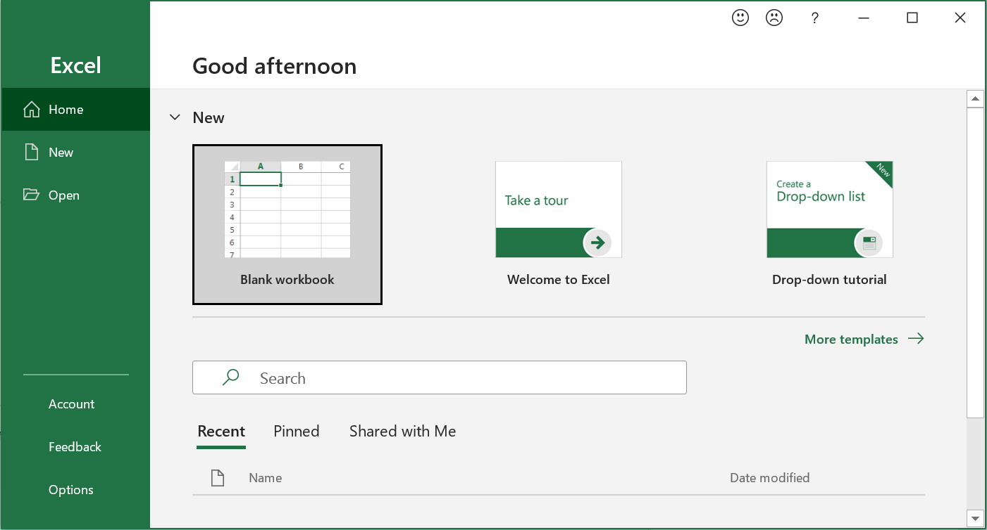

Basic Functions
Include built-in functions and formulas to help you calculate spreadsheets.
SUM: =SUM(A1:A10) – Adds up values in a range
AVERAGE: =AVERAGE(B1:B10) – Calculates the average of numbers
IF: =IF(C1>100, "Yes", "No") – Checks if a condition is met
Charts: Easily create charts (bar, pie, line) from your data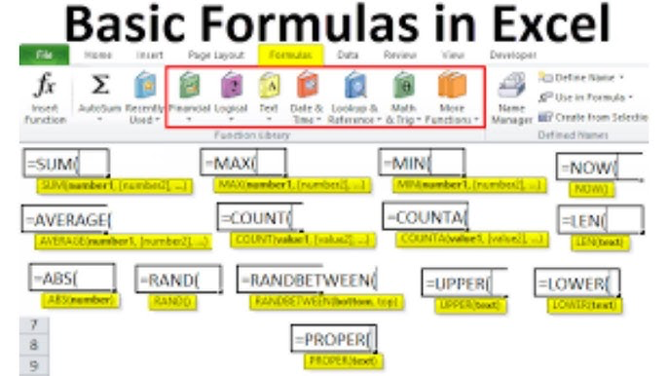

Formatting Worksheets
Customize cells, rows, and columns.
- Adjust column width and row height
- Apply number, currency, or date formatting to cells
- Use cell styles and colors to highlight important data
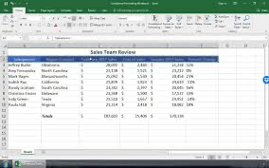

Creating Charts
Visualize your data with charts to identify trends and patterns.
- Select your data range to chart
- Go to the Insert tab and choose your chart type
- Customize chart elements like title, labels, and legend

