DS TASK 1

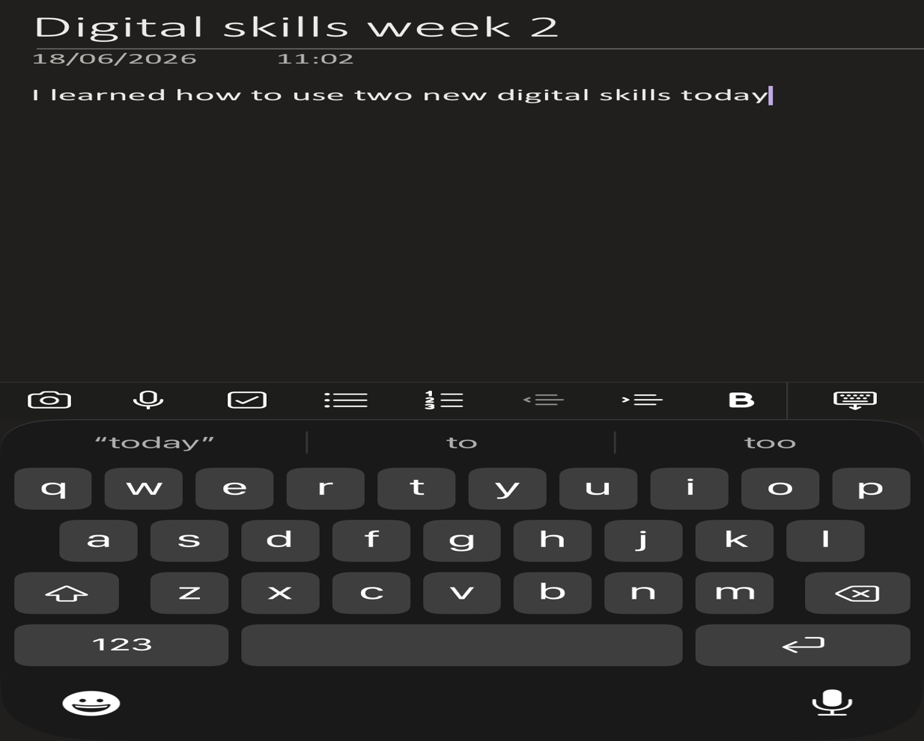

This shows how I was able to use one note and add a note saying how much digital skills I learnt today. This is my notes on week 2 learning materials in class.

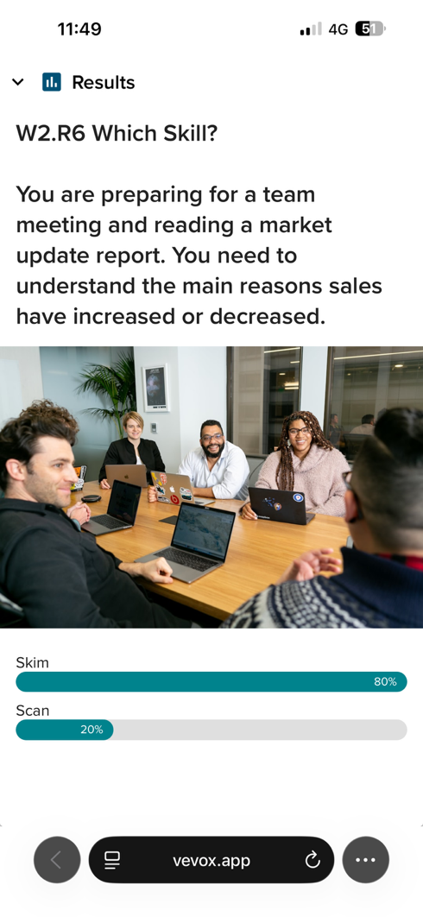This is me using vevox which is a material to help in my learning as it shows a reflection of the questions whether you get it right or not so you can correct yourself.

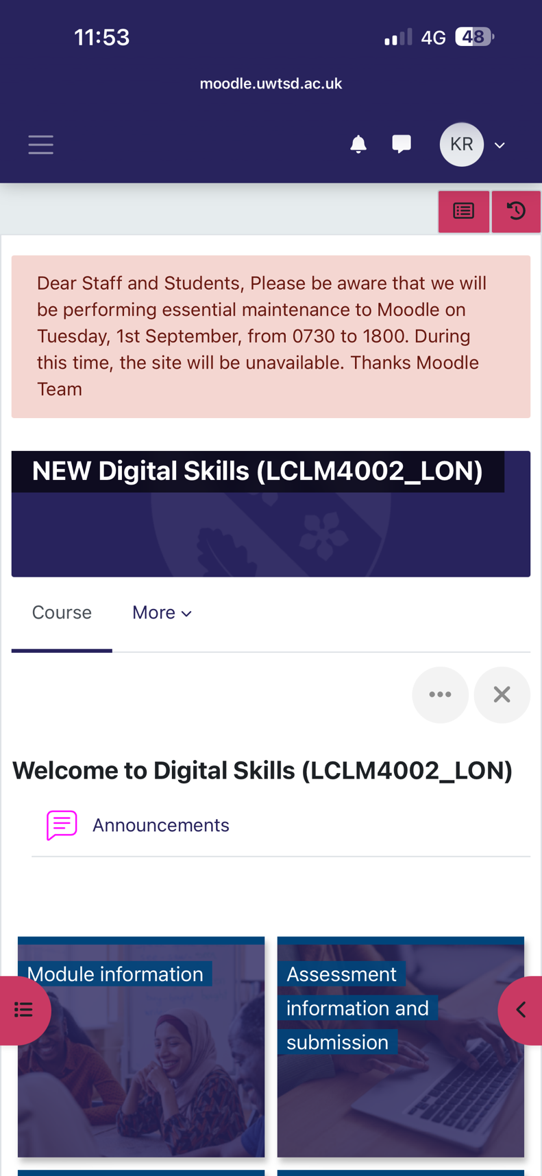
This material is moodle which gives me a guide to get to what we are learning in the week and how to get to the assessment information also.

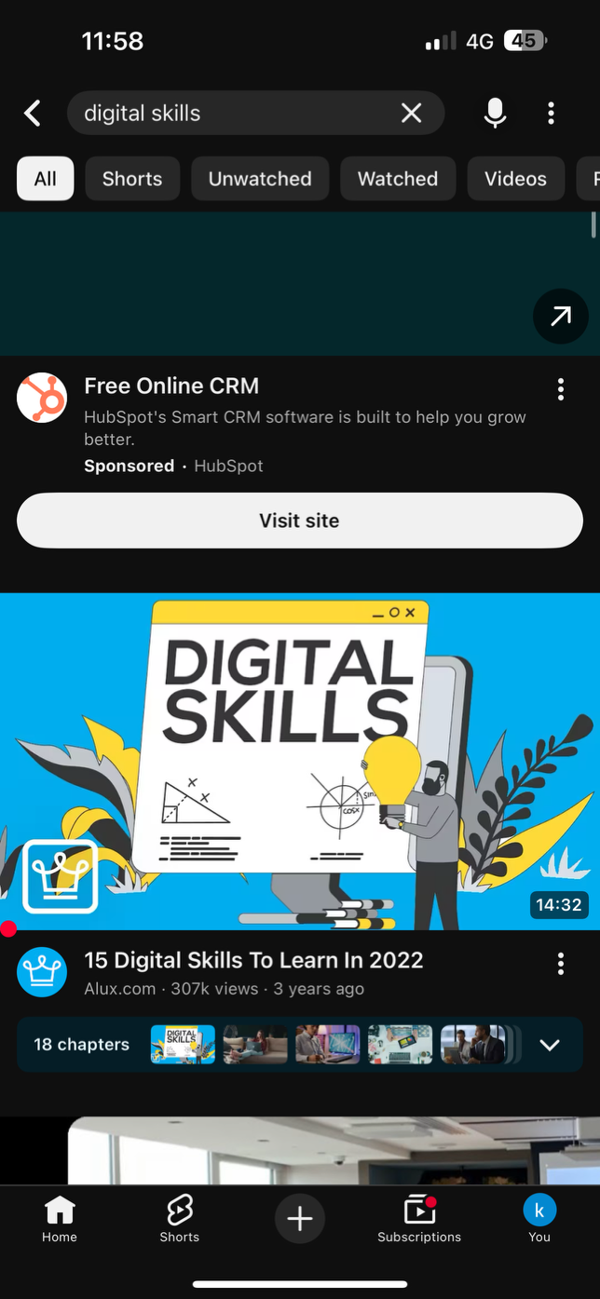
This is me searching on YouTube as a material for learning purpose to get a better inlook into digital skills in my day to day.

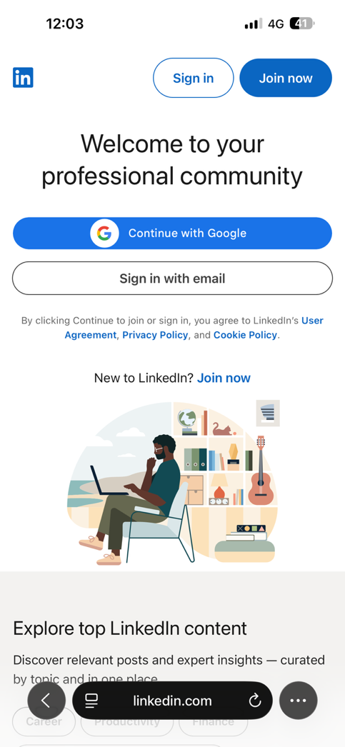
This is a material called LinkedIn that I acquired today from week 2 material it shows me signing in to learn on LinkedIn.

My Short Reflection
My digital life is a way to help me learn new things in my day to day life. I use the digital tools as an advocate to learn and reflect on my work while going to university and also to use on a daily basis. I feel quite confident in using different digital tools when it is needed but if I feel it takes time to reflect on the tools you use. I sometimes feel nervous about the work but then I remember that once you take your time all things will come to you more easy. Digital skills are important for me because it is used in everyday life whether it’s buisness related or not but the point is that we use it everyday even without noticing. I hope this module will help me in my buisness studies as digital skills is used in buisness to help advocate their buisness.

