

LEVEL 4 ASSESSMENT SPECIFICATION

Student name: | Matthew Rawlings | Student ID number: | 2015848
Programme: | HNC Electrical/Electronic Engineering
Module: | Programmable Logic Controllers
Module code: | PCEE4005 | Contribution to Overall Module Assessment (%): | 50%
Lecturer: | Jason Pointer | Internal Verifier: | Lance Rutherford
Assignment Title: | Introduction to PLC Systems & Program Design | Word count (or equivalent): | 2000
Submission deadline: | 20/01/22 | Return date of provisional marks & written feedback: | 10/02/22
Submission method: | All written assessments, where practical and possible, must be submitted via Turnitin unless otherwise instructed by the Lecturer. (Please DO NOT put this assessment specification into Turnitin or it will match many similarities with other students’ submissions.)  Alternative submission method (if applicable):  Late submission of the assessment will result in a late penalty mark. Penalties for late submission: Up to one week late, maximum mark of 40%. Over one week late, 0%. Only the Extenuating Circumstances Panel may approve a change to submission dates.
Academic honesty / referencing: | Academic honesty is required. In the main body of your submission you must give credit to authors on whose research and ideas your work is based. Append to your submission a reference list that indicates the books, articles, etc. that you have used, cited or quoted in order to complete this assessment.

Module Learning Outcomes
(from module syllabus)
- Demonstrate an understanding of the concepts of process control using an industry standard PLC.
- Undertake basic PLC system design and implementation processes, comparing theoretical expectations to actual outputs ensuring correct operation and consideration of maintenance and reliability.

Student FEEDBACK FORM

This section details the extent to which the assessment criteria are demonstrated by you, which in turn determines your mark. The marks available for each category of skill are shown. Lecturers will use the space provided to comment on the achievement of the task(s), including those areas in which you have performed well and areas that would benefit from development/improvement.
Generic Assessment Criteria | Marks available | Marks  awarded
1. Engagement with Literature Skills  . | 15 | 8.3
Engagement with a wide range of literature sources, including sources retrieved independently but very few textbooks are included in the list. Generally sound referencing, with no real inaccuracies or inconsistencies.

2. Knowledge and Understanding Skills | 25 | 16.9
Task 1 achieved 60%.
Task 2 achieved 65%,
Task 3 achieved 78%.
Knowledge of the basic underlying concepts and principles of the work required for Task 1. Showed an excellent understanding of the requirements of Task 3.
3. Cognitive and Intellectual Skills | 10 | 6
Sound evaluation of the underlying concepts and principles applied to the construction of the motor controller.

4. Practical Application Skills | 40 | 30.6
Task 4 achieved 79%.
Task 5 achieved 74%.
An excellent application of the software to produce fully functional programs to cover the requirements of Task 4 and 5. Required very little support in the development of these programs and was able to show full operation.

5. Transferable Skills for Life and Professional Practice | 10 | 6.6
Work is accurate, coherent, fluent, well-structured and organised.
Assessment Mark (Assessment marks are subject to ratification at the Exam Board. These comments and marks are to give feedback on module work and are for guidance only until they are confirmed.) | Late Submission Penalties (tick if appropriate) |  | 68%
 | Up to 1 week late (40% Max) |  | 68%
 | Over 1 week late (0%) |  | 68%

Matthew Rawlings
150589@pembrokeshire.ac.uk
Programmable Logic Controllers
Assignment 1

Contents
Table of Figures 2
Task 1 3
a) i) Unitary PLC 3
a) ii) Modular PLC 3
b) PLC Components 5
c) PLC Protection 6
Task 2 7
a) 7
b) 8
Task 3 – Timers 10
a)i) On-Delay Timers 10
ii) Off-Delay Timers 11
iii) Pulse Timers 11
b) 12
Task 4 – Programming Problems 13
a) 13
b) 14
Task 5 15
Bibliography 16
References 17

Table of Figures
Figure 1- MicroPLC810 3
Figure 2 - MicroPLC810 datasheet 3
Figure 3 - Optocoupler diagram 4
Figure 4 - Logic Gate Circuit 5
Figure 5 Q=A.(B) ̅ 7
Figure 6 - Q = B.C 8
Figure 7 - On-Delay Timing Diagram 9
Figure 8 - On-delay Timer in Ladder Logic 9
Figure 9 - Off Delay Timing Diagram 10
Figure 10 - Pulse Timer Timing Diagram 10
Figure 11 - Cascaded system 11
Figure 12 - Sequenced Timers 11
Figure 13 - Washing Machine PLC Program 12
Figure 14 - £10 Money Counter PLC Program 13
Figure 15 - Fin Fan Controller PLC Program 14

Task 1

i) Unitary PLC
A unitary PLC is considered the simpler PLC type, using a CPU, Power Supply and I/O connection points. Unitary PLCs are used in applications where a small number of inputs and outputs are required. An example of a suitable program would be a conveyor belt which requires a limited number of inputs and outputs. Being small and compact, Unitary PLCs are usable in multiple environments, in cabinets, alongside other PLCs and other small spaces. Though they are compact, the lack of accommodation for inputs and outputs makes them unsuitable for more large-scale projects. A common example of a unitary PLC is a MicroPLC180 by Allen-Bradley. This type of PLC holds 8 inputs and 4 outputs which is communicated using function block and ladder logic programming. Figure 2 depicts the datasheet for this PLC and shows typical values for a unitary PLC.

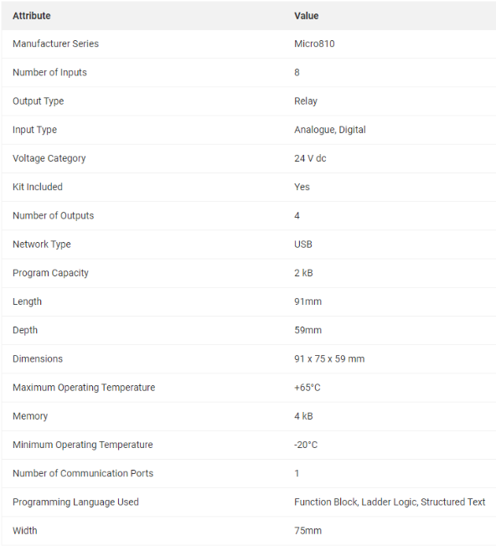
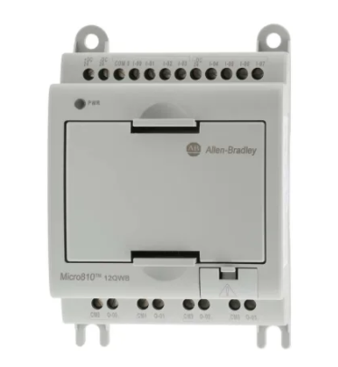

Figure 1- MicroPLC810

Figure 2 - MicroPLC810 datasheet

ii) Modular PLC
Unlike the Unitary PLC, Modular PLCs are more suited to larger scale with the ability to accommodate a larger quantity of inputs and outputs. Examples of an environment where this is used is in the manufacturing sector, where either a sequence or batch production is required. Modular PLCs are made up of a power supply, CPU, input and output modules. Modular PLCs can be expanded which increases the number of inputs and outputs which are available for use. This is an advantage of this type of PLC as it has a higher capacity for memory than a Unitary PLC. This is a consideration which must be assessed before selecting a PLC for an operation, number of outputs and inputs is the main criteria and is highly likely to be chosen for large scale operations. Although this is the case, modular PLCs are more expensive than unitary PLCs. There are multiple manufacturers of Modular PLCs, an example is Mitsubishi FX3G Logic Module.
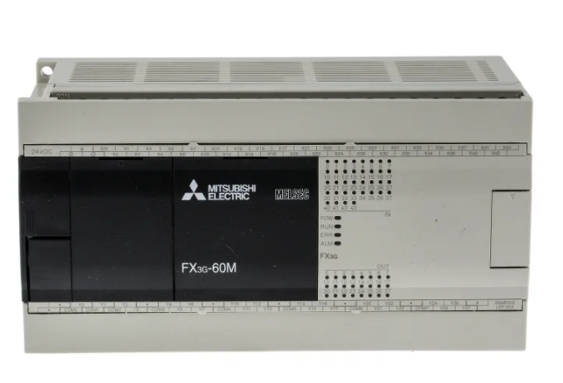
Figure 3 - Mitsubishi FX3G

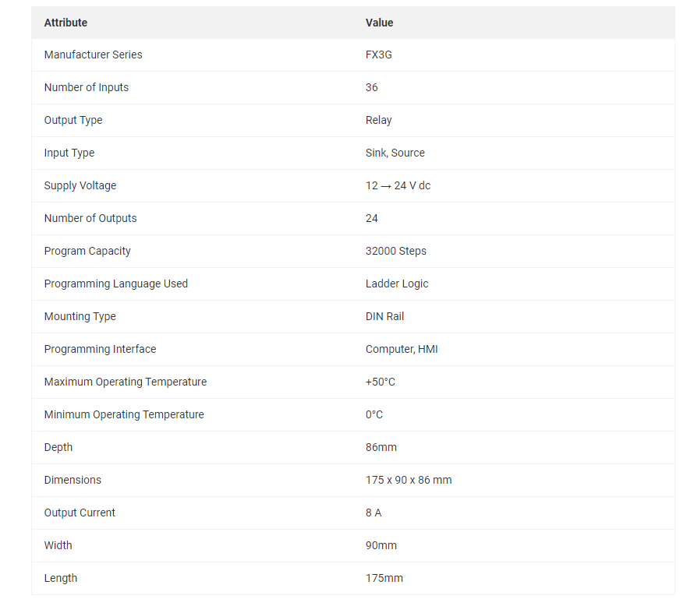

Figure 4 - Mitsubishi FX3G Datasheet

Shown in Figure 3 is a modular PLC used in industry, produced by Mitsubishi. Figure 4 shows common values for this type of PLC. This PLC holds 36 inputs and provides 24 outputs which can be used for multiple systems in a variety of environments. This PLC supports ladder logic which is common in modular applications as the majority of large programs are operated using ladder logic as opposed to functional blocks and logic gates.

PLC Components
All types of PLCs use similar processes and components to carry out a desired function. Programmable Logic Controllers use input and output modules, CPUs, Power Supply and a form of memory unit as depicted in Figure 5. The Processor or CPU is the part of the PLC which reads the input and as per the program which is saved in the memory. The actions determined by the program are communicated to the CPU and are sent to the output module. The memory unit as seen in Figure 5 is where the program is stored and saved. PLCs have different typed of memory, RAM, Random Access Memory and ROM, Read Only Memory. RAM is used for the operator’s program whereas ROM is used for fixed data for the CPU and fixed storage for the PLC. The input and output modules mentioned are the parts of the PLC which communicate with the environment. For example, externally there are sensors being used to measure temperature, pressure, speed, level and position etc. These sensors can transmit data in forms of voltage, current and discrete values, being either 0 or 1, on or off. Readings from these instruments are communicated via the input interface which can be discrete, analogue or digital input. The CPU will interpret these and communicate to the output module. The output module is used to communicate to controllers, valves, solenoids, shutdown systems or more simply an indicator/ control panel. The power supply is used in a PLC to convert mains power to an appropriate voltage for the PLC, which is 5V, making it usable for the CPU. A programming device is external to the PLC but is used to transfer the program to the memory, ready for use.
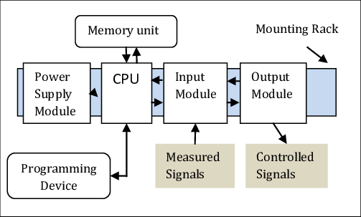
Figure 5 - PLC diagram

PLC Protection
PLCs can contain vey essential programming for critical systems, this being shutdown systems, safety systems and other control systems. Overloading PLCs can cause damage to the internals of the component which in turn will cause systems to fail. Protecting PLCs from faults and overloading is essential. This is executed by using a component called an optoisolator or optocoupler. Digital input pulses pass through an LED which is positioned opposite a phototransistor which when a light signal is detected rises the voltage in the circuit. This arrangement protects the PLC because there are two circuits electrically isolated from each other, meaning that an overload in the input will not affect the PLCs voltage.

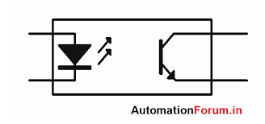
Figure 6 - Optocoupler diagram
This is also used in higher voltage circuits so that the loops are isolated from each other.

Task 2

Pictured in Figure 7 is a logic gate circuit which was used to produce the truth table below.
A | B | C | Q
0 | 0 | 0 | 0
0 | 0 | 1 | 0
0 | 1 | 0 | 0
0 | 1 | 1 | 1
1 | 0 | 0 | 1
1 | 0 | 1 | 1
1 | 1 | 0 | 0
1 | 1 | 1 | 1
Figure 7 - Logic Gate Circuit

$$Q=\overline{A}.B.C+A.\overline{B}.\overline{C}+A.\overline{B}.C+A.B.C$$

The inputs of the circuit pictured in Figure 7 each pass through multiple different logic gates which manipulates the signal to give a desired output.

b)

Shown below is the Boolean equation for the circuit in Figure 7.
$$Q=\overline{A}.B.C+A.\overline{B}.\overline{C}+A.\overline{B}.C+A.B.C$$
Using Karnaugh Maps, this equation can be simplified to make the equation more simple and easier to use and to build a circuit. Simplifying reduces the number of gates needed while having the same outcome.

 | BC
A |  | 00 | 01 | 11 | 10
 | 0 | 0 | 0 | 1 | 0
 | 1 | 1 | 1 | 1 | 0

Using a Karnaugh map the Q= 0 outputs are ignored but the Q=1 outputs are grouped together to build the new equation. Groups can contain 1, 2, 4, 8 etc Q=1 output.
Below is the simplified equation which was determined using Karnaugh Maps. As seen, it is far simpler than the previous Boolean expression.
$$Q=A.\overline{B}+B.C$$
Using a suitable software, MultiSim, the circuit was simplified and built in ladder logic. The circuit was tested and operated as per specification and shown in the following figures.
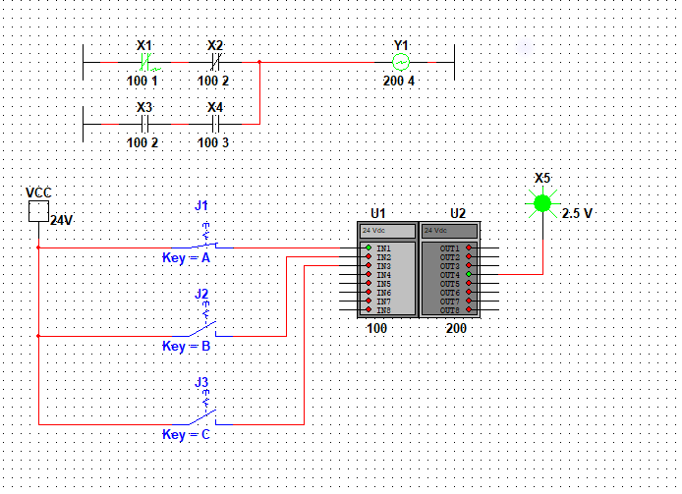
Figure 8 Q=A.(B) ̅

Pictured in Figure 8 is the ladder logic diagram of $Q=A.\overline{B}+B.C$, after simplifying, this circuit was built. Figure 8 shows when A=1 and B=0 then Q=1 as seen in the green LED (X5) as well as a signal on the output coil Y1. Using switches an input was able to be simulated for testing purposes.

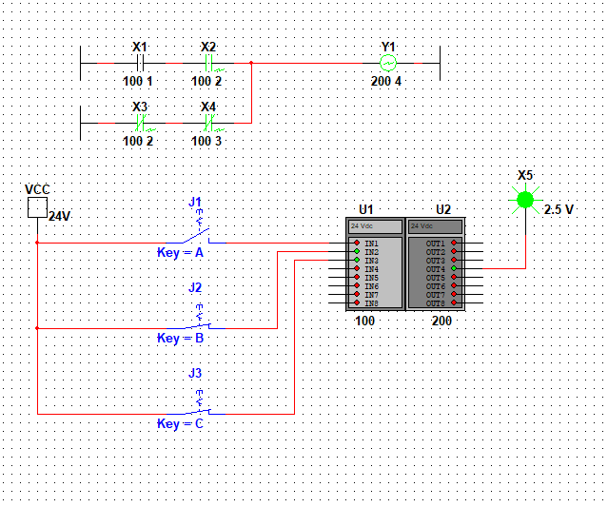
Figure 9 - Q = B.C
Figure 9 shows the ladder logic $Q=A.\overline{B}+B.C$. Figure 9 shows when B=1 and C=1 then Q=1 and seen the green LED (X5) has operated as well as a signal on the output coil, Y1. The same system was used as in Figure 8 where switches simulated an input.

Task 3 – Timers

a)i) On-Delay Timers
Timers are used in PLC programming in order to control the time an output is subjected to a controlling signal. In all cases, three types of timers are used, on-delay, off-delay and pulse timers. Each type of timer is utilised in both ladder logic and functional block logic programs.
On-delay timers are used when an output is required to change from 0 to 1 a predetermined time after an input is received by the component. A time is set prior to the program running which is suitable for the task.
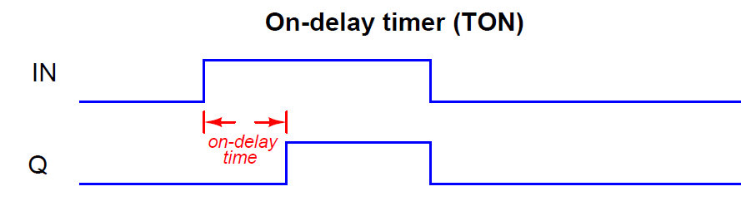
Figure 10 - On-Delay Timing Diagram
In operation, an example of where this is used is in fan controllers, motor control and starting sequences such as boiler control where a suitable sequence is required for successful start-up. Using on-delay timers can be used to create staggered starts. Shown in Figure 10 is an example of an on-delay (TON)
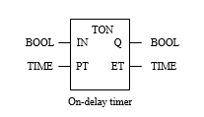
Figure 11 - On-delay Timer in Ladder Logic

ii) Off-Delay Timers
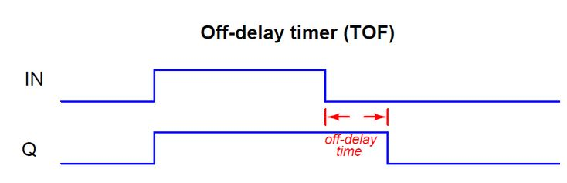
Off delay timers, similar to on delay timers are used in ladder and logic gate PLC programming. Off-delay timers are used when an input must be held after a stop sequence is initiated, the input of the rung or function becomes 0 or false. This time may be a run-down, cool down or damping timer which is set prior to running the program and the system.
Figure 12 - Off Delay Timing Diagram
In order for the delay to be initiated, the input must be 0, as seen in Figure 12.

iii) Pulse Timers
Pulse timers differ slightly to the previous types of timers. When a pulse timer receives the appropriate input as per setup, the output is enabled for a set period of time, regardless of how long the timer is subjected to an input. Pulse timers like On and Off Delay can be used in ladder logic and function block programming, utilised in multiple environments.
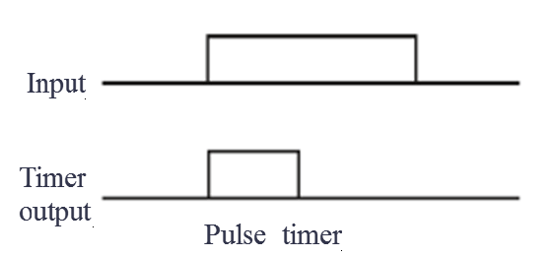
Figure 13 - Pulse Timer Timing Diagram
Figure 10 shows the timing diagram of a Pulse Timer. An example of where this is used is in an alert or alarm system.

b)
A cascade system is a type of system which uses two or more controllers where the output of the first controller feeds into the second controller, providing a setpoint. In terms of timers, all of the above timers can be utilised. On and Off Delay timers can be used in timed systems such as, washing machine cycling, fan controllers and pump operation. Different times can be set and using logic gates, the signal can be manipulated, an example is a NOT gate which can reverse the input. These timers can provide signal to the next which makes them suitable in a cascade loop. A pulse timer can be used to initiate the start of a cascade loop. An input can be received on the timer which may be the push of a button or another type of input which will trigger an output. Using a SET/RESET, this input can trigger the start of a cascade loop. Stop and start loops commonly use cascade loops to initiate and stop system operations. Another example of a cascade loop is, batch production. Batch production for example will add multiple products into the same vessel. A cascaded timer system can control this by opening valves for a certain period of time, provided that there is a constant supply which would allow controlled additions. Figure 14 shows a very simple example of a cascade timer system which as seen operates three different lights using three cascaded timers.
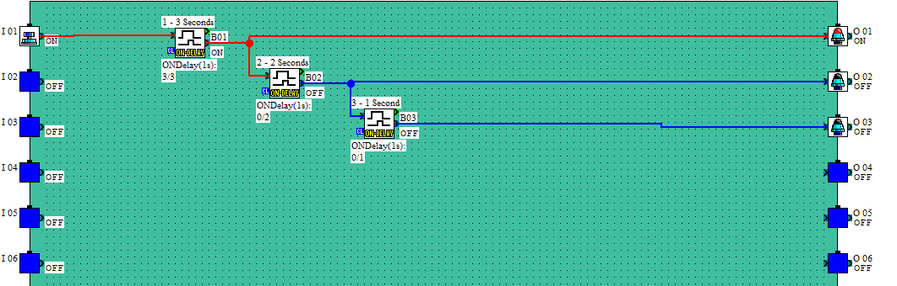
Figure 14 - Cascaded system
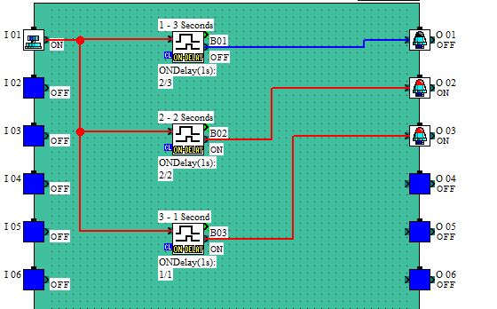
Sequencing is another use of timers which differs to that of cascaded. Sequencing is when there are multiple timers in a program which are all started at the same time but set at different times to give or remove an output depending to the setup of the timer. On and Off delay can be used in multiple sequenced systems to give multiple outputs at different times. This type of system is used in sequential systems such as a car wash. A car wash carries out multiple tasks all within the same time frame. Once the program has started, each timer will have an on delay until they are required. This can also operate in an off sequence. All outputs come on at the same time and off in a sequence.

Figure 15 - Sequenced Timers

Figure 15 depicts a simple sequenced system which when operated each timer will be subjected to an input at the same time but as seen give outputs at different intervals.

Task 4 – Programming Problems

a)
Washing Machine PLC program
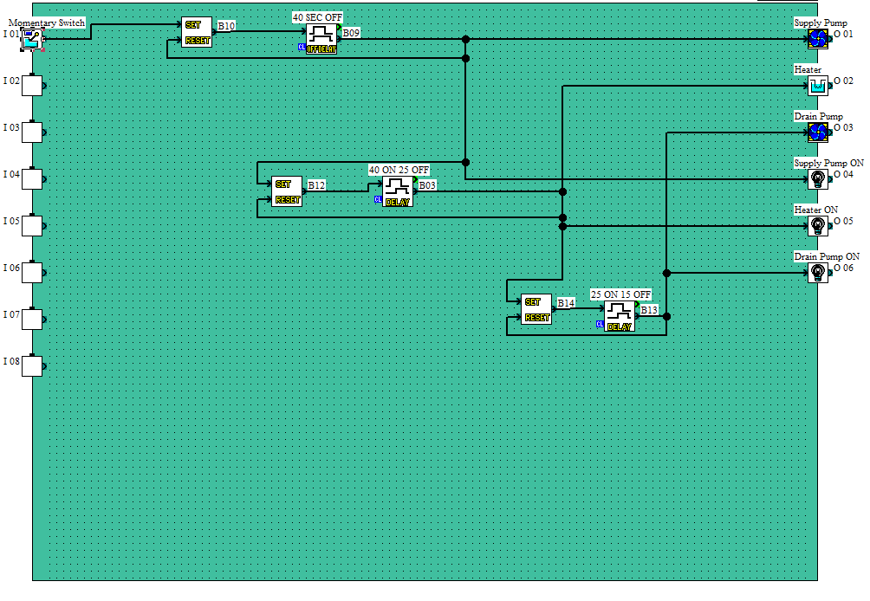
Figure 16 - Washing Machine PLC Program
Figure 16 shows a Washing machine cycle PLC program using three different timers. The momentary switch operates a set-reset for each timer which initiates the cycle. The supply pump operates for 40 seconds before turning off where the heater has a 40 second on delay and a 25 second off delay which accounts for the supply pump and heater operation. A drain pump then operates for 15 seconds before turning off. This system works as per specification and indicator lamps also operate correctly.

b)
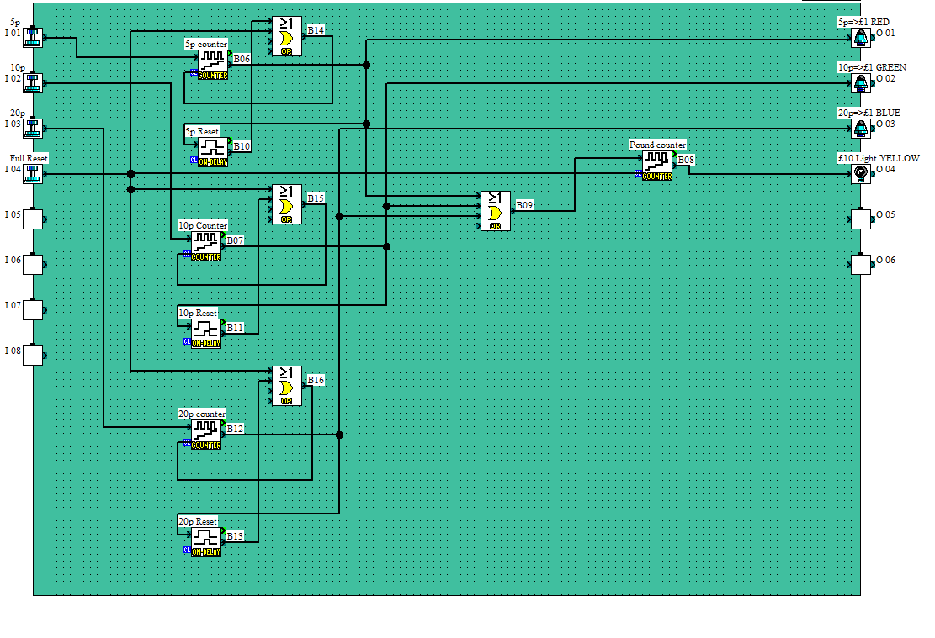
Figure 17 - £10 Money Counter PLC Program
Figure 17 shows a money counter program which when a total of £10 is collected an indictor lamp operates to show this. Three different counters were required for three different coins with different values as seen in the program. Once a total of £1 is reached by each coin, a light will operate for each counter. When £10 is reached, a single indicator light will operate to show completion. There is also a ‘Full Reset’ button which can be operated to reset the system in case of an error. The system operates correctly as per specification.

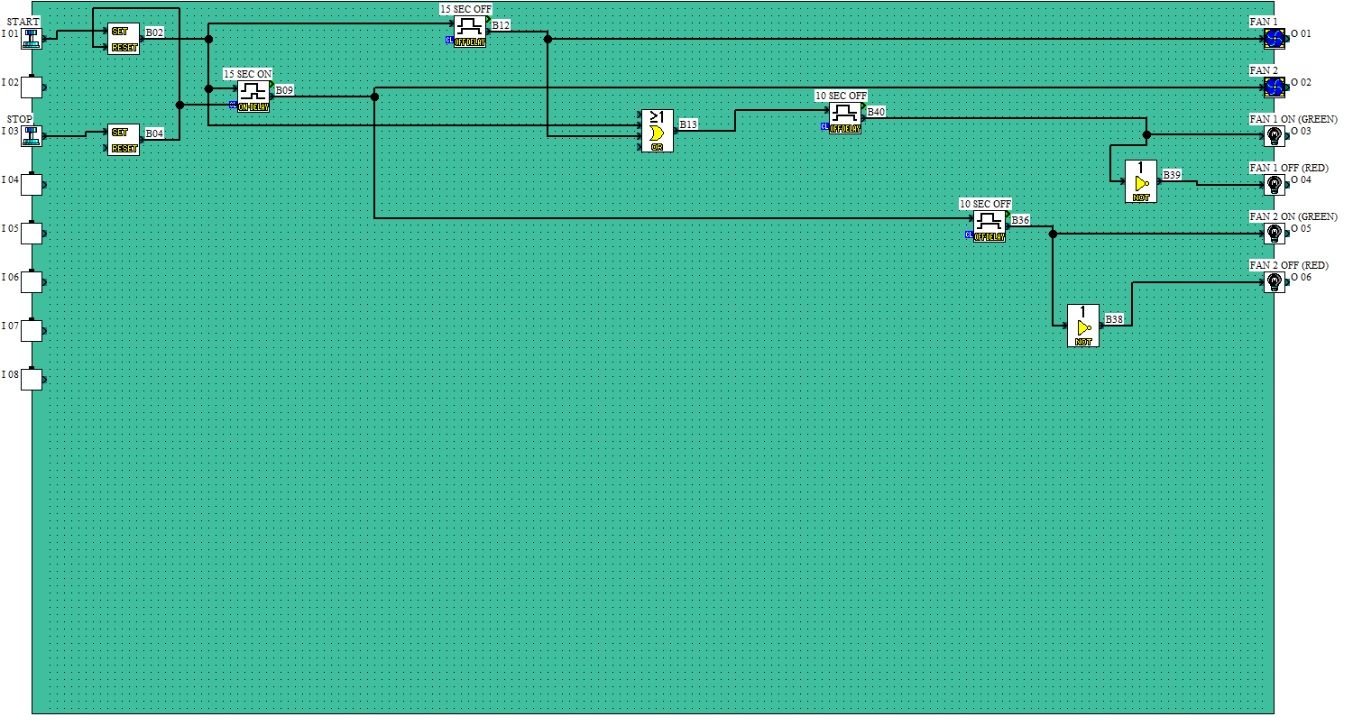
Task 5
Figure 18 - Fin Fan Controller PLC Program

Figure 18 shows a fin fan controller PLC program where both must be operated for different periods of time. The start button initiates the sequence, operating ‘Fan 1’, after 15 seconds ‘Fan 2’ comes on along with the indicator lamps and these stay on for as long as the fans are operating. In the stop sequence, after the button is pressed the fans turn off in the same sequence with a 10 second run down period to account for the fans slowing down, the off lights coming on. The system works as requested by specification.

Bibliography
Bagat, K., 2021. Pulse Timer Instruction in PLC Programming. [online] Information Wala. Available at: https://informationwala.com/pulse-timer-instruction-in-plc-programming/ [Accessed 6 December 2021].

Cartiman, 2012. Unitary PLC, Rack-Mounted PLC and Modular PLC | CustomWritings. [online] Customwritings.co. Available at: https://customwritings.co/unitary-plc-rack-mounted-plc-and-modular-plc/ [Accessed 2 December 2021].
CenTec Inc. 2002. ELECTRICAL THEORY/TECHNOLOGY PLC CONCEPTS BASIC ELECTRONICS. 1st ed. Greenville: CenTec INC., pp.234 - 238.

D&E Notes. n.d. Programmable Logic Controller - PLC. [online] Available at: https://www.daenotes.com/electronics/industrial-electronics/PLC-programable-logic-control [Accessed 3 December 2021].

Electrical4u. n.d. On Delay Timer | Off Delay Timer Working Principle | Electrical4u. [online] Available at: https://www.electrical4u.net/basic-accessories/on-delay-timer-off-delay-timer-working-principle/#:~:text=On%20delay%2C%20timers%20are%20the%20most%20used%20timer,there%20is%20no%20output%20until%20the%20preset%20time [Accessed 4 December 2021].

Instrumentation, F., 2018. Introduction to Optocouplers. principle, Application. [online] Industrial Automation, PLC Programming, scada & Pid Control System. Available at: https://forumautomation.com/t/introduction-to-optocouplers-principle-application/5070 [Accessed 3 December 2021].

Inst Tools. n.d. PLC Timer Programming Examples : TON, TOF, TP and TONR. [online] Available at: https://instrumentationtools.com/plc-program-for-iec-timers-ton-tof-tp-tonr-used-in-s7-1200/ [Accessed 6 December 2021].

Uk.rs-online.com. n.d. 2080-LC10-12QWB | Allen Bradley Micro810 PLC CPU - 8 Inputs, 4 Outputs, Relay, USB Networking | RS Components. [online] Available at: https://uk.rs-online.com/web/p/plcs-programmable-logic-controllers/7508602?cm_mmc=UK-PLA-DS3A-_-google-_-CSS_UK_EN_Automation_%26_Control_Gear_Whoop-_-PLCs+-+Programmable+Logic+Controllers_Whoop-_-7508602&matchtype=&aud-828197004210:pla-326418213834&gclid=EAIaIQobChMIiseVjdfo9AIVyevtCh2m3QAREAQYAyABEgI70_D_BwE&gclsrc=aw.ds [Accessed 2 December 2021].
Sundaresan, H., n.d. OFF Delay Timer using PLC - Timer Off Delay Instruction. [online] Inst Tools. Available at: https://instrumentationtools.com/off-delay-timer-using-plc/ [Accessed 4 December 2021].

Staff, E., n.d. Cascade Control Principle. [online] Inst Tools. Available at: https://instrumentationtools.com/cascade-control-principle/ [Accessed 7 December 2021].

Unicourse.org. 2018. Design and Operational Characteristics of a PLC System. [online] Available at: https://unicourse.org/wp-content/uploads/2020/04/U15-WB-1-1.pdf [Accessed 3 December 2021].

Bolton, W., 2015. Programmable Logic Controllers. 6th ed. Oxford: Elsevier, pp.230-234.

References
Uk.rs-online.com. n.d. 2080-LC10-12QWB | Allen Bradley Micro810 PLC CPU - 8 Inputs, 4 Outputs, Relay, USB Networking | RS Components. [online] Available at: https://uk.rs-online.com/web/p/plcs-programmable-logic-controllers/7508602?cm_mmc=UK-PLA-DS3A-_-google-_-CSS_UK_EN_Automation_%26_Control_Gear_Whoop-_-PLCs+-+Programmable+Logic+Controllers_Whoop-_-7508602&matchtype=&aud-828197004210:pla-326418213834&gclid=EAIaIQobChMIiseVjdfo9AIVyevtCh2m3QAREAQYAyABEgI70_D_BwE&gclsrc=aw.ds [Accessed 9 December 2021].

Instrumentation, F., 2018. Introduction to Optocouplers. principle, Application. [online] Industrial Automation, PLC Programming, scada & Pid Control System. Available at: https://forumautomation.com/t/introduction-to-optocouplers-principle-application/5070 [Accessed 3 December 2021].

Inst Tools. n.d. PLC Timer Programming Examples : TON, TOF, TP and TONR. [online] Available at: https://instrumentationtools.com/plc-program-for-iec-timers-ton-tof-tp-tonr-used-in-s7-1200/ [Accessed 6 December 2021].

Uk.rs-online.com. n.d. FX3G-60MR/DS | Mitsubishi FX3G Logic Module - 36 Inputs, 24 Outputs, Relay, Computer, HMI Interface | RS Components. [online] Available at: https://uk.rs-online.com/web/p/plcs-programmable-logic-controllers/7054938 [Accessed 10 December 2021].

2080-LC10-12QWB | Allen Bradley Micro810 PLC CPU - 8 Inputs, 4 Outputs, Relay, USB Networking | RS Components (rs-online.com)
2080-LC10-12QWB | Allen Bradley Micro810 PLC CPU - 8 Inputs, 4 Outputs, Relay, USB Networking | RS Components (rs-online.com)
FX3G-60MR/DS | Mitsubishi FX3G Logic Module - 36 Inputs, 24 Outputs, Relay, Computer, HMI Interface | RS Components (rs-online.com)
https://www.researchgate.net/figure/Schematic-diagram-of-a-PLC_fig1_298959737
https://www.google.com/url?sa=i&url=https%3A%2F%2Fforumautomation.com%2Ft%2Fintroduction-to-optocouplers-principle-application%2F5070&psig=AOvVaw0vIBXVUL5P4ZJ5EWv6-nEe&ust=1640793682676000&source=images&cd=vfe&ved=0CAwQjhxqFwoTCLiS9PbuhvUCFQAAAAAdAAAAABBQ
https://www.electrical4u.net/basic-accessories/on-delay-timer-off-delay-timer-working-principle/#:~:text=On%20delay%2C%20timers%20are%20the%20most%20used%20timer,there%20is%20no%20output%20until%20the%20preset%20time
https://www.electrical4u.net/basic-accessories/on-delay-timer-off-delay-timer-working-principle/#:~:text=On%20delay%2C%20timers%20are%20the%20most%20used%20timer,there%20is%20no%20output%20until%20the%20preset%20time

