CHAPTER 1

1.0 Introduction
The UK's healthcare system is going through one of the biggest changes in structure since the National Health Service (NHS) was set up in 1948 (Williams, 2025). Digital innovation and telemedicine are becoming less optional and more important parts of how healthcare is delivered (Bedi, 2025). This change has happened faster because of demographic pressures, a growing demand for services, a lack of workers, and most importantly, the COVID-19 pandemic (Abnett and Mohan, 2026). As healthcare systems work to find a balance between efficiency and fairness, it has become very important to understand how digital innovation affects access to healthcare (De Widt et al., 2026).
However, in the UK, healthcare accessibility means more than just having services available (Herrick and Armstrong, 2025). It also means that people can easily get timely, appropriate, and fair care, no matter their socioeconomic status, location, age, disability, or digital skills (Ch et al., 2025). Long wait times, differences in the workforce between regions, limited services in rural areas, and transport problems have all made it harder for people to get to places in the past (Akhtar et al., 2025). In response, national policy has increasingly seen digital transformation to make things more efficient and give more people access (Jena, et al., 2025). According to the NHS England Long Term Plan lists digital-first primary care, remote monitoring, electronic prescribing, and integrated digital health records as important ways to modernize how healthcare is delivered (Guo et al., 2025).
Furthermore, the COVID-19 pandemic significantly accelerated the digital transformation of primary care services in the United Kingdom (Brown et al., 2023). Prior to 2020, the majority of general practice (GP) consultations were conducted face-to-face, with remote appointments representing only a small proportion of total activity (NHS England, 2025). However, during the first national lockdown in March 2020, consultation patterns changed dramatically. As illustrated in Figure 1.0, face-to-face appointments declined sharply while remote consultations increased rapidly, becoming the dominant mode of interaction during the early stages of the pandemic.
Evidence from an interrupted time series analysis by Mesiano and Santos (2025) indicates that remote consultations accounted for over 70% of GP consultations in England during peak lockdown periods. Figure 1 clearly demonstrates this shift, showing a steep reduction in in-person visits immediately following the first lockdown announcement, alongside a corresponding rise in telephone and video consultations. Although face-to-face consultations have gradually resumed since 2021, remote appointments continue to represent approximately 30–40% of overall GP activity, reflecting a sustained structural change in service delivery rather than a temporary emergency response (Sheikh et al., 2023).
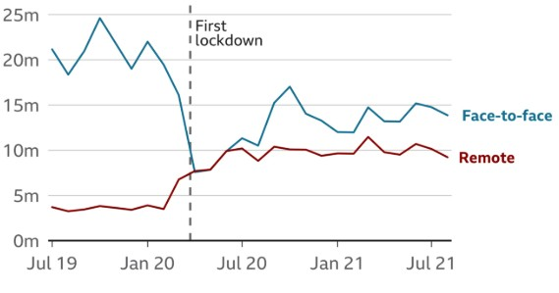
Figure 1.0: Trends in Face-to-Face and Remote GP Consultations in England (July 2019 – July 2021). Source: Adapted from national GP appointment data (NHS England, 2025).
While digital expansion through platforms such as the NHS App has improved convenience, appointment flexibility, and reduced the need for physical travel, concerns regarding digital exclusion remain significant (Abel et al., 2024). As illustrated in Figure 2, NHS App login sessions and online appointment bookings increased sharply following the first national lockdown, with a marked upward trajectory from early 2020 onwards (Hutchings, 2023).
The interrupted time series analysis demonstrates sustained growth in digital engagement beyond the initial emergency response, indicating that digital access has become embedded within routine healthcare pathways.
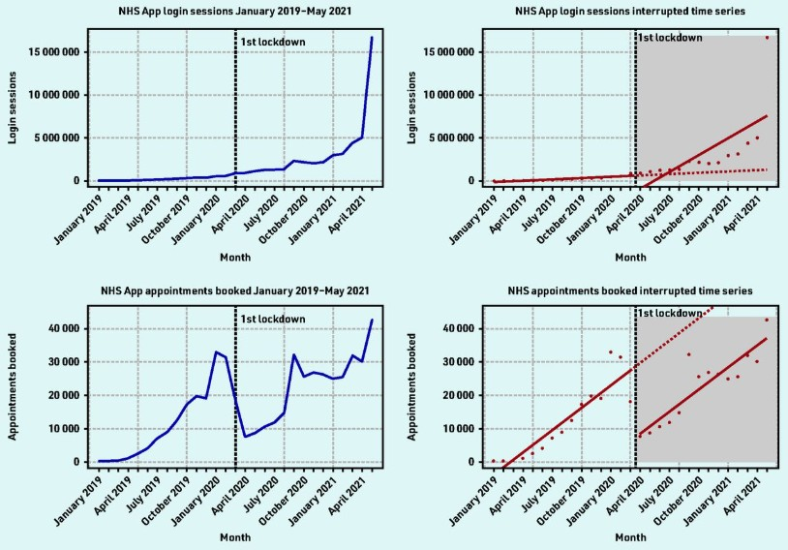
Figure 1.1: Trends in NHS App Login Sessions and Online Appointment Bookings in England. Source: (Hutchings, 2023).
However, this rapid uptake must be considered alongside national data on digital inequality. The Office for National Statistics reports that approximately 7% of UK adults, equivalent to around 3–4 million people, had not used the internet recently, with non-use disproportionately higher among older adults, individuals with disabilities, and those from lower socioeconomic backgrounds (ONS, 2023). In particular, adults aged 75 years and over are significantly less likely to possess essential digital skills compared to younger populations (Davies et al., 2024). Therefore, although Figure 2 reflects substantial growth in digital participation, it simultaneously highlights the risk that individuals lacking internet access or digital literacy may experience reduced healthcare accessibility within an increasingly digital-first NHS model.
These numbers show a major problem with digital transformation, while telemedicine can make it easier for people to get healthcare by removing barriers of time and space, it can also make things worse for people who do not know how to use computers, have unreliable internet connections, or are not sure how to use online systems (Petrou et al., 2023). According to data from the Office for National Statistics on internet usage in the UK (see Appendix 1), older adults and people from lower socioeconomic groups are still much less likely to use the internet (ONS, 2023). Consequently, certain segments of the population may find it challenging to interact with digital healthcare platforms. Parvathy (2025) contends that digital healthcare may exacerbate pre-existing health disparities if inclusivity initiatives are not integrated into implementation strategies. Greenhalgh et al. (2025) discovered that while digital consultations were effectively integrated into numerous UK practices, certain services were subsequently combined with in-person care or terminated due to concerns regarding accessibility and quality.
Thus, healthcare accessibility must be considered in a variety of manners. Telemedicine has many well-known benefits, such as lower travel costs, better access for people in rural areas, and more flexible appointment times (Cheshmehzangi and Zou, 2025). For people with chronic illnesses or mental health problems, remote consultations may help them keep getting care without too much trouble. But accessibility also has to do with relationships and clinical settings. Some patients say they feel less reassured when they do not have a physical exam, and doctors have worried about the limits of diagnosis in settings that are purely remote (Greenhalgh et al., 2025).
Furthermore, Digital healthcare is often touted as a cost-effective way to deal with rising demand from an economic point of view (Bandyopadhyay et al., 2024). The UK's ageing population and lack of workers put a lot of stress on primary and secondary care services (Chambers et al., 2024). The goal of digital triage systems, electronic prescribing, and remote monitoring technologies is to make service pathways more efficient and make better use of resources. However, long-term cost-effectiveness is still being assessed, especially considering infrastructure expenses, cybersecurity threats, and workforce training (Sexton et al., 2025).
This Report expands upon the research proposal and rigorously evaluates whether digital innovation and telemedicine have authentically enhanced healthcare accessibility among various UK populations. It aims to assess both the quantifiable growth of digital services and the more subtle consequences of digital exclusion. This study will evaluate the alignment of digital transformation with the foundational NHS principle of equitable care based on need through the analysis of national policy, empirical research, and statistical trends.

CHAPTER 2

2.0 Background
Digital transformation is now a defining part of healthcare systems around the world. Digital innovation and telemedicine have had a bigger impact on how health services are delivered, accessed, and managed in the UK (Gobburi, et al., 2025). Several things have led to the shift toward digital healthcare, such as the need to make services more efficient, rising demand for healthcare, changes in the population, and the growing role of technology in daily life (Geifman et al., 2023). To critically assess the effect of digital innovation on healthcare access, it is important to know the history of digital innovation in the UK healthcare system.
The National Health Service (NHS) is the main way that the UK healthcare system works. It provides healthcare services that are mostly free at the point of delivery (May et al., 2023). The NHS has been trying to provide fair healthcare based on need rather than ability to pay since it started in 1948. But even though this is the case, not everyone has had the same access to healthcare services (Peek et al., 2024). In the past, geographic inequalities, a lack of workers, long wait times, and differences in income and education have all made it harder for people to take care when they need it (Lennon et al., 2023). Because of this, policymakers have been looking more for digital innovation to solve these problems that have been around for a long time.

2.1 Digital Innovation in Healthcare
Digital innovation in healthcare means using digital tools to make healthcare services easier to get to, manage, and deliver. Electronic health records (EHRs), mobile health apps, online appointment booking systems, digital prescribing platforms, remote monitoring devices, and AI tools used for diagnosis and clinical decision-making are all examples of digital healthcare technologies (Imison et al., 2024).
However, as part of its healthcare reform, the UK government has made digital healthcare transformation a top priority. The NHS England Long Term Plan stresses the growth of digital-first primary care, the creation of integrated digital health records, and the use of technology to make it easier for patients to get involved and get services (NHS England, 2025).
Also, one of the most important things to happen in digital healthcare is the rise of electronic health records (Fish et al., 2025). Digital record systems make it easier for healthcare workers to quickly get patient information, share data between different healthcare organizations, and make sure that care is continuous (Antonacci et al., 2023). Digital prescribing systems also let patients ask for repeat prescriptions online, which makes things easier for doctors and nurses and speeds up primary care services (Hashiguchi, 2024).
Therefore, you can see that NHS organizations are using more digital technologies in their healthcare services. To improve patient care and service efficiency, healthcare providers are using digital consultation systems, electronic referral pathways, and digital monitoring technologies.
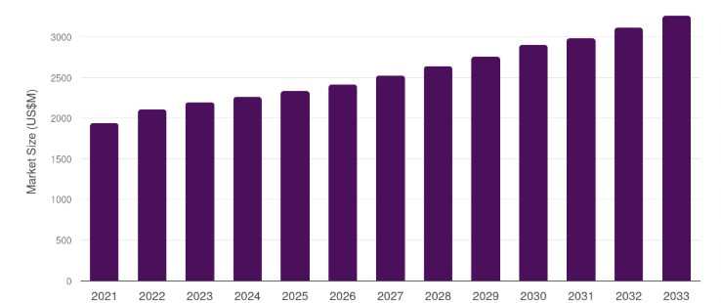
Figure 2.0: UK Electronic Health Record Market from 2021 to 2033.
Source: (Srinivasa et al., 2025).
Furthermore, figure 2.0 above shows that the market for electronic health record systems in the UK has been growing steadily since 2021 and is expected to keep growing until 2033. This rise shows that healthcare organizations are relying more on digital record systems (Srinivasa et al., 2025). More electronic health records make it easier for healthcare providers to share information and coordinate care across different healthcare settings (Kurniawan et al.,2024). According to Cronin et al. (2024) Electronic health record systems can help make healthcare delivery more efficient and make healthcare services easier to get by making patient information more available and cutting down on administrative waste.

2.2 Development of Telemedicine in the UK
Telemedicine is when healthcare services are provided from a distance using communication tools like phone calls, video conferencing, and digital communication platforms (Debnath,2024). Telemedicine lets doctors and nurses check on and treat patients without them having to go to a hospital or doctor's office (Furlepa et al., 2023).
Historically, telemedicine was used primarily in specialist medical services or rural healthcare settings where access to healthcare providers was limited. However, technological advancements and improved internet connectivity have enabled telemedicine to expand significantly within mainstream healthcare services (Stanberry, 2023).
However, the COVID-19 pandemic sped up the use of telemedicine in the UK's healthcare system by a lot. During the pandemic, remote consultations were necessary to keep primary care services running while lowering the risk of spreading infections (Alashek et al., 2024). Healthcare providers quickly started using phone and video consultations so they could keep giving care while keeping patients and doctors from meeting each other (Omboni et al., 2023).
Conversely, the growing use of telemedicine has shown that it can make healthcare more accessible in many ways (Nittari et al., 2023). Also, remote consultations let patients get medical care without having to go to a medical facility. This can be especially helpful for people who live in rural areas or have trouble getting around. Telemedicine also lets healthcare providers schedule appointments more flexibly, which could mean they can see more patients (Flynn et al., 2024).

2.3 Benefits of Digital Innovation for Healthcare Accessibility
According to Varadarajan (2024), Digital healthcare technologies could make it much easier for people to get care by breaking down physical, geographical, and administrative barriers. Furthermore, digital platforms make it easier for patients to make appointments, ask for repeat prescriptions, get medical records, and talk to doctors and nurses.
Also, digital platforms like the NHS App have made it easier for patients to connect with healthcare services online. Patients can use the NHS App to make appointments with their GP, see their medical records, order repeat prescriptions, and get health advice (Putra et al., 2024). More people are using these digital services, which shows that people are becoming more comfortable with digital healthcare technologies.

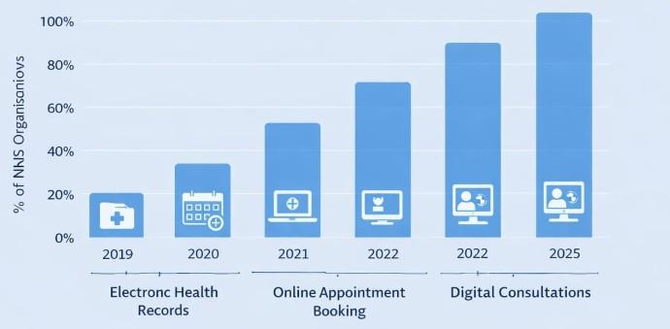
Figure 2.1: Adoption of Digital Health Technologies within NHS Healthcare Services. Source: (Statista, 2026).
NHS organizations have increasingly embraced digital technologies to support healthcare delivery, as Figure 2.1 illustrates. The development of digital health infrastructure facilitates better coordination between various healthcare sectors and allows healthcare providers to provide services more effectively.

2.4 Digital Exclusion and Inequality
Digital exclusion is still a big problem in the UK's healthcare system, even though digital healthcare innovation has many benefits (Holmes and Burgess, 2023). Digital exclusion is when some people or groups cannot use, afford, or access digital technologies like computers, smartphones, or platforms that work over the internet (Helsper, 2024). As healthcare services use more digital tools like telemedicine consultations, online appointment booking, and electronic health records, people who do not have access to or know how to use these tools may find it harder to get the care they need (Park, 2023). Digital exclusion can happen for several reasons, such as not having a good internet connection, not knowing how to use digital technology, not being able to afford it, not being able to speak the language, or having a physical or mental disability that makes it hard to use digital technology (Van Deursen et al., 2025).

The Office for National Statistics (ONS) says that millions of adults in the UK still do not have basic digital skills or regular internet access (ONS, 2023). According to the ONS, older adults are much less likely to use the internet than younger adults. For example, people 75 and older are much less likely to use online services than people in their 20s and 30s (Hider et al., 2023). People from lower-income households are also more likely to be digitally excluded because of the costs of internet subscriptions, digital devices, and technology training (Correa et al., 2022). People with disabilities may also have trouble using digital platforms that don't have features that make them easy for everyone to use.
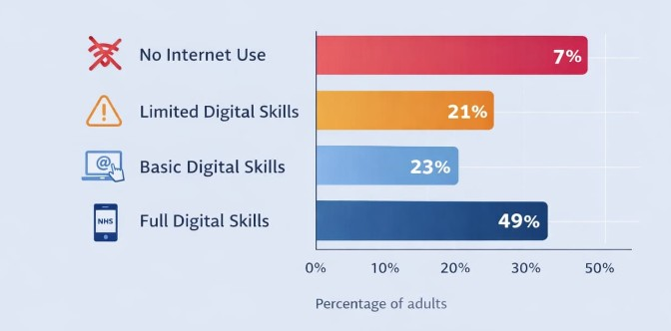
Figure 2.2: Internet Usage and Digital Skills Across the UK Population
Source: (Office for National Statistics, 2023).
As illustrated in Figure 2.2 above, digital skills and internet usage vary significantly across different age groups and socioeconomic backgrounds within the UK population (ONS, 2023). Younger people tend to be more digitally proficient and comfortable using digital services, while older people often have trouble using digital devices or finding their way around online platforms (Goodman-Deane, 2023). This difference shows how digital healthcare systems can unintentionally make healthcare inequalities worse if other ways to get care are not kept up. For instance, people who have trouble using online appointment systems may have to wait longer for healthcare services than people who are comfortable with technology (Eynon and Geniets, 2023).
Additionally, geographical factors also play a role in digital exclusion. Rural areas may not have good broadband access, which can make it hard to take part in video consultations or use online healthcare platforms (Serafino, 2023). This issue is especially important in rural areas where there may not be many healthcare facilities. Depending on how reliable the digital infrastructure is, digital healthcare services could either make access easier or make existing inequalities worse (Durand et al., 2025).
However, there are also issues about the quality and effectiveness of remote consultations done through telemedicine, in addition to problems with digital access and skills. Some healthcare professionals argue that telemedicine consultations may not consistently deliver the same quality of clinical evaluation as in-person appointments (Plichta, 2022). Physical examinations, the observation of non-verbal cues, and direct patient interaction are essential for accurate diagnosis and treatment planning. The lack of these components in remote consultations could influence clinical decision-making and patient reassurance (Imran, 2023).
Conversely, there are also issues that some groups of patients may not feel comfortable sharing their health problems online, especially those with complicated medical conditions, mental health needs, or not much experience with technology (Robinson et al., 2024). Because of this, many healthcare providers now use hybrid models of care that mix digital consultations with regular in-person appointments (DiMaggio, 2024). These mixed methods try to make digital healthcare services as efficient and easy to use as possible while making sure that patients who need in-person care still get the help they need (Wilson-Menzfeld et al., 2025).
In general, digital innovation and telemedicine could make healthcare easier to get, but it is still important to deal with digital exclusion to make sure that everyone gets the same level of care. So, policymakers and healthcare organizations need to think about ways to promote digital inclusion, like upgrading broadband infrastructure, offering digital literacy training, and making sure that there are still other ways to get healthcare that do not involve technology (Mariën and Prodnik, 2024). Without these steps, new digital healthcare technologies could make existing inequalities worse instead of making it easier for people to get healthcare.

2.5 Summary
Digital innovation and telemedicine have become increasingly important components of healthcare delivery in the United Kingdom. Technologies such as electronic health records, telemedicine platforms, and digital patient services have the potential to improve healthcare accessibility and efficiency. Government initiatives such as the NHS Long Term Plan have promoted digital transformation as a strategy for modernising healthcare services and addressing increasing healthcare demand.
However, the benefits of digital healthcare must be balanced against challenges such as digital exclusion, unequal access to technology, and concerns about the quality of remote consultations. Ensuring that digital healthcare services remain accessible to all population groups is essential for maintaining equitable healthcare delivery.
This background discussion provides the context for the present study, which aims to critically evaluate the impact of digital innovation and telemedicine on healthcare accessibility in the United Kingdom.

REFERENCES
Abel, G., Atherton, H., Sussex, J., Akter, N., Aminu, A.Q., Aminu, A., Bak, W., Bryce, C., Clark, C.E., Clark, C. and Cockcroft, E. (2024) ‘Current experience and future potential of facilitating access to digital NHS primary care services in England: the Di-Facto mixed-methods study’, Health and Social Care Delivery Research, 12(32), pp. 1–197.
Abnett, H. and Mohan, J. (2026) ‘Organization by regulation: regulatory reform and the creation of National Health Service (NHS) Charities in England and Wales in the 1980s–1990s’, Management & Organizational History, pp. 1–24.
Akhtar, F., Saleem, H. and Zubair, M. (2025) ‘The impact of telemedicine on healthcare delivery: opportunities and challenges’, Journal of Health, Medical Research and Innovations, 3(2), pp. 89–101.
Alashek, W.A. and Ali, S.A. (2024) ‘Satisfaction with telemedicine use during COVID-19 pandemic in the UK: a systematic review’, Libyan Journal of Medicine, 19(1), p. 2301829.
Antonacci, G. et al. (2023) ‘Healthcare professional and manager perceptions on drivers, benefits, and challenges of telemedicine: results from a cross-sectional survey in the Italian NHS’, BMC Health Services Research, 23(1), p. 1115.
Bandyopadhyay, A. et al. (2024) ‘Economic and financial concern of digital healthcare systems’, Economic Affairs, 69(2), pp. 1129–1143.
Bedi, R. (2025) ‘Back to the future: moving beyond a 1948 mindset to design NHS dentistry for 2025’, British Dental Journal, 239(10), pp. 683–685.
Bhattacharyya, S.S. and Mandke, P.V. (2022) ‘Study of awareness, adoption and experience of telemedicine technology services’, Journal of Science and Technology Policy Management, 13(4), pp. 788–811.
Brown, M.R. et al. (2023) ‘Digital outpatient health solutions as a vehicle to improve healthcare sustainability—a United Kingdom focused policy and practice perspective’, Frontiers in Digital Health, 5, p. 1242896.
Ch, A.S. et al. (2025) ‘Health equity in telemedicine: addressing disparities in digital healthcare access’, Insights – Journal of Life and Social Sciences, 3(3), pp. 56–62.
Chambers, D. et al. (2024) ‘Digital and online symptom checkers and health assessment/triage services for urgent health problems: systematic review’, BMJ Open, 9(8), p. e027743.
Cheshmehzangi, A. and Zou, T. (2025) Accessibility inequality and confronting the global access gap: global realities of uneven access. Singapore: Springer Nature.
Cook, E.J. et al. (2022) ‘Exploring the factors that influence the decision to adopt and engage with an integrated assistive telehealth and telecare service’, BMC Health Services Research, 16(1), p. 137.
Correa, T., Pavez, I. and Contreras, J. (2022) ‘Digital inequality and mobiles: opportunities and challenges of relying on smartphones for digital inclusion in disadvantaged contexts’, in Handbook of digital inequality, pp. 62–74.
Cronin, R.M. et al. (2024) ‘Comparison of family health history in surveys vs electronic health record data mapped to the observational medical outcomes partnership data model in the All of Us Research Program’, Journal of the American Medical Informatics Association, 28(4), pp. 695–703.
Davies, A.R., Honeyman, M. and Gann, B. (2024) ‘Addressing the digital inverse care law in the time of COVID-19’, Journal of Medical Internet Research, 23(4), p. e21726.
Debnath, D. (2024) ‘Activity analysis of telemedicine in the UK’, Postgraduate Medical Journal, 80(944), pp. 335–338.
De Widt, D., Sun, S. and Baylis, R. (2026) ‘Innovation in capital funding by public hospitals during austerity’, The British Accounting Review, p. 101842.
DiMaggio, P. et al. (2024) ‘From unequal access to differentiated use’, Social Inequality, 1(1), pp. 355–400.
Durand, A. et al. (2025) ‘Access denied? Digital inequality in transport services’, Transport Reviews, 42(1), pp. 32–57.
Eynon, R. and Geniets, A. (2023) ‘The digital skills paradox’, Learning, Media and Technology, 41(3), pp. 463–479.
Flynn, D. et al. (2024) ‘COVID-19 pandemic in the United Kingdom’, Health Policy and Technology, 9(4), pp. 673–691.
Furlepa, K. et al. (2023) ‘Recommendations for the development of telemedicine in Poland’, International Journal of Environmental Research and Public Health, 19(3), p. 1221.
Geifman, N., Armes, J. and Whetton, A.D. (2023) ‘Identifying developments over a decade in the digital health and telemedicine landscape in the UK’, Frontiers in Digital Health, 5, p. 1092008.
Gobburi, R.K. et al. (2025) ‘Telemedicine use in rural areas of the United Kingdom’, Informatics and Health, 2(1), pp. 41–48.
Goodman-Deane, J., Bradley, M. and Clarkson, P.J. (2023) ‘Digital technology competence and experience in the UK population’, Ergonomics and Human Factors.
Greenhalgh, T. et al. (2023) ‘The impact of remote care approaches on continuity in primary care’, British Journal of General Practice.
Greenhalgh, T. et al. (2025) ‘After the disruptive innovation: how remote and digital services were embedded, blended and abandoned in UK general practice – longitudinal study’.
Guo, R., Thompson, C. and Reyes, M. (2025) ‘Telehealth revolution’, in Healthcare Informatics Innovation Post COVID-19 Pandemic, p. 24.
Hashiguchi, T.C.O. (2024) Bringing health care to the patient: an overview of the use of telemedicine in OECD countries. OECD Health Working Papers.
Helsper, E.J. (2024) ‘The social relativity of digital exclusion’, Communication Theory, 27(3), pp. 223–242.
Herrick, C. and Armstrong, D. (2025) ‘How many doctors does a health system need?’, Social Science & Medicine, 371, p. 117882.
Hider, S. et al. (2023) ‘Digital exclusion as a potential cause of inequalities in access to care’, Rheumatology Advances in Practice, 7(1), p. rkac109.
Holmes, H. and Burgess, G. (2023) ‘Digital exclusion and poverty in the UK’, Digital Geography and Society, 3, p. 100041.
Hutchings, R. (2023) ‘The impact of Covid-19 on the use of digital technology in the NHS’, Nuffield Trust, 27, pp. 2002–2008.
Imison, C., Castle-Clarke, S., Watson, R. and Edwards, N. (2024) Delivering the benefits of digital health care. London: Nuffield Trust.
Imran, A. (2023) ‘Why addressing digital inequality should be a priority’, The Electronic Journal of Information Systems in Developing Countries, 89(3), p. e12255.
Jena, A. et al. (2025) ‘Policy innovation in healthcare’, Health, 5, p. 6.
Kurniawan, A. et al. (2024) ‘Adaptive scenario planning development for digital health industry’, International Journal, 7(9).
Lennon, M.R. et al. (2023) ‘Readiness for delivering digital health at scale’, Journal of Medical Internet Research, 19(2), p. e6900.
Mariën, I. and Prodnik, J. (2024) ‘Digital inclusion and user empowerment’, Info, 16(6), pp. 35–47.
May, C. et al. (2023) ‘Towards a wireless patient’, Social Science & Medicine, 61(7), pp. 1485–1494.
Mesiano, N. and Santos, R. (2025) ‘Impact of COVID-19 on primary care consultation mode in England’, Health Policy, p. 105502.
NHS England (2025) Digital transformation (digital technology in health and care). Available at: https://www.england.nhs.uk/digitaltechnology/ [Accessed: 10th February 2026].
Nittari, G. et al. (2023) ‘Telemedicine in the COVID-19 era’, International Journal of Environmental Research and Public Health, 19(9), p. 5101.
Office for National Statistics (ONS) (2023) Exploring the UK’s digital divide. London: ONS. Available at: https://www.ons.gov.uk [Accessed: 11th February 2026].
Omboni, S. et al. (2023) ‘The worldwide impact of telemedicine during COVID-19’, Connected Health, 1, p. 7.
Park, S. (2023) ‘The state of digital inequalities’, in Digital capital. London: Palgrave Macmillan.
Parvathy, D.J. (2025) ‘Digital divide in telemedicine services’, Medical Clinical Case Reports Journal, 3(3), pp. 1067–1069.
Peek, N., Sujan, M. and Scott, P. (2024) ‘Digital health and care in pandemic times’, BMJ Health & Care Informatics, 27(1), p. e100166.
Petrou, C. et al. (2023) ‘A call for digital inclusion initiatives in mental health services’, Journal of Psychiatric and Mental Health Nursing, 30(5), pp. 911–941.
Plichta, P. (2022) ‘Use of ICT by young people with intellectual disabilities’, E-methodology, 5(5), pp. 10–23.
Robinson, L. et al. (2024) ‘Digital inequalities and why they matter’, Information, Communication & Society, 18(5), pp. 569–582.
Serafino, P. (2023) ‘Exploring the UK’s digital divide’, Office for National Statistics, pp. 1–24.
Sexton, V. et al. (2025) ‘Safety and accuracy of digitally supported urgent care triage’, BMC Medical Informatics and Decision Making, 25(1), p. 52.
Sheikh, A. et al. (2023) ‘Health information technology and digital innovation’, The Lancet Digital Health, 3(6), pp. e383–e396.
Srinivasa, A. et al. (2025) ‘Estimating the future UK consultant physician workforce’, The Lancet Regional Health – Europe, 58.
Stanberry, B. (2023) ‘Telemedicine: barriers and opportunities in the 21st century’, Journal of Internal Medicine, 247(6), pp. 615–628.
Statista (2026) Barriers against effective use of technologies at work by NHS staff in the UK 2024. Available at: https://www.statista.com [Accessed: 6th March 2026].
Van Deursen, A.J. et al. (2025) ‘The compoundness and sequentiality of digital inequality’, International Journal of Communication, 11, pp. 452–473.
Varadarajan, R. (2024) ‘Inclusive innovations in healthcare services’, European Journal of Marketing, 58(13), pp. 107–129.
Williams, B. (2025) ‘The British NHS at 75’, International Journal of Social Determinants of Health and Health Services, 55(1), pp. 76–87.
Wilson-Menzfeld, G. et al. (2025) ‘Identifying and understanding digital exclusion’, Behaviour & Information Technology, 44(8), pp. 1649–1666.

APPENDICES
Appendix 1:
Table 1: Internet Non-Use by Age Group in the UK. Source: (ONS, 2023).
Age Group | Percentage Not Using the Internet | Key Observation
16–24 years | ~1% | Very high digital engagement
25–44 years | ~2% | Majority confident with digital services
45–64 years | ~4% | Gradual decline in digital participation
65–74 years | ~10% | Noticeable digital access gap
75 years and over | ~29% | Highest level of internet non-use

Table 1 in Appendix 1 presents data on internet non-use across different age groups in the United Kingdom. The statistics show that internet usage is highest among younger populations, with only about 1% of individuals aged 16–24 and 2% of those aged 25–44 reporting that they do not use the internet. However, the proportion of non-users gradually increases with age. Approximately 4% of people aged 45–64 report not using the internet, while this rises to around 10% among individuals aged 65–74. The highest level of internet non-use is observed among individuals aged 75 years and above, where nearly 29% do not use the internet (ONS, 2023).
These findings highlight a clear age-related digital divide, where older adults are significantly less likely to engage with digital technologies compared with younger age groups. This gap has important implications for digital healthcare services, as individuals with limited internet access or digital skills may experience difficulties accessing online healthcare platforms such as telemedicine consultations, digital appointment systems, and patient portals.

