Task one: Semiotic Analysis

The task has asked me to analyse the semiotics of a piece of art of my choosing which, according to Eco (1976), concerns anything that can be interpreted as a sign. Vickers et al (2012) define signs as objects that represent something beyond themselves.I have chosen to deconstruct a movie poster as there are multiple signs that the artist has included which suggest a deeper meaning behind them. In what ways are these kinds of posters and and advertisements used to lure us into a certain piece of media, such as a film, and how do they explain the narrative without giving away a whole story.

In 2011, BLT Communications, LLC produced a promotional graphic for Marvel studios with the purpose of targeting a population of consumers in order to act as a form of advertisement for their upcoming movie: ‘Captain America: The First Avenger’. The image portrays Captain America standing at the forefront of the poster with his allies to the left of him and his enemies to the right. The way the artist has depicted him in this image may suggest the intention of conveying connotations of bravery and heroism. This is evident from the stance and the facial expression of the hero/character which both create the impression that this character perceives strength through physical body language and physical emotional state (Safanta, 2018).

The positioning used in the poster in a very common trope when it comes to the designing of film posters, the main character is always centred and the most visible, as this is the first place a person is most likely to look when it comes to this form of media, the centre. Asides from making the main character stand out, positioning in advertising is also useful for displaying other narratives, the United States flag shown in the background of the poster gives the person viewing it the easy assumption about the setting of the movie, this tends to end up being a lot more useful than using text, as many viewers would not take the time to read it. The portrayal of the female character shows body language that would imply that she is not the typical ‘damsel in distress’ character, instead the author has seemed to intend to portray her as a heroine/character that shows strength and independence ( Dehchenari, 2012) . Furthermore, the positioning of the character would display to viewer that she is a side character, but also an important one, she is positioned close to the centred main character.

Overall, the author of this promotional material has utilised semiotics in order to maximise the messages they are allowed to portray in such a limited medium. To summarise, I have discussed the creator’s intentions for the interpretation of this piece in the sense that the reader is supposed to be left with a notion that the hero is brave and strong. In addition to that, the author has used the positioning of the characters to create an impression of the role the characters play and a narrative – creates a setting for the story without revealing the plot.
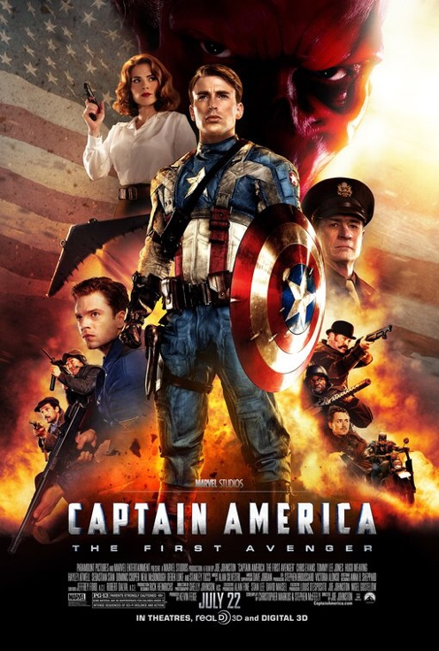

Bibliography

Eco, A (1976) A Theory Of Semiotics, Indiana
https://books.google.co.uk/books?hl=en&lr=&id=BoXO4ItsuaMC&oi=fnd&pg=PR7&dq=info:baLhFcWXrScJ:scholar.google.com/&ots=991Y2qKuho&sig=fd2qoKYn1h_vbcEQsAw3kEyehVI&redir_esc=y#v=onepage&q&f=false

Vickers et al (2012) Understanding visualisation: A formal approach using category theory and semiotics,
https://scholar.google.com/scholar?hl=en&as_sdt=0%2C5&q=a+theory+of+semiotics&oq=#d=gs_qabs&u=%23p%3DPfyKgc0_nI8J

Gabriel, B (2012) The Rugged Action Hero And His Sexy Love Interest: Gender In Popular Movie Posters,
https://scholar.google.co.uk/scholar?hl=en&as_sdt=0%2C5&as_vis=1&q=Portrayals+of+male+and+female+characters+in+movie+posters%2C&btnG=#d=gs_qabs&u=%23p%3DXF14laF0lM8J

Dehchenari, M(2012) Representation of women in action movie posters across three eras of Hollywood
https://scholar.google.co.uk/scholar?hl=en&as_sdt=0%2C5&as_vis=1&q=Portrayals+of+male+and+female+characters+in+movie+posters%2C&btnG=#d=gs_qabs&u=%23p%3Do-OE4EufaxEJ

Safanta (2018) Semiotics in superhero movies https://scholar.google.co.uk/scholar?start=10&q=semiotics+in+superhero+movies&hl=en&as_sdt=0,5&as_vis=1#d=gs_qabs&u=%23p%3DZSqscVh

Task Two: Manifesto

- Art is a privilege, it shouldn’t be taken for granted

- There does not always have to be a second layer/deeper meaning to ones art

- Creative privileges should not be used to spread hate and false narrative

- You do not need to explain your work to all that try to question it

- It doesn’t always have to be political

- Keep track of all your ideas, even the ones you don’t currently have faith in

- There is no incorrect way of producing your work if you enjoy what you are creating

- Use your work to shut down falsely perceived ideas on the world and the world of art

Keywords and images

- There does not always have to be a second layer/deeper meaning to ones art
Keyword: Decoration

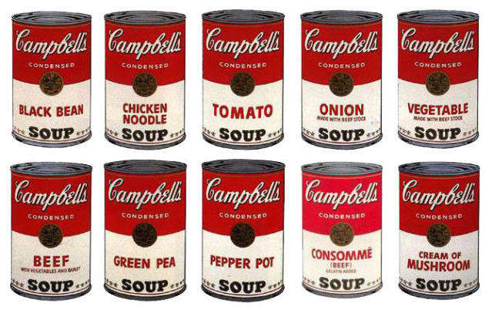

The most common question people will tend to ask when viewing someone else’s art is “But what does it mean?” Many believe that art that lacks a deeper meaning or narrative is just “decoration” An example of where this idealism has been applied is the famous image created by Andy Warhol, an illustration of Campbell’s soup. ‘The Campbell’s brand has no meaning apart from that of a heavily advertised consumer product’ (Schroeder 1997) People have spent a lot of time trying to figure out exactly why this type of media exists, but there doesn’t always need to be multiple layers to art, some things have to simply be taken at face value. It is purely up to the artist whether they decide to add a wide narrative to their work, there can always be a surface level personal meaning without creating a statement.

- It doesn’t always have to be political

Many artists may feel pressured to create art that is motivated by society and government ideology. Artists should be free to make political claims or talk about political issues, but the frequent claim that ‘all art is political’ is a false one. Mouffe (2001) claims that politics is visible in every piece of art, however, others such as Ranciere(2009) suggest that although themes of politics are usually visible within art, it is not always present. I accept that a large proportion of art is politically motivated and intended to offer perspective on social issues, however, I also believe that art should act as an escape from reality; free from politics or social injustice.

- Art is a privilege, it shouldn’t be taken for granted

An issue that all artists have had to face at some point is the realisation that not everyone believes art is a paid job. There have been many instances of companies and businesses showing complete unwilling to provide payment to those who were going to design artwork and graphics to help promote their company. When looking for an artist to create a design for them, businesses will often suggest the artist should reinvent their style of art to be more marketable (Joy Forever, 2014). This is disrespectful towards the artist and their work as it proposes their art should be changed to suit their needs which is a subtle form of exploitation.

Bibliography

Joy Forever, (2014), The Political Economy of Social Creativity, retrieved from: http://repozytorium.amu.edu.pl:8080/bitstream/10593/14154/1/Joy_Forever._The_Political_Economy_of_So.pdf#page=94

Rancière, J. (2009),Contemporary art and the politics of aesthetics, retrieved from: https://scholar.google.com/scholar?hl=en&as_sdt=0%2C5&q=can+art+be+non+political&btnG=#d=gs_qabs&u=%23p%3D4aPp_XYZ12cJ

Danto A. (2014) What Art Is http://www.collinbradford.org/courses/ARTS341/documents/DantoArtAndMeaning.pdf

Task 3: Reflective writing

A reflection of Bryan Tillman’s Creative Character Design for development of character personalities and originality.
When attempting to create an original character design, I must try and stay away from accidentally using too much inspiration from characters I have recently seen, picking out certain traits could work well, but try to steer away from similarity. Tillman (2019) talks about the very common concepts that tend to get used when creating characters for a storylines ‘there needs to be a hero, a villain, etc’ I need to try and stay away from these concepts, and if I were to use them I need to make sure they are original as possible, I could experiment with adding more moral greyness to the characters motives.

Tillman (2019). mentions the three main principles, known as archetypes, these represent the personalities and traits that humans tend to identify with, it is important that I research these so that I can give my character traits that make them relatable to those viewing them, it’ll also allow me to make them more realistic and more human. A backstory is another highly important aspect that I will have to look into in more depth, developing skills in this area makes my characters more interesting and makes it easier for me to give them a specific purpose and strengthen the character design, this also helps toward storytelling as it allows room to develop a future story and a universe/setting in which the character would live.

‘The character is always service to the story’ (Tillman 2019) as mentioned before, it is difficult to create a character without being influenced by what is around me, which is what will make producing an original idea so difficult and taxing, to accomplish a better idea of originality I should try not to look too much at other media forms when I am creating a character.Use of shape will also be important to me, this is something I already have a lot of background knowledge on, the kinds of of shapes you use when creating your character can add a lot of personality and gives a base idea of how someone would view the character, for example, rounder shapes would give a softer and more sympathetic appearance, while sharper shapes like triangles would be more likely used for a villain. However, these roles can be challenged which creates even more originality.

It is very important that I use references more often for my character designs, which is something I often forget to do. This is extremely useful as stated by Tillman (2019)
It is very important that I use references more often for my character designs, which is something I often forget to do. This is extremely useful as stated by Tillman (2019) as no one really knows exactly how to draw something unless they use a reference. In my own work, you can clearly see improvements where I referenced and this also helps to add a lot more personality to the character, posing is a very effective way to do this.

Bibliography

Tillman B. (2019) Creative Character Design 2e https://www.taylorfrancis.com/books/978135126168

Hart C. (2008) Cartooning: the ultimate character design book https://issuu.com/sixthandspring/docs/cartooning_ultcharacterdesign

Bancroft T (2004) Creating characters with personality https://books.google.co.uk/books/about/Creating_Characters_With_Personality.html?id=tiyD-oPMi_QC

