Animal bone assemblage from Medieval Monmouth

David Hinsull (2103522)

Abstract
This report examines bone assemblage from Monnow Street in Monmouth which had a total of three hundred fifteen bones. The bones contain the species, Bos, Ovis, Sus, Cervus, Equus and Lepus. It also explores the possibility of the assemblage being a part of a butchery or tannery.

Acknowledgments
Thank you to the people below for the help provided in my research and in my report:
Josh Rankin, Nikki Griffiths, Dave Lewis, Julia Jones, Sing Lee, Emily Hughes and Cleo Harris for research.
Ros Coard: for helping me with my research and understanding of the methodology.
Kayne Thomas: for helping us put the data we discovered into the spreadsheet as well as research.

Contents
Contents
Abstract 1
Acknowledgments 2
Contents 3
Intro 4
Methodology 7
Results and findings 9
Discussion 15
Conclusion 18
References 19
Appendices 22

Intro
The animal bone assemblage dates to the twelfth century and was uncovered on Monnow Street, which was a medieval burgage plot, an area of land that was rented to people from the lord (burgage plots, n.d.). The assemblage is not from one sealed context and the site had clear evidence of high activity. The aim of this report is to understand what was in the assemblage, how people interacted with animals during the medieval period and how it came to be. The objective is to understand how many different species are in our assemblage, the age of animals and the types of bones we found in our assemblage. This assemblage was originally part of a larger assemblage that was uncovered in 1994 and had over 20,000 bones (Medieval, n.d.). On the other hand, this is the only part of the assemblage which survives today.
Map of Monmouth dating to 1610
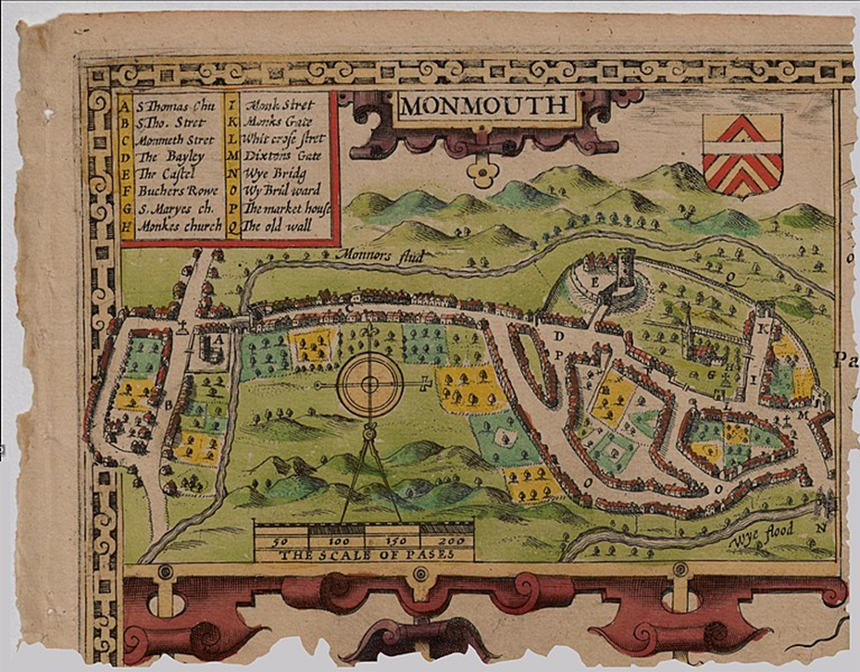
(Rotte, 1610)

Modern map to show where Monnow Street is.
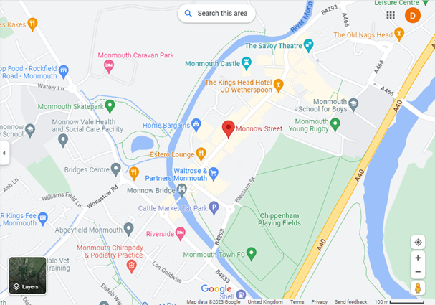

(Google Maps Monnow Street, n.d.)

Monmouth is a Welsh town situated where the river Monnow joins the river Wye and is on the Welsh border (Welcome to Monmouth, n.d.). Monmouth was first a roman settlement built around 43-55AD (Visit Monmouthshire, n.d.) Monmouth truly started to thrive during the medieval period, as after the Norman conquest Monmouth Castle was built in 1067 by William Fitz Osbern (Visit Monmouthshire, n.d.). In 1075 Monmouth had a Benedictine priory and by the mid-12th century, the Monnow Bridge was built on the Western end of the town to protect Monmouth (Visit Monmouthshire, n.d.). During the medieval period Monmouth was involved in a great deal of intermittent border warfare and skirmishes as it was part of the Welsh Marches (Visit Monmouthshire, n.d.). Monmouth’s population over time has been affected by periodic flooding of the rivers Monnow and Wye and the ravages of the Black Death (1346-1352) (Visit Monmouthshire, n.d.). However, by about 1450 the street plan of the centre of Monmouth had evolved and is still recognisable today (Visit Monmouthshire, n.d.). Monmouth had a burgage plots system which was common during the medieval period. The land would be rented to “freemen”; settlers who saw an opportunity (burgage plots, n.d.). This, therefore, removed the feudal system and the burgage plots became shops, inns and workshops which helped with the evolution of towns (burgage plots, n.d.).
The main animals found in our assemblage at Monmouth were Bos (Cow), Ovis (Sheep), Sus (Pig), Equus (Horse), Lupus (dog) and Cervus (deer). Cows were vital animals due to secondary materials such as milk, leather and work as well as the primary factor of meat (Holmes, Hamerow and Thomas, 2021). From the seventeenth century, cattle were important for arable production and agricultural tasks such as ploughing (Holmes, Hamerow and Thomas, 2021). All animals in the assemblage have secondary materials. On the other hand, horses were not killed often and were properly looked after due to their value (Orlando Attractions, 2019). Horses were used in transportation, war, agriculture and recreation (Orlando Attractions, 2019).

The reason archaeologists look at animal bones is to understand human interactions (such as human activity, society, diet and culture) with animals during the past, different species of animals during that period and their environments (O’Connor, 2004.) The knowledge we uncover from animals is discovered through several methodologies.

Methodology
The assemblage presents a variety of bone types such as the scapula, femur and tibia, then from the structural left and right of the animal and juvenile to adult. Therefore, it led people to be able to start inferring more about the assemblage. Elizabeth Reitz’s book “Zooarchaeology” has been very useful in helping determine the species of the different types of bone which helps people to understand the different types of animals in the assemblage as well as helping identify animals left and right sides (Elizabeth Jean Reitz and Wing, 1999).
Another method used is the Number of Identified Specimens (NISP). This is when every element in the assemblage is counted, for example, if there was a left and a right scapula from an Ovis it would have a NISP of two (O’Connor, 2004, page 55). On the other hand, the weakness of using this approach is that it is only valid if the number of elements is limited and does not describe the full assemblage just what is on the table (Halmhofer, S.,2018). For example, we counted the NISP of the Bos to be one hundred and thirty-six by laying all the Bos bones on the table in anatomical position as well as placing them into left and right and counting them.
Minimum number of individuals (MNI) looks at the fewest number of animals that can be represented in an assemblage (Lambacher et al., 2016). The issues with MNI are that mammals have a small amount of left and right symmetry, lack of clarity, rare taxa are overestimated and finally, there is a chance that the numbers will be inflated (O’Connor, 2004, page 60).
Another method used was epiphyseal fusion. Epiphyseal fusion looks at the proximal and distal ends to figure out if they are fused or not. This helps estimate the age of the animal because bones undergo fusion at different predicted times, for example, 12-15 months for the fusion of proximal epiphysis on cattle radius (O’Connor,2004, page 92). The issues with this methodology are that it does not work well with disarticulate fragments of bone; as fragmented bone may not fully replicate their population and the selection of fused specimens which may have been manufactured into bone tools can spoil the epiphyseal data (O’Connor, 2004. ; Brothwell, et.al , 2016).
All these methodologies have their own advantages and disadvantages however, when they are used together they help people understand and interpret bone assemblages to the best of our abilities. As using these methods together improves the reliability of the results.
Another type of methodology is the cut marks found on bones which can be categorized in many different ways. The way bone has been cut and helps zooarchaeolgists to interpret which tools were used (Eliopouloe, et.al., 2016). In the assemblage findings, people were able to categorize our cut marks into horizontal and vertical. The difference between a cut mark and a chop mark is that chop marks produce a v shape which is broader than a cut mark and the blade hit the bone at a perpendicular angle compared to a cut mark which are thin striations on the surface of the bone (Potts and Shipman, 1981).
Teeth were also examined in the assemblage, and how they link to different species, for example, Bos has molars and pre-molars (Wang et al., 2020). Some other animals also have canines and incisors or just one of these types of teeth (DK Find Out! n.d.). Teeth also enable people to calculate the age of the animal as well as the animal’s diet (Mainland et al., 2016).
Finally, people printed out the picture of animals in the assemblage and then counted the number of animal bones to see how many near whole animals we have to help calculate the MNI. For example, we calculated the MNI for Ovis by counting the femurs which gives an MNI of twelve.

Results and findings
The bones found in the assemblage had a good bone surface texture which shows they were protected by the soil. The species in the assemblage include Bos, Ovis, Sus, Equus and Lupus. The assemblage also includes antlers and teeth. The total number of bones in the assemblage is three hundred and fifteen. There are also signs of human interaction with the animals such as butchery marks and also gnaw marks from other animals. This chart shows that we have a large assemblage of domesticated animals, it also shows that the most bones we have are from cows with sixteen and then the second most common species is Ovis. See appendix one.

Chart showing predominant animals in assemblage.
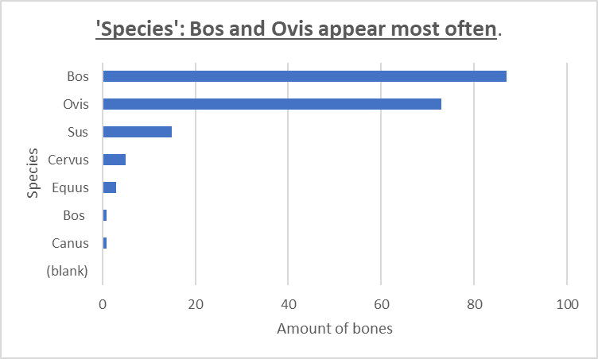

Species | NISP | %NISP | MNI | %MNI
Pig | 31 | 9.8 | 5 | 15.6
Dog | 1 | 0.3 | 1 | 3.1
Horse | 4 | 1.3 | 1 | 3.1
Sheep | 134 | 42.5 | 12(13) | 37.5(37.1)
Deer | 9 | 2.9 | 4(5) | 12.5(35.7)
Cattle | 136 | 43.2 | 9(10) | 28.1(10.6)
Total | 315 |  | 32(35)
Table 1 NISP, %NISP, MNI and %MNI for all species.
There are nineteen radii in the assemblage 47.4% of the radii are Bos, 47.4% are Ovis, and Cervus is 10.5%. This shows that there was clearly a high number of domesticated animals in the assemblage however, it is unusual to see Cervus.

Drawing of an Ovis Radius Juvenile
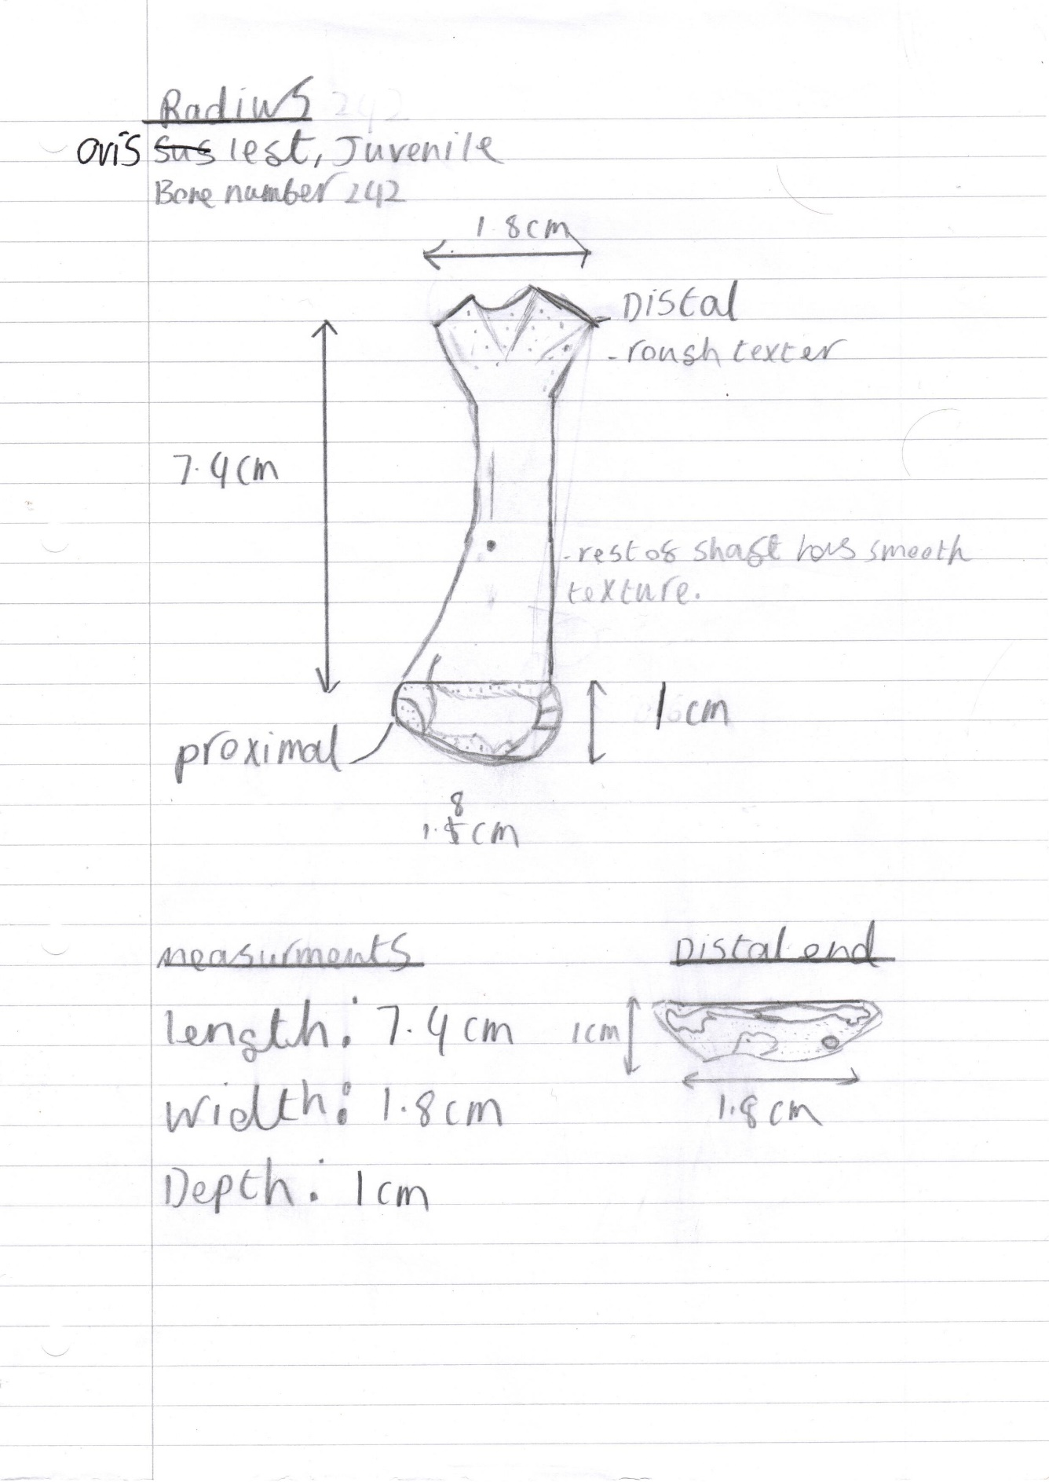
(Own image 17/3/23)

There is a total of twenty-four femurs in the assemblage. Overall, there are more right-sided femurs in comparison to left. Also, there were a total of eleven unfused femurs and four fused femurs which indicates a high number of young animals in the assemblage.
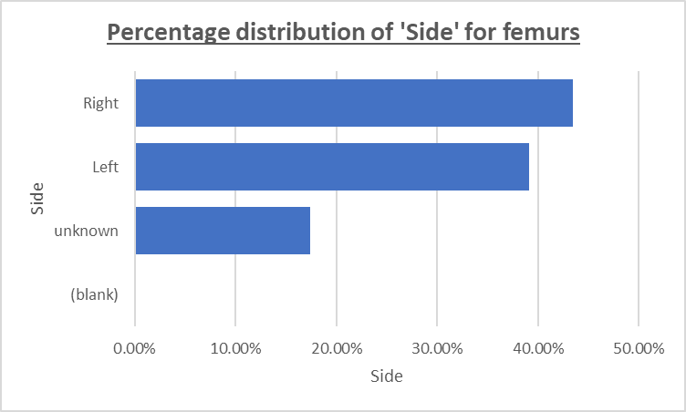
A total of twenty-eight humeri are in the assemblage. There are fifteen distal shafts, five shafts, five distal ends one complete humerus and one proximal end. 85% of the humeri show signs of butchery.
Table showing cut marks on the humeri
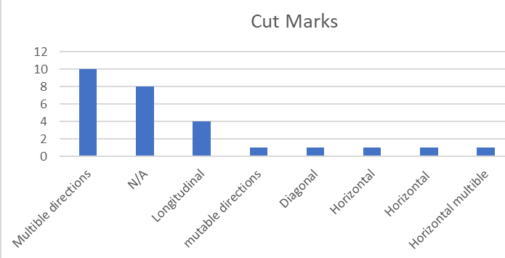

There are twenty-one scapulae all of which show butchery marks. Six out of the twenty-one scapula do not have possible gnaw marks or Canine marks. There are ten scapulae with possible canine teeth marks and five with rodent teeth marks in. At least four of the scapulae show signs of damage at the anterior and ten of the scapulae have broken medials. The medial is the longest of the borders of the scapula and is where muscles connect to the scapula (Valasek et al., 2010). The anterior is the costal surface of the scapula facing the rib cage (Cowan, Mudreac and Varacallo, 2020). Look at appendix two.
The total amount of tibia in the assemblage is thirty-four. Out of the thirty-four tibias, eighteen are fused, eleven are unfused and five are unknown. There are eighteen distal shafts, seven proximal shafts, five shafts, two proximal epiphysis plates and one distal epiphysis plate. Thirty of the tibias show marks of butchery.

Bone numbers of the tibia for left and right and if they have cut marks
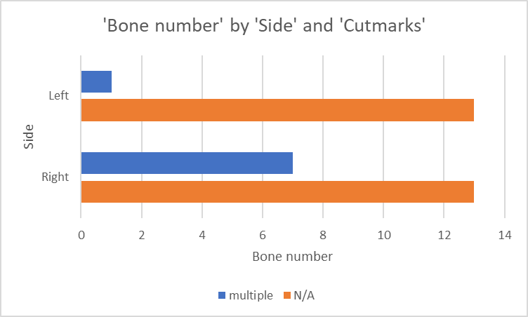
There are twenty-three metacarpals and fifteen metatarsals in the assemblage. There are also two Equus metatarsals. Bos had seventeen metacarpals or metatarsals, sus had four metacarpals or metatarsals and Ovis had fifteen metacarpals and metatarsals.
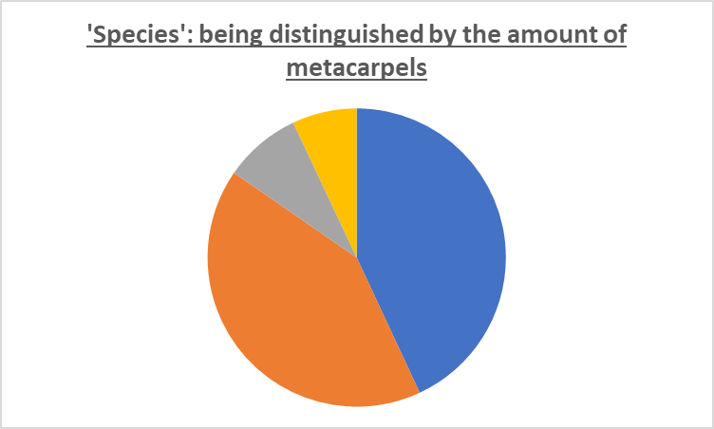
Key:
Blue= Bos 43%.
Orange= Ovis 42%.
Grey= Sus 8%.
Yellow= Equus 7%.
In total there are seventeen phalanges, of which nine are Bos and eight are Ovis phalanges. Out of the Bos phalanges, there are three right-sided phalanges and six left-sided phalanges.
Finally, in the assemblage, there are teeth, astagalus, phalanx and calcaneus. There is also a Canis molar which was unexpected in the assemblage.

Discussion
The good bone surface from the assemblage could be attributed to lime mortar seeping into the ground during the construction of buildings; as the assemblage is found in Monmouth city centre where lots of buildings would have been built. Evidence which supports this is, “hydrated lime and quicklime both delay the decay of the carcass during the first 6 months” (Schotsmans et al., 2012), which could explain why these bones survived. This is in contrast to much of Wales, which has highly acidic soil which meant that the bones would have a poor bone surface making it harder to distinguish cut marks on bones and also make bones harder to identify. Furthermore, the bones probably originate from the rubbish pits of the homes on Monnow street which look like they have quickly been covered up due to the lack of gnaw marks.
The reason this assemblage could have been part of a butchers is that they have a similar mark to a Roman animal scapula found on Elms Farm, Essex (Baker and Worley, 2019, page 54). Another interpretation is the v shape was caused by bone breakages and degradation. Also, changes in butchery techniques were not due to technological development and were due more to changes in technique (Grant, n.d., page 56). There is also evidence of cut and chop marks on the bone.
Example of V shape in the scapula
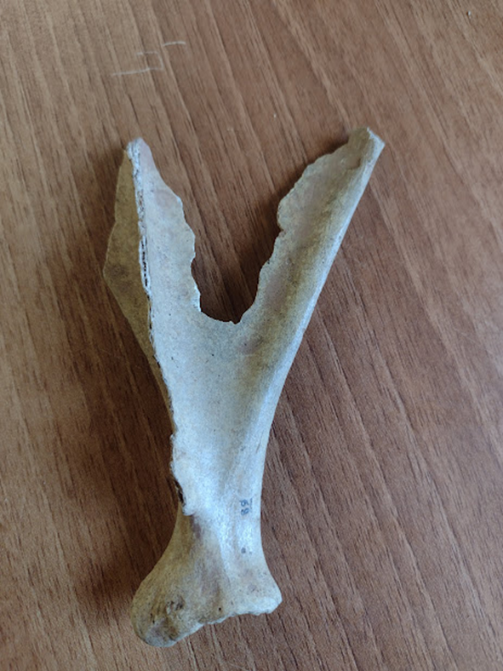
(Own image, 10/3/23)
During the medieval period, butchers were skilled professionals because it was believed food could cause disease if not treated correctly, for example, pork butchers in York had to get rid of their pork within twenty-four hours or fines would be incurred (Chadwick, n.d.). This, therefore, shows an ordered society which had strict rules on policing meat due to the fear of disease, for example, the smell of rotten food was link to miasma which was the belief that bad air could cause disease (Chadwick, n.d.).
The first butchers guild was set up in 1272 (Medieval Britain, 2022). During the medieval period, peasants would eat pork because pigs were self-sufficient in gathering food and needed little space. They would also sometimes be able to have some cheap cuts from the butcher compared to the wealthy who were able to eat pork, lamb and mutton, beef and chicken (Marilee, 2022; Medieval Britain, 2022). The reason there may not be any chicken in the assemblage is due to the bones already dissolving due to their size compared to a cow or sheep.
Another interpretation that this butcher is that they was only killing old and young animals. Evidence of this is that we have two old key domestic animals in our assemblage and a lot of juveniles. This suggests that this is a high-end butcher because young animal meat was quite expensive. This, therefore, implies that the meat could have gone to Monmouth castle because the Benedictine priory was prohibited from eating meat from a four-legged animal (Kelly, 2019). The reason why there are more right sides of bones compared to left could be because the left was considered with the Devil and evil spirits (Merriam-webster.com, 2019).
One issue with the interpretation being a butcher’s site is that there are no remains of small animals like hares, birds, or fish in our assemblage. This could be because these animals’ carcasses were sold completely or because their archaeological remains did not survive. Also, lots of chickens were owned by peasants and therefore did not need to go through the butchers for example, in medieval England more than four-fifths of peasants owned chickens around 1300 (Dyer, 2020).
Furthermore, for butchers, it is unexpected to find the possibility of a dog, deer and horse in the archaeological assemblage which suggests that it may not have been a butcher itself however, the animals had gone through the butchery practice. In addition the deer was a symbol of Christ and therefore had strict rules on who was allowed to hunt them; deer hunting was considered a sport and only nobility and royalty could hunt them (Swinfen, 2017).
Some of the bones were used as a secondary product, for example, bone 183 has just the shaft and has had a longitudinal cut which could suggest that it was going to be made into bone pins. This was common in the medieval period as bone could make many items such as game pieces, cutlery and handles (Luik, Piličiauskienė and Blaževičius, 2019). Further evidence of bone being worked on in Monnow street is the excavation of 61-63 Monnow Street (1988), which showed two complete bone combs in Number 61 (archwilio.org.uk, n.d.). There is a possibility they dried the bone out before working on it because it is stronger, stiffer and shows little deformation compared to wet bone (Samuel et al., 2016). There is further evidence that the horns could also have been used as a secondary product as there are chop marks in the horns and the horns have been removed from the skull. Horns were used to make tool handles and utensils for eating and drinking (The Worshipful Company of Horners, n.d.).
On the other hand, there is also evidence it could be a tannery because the horn cores and feet were present in the assemblage. Evidence of this is that we have twelve horn cores and nine Bos phalanges. This is supported because butchers would leave the horn and hooves attached to the skin (Medieval, 2017). Further evidence to support this theory comes from, “A Late Medieval Tannery at Tickhill, South Yorkshire” which shows that the tannery at Tickhill also had a large assemblage of cattle which is similar to this assemblage which has MNI percentage for cattle to be 28.1% (Burgess and Andrews, 2017). Tanneries occasionally processed the carcasses of old horses that could explain why a horse is in our assemblage (Burgess and Andrews, 2017). Another reason it possibly could have been a tannery is that Monnow street is situated close to the water from the River Monnow. This is supported by the article which argues that tanneries were located on the outer boundaries of settlements and close to water (Burgess and Andrews, 2017).

Picture of a horn in the assemblage which has clearly been worked on
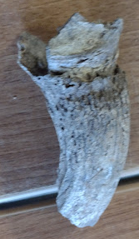
(Own image/ 2023)
We can also presume that the assemblage was not during a time of cattle panzootic pandemic because both young and old animals were slaughtered and show no sign of disease. Timothy Newfield states “England and Wales have accounts which illuminate the European cattle panzootic decease from Europe in c.1315” (Newfield, n.d.). If it was during the time of panzootic disease there would be more of an array in the age of cattle at death.

Conclusion
To conclude, the Monnow Street assemblage shows a high percentage of domesticated animals such as Bos (28.1% MNI and 43.2% NISP) and Ovis (37.5% MNI and 42.5% NISP). The assemblage also displays a high percentage of butchery marks such as cut and chop marks. This, therefore, led to the interpretation that the site was either part of a butchers practice or tannery however, after long consideration it can be argued that the assemblage would more likely belong as part of a tannery due to the assemblage containing horns, toes and horse bones and that the bones had clearly been through the butchery process beforehand. This would also explain why there are no small animals such as fish or birds represented in the assemblage, as they would be sold with a full skeletal system in the medieval period compared to today. On the other hand, this does not clarify why there was Canis in the assemblage. To summarise, the Monnow street assemblage in Monmouth has a high interpretation to have been part of a tannery due to the high level of domesticates and the fact that horns and toes were discovered in the assemblage.

References
archwilio.org.uk. (n.d.). GGAT09864g. [online] Available at: https://archwilio.org.uk/her/chi3/report/page.php?watprn=GGAT09864g&dbname=ggat&tbname=core&sessid=CHI38618vtq&queryid=Q984837001678791078 [Accessed 14 Mar. 2023].
Britannica (2019). Tooth | anatomy. In: Encyclopædia Britannica. [online] Available at: https://www.britannica.com/science/tooth-anatomy.
Brothwell, D.R., Thomas, K.D. and Clutton-Brock, J. (2016). Research Problems in Zooarchaeology. Routledge.
burgage plots. (n.d.). Home. [online] Available at: https://www.burgageplots.info/.
Burgess, A. and Andrews, P. (2017). A Late Medieval Tannery at Tickhill, South Yorkshire. Yorkshire Archaeological Journal, 89(1), pp.99–113.
Chadwick, E. (n.d.). Something Rotten round here: The Myth About The Medieval Spicing of tainted Meat @ Elizabeth Chadwick. [online] Elizabeth Chadwick. Available at: https://elizabethchadwick.com/blog/the-myth-about-the-medieval-spicing-of-rotten-meat/ [Accessed 8 Mar. 2023].
Cowan, P.T., Mudreac, A. and Varacallo, M. (2020). Anatomy, Back, Scapula. [online] PubMed. Available at: https://www.ncbi.nlm.nih.gov/books/NBK531475/.
DK Find Out! (n.d.). DK Find Out! | Fun Facts for Kids on Animals, Earth, History and more! [online] Available at: https://www.dkfindout.com/uk/animals-and-nature/food-chains/types-teeth/.
Donkin, R.A. (1962). Cattle on the Estates of Medieval Cistercian Monasteries in England and Wales. The Economic History Review, 15(1), p.31.
Dyer, C. (2020). Peasants and poultry in England, 1250-1540. Quaternary International, 543, pp.113–118.
Elizabeth Jean Reitz and Wing, E.S. (1999). Zooarchaeology. S.L.: Cambridge.
Fulton, H. (2012). Urban culture in medieval Wales. Cardiff: University of Wales Press.
Ghui, Melodi & Eliopoulos, Constantine & Borrini, Matteo. (2016). A Methodology in Differentiating Between Knives from Cut Marks on Bone. 10.13140/RG.2.1.3474.9208.
Google Maps Monnow Street. (n.d.). [Online Image] Google Maps. Available at: https://www.google.com/maps/place/Monnow+St,+Monmouth/@51.8102055,-2.7235719,15z/data=!4m10!1m2!2m1!1smonnow+street!3m6!1s0x4871b8055ed9d9c3:0xe6b9525178d5f32!8m2!3d51.8106135!4d-2.7179178!15sCg1tb25ub3cgc3RyZWV0kgEFcm91dGXgAQA!16s%2Fm%2F0j9kk_0 [Accessed 18 Mar. 2023].
Grant, A. (n.d.). SOME OBSERVATIONS ON BUTCHERY IN ENGLAND FROM THE IRON AGE TO THE MEDIEVAL PERIOD. [online] Available at: https://sciencepress.mnhn.fr/sites/default/files/articles/pdf/az1987_ns1_a9.pdf [Accessed 8 Mar. 2023].
Halmhofer, S. (2018). Knowledge Feature – Determining MNI (Minimum Number of Individuals). [online] Bones, Stones, and Books. Available at: https://bonesstonesandbooks.com/2018/03/14/knowledge-feature-determining-mni-minimum-number-of-individuals/ [Accessed 14 Feb. 2023].
Holmes, M., Hamerow, H. and Thomas, R. (2021). Close Companions? A Zooarchaeological Study of the Human–Cattle Relationship in Medieval England. Animals, 11(4), p.1174.
Kelly, L. (2019). A Medieval Monk’s Menu | Historic Environment Scotland | HES. [online] Historic Environment Scotland Blog. Available at: https://blog.historicenvironment.scot/2019/05/monks-menu/.
Luik, H., Piličiauskienė, G. and Blaževičius, P. (2019). LATE MEDIEVAL AND EARLY MODERN BONE AND ANTLER WORKING IN THE VILNIUS CASTLE COMPLEX. CPAG, [online] 29, pp.187–201. Available at: https://revistaseug.ugr.es/index.php/cpag/article/download/9772/9443/ [Accessed 13 Mar. 2023].
Mainland, I., Towers, J., Ewens, V., Davis, G., Montgomery, J., Batey, C., Card, N. and Downes, J. (2016). Toiling with teeth: An integrated dental analysis of sheep and cattle dentition in Iron Age and Viking–Late Norse Orkney. Journal of Archaeological Science: Reports, 6, pp.837–855.
Marilee, H. (2022). Medieval Food and Drink - English History. [online] English History. Available at: https://englishhistory.net/middle-ages/food-and-drink/#:~:text=Nobility%20and%20other%20wealthy%20individuals [Accessed 10 Mar. 2023].
Medieval. (2017). Medieval: Leather tanning - Medieval to Edwardian. [online] Available at: https://mittelzeit.blogspot.com/2017/06/leather-tanning-medieval-to-edwardian.html#:~:text=Wherever%20the%20tanner%20discarded%20horn [Accessed 14 Mar. 2023].
Medieval Britain. (2022). Medieval Occupations and Jobs: Butcher. History of Butchers, Types of Meat. [online] Available at: https://medievalbritain.com/type/medieval-life/occupations/medieval-butcher/.
Medieval. (n.d.). Available at: https://www.archaeoleg.org.uk/pdf/med/KEY%20SITES%20SE%20WALES%20MEDIEVAL.pdf [Accessed 8 Mar. 2023].
Merriam-webster.com. (2019). The Left Hand of (Supposed) Darkness. [online] Available at: https://www.merriam-webster.com/words-at-play/sinister-left-dexter-right-history.
Newfield, T. (n.d.). A cattle panzootic in early fourteenth-century Europe *. [online] Available at: https://www.bahs.org.uk/AGHR/ARTICLES/57_201Newfield.pdf [Accessed 23 Feb. 2023].
Nicole Lambacher, Karina Gerdau-Radonic, Emma Bonthorne, Francisco José Valle de Tarazaga Montero, Evaluating three methods to estimate the number of individuals from a commingled context,Journal of Archaeological Science: Reports,Volume 10,2016,Pages 674-683,ISSN 2352-409X,https://doi.org/10.1016/j.jasrep.2016.07.008.(https://www.sciencedirect.com/science/article/pii/S2352409X16303650)
Orlando Attractions. (2019). Magnificent Horses at Medieval Times Orlando Attractions. [online] Available at: https://www.orlandoattractions.com/the-horses-of-medieval-times/#:~:text=In%20the%20serene%20setting%2C%20the [Accessed 2 Mar. 2023].
Polydora [Vnv] Baker and Worley, F. (2019). Animal bones and archaeology: recovery to archive. [online] Swindon: Historic England. Available at: https://historicengland.org.uk/images-books/publications/animal-bones-and-archaeology/animal-bones-archaeology-handbook/ [Accessed 7 Mar. 2023].
Potts, R. and Shipman, P. (1981). Cutmarks made by stone tools on bones from Olduvai Gorge, Tanzania. Nature, [online] 291(5816), pp.577–580. Available at: https://www.nature.com/articles/291577a0 [Accessed 16 May 2019].
Rotte, J. ed., (1610). File: Old map of Monmouth, Wales.jpg. [Online Image] Wikipedia. Available at: https://en.wikipedia.org/wiki/File:Old_map_of_Monmouth,_Wales.jpg [Accessed 3 Mar. 2023].
Samuel, J., Park, J.-S., Almer, J. and Wang, X. (2016). Effect of water on nanomechanics of bone is different between tension and compression. Journal of the Mechanical Behavior of Biomedical Materials, [online] 57, pp.128–138. Available at: https://www.sciencedirect.com/science/article/abs/pii/S1751616115004634 [Accessed 3 Dec. 2021].
Schotsmans, E.M.J., Denton, J., Dekeirsschieter, J., Ivaneanu, T., Leentjes, S., Janaway, R.C. and Wilson, A.S. (2012). Effects of hydrated lime and quicklime on the decay of buried human remains using pig cadavers as human body analogues. Forensic Science International, 217(1-3), pp.50–59.
Swinfen, A. (2017). The History Girls: Medieval Hunting - by Ann Swinfen. [online] The History Girls. Available at: http://the-history-girls.blogspot.com/2017/02/medieval-hunting-by-ann-swinfen.html [Accessed 18 Mar. 2023].
The Worshipful Company of Horners. (n.d.). The Craft of the Horner. [online] Available at: https://www.horners.org.uk/the-company/the-craft/#:~:text=The%20craft%20of%20the%20Horner%20was%20essential%20to%20medieval%20communities [Accessed 10 Mar. 2023].
Valasek, P., Theis, S., Krejci, E., Grim, M., Maina, F., Shwartz, Y., Otto, A., Huang, R. and Patel, K. (2010). Somitic origin of the medial border of the mammalian scapula and its homology to the avian scapula blade. Journal of Anatomy, 216(4), pp.482–488.
Visit Monmouthshire. (n.d.). Brief history of Monmouthshire. [online] Available at: https://www.visitmonmouthshire.com/information/events-management/history [Accessed 24 Feb. 2023].
Visit Monmouthshire. (n.d.). Monmouth Castle (Cadw) - Castle in Monmouth, Monmouth. [online] Available at: https://www.visitmonmouthshire.com/things-to-do/monmouth-castle-cadw-p1503151 [Accessed 26 Feb. 2023].
Wang, J., Cheng, C., Chen, Y., Yang, D., Zheng, J. and Zhou, Z. (2020). Transfer of functional structures from multiple bovine teeth to a multilevel grinding head via a biomimetic approach. Tribology International, [online] 152, p.106564. Available at: https://www.sciencedirect.com/science/article/pii/S0301679X20303959 [Accessed 3 Mar. 2023].
Welcome to Monmouth. (n.d.). Welcome to Monmouth. [online] Available at: https://www.welcometomonmouth.co.uk/ [Accessed 26 Feb. 2023].
www.monmouth.gov.uk. (n.d.). Home - Monmouth Town Council. [online] Available at: https://www.monmouth.gov.uk/ [Accessed 24 Feb. 2023].

Appendices
Appendix one

Appendix two
Bone Number | Species | Bone | Side | Segment | Age | Butchered | Description
431 | Sus | Scapula | Right | Fragmented | Unknown | Yes | Horizontal and longitudinal cut marks
128 | Sus | Scapula | Left | Fragmented | Fused | Yes | Horizontal chop marks and longitudinal cut marks
89 | Sus | Scapula | Left | Fragmented | Fused | Yes | Longitudinal cut marks and chop marks
53 | Ovis | Scapula | Left | Fragmented | Fused | Yes | Longitudinal+ horizontal chop marks and longitudinal cut marks
113 | Ovis | Scapula | Left | Fragmented | Fused | Yes | Horizontal chop marks and longitudinal cut marks
42 | Ovis | Scapula | Left | Fragmented | Fused | Yes | Horizontal chop marks and longitudinal cut marks.
109 | Bos | Scapula | Right | Fragmented | Fused | Yes | Longitudinal chop marks and horizontal and longitudinal cut marks.
126 | Bos | Scapula | Right | Fragmented | Fused | Yes | Horizontal chop marks and cut marks. Also, a possible breakage.
88 | Bos | Scapula | Right | Fragmented | Fused | Yes | Horizontal breakage and damage to the anterior. 2 clear chop marks and longitudinal cut marks.
423 | Bos | Scapula | Right | Fragmented | Fused | Yes | Only the anterior remains and the rest have been chopped off. At least 2 chop marks.
43 | Bos | Scapula | Left | Fragmented | Fused | Yes | Damage to the anterior no medial horizontal attempted chop mark. Multiple chops.
103 | Bos | Scapula | Left | Fragmented | Fused | Yes | Slight damage to anterior. No meidal. Horizontal cut. Several attempted chops mark.
125 | Bos | Scapula | Left | Fragmented | Fused | Yes | Chop at the anterior, no medial. 2 distinct chop marks and longitudinal cut marks.
50 | Bos | Scapula | Right | Fragmented | Fused | Yes | Longitudinal cut marks and medial removed.
130 | Ovis | Scapula | Right | Proximal fragment | Fused | Yes | Longitudinal cut marks, removed medial
432 | Ovis | Scapula | Right | Fragmented | Fused | Yes | Medial missing, longitudinal cut marks and at least 1 chop mark.
102 | Ovis | Scapula | Right | Fragmented | Fused | Yes | Removal of the anterior and longitudinal cut marks.
57 | Ovis | Scapula | Right | Fragmented | Fused | Yes | Broken meidal and longitudinal cut marks.
127 | Ovis | Scapula |  | Fragmented | Fused | Yes | Only anterior is intact with the distal end and had 2 chop marks.
117 | Ovis | Scapula |  | Fragmented | Unknown | Yes | Distal and proximal end removed and longitudinal cut marks.

