

BMSW4006 Managing Enterprise in the 21st Century

Business name - Pharmacy Health First


Table of Contents
Introduction 3
Business description and history 4
Aim and objectives 4
Mission and value 4
Business structure 4
Product or service description 5
Market analysis and trend analysis 6
SWOT analysis 6
PESTLE analysis 7
Operations 8
Technology plan 8
Management of organisation 9
Development, milestone, and exit plan 10
Financial data 10
Conclusion 12
References 13

Introduction
Medical shops or chemists may refer to pharmacies because they sell or create pharmaceuticals. Pharmacists play a crucial role in helping patients feel better and recover faster in their recovery efforts. Patients and their healthcare teams benefit greatly from the expertise of pharmacists (Baker, Baker and Dworkin, 2017). The pharmaceutical sector in the United Kingdom is one of the most profitable in the nation in terms of investment to output. In the United Kingdom, owning a pharmaceutical company is both financially and emotionally gratifying. This organisation is the only place to go if want to provide a reliable service. "Pharmacy Health First" will be the subject of this report, along with all of the parts and analyses that will be needed to get the company up and running.
Business logo –

Business description and history
As a consequence, pharmacy has emerged as a critical component of our everyday lives. In the United Kingdom alone, over half of the population of 300 million individuals uses at least one prescription pharmaceutical every day, resulting in sales of $250 billion each year in the country. It is not included in this total the number of over-the-counter medications and health aids that individuals use (Smith, Wertheimer and Fincham, 2013). It was about 2400 BC that a clay tablet was unearthed in Mesopotamia (modern-day Iraq) that contained the world's first documented medical prescriptions. In this Sumerian cuneiform record, poultices, salves, and washes are all documented in detail. Some of the ingredients in the wine or milk were items such as myrrh and bat droppings, as well as turtle shell powder and other natural materials such as river silt, snake skins, and "cow's stomach hair."
Pharmacology may trace its roots back to antiquity. Using the juice from a succulent leaf to treat wounds has been practised for generations, and it continues to this day. Based on a predefined' medicines were made by Hygeia, a goddess in Greek mythology. Might say she was his chemist or his apothecary (Schumock and Stubbings, 2013).

Aim and objectives
This business plan is intended to assist in the development of a self-owned corporation that will provide services to the general public. It has been established that Pharmacy Health First will provide people with the right and adequate pharmaceuticals at a fair and consistent cost of medications.

Mission and value
It is the only mission of a healthcare organisation to help people achieve more, feel better, and live longer lives via the use of science. Your job has the potential to assist millions of people every day, and your work has the potential to help them. Pharmacy Health First, as a pharmacy, adheres to its basic principles, which include respecting people, being honest, and working in a collaborative environment with others (Klandt, 2012). Pharmacy Health First pharmacists are able to improve the lives of their patients while also providing them with high-quality goods because of their dedication.

Business structure
As a consequence, Pharmacy Health First's plans for the United Kingdom need a detailed evaluation of the pharmacy company they want to build. Pharmacy Health First's goal will be tough to achieve if this isn't done. All terms and conditions shall be adhered to in line with the sole proprietorship structure of Pharmacy Health First, which is a start-up company (Kenny and Meadowcroft, 2009).
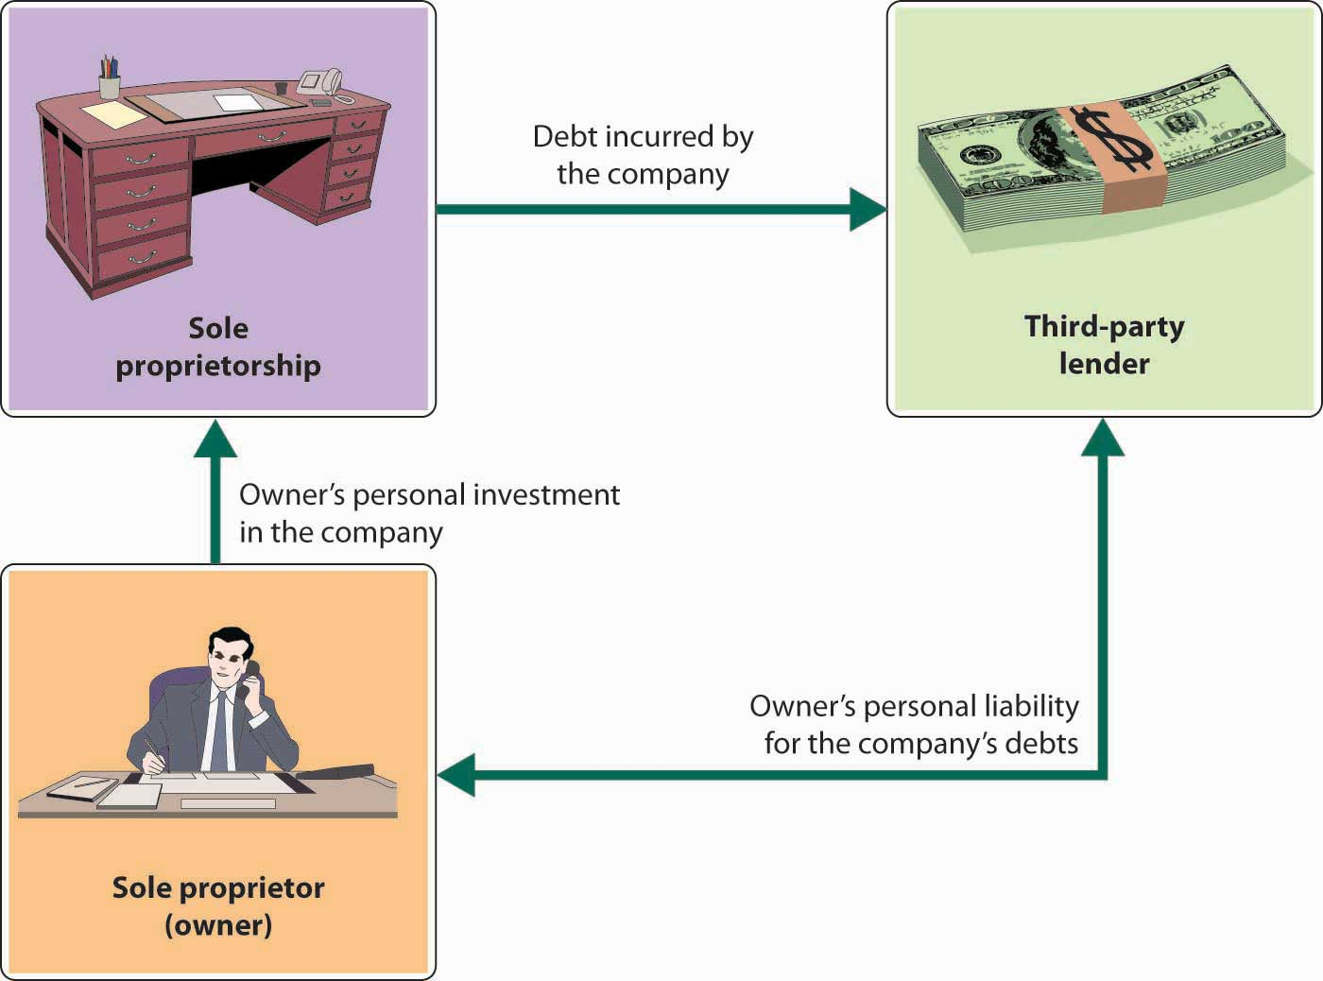

Product or service description
Pharmacy Health First will offer a wide range of services in addition to providing consulting services to its customers. The Pharmacy Health First team will work in close collaboration with the patient's medical practitioner to ensure that each patient's specific needs are met. Here is a list of the services and products that will be available at the Pharmacy Health First location:
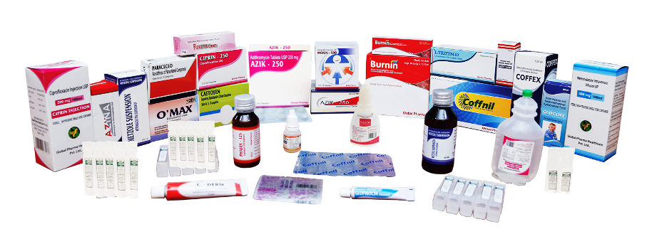
Services –
- Medical administration and help the patients’ consulting services are available
- Diabetes testing
- Blood grouping and CBC testing
- Blood pressure measuring
- Drugs may be prescribed with greater precision using pharmacogenomics
- Personal medicine that is no longer needed is disposed of away

Products –
Prescription Drugs - A vast variety of drugs, many of which need a doctor's prescription, will be available at Pharmacy Health First.
Non-prescription Drugs – A number of prescription-free medications will also be available at Pharmacy Health First. Pharmacy shelves are filled with painkillers, antihistamines, and anti-allergy medications, to name a few.
Toiletries - In addition, Pharmacy Health First often carries a variety of toiletries. If you're looking for anything like mouthwash or sunscreen or conditioner or shampoo, that individuals are likely to find it at their local drugstore (Haynes, 2008).
Vitamins and Minerals - Pharmacy Health First will have a wide range of supplements in addition to vitamins and minerals. Because they don't need a prescription to use, non-prescription drugs are comparable to vitamins and minerals in that they affect the body.

Market analysis and trend analysis
Only two major firms remain in the retail pharmacy market in the United Kingdom: Alliance Boots and Lloyds pharmacy. More than a third of the market would be controlled by these two corporations in 2006. For over-the-counter retail pharmacy sales alone, the four major supermarkets have a 9.6 per cent market share, compared to almost half of the market in health and beauty, where grocers have nearly half of the market.
It is essential for community pharmacies to establish efficient marketing strategies based on current data about consumer behaviour in order to attract consumers and build client loyalty (Hassanien and Dale, 2011). Walk-in clients and postal customers account for the majority of Pharmacy Health First's business.

SWOT analysis
Strength
- Capacity to deliver services to people of various socioeconomic backgrounds
- Customers place a high value on trust and dependability.
- Problem solution with high accuracy in medicine administration
- Communication abilities that are second to none
- The ability to comprehend the challenges and requirements of consumers

Weakness
- Having no business plan is a big problem
- There is very little training provided for employees
- An organizational structure that is lacking ineffectiveness
- Because there is a lack of suitable tools and equipment
Opportunities
- Obtaining access to the information of the Pharmaceutical Society of the United Kingdom
- Customers' recommendations to other customers
- Accessibility for a variety of various types of persons
Threats
- Currency devaluation
- Unsatisfactory living standards
- Competitors

PESTLE analysis
Political factors
National health plans are favoured by the pharmaceutical industry as a means of expanding and strengthening it (Gatwood, Hohmeier, Farr and Eckel, 2018). Almost wherever you go, the pharmaceutical industry is heavily regulated. The pharmaceutical industry is governed by several governmental agencies and pieces of drug-related legislation.
Economic factors
The pharmaceutical market develops as the economy expands. The fastest-growing markets, such as the UK, help sales reps increase their sales volume. Technological breakthroughs have the potential to affect economic dynamics. People without jobs are thus becoming less numerous.
Social factors
Health care system changes, population growth rates, and other variables are all taken into consideration. A company's products and operations may be influenced by societal concerns. As the population becomes older, so does the amount of medical care that is required (Fair, 2009). So too increases the need for healthcare as the population expands.
Technological factors
Technology will only continue to improve and become more user-friendly in the future. It is now possible for pharmacists to totally automate and cross-reference a patient's prescription refill history with other prescription information, enabling them to better monitor and manage a patient's overall health and safety.
Legal factors
The pharmaceutical business sets the regulations for advertising drugs. Representatives must pass all of the medical knowledge tests that are administered throughout the recruitment procedure (De Silva, 2011). In certain countries, the government requires that the advertising agency verify that the company's promotional claim is based on accurate information.
Environmental factors
Weather, climate, and societal pressure to take a more socially responsible approach to business are all examples of elements that have an effect on the environment as a whole. The general public wants firms to make a bigger social impact under the cover of "Corporate Social Responsibility" (CSR). It's not uncommon for members of society to mull about potential solutions to today's pressing problems.

Operations
- Vaccines may be used to prevent a wide variety of illnesses and disorders, including the flu virus, hepatitis, smallpox, and more (Cobaugh, 2021).
- Provide assistance and encouragement to patients in-store as well as over the phone.
- The use of electronic health records may improve outcomes by making it easier to coordinate healthcare services.

Technology plan
Pharmacy software may be a game-changer for independent pharmacists who seek to enhance their bottom line by making business adjustments. Pharmacists may use pharmacy management software to get insight into and speed up the management of their pharmacy's drug inventory, as well as monitor and optimise the supply of pharmaceutical goods.

Inventory management
Pharmacies need to be able to correctly manage inventory levels in order to keep expenses under control and operate at peak efficiency. Real-time inventory tracking, order creation, electronic transmission, and inventory receiving are all desirable features to include in this capability (BUTLER, 2016).
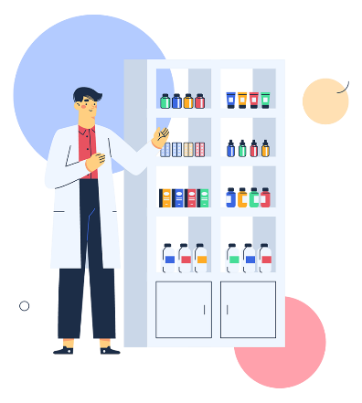
Workflow systems
Due to the growing usage of automated dispensing systems in pharmacies, it is vital that robotic systems be smoothly integrated into the operations process.

Management of organisation
The organisational chart governs the flow of information and communication inside a company. Using hierarchical frameworks to represent managerial knowledge, we can see how information is passed down to employees in various departments. Many pieces of evidence continue to point to horizontal communication as the default mode of operation. It occurs between individuals and departments rather than between top management and employees in most modern firms, to put it another way (Bolster, 2011). An organisation chart helps a company in identifying its needs, matching employees to available jobs, assessing its people, and developing a human resource budget that is focused on human resources, among other tasks.

Development, milestone, and exit plan
An extensive supply chain network is maintained by the firm to avoid becoming reliant on its present suppliers in the future. They will be able to access the resources they need swiftly and effectively in the event of an emergency or unforeseen demand for their services (Baker, Baker and Dworkin, 2017). Websites are used as a backup plan for firms whose physical facilities have a poor image for the company. Prior to a crisis situation, pharmaceutical companies have received requests from the UK government for emergency pharmaceuticals.

Financial data
Profit and loss statement for Pharmacy Health First for consecutive 3 years
Pharmacy Health First
Profit and loss statement
For 3 consecutive years
Particulars | 21-22 | 22-23 | 23-24
Sales | 90,000,000 | 95,000,000 | 100,000,000
Cost of goods sold | 55,000,000 | 70,000,000 | 75,000,000
Gross margin | 35000000 | 25000000 | 25000000
Operating expenses
Selling & marketing expense | 4,000,000 | 5,600,000 | 7,500,000
Administrative expense | 10,000,000 | 12,000,000 | 15,000,000
Total Operating expense | 14000000 | 17600000 | 22500000
Net profit | 21000000 | 7400000 | 2500000
Tax | 4200000 | 1480000 | 500000
Net profit after tax | 16800000 | 5920000 | 2000000

The profit and loss statement for Pharmacy Health First demonstrates that the company's first year was a financial success. The expected net profit after tax for the fiscal year 2021-2022 is 16800000 dollars. Profits at Pharmacy Health First are likely to increase consistently over the next few years.
Balance Sheet for Pharmacy Health First for consecutive 3 years
Pharmacy Health First
Balance sheet
For 3 consecutive years
Particulars | 2021-2022 | 2022-2023 | 2023-2024
Assets
Current assets
Cash | 90000000 | 110000000 | 125000000
Accounts receivables | 0 | 90000000 | 110000000
Inventory | 100,000,000 | 228,000,000 | 249,800,000
Total current assets | 190000000 | 428000000 | 484800000
Property, plant and equipment
Land and building | 200,000,000 | 150,000,000 | 140,000,000
Equipment | 350,000,000 | 120,000,000 | 130,000,000
Total property, plant and equipment | 550,000,000 | 270,000,000 | 270,000,000
Depreciation | 110000000 | 54000000 | 54000000
Net property, plant and equipment | 440,000,000 | 216,000,000 | 216,000,000
Total assets | 630000000 | 644000000 | 700800000
Liabilities and shareholder's equity
Current liabilities
Accounts payable | 39600000 | 48000000 | 52000000
Accrued expenses | 140,000,000 | 100,000,000 | 110,000,000
Total current liabilities | 179600000 | 148000000 | 162000000
Owner's equity | 300,000,000 | 500,000,000 | 450,000,000
Retained earnings | 110,000,000 | 50,000,000 | 80,000,000
Total equity capital | 410000000 | 550000000 | 530000000
Total liability, and owner’s equity | 589600000 | 698000000 | 692000000

Cash flow statement for Pharmacy Health First for consecutive 3 years
Pharmacy Health First
Cash flow
For 3 consecutive years
Particulars | 21-22 | 22-23 | 23-24
Cash inflow
Beginning cash balance | 0 | 48000000 | 92500000
Sales | 90,000,000 | 95,000,000 | 100,000,000
Cash collection | 45000000 | 47500000 | 50000000
Cash credit collection | 0 | 45000000 | 47500000
Total cash inflow | 135000000 | 235500000 | 290000000
Cash outflow
COGS | 55,000,000 | 70,000,000 | 75,000,000
Payment (cash) | 22000000 | 28000000 | 30000000
Payment (credit) | 0 | 33000000 | 42000000
Administrative O/H | 10,000,000 | 12,000,000 | 15,000,000
Total cash outflow | 87000000 | 143000000 | 162000000
Ending cash balance | 48000000 | 92500000 | 128000000

Conclusion
According to the study, it is also one of the most effective ways to learn about your competitors in the UK sector. Understanding the marketing criteria and approach utilised by Pharmacy Health First's rivals may help Pharmacy Health First build and implement a marketing strategy and plan that will help the company grow.

References
Baker, J., Baker, R. and Dworkin, N., 2017. Health Care Finance. Sudbury: Jones & Bartlett Learning, LLC.
Bolster, C., 2011. Exploring health care careers.
BUTLER, D., 2016. BUSINESS DEVELOPMENT. [Place of publication not identified]: ROUTLEDGE.
Cobaugh, D., 2021. The Pharmacy Forecast report: Planning or preparedness? American Journal of Health-System Pharmacy,
De Silva, T., 2011. Integrating business management processes.
Fair, E., 2009. Developing a Competitive Business. American Pharmacy, 32(5), p.61.
Gatwood, J., Hohmeier, K., Farr, G. and Eckel, S., 2018. A Comparison of Approaches to Student Pharmacist Business Planning in Pharmacy Practice Management. American Journal of Pharmaceutical Education, 82(5), p.6279.
Hassanien, A. and Dale, C., 2011. Hospitality business development.
Haynes, R., 2008. Compliance in health care. Baltimore: Hopkins.
Kenny, M. and Meadowcroft, J., 2009. Planning sustainability. London: Routledge.
Klandt, H., 2012. Entrepreneurship and business development. Aldershot u.a.: Avebury.
McKeran, D., 2014. Planning for growth. Chalford, Gloucestershire: Management Books 2000.
Schumock, G. and Stubbings, J., 2013. How to develop a business plan for pharmacy services.
Smith, M., Wertheimer, A. and Fincham, J., 2013. Pharmacy and the US health care system. London: Pharmaceutical Press, UK distributor:Stationery Office.



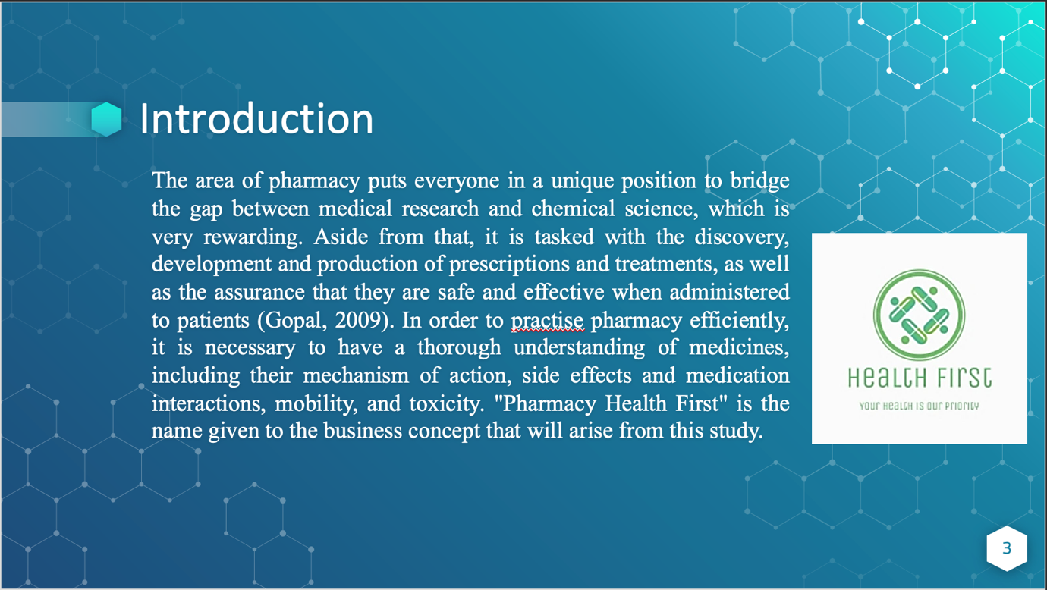
- The area of pharmacy puts everyone in a unique position to bridge the gap between medical research and chemical science, which is very rewarding. Aside from that, it is tasked with the discovery, development and production of prescriptions and treatments, as well as the assurance that they are safe and effective when administered to patients (Gopal, 2009). In order to practise pharmacy efficiently, it is necessary to have a thorough understanding of medicines, including their mechanism of action, side effects and medication interactions, mobility, and toxicity. While doing so, it is necessary to have a thorough awareness of the various treatment options as well as the sickness process. For example, in order to practise clinical pharmacy, one must be familiar with the methods used to gather and analyse physical and laboratory information. One of the most important roles of a pharmacist is to help people recover from disease and have healthy lives. There is a widespread belief that people should only purchase medicine after consulting a pharmacist, who is an expert in the field. Pharmacies, on the other hand, aren't your run-of-the-mill businesses (Feinberg, 2008). For both buyers and sellers, lawyers who are knowledgeable in the pharmaceutical industry and aware of the possible dangers may offer value to the transaction.' "Pharmacy Health First" is the name given to the business concept that will arise from this study.
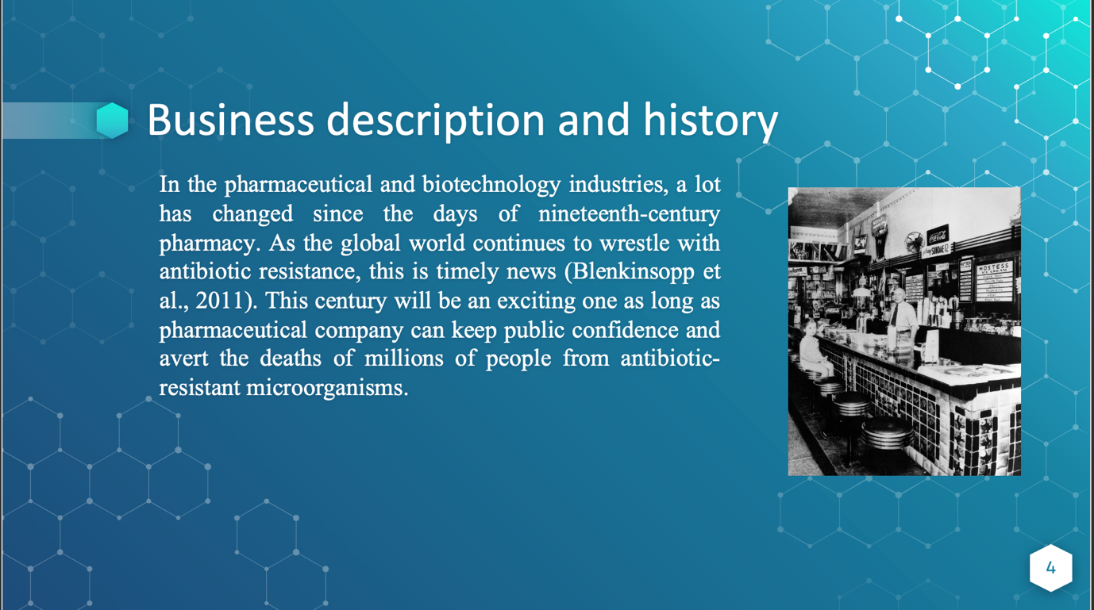
- In the pharmaceutical and biotechnology industries, a lot has changed since the days of nineteenth-century pharmacy. During the Middle Ages, apothecaries and pharmacies began to market traditional treatments based on centuries of folk knowledge, which resulted in a wide range of therapeutic options. Antibiotic research has ground to a standstill because to the huge pharmaceutical companies' inability to make enough money from it, despite some notable advances. As the global world continues to wrestle with antibiotic resistance, this is timely news (Blenkinsopp et al., 2011). This century will be an exciting one as long as pharmaceutical company can keep public confidence and avert the deaths of millions of people from antibiotic-resistant microorganisms.
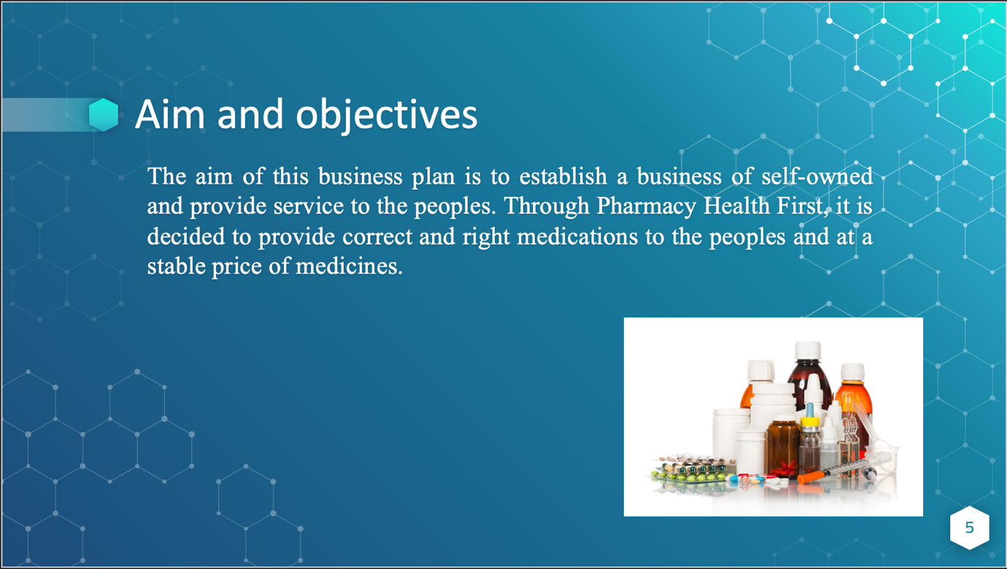
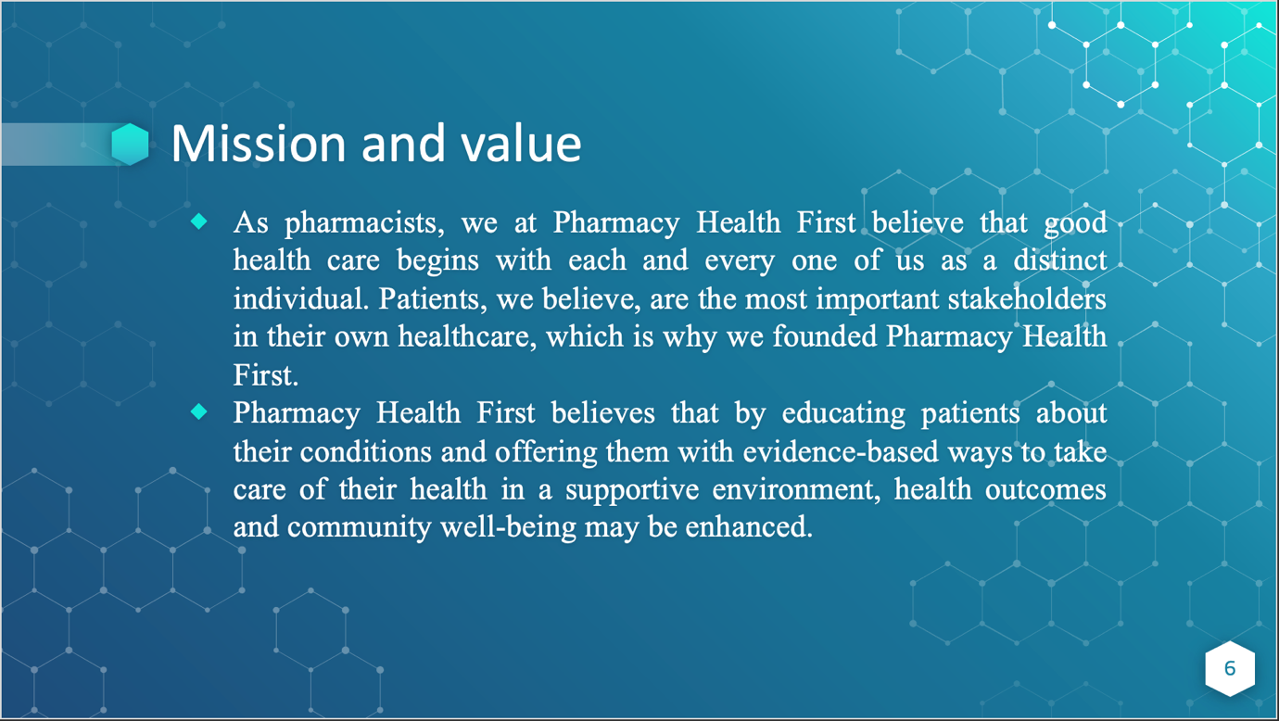
- As pharmacists, we at Pharmacy Health First believe that good health care begins with each and every one of us as a distinct individual. Patients, we believe, are the most important stakeholders in their own healthcare, which is why we founded Pharmacy Health First. As a result, we urge patients to be active participants in their own health care. Our fundamental convictions are that education, good living choices, and natural health are important (Bernhagen, 2014). Pharmacy Health First believes that by educating patients about their conditions and offering them with evidence-based ways to take care of their health in a supportive environment, health outcomes and community well-being may be enhanced.
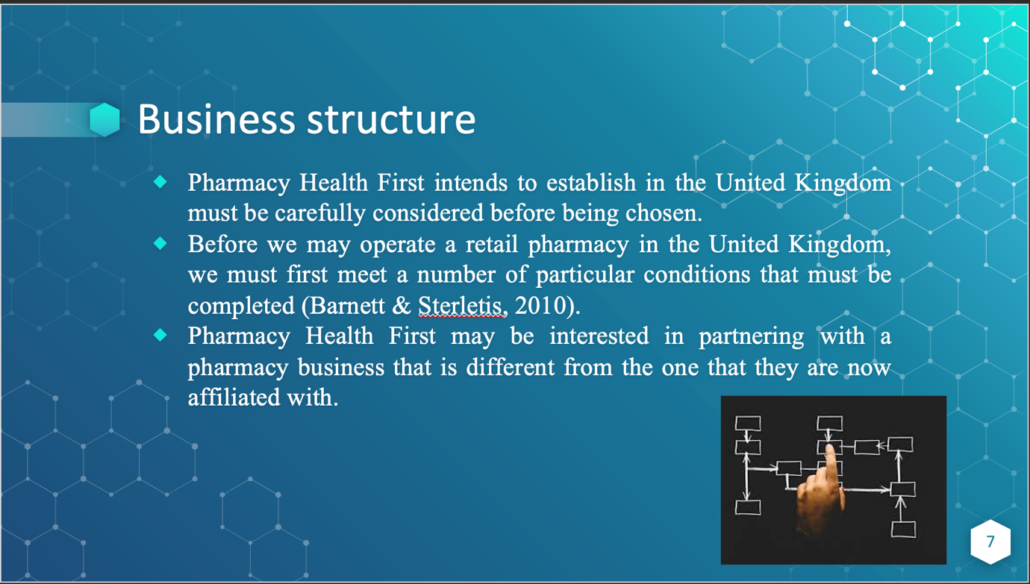
- Consequently, the kind of pharmacy company that Pharmacy Health First intends to establish in the United Kingdom must be carefully considered before being chosen. If this is not done, it will be difficult to achieve Pharmacy Health First's mission. Before we may operate a retail pharmacy in the United Kingdom, we must first meet a number of particular conditions that must be completed (Barnett & Sterletis, 2010). However, Pharmacy Health First may be interested in partnering with a pharmacy business that is different from the one that they are now affiliated with. As previously indicated in the company structure description, Pharmacy Health First will operate in the same manner as a traditional retail pharmacy.
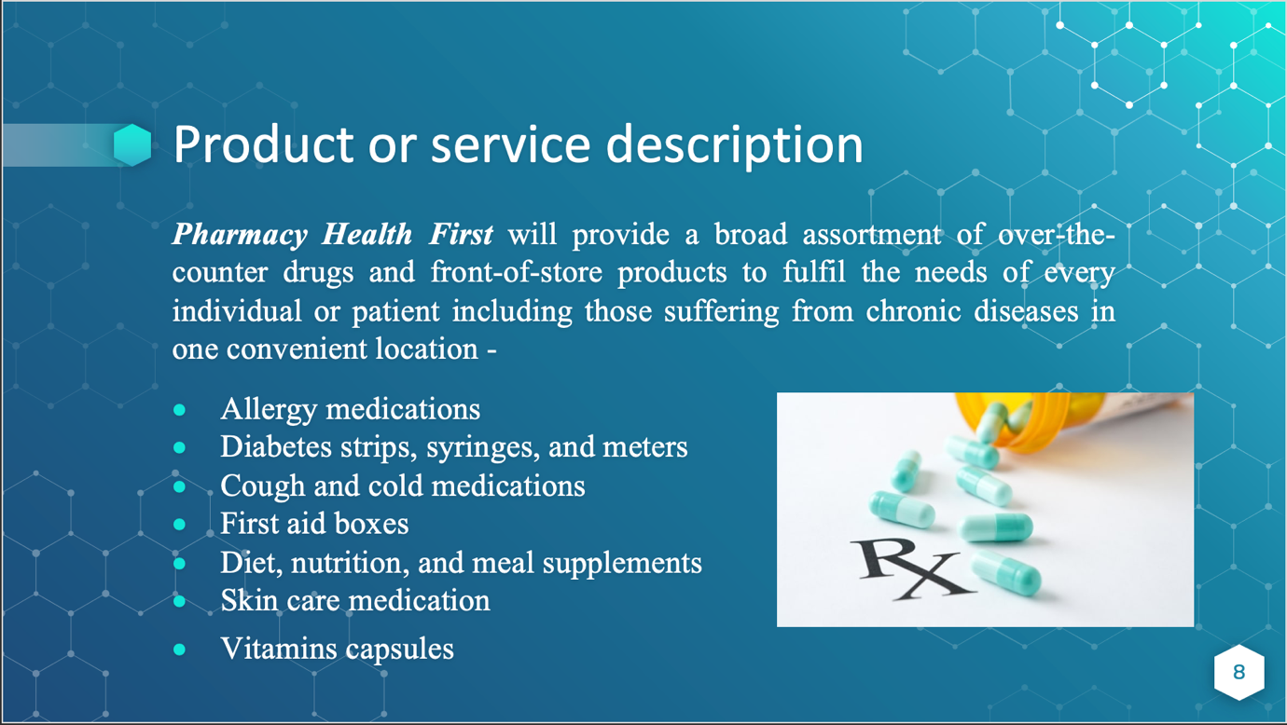
Pharmacy Health First is a full-service pharmacy at a convenient location in the United Kingdom that provides a variety of services (UK). Pharmacy Health First will provide a broad assortment of over-the-counter drugs and front-of-store products to fulfil the needs of every individual or patient including those suffering from chronic diseases in one convenient location -
- Allergy medications
- Diabetes strips, syringes, and meters
- Cough and cold medications
- First aid boxes
- Diet, nutrition, and meal supplements
- Skin care medication
- Vitamins capsules
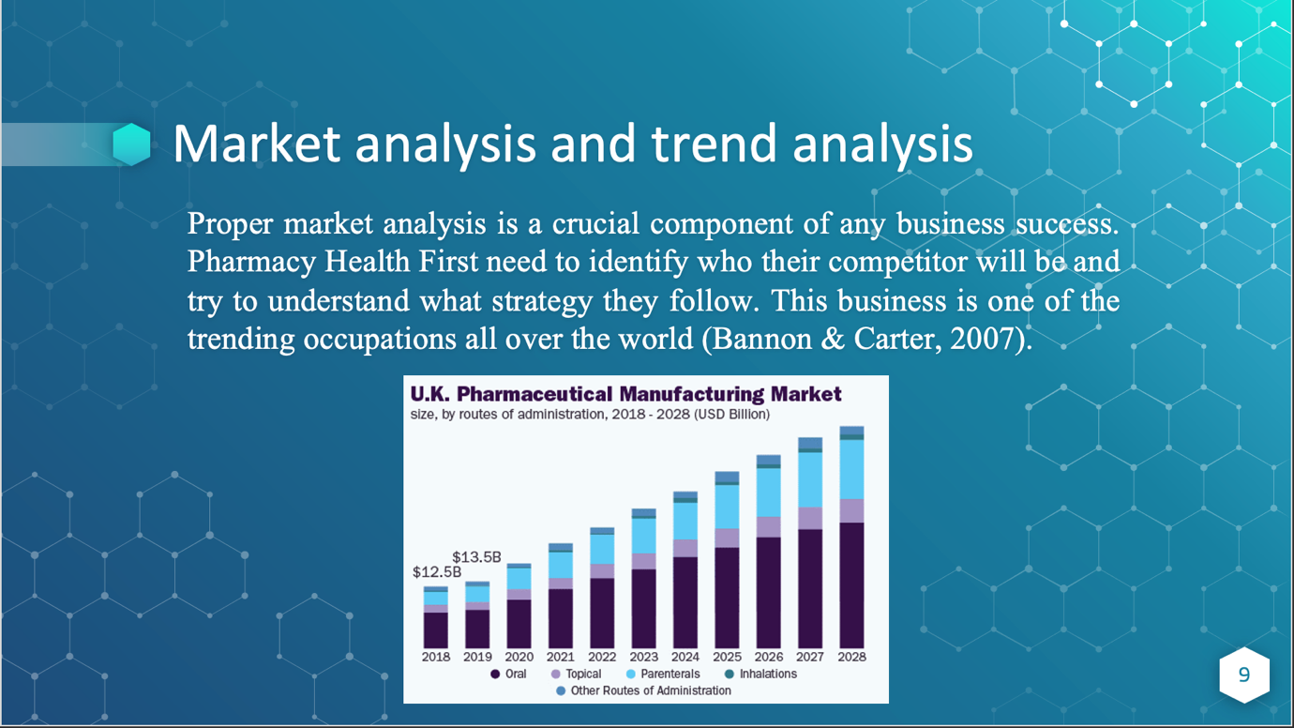
- Proper market analysis is a crucial component of any business success. Pharmacy Health First need to identify who their competitor will be and try to understand what strategy they follow. This business is one of the trending occupations all over the world (Bannon & Carter, 2007). A statistical report shows that the global pharmaceutical industry's total revenue at the end of 2019 is 1.25 trillion U.S. dollars, and this amount is growing day by day.
- Target customers
- Pharmacy Health First's core consumers are walk-ins and mail-order customers. There is a lot of rivalry in the pharmaceutical industry. Local, mail-order and Canadian pharmacies are all part of the pharmacy business.
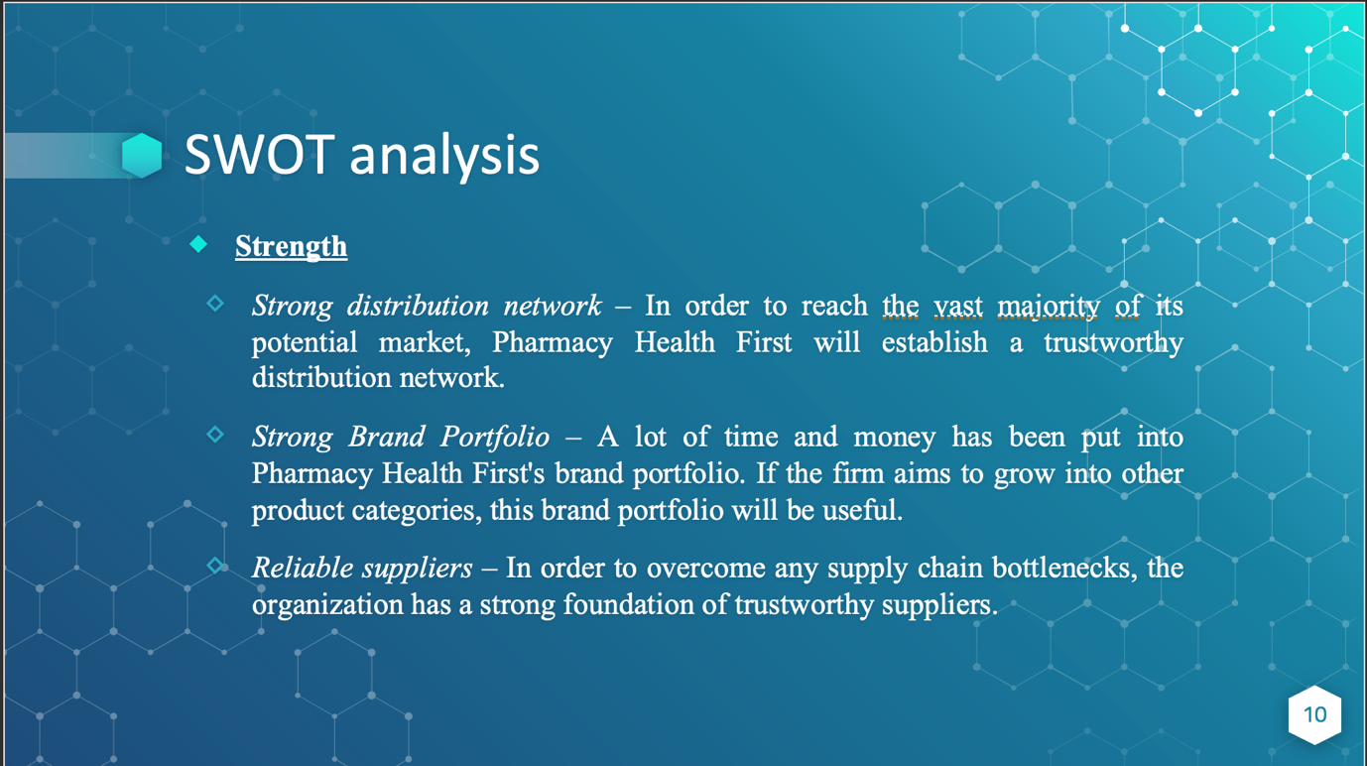
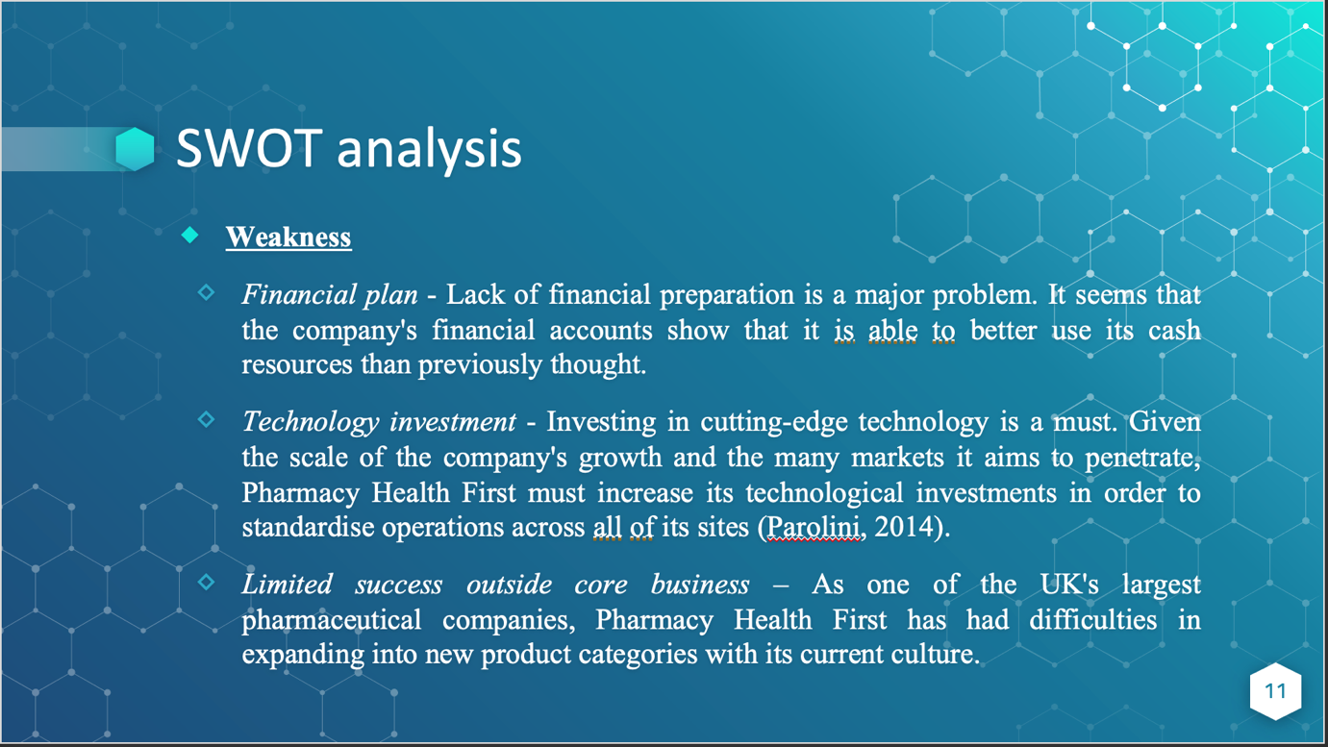

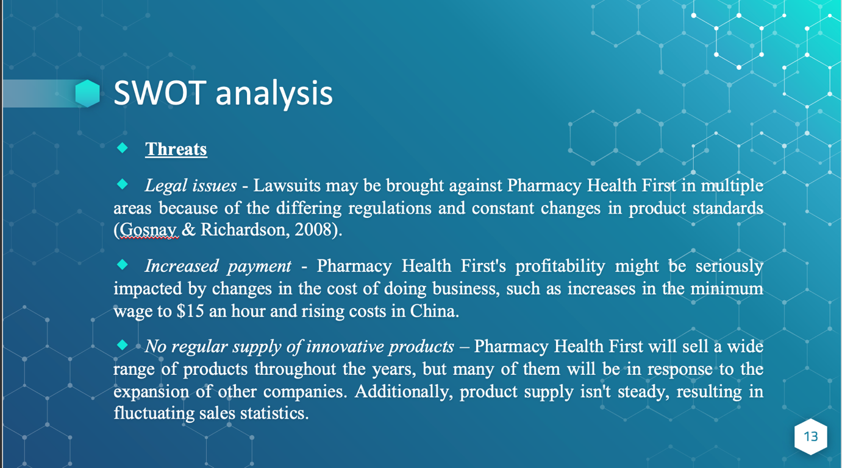
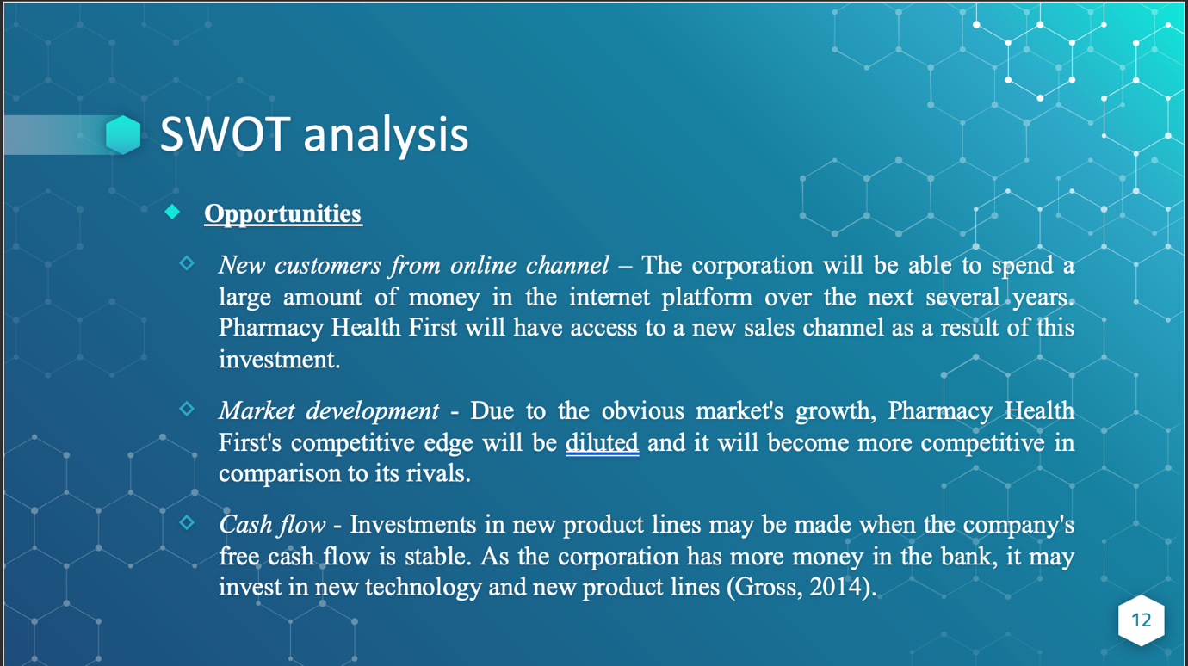
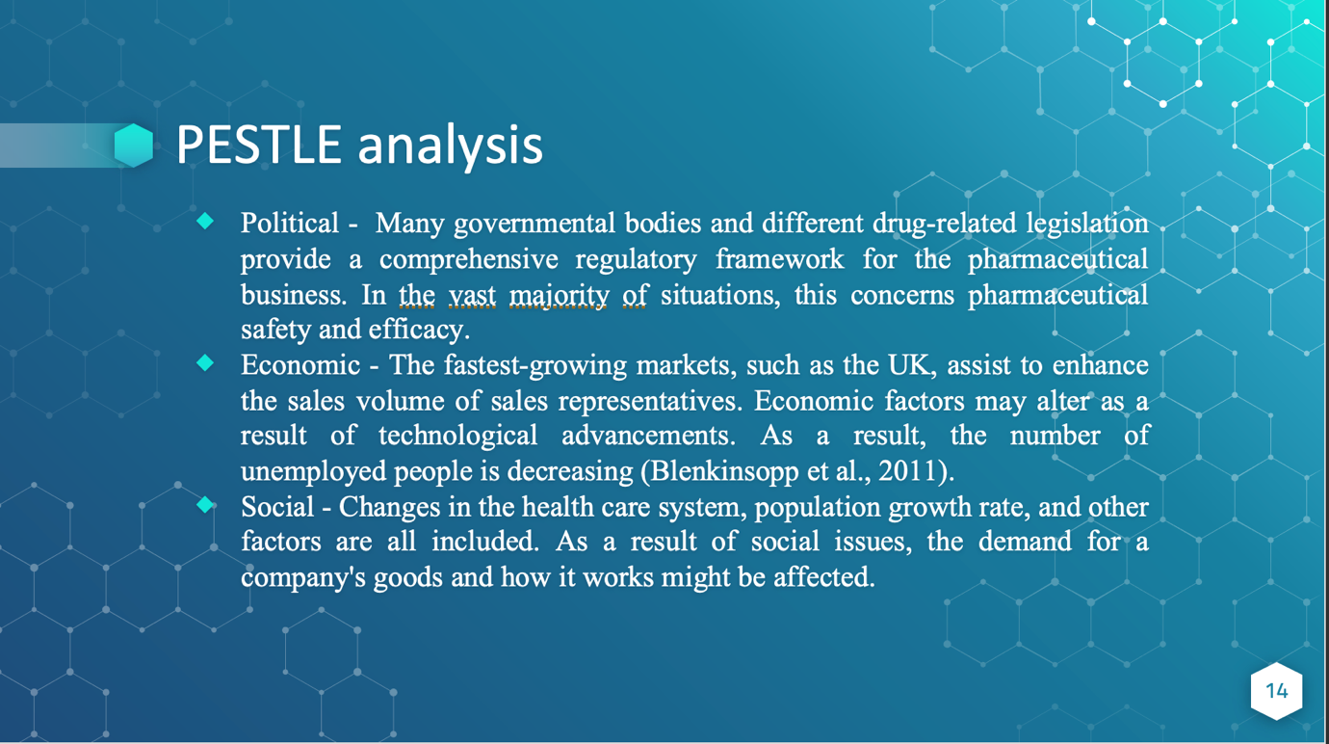
- Political factor - The pharmaceutical sector is subject to severe regulations in practically every nation. Many governmental bodies and different drug-related legislation provide a comprehensive regulatory framework for the pharmaceutical business. In the vast majority of situations, this concerns pharmaceutical safety and efficacy. It may also have an impact on how and where pharmaceuticals are marketed and sold (Feinberg, 2008).
- Economic factor
- As the economy grows, so does the pharmaceutical market. The fastest-growing markets, such as the UK, assist to enhance the sales volume of sales representatives. Economic factors may alter as a result of technological advancements. As a result, the number of unemployed people is decreasing (Blenkinsopp et al., 2011). In a bad economy, organizations make less money, which means they have less money to spend on research.
- Social factor
- Changes in the health care system, population growth rate, and other factors are all included. As a result of social issues, the demand for a company's goods and how it works might be affected. With an aging population comes an increased need for medical care. As the population grows, so does the need for medical care.
- Technological factor
- Even though biotech has a highly unique impact, complexity, and is less susceptible to generic competition, it is becoming more popular. People's lives can be extended with more innovation and re-development. This implies that technical advancements are keeping pace with population growth. Medications are in greater demand as well.
- Environmental factor
- Pollution and garbage, as well as other environmental factors. People require more medication to treat illnesses that arise as a result of poor environmental cleanliness. People are becoming unwell owing to the poor quality of the environment, such as air pollution and water pollution, as the environmental issue has grown more pressing.
- Legal factor
- Advertising for pharmaceuticals is governed by rules set by the pharmaceutical industry itself. All of the medical knowledge exams that are performed throughout the recruiting process must be passed by representatives. There are several nations where the government demands that the advertising agency check that the promotional claim matches the facts supplied by the firm. Providing a fair playing field by enforcing government regulations may help build consumer confidence. A thorough evaluation ensures that the data is secure and stable. Protecting original brands and anticipating generic pharmaceutical threats are both made easier thanks to the patent system.
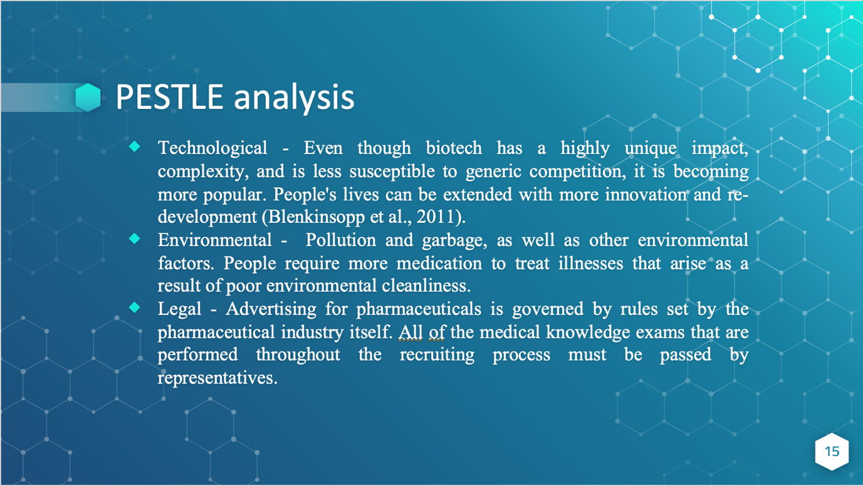

- Technological factor
- Even though biotech has a highly unique impact, complexity, and is less susceptible to generic competition, it is becoming more popular. People's lives can be extended with more innovation and re-development (Blenkinsopp et al., 2011). This implies that technical advancements are keeping pace with population growth. Medications are in greater demand as well.
- Environmental factor
- Pollution and garbage, as well as other environmental factors. People require more medication to treat illnesses that arise as a result of poor environmental cleanliness. People are becoming unwell owing to the poor quality of the environment, such as air pollution and water pollution, as the environmental issue has grown more pressing.
- Legal factor
- Advertising for pharmaceuticals is governed by rules set by the pharmaceutical industry itself. All of the medical knowledge exams that are performed throughout the recruiting process must be passed by representatives. There are several nations where the government demands that the advertising agency check that the promotional claim matches the facts supplied by the firm. Providing a fair playing field by enforcing government regulations may help build consumer confidence (Blenkinsopp et al., 2011). A thorough evaluation ensures that the data is secure and stable. Protecting original brands and anticipating generic pharmaceutical threats are both made easier thanks to the patent system.
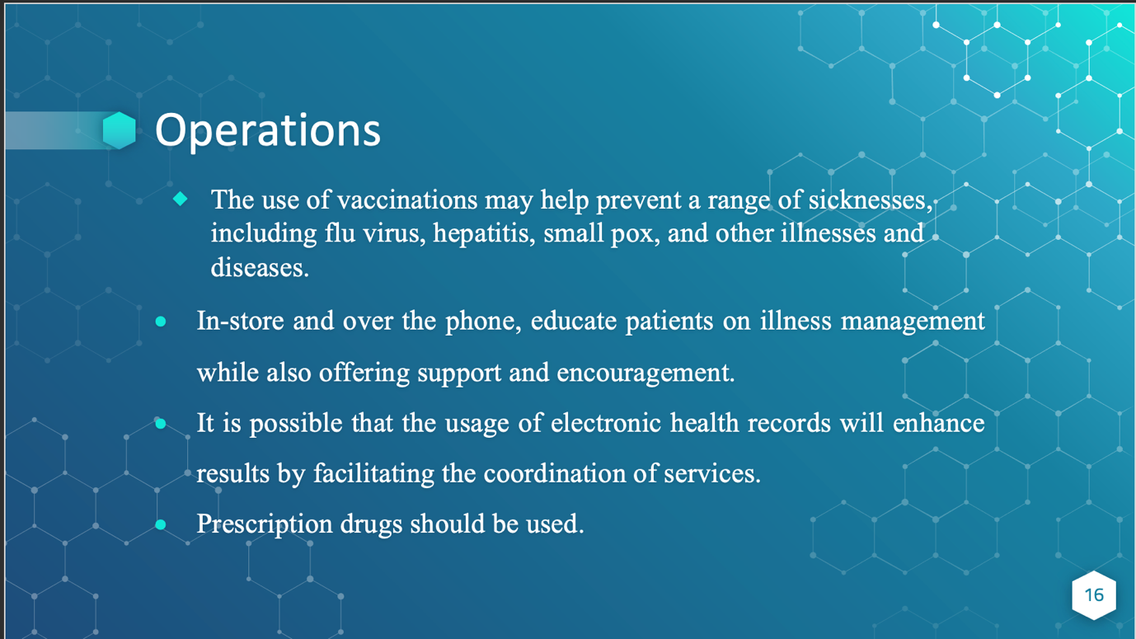
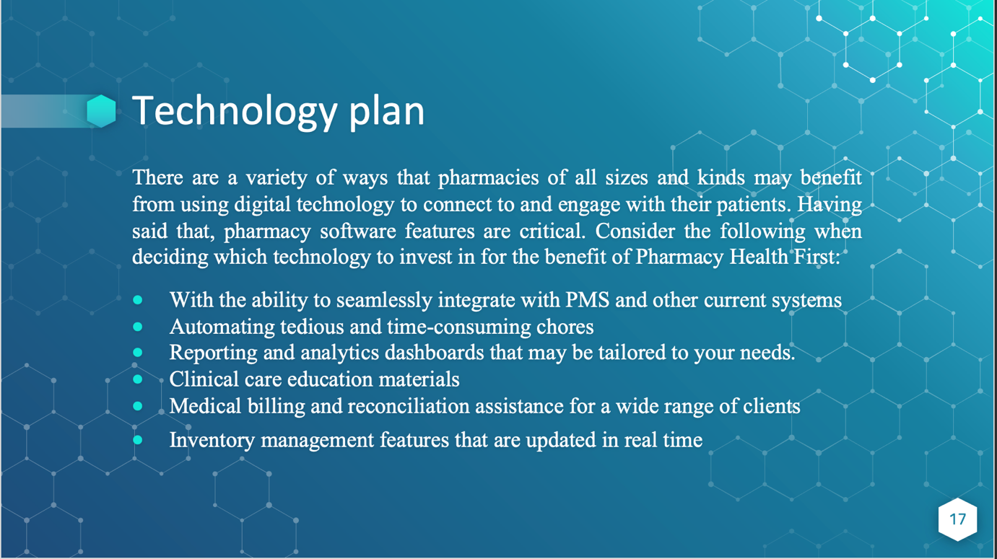
- Independent pharmacists who seek to improve their bottom line by making business improvements may find pharmacy software to be a game-changer. According to a recent research, small and large retail pharmacies alike may benefit from leveraging technology to run more efficiently, increase profitability, and improve patient care in their respective locations (Bernhagen, 2014). There are a variety of ways that pharmacies of all sizes and kinds may benefit from using digital technology to connect to and engage with their patients. Having said that, pharmacy software features are critical. Consider the following when deciding which technology to invest in for the benefit of Pharmacy Health First:
- With the ability to seamlessly integrate with PMS and other current systems
- Automating tedious and time-consuming chores
- Reporting and analytics dashboards that may be tailored to your needs.
- Clinical care education materials
- Medical billing and reconciliation assistance for a wide range of clients
- Inventory management features that are updated in real time
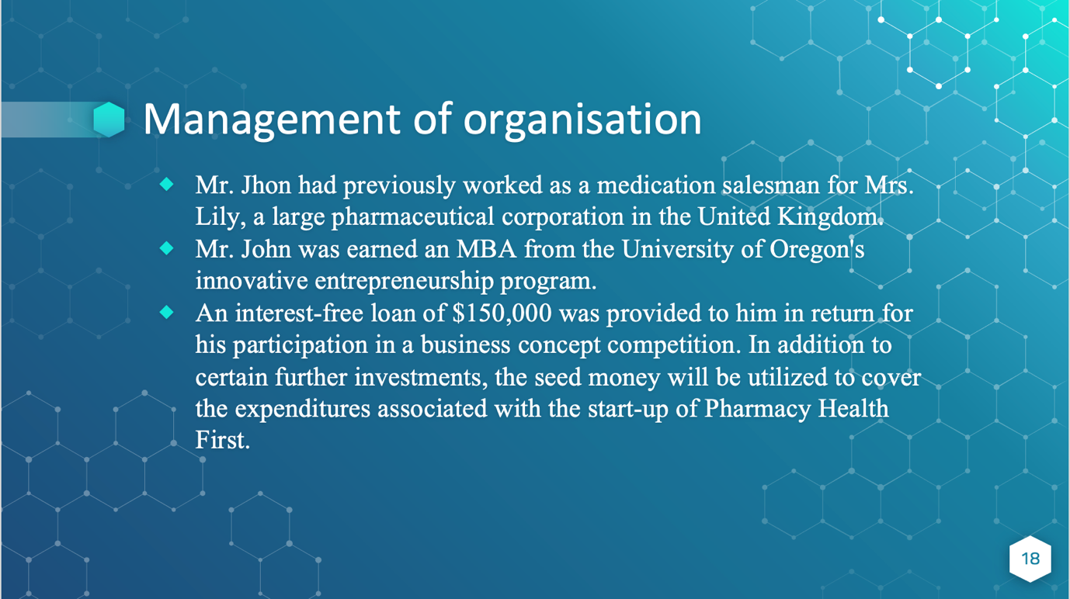
- Mr. Jhon had previously worked as a medication salesman for Mrs. Lily, a large pharmaceutical corporation in the United Kingdom. Companies that manufacture prescription medications are lucrative, but they are also plagued by inefficiencies. He was in a position to see it for himself. Mr. John was earned an MBA from the University of Oregon's innovative entrepreneurship program. An interest-free loan of $150,000 was provided to him in return for his participation in a business concept competition. In addition to certain further investments, the seed money will be utilized to cover the expenditures associated with the start-up of Pharmacy Health First. Mr. John attended the University of Oregon, where he majored in chemistry and finished with a bachelor's degree.
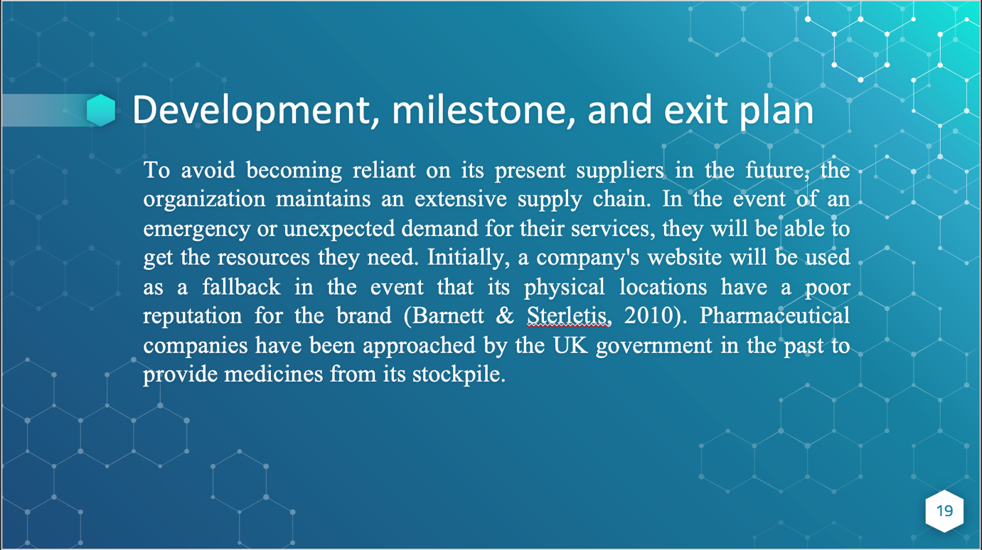
- To avoid becoming reliant on its present suppliers in the future, the organization maintains an extensive supply chain. In the event of an emergency or unexpected demand for their services, they will be able to get the resources they need. Initially, a company's website will be used as a fallback in the event that its physical locations have a poor reputation for the brand (Barnett & Sterletis, 2010). Pharmaceutical companies have been approached by the UK government in the past to provide medicines from its stockpile. As a result, it is imperative that the United States and the European Union create a strong working partnership based on mutual respect and cooperation.
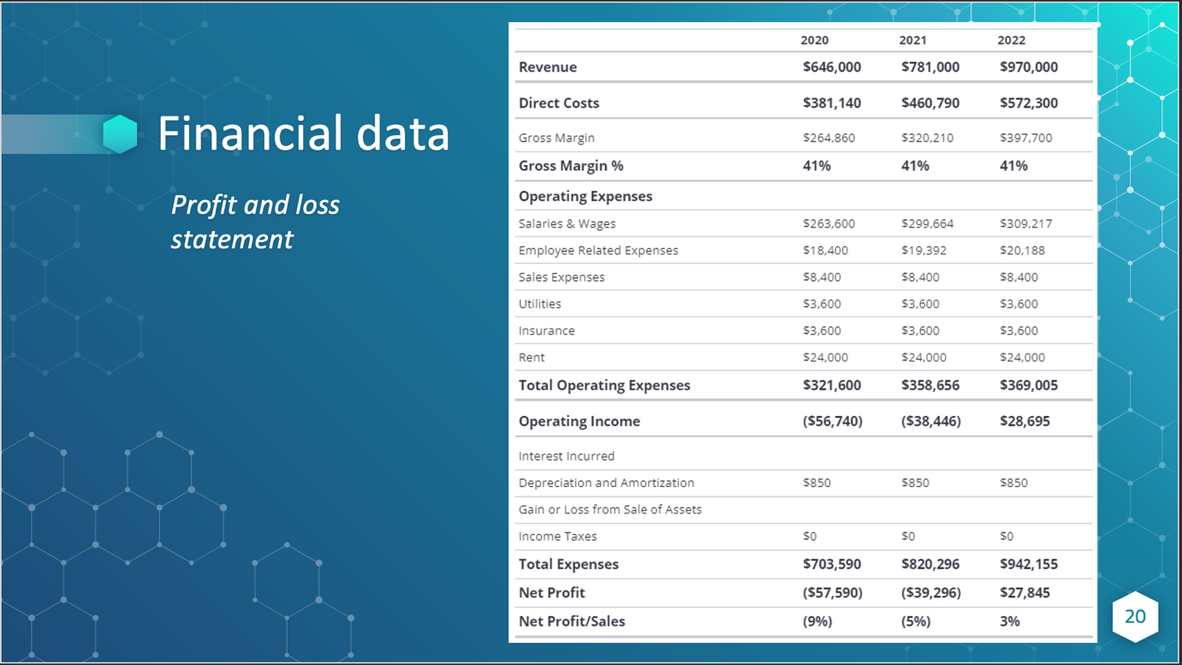
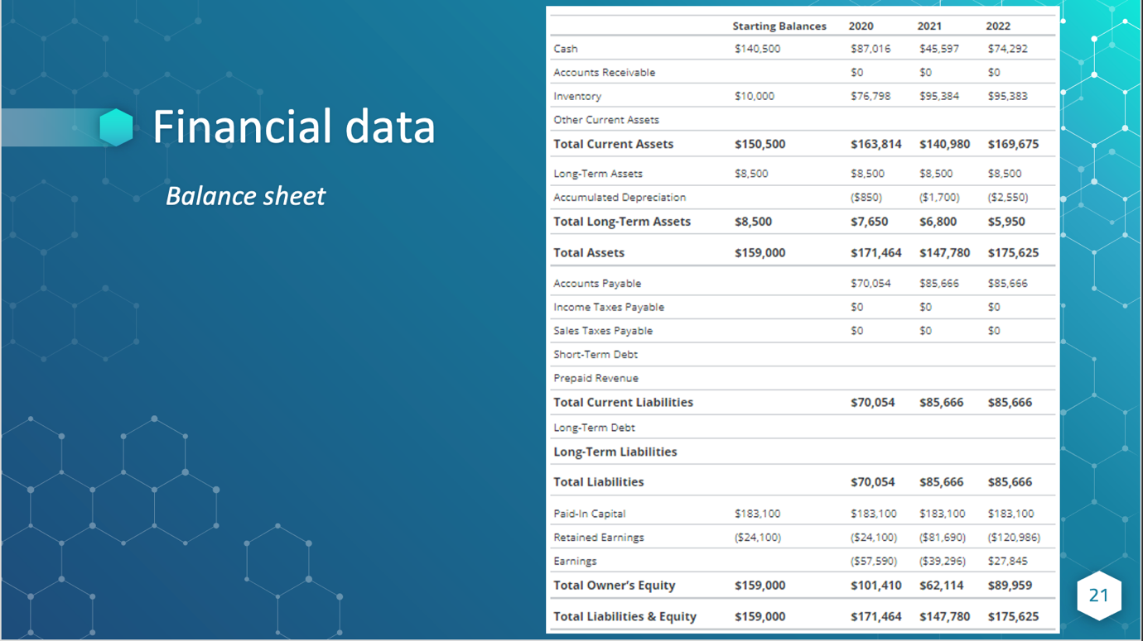

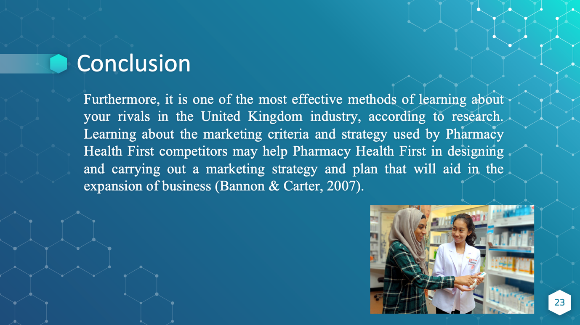
- Furthermore, it is one of the most effective methods of learning about your rivals in the United Kingdom industry, according to research. Learning about the marketing criteria and strategy used by Pharmacy Health First competitors may help Pharmacy Health First in designing and carrying out a marketing strategy and plan that will aid in the expansion of business (Bannon & Carter, 2007). When it comes to determining which parties will aid a company's growth by adhering to all current rules and regulations, the macro and micro structure of the market may be very useful in determining which parties will comply with all current laws and regulations.



