

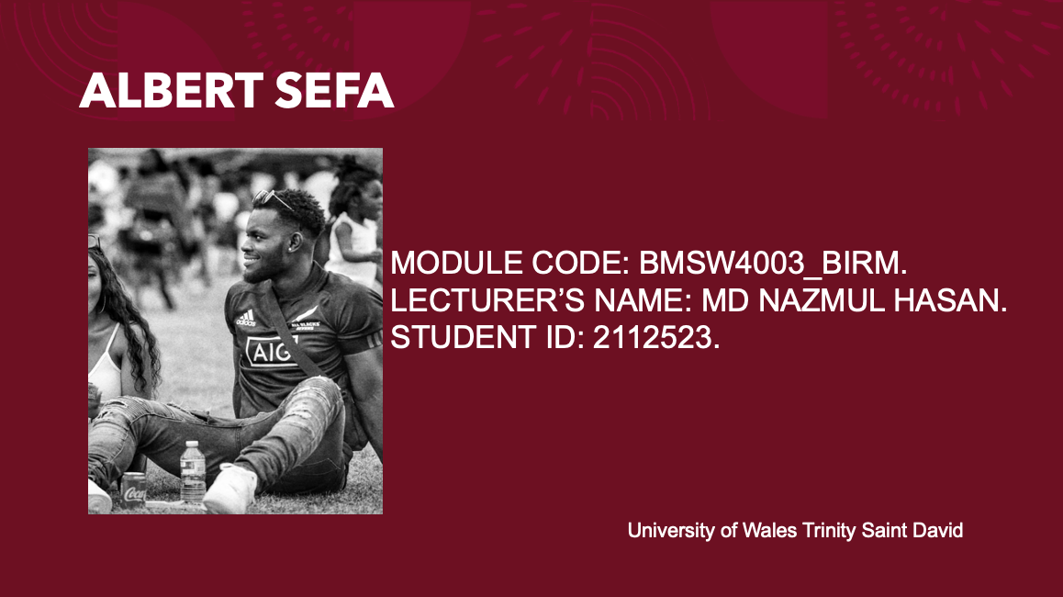

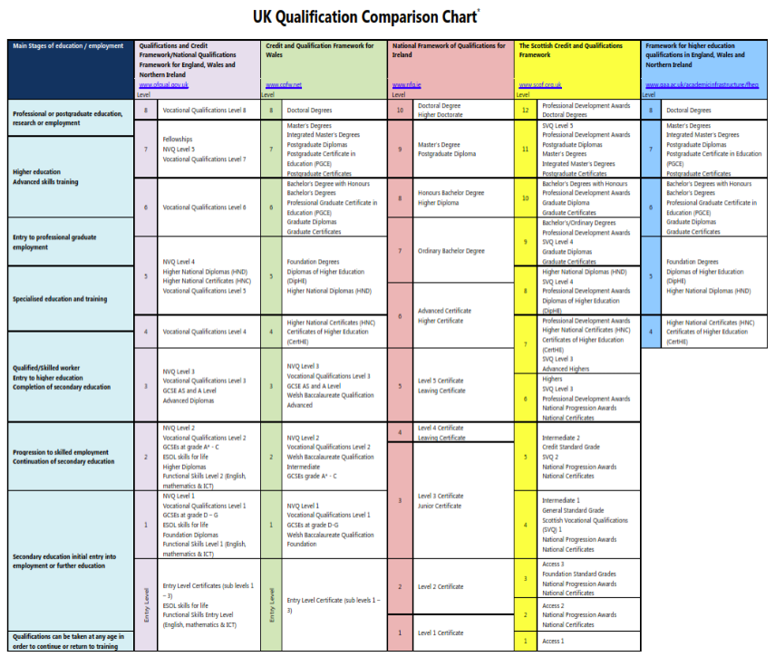

Different academic level.
The framework of the academic level in the UK is not that complicated. Most qualifications can be acquired through school, college, work and university. Each qualification tests your level of competency, knowledge and skill that are needed to your specific qualification. Qualifications is a form of identity that proves your competency and how much you know about your career choice. Employers and teachers acknowledge qualifications because it shows what you have learnt and how you can replicate that result in your chosen field. (Nidirect government service).



What is Grit?
The word grit generally means to have passion and perseverance. For example, setting goals and following through with it and working hard on all your commitments or goals you set for yourself. (Duckworth 2021). When it comes to success, talent and luck are big factors but having grit can take you a lot further than you want to be. Grit can also signify having a deep commitment, strength of character and having great effort on achieving goals despite the obstacles and setbacks you will encounter. (Psychol 2020). Although Grit Scale shows you the passion and perseverance for long-term goals and how well you are going to do in life, it is not the end all be all because you can always improve on it. Your grit score can always change throughout your life endeavours.


Angela Duckworth.
She is a professor at the University of Pennsylvania. Angela introduced the concepts of grit scale in 2013 during her TED talk which it received a lot of attention few years after. (Kelsie and Aubrey 2019). The reason why she came up with this concept was that she realised that some of her smartest students were not necessarily her best students when she was teaching seventh grade math in a public a school. After her realisation she stop teaching to become a psychologist researcher at the University of Pennsylvania to understand how perseverance can play a part in someone achievements. She conducted some studies on children and adults in challenging environments. The assumption about having a high grit shows that an individual is more motivated not to give up and maintain focus for years on end. Angela measured grit by developing a grit scale which was a self-reposted questionnaire that was used to assess an individual work ethic and how it can contribute to their success. The grit scale questionnaire that all the respondents had to answer was one to five, with the five being “very much like me” and one being “not at all like me”. After the completion of each survey, their grit score was then calculated to determine how their grit was related to other aspects of their success. My grit analysis for the primary and secondary data is based on the research that Angela and her team conducted. According to Angela Duckworth IQ was not the only factor that separated the hood students and the students that were struggling. (Kelsie and Aubrey 2019).

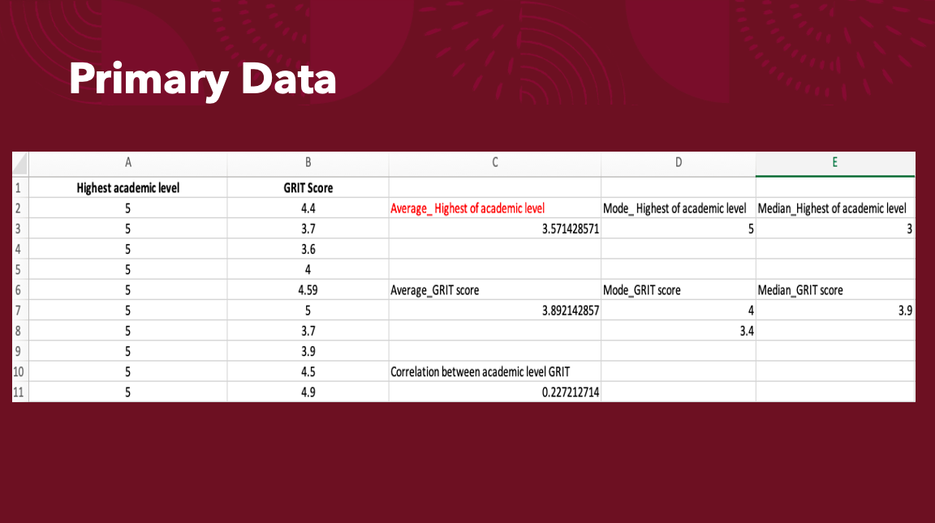
Primary data.
As you can see in this primary data it shows the highest academic level of 71 people and their Grit score. First, I calculated the average highest of academic level by adding the all the numbers and then dividing it by the count of the numbers. To calculate the mode highest of academic level I put all the numbers in order then I counted the number that appeared more often. Finally, I calculated the median highest of academic level by putting all the numbers into ascending order from lowest to highest then I picked the middle value. I used the same formula for the Grit score as well and I used Excel for all my calculation.

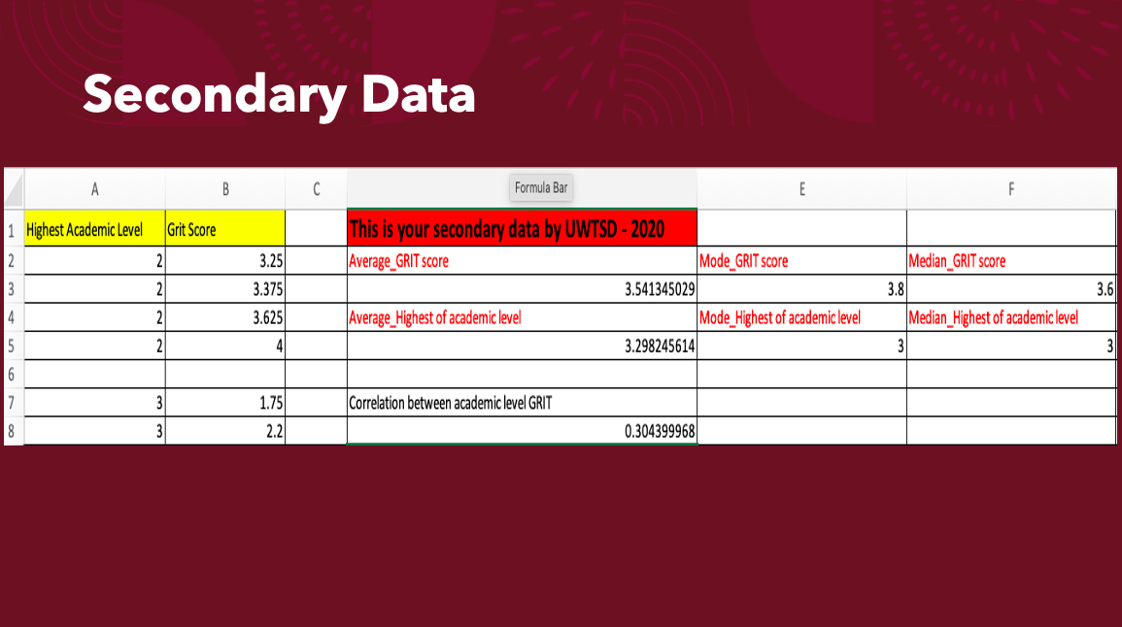
Secondary data.
For the secondary data I used the same formula for the primary data that calculated to find the average, the mode and the median for the highest academic level and grit score of each person. I did all the calculation on Excel, to find the average by using this formula “=AVERAGE(A2:A175)”. For the mode I used “=MODE.MULT(A2:A175)” and to find the median I used “=MEDIAN(A2:A175). That is how I found the highest academic level of each category. The grit score is roughly the same formula that I used for the highest academic level. I changed the letter “A” attached to the numbers to “B” based on the columns that was represented on Excel.

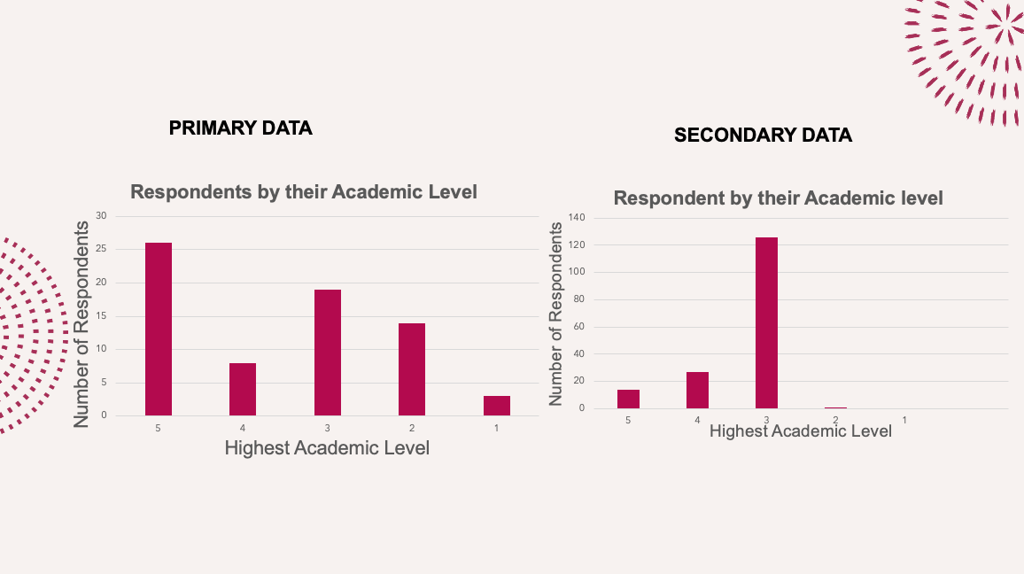

Chart of the academic level for the primary data and secondary data.
As you can see here, I transformed my data into chart to make it more understandable to read. I then compared the highest academic level of the primary data and secondary data, and I found was that the highest academic level of the primary data was higher than the second data which was 26 number of respondents that had the highest level of academic was 5.
Although the number of respondents was a lot more for the secondary data, the highest academic level was 3 which consisted in 125 respondents. Less than 5 people had level 1 as their highest academic level for the primary data. Compared to the secondary data, 2 was the highest academic level.

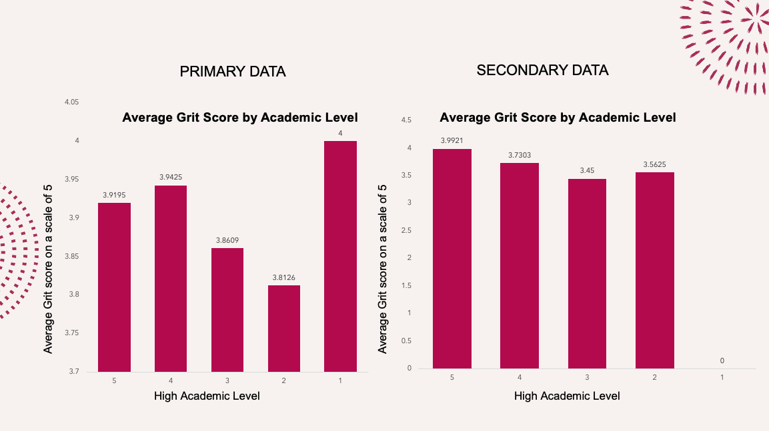

Average Grit score by Academic Level.
Looking at this chart you can see that the highest average score for the primary data is 4 and looking back at the previous chart regarding the highest academic level, the number of correspond (which was less than 5) had level 1 for the highest academic level. Which meant that for this one the lower academic level you had the grittier you were. Not having the best academic level does not really matter because the grittier you are the more you likely you are to succeed in any endeavours.

For the secondary data that it shows that the higher your academic level the higher your grit score is going to be. Compering the two chart there is clearly a big different in the average grit score by academic level. So that means the probability of you having a high grit score reflected on your ability to have a high academic level.

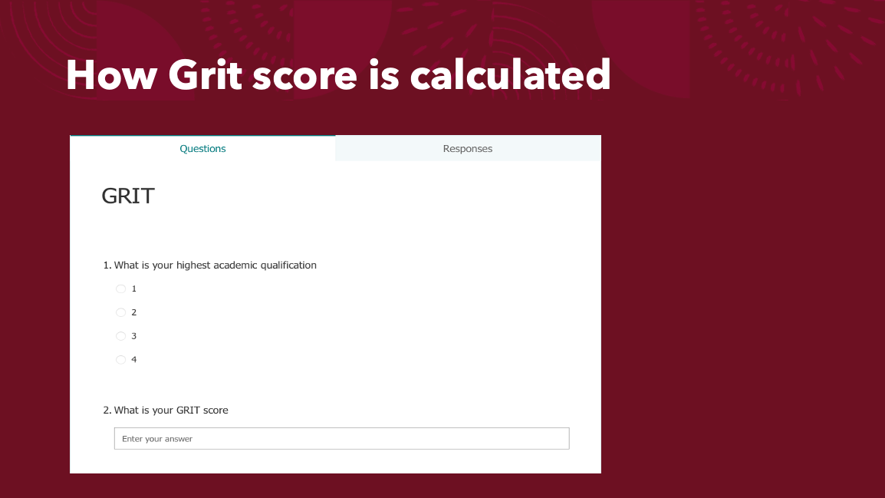

How is grit score calculated?
First, we must keep in mind that grit score shows you how gritty you are, and it reflects on how you see yourself right now.
Grit is calculated by using the average score of items. For example, if you have 12 items you must chose a number on each item from 1 to 5 according to how much you identify yourself with it. After you add up your total score then you divide it by the 12 items you had and that show your level of grittiness. (Cabral 2021).

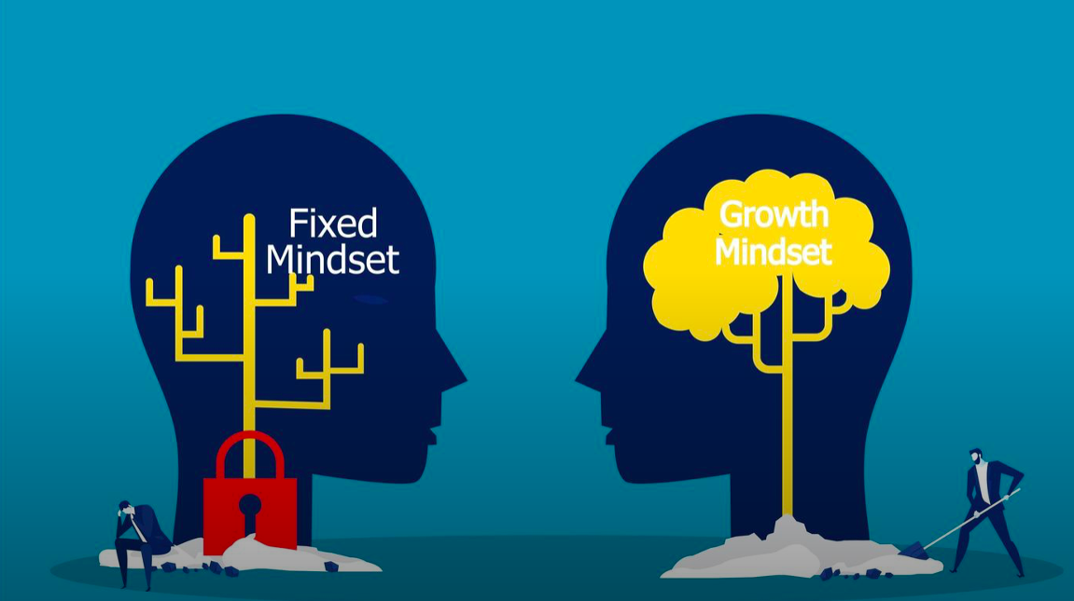

Growth Mindset
Carol Dweck introduced the growth mindset theory stating that having the effort to build yourself makes you stronger and doing that you can get smarter by learning your goals so you can spend more time on working harder on your achievements. Growth mindset is having the belief that you can cultivate yourself through effort (Mindset work, 2017) and that is what having grit is all about. Another type of mindset is fixed mindset which is a negative way of thinking because it believes that one cannot improve their talent or intelligence so therefore it leads to them being unmotivated, hiding mistakes and to improving on it. Giving up easily is also a sign of a fixed mindset. (Jennifer, 2020). If a person has a fixed mindset the probability of their grit score being high is going to be very low and it can affects their growth and progression throughout their endeavours.



Wisdom
In the Cambridge dictionary wisdom means to have the ability to use your experience and make judgments in life circumstances. Having wisdom is something that it cannot be taught because it is about making the correct decisions through experiences in life. As we know having grit shows some level of commitment and perseverance to achieve things in your life. But having wisdom gives you the ability to learn from your mistakes through experience and to be a better version of yourself. Although wisdom is a subjective, it has the capability to see through the subject of any matter regardless of any distractions. (Diffen,2021). According to the DIKW pyramid wisdom is the result of a process that calculates the extrapolation of knowledge. (Ayan, 2019)

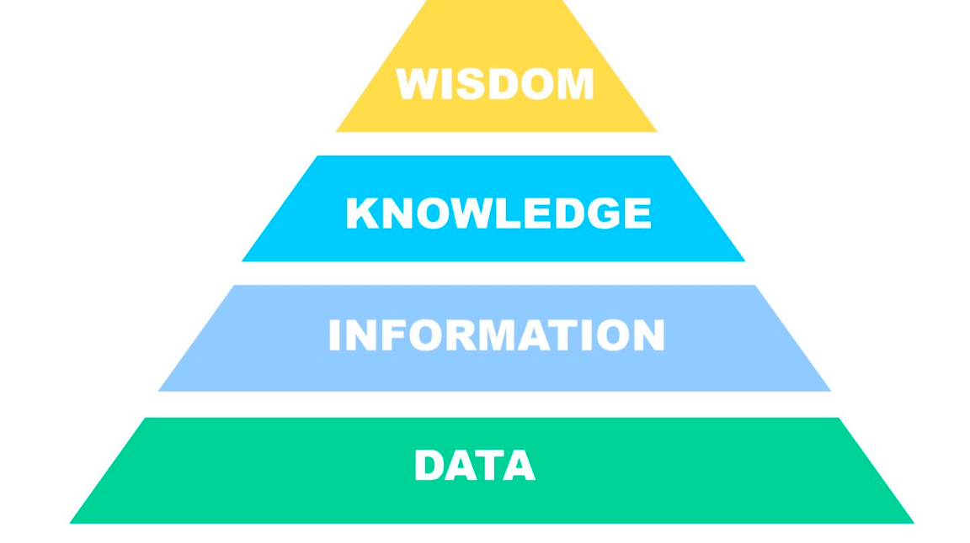

DIKW MODEL
First, we need to understand what DIKW stands for data, information, knowledge and wisdom. It is used to look at the extraction of value of a data and information. (Ayan, 2019). I used this model to help me analyse the primary data and the secondary data. Transforming the data into chart was essential using this model because you can then visualise the information properly and have a rough idea of what it is being portraited. I then converted the chart into information by connecting the pieces to add more value and explain what the comparison between the primary data and the secondary data. After doing that it was then easier for me to understand and take in the knowledge of the information. I made a good judgment on the comparison between both data using the DIKW model.

References:

Nidirect Government services, Qualification: what the different levels mean. Available at https://www.nidirect.gov.uk/articles/qualifications-what-different-levels-mean (Accessed: 1 December 2021).

The Paragon Education, UK Qualification Comparison Chart. Available at http://paragon.myvnc.com/TheParagon-Education/NWET&D/Themes/Qualifications/UK-Comparison-Chart.html (Accessed: 1 December 2021). (IMAGE)

Anderson K and Francisco A. (2019) The Research Behind the TED Talk: Angela Duckworth on Grit. Available at https://digitalpromise.org/2019/03/06/research-behind-ted-talk-angela-duckworth-grit/ (Accessed: 1 December 2021)

DeBaker K. (2020) Grit and Bear It: A Leader’s Ability to Weather The Unexpected, Available at https://www.pncwa.org/index.php?option=com_dailyplanetblog&view=entry&category=leadership-development&id=186:leadership-corner-sept-2020 (Accessed: 2 December 2021). (IMAGE)

Brahmachary A. (2019) DIKW Model: Explaining the DIKW Pyramid or DIKW Hierarchy. Available at https://www.certguidance.com/explaining-dikw-hierarchy/ (Accessed: 2 December 2021)

Medium (2019) DIKW Pyramids and Car Crashes. Available at https://medium.com/ironkeel/dikw-pyramids-and-car-crashes-de77591f1491 (Accessed: 2 December). (IMAGE)

Diffen, Knowledge vs Wisdom. Available at https://www.diffen.com/difference/Knowledge_vs_Wisdom (Accessed: 2 December)

Forbes (2021) Wither Wisdom? A Question For Our Times. Available at https://www.forbes.com/sites/johnbaldoni/2021/04/22/wither-wisdom-a-question-for-our-times/?sh=3f5b101d32aa (Accessed: 2 December). (IMAGE)

Smith J. (2020) Growth Mindset vs Fixed Mindset: How what you think affects what achieve. Available at https://www.mindsethealth.com/matter/growth-vs-fixed-mindset (Accessed: 3 December)

Steiner F. (2018) Growth mindset vs Fixed mindset: These mindsets are based on our perception and response to failure and challenging tasks. Available at https://www.blufftonicon.com/news/2021/03/18/growth-mindset-vs-fixed-mindset (Accessed: 4 December). (IMAGE)

Cabral C. (2021) The Grit Test: Your Grit Score and What it Means. Available at https://www.shortform.com/blog/grit-test/ (Accessed: 5 December)

Forms Office, GRIT. Available at https://forms.office.com/Pages/DesignPage.aspx?auth_pvr=OrgId&auth_upn=2112523%40student.uwtsd.ac.uk&lang=en-GB&origin=OfficeDotCom&route=Start#FormId=-REPTm4EBUWcuNshUjEeIQ_Fi8qw_BNNjqeA4Sw0lCRUMElHMTNNOUUxTjFGSjFKS0hBS1VUSjk5VC4u ( Accessed: 5 December). (IMAGE)

