Assignment Title | Assignment 2:  Report entitled –  Hotel standards, reputation management, building and retaining customer loyalty
Programme Name | International Hotel Management
Student Name | Muhammed Karim
Student Number | 2208392
Module Code | BMIH4003
Module Title | Hospitality and Guest Services
Lecturer Name | Lisa Bassler,  Kathryn Flynn,  Melissa John,  Charlotte Joyner,  Muhammad Cassamo
Assignment Wordcount | 1495

Executive Summary
Owing to the intense competition in the hospitality industry, businesses must keep up with the latest developments in their industry to remain competitive. Being abreast of the industry as a whole is one of the best methods to ensure that your company delivers the level of customer care that your clients want. This is essential in order to meet client expectations. This study focuses on strategies for developing consumer trust in hotel management and service (Alketbi et al., 2020).

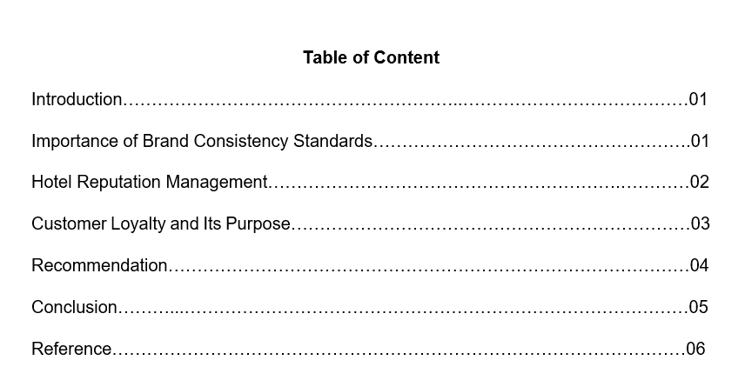

Introduction
To achieve success, not focusing on acquiring new consumers is enough. Developing customer satisfaction and loyalty keep existing customers satisfied. In the hospitality industry, customer satisfaction is mostly determined by the caliber of service rendered (O'Neill, and Mattila, 2010). A management plan that prioritizes customer satisfaction has the ability to build customer loyalty, hence enhancing the good image of the tourism destination. Hence, it is necessary to analyze the significance, from the standpoint of customers, of various hotel attributes in the selection process. For the success of the hospitality industry, visitor satisfaction research is crucial (Erdem, and Jiang, 2016). This study addresses consumers’ will to return to a hotel or the reception of recommendations for other tourists. Failing to pay adequate attention to the aspects that consumers appreciate the most, it faces the danger of receiving negative feedback from its guests, which in turn diminishes the possibility of those guests returning in the future.

Importance of Brand Consistency Standards
Brand consistency is the process of ensuring that the way a company is presented and what it stands for are consistent across all marketing platforms, thereby unifying the image and message that your current and potential customers see. Consistency of a brand involves being recognizable, establishing trust, and expressing personality. Increasing client faith and loyalty through good branding adds individuality, encouraging consumers to engage with your company (Lee, and Jeong, 2014). Consistency of a brand is characterized by
Increase consumer trust and loyalty: Effective branding provides a business with a personality that compels people to interact with it.
Stand out from competitors: It distinguishes from the competition and provides consumers with an emotional reason to choose the hotel.
Boost brand authority: The brand can become an industry leader by increasing its authority (O'Neill, and Mattila, 2010).
Brand names and guidelines for using them can have a major impact on the promotion of any hotel or resort. The topic of branding has long been up for discussion. Franchises, memberships, or new brands may need to be formed. Recognizability and consistency are two benefits of having a brand. In order to develop a brand, it is necessary to pay close attention to the target audience, the target market, and all deliverables, including the Brand handbook. A product's brand includes not only the name of the product itself, but also the quality and reliability with which the product is offered to customers. In order to attract more customers, businesses should set themselves apart from their competitors by implementing brand standards. Consumers are more likely to pick well-known Hotel / Resort Brands over generic products that aim to reduce R&D and risk because of the superior quality of the former (O'Neill, and Mattila, 2010).

Hotel Reputation Management
Management of a hotel's reputation involves monitoring and altering internet perceptions. It includes monitoring review sites, publishing on social media, and optimizing your website for search results, among other tasks. Some ways to improve the hotel’s reputation are given below.
- Social media allows businesses to promote their company and communicate with their followers. Consistency is essential for expanding and retaining your planning community and target audience, given the abundance of material on all social media platforms. Keep a consistent voice across all platforms. Also, social media can link planners and guests. Use your profiles to persuade guests that the residence is secure. As the hotel's expert, keep visitors informed on local activities and changes to the property.
- Keeping up with the ever-changing digital landscape will prevent slipping behind. During this economic downturn, emphasize how you are assisting customers and employees, preserving cleanliness, and, if applicable, planning for when the economy recovers. Digital marketing strategy for group organizations must combine many channels and content types to be effective.
- People enjoy being recognized and respected. Hence, address them by name and include their comments in response. This demonstrates that owners value their opinions. Individualized responses are required.
- After a stay, clients forget to offer online reviews; therefore, it is necessary to request them. Send emails to guests requesting reviews, or create a page for comments and reviews on the website. Asking for feedback at the point of sale is a second approach for obtaining reviews more quickly, personally, and directly.
Ultimately, online and offline reviews are a vital component of the hotel industry. That is the first thing someone sees while searching for a hotel name. These will enhance traffic and bookings, as well as customers' confidence in their decision to stay at the facility. So, if the hotel authority is seeking strategies to boost the hotel's business, they should prioritize obtaining good online reviews (So et al., 2016).
Bad reviews have the potential to influence the booking decisions of your hotel. However, this criticism can also be utilized to address any flaws that you were unaware of. Consumers are hesitant to buy from businesses with unfavorable evaluations. This will ultimately harm the hotel's website traffic and income (Schuckert et al., 2015).

Customer Loyalty and Its Purpose
Every successful business pursues two objectives: retaining existing customers and acquiring new ones. The same holds true for hotels (Lai, 2019).
Hotel loyalty programs reward customers for spending money at their properties. Typically, members gain perks in the form of points for booked nights or money spent. These points are redeemable for future stays, room upgrades, dining discounts, and other perks. Some hotel loyalty programs reward members for shopping at partner establishments or using credit cards with which they have a partnership (Campbell 2021).
Hotels that wish to increase customer loyalty or retain guests should focus on enhancing hotel service, visitor perception, and the guest experience. By exceeding their guests' expectations and providing great customer service, hotels may increase customer loyalty. Positively responding to visitor evaluations and feedback (Lai. 2019). Consistently committing to development while cultivating relationships with repeat travelers. Understanding what guests anticipate from a hotel and providing a customized experience (Poku et al., 2013).
Loyal guests create an atmosphere that is beneficial to a hotel's long-term performance, therefore maintaining them should be a top priority. It's good for business when visitors stay at the same hotel again since it means the staff gets to know them and establishes rapport with them. This helps the resort's staff provide better service by anticipating guests' wants and needs (Campbell, 2021). Exceptional service results in customer loyalty. It is the outcome of guests consistently receiving excellent service and understanding that when they book with their reputable brand, their needs will always be met. When the hotel begins to see people frequently at the resort and they become identifiable, they have likely become loyal consumers (Kandampully, 2011).

Recommendation
The primary factor that makes it more difficult to achieve better levels of customer satisfaction is the tendency toward standardization of services, which reduces the possibility of tailoring the offer to the specific needs of each guest. This is due to the fact that increasing customization of the service is required to meet rising client expectations (Erdem, and Jiang, 2016). During informal chats with the hotel's management, it became clear that the business utilizes marketing techniques. This discovery was facilitated by interviews. The administration determines the types of tourism services to be offered without first asking clients what they want or attempting to meet their specific requirements. And services are not differentiated depending on client satisfaction ratings (Luck, and Lancaster, 2013). The absence of a well-defined Customer Relationship Management as known as a CRM system is a constraint to the hotel's approach to customer satisfaction management. If a client database does not exist, data collecting is not organized, and the results are not immediately accessible or usable by top management for the formulation of marketing strategies. In the lack of benchmarking data on customer satisfaction, management is unaware of the strategies adopted by the competitors. The hospitality business has a great deal of untapped customer happiness and competitive success potential, but in order to compete at a higher level, management will need to implement creative CRM tactics. Accounting and cost data alone are insufficient to make decisions about the most fundamental aspects of customer satisfaction; a customer database must be constructed on the go (Erdem, and Jiang, 2016).

Conclusion
The hotel industry is one of the areas within the hospitality sector that places a significant emphasis on developing its brand and reputation (Lai, 2019). When it comes to hotel sales, the worth of a customer who stays at the establishment more than once cannot be understated. Several studies have gained that expense of gaining a new client can be five to eight times more than the expense of maintaining an existing one. Developing a customer base that is devoted and profitable, lowering the costs associated with acquiring new customers, and establishing a robust network of promoters are some of the key benefits that can be gained from focusing on the guest retention strategy rather than the guest acquisition strategy when formulating the hotels' guest retention strategy (Al-Msallam, 2015).

Reference
Campbell, K. (2021) “A Comprehensive Guide to Hotel Client Loyalty,” CVENT, 6 August. Available at: https://www.cvent.com/en/blog/hospitality/hotel-customer-loyalty (Accessed: February 26, 2023).
Lai, I.K.W., 2019. The influence of hotel image and reputation on client loyalty: An empirical investigation in Macau. Journal of Hospitality and Tourism Management, 38, pp.111-121.
Alketbi, S., Alshurideh, M. and Al Kurdi, B., 2020. Service Quality and Client Retention in UAE Hotels: A Qualitative Research. PalArch's Journal of Archaeology of Egypt/Egyptology, 17(4), pp.541-561.
Al-Msallam, S., 2015. Customer satisfaction and brand loyalty in the hotel industry. International Journal of Management Sciences and Business Research, 4.
Poku, K., Zakari, M. and Soali, A., 2013. Impact of service quality on customer loyalty in the hotel industry: An empirical study from Ghana. International Review of Management and Business Research, 2(2), pp.600-609.
Kandampully, J., Juwaheer, T.D. and Hu, H.H., 2011. The effects of a hotel's image and its effect on tourism customer loyalty. International Journal of Hospitality & Tourism Administration, 12(1), pp.21-42.
So, K.K.F., King, C., Sparks, B.A. and Wang, Y., 2016. The role of customer engagement in building consumer loyalty to tourism brands. Journal of Travel Research, 55(1), pp.64-78.
Schuckert, M., Liu, X. and Law, R., 2015. Hospitality and hotel reviews: Recent fashions and future directions. Journal of Travel & Tourism Marketing, 32(5), pp.608-621.
Luck, D. and Lancaster, G., 2013. The importance of CRM to the ways of hotel companies. Worldwide hospitality and tourism themes.



