
Managing Enterprise in the 21st Century

Business Plan

MOTOR WHEELS


Student: Nauris Skele
Student Number: 2430016
Weekend group: 3

Submission Date: 24.11.2025
Lecturer: Charles Obinwa
Table of Contents
Group Information 2
Executive Summary 4
Business Concept 5
Business Description 5
Product Description 5
Business Objectives (SMART Objectives) 5
Short-Term Objectives (less than a year) 5
Market Analysis and Marketing Plan 6
Market Analysis (Competitors, Customers, Target Groups) 6
PESTEL Analysis 6
SWOT Analysis 6
Marketing Mix (4Ps) 6
Management Team 6
Management Team and Their Background 7
Financial Plan (Half Year) 7
Sources of Finance 7
Cash Flow Forecast 7
Sales Forecast 7
Cost of Production Forecast 7

Operations and Management Plan 7
Production of Good and Service 7
Technology Plan 7
Human Resource Plan 7
Expansion Plan 8
Reference List 8

Executive Summary

My name is Nauris Skele I am the CEO and founder of Moto Wheels, a car repair garage business that will be situated in Ipswich town, a busy location not far from London.

Business overview
My business will be a car repair shop. We specialise in engine repairs, engine part replacements, wheel alignment, gearbox replacements, and complete gearbox component changes. In addition, we offer services such as oil changes, car diagnostics, and general repairs to ensure vehicles are back on the road without faults.
We will also sell and replace tires directly in our garage, providing customers with a full range of services in one place. This local car repair shop will carry out annual MOT tests and repairs for all four-wheel vehicles.
Our main customers will be taxi drivers and local residents who need reliable car repairs. We aim to provide guaranteed services that encourage customers to return and remain loyal in the future.

Skills, experience and motivation for starting the business
I want to open this business because I already have family members in my country of origin who run similar businesses. I have five years of experience working in their car repair shop, where I carried out many repairs. These included engine repairs, diagnostics, oil changes, and wheel component replacements, all completed to high-quality standards.
I also performed tyre replacements, switching from summer tyres to winter tyres. In Latvia, it is a legal requirement to use winter tyres between 1 December and 1 March, so I gained valuable experience ensuring vehicles complied with this regulation.

Legal format and management structure
  - Motor Wheels will be registered as a Sole Trader. A sole trader is UK government defines this as A sole trader is a business run by an individual and work for yourself. This is also known as being a ‘sole trader’.

  - . I chose to be a sole trader;
- It also further states that you can keep all your business’s profits after you have paid tax on them. You’re personally responsible for any losses your business makes
- Sole trader businesses have ‘unlimited liability’ which means owners are personally responsible for all of the debts of the business. If something goes wrong, you will have less protection. You may be able to get more protection with business insurance.
- . I chose to be a sole trader

Roles and Responsibilities of management:
Owner; That's who have and own this company and looks after all business and take final decision
Manager; That's who have wrights run business under the owners wrights and explain to owner
Part Manager; Person who order parts and take care about all staff what company needs to order for wright order
Mechanic; Runs and fix all costumer cars which are arrive to shop for all costumer needs and do its on time
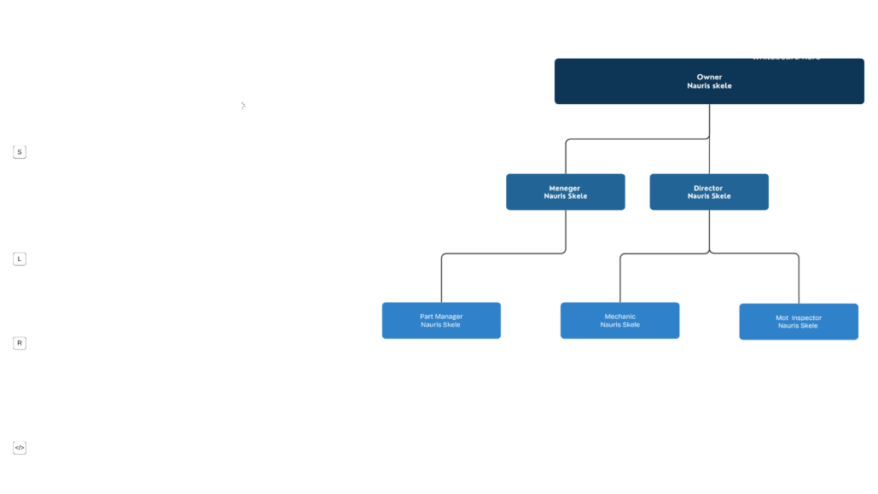
Mot Inspector ; Take cars to check Yearly cars condition to ensure its on good condition and give yearly certificate

PESTLE Analysis for my business

Political:
- Environmental Regulations and Emission Standards: Governments worldwide are implementing stricter emission targets for vehicles to combat climate change. This leads to:
  - An increase in electric and hybrid vehicles, which require different maintenance and repair skills, equipment, and parts compared to traditional internal combustion engines.
  - Potential loss of business for shops not equipped or certified to service newer, more complex low-emission vehicles.

Emission standards for greener world
Safety standards for business and community
Social:
factors in a PESTLE analysis that are affecting car repair businesses include changing consumer attitudes toward car ownership, increased demand for transparency and convenience, and demographic shifts like an aging population and the decline of do-it-yourself (DIY) repairs.
- Consumers today are digitally empowered and expect seamless, connected experiences. Car repair businesses need to adapt by offering digital services, such as online booking, transparent repair tracking, and data-driven communication, to meet customer expectations

- Technological:
- Advanced Diagnostic Systems: Modern cars are equipped with complex onboard computers and sensors (OBD-II systems) that necessitate the use of sophisticated diagnostic software and scanners to identify problems accurately. This technology reduces diagnostic time but requires ongoing investment in current software and training.

Get online page to book appointments for costumers
From home and save time to come to shop
We get car collections from home if costumer cant or not have time to bring car to shop and we deliver back
Get right price online or by phone with costumer center before them come on shop with not surprised overpaid
Environmental:
Parts recycling and oil disposal
Legal:
Consumer Rights Laws: Give costumers warranty for repaired car that's will be on my service 6 months or 40.000 thousand miles

Marketing approach
- The 4 Ps of Marketing: This model is a foundational framework for developing a marketing strategy.
  - Product: What you are selling.
  - Price: The cost of your product or service.
  - Place: Where and how you will sell your product (e.g., online, retail).
  - Promotion: How you will communicate your product to your audience.
- The 7 Ps of Marketing: An expansion of the 4 Ps, adding three more elements crucial for service-based businesses.
  - People: The role of the employees and their interaction with customers.
  - Process: The systems and procedures used to deliver the service.
  - Physical Evidence: The tangible aspects of the service, like a website or a physical location.

My business demographics customers will be just starting from 18 years old because people are not driving a car less that's age
This company will be base on Ipswich town witch is large Suffolk town with many cars around
Income ;
MOT centre will be full booked Because MOT needs do every year for all cars
Targeting:
Primary audience who will come to my shop will be any person who has have a car and 18 up that's age for fix that car or do MOT
Positioning:
My Company will be positioned as a fast and quality based garage that offer guaranteed repair services to our customers.
Marketing channels:
I will use social media marketing and send out posters about my business. And location. I’m using this poster methods because I’m now working on printing company and I know how to do posters and where can get them for good price Other methods will be costumers will recommend my garage other people to know where my business locations will be
Promotion Strategy:
We will be give loyal customers after every 5 time oil change for free. And free car check if you fix car on my shop.
Start up costs |  | Amount
Rent Deposit |  | 4000
Accessories |  | 1500
Toiletries |  | 100
Insurance |  | 300
Parts |  | 2800
Accountant |  | 150
Marketing fees |  | 400
Facilities and equipment |  | 8200
Total |  | 17450

 | Fixed Cost per month
 | License and software |  |  | 300
 | Salary |  |  | 2800
 | Marketing |  |  | 150
 | Rent |  |  | 3000
 | Total |  |  | 6250
 | Variable costs |  | Jan |  |  | Feb |  | March |  |  | April |  | May |  | June
 | Accessories |  | 400 |  |  | 350 |  | 250 |  |  | 350 |  | 150 |  | 120
 | marketing fees |  | 250 |  |  | 300 |  | 250 |  |  | 200 |  | 180 |  | 200
 | Toiletries |  | 125 |  |  | 100 |  | 150 |  |  | 75 |  | 90 |  | 100
 | Gas and electricity |  | 775 |  |  | 750 |  | 650 |  |  | 625 |  | 420 |  | 420
 | total |  | 1550 |  |  | 1500 |  | 1300 |  |  | 1250 |  | 840 |  | 840
 |  |  |  |  | cash flow forecast
Description |  | Jan |  |  | Feb |  |  |  | Mar |  |  | April |  | May |  | June
Fixed costs |  | 6250 |  |  | 6250 |  |  |  | 6250 |  |  | 6250 |  | 6250 |  | 6250
variable costs |  | 1550 |  |  | 1500 |  |  |  | 1300 |  |  | 1250 |  | 840 |  | 840
Total costs |  | 7800 |  |  | 7750 |  |  |  | 7550 |  |  | 7500 |  | 7090 |  | 7090
Ravenue |  | 1500 |  |  | 2500 |  |  |  | 2800 |  |  | 3700 |  | 4300 |  | 5800
Profit/loss |  | -6300 |  |  | -5250 |  |  |  | -4750 |  |  | -3800 |  | -2790 |  | -1290

Start up cost for my business MOTOR WHEELS at Location in Ipswich

- Rent 4000£
- Accessories 1500£
- Toiletries 100£
- Gas and electricity 300£
- Salary 2800£
- Accountant 150£
- Marketing fees 400£
- Facilities and equipment 8200£

References

https://www.google.com/search?q=examples+of+PESTLE+techonological+factors+that+is+affecting+car+repair+businesses

https://www.google.com/search?q=examples+of+PESTLE+Socialfactors+that+is+affecting+car+repair+businesses

https://www.google.com/search?q=examples+of+pestle+political+is+affecting+car+repair+businesses

https://www.gov.uk/become-sole-trader

https://www.google.com/search?q=marketing+approaches+for+business

