

University of Wales Trinity St. David
Electrical/Electronic Engineering

ACDA6004

Matt Haycock
2012802

Assignment report – Power Electronics & Drives

Date 25th April 2023

Contents
1. Abstract 4
2. Introduction 5
3. Task1 6
3.1 Motor A 6
3.2 Motor B 8
3.3 Motor C 10
3.4 Motor D 12
3.5 Motor E 14
4. Conclusion 16
5. Task 2 17
5.1 Diodes 17
5.2 Thyristors (SCRs) 18
5.3 IGBT 19
5.4 Comparison Table 20
5.5 Harmonics and Power factor 21
6. Conclusion 23
7. References 24

Figures

Figure 1 VFD system in factory 5
Figure 2 Rolling Mill in operation 7
Figure 3 Gantry Crane in operation 9
Figure 4 Conveyor in production 11
Figure 5 Cutting machine in factory 13
Figure 6 Fans in factory 15
Figure 7 Typical diode 17
Figure 8 Diode bridge rectifier 17
Figure 9 Thyristor 18
Figure 10 IGBT 19
Figure 11 Circuit diagram of diode bridge half wave rectifier and accompanying waveform 21
Figure 12 Circuit diagram of a three-phase full wave diode rectifier. 21
Figure 13 IGBT Rectifier circuit 22

Tables
Table 1 Motor A comparison table 6
Table 2 Motor B comparison table 8
Table 3 Motor C comparison table 10
Table 4 Motor D comparison table 12
Table 5 Motor E comparison table 14
Table 6 Rectifier comparison table 20

Abstract
This report shows solutions when a refit was required in a factory for its motor drive systems. The following equipment were required:
- 5 Rolling mills
- 10 Gantry cranes
- 23 Conveyors
- 17 Cutting machines
- 127 Pumps/fans
All ABB motors were chosen to aid with ease of installation, set up and configuration, making compatibility with communication also a factor for choice. A common DC bus would be used to improve quality of power, efficiency, and wiring reduction. System control would be performed with a PLC set up it gave a balance of precision of speed and torque as well as being able to communicate with other equipment in the factory. An HMI display would also monitor and log the running of the equipment and display warnings or alarms when triggered.
For rectification, diodes in series would be used for the lower powered drives, and for higher powered drives, IGBT would be used.
The total price of the refit was estimated to cost £ 345,319.43

Introduction
In modern industrial automation, an essential component was the motor drive system. They were used in various industries and were a used in various applications due their ability to control torque and speed.
To choose the correct equipment for a solution within industry, factors such as control and monitoring systems, type of starter, use of DC buses and cost all play a part in the overall decision.
For the use of the motor drive system, variable frequency drives (VFD), as shown in figure 1, [1]were used in many industries as they offered efficiency and precision by the use of electrical control to adjust the frequency and voltage when required to move cranes or heavy-duty appliances. In comparison, hydraulic or mechanical systems were less efficient and precise as they relied on a high level of physical components such as gears, pistons, and levers for the power, which had the potential to break down and wear. [2]
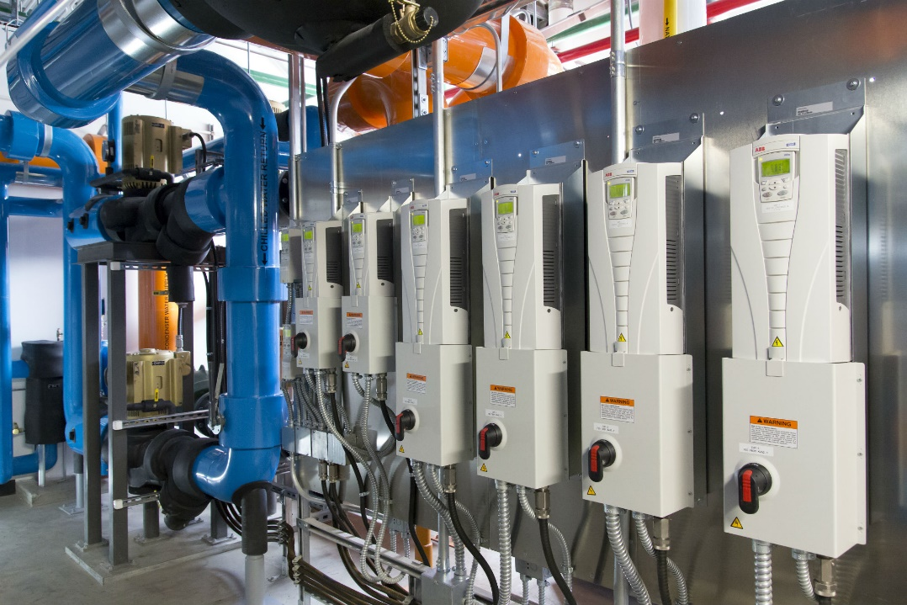
Figure 1 VFD system in factory
Harmonics also play a big part in motor drive systems, as the VFD converts the AC power into DC and then back to AC at a variable frequency. A distorted waveform would be produced for current, and a harmonic distortion would develop. This would reduce efficiency and interfere with equipment close by. [3]
Power factor takes the ratio of real and apparent power in an electrical system and shows how efficient the system is when running. When this is low, efficiency is compromised which would result in penalties by energy companies. [4]
The VFD has a big impact on the power factor as they run with frequency varying to the motor. This would be improved by phase adjustment between voltage and current.

Task1

Motor A
Manufacturer | Product Series | Technical Spec | Price
ABB | ACS880-01  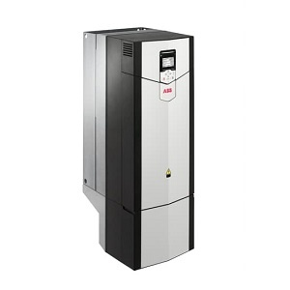 [5] | Max Power Output – 560kW  Output Voltage – 0 to 500VAC  Phase – 3  Max frequency – 500Hz  Reversible – Yes  Variable speed – Yes  Protection – Overload/Phase loss  Communication – Ethernet Ip/device Net | £21,438.40
Siemens | Sinamics G120P  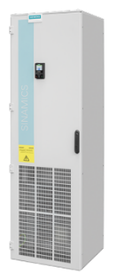 [6] | Max Power Output – 560kW  Output Voltage – 0 to 690VAC  Phase – 3  Max frequency – 650Hz  Reversible – Yes  Variable speed – Yes  Protection – Overload/Phase loss  Communication – CANopen/Ethernet | £20.121.43
Schneider | Altivar Process ATV930C63N4  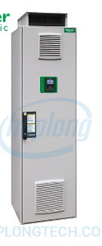 [7] | Max Power Output – 630kW  Output Voltage – 0 to 480VAC  Phase – 3  Max frequency – 600Hz  Reversible – Yes  Variable speed – Yes  Protection – Overload/Phase loss  Communication – Ethernet Ip/device Net | £18,341.98
Danfoss | VLT Automation Drive FC302  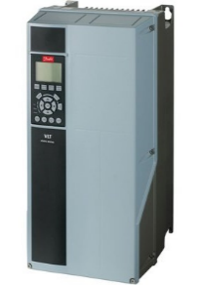 [8] | Max Power Output – 950kW  Output Voltage – 0 to 480VAC  Phase – 3  Max frequency – 600Hz  Reversible – Yes  Variable speed – Yes  Protection – Overload/Phase loss  Communication – Ethernet Ip/device Net | £20,154.76
Table 1 Motor A comparison table

As shown in table 1, the ABB ACS880-01 was chosen for the rolling mill motor. This was due to the addition of a PSTX motor starter, which would produce a soft start and also include a relay to protect the motor. It also provided overload protection of the motor. This was especially important for a rolling mill as the drive and motor system would be under heavy stress form high loads and temperature.
An external DC bus would be fitted to allow a common DC bus configuration. This would be useful for the rolling mills as multiple drives would be used. This would allow the energy to be used in multiple drives and would increase the efficiency of the drives and lower running costs. [9]
The ACS880-01 also had other protection with regards to over and under voltage, overcurrent, phase loss and short circuits. All this protection aided to keep the rolling mill reliable and safe
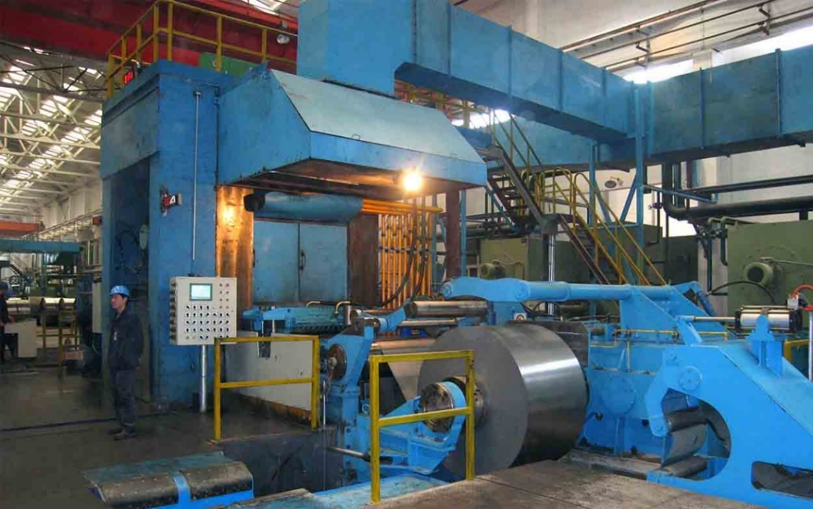
Figure 2 Rolling Mill in operation
The system also had the capability to data log any fault condition along with speed of motor, temperature, voltage and current. This would be beneficial to identify trends that could cause potential long-term effects for the tool. A diagnostic tool further enhanced monitoring by identifying root causes to resolve issues quicker.
The control system was compatible with communication protocols such as Ethernet, Modbus and CANopen. This gave the system a flexibility to integrate with a variety of other systems. [10]
The price of the ABB ACS880-01 was £21,438.40, and five were required for the new refit.
Total price 21,438.40 X 5
= £107,192

Motor B
Manufacturer | Product Series | Technical Spec | Price
ABB | ACS880-01-169A-3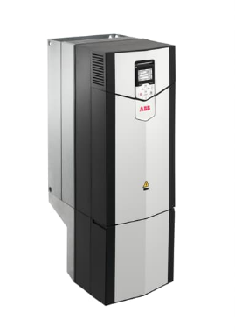 [11] | Max Power Output – 90kW  Output Voltage – 380 to 415VAC  Phase – 3  Common DC Bus – Yes (External)  Reversible – Yes  Variable speed – Yes  Protection – Overload/Phase loss  Communication CAN  Device Net  Ethernet/IPr | £8549.23
Siemens | SINAMICS G120C  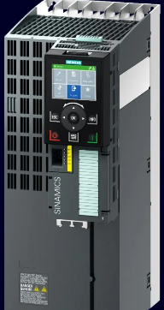 [12] | Max Power Output – 250kW  Output Voltage – 380 to 480VAC  Phase – 3  Common DC Bus - Yes  Reversible – Yes  Variable speed – Yes  Protection – Overload/Phase loss  Communication – Scaler VF/ Siemens' Start drive | £9213.43
Schneider | Altivar Process ATV630D90N4  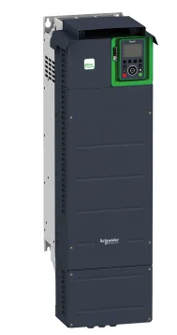 [13] | Max Power Output – 90kW  Output Voltage – 0 to 400VAC  Phase – 3  Common DC Bus - Yes  Reversible – Yes  Variable speed – Yes  Protection – Overload/Phase loss  Communication – Modbus/TCP, Modbus serial link | £10,121.34
Danfoss | VLT Automation Drive FC 302  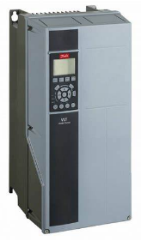 [14] | Max Power Output – 150kW  Output Voltage –380 to 500VAC  Phase – 3  Common DC Bus - Yes  Reversible – Yes  Variable speed – Yes  Protection – Overload/Phase loss  Communication PROFIBUS DP V1 /DeviceNet/CANopen | £9132.12
Table 2 Motor B comparison table

As shown in table 2, the ACS880-01-169A-3 was chosen for the motor drive system for the gantry crane due to the cranes requirements of reversible and variable speeds. This drive system allowed for this with a range of speed control. With a range up to 600Hz, this allowed high accuracy and precision for the movement of the crane and allowed movement in both directions which was imperative for efficiency and safety. A soft starter would be applicable due to smooth acceleration.
The ACS880-01 also gave a high level of protection against overloads which would prevent the motor from burn out due to overheating from high current. The drive would shut down if undervoltage was detected from not operating at it rated load. [15]
Fluctuations in voltage were also protected against using sensors with pre-sets. If the pre-set was exceeded, the system would take corrective action.
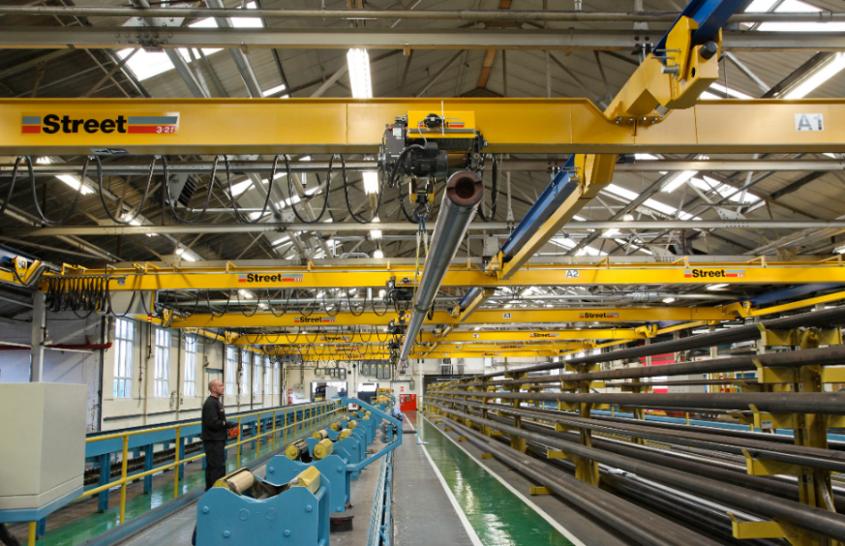
Figure 3 Gantry Crane in operation

The drive supported a common DC bus configuration. This would aid the gantry crane system by saving energy and reduce the harmonics. These would cause distortion of current and voltage if a load of non-linearity from the variable load. Stability and precision would be compromised.
As ten cranes was required in the refit, the common DC bus allowed multiple drives to share a power source. This would reduce components; wiring simplification and costs would be lowered. The ACS880-01 offered flexibility and control for the motors torque and speed by starting the motor gradually and give better positioning to handle material, as shown in figure 3 [16]
The price of the ABB ACS880-01-169A-3 was £8549.23, and ten were required for the new refit.
Total price £8549.23 X 10
= £85,490.23

Motor C
Manufacturer | Product Series | Technical Spec | Price
ABB | ACS880-01-038A-3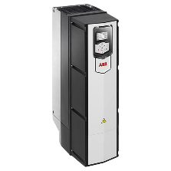 [17] | Max Power Output – 15kW  Output Voltage – 380 to 480VAC  Phase – 3  Common DC Bus - Yes  Reversible – Yes  Variable speed – NO  Protection – Overload/Phase loss  Communication Modbus, PROFIBUS | £4247.53
Siemens | SINAMICS G120C  6SL3210-1KE23-2UP1  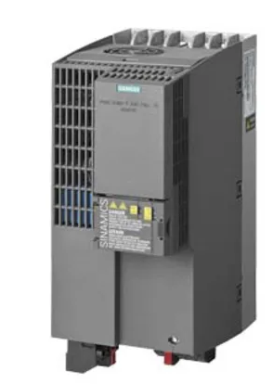 [18] | Max Power Output – 11kW  Output Voltage – 380 to 400VAC  Phase – 3  Common DC Bus - Yes  Reversible – Yes  Variable speed – No  Protection – Overload/Phase loss  Communication – ROFIBUS DP, USS, Modbus RTU | £6512.67
Schneider | Schneider Electric Altivar 312  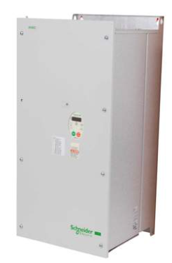 [19] | Max Power Output – 18kW  Output Voltage – 0 to 480VAC  Phase – 3  Common DC Bus - Yes  Reversible – Yes  Variable speed – No  Protection – Overload/Phase loss  Communication – Modbus, CANopen, DeviceNet | £5412.98
Danfoss | Danfoss VLT Micro Drive FC  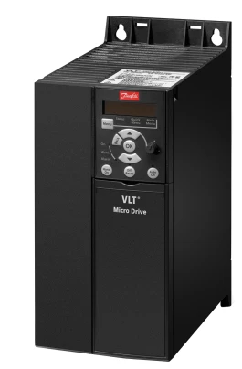 [20] | Max Power Output – 22kW  Output Voltage –20 0 to 450VAC  Phase – 3  Common DC Bus - No  Reversible – Yes  Variable speed – Yes  Protection – Overload/Phase loss  Communication Modbus RTU, CANopen, Profibus | £3412.54
Table 3 Motor C comparison table

As shown in table 3, the ACS880-01-038A-3 was chosen due to variable drives starter, as this would reduce any inrush of current by reducing any stress the motor would incur. The starter would also protect against any overloads or short circuits. Using a voltage of 380 – 420VAC and an output of 15kW, this would be sufficient to run a conveyor in a factory. [21]
Energy saving would also be beneficial by the speed adjustment of the motor matching load requirements. Extensive use of the conveyor would be saved by this variable drive.
Longevity of the conveyors motor would be possible from a steady operation by the variable drive and maintain components under constant stress.

Figure 4 Conveyor in production

As shown in figure 4 [22] ,downtime reduction and productivity increase would be possible from controlled precision of torque and speed of the motor. This would allow specified requirements of the conveyor’s operation.
This model was also adaptable to use a range of communication protocol and was capable of simple integration with control systems.
By having a common DC bus would also allow quality improvements of power for the system by lowering the possibility of spiking and various noise to the supply.
The price of the ABB ACS880-01-038A-3 was £4247.53, and twenty-three were required for the new refit.
Total price £ 4247.53 X 23
= £ 97,693.19

Motor D
Manufacturer | Product Series | Technical Spec | Price
ABB | ACS310-03E-13A8-4 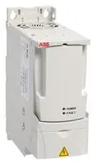 [23] | Max Power Output – 5.5kW  Output Voltage – 380 to 480VAC  Phase – 3  Common DC Bus - No  Reversible – Yes  Variable speed – NO  Protection – Overload/Phase loss  Communication Modbus, PROFIBUS | £914.40
Siemens | SINAMICS G120C  6SL3210-1KE21-3UB1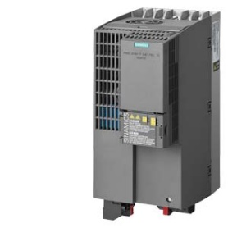  [24] | Max Power Output – 10kW  Output Voltage – 380 to 400VAC  Phase – 3  Common DC Bus - Yes  Reversible – Yes  Variable speed – No  Protection – Overload/Phase loss  Communication – ROFIBUS DP, USS, Modbus RTU | £903.90
Schneider | Altivar 61: ATV61HU22N4  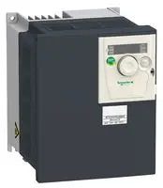 [25] | Max Power Output – 5.5kW  Output Voltage – 0 to 480VAC  Phase – 3  Common DC Bus - Yes  Reversible – Yes  Variable speed – No  Protection – Overload/Phase loss  Communication – Modbus, CANopen, DeviceNet | £1890.12
Danfoss | Danfoss VLT Micro Drive FC  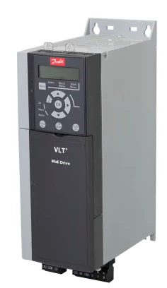 [26] | Max Power Output – 5.5kW  Output Voltage –20 0 to 450VAC  Phase – 3  Common DC Bus - No  Reversible – Yes  Variable speed – Yes  Protection – Overload/Phase loss  Communication Modbus RTU, CANopen, Profibus | £1089.12
Table 4 Motor D comparison table

As shown in table 4, the ACS310-03E-13A8-4 was chosen for the motor drive for the cutting machine, as shown in figure 5 [27], with a power rating of 5kW would give the machine control of speed and torque required as it was a variable frequency drive. This would be important for a cutting machine as different material and type of cut would be required for the operation. The use of a DOL (Direct on Line), starter would be required due to the size of the motor.
The three phases would give the machine necessary integration of the power within the factory. [28]
The system also incorporated over voltage and current protection as well as protection against a thermal overload.
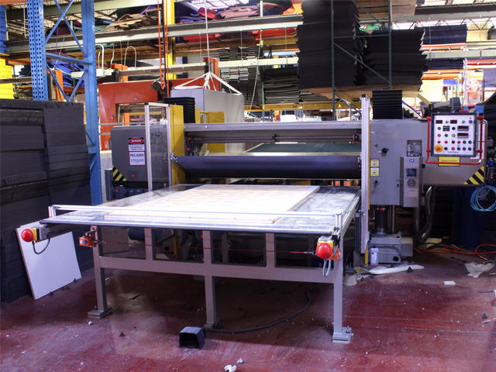
Figure 5 Cutting machine in factory
Communication of the system used various options such as ethernet and Profibus. This would allow a simplified integration of the control system.
The system was also in the mid-range price bracket and would provide a balance of reliability and efficiency at a reasonable price. For applications like the cutter that required power requirements of a moderate level, this equipment would suit.
The price of the ACS310-03E-13A8-4 was £914.40, and seventeen were required for the new refit.
Total price 914.40 X 17
= £15,544.80

Motor E
Manufacturer | Product Series | Technical Spec | Price
ABB | ACS150-01E-07A5-2  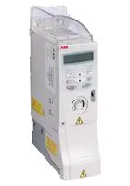 [29] | Max Power Output – 1.5kW  Output Voltage – 200 to 240VAC  Phase – 1  Common DC Bus - No  Reversible – No  Variable speed – NO  Protection – Overload/Short circuit  Communication Modbus, PROFIBUS | £310.23
Schneider | ATV12HU15M2  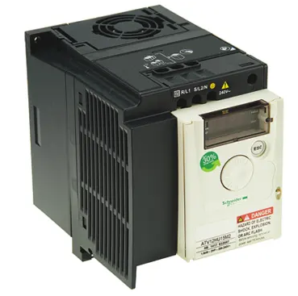 [30] | Max Power Output – 1.5kW  Output Voltage – 230VAC  Phase – 1  Common DC Bus - Yes  Reversible – No  Variable speed – No  Protection – Overvoltage, Undervoltage, Overcurrent  Communication – Modbus, CANopen, Ethernet | £160.38
Siemens | 6SL3210-1PB21-0AL0  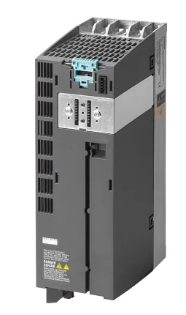 [31] | Max Power Output – 2.2kW  Output Voltage – 230VAC  Phase – 1  Common DC Bus - Yes  Reversible – No  Variable speed – No  Protection – Overvoltage, Undervoltage, Overcurrent Communication – Modbus, CANopen, DeviceNet | £389.12
Danfoss | 132F0005  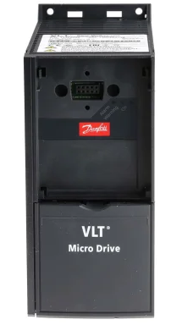 [32] | Max Power Output – 1.5kW  Output Voltage – 230VAC  Phase – 1  Common DC Bus - No  Reversible – No  Variable speed – No  Protection – Overvoltage, Undervoltage, Overcurrent Communication Modbus, CANopen, Ethernet | £533.68
Table 5 Motor E comparison table

As shown in table 5, the ACS150-01E-07A5-2 was chosen due to it being the same manufacturer as the rest of the motor drive and would make it easier for aftermarket and maintenance to supply and sustain the equipment.
A DOL would be used for this motor drive as it would benefit the use of a pump or fan, as shown in figure 6 [33], due to having low power, a soft starter wouldn’t be required. This would give longevity to the equipment by preventing an inrush of current and reduce stresses on the motor itself. [34]
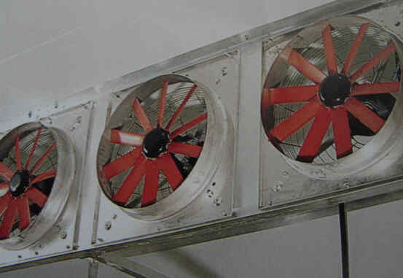
Figure 6 Fans in factory
Protection came from ground fault detection to monitor shorts in the system. A monitoring sensor in the unit would also detect if the motor overheated and would stop if a set limit was reached.
Various protocols such as ethernet or Modbus were used for this motor drive system to be integrated with either a PLC or HMI. This would monitor in real time of the motor’s performance and alarms.
The price of the ACS150-01E-07A5-2 was £310.23, and 127 were required for the new refit.
Total price £310.23 X 127
= £39,399.21

Conclusion
The decision was made to use common DC bus for the motor drive system of the high-powered devices as it allowed them to share power and become more efficient.
Via the DC link, the drives connected to the common DC bus. By way of energy saving, regenerative braking fed the energy back to the DC bus instead of heat dissipation. This would in turn power the other drives. [35]
Impact on the environment would also be reduced as efficiency and cost would be aided.
A PLC using ethernet communication was preferred as this was frequently used in industry and gave high speed transmission of data. This was important for real time communication and control. [36]
The PLC would have the ability to expand to a larger system if required as the addition of drives to the system would increase I/O capabilities.
An HMI would also be used to monitor the overall system and show if any alarms or warnings are triggered due to malfunction or electrical faults.

Task 2
For the use of variable frequency drives (VFD), and the rectification of the incoming mains, various types of devices could be used by way of semi – conductor. These would include insulated gate bipolar transistors (IGBTs), thyristors or silicon-controlled rectifiers (SCRs), and diodes.

Diodes
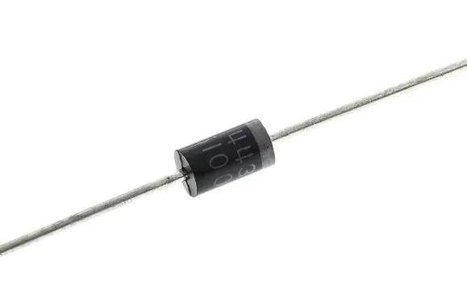
Figure 7 Typical diode
Diodes were used in systems that required low power, and with regards to rectification, the simplest. Applied within full or half-wave rectifiers, diodes allow only one direction of flow of current. In comparison to other rectifiers, the loss of power is high due to forward voltage drop when conducting current. Dissipation of heat occurs during this process, hence the loss of power. [37]
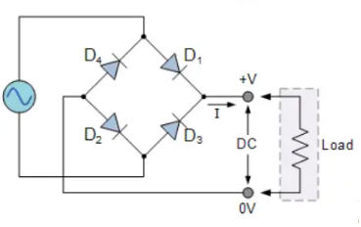
Figure 8 Diode bridge rectifier
As shown in figure 8 [38], the diode bridge rectifier would give half positives waveforms and would be smoothed out with capacitors. Overall, the diode was low cost and simplistic, but low on efficiency in comparison to other rectification methods. These would be sufficient for the lower power pumps and fans.

Thyristors (SCRs)

As shown in figure 9, the thyristor was capable of a higher level of power in comparison with the diode. They were a rectifier that was controllable and was able to alter the flow of current within by the adjustment of the angle of trigger for the signal of the gate. [39]
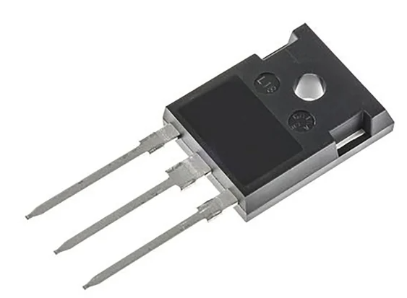
Figure 9 Thyristor

But the SCR drop of voltage was higher in comparison to an IGBT. This was due to a forward voltage drop, like the diode, but current would still conduct even if the signal from the gate was off. It would latch and until current dropped its levels, still be in the on-state. A delay in actually turning off the signal would cause unwanted dissipation of power. [40]
Overall, the SCR was applicable for AC motors and applications that required large amounts of power, but efficiency would be an issue. These would be applicable for the higher-powered applications like the cutting machine, conveyor, crane and rolling mill.

IGBT
As shown in figure 10 [41], the IGBT was a power device that used a combination of large impedance form the input of MOSFET and small losses of conduction when on-state of a BJT. They have capacity for high voltage and current applications.
Used frequently for motor drives and supplies of power, they are capable of high-speed switching, this would be useful for the motor drive system as it gave a higher level of precision and control for the motors speed and torque. [42]
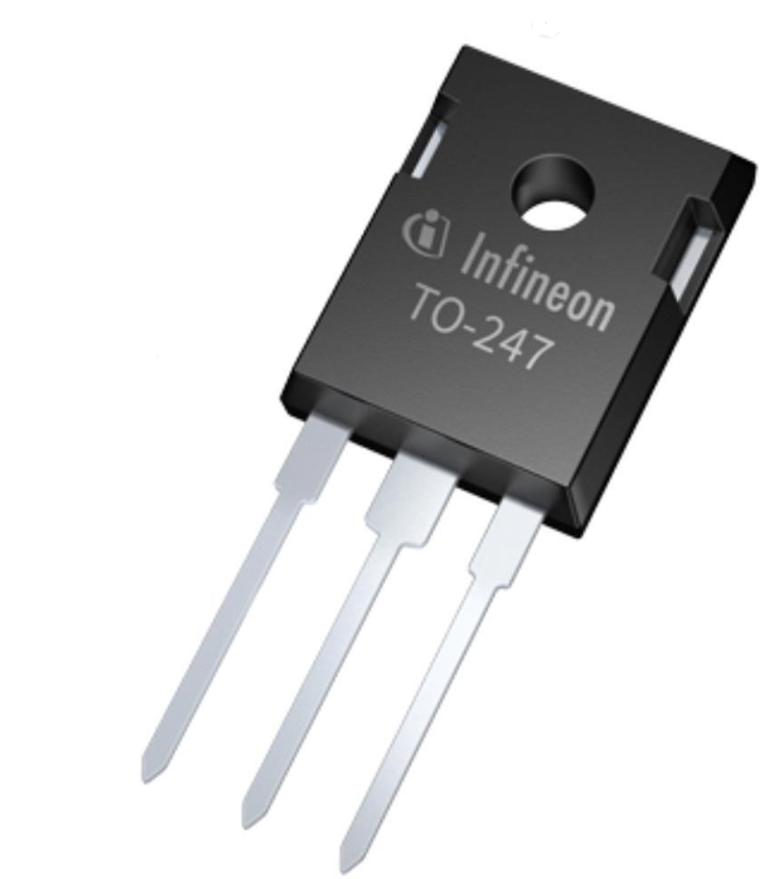
Figure 10 IGBT

It would also give better efficiency by switching current and voltage on and off at high speed. This would lower the time of on state and lower loss of conduction. This would result in a smooth operation with a smaller amount of energy loss. Lifetime of the component would be increased as heat loss would be minimised and lower the inclusion of any system to for cooling. [43]
Overall, the IGBT would be the most beneficial for the motor drive systems mains as it aided in allowing precision of control which helped performance and efficiency.

Comparison Table
Device Type | Advantages | Disadvantages | Applications
Diodes  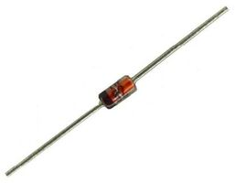 [44] | - Low Cost  - Simple set up | - High power loss | - Low power pumps  - Cutting machine
Thyristors  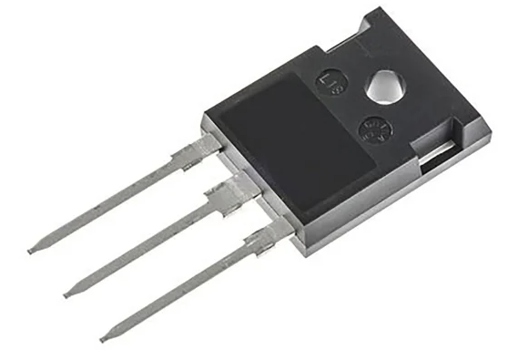 [45] | - High current and voltage ratings  - Able to control AC power | - High voltage drop off  - Turn off time slow  - Harmonic distortion likely | - Gantry cranes  - Rolling mill
IGBT  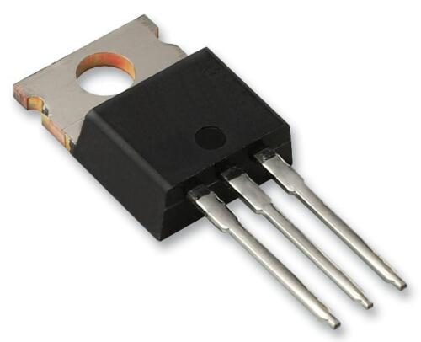 [46] | - Low power loss  - Fast switching speed  - Able to handle high voltage and current  - Low harmonic distortion | - High cost | - Gantry cranes  - Rolling mill
Table 6 Rectifier comparison table

Harmonics and Power factor
The three different types of rectification had varying levels of harmonic distortion. Diodes contained a harmonic distortion of high levels, while IGBTs contained low levels, SCR rectifiers sat in between the other two for these levels.
When using a diode bridge rectifier, a capacitor could be used to smooth the output voltage and lower ripples in the waveform. As the diode conducted the capacitor would charge, then discharge when the diode was off, as shown in figure 11 [47]. Careful consideration of the value of the capacitor would be important as it required filtering effectively and not cause resonance, as this would lead to influx of heat and a reduction in efficiency. [48]
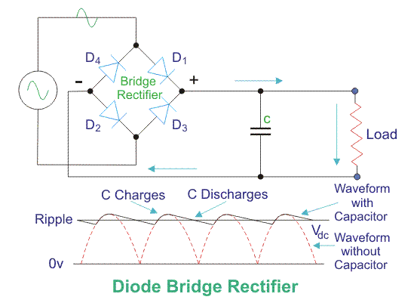
Figure 11 Circuit diagram of diode bridge half wave rectifier and accompanying waveform
A three-phase bridge full wave diode rectifier, as shown in figure 12 [49], would lower distortion by cancellation of the harmonics over the three phases, as it contained a lower output of ripple. This was due to having a six times frequency of the waveform. Six diodes would be used in total for the bridge set up, with a pair of diodes connected to each phase of the AC input. [50]
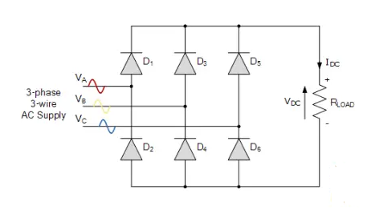
Figure 12 Circuit diagram of a three-phase full wave diode rectifier.
Passive filters could also be used to attenuate harmonics at a specific level and would be situated at the input or output of the drive. These would contain a mixture of resistors, capacitors, and inductors. At certain frequencies they would impede the current flow. This would be determined by the requirements of the frequencies to be attenuated. [51]
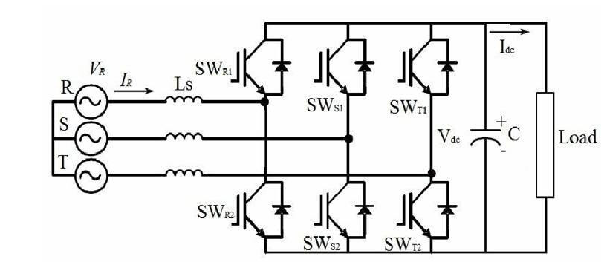
Figure 13 IGBT Rectifier circuit
For IGBT, as shown in figure 13 [52], and SCR type rectifiers, an active front end set up would manipulate the waveform of the current input and lower harmonic distortion. This active switching circuit would be used to lower distortion from the input and a sinusoidal waveform. [53]
Power factor correction circuits would also increase efficiency of the system and lower the harmonic distortion levels. If the power factor was too low, it would indicate that the correlation between input and load power was distorted and out of sync. This would produce a high harmonic distortion. Input current and voltage waveforms would be corrected by using this method of power factor correction. [54]
Harmonics cause vary effects on power and power factors. A loss of power is apparent when a current of harmonic distortion flows into elements of resistance. Efficiency and consumption of energy are compromised. The reactive power increases thus lower the power factor.
With this distortion of harmonics present the potential to damage equipment like transformers and cable due to overloading would be apparent.

Conclusion
With regards to rectification of the system, diodes were chosen for the smaller motor drives as they would handle lower current. When the motor power increased the current also increased and this would cause the diode to fail.
Efficiency would also be compromised as losses occur from voltage drops when conducting current, so efficiency of energy was a paramount for high power machines. [55]
For the higher power drives, IGBT would be preferred as they had the ability to minimise harmonics and improve power factor. The IGBT efficiency came from low on state resistance and high switching speeds.
The power factor would be improved by the adjustment of the phase between current and voltage. This would also reduce harmonic distortion by the reduction of the higher frequencies in the waveform. Interference with equipment in close proximity would also be lowered.

References

[1] | Fuller, “ABB VFD,” Fuller, [Online]. Available: https://fullerengr.com/abb-vfds/. [Accessed 23 March 2023].
[2] | T. H. Blair, “Variable Frequency Drive Systems,” in Energy Production Systems Engineering, Wiley , 2017, pp. 441 - 466.
[3] | L. Motta, “Active / passive harmonic filters: Applications, challenges & trends,” IEEE, belo Horizonte, 2016.
[4] | M. Nalbant, “Power factor calculations and measurements,” IEEE, Los Angeles, 2002.
[5] | I. C. Direct, “ABB AC Drives ACS880-01-302A-5,” [Online]. Available: https://www.industrialcontroldirect.com/abb-acs880-01-302a-5-5421.html. [Accessed 7 March 2023].
[6] | Siemens, “SINAMICS G120P - a broad portfolio with a specific focus,” [Online]. Available: https://new.siemens.com/fr/fr/produits/automatisation-entrainements/variateurs/low-voltage-converters/industry-specific-frequency-converter/sinamics-g120p.html. [Accessed 7 March 2023].
[7] | Schneider, “Altivar Process 930 Variable Frequency Drives VFD,” Schneider, [Online]. Available: https://www.se.com/us/en/product-range/63124-altivar-process-930-variable-frequency-drives-vfd/. [Accessed 7 March 2023].
[8] | Danfoss, “VLT® AutomationDrive FC 301/FC 302,” Danfoss, [Online]. Available: https://www.danfoss.com/de-de/products/dds/low-voltage-drives/vlt-drives/vlt-automationdrive-fc-301-fc-302/. [Accessed 7 March 2023].
[9] | Y. Chen, “The application of common DC bus-bar in variable frequency AC speed-adjusting system,” IEEE, Homhot, 2011.
[10] | J. jaspernite, “Measurement, analysis and modeling of real-time source data traffic in factory communication systems,” IEEE Explore, [Online]. Available: https://ieeexplore.ieee.org/document/882565. [Accessed 23 March 2023].
[11] | ABB, “Detailed information for: ACS880-01-169A-3,” ABB, [Online]. Available: https://new.abb.com/products/3AUA0000108027/acs880-01-169a-3. [Accessed 8 March 2023].
[12] | Siemens, “SINAMICS G120 - The modular multifunctional frequency converter,” Siemens, [Online]. Available: https://www.siemens.com/global/en/products/drives/sinamics/low-voltage-converters/standard-performance-frequency-converter/sinamics-g120.html. [Accessed 8 March 2023].
[13] | RS, “Schneider Electric Variable Speed Drive, 90 kW, 3 Phase, 400 V, ALTIVAR 630 Series,” Schneider, [Online]. Available: https://uk.rs-online.com/web/p/inverter-drives/8724088?cm_mmc=UK-PPC-DS3A-_-bing-_-3_UK_EN_Automation+%26+Control+Gear_Inverter+Drives_Exact-_-Schneider+Electric+-+8724088+-+ATV630D90N4-_-atv630d90n4&matchtype=e&kwd-72087342724419:loc-188&gclid=4048089b6b. [Accessed 8 March 2023].
[14] | Danfuss, “AutomationDrive FC 301 / FC 302,” Danfuss, [Online]. Available: https://www.danfoss.com/en/products/dds/low-voltage-drives/vlt-drives/vlt-automationdrive-fc-301-fc-302/#tab-overview. [Accessed 8 March 2023].
[15] | A. Tsimtsios, “An undervoltage protection function for distributed generators complying with the low-voltage-ride-through requirements,” in 15th International Conference on Developments in Power System Protection (DPSP 2020), Liverpool, 2020.
[16] | Streetcrane, “Underslung Cranes,” Streetcrane, [Online]. Available: https://streetcrane.co.uk/cranes/underslung-cranes/. [Accessed 23 March 2023].
[17] | Q. Controls, “ACS880,” ABB, [Online]. Available: https://new.abb.com/products/3AUA0000108019/acs880-01-038a-3. [Accessed 8 March 2023].
[18] | RS, “Siemens Inverter Drive,” Siemens, [Online]. Available: https://uk.rs-online.com/web/p/inverter-drives/1749043?cm_mmc=UK-PLA-DS3A-_-bing-_-PLA_UK_EN_Automation_%26_Control_Gear_Whoop-_-Inverter+Drives_Whoop+(2)-_-1749043&matchtype=e&pla-4574999169032303&gclid=0faf69f6268719f2ba240dfee68bc3d5&gclsrc=3p.ds&msclk. [Accessed 8 March 2023].
[19] | Schneider, “Schneider Altivar 480V 18.5kW 25hp Variable Speed Drive,” CEF, [Online]. Available: https://www.cef.co.uk/catalogue/products/1862833-variable-speed-drives-480v-18-5kw?gclid=837c8abdca86180a3066eeb508902bf6&gclsrc=3p.ds&msclkid=837c8abdca86180a3066eeb508902bf6&utm_source=bing&utm_medium=cpc&utm_campaign=Smart%20Shopping%3A%20Industrial%20. [Accessed 8 March 2023].
[20] | RS, “Danfoss Inverter Drive, 11 kW, 3 Phase, 400 V,” Danfoss, [Online]. Available: https://uk.rs-online.com/web/p/inverter-drives/8918845. [Accessed 8 March 2023].
[21] | C. Nwaoha, “Process Plant Equipment,” in Operation, Control, and Reliability, London, Wiley, 2012, pp. 234- 237.
[22] | SSME, “Food Grade Modular Belt Food Conveyors,” SSME, [Online]. Available: https://www.stainlesssteelequipment.co.uk/en-gb/products/food-conveyors/food-grade-modular-belt-food-conveyors. [Accessed 23 March 2023].
[23] | Farnell, “ACS310-03E-08A0-4,” ABB, [Online]. Available: https://uk.farnell.com/abb/acs310-03e-13a8-4/inverter-drive-3-ph-5-5kw/dp/2628043. [Accessed 9 March 2023].
[24] | RS, “Siemens Inverter Drive, 5.5 kW, 3 Phase,,” Siemens, [Online]. Available: https://uk.rs-online.com/web/p/inverter-drives/7918649?cm_mmc=UK-PLA-DS3A-_-bing-_-PLA_UK_EN_Automation_%26_Control_Gear_Whoop-_-Inverter+Drives_Whoop+(2)-_-7918649&matchtype=e&pla-4574999182199086&gclid=25d38965f87918a8a993ed6c1d1c336d&gclsrc=3p.ds&msclk. [Accessed 9 March 2023].
[25] | Farnell, “ATV312HU55N4,” Siemens, [Online]. Available: https://uk.farnell.com/schneider-electric/atv312hu55n4/drive-v-s-atv312-500v-5-5kw-3ph/dp/2043010. [Accessed 9 March 2023].
[26] | RS, “Danfoss Inverter Drive, 5.5 kW,,” Danfoss, [Online]. Available: https://uk.rs-online.com/web/p/inverter-drives/1250759?cm_mmc=UK-PLA-DS3A-_-bing-_-PLA_UK_EN_Automation_%26_Control_Gear_Whoop-_-Inverter+Drives_Whoop+(2)-_-1250759&matchtype=e&pla-4574999169032586&gclid=9c93b366ccaa12540025d76f20d11a06&gclsrc=3p.ds&msclk. [Accessed 9 March 2023].
[27] | S. cut, “Plasma Cutting,” [Online]. Available: https://swift-cut.com/?utm_campaign=CAM_STD_PPC&utm_source=SOUR_BING_PPC&msclkid=3ceab4b9109d13408705d0a583e0e583. [Accessed 23 March 2023].
[28] | J. Fleckenstein, in Three-Phase Electrical Power, London, CRC Press, 2017.
[29] | Farnell, “ACS150-01E-07A5-2,” ABB, [Online]. Available: https://uk.farnell.com/abb/acs150-01e-07a5-2/inverter-drive-micro-1-ph-1-5kw/dp/2628020. [Accessed 9 March 2023].
[30] | RS, “Schneider Electric Variable Speed Drive,” Schneider, [Online]. Available: https://uk.rs-online.com/web/p/inverter-drives/6695786. [Accessed 9 March 2023].
[31] | RS, “Siemens Power Module, 2.2 kW,” Siemens, [Online]. Available: https://uk.rs-online.com/web/p/inverter-drives/2255459. [Accessed 12 March 2023].
[32] | RS, “Danfoss Inverter Drive, 1.5 kW,,” Danfoss, [Online]. Available: https://uk.rs-online.com/web/p/inverter-drives/8918883. [Accessed 12 March 2023].
[33] | Dreamstime. [Online]. Available: https://www.dreamstime.com/industrial-fan-factory-ventilation-heating-industrial-fan-factory-ventilation-heating-image131808836. [Accessed 23 March 2023].
[34] | T. Siyun, “Design on controller of magnetic controlled soft starting for middle-high voltage motor,” in 2010 The 2nd Conference on Environmental Science and Information Application Technology, Wuhan, 2010.
[35] | M. Chen, “Research on Parallel Operation Control of Modules Based on Common DC Bus,” in 2018 IEEE 2nd International Electrical and Energy Conference (CIEEC), Beijing, 2018.
[36] | L. Wang, “Development of a distributed control system for PLC-based applications,” in 2010 International Conference on Machine Learning and Cybernetics, Qingdao, 2010.
[37] | S. Steudel, “Ultra-High Frequency rectification using organic diodes,” in 2008 IEEE International Electron Devices Meeting, San Francisco, 2023.
[38] | E. 4U, “Diode Bridge Rectifier,” [Online]. Available: https://www.electrical4u.com/diode-bridge-rectifier/?utm_content=cmp-true. [Accessed 23 March 2023].
[39] | “IEEE Standard Test Specification for Thyristor Diode Surge Protective Devices,” [Online]. Available: https://ieeexplore.ieee.org/document/9447436. [Accessed 23 March 2023].
[40] | K. Do, “A New SCR Structure With High Holding Voltage and Low ON-Resistance for 5-V Applications,” [Online]. Available: https://ieeexplore.ieee.org/document/8967020. [Accessed 23 March 2023].
[41] | Infineon, “Discrete IGBT without Anti-Parallel Diode,” Infineon, [Online]. Available: https://www.infineon.com/cms/en/product/power/igbt/igbt-discretes/discrete-igbt-without-anti-parallel-diode/. [Accessed 26 March 2023].
[42] | V. Kumar, “Insulated Gate Bipolar Transistor IGBT Theory and Design,” Wiley, 2003, pp. 1 -14.
[43] | L. Han, “A Review of SiC IGBT: Models, Fabrications, Characteristics, and Applications,” Transactions on Power Electronics, vol. 36, no. 2, pp. 2080 - 2093, 2021.
[44] | RS, “Vishay 400V 1A, Rectifier Diode, 2-Pin DO-204AL 1N4004-E3/54,” Vishay, [Online]. Available: https://uk.rs-online.com/web/p/schottky-diodes-rectifiers/8651861. [Accessed 26 March 2023].
[45] | RS, “Vishay VS-40TPS12A-M3, Thyristor 1200V, 35A 40mA,” RS, [Online]. Available: https://uk.rs-online.com/web/p/thyristors/9194404. [Accessed 26 March 2023].
[46] | RS, “Infineon IRG4PC50KDPBF IGBT, 52 A 600 V, 3-Pin TO-247AC, Through Hole,” RS, [Online]. Available: https://uk.rs-online.com/web/p/igbts/9133764. [Accessed 26 March 2023].
[47] | E. 4U, “Diode Bridge Rectifier,” [Online]. Available: https://www.electrical4u.com/diode-bridge-rectifier/. [Accessed 26 March 2023].
[48] | S. Gupta, “A Diode Bridge Rectifier With Improved Power Quality Using the Capacitive Network,” Transactions on Industry Applications, vol. 54, no. 2, pp. 1563 - 1572, 2017.
[49] | E. 4U, “What is a Three Phase Full Wave Diode Rectifier?,” [Online]. Available: https://www.electrical4u.com/three-phase-full-wave-diode-bridge-rectifier/. [Accessed 26 March 2023].
[50] | A. D. Gerlando, “Analytical model and implementation by equations of three-phase diode bridge rectifiers operation,” in The XIX International Conference on Electrical Machines - ICEM 2010, Rome, 2010.
[51] | J. Das, in Power System Harmonics and Passive Filter Designs, Wiley, 2015, pp. 203 - 210.
[52] | Sinepower, “IGBT rectifier vs 12 pulse rectifier,” [Online]. Available: https://www.sinepower.com/pt/igbt-rectifier-vs-12-pulse-rectifier-which-one-is-better/. [Accessed 24 April 2023].
[53] | L. Tan, “A novel control method for IGBT current source rectifier,” in 13th International Power Electronics and Motion Control Conference, Poznan, 2008.
[54] | Y. Roh, “Active Power Factor Correction (PFC) Circuit With Resistor-Free Zero-Current Detection,” Transactions on Power Electronics, vol. 26, no. 2, pp. 630 - 637, 2010.
[55] | E. Pool-Mazun, “Modular Three-Phase Diode Rectifier With High-Frequency Isolation and Selective Harmonic Elimination Modulation,” Journal of Emerging and Selected Topics in Industrial Electronics, vol. 4, no. 1, pp. 242 - 252, 2022.
[56] | 2D, “SA-IRxxxxV6-007 Infrared temperature sensor,” 2D, [Online]. Available: http://2d-datarecording.com/Downloads/Datasheets/Sensors-temperature/Pdf/SA-IRxxxxV6-007.pdf. [Accessed 20 November 2022].
[57] | A. Electronics, “Calex PC21MT-0,” RS, [Online]. Available: https://www.alliedelec.com/product/calex/pc21mt-0/70746067/. [Accessed 20 November 2022].
[58] | PyroCouple, “Compact Non-Contact Temperature Sensor,” Farnell, [Online]. Available: https://www.farnell.com/datasheets/222417.pdf. [Accessed 20 November 2022].
[59] | Euautomation, “D6T8L06,” Digikey, [Online]. Available: https://www.digikey.co.uk/en/products/detail/omron-electronics-inc-emc-div/D6T8L06/3671588. [Accessed 20 November 2022].
[60] | Omron, “MEMS Thermal sensor,” Omron, [Online]. Available: https://omronfs.omron.com/en_US/ecb/products/pdf/en_D6T_users_manual.pdf. [Accessed 20 November 2022].
[61] | RS, “Calex PC21MT-0 mA Output Signal Infrared Temperature Sensor, 1m Cable, 0°C to +250°C,” RS, [Online]. Available: https://in.rsdelivers.com/product/calex/pc21mt-0/calex-pc21mt-0-ma-output-signal-infrared-sensor-1m/0553349#_. [Accessed 20 November 2022].
[62] | PyroCouple, “General Purpose Infrared Temperature Sensor with Analogue Output,” Pyrocouple, [Online]. Available: https://docs.rs-online.com/8a16/0900766b80bd1522.pdf. [Accessed 20 November 2022].
[63] | Siemens, “SINAMICS G120P - a broad portfolio with a specific focus,” [Online]. Available: https://new.siemens.com/fr/fr/produits/automatisation-entrainements/variateurs/low-voltage-converters/industry-specific-frequency-converter/sinamics-g120p.html. [Accessed 7 March 2023].

