

Module name: Strategic Management

Module code: LCMB7003

A Strategic Management Analysis of Unilever Plc

Student name: Prajapati Jigarkumar Yogeshbhai

Student Id: 2430810
Lecturer’s Name: Balendran Kandasamy

Words: 5156

Table of Contents
Introduction 3
Section 1: Strategic Analysis of Unilever Plc 3
1. Organisational Context and Overview 3
2. External and Internal Environment Analysis 4
2.1 External Environment Analysis (PESTEL Framework) 4
2.2 Critical Success Factors and Strategic Challenges 6
2.3 Internal Environment Analysis 7
2.4 VRIO Analysis 8
2.5 Internal Strengths and Competitive Advantage 9
3. CSR and Sustainability Objectives 10
4. Comprehensive and Holistic View of Unilever 11
5. Strategic Choices and Implementation 13
6. Strategic Evaluation and Recommendations 15
6.1 Strategic Analysis based on SWOT Analysis 15
6.2 Strategic Evaluation using Ansoff’s Matrix 16
6.3 Strategic Improvement Recommendations 17
6.4 Justification of Recommendations 17
Section 2: Reflective Account (Gibbs Reflective Cycle) 18
Conclusion 20
References List 22

Introduction
The report of the strategic management of Unilever Plc by looking at its external and internal environment, the competitive positioning and sustainability integration. It will compare the ways in which Unilever is gaining sustainable competitive advantage in the intensely competitive global FMCG market by using major frameworks like PESTEL, VRIO and the Balanced Scorecard.

Section 1: Strategic Analysis of Unilever Plc

1. Organisational Context and Overview
Unilever Plc is a major multinational Fast-Moving Consumer Goods (FMCG) company, which was founded in 1929 because of merger between Margarine Unie and Lever Brothers. The firm has developed over the decades to be a global powerful organisation that has more than 400 brands and operates in more than 190 countries such as dove, lifebuoy, and Knorr (Hein Schumacher, 2024). With this comprehensive brand portfolio, Unilever can serve the diverse needs of consumers in various market segments supporting its global presence and competitive positioning. The mission statement of Unilever is based on the idea of making sustainable living a commonplace, which shows the great level of involvement in the process of making sustainability the part of its functioning. Its vision is in line with long term value creation through balancing economic performance, environmental and social responsibility. The multi-brand model of Unilever covers the important segments, which allows the company to integrate sustainability, minimize environmental harm, diversify risks, enjoy economies of scale, and access extensive markets. Unilever is financially performing well, with a turnover of €59.6 billion in 2024, and a fundamental sales growth of 7.0% (Unilever, 2024c). This is an indication of the company's sustainability in terms of growth despite macroeconomic issues like inflation and changing consumer demand. Nevertheless, much of this growth has been promoted by pricing policies as opposed to volume growth, which points to the competitive factors in the industry (Unilever, 2024a).
The FMCG industry is highly competitive, has low switching costs and substitutes of the products are high. Consumers can easily change brands, which increases the level of differentiation and constant innovation. The major competitors of Unilever are Procter and Gamble and Nestle, both have a good brand portfolio and worldwide distribution channels. Consequently, the competitive environment is very dynamic with companies competing based on price, quality, innovation and brand name. In this, Unilever has branded itself as a differentiation-oriented organisation, with its sustainability initiatives, brand equity, and innovation capabilities to establish competitive advantage. Its great interest in emergipotential butere it makes more than 50% of its income, further enhances its growth potential, but also subjects the company to economic and political risks (Unilever, 2024c). In general, the strategic positioning of Unilever is based on a balance between globalizing, local responsiveness, and differentiation as driven by sustainability.

2. External and Internal Environment Analysis

2.1 External Environment Analysis (PESTEL Framework)
Unilever is in a very dynamic global environment where the macro-environmental factors are important in influencing its strategic decision making. Using the PESTEL framework allows systematically assessing these external factors and the consequences they have on organisational strategy.
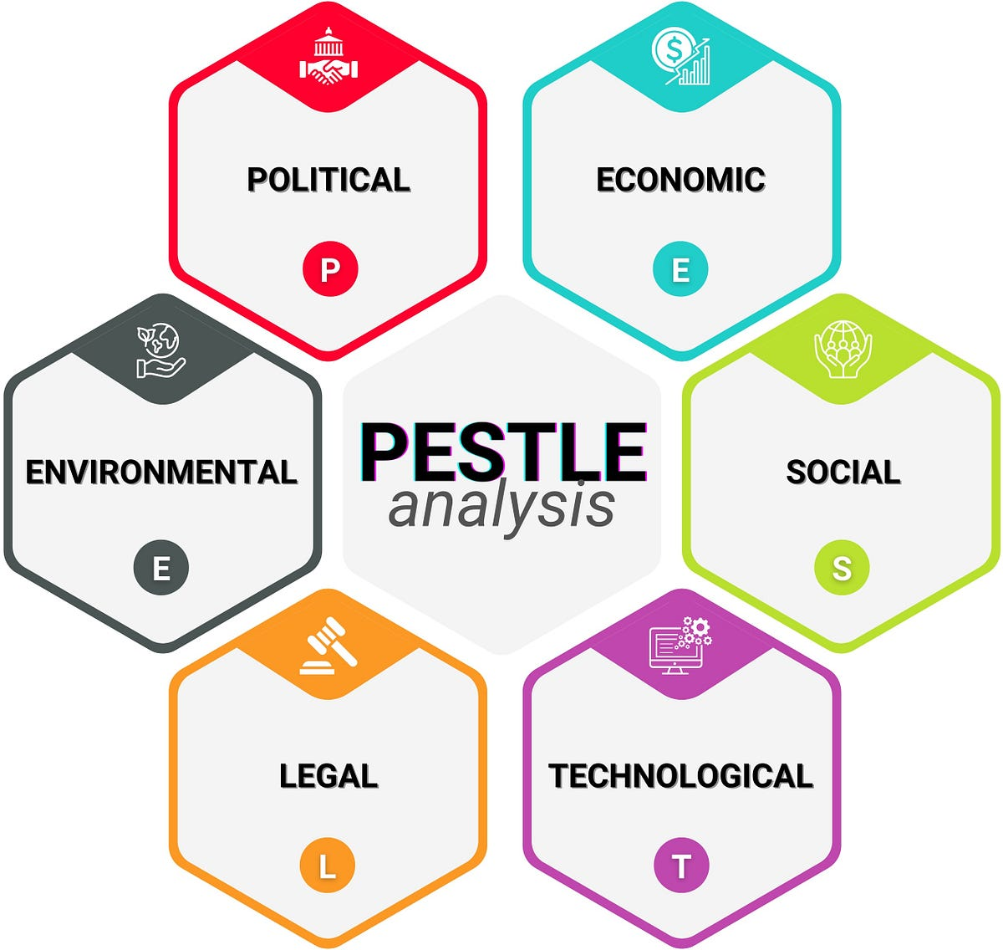
Figure 1: PESTLE Analysis
(Source: Iqbal, 2025)
Political Factors: The United Kingdom, being one of the key bases of operations and governance of Unilever, exhibits moderate political stability with a Political Stability Index score of about 0.51 in 2023. It signifies the presence of rather low risks of political violence and the growing institutional pressures and policy ambiguities (Trading Economics, 2024). The UK political stability is an advantage to Unilever as it allows the company to invest in the long-term in innovation and sustainability, but the costs of compliance and limits to operations are increasing due to the growth of regulatory attention. Political risks in emerging markets increase the risks associated with supply chains, and geographically diversified operations and flexible governance approaches are needed to ensure resilience and strategic flexibility.
Economic Factors: The economic environment has a critical impact on the performance of Unilever and its strategic positioning. In 2024 and 2025, the UK economy experienced an economic growth of about 1.1% and 1.3% respectively, which is a small growth (Gross, 2026). This sluggish growth is a sign of a limited consumer purchasing power, especially in the developed markets. Unilever growth in 2024 was more price-led than volume-driven, as it was a result of inflation, and the rising costs (Unilever, 2024b). This can help in the short term to improve financial performance; however it will pose a threat of price elasticity and resistance by consumers. As a result, Unilever needs to improve the efficacy of its supply chain, as well as implement local pricing practices in emerging markets to remain competitive (Unilever, 2024a).
Social Factors: The social trends are crucial in determining the consumer behaviour and strategic priorities. The growing awareness of consumers towards sustainability, ethical sourcing, and health-based products has greatly affected the way Unilever has been strategizing. The fact that the company is focused on sustainability-based branding is in tune with the change in societal expectations that enable the company to be distinguished among other companies in the market. Recent research indicates that sustainability is turning out to be a strategic need, rather than a peripheral concern (Sedovs and Volkova, 2024). Nonetheless, changing consumer tastes are also problematic. The necessity to possess affordable items that are eco-friendly brings about a necessity to strike a balance between the cost-effectiveness and ethics. Unilever works through this, through inclusion of sustainability in its value proposition, enhancement of brand loyalty and long-term customer relations.
Technological Factors: The changes in the FMCG industry are related to technological advancements, particularly in digital marketing, data analytics, and e-commerce. One thing that Unilever has done is to invest more in digital transformation and innovation (Hein Schumacher, 2024). Digital can be applied in carrying out targeted marketing, improved customer interaction as well as provide supply chain visibility. These functions contribute to the effectiveness in operation and strategic agility. In addition, technological innovation enhances product development and sustainability, such as environmentally friendly packaging. The pace of technological change however requires an organisation to be constantly invested in and adapted. Failure to keep abreast of digital trends could lead to loss of competitive advantage, particularly to digital natives.
Environmental Factors: Environmental considerations are one of the most prominent external forces which influence Unilever. Sustainable business practices are required by climate change, scarcity of resources and the regulatory requirements. The fact that the company has established the goal to become a net-zero emitter by 2039, and all their packaging recyclable proves the proactive attitude of Unilever to the issues of the environment (Unilever PLC, 2024). These are not just the compliance-based efforts but also strategically grounded on the expectations of the consumers and brand positioning. Sustainability programs, however, are linked with high costs and complexities of operations. A balance between the financial performance and environmental objectives is a very important strategic question.
Legal Factors: Legal factors cover laws as far as environmental factors, labour relations and corporate governance. More stringent ESG regulations are becoming a reality, and organisations must become more transparent and accountable (Anas, 2026). Unilever is also obliged to follow these rules in the case not to undermine its image and avoid the threat of a lawsuit, as it is in the case of this company. This has seen it incorporate the governance structures and sustainability reporting in its strategic procedures.

2.2 Critical Success Factors and Strategic Challenges
According to the PESTEL analysis, some critical success factors (CSFs) can be identified regarding Unilever:
- Good brand differentiation within a competitive market.
- Professional cost management in times of inflation.
- Integration of sustainability in line with the expectations of consumers.
- Operational flexibility across the whole globe to cope with geopolitical risks.
- Ability to transform digitally to increase efficiency.
Meanwhile, the strategic challenges related to the organisation are:
- Reliance on growth based on price which might not be sustainable in the long run.
- Low switching costs because of high intensity of competition in the FMCG industry.
- Increased cost of operation due to sustainability projects.
- Lack of economic stability in emerging markets.
- Regulatory forces associated with the compliance with ESG.
All these points to the complexity of the strategic environment of Unilever and the necessity of integrated and adaptive strategic management.

2.3 Internal Environment Analysis
The competitive advantage of Unilever is based on a mixture of strong resources, capabilities, and core competencies, which constitute the internal environment of this company.
Key Resources
The greatest asset that Unilever has is its vast portfolio of brands of more than 400 brands, which offers a wide market reach and coverage to consumers (Hein Schumacher, 2024). This scale will help the company to take advantage of economies of scope and will help in eliminating reliance on single products. Another resource of great importance is financial strength. Unilever has an impressive financial performance with a turnover of 2024 of €59.6 billion and operating profit of €9.9 billion, which enables the company to invest in innovation and growth (Unilever, 2024c; 2024a). Moreover, it has a world supply chain and distribution channel which allows the delivery of its products efficiently to various markets.
Capabilities
Unilever has several strategic capabilities such as:
- Excellence in marketing, making it possible to create a strong brand positioning.
- The ability to innovate, assisting product development.
- Integration of sustainability, operations in line with ESG goals.
- Digital transformation, improvement of efficiency.
These are the abilities that make the organisation react in a competent response to the changes in the market and avoid being pushed to the periphery.
Core Competencies
The core competencies of Unilever are:
- Brand management expertise
- Sustainable business practices
- Global market adaptability
These competencies are the capability of the organisation to combine resources and capabilities to generate value.

2.4 VRIO Analysis
The VRIO model can offer a systematic analysis of the strategic competencies of Unilever.

Resource / Capability | Valuable (V) | Rare (R) | Inimitable (I) | Organised (O) | Competitive Implication
Strong Brand Portfolio (400+ brands) | ✔ | ✔ | ✔ | ✔ | Sustained Competitive Advantage
Sustainability Leadership (ESG) | ✔ | ✔ | ✔ | ✔ | Sustained Competitive Advantage
Global Supply Chain Network | ✔ | ✖ | ✖ | ✔ | Temporary Competitive Advantage
Financial Strength (€59.6bn revenue) | ✔ | ✖ | ✖ | ✔ | Competitive Parity
Digital Transformation Capability | ✔ | ✖ | ✖ | ✔ | Temporary Competitive Advantage
Innovation & R&D Capability | ✔ | ✔ | ✖ | ✔ | Temporary Competitive Advantage

Table 1: VRIO framework
(Source: Self-Created)
The brand equity and inherent sustainability of Unilever generate VRIO-qualified benefits, but whilst they are valuable and supported by the organisation, their rarity is diminishing as competitors intensify ESG, and sustained advantage requires continuous innovation, not just a fixed reputation.

2.5 Internal Strengths and Competitive Advantage
The inner strengths of Unilever are significant to maintain the competitive advantage. Its wide brand portfolio enables it to serve a wide range of consumers and minimize the risk associated with the market and boost its resilience. Moreover, its financial position allows it to invest in innovation and strategic initiatives all the time. Sustainability as core strategy is a distinguishing element between Unilever and its competitors, which is in line with the modern strategic management views based on the importance of ESG as a long-term value-creator (Nain et al., 2025). Improves the reputation and draws in conscious consumers; with digital transformation comes improved efficiency, but constant change is necessary to maintain a competitive advantage.
All in all, the external environment of Unilever is both challenging and promising and it needs strategic flexibility and hardiness. It has good internal resources and capabilities especially in branding, sustainability and innovation which give it a very good base of competitive advantage. Combining these internal strengths with external environmental knowledge helps Unilever to maintain its strategic position in the world FMCG business.

3. CSR and Sustainability Objectives
Unilever Corporate Social Responsibility (CSR) strategy is so interwoven in the overall business model that sustainability is not only a peripheral activity but a core competitive advantage generating activity. The long-term strategic orientation on environmental responsibility is shown by the company through its goal of attaining net-zero in its value chain by 2039 and 100% recyclable, reusable, or compostable packaging of its products (Unilever PLC, 2024). These measures are not only in line with the global sustainability objectives, but also in reaction to the growing regulatory demands and consumer demands towards ethical consumption.
Importantly, the CSR strategy of Unilever has shown a good correlation with the business goals, especially in the increase of brand differentiation and customer loyalty. Sustainability is a major point of differentiation in the highly competitive FMCG sector where there are low switching costs and thus, ensures brand loyalty and consumer confidence. This is in line with the argument that sustainability-motivated strategies can create long-term value and have a positive impact on investor perceptions (Nain et al., 2025). Additionally, through sustainability in the product innovation and supply chain management, Unilever improves efficiency in operations and risk management especially in the aspects of scarcity of resources and disruptions caused by climate changes.
Nevertheless, there are not only challenges to the effectiveness of this alignment. The introduction of sustainability efforts can be quite expensive, and it can affect the profitability in the short term. Also, the questions as to how far such initiatives are substantive change or reputational positioning continue to be subject to scrutiny. However, the active and proactive nature of the strategic alignment of CSR and business goals shows that Unilever is on the right track, not only in the financial aspect of its business but also in sustainable development.

4. Comprehensive and Holistic View of Unilever
The Balanced Scorecard was the creation of Kaplan and Norton (1992) and is a multidimensional tool, which is used to assess the performance of organisations by combining both non-financial indicators and financial ones. In the case of Unilever, the framework is especially applicable because the company can tie its strategic goal of making sustainable living a commonplace with the quantifiable results in the financial, customer, internal process, and learning and growth perspectives.
Financially, the major goal of Unilever is to attain profitable and sustainable growth and at the same time, be efficient in its operations. The company has been performing well in terms of financial performance as 2024 reported a turnover of €59.6 billion and an operating profit of €9.9 billion with a margin of about 16.7% (Unilever, 2024a; 2024c). Revenue growth, operating margins, and underlying sales growth are some of the key performance indicators (KPIs) that have increased to 7.0% in 2024. The objectives are usually focused on the expansion of the margins and generation of shareholder value over the long-term. The concept of strategic effort like pricing optimization and cost-efficiency programmes have been adopted to counter the inflationary forces and continue to generate profit.
Customer perspective deals with increasing brand loyalty, trust and consumer satisfaction. The aim of Unilever is to enhance its relationship with consumers by providing them with high quality and sustainable products. KPIs will involve brand equity, the customer retention rates, and market share in product categories. Since switching costs in the FMCG industry are low, it is important to retain customers. The targets include growth in emerging markets and development of consumer perception on sustainability. Programs like purpose-driven branding (e.g., the ethical campaigns of Dove) and more spending on marketing facilitate this goal.
On the internal business processes, Unilever is trying to maximize the operational efficiency and innovation capabilities. The main goals are to build supply chain resilience, decrease environmental impact, and speed up the process of product development. KPIs encompass efficiency in production, time to market new products and sustainability indicators like carbon emission and waste minimization. The targets are in line with the ambition of the company to reach net-zero emissions by 2039 and 100% recyclable packaging (Unilever PLC, 2024). Digital transformation of supply chains and introduction of sustainable sourcing practices are part of the strategic initiatives that increase the efficiency and environmental performance.
Lastly, learning and growth perspective focuses on innovation and development of organisational capability. Unilever aims to create a culture of continuous improvement, employee interaction and technology. KPIs cover the productivity of employees, effectiveness of training and output of innovations. Targets are geared towards enhancing digital capabilities and leadership development. Moving towards digital platforms, e-commerce, and employee upskilling programmes are some of the initiatives that make sure that the organisation is flexible in a fast-changing market. Also, the emphasis on data analytics and AI-driven decision-making can further enhance the organisational agility, allowing a faster strategic response, enhanced operational efficiency, and competitive advantage in ever more complex global markets.
Overall, the Balanced Scorecard demonstrates that the Unilever company has a highly developed sustainability and performance management strategy, and it ensures that the strategic goals are balanced with the realisation of the strategy at all the organisational levels. Moreover, the alignment improves strategic control as it allows monitoring the performance in both financial and non-financial aspects. It ensures that sustainability goals are incorporated into the operating processes and it is easy to generate value in the long-term. It also contributes to the informed decision-making process as key performance indicators are linked to organisational priorities and consequently, increases accountability, flexibility and overall strategic coherence in an extremely competitive and dynamic business environment.

5. Strategic Choices and Implementation
This strategic positioning is an intentional alignment of the business-level differentiation and corporate-level diversification and internationalisation to help Unilever maintain a competitive edge in the highly competitive FMCG industry.
Business-Level Strategy
At the business level, the differentiation strategy is the main strategy that Unilever uses, specifically, brand equity, product innovation, and sustainability. As opposed to cost leadership that focuses on minimising costs, Unilever generates value by ensuring premium branding and purpose driven products especially the brands Dove and Lifebuoy. The sustainability promises, such as net-zero emissions by 2039 and green packaging, are another area of diversification that echo with the changing consumer trends (Unilever PLC, 2024).
Nevertheless, there are challenges to this strategy. The fact that the company counts on price growth to achieve growth in 2024 implies that differentiation might not be effective enough to counter the macroeconomic forces like inflation (Unilever, 2024a). Differentiation enables Unilever to enjoy relatively higher margins (around 16.7% operating margin), but it also presents the company with the challenge of price sensitivity in the emerging markets, where consumers are more price sensitive.
Strategically, it is a good idea to remain differentiated as there is highly competitive rivalry and low switching costs in the FMCG industry. Differentiation will minimize direct price competition and increase customer loyalty, thus, contributing to long-term profitability. As such, it is advised that Unilever should further entrench its differentiation strategy, especially through incorporation of digital innovation and product development that are sustainability-oriented, which is hard to imitate by the competitors.
Corporate-Level Strategy
Unilever is using both the diversification and international expansion strategy at the corporate level. Its diverse range of more than 400 brands in various product lines evidences a high level of diversification, which helps to learn no one-market segment (Hein Schumacher, 2024). This strategy increases the resilience by diffusing risk and seizing opportunities with a variety of consumer needs. The rising market orientation of Unilever leads to growth but poses more risks; diversification of the portfolio makes it less efficient, and the company needs to be strategic about high-growth brands to be more agile and resource-efficient (Unilever, 2024c; Ban Hameed Jasim, 2025).
Change Management and Strategic Implementation
Unilever has experienced great organisational transformations, especially in digital transformation, and integration of sustainability. The company has also started investing more in e-commerce and digital capabilities, which can help it address evolving consumer behaviour (Hein Schumacher, 2024). This transformation has enhanced efficiency in operations and responding to the market which shows that changes have been implemented effectively.
Also, the incorporation of sustainability in core strategy is evidence of a proactive strategy towards change. Instead of viewing CSR as an ancillary action, Unilever has integrated ESG principles in its value proposition in accordance with what stakeholders expect and regulatory dynamics. This is an indication of the increased role of sustainability as a strategic force (Regina et al., 2024). Though the sustainability is on the better side, the price-based growth strategy of Unilever implies that the company has not been able to complete its operational transformation and there are hurdles to the implementation due to the costs-innovation trade-offs, cultural opposition, and complexity of global digital and sustainability integration.
Overall Evaluation
All in all, the strategic decisions of Unilever are well balanced with the dynamics in the industry and long-term trends. The diversification and international expansion further sustain its growth and resilience as its differentiation strategy offers a good competitive platform. Nonetheless, to be more strategic in its performance, the company needs to become more efficient in execution by:
- Increasing innovation to stimulate volume.
- Denoting its brand portfolio to streamline.
- Digitizing operations.
By developing these areas, Unilever is in a better position to achieve its strategic vision into sustained competitive advantage and better performance.

6. Strategic Evaluation and Recommendations
The existing strategy of Unilever can be critically analysed by means of applying the SWOT analysis and the Matrix developed by Ansoff that allows to organize the assessment of the competitive position of the company and its strategy in the future.

6.1 Strategic Analysis based on SWOT Analysis
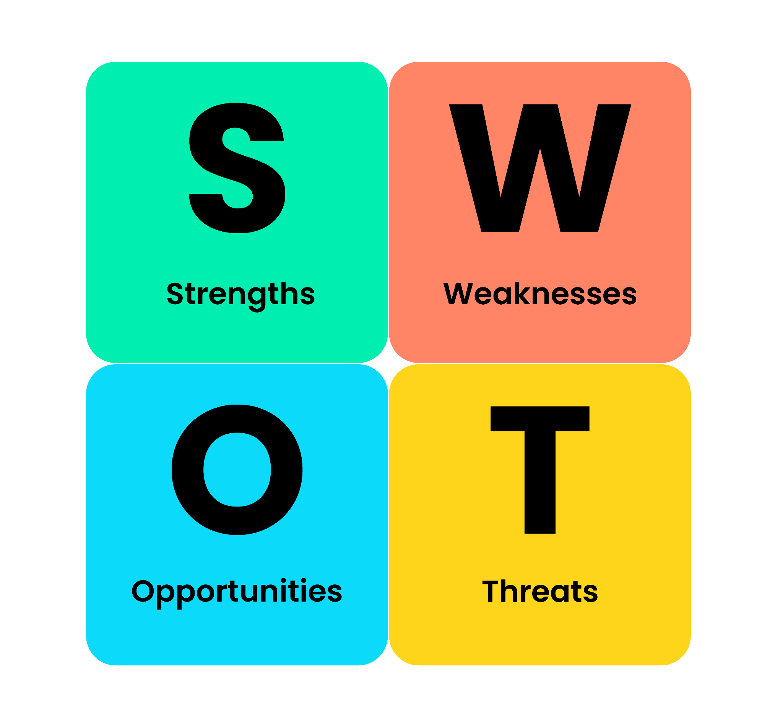
Figure 2: SWOT analysis
(Source: Businessballs, 2020)
Strengths: The global presence and portfolio of 400+ brands make Unilever diversified and make it reach out to a larger market. Its net-zero promise enhances brand equity and represents valuable, rare resources to maintain a competitive advantage over time (Hein Schumacher, 2024; Unilever PLC, 2024; Ban Hameed Jasim, 2025).
Weaknesses: The dependence of price-led growth in 2024 indicates a lack of volume growth and threat of declining demand. The brand portfolio size also leads to more complexity, which may decrease efficiency and strategic focus (Unilever, 2024a).
Opportunities: The growing demand for sustainable and ethically conscious products will help Unilever to capitalize on its sustainability leadership. The growth of digital commerce presents a chance to improve customer interaction, operational effectiveness and strategic decision-making using data.
Threats: High substitutes, low switching costs and intense competition in the FMCG industry make competition tough. Profitability is at risk due to inflation, supply chain upheavals, and macro-economic instability, which need incessant innovation and strategic flexibility to sustain competitiveness.

6.2 Strategic Evaluation using Ansoff’s Matrix
Using the Matrix offered by Ansoff gives an additional understanding of the strategy of growth of Unilever. The company mainly works in market penetration and product development strategies.
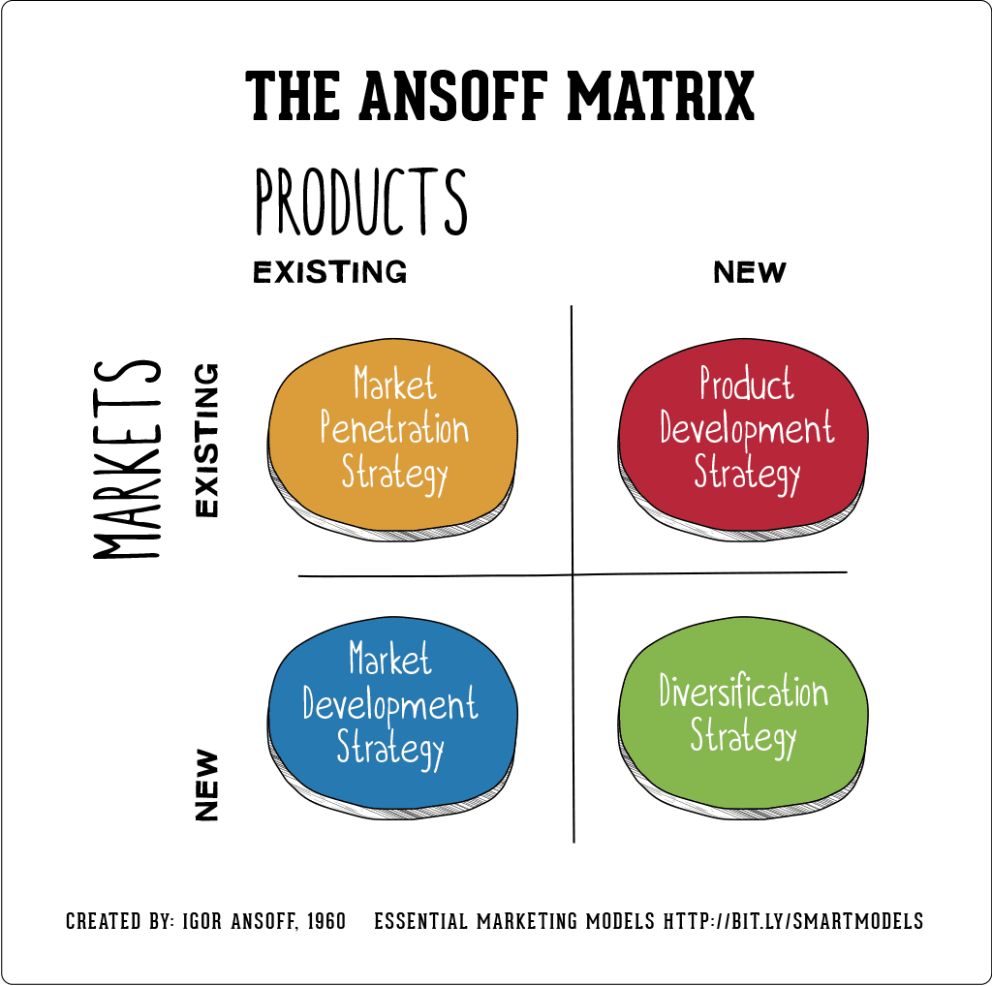
Figure 3: Ansoff matrix
(Source: Hanlon, 2021)
The penetration of the markets is witnessed in terms of pricing and brand reinforcement in the existing markets. Nevertheless, the dependence on the growth of prices but not volumes indicate low efficiency of this strategy in the long run. Demonstration of product development is shown by constant innovation especially in sustainable product lines which shows correspondence with the trends and regulation requirements of consumers. Another activity that Unilever participates in is market development, especially in emerging markets where it earns more than half of the revenue (Unilever, 2024c). Although this is a strategy that has potential to grow the company, it puts the company at risk of political and economic factors. Diversification is limited but can be seen in efforts of portfolio restructuring to concentrate on high growth areas.

6.3 Strategic Improvement Recommendations
Unilever must focus on a growth based on the volume through innovation of products and affordability especially in emerging economies by cutting down on dependence on higher prices to boost its competitive advantage (Muhammad et al., 2025). Customer insights, operational efficiency and marketing effectiveness can be enhanced by accelerating the digital transformation and adoption of e-commerce, which is consistent with the theory of dynamic capabilities (Dimitrova et al., 2025). Also, positioning and efficiency can be reinforced by streamlining the brand portfolio towards high-performing brands. Lastly, more sustainability in the main business processes by being innovative may result in increased long-term firm value and investor confidence (Nain et al., 2025).

6.4 Justification of Recommendations
These suggestions are based on the theory of strategic management and the practice. The RBV justifies the necessity to improve such valuable and rare capabilities as innovation and sustainability, whereas the theory of dynamic capabilities focuses on flexibility in unstable markets. Moreover, the data found in empirical studies underscores the importance of sustainability and digital transformation as the means of attaining the long-term competitive advantage (Regina et al., 2024).
In general, the current strategy of Unilever is highly consistent with the trends in the market, but to be successful in the long term, the company needs to lessen its focus on pricing strategies, increase innovation, and more effectively utilize digital and sustainability opportunities.

Section 2: Reflective Account (Gibbs Reflective Cycle)
Description
Researching, analysing and preparing strategic management reports on Unilever Plc involved systematic and structured processes. To begin with, I chose Unilever as the focal organisation because it is a strong global organisation, has a wide portfolio of brands, and has been well documented that it has a sustainable strategy. The research stage entailed the collection of information in the form of reputable academic sources, reports by the industry and corporate publications like annual reports and presentations to investors.
After data collection, I used the most important strategic management frameworks such as PESTEL, Porters Five Forces, VRIO and the Balanced Scorecard to analyse the external and internal environments of Unilever. An in-depth analysis of the strategic position of the organisation was developed on each of the frameworks. This had to be done through synthesising the quantitative resources such as the measures of financial performance, but qualitative data on the sustainability and competitive advantage. The last step was to organize the report according to the assignment brief, have logical flow, coherence and critical analysis, instead of a descriptive writing.
Feelings
I was confident at the start of the assignment that I would have no trouble taking in the concepts of strategic management but that I was not sure how I would be able to critically apply these concepts to a real-world organisation. The scope of the activities of Unilever and the intricacy of its sustainability projects at first were overwhelming. Nevertheless, as the study was going on, I gained confidence. The availability of the specific company reports, and the literature enabled me to get a better idea of the practical functioning of theoretical frameworks. I was especially interested in the fact sustainability has become a part of the Unilever strategy because I had a different view of CSR as a support activity in the company. I nonetheless had some problems in mixing descriptive and critical analysis. It was a tendency to work towards interpreting frameworks, not analysing and this had to be consciously overcome.
Evaluation
In general, it was an effective process that helped me to hone both my analytical and research skills. The variety of different and credible sources such as academic journals and reports of the companies was one of the strengths of my approach as it contributed to the increase in the credibility of my analysis. Also, the use of various strategic frameworks enabled a stratification of the strategic position of Unilever in a holistic manner. Another advantage was the real-life data, including the revenue, operating margins, and sustainability targets use, which enhanced the practicality of the report. This theoretical and a practical fit is the crucial element towards advanced academic results. Nevertheless, there were some restrictions, too. First, my analysis was not in depth as I paid more attention to the description of models and not on their critical assessment. Moreover, it was difficult to control the number of words and cover all the necessary sections. This sometimes resulted in problems of prioritisation, such that some areas needed more detailed analysis than others.
Analysis
The experience demonstrates the role played by critical thinking in strategic management. The current studies indicate that strategic analysis does not just involve application of the frameworks but also the capacity to interpret and assess the implications of the frameworks in the dynamic settings (Ban Hameed Jasim, 2025). The assignment enabled me to gain a better insight into how organisations such as Unilever can use internal capabilities and external opportunities to gain sustainable competitive advantage. The interdependence of the strategic factors was revealed using such frameworks as VRIO and PESTEL. To illustrate, the environmental pressures as taken out in the PESTEL analysis had a direct impact on the sustainability strategy of Unilever and consequently, this became a competitive advantage in the VRIO analysis. This further affirmed the significance of using various tools of analysis as opposed to viewing them separately. Also, the assignment helped me to develop my knowledge on sustainability as a strategic driver. In academic literature, the notion of sustainability is becoming a part of the business strategy, as opposed to an activity occurring on its fringes (Regina et al., 2024). This was clearly seen in the way Unilever has carried it out whereby the ESG efforts are strongly aligned to financial performance and the brand positioning.
The other important learning outcome is the importance of data in helping to support strategic analysis. Implementation of financial measures and performance measures enhanced the validity of my arguments. It also emphasized on evidence-based decision-making in strategic management.
Conclusion
Overall, this experience of working on this assignment largely helped me to put theories of strategic management into practice. I gained more research, analytical and critical thinking skills especially in the assessment of the complicated organisational strategies.
The experience also emphasised the use of a combination of various perspectives such as financial, environmental and competitive factors to build up an overall understanding of organisational performance. Although there was a problem faced especially in getting depth of analysis and content structure, they were all learning experiences.
Action Plan
I will take several strategies to enhance my future academic work. First, I will work on the development of critical analysis, in which I will always ask questions of what the implications of theoretical frameworks are, instead of describing them. Secondly, I will better manage time during the research stage to have time to further assess the research and revise.
Also, I will read more academic literature to be more theoretically prepared and be able to make arguments better. It will also be a priority to develop better skills in the synthesising information of multiple sources. Lastly, I will keep perfecting my academic writing style to make it easy to understand, coherent and precise, which are required in postgraduate level writing. With these supplements, I will hope to come up with more insightful and critically sound analyses in future assignments.

Conclusion
To sum it up, Unilever has been successful in its strategy due to brand equity, integration of sustainability and global market presence. It has a differentiation strategy and thus resilience against the competitive and economic challenges. The ongoing innovation, digitalization, and sustainability-driven projects are still necessary to retain the long-term competitive edge and keep up with the changing market trends.

References List
Anas, K. (2026). Unilever Corporate Governance Report. [online] Scribd. Available at: https://www.scribd.com/document/793357705/Unilever-Corporate-Governance-Report? [Accessed 16 Apr. 2026].
Ban Hameed Jasim (2025). Strategic Management for Sustainable Competitive Advantage: Integrating RBV, Dynamic Capabilities, Digital Transformation, and ESG. South Asian Research Journal of Business and Management, 7(05), pp.420–423. doi:https://doi.org/10.36346/sarjbm.2025.v07i05.003.
Businessballs (2020). SWOT Analysis: Strengths, Weaknesses, Opportunities, Threats - BusinessBalls.com. [online] Businessballs.com. Available at: https://www.businessballs.com/strategy-innovation/swot-analysis/.
Dimitrova, T., Komandrovska, V., Marinov, M. and Taranenko, A. (2025). Strategic Innovative Management and Sustainable Development of Industrial Enterprises. Economics Ecology Socium, [online] 9(1), pp.77–89. doi:https://doi.org/10.61954/2616-7107/2025.9.1-7.
Edgars Sedovs and Volkova, T. (2024). Sustainability: Is It a Strategic Management Research Fashion? Sustainability, 16(17), pp.7434–7434. doi:https://doi.org/10.3390/su16177434.
Gross (2026). GDP first quarterly estimate, UK. [online] Ons.gov.uk. Available at: https://www.ons.gov.uk/economy/grossdomesticproductgdp/bulletins/gdpfirstquarterlyestimateuk/octobertodecember2025? [Accessed 16 Apr. 2026].
Hanlon, A. (2021). The Ansoff Model. [online] Smart Insights. Available at: https://www.smartinsights.com/marketing-planning/create-a-marketing-plan/ansoff-model/.
Hein Schumacher (2024). Investor Relations first half 2024 Overview | Unilever. [online] Unilever. Available at: https://www.unilever.com/investors/results-events/results-events-webcasts/overview-q2-2024/? [Accessed 16 Apr. 2026].
Iqbal, A. (2025). PESTLE Analysis: The CEO’s Guide to Future-Proofing a Business. [online] Medium. Available at: https://medium.com/techno-preneurship/pestle-analysis-the-ceos-guide-to-future-proofing-a-business-877e6c4e20ea.
Muhammad, N.I., Sirait, A.H., Ahmad, A.C. and Jabid, A.W. (2025). Business Sustainability Strategy: Systematic Literature Review. Society, 13(1), pp.705–727. doi:https://doi.org/10.33019/society.v13i1.784.
Nain, M.Z., Ali, M., Zaki, M. and Fahad, M. (2025). Sustainability as a Strategic Innovation and Its Effect on Modern Investor Attitudes. MDIM Journal of Management Review and Practice. doi:https://doi.org/10.1177/mjmrp.251323763.
Regina, K., Gomes, S.C., Cesar, M. and Magnus Luiz Emmendoerfer (2024). Strategic Management for Sustainability. Revista de Administração Contemporânea, [online] 28(6). doi:https://doi.org/10.1590/1982-7849rac2024240221.en.
Sedovs, E., Volkova, T. and Ludviga, I. (2024). Sustainable development and strategic management - what is on the horizon in our non-ergodic world research? Sustainable Futures, 9, p.100414. doi:https://doi.org/10.1016/j.sftr.2024.100414.
Trading Economics (2024). United Kingdom - Political Stability And Absence Of Violence/Terrorism: Estimate - 2022 Data 2023 Forecast 1996-2020 Historical. [online] tradingeconomics.com. Available at: https://tradingeconomics.com/united-kingdom/political-stability-and-absence-of-violence-terrorism-estimate-wb-data.html.
Unilever (2024a). Improved performance led by volume growth and gross margin expansion. [online] Available at: https://www.unilever.com/files/ir-q4-2024-full-announcement.pdf?.
Unilever (2024b). Innovation and brand investment driving faster volume growth. [online] Available at: https://www.unilever.com/files/ir-q2-2024-full-announcement.pdf?.
Unilever (2024c). Unilever Annual Report and Accounts 2024. [online] Available at: https://www.unilever.com/files/unilever-annual-report-and-accounts-2024.pdf?.
Unilever PLC (2024). Annual Report and Accounts 2023. [online] Unilever. Available at: https://www.unilever.com/investors/annual-report-and-accounts/?.

