Peer reflection
Name: Mehwish Nawaz
Module: coaching and mentoringBMSW6007

Submission Date:
30th of June 2025
Table of Contents
Introduction 4
Performance in the Peer Coaching Exercise 4
Reflection on the Instant Payoff Coaching Model 5
Gibbs Reflective Cycle 5
1. Description: 6
2. Feelings: 6
3. Evaluation: 6
4. Analysis: 7
5. Conclusion: 7
6. Action Plan: 7
Cognitive and Intellectual Skills 8
Strengths and Weaknesses 10
Strengths: 10
• Active Listening 10
• Encouragement and Support 10
• Logical Structure 10
• Empathy 11
• Clarity in Summarization 11
Weaknesses: 11
• Overly Directive Approach 11
• Questioning Techniques 11
• Time Management 11
• Adaptability 12
• Confidence in Handling Difficult Topics 12
Future Goals for Development 12
after covid 19 significanse of coaching in workplaces 12
abilities to be a successful coach 13
anaylses of coaching models 13
Personal Development Plan 14
Conclusion 14
References 15

Introduction
This reflection uses the Instant Payoff Coaching Model to critically assess how well I performed in a peer training exercise. The coaching consultation's objective was to help my coachee, Halima, deal with situations that required her to use her presentation skills. The consultation gave me the chance to consider my areas of strength and growth and to put training theories into practice.
This essay will analyses how I performed in relation to educational literature, emphasizing the value of training, necessary skills, comparison to different coaching approaches, and a personal development plan (Jackson, 2004).

Performance in the Peer Coaching Exercise
To adhere to the Instant Payoff Coaching Model, I helped Halima identify problems, visualize success, identify obstacles, and come up with solutions during the training consultation. Instead of encouraging Halima to come up with her own answers, I took a more direct approach, which is when I veered off course. The middle component of coaching is self-discovery, which I did not fully facilitate even though I effectively summed up her concerns.
Rather of focusing on cooperatively recognizing and classifying constraints, I tended to take on the role of a trainer (Aranzabal et al., 2022). I should have helped the coachee better by using strategic thinking and reflection techniques, as the Instant Payoff Model places a strong emphasis on helping them express their own difficult circumstances and ability responses. As a result of my method, Halima began to rely more on my advice rather than creating her own plans to deal with her challenging circumstances. The coaching session's usefulness was limited by this omission, which also shows where my future education practice must be improved (Hampson, 2020).
Moreover, my capacity to offer helpful criticism in a non-directive way has become another obstacle. Instead of serving as a marketing consultant, the instructor must serve as a facilitator to deliver effective training (Luo et al., 2019). By applying my approach in curated education programmes, I may enable the coachee to take greater responsibility for their own development, which is a principle that is emphasized. Furthermore, I found that occasionally my answers lacked dedication, therefore I might have wanted to encourage Halima to provide more detailed thoughts to help her identify the root causes of her difficult circumstances (Sager et al., 2014).

Reflection on the Instant Payoff Coaching Model
The Instant Payoff Model is suited for short-term problem-solving because it places an emphasis on immediate, actionable results. It has four stages: problem definition, desired result visualization, obstacle identification, and solution brainstorming. Although I was aware of the version’s structure, my execution did not entirely conform to its principles. I gave direct instruction on presentation techniques rather than working with others to explore constraints. This limited Halima’s ability to reflect on herself and take responsibility for her responses, which is essential for training to be effective (Raman, 2023).

Gibbs Reflective Cycle
One methodical approach to reflect that enables people to review reports and make plans for improvements is Gibbs' Reflective Cycle (1988). It has the following six stages:
- Description – Describe the event or activity.
- Feelings – Analysing feelings and responses.
- Evaluation – Finding the advantageous aspects and undesirable aspects.
- Analysis – Examining the reasons behind the way things transpired.
- Conclusion – A summary of the main findings.
- Action Plan – Making defined plans for future practice improvements.
I will be able to assess my overall coaching effectiveness and pinpoint areas for improvement with the aid of this model.

1. Description:
In the coaching consultation, I guided Halima through problem identification, envisioning achievement, identifying hurdles, and brainstorming solutions in accordance with the Instant Payoff Coaching Model. Nevertheless, I departed from the version by utilizing a directive approach, emphasizing recommendations above aiding in self-discovery. I did not give her enough authority to come up with her own solutions, even though I did a good job of summarizing her problems (Landsberg, 2015).

2. Feelings:
I was confident in my training skills at first because I had done my homework. As the session progressed, though, I became aware that I was controlling the conversations too closely. I realized that training should be more about facilitating than teaching, so I was only mildly irritated by this. In my opinion, Halima's level of engagement also decreased, which led me to question the success of the consultation.

3. Evaluation:
My coaching has been effective in certain ways. My ability to actively listen helped me establish rapport and foster a positive environment. I also made sure that the session was coherent and clear by establishing it methodically. I did not, however, effectively employ open-ended questions, which limited Halima's capacity to come up with her own answers. Additionally, I spent too much time giving explanations instead of encouraging reflected image, which reduced the effectiveness of the session.

4. Analysis:
A major contributing factor to my focused method is my lack of confidence in my cognitive abilities. Asking thoughtful questions that promote introspection is essential to effective training. My inability to accomplish this limited Halima's capacity to consider her demanding circumstances with seriousness. I also had trouble adapting to her comments in a dynamic way, which is a crucial skill in teaching. These difficulties imply that I require additional instruction in adaptive education techniques along with effective questions.

5. Conclusion:
This encounter brought to light both my coaching abilities and shortcomings. I need to improve my questioning techniques and become more flexible, even if I passed the listening test and conducted the discussion well. Additionally, it is my goal to allow the coachee greater control over their learning system.

6. Action Plan:
I will make sure that I assist rather than teach by practicing asking more open-ended questions. I am going to seek feedback from colleagues regarding my coaching style and make necessary adjustments. To help colleagues develop their skills in a supportive setting, I will arrange peer training workshops.
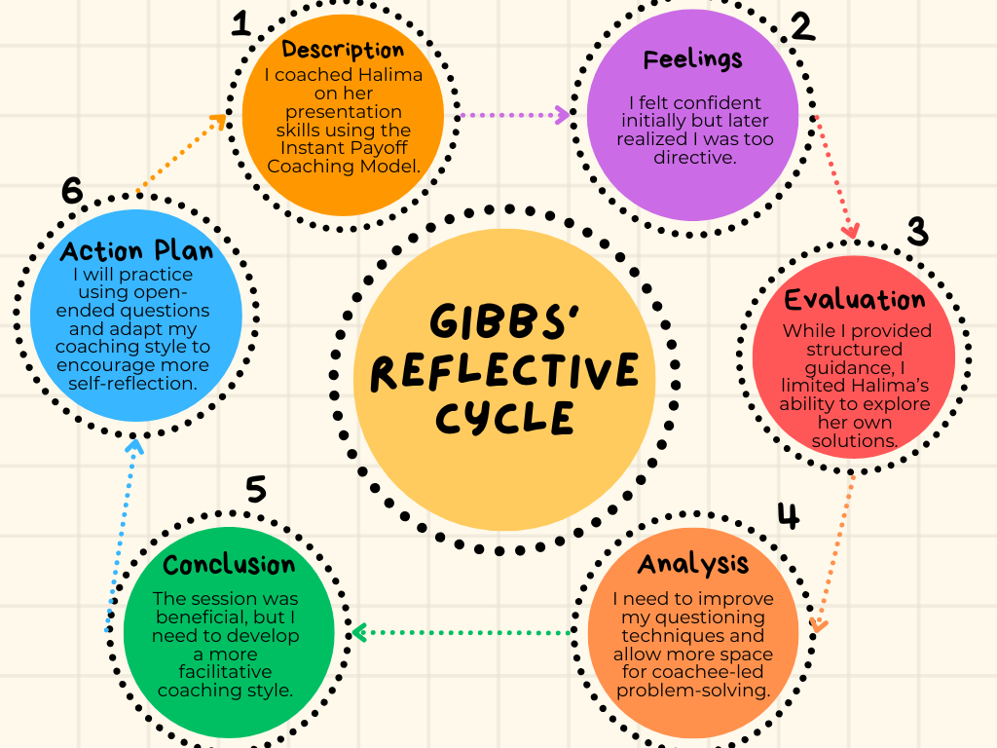
At my workplace, coaching is natural, and staff members mostly conduct research through mentorship and educational courses. But training can significantly enhance employee development, especially in a post-COVID hybrid environment. Teamwork, problem-solving skills, and leadership abilities can all be enhanced by implementing dependent training programmes.

Cognitive and Intellectual Skills
Cognitive and intellectual skills are essential for effective coaching because they impact how coaches evaluate information, respond to client signals, and change their approach to help coachees progress. These abilities include critical thinking, problem solving, active analysis, information processing, and reflective practice. In the peer coaching exercise, my cognitive and intellectual talents were critical in arranging the session, recognizing areas for improvement, and reacting carefully to my coachee's concerns (Peláez Zuberbuhler et al., 2020).
One of the most important cognitive skills I used was active listening mixed with critical reasoning. I was able to closely listen to Halima's worries and clearly paraphrase them, demonstrating that I had properly digested the material. Active listening enables coaches to establish rapport and detect underlying concerns that the coachee may not openly express (Brodowicz, 2025).
I examined the emotional aspects in Halima's issues regarding her presentation anxiety, attempting to identify the source of her worry. This insight drove how I organized the remainder of the conversation. Skills were key in structuring the session, recognizing areas for improvement, and reacting carefully to my coachee's concerns.
However, one of the difficulties I discovered was depending too much on my preconceived assumptions and proposing answers too soon. This demonstrates a flaw in my critical thinking approach, as I should have asked more in-depth questions to assist Halima in reaching her own conclusions. Answering questions is less effective than asking the proper questions. This takes cognitive flexibility, which allows the coach to tailor their asking to the coachee's replies, a skill I need to improve (Mbokota and Myres, 2024).
Problem-solving is another essential cognitive skill that is applicable to coaching. Throughout the session, I worked to assist Halima in developing attainable goals, which entailed breaking down her bigger difficulty into smaller bits. While I could give organized instruction, my problem-solving style inclined toward directive coaching. I now see that facilitative problem-solving—in which the coachee investigates potential solutions—is more helpful in developing long-term confidence and self-efficacy.
Furthermore, intellectual interest is important in coaching because it motivates the coach to learn not just the 'what' but also the 'why' of a coachee's conduct. Although I showed interest, I occasionally lacked the capacity to explore deeper, which may have yielded more profound discoveries. To improve this, I intend to improve my capacity to ask probing questions and connect fresh knowledge to coaching objectives in real time.
Reflective thinking is also a key component of intellectual development in coaching. Through Gibbs' Reflective Cycle, I was able to assess my cognitive strengths and opportunities for growth. Reflection enabled me to examine my coaching approach, the efficacy of my interventions, and the alignment between my aims and actual practice (Young, 2023).

Strengths and Weaknesses

Strengths:

Active Listening
By engaging in Halima's worries and outlining her main difficulties, I developed strong listening skills. Because it fosters agreement and promotes candid communication, active listening is essential in coaching (Clutterbuck, 2020).

Encouragement and Support
By developing trust and acknowledgment, my body language and vocal affirmations produced a beneficial learning environment. Throughout the session, encouragement gave Halima a sense of security and support (Landsberg, 2015).

Logical Structure
The session had a logical flow, ensuring that Halima's concerns could be read, and that the communication was organized and goal oriented (Landsberg, 2015).

Empathy
During the technique, I was able to recognize Halima's difficulties and demonstrate genuine concern, which helped her feel appreciated (Passmore, 2010).

Clarity in Summarization
I helped Halima better understand her current situation and identify specific answers by providing concise but effective summaries of our conversations (Passmore, 2010).

Weaknesses:

Overly Directive Approach
I helped Halima better understand her current situation and identify specific answers by providing concise but effective summaries of our conversations (Landsberg, 2015).

Questioning Techniques
My use of open-ended questioning became constrained, which hindered Halima's ability to examine herself and solve problems. It highlights that coachee can engage in deeper self-reflection using effective questioning techniques (Clutterbuck, 2020).

Time Management
Instead of helping Halima with self-reflection, I spent too much time on clarification, which reduced the session's effectiveness. In the classroom, organized time management is crucial (Landsberg, 2015).

Adaptability
I had trouble dynamically changing my approach in response to Halima's answers. Flexibility is essential for effective coaching, allowing the coachee to direct the conversation while the educator provides dependent guidance (Passmore, 2010).

Confidence in Handling Difficult Topics
Another thing I needed to work on was my confidence in handling sudden changes in the verbal exchange. Adaptability is necessary for effective training because the cache’s responses may also take the session in an unexpected direction. I found it difficult to handle these situations, which hindered the session's flow (Cox & Bach Kirova, 2007).

Future Goals for Development
In order to enhance my coaching abilities, I've even determined a few main goals:
- Use more open-ended and insightful questions to hone my questioning strategies.
- Improve my flexibility so that I can respond tocoachee,s comments more swiftly.
- Enhance my ability to guide coachee toward self-generated responses rather than giving them instructions.
- Prioritize higher-level responses and assist in subsequent lessons.

Importance of Coaching in Post-COVID Workplaces
The COVID-19 pandemic increased the demand for training in the workplace, especially for remote and hybrid work arrangements. Coaching helps staff members adjust to new problems by providing tailored growth. Education provides a customized approach that improves employee engagement and retention as compared to standard education. Dependent education tasks should help my organization guide employee growth and performance (Haque, 2023).
As more workplaces become digital, coaching has become more important in helping workers manage stress, maintain productivity, and enhance their professional growth. Instead, then depending entirely on administrative assistance, a well-established training structure can enable staff members to expand their troubleshooting skills on their own. My administrative center's staff would become more self-reliant, involved, and proactive if an education lifestyle were implemented (Shiri et al., 2023).

Skills Required to be an Effective Coach
Together with active listening, emotional intelligence, goal setting, and flexibility, these skills are essential for effective education. I tried encouraging and listening with energy, but I still need to work on my thought processes and ability to help people reflect on themselves. My efficacy as a trainer in both personal and professional contexts will be enhanced by honing those abilities (Gupta, 2023).
It is imperative for coachee to possess the capacity to adapt their conversational style to suit their unique coachee. While a more open-ended exploration conversation may be beneficial for some, others may require a more established, directed approach. By improving my adaptability in communication styles, I can ensure that, based on the cache needs, I can offer the best guidance (Ikar, 2023).
Patience is another essential skill. A patient and nonjudgmental approach is necessary for coaching, allowing the coachee to find answers at their own speed. I need to be more patient and give the coachee time to practice and mirror their thoughts without feeling pressured (Wood, 2014).

Comparison of Coaching Models
The GROW model and Solution-Focused Coaching are two models that are different from the Instant Payoff Coaching Model. The Instant Payoff Model concentrates on short-term fixes, whereas GROW provides a foundational structure for long-term improvement. On the other hand, solution-focused coaching stresses practical solutions but does not use the Instant Payoff Model's methodology. Knowing these differences can make it easier to adapt coaching methods to various situations (Blackburn, 2023).

Personal Development Plan
Area for Improvement | Action Plan | Success Criteria | Review Date
Improve questioning techniques | Practice open-ended questioning | More reflective responses from coachee | Dec 14, 2024
Develop a non-directive approach | Role-play coaching scenarios | Encouraging coachee to generate their own solutions | Dec 21, 2024
Enhance time management skills | Set time limits for each coaching stage | Balanced session flow with self-reflection time | Dec 28, 2024

Conclusion
This reflection shows that, even though I have strengths in encouraging others and active listening, I would like to improve my questioning techniques and pursue more facilitative teaching methods.
Enhancing my skills will help me succeed both professionally and in the public sector, as coaching is a crucial role in post-COVID workplaces. Going forward, I will focus on improving my adherence to training models and encouraging coachee to discover themselves to maximize their potential for improvement.

References
Aranzabal, A., Epelde, E. and Artetxe, M., 2022. Team formation on the basis of Belbin’s roles to enhance students’ performance in project based learning. Education for Chemical Engineers, 38, pp.22–37. https://doi.org/10.1016/j.ece.2021.09.001
Blackburn, S.C.N.G., 2023. Coaching models: Solution-focused coaching model. Coach Foundation. Available at: https://coachfoundation.com/blog/solution-focused-coaching-model/.
Brodowicz, M., 2025. The impact of coaching on personal and professional development. Aithor. Available at: https://aithor.com/essay-examples/the-impact-of-coaching-on-personal-and-professional-development.
Clark, T., 2020. The 4 stages of psychological safety. Oakland: Berrett-Koehler Publishers.
Clutterbuck, D., 2020. Coaching the team at work 2: The definitive guide to team coaching. 4th ed. London: Nicholas Brealey.
Cox, E. and Bach Kirova, T., 2007. Coaching with emotion: How coaches deal with difficult emotional situations. International Coaching Psychology Review, 2(2), pp.178–186. https://doi.org/10.53841/bpsicpr.2007.2.2.178
Gupta, S., 2023. The importance of self-reflection: How looking inward can improve your mental health. Verywell Mind. Available at: https://www.verywellmind.com/self-reflection-importance-benefits-and-strategies-7500858.
Hampson, T., 2020. What we talk about when we talk about teaching: Teacher knowledge sources in an online practice community. University of Oxford. Available at: www.teachingenglish.org.uk/publications/elt-masters-dissertations.
Haque, S.M.S., 2023. The impact of remote work on HR practices: Navigating challenges, embracing opportunities. European Journal of Human Resource Management Studies, 7(1), Article 1549. https://doi.org/10.46827/ejhrms.v7i1.1549
Ikart, E.M., 2023. Emotional intelligence: Why it matters in change leadership and innovation in the 21st-century styles of work. International Journal of Business Innovation, 2(4), p.e34732. https://doi.org/10.34624/ijbi.v2i4.34732
Jackson, P., 2004. Understanding the experience of experience: A practical model of reflective practice for coaching. International Journal of Evidence Based Coaching and Mentoring, 2(1), pp.57–68.
Landsberg, M., 2016. Mastering coaching: Practical insights for developing high performance. London: Profile Books.
Luo, C.-C., Wang, Y.-C. and Tai, Y.-F., 2019. Effective training methods for fostering exceptional service employees. Journal of Hospitality and Tourism Insights, ahead-of-print(ahead-of-print). https://doi.org/10.1108/JHTI-01-2019-0013
Mbokota, G. and Myres, K., 2024. Coach competencies to facilitate transformative learning: A multiple case study involving public-sector executives in South Africa. Human Resource Development International, pp.1–31. https://doi.org/10.1080/13678868.2024.2365447
Passmore, J., 2010. A grounded theory study of the coachee experience: The implications for training and practice in coaching psychology. International Coaching Psychology Review, 5(1), pp.48–62.
Peláez Zuberbuhler, M.J., Salanova, M. and Martínez, I.M., 2020. Coaching-based leadership intervention program: A controlled trial study. Frontiers in Psychology, 10, p.3066. https://doi.org/10.3389/fpsyg.2019.03066
Raman, A.M., 2023. Project management. San International Scientific Publications.
Sager, J., Dubinsky, A., Wilson, P. and Shao, C., 2014. Factors influencing the impact of sales training: Test of a model. International Journal of Marketing Studies, 6(1), pp.1–10. https://doi.org/10.5539/ijms.v6n1p1
Shiri, R., El-Metwally, A., Sallinen, M., Pöyry, M., Härmä, M. and Toppinen-Tanner, S., 2023. The role of continuing professional training or development in maintaining current employment: A systematic review. Healthcare (Basel, Switzerland), 11(21), p.2900. https://doi.org/10.3390/healthcare11212900
Wood, M.I., 2014. Non-directive and non-judgmental coaching with ease. International Coaching Federation Blog. Available at: https://coachingfederation.org/blog/non-directive-and-non-judgmental-coaching-with-ease.
Young, R., 2023. The power of critical thinking: Enhancing decision-making and problem-solving. Forbes. Available at: https://www.forbes.com/councils/forbescoachescouncil/2023/07/28/enhancing-decision-making-and-problem-solving/.

