The Entity Relationship diagram is designed to collect all the details about customer about quantity of products or services and to process the order further to the main store. From the main store they will send the necessary items toward warehouse where they will check if they have the products in stock or they will order the necessity of items for the order from the suppliers. All financial datas will be collected by Finance department where they will be able to calculate daily cost, daily income, quarterly year financial report and yearly report, all the data will be stored into cloud storage wich can be accessed by all devices with internet conection and also will be printed for physical storage.
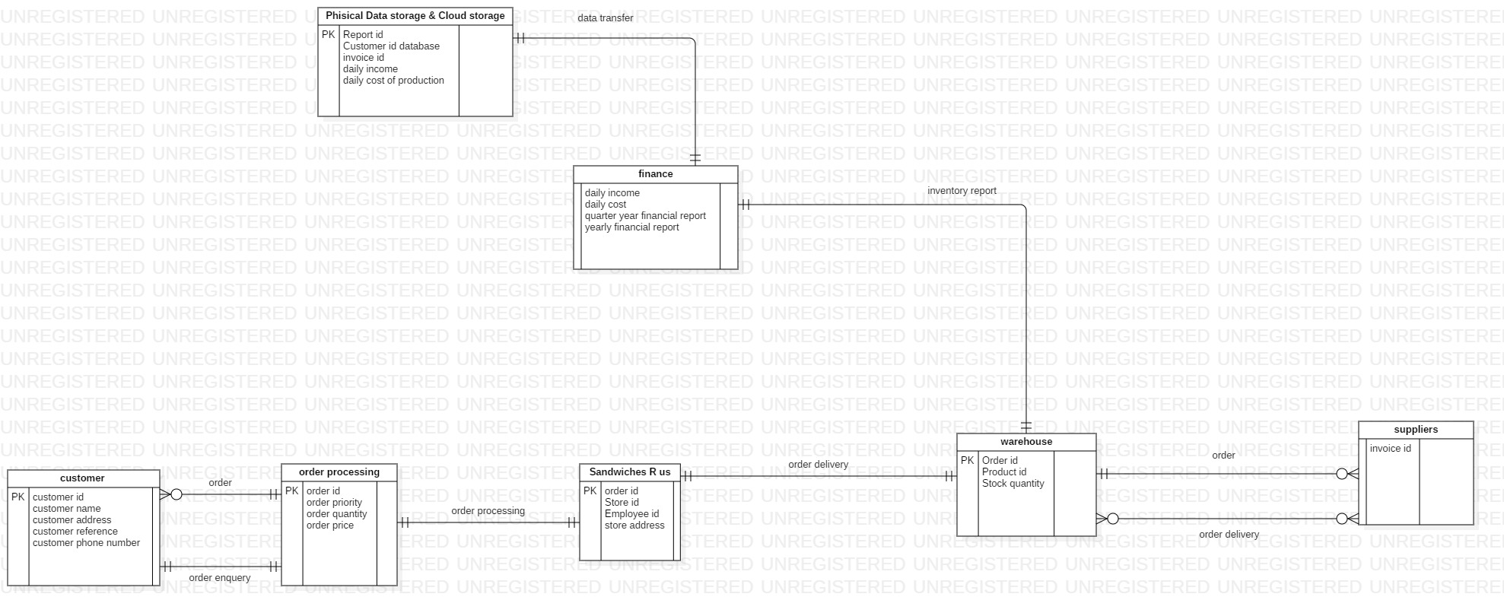
The Use care Diagram is designed for easy use of the system and to have explained reports about company that can be accesed by any device as long as you have permission to acces the cloud storage.


