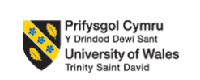

Programme: Master of Business Administration
Module: Human Capital Management
Module code: LCMB7023
Title: The Influence of National and International Labour Markets on HRM and IHRM Strategies
Lecturer: Dr Charles A.C. Oham
Assessment Component 01: Individual Report
Student Name: Md Rabiul Hassan Student ID: 2504429
Group: 03 Term: 01

Executive Summary
This report focuses on the macro-environmental factors that are transforming all labour markets throughout the globe and analyse their potential impact to the Human Resource Management (HRM) and International HRM (IHRM). Rapid technological advancement, including AI, automation and electronic platforms are transforming work patterns and require reskilling over a lifetime and ethical concerns in employment. Another group of changes in the demographic trend that is changing workforce make up and are influencing talent availability, and furthermore, global mobility and international staffing are getting tough due to the issue of ageing populations, youth bulges, and changes in the migration patterns and furthermore, geopolitical uncertainties are creating challenges that are making mobility across the globe and both national and time-national staffing hard.
The report has also proposed that there are growing skills gaps and talent shortages in the critical aspects, and that strategic HRM planning is needed, such as up-skilling, education relations, and big data recruiting. In addition, a reflective section evaluates the personal preparedness to work abroad with the help of a SWOT construct which is based on the major personal competencies including technology, communication, teamwork, leadership and self-directed learning. Overall, the report identifies the necessity of the HR practices to become adaptive and culturally sensitive and future-oriented in order to be competitive in a constantly changing global environment.

Table of Contents
Introduction 4
1. Technological Advancements Reshaping Labour Markets and Their Implications for HRM and IHRM Strategies 4
2. Demographic and Geopolitical Factors Influencing Employment Markets and Their Challenges for HR Professionals 8
3. Addressing Skills Gaps and Talent Shortages in Critical Sectors through Strategic HRM 12
4. Reflective Report on Preparedness for Working in an International Context 14
Reference List 20

Introduction
This report attempts to examine the major macro-environmental issues that are transforming the labour markets throughout the entire globe and evaluate the implications that they hold to the Human Resource Management (HRM) and International HRM (IHRM). It presents the dynamics of the workforce availability, talent mobility, and HR in organisations as a result of the technological development, demographic changes and shift in geopolitics. Skills deficiencies and absence of talents and the challenges of managing diverse international work forces are some of the critical areas that have been mentioned in the discussion. The report further analyzes strategic HRM practices that have the potential of offering resilience to the overall workforce in a long term. The reflective part assesses him to be ready to take work in the international setting depending on the skills that are crucial in global employability and professional performance.

1. Technological Advancements Reshaping Labour Markets and Their Implications for HRM and IHRM Strategies
Technological Advancements Impacting Labour Markets
Innovations like AI technologies are becoming part of the recruitment industry, making the tasks of screening resumes and evaluating qualifications effective with support of algorithms and therefore efficient and less prone to human bias. Haleem et al. (2021) research stated automation is transforming other business sectors, such as manufacturing and customer services as robots and computerised systems are stamping out repetitive tasks, such as assembly line labour or handling simple customer queries with chatbots.
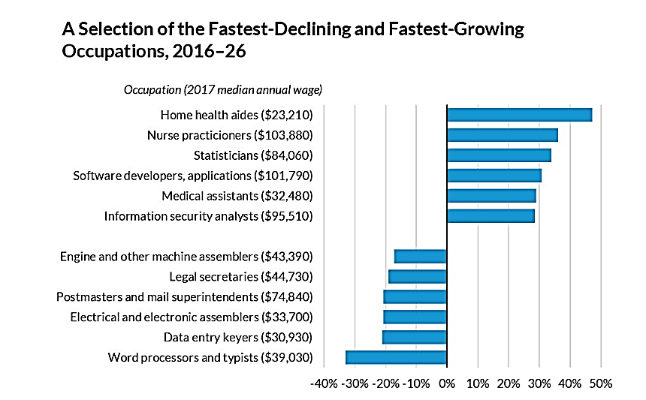
Figure 1: Selection of fastest declining and fast growing occupations
(Source: Brown and Loperst, 2018)

As stated by Brown and Loperst (2018), service are predicted to explode in the 2016 to 2026 forecast: home health aides (~$23k) 47%, nurse practitioners (~$104k) 35p%, statisticians (~$84k) 34%, software developers (~$102k) 31%, medical assistants (~$32k) 29%, information security analysts (~$96k) 28%. Office/assembly occupations are declining: typists -33, data entry -21, electronics assemblers -16, postmasters -20, legal secretaries -19 machine assemblers -15.
Ali (2023) demonstrated that the advent of online applications, including Uber, Upwork, and other gig economy applications, has upset conventional employment patterns. The gig economy is a rapidly increasing phenomenon in the world, providing new avenues for individuals to work across borders, and altering the demands and design of the working population.
The effects of automation and artificial intelligence are taking a trend that is decades old even faster. The personnel in the switchboard have been substituted by phone and interactive voice Response menus and most of the grocery stores clerks have been substituted by self-checkout machines. As AI advances, there are reports that the jobs of truck drivers, paralegals and even surgeons could be overturned due to evolving technology (Lobel, 2024). In this context, tech employment might appear as the only professions with the secured employment increase.
Implications for HRM and IHRM
The rapid technological change implies the aspect of involving the digital operation in HRM, according to Parry and Battista (2023), which can involve the leverage of AI to perform the recruitment and reskilling tasks. Despite the high level of effectiveness they might yield, it has been discovered as well that AI application as a hiring method can be discriminatory and biased in case algorithms are not explicitly presented or well-controlled. This casts doubt on the assumption that digitalization is bound to improve HR decision-making. Similarly, reskilling programs offer flexibility to the workforce, although it depends on organizational investment, motivation, and commitment of the leaders, if they do not meet the requirements, the probability of skills gaps to exist is high. Phillips (2020) highlights that remote working was introduced, but scientists have warned that virtual working has also relocated some employees to an even more distant state at the expense of organizational commitment and engagement.

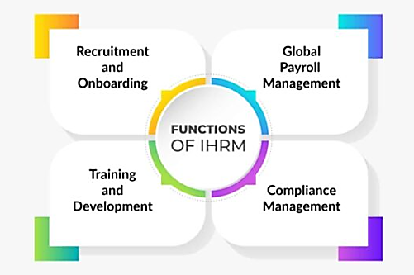
Figure 2: Functions of IHRM
(Source: Alp Consulting, 2023)
At the IHRM level, which Parry and Battista (2023) rightly mention, is that, the countries are unlikely to be equally technologically developed, meaning that it will be hard to be digitally integrated when collaborating in a multinational team. Although this presents a challenge to the operations, Haleem et al. (2021) believe that it provides a chance of knowledge transfer between the technologically advanced and the emerging markets. However, the cultural differences introduce obstacle to standardization of international HR practices, where IHRM needs to create a balance between global digitalization and the national cultural sensitivity.

2. Demographic and Geopolitical Factors Influencing Employment Markets and Their Challenges for HR Professionals
The global labour market is predetermined by demographic and geopolitical factors, when it comes to the workforce composition, the supply and demand of talent and the recruitment strategies. HRM is one such field to consider all these aspects as while HR staff should keep up with shifting population trends and overcome the challenges of global migration, demographics, and political insecurity (Chamie, 2020). Due to the competitive nature of the current environment, it is essential to comprehend such factors as part of proper planning and management of workforce within an organisation.
Key Demographic Factors
Goh and McNown (2020) stated among the critical demographic pressures is the aging population in developed economies, including Japan and most of the European countries. This poses a challenge to the HR professionals who should adjust their recruitment policies to attract young talent and retain older employees by offering work flexibility arrangements or reskilling operations.
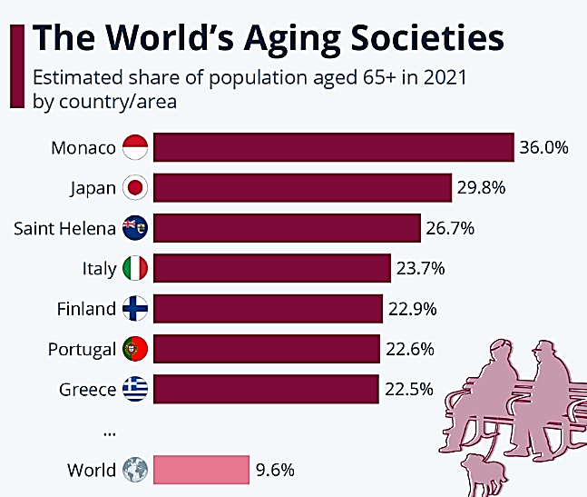
Figure 3: The world’s aging societies
(Source: North, 2023)
As figure 3, stated Japan is no longer the country that is mentioned in the news about the aging demographics, but the minute city-state of Monaco is leading them all in the longevity game because of having more than a third of the total population aged over 65 around 39,000 people (North, 2023). However, a youth bulge is taking place in most of the developing countries with great percentages of the populations found below 30 years of age. This population imposes some challenges and opportunities to HRM. Although the high number of youths can provide a strong and energetic workforce, the dilemma faced by the HR professional includes offering adequate training and career growth to make the youth realise their potential (Goh and McNown, 2020). The youth bulge leads to competition in terms of jobs in situations, and this creates a necessity of having HR practices capable of aligning employment creation with the ability to train and assimilate the workers to the labour force.
Geopolitical Factors
According to Chamie (2020), the most important geopolitical drivers of global workforce are globalisation and migration, although this particular perspective fails to consider the fact that gains that are received when labour mobility occurs are not distributed equally. A steady flow of skilled immigrants due to the liberalisation of immigration laws in some countries has come with narrowed borders in other countries resulting in the world being a patchy bottom. Although in this case, skilled migration helps in substituting shortages in the field of healthcare, engineering and technology (Fernández-Reino et al., 2020), the critics indicate that overdependence on the labour force will cause weakness in the long run - particularly when the geopolitical factors complicate the situation or alter the policies. To HR practitioners, global talent management transcends the administrative part of dealing with visas and work permit to extending it to inclusive cultures, management of power distances between home country employees and the migrant employees and ethics in recruitment.
As well as there is the issue of political instability that causes movement of labour to be a hard task. An example is Brexit and the evolving policies of the U.S. immigration that can interrupt the flows of talent quickly owing to the changes in geopolitics (Marini, 2024). This type of uncertainty, according to the research, increases the risk in the organisation and even forces multinational firms to rebuild workforce planning, succession pipelines and global staffing models. Consequently, it is necessary to assume that the HR professionals will face instability of the policies rather than react to them, integrating international human resource demands with domestic regulatory restraints.
Challenges for HR Professionals
These regional and demographic factors pose some challenges within the HR professionals. This is complicated because as an HRM, there is a need to compete in the global talent market as a way of attracting and retaining the talent especially due to the fact that in diverse fields there are shortages of skilled labour. The process of managing the diversity of the workforce obliges the HR professionals to create the strategies that would accommodate various cultures, values, and expectations (Khalid Alrashedi, 2024). Furthermore, there is the international labour of the international labour laws, which differ in various countries and this will force the HR professionals to be flexible and legally abiding across countries.

3. Addressing Skills Gaps and Talent Shortages in Critical Sectors through Strategic HRM
The skills gap is the gap that exists between the skills that the employers are demanding and the skills that the workers possess, whereas talent shortages are the result of lack of qualified talent to occupy the roles that are urgent. The two difficulties are particularly noticeable in technology, healthcare, and hospitality sectors that are characterised by sealing shifts in the industry that worsens the necessity of specific skills and qualified employees (Orphanidou et al., 2023). The presence of these gaps needs to be addressed in order to make organisations competitive and efficient.
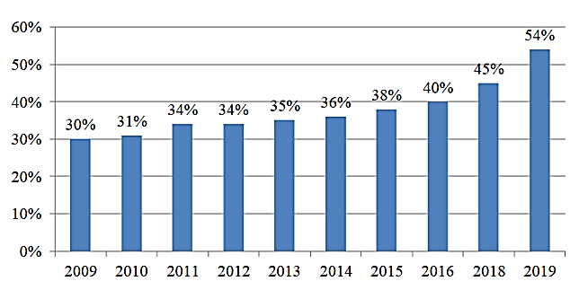
Figure 4: Global talent shortages
(Source: Oleksandr Akimov, 2021)
As stated in figure 4, Oleksandr Akimov (2021), illustrates that the talent shortage in the world has been increasing steadily from 30% in 2009 to 54% in 2019. This tendency indicates the increasing challenge in finding qualified employees in the organisation that suggests the exacerbation of a skills gap during the decade. The deficit was at its highest in 2019.
Key Sectors Facing Talent Shortages
Due to the lack of skilled professionals, the technological industry is facing a major shortage of personnel, especially in such areas as software engineering and data science (Scaffidi, 2018). The enormous speed at which technology is being introduced, and the rising need to undergo digital transformation has resulted in a fierce rivalry over skilled tech employees. Considering that organisations have difficulties filling positions, especially positions that need niche skills like AI and cybersecurity.
The global talent shortage is being experienced in the healthcare industry especially in the nursing field and the medical practitioners. It is significantly affected by the fact that ageing populations in developed countries and the growing pressure on healthcare systems are increased by such crises as the COVID-19 pandemic (Medici, 2021). The problem of shortage of health care professionals is a burden to the patient care and the delivery of health care in general.
The hospitality industry is not an exception as it has its group of hurdles especially in the attraction and retention of qualified employees. As competition increases, demand volatility, and seasonal nature of work, it is still hard to retain experienced employees as chefs, managers as well as hospitality service workers.
Strategic HRM Approaches
Strategic Human Resource Management (SHRM) includes a long-term evidence-based response to persistent skill shortage and demographic change, which reinforces organisational competencies in a manner that aids an organisation in responding to future challenges. One of them is talent development and retention, and organisations retain and have a sustainable and flexible workforce.
Investing in Reskilling and Upskilling
Organisations are increasingly turning towards constant learning approaches in order to reduce skill gaps brought about by change of technology. It has been demonstrated that companies that invest in well-structured development programmes have been reported to have more adaptive and productive employees since the competencies required in the emerging technology are offered to employees (Singh, 2019). As an example, a survey by the World Economic Forum achieved that by 2025, more than 50% of the workers would need a substantial amount of reskilling as a result of automation. This proves the essential nature of reskilling as not optional but the key to organisational resilience.
Building Talent Pipelines Through Education Partnerships
Any strategic partnership with universities, technical colleges and vocational institutions helps companies access the young talent in cases of employing them in the future, as well as supporting the development of curricula to fit the needs of the industry. Oviawe (2018) points out that settling the imbalance between graduate skills and labour market expectations through education-industry partnerships is achieved. The strategy works effectively especially in industries that are undergoing a high technology change where the conventional qualifications might be obsolete.
Leveraging Technology and Data-Driven Recruitment
Sophisticated screening technologies such as the use of AI, predictive analytics, and the big data platform are also becoming central to HRM practices nowadays. Scaffidi (2018) proceeds to suggest that data-based recruitment improves the accuracy of hiring, as this approach aligns hiring principles with the tasks and applicants based on the ability to perform or exhibit certain behaviour traits. Empirical evidence demonstrates that the recruitment process can be made more objective and faster by using AI, but it remains to be subject to critical evaluation because of alcoholism fairness issues.

4. Reflective Report on Preparedness for Working in an International Context
Organisational operations have changed dramatically due to globalisation, tremendous technological advancement, and the emergence of remote working. According to Phillips (2020), the cross-border, time zone, and culture-working ability is now a necessity of professionals who get into foreign surroundings. In this reflective report, I assess my readiness to work in a global work environment through SWOT framework in relation to five fundamental competencies, namely, technology, communication, teamwork, leadership, and self-directed learning. This structure does not only identify my strengths and weaknesses as an internal factor, but also studies the external opportunities and threats that could pose challenges to my international career preparedness.
Technology
Strengths
I am vastly digital and am capable of being online in such communication tools as Zoom, Microsoft Teams, and Slack. These are the tools that are required in the process of work coordination within geographical boundaries. Practical experience and understanding of cloud-based services (Google drive, OneDrive) and project management tools (Trello, Asana) will make me effective in working with the other people and maintains productivity in remote work teams. It has been discovered that a digital competency is a positive influence on the workflow integration in foreign settings.
Weaknesses
Though I am not very competent in the latest technologies, such as artificial intelligence, blockchain, machine learning, solutions, or data analytics, I still have the minimum level of competence. This is a gap that may limit my performance in an environment with well-developed technologies as more organisations around the world become digital and implement advanced forms of digital systems.
Opportunities
Online courses, micro-courses, and industry-specific workshops are becoming increasingly more accessible and may be used to help me improve my technological expertise (Kudyba et al., 2020). New sources of learning that can assist me in competing better include the introduction of the AI-based system of managing human resources, analytics integration, and the tools of virtual working teams.
Threats
Threats are also rapid change in technology which is threatening as the digital requirements are evolving rapidly compared to the individual capacity to change (Emmanuel et al., 2024). Absence of continuous upskilling may result in acquisition of outdated skills that will reduce the level of employability in the international context.

Communication
Strengths
I have an ability to modify my communication patterns when addressing the people of other cultures. The past experience of working with respective colleagues has sensitized me to cultures related to Europe, the Asia region, and North America. My personal communication skills have allowed me to make sure that communication barriers in remote collaboration do not exist because of my ability to be an active listener, explain misunderstandings, and remain respectful.

Weaknesses
I also find myself struggling to recognize the indirect communication patterns that have been dominating the high context cultures in which the message is not delivered in a direct manner, but passed in a subtle way. This may bring about misconception (Sogancilar and Ors, 2018). Moreover, I have a chance to speak only English language which means that I cannot communicate with non-English speaking customers or co-workers on a high scale.
Opportunities
Learning additional languages such as Spanish or Mandarin that would broaden my ability to communicate in the foreign markets. Intercultural communication workshops may also help me to learn to be sensitive in the tone, body language, culture specific communications norms.
Threats
The result of communication misunderstanding can be the harmful effect on the team cohesion or project outcome. Also the lack of a linguistic diversity may decrease careers in the fields where it is impossible to speak English in a general way.

Teamwork
Strengths
I have been collaborating with multinational teams so successfully and I have worked with them with the knowledge sharing, problem solving as well as cultural flexibility. It is an added benefit to a team performance because of my openness and willingness to adopt varying opinions. Access and exposure to collaborative computerized equipment’s also qualify me as competent in the organizing of remote performance.
Weaknesses
Most of my work experience in the capacity of a team leader has been relative to similar time zones. One of the possible solutions to this issue like meeting, developing progress, and keeping the interest up during extremely different time zones is also sought (Emmanuel et al., 2024). Neither am I well exposed to long term fully virtual global teams.

Opportunities
It is possible to participate in international virtual working, global hackathons, and international options that will provide me with more experience in how to cope with the time- zone difference and improve my approach to the remote work team.
Threats
Time zone differences in communication, decision making and vindicated cohesion of virtual teams can be experienced. The constant utilization of digital tools may also be threatening to the interpersonal relationship unless it is combined with the conscious development of a relationship.

Leadership
Strengths
I also have experience working in small multicultural team and have learned that cultural intelligence, empathy and flexibility are essential in leadership. My leadership style insists on respect, inclusiveness, and open communication, which contribute to the development of trust with a variety of groups. These are critical attributes of global leadership.
Weaknesses
I should also improve my virtual leadership skills that deal mostly with conflict, lack of engagement, and expectations of different performance levels. A cross-cultural leadership in the lack of physical presence demands an additional positive strategic communication, motivation practices, and online facilitating competencies.
Opportunities
In the field of leadership, the development programmes available include global leadership, virtual team management, and conflict resolution which give me an opportunity to hone my leadership skills. Experienced international managers may also mentor me to become more mature as a leader.
Threats
There may be misunderstanding of cultures, dissimilar work ethics, or virtual misunderstanding that reduces the effectiveness of leadership (Sogancilar and Ors, 2018). I might not be effective in the global stressful environments without building greater conflict-management abilities.
Self-Directed Learning
Strengths
My other qualities are also proactive to the learning process and, so far, I have completed cross-cultural communications, international business etiquette, and international operations courses. Personal interest and desire instigate an ongoing improvement and enable me to be aware of the standards in the workplace internationally.
Weaknesses
I am not properly familiar with the complex dynamics of the world in the political, economic trends besides the advanced leadership models. These areas are important to make quality decisions in the international business environments.
Opportunities
The increasing number of MOOCs, courses of online communication, and other forms of professional networking is one of the best opportunities to expand knowledge (Martinez and Gomez, 2025). It can also enrich my global worldview through holding international conferences and even communicating with people using the internet.
Threats
The dynamism in the international market presents that outdated knowledge as a possible impediment in a span of time. The inability to adhere to the continuous learning may disrupt my personal competency to perform on the international level.
Action Plan
Area | Action | Timeline
Technology | Taking online courses in AI, data analytics, and industry-specific software relevant to international markets (CHUMWATANA and Hpone, 2025). | 6 months
Communication | Enrolling in a language course (Example: Spanish or Mandarin) and improving cross-cultural communication skills. | 12 months
Teamwork | Gaining experience in managing teams across different time zones and exploring tools for better virtual collaboration. | Ongoing, next 6 months
Leadership | Pursuing leadership training focused on virtual and multicultural team management. | 12 months
Self-Directed Learning | Continuing engaging in online courses on global business practices and leadership development. | Ongoing, next 6 months
Table 1: Action Plan
(Source: Author)

Reference List
Ali, Z. (2023). LABOR MARKET DYNAMICS IN THE GIG ECONOMY: OPPORTUNITIES, CHALLENGES, AND THE FUTURE OF WORK. Journal of Applied Finance and Economic Policy, 7(01), 57-68. https://journals.ifasra.com/index.php/jafep/article/download/35/43
Alp Consulting (2023). What is International Human Resource Management? 21 Dec. https://alp.consulting/what-is-international-human-resource-management/.
Brown, S. and Loprest, P.J. (2018). How is technological advancement changing the labor market? https://www.urban.org/urban-wire/how-technological-advancement-changing-labor-market.
Chamie, J. (2020). International migration amid a world in crisis. Journal on Migration and Human Security, 8(3), 230-245. https://journals.sagepub.com/doi/pdf/10.1177/2331502420948796
CHUMWATANA, T. and Hpone, A.K.K., 2025. Bridging the IT skill gap with industry demands: An AI-driven text mining approach to job market trends using large language model. Journal of Theoretical and Applied Information Technology, 103(6), pp.2270-2282. https://jatit.org/volumes/Vol103No6/12Vol103No6.pdf
Emmanuel, O.K., Grace, J. and John, M., 2024. Collaborative Learning Tools [online] https://www.researchgate.net/profile/Emmanuel-Ok-2/publication/386250907_Collaborative_Learning_Tools/links/674a36f3790d154bf9b64857/Collaborative-Learning-Tools.pdf
Fernández-Reino, M., Sumption, M. and Vargas-Silva, C., 2020. From low-skilled to key workers: The implications of emergencies for immigration policy. Oxford Review of Economic Policy, 36(Supplement_1), pp.S382-S396. https://pmc.ncbi.nlm.nih.gov/articles/PMC7313883/pdf/graa016.pdf
Goh, S.K. and McNown, R., (2020). Macroeconomic implications of population aging: Evidence from Japan. Journal of Asian Economics, 68, p.101198. https://2024.sci-hub.box/8255/d60176634e31e72cf0f36ae229d4705a/goh2020.pdf
Haleem, A., Javaid, M., Singh, R. P., Rab, S., and Suman, R. (2021). Hyperautomation for the enhancement of automation in industries. Sensors International, 2, 100124. https://www.sciencedirect.com/science/article/pii/S2666351121000450
Khalid Alrashedi, A. (2024). The key sustainable strategies criteria for effective human resource management practices. Sustainability, 16(12), 5250. https://www.mdpi.com/2071-1050/16/12/5250/pdf
Kudyba, S., Fjermestad, J. and Davenport, T., 2020. A research model for identifying factors that drive effective decision-making and the future of work. Journal of Intellectual Capital, 21(6), pp.835-851. https://www.researchgate.net/profile/Jerry-Fjermestad/publication/340840389_A_research_model_for_identifying_factors_that_drive_effective_decision-making_and_the_future_of_work/links/5f99631c458515b7cfa41ef6/A-research-model-for-identifying-factors-that-drive-effective-decision-making-and-the-future-of-work.pdf
Lobel, O. (2024). The Future of Work in the Era of AI. Ind. LJ, 100, 359. https://papers.ssrn.com/sol3/Delivery.cfm?abstractid=5237172
Marini, G. (2024). Brexit and the war for talents: Push & pull evidence about competitiveness. Higher Education, 88(4), 1629-1644. https://link.springer.com/content/pdf/10.1007/s10734-024-01186-1.pdf
Martinez, M.E. and Gomez, V., 2025. Active learning strategies: a mini review of evidence-based approaches. Acta Pedagogia Asiana, 4(1), pp.43-54. https://tecnoscientifica.com/journal/apga/article/download/555/275
Medici, A. C. (2021). Health sector challenges and policies in the context of ageing populations. UN DESA. https://www.researchgate.net/profile/Andre-Medici/publication/356731657_Health_sector_challenges_and_policies_in_the_context_of_ageing_populations/links/61a91e1d29948f41dbbc31ac/Health-sector-challenges-and-policies-in-the-context-of-ageing-populations.pdf
North, M. (2023). How 4 countries are addressing their ageing populations. World Economic Forum. https://www.weforum.org/stories/2023/09/life-expectancy-countries-ageing-populations/.
Oleksandr Akimov (2021). Global talent shortage compiled by the authors according to the data. The Impact of Migration of Highly Skilled Workers on The Country’s Competitiveness and Economic Growth https://www.researchgate.net/figure/Global-talent-shortage-Source-compiled-by-the-authors-according-to-the-data-from_fig1_352984300
Orphanidou, Y., Efthymiou, L., Morphitou, R., Vlachos, D., Papadopoulos, M., Yakavenka, V. and Psilla, D., (2023, September). EXPLORING THE SKILLS GAP IN TOURISM AND HOSPITALITY: TOWARDS A NEW CLASSIFICATION OF SKILLS, COMPETENCIES, AND JOB POSITIONS. In 16th Annual Conference of the EuroMed Academy of Business. https://www.researchgate.net/profile/Michael_Neubert7/publication/374792524_euromed2023-book-of-proceedings-2023-09-24pdf/data/652fd3c75d51a8012b52c0b2/euromed2023-book-of-proceedings-2023-09-24.pdf#page=607
Oviawe, J. I. (2018). Revamping technical vocational education and training through public-private partnerships for skill development. Makerere Journal of Higher Education, 10(1), 73-91 https://www.ajol.info/index.php/majohe/article/view/182125/171507
Parry, E. and Battista, V., 2023. The impact of emerging technologies on work: a review of the evidence and implications for the human resource function. Emerald Open Research, 1(4). https://www.emerald.com/insight/content/doi/10.1108/eor-04-2023-0001/full/pdf
Phillips, S. (2020). Working through the pandemic: Accelerating the transition to remote working. Business Information Review, 37(3), 129-134. https://journals.sagepub.com/doi/pdf/10.1177/0266382120953087
Scaffidi, C. (2018). Employers’ needs for computer science, information technology and software engineering skills among new graduates. International Journal of Computer Science, Engineering and Information Technology, 8(1), 1-12. https://www.academia.edu/download/55934610/8118ijcseit01.pdf
Singh, D. (2019). A literature review on employee retention with focus on recent trends. International Journal of Scientific Research in Science and Technology, 6(1), 425-431. https://www.academia.edu/download/60641051/5095_lit_review_paper20190919-118800-dzni7v.pdf
Sogancilar, N. and Ors, H., (2018). Understanding the challenges of multicultural team management. Journal of Business Economics and Finance, 7(3), pp.259-268. https://dergipark.org.tr/en/download/article-file/551593

