DS 1 work

My Screenshots/Photos
- Please add 4–6 screenshots or photos of your digital life.
- You can use your phone or laptop.
- For each screenshot, write one or two sentences explaining what it shows.

Screenshot/Photo 1
KTM DUKE 125
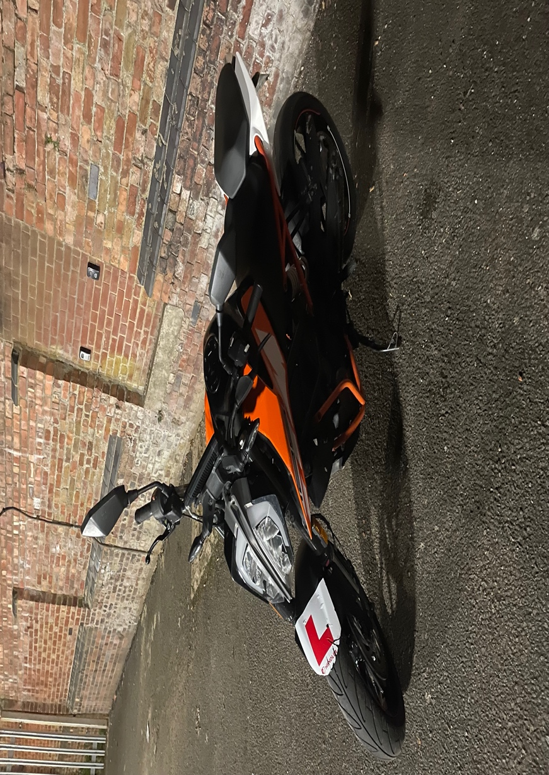
This is my Ktm Duke 125, it is a 125cc motorbike.It helps me get to different locations and also keeps in track of my time and speed due to the speedometer on the vehicle.it also keeps track of miles been done so I can do a rough estimate on when to service bike next. I feel the way this could be made better is if I upgrade to a bigger CC engine bike because then digital tools would be more advance

Screenshot/Photo 2
MY LAPTOP
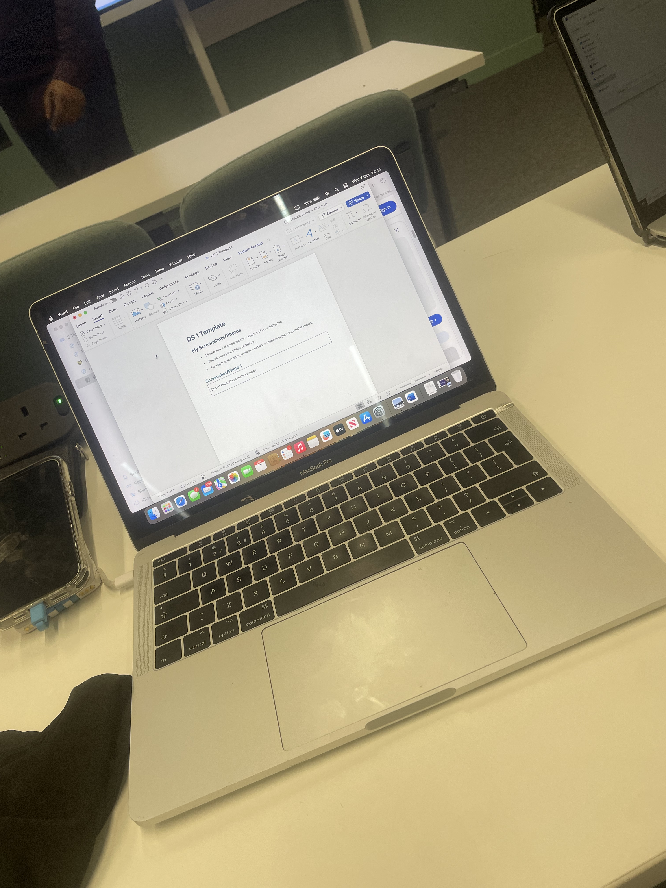
This is my laptop, on this I can search for information and it helps me complete tasks for university also for my daily life. This helps me keeps organised and assist me when I need to complete research and studies, also very helpful for homework.

Screenshot/Photo 3
MOCK UP OF MY BRAND LOGO
I used my application on my laptop to create this logo which I will then use for my business. It will be applied on many stocks to increase brand sales. It will also help my business stand out and be recognised for its own type of look

Screenshot/Photo 4
DJI OSMO POCKET 3
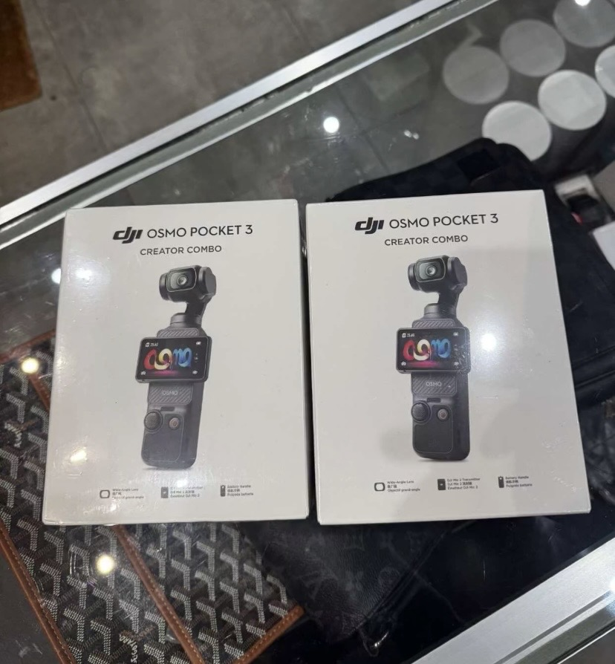
This is a camera with face recognition and it helps me capture moments in real time and allows me to upload an edit online. I can then use it for my business purposes or even just personal. People use it for content creation or personal life.

Screenshot/Photo 5
WI FI extender
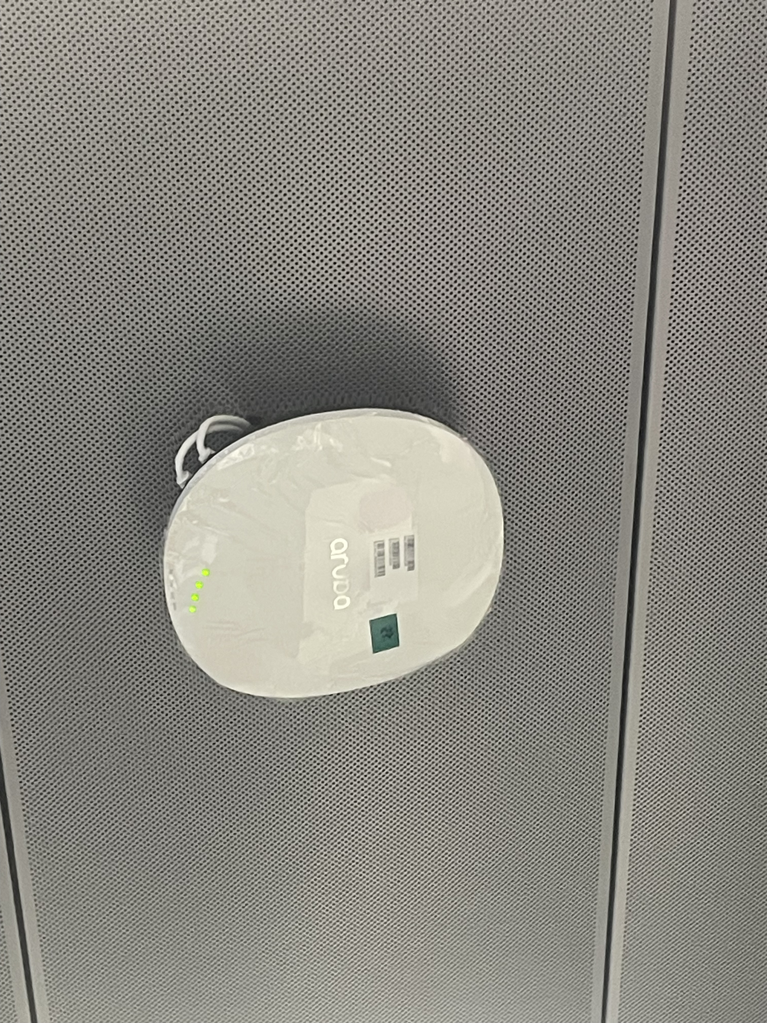
This is a tool that helps wi-fi reach all over the property instead of just in one location, If multiple people are on one wi-fi it helps split the load onto two devices. May help some devices run smoother with better connection.

My Short Reflection
- Write 5–8 simple sentences about your digital life.
- You can use the sentence starters below if helpful.
I use digital tools and skills daily and with both of these it makes achieving my goal as an entrepreneur easier and a lot more organised.there’s a few things I’d like to upgrade

I believe without these digital skills I would not be able to achieve the task or give out the service I want. These digital tools have an impact on my daily life and help in a positive way to reach the end goal.
I would like to build confidence with more online tools as it would help build my knowledge and also be a positive asset for my career.

​​

