Reflective report on Kolb’s reflective cycle and SWOT analysis
Professional Career Development
2/06/2023
Jaroslav Demeter (2240603)

Contents
Terms of Reference 1
Executive Summary 1
Introduction 1
Main Findings 1
Conclusion 4
References List 5

Terms of Reference

This Report was requested by James Squire - Wood for my Professional Career Development Module and it was requested for 02/06/2023.

Executive Summary

In this Report I will talk about the theories and applications behind Kolb’s Reflective Cycle and the Swot Analysis. Following I will talk about the theory behind them and show practical examples based on my personal experience.

Introduction

In the following pages I will show you the theory and application of two different tools commonly used in Business and Marketing circles. The Kolb’s Reflection Cycle by David Allen Kolb, and The SWOT by Albert Humphrey. Both are reflective tools looking to identify through self-awareness the way forward and correct what is necessary in order to better achieve your goals. You will be able to see first learning diagrams to show you how this tools work, and then practical diagrams applicated to my own working circumstances.

Main Findings

  - Kolb, D.A.
David Allen Kolb ¹⁾ was an American educational theorist, responsible for the creation of the Kolb’s Reflective Cycle or Experimental Learning Theory (ELT) in 1984. (Various,.)
²⁾ Kolb believed that what we learned is directly related to our experiences, and through a process of reflexion we can transform it into action. (Paul Main, 2009)
³⁾ “Learning is the process whereby knowledge is created through the transformation of experience” (Kolb, 1984, p. 38).
⁹⁾ Kolb’s Learning Cycle is based on the John Dewey’s theory that says that learning must be based in experience, Kurt Lewin’s work around the fundamentality of active learning, and Jean Piaget’s accent on the direct relation between a person and an intelligent environment. (University of IOWA,.)
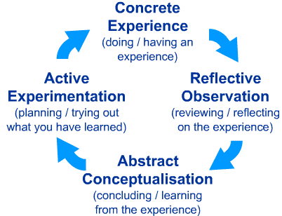
⁴⁾ (ISC Medical, 2019)

To apply this to my work, I will use the following example. ⁵⁾ (Mrsstrickey, 2021)
- Concrete Experience:
The Staff absence is definitely a problem that needs to be revised and solved.
- Reflective Observation:
The next steps to correct this situation will need to be meeting with my service support manager and addressed and discuss the situation.
- Abstract Conceptualisation:
Some ways to rectify the situation could be revise the holiday calendar of each employee by site and make sure that they are all taking holidays on different dates so they can cover each other when one of them is out. Other way is also make sure they are aware of the necessity of flexibility and work as a unit.
- Active Experimentation:
Visit the sites and put these ideas into practice, talk with every staff member and make them aware of it.
In the practical assessment of Kolb’s Reflective Cycle to my work needs, I was surprised how this method helped me to work out a very recurrent problem for my manager and me. The resolution helped me to see the seriousness of the problem and identify the right way ahead to fix it. I will make sure to mention this to her and hopefully put it into action.

  - SWOT
Is a strategic planning tool regularly used in business and marketing. ⁶⁾ (British Library,.) Was created by Albert Humphrey between the1960’s and 1970’s ⁷⁾ (By the MindTools Content Team,.) SWOT stands for Strengths, Weaknesses, Opportunities and Threats.
First on the next page see an explanatory diagram to understand and learn to apply this technique to your needs.
Bellow this, see a practical diagram applicating the SWOT technique to my work. I could identify some of my Strengths like Time Management among others, but more importantly I could single out my weaknesses to be corrected and opportunities to become my goals. Threats are also important, and I need to stay alert, so they don’t become weaknesses.

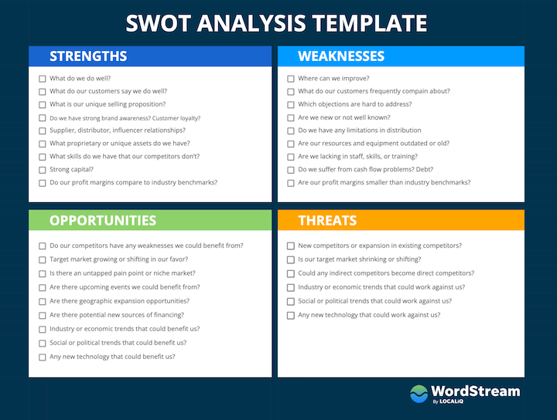
⁸⁾ (Dan Shewan, 2022)

Practical application of SWOT on myself withing my working environment.
Strengths Weaknesses

Opportunities Threats

When it comes to the SWOT analysis, I have seen weaknesses that can be turned into strengths like my weak communication skills that I know I can easily improve on this course. The lack of flexibility will take more on my part than expected but I know it can be achieved, while the conflict resolution skill, I believe will come with time and experience, but I am also very much looking forward to improving this too. When it comes to Threats, there are some that I will be able to correct and prevent from becoming weaknesses and others that are just out of my hand and I can only monitor in the hope that stay the way they are or improve and not the opposite. I am happy to say that I knew about my Strengths, but I loved to be able to identify my opportunities, to work towards them.

Conclusion

In the course of elaborating this report I have learnt somethings about myself and others about my work environment. Both tools had helped me to see and recognise things about myself that probably I was not aware of before and identify problems at work and the way to find a way to fix it.

References List

⁶⁾ British Library / Business & IP Centre. (.). What is SWOT Analysis. [Online]. bl.uk. Last Updated: .. Available at: https://www.bl.uk/business-and-ip-centre/articles/what-is-swot-analysis#:~:text=The%20SWOT%20framewo [Accessed 27 May 2023].
⁷⁾ By the Mind Tools Content Team. (.). SWOT Analysis. [Online]. Mind Tools. Last Updated: .. Available at: https://www.mindtools.com/amtbj63/swot-analysis [Accessed 27 May 2023].
⁸⁾ Dan Shewan. (2022). How to Do a SWOT Analysis. [Online]. wordstream.com. Last Updated: September 2022. Available at: https://www.wordstream.com/blog/ws/2017/12/20/swot-analysis [Accessed 27 May 2023].
⁴⁾ ISC Medical / Teaching & Communication Skills.. (25th March 2019). THE BENEFITS OF EXPERIENTIAL LEARNING AND KOLB’S LEARNING CYCLE FOR TRAINING. [Online]. ISC Medical. Available at https://www.medical-interviews.co.uk/blog/benefits-experiential-learning-kolbs-learning-cycle-training. [Accessed 27 May 2023].
³⁾ Kolb, D. A. (1984). Experiential learning: Experience as the source of learning and development (Vol. 1).p.38. Englewood Cliffs, NJ: Prentice-Hall.
⁵⁾ mrsstrickey. (2021). Reflective Practice. [Online]. Teachwithmrst.com. Last Updated: May 16, 2022. Available at: https://www.teachwithmrst.com/post/reflective-practice [Accessed 27 May 2023].
²⁾ Paul Main. (2009). Kolb's Learning Cycle, What is Kolb's Learning Cycle and how can this inform effective classroom practice?. [Online]. structural-learning.com. Last Updated: 9 September2 2009. Available at: https://www.structural-learning.com/post/kolbs-learning-cycle [Accessed 27 May 2023].
⁹⁾ University of Iowa.. (.). David's Kolb Learning Cycle. [Online]. University of Iowa. Available at https://teach.its.uiowa.edu/sites/teach.its.uiowa.edu/files/docs/docs/David_Kolbs_Learning_Cycle_ed.pdf. [Accessed 31 May 2023].
¹⁾ Various. (...). David A. Kolb. [Online]. Wikipedia. Last Updated: .... Available at: https://en.wikipedia.org/wiki/David_A._Kolb [Accessed 27 May 2023].

