Electronics Report

Task 1

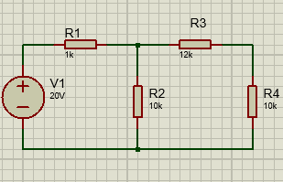
Part 1:
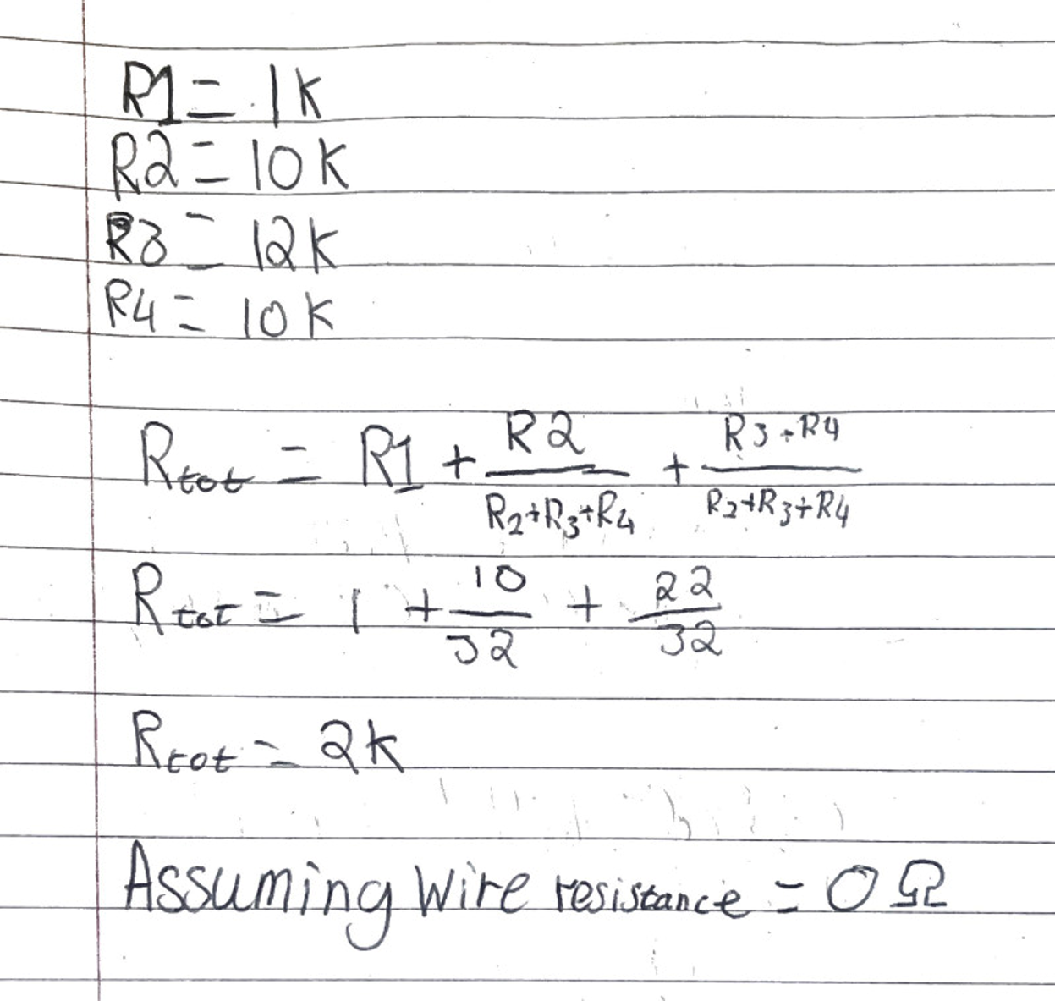
I started by making the circuit that we were to base the task on, in proteus as can be seen in the image on the right. The aim of the first part was to work out the internal resistance of the circuit. This is worked out by combining all of the resistance of the resistors. For this calculation I have set R4 to equal 10k Ohms(Ω). For this I have assumed that the resistance of the wires is equal to 0 ohms as that simplifies the equation. As you can see from the working out the internal resistance of the circuit is 2 this is because R1 is in series but R2,R3 and R4 are all in parallel so require more than just adding to each other.

Part 2:
This part asks you to design a circuit that can be used to find the current over the variable resistor (R₄) at different voltages then use those found currents to find the power at different voltages and compare them on a graph.
Resistance,Ω (R₄) | Current,A (I₄) | Power,W (W₄)
0 | 1.41 | 0
2 | 1.22 | 2.98
4 | 1.08 | 4.67
6 | 0.96 | 5.53
8 | 0.87 | 6.06
10 | 0.79 | 6.24
12 | 0.73 | 6.39
14 | 0.68 | 6.47
16 | 0.63 | 6.35
18 | 0.59 | 6.27
20 | 0.55 | 6.05

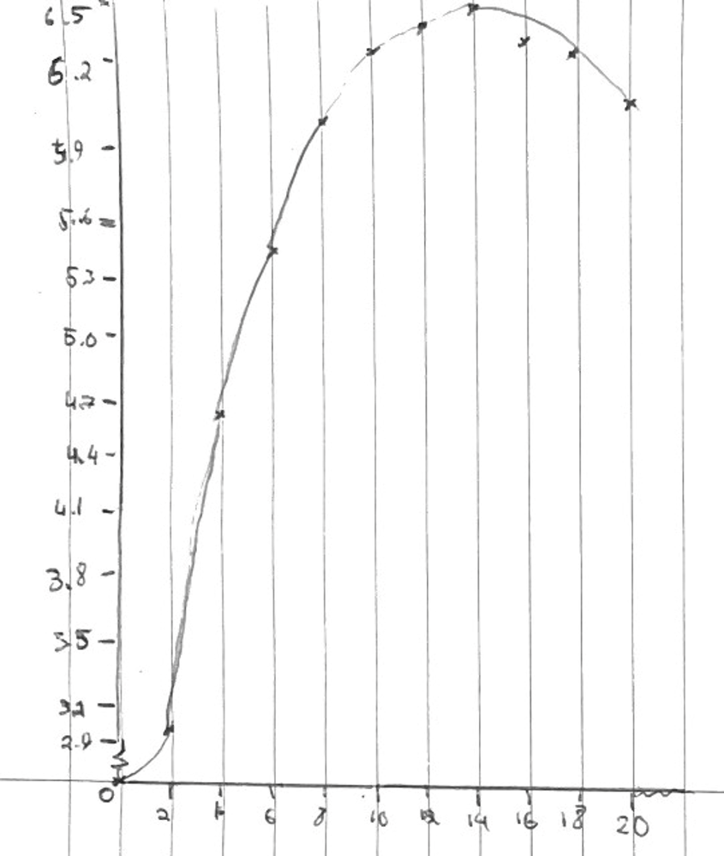

Part 3:
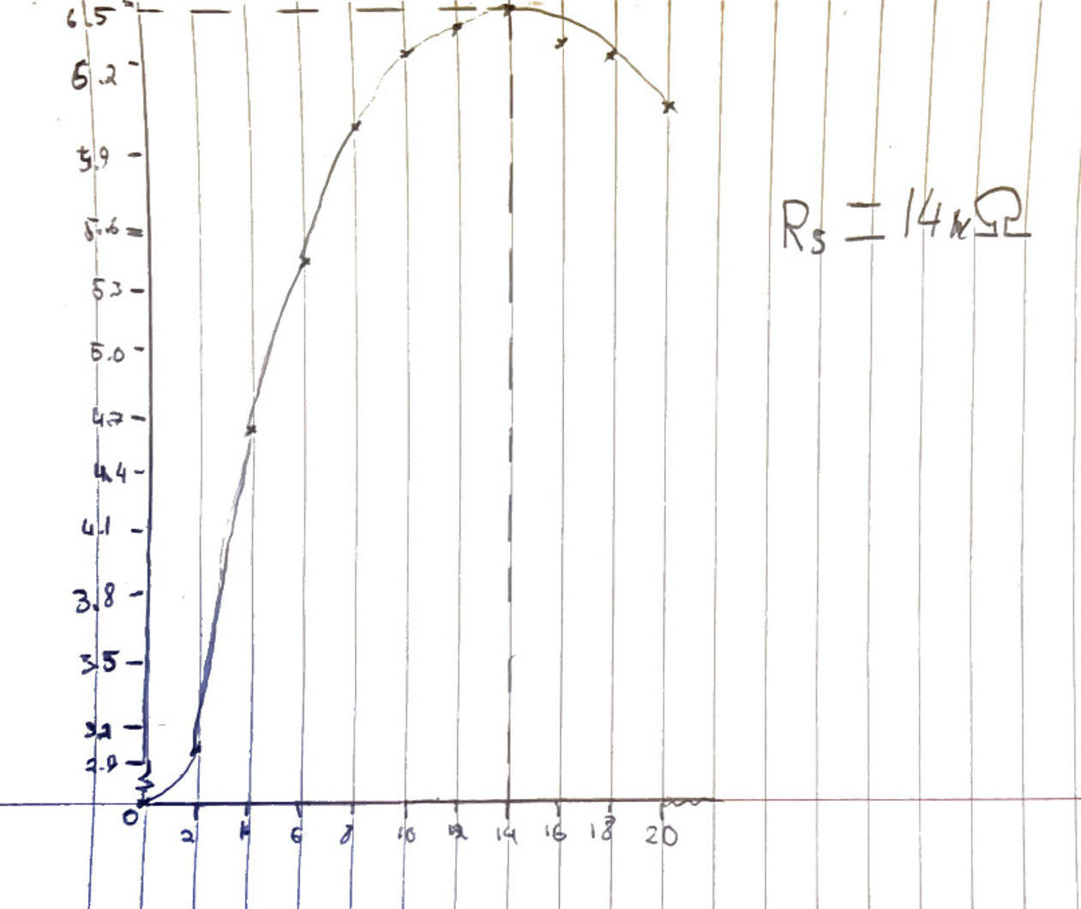
The peak of the graph in the previous part shows the internal resistance of the whole circuit as you can see the internal resistance of the circuit is 14Ω

Task 2

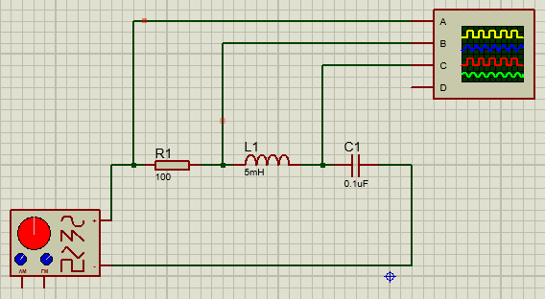
Part 1:
The circuit to the left is the one that the second task is based on, the top box is an oscilloscope, the bottom box is a signal generator and the components are a resistor, an inductor and a capacitor respectively. The first stage of this was to set the signal generator at an output of 10V at 1KHz.

Frequency (KHz) | Voltage A (V) | Voltage B (V) | Voltage C (V)
0 | 0 | 0.00 | 0.00
2 | 10 | 9.76 | 10.76
4 | 10 | 9.26 | 13.76
6 | 10 | 5.76 | 21.26
8 | 10 | 5.00 | 16.76
10 | 10 | 8.50 | 8.26
12 | 10 | 10.26 | 4.76
14 | 10 | 10.50 | 2.26
16 | 10 | 9.76 | 2.26
18 | 10 | 9.76 | 1.75
20 | 10 | 9.76 | 1.50
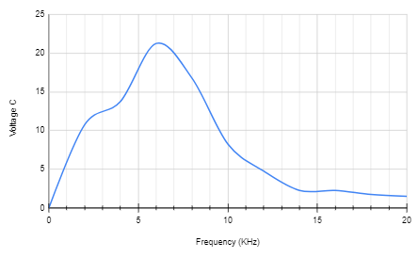
As you can see from the graph the resonant frequency is about 6KHz

