

Marketing Strategies Portfolio
Brand Extension: Google Nest Smart Ecosystem
Module Name: Marketing Management
Module Code: LCMB7024
Programme: Master of Business Administration (MBA)

Student Name: Tahmina Aktar
Student ID: 2508483
Lecturer: Laila Maazouz
Word Counts: 2510
Submission Date: 30 April 2026

Table of Contents
1. Element 1: Brand Extension Poster Presentation 3
2. Element 2: Develop a Segmentation, Targeting, Differentiation, and Positioning (STDP) Analysis for Google Nest 4
2.1 Market Segmentation 4
2.2 Targeting Strategy 5
2.3 Differentiation Strategy 5
2.4 Positioning Strategy 6
3. Element 3: Marketing Mix (7Ps) 8
3.1 Product (Service Offering) 8
3.2 Price 9
3.3 Place (Distribution) 9
3.4 Promotion 10
3.5 People 10
3.6 Process 11
3.7 Physical Evidence 11
4. Element 4: Reflection 12
4.1 Reflection on Brand Development 12
4.2 Reflection on Poster Preparation and Presentation 12
4.3 Action Plan for Improvement 13
5. Reference List 14

1. Element 1: Brand Extension Poster Presentation
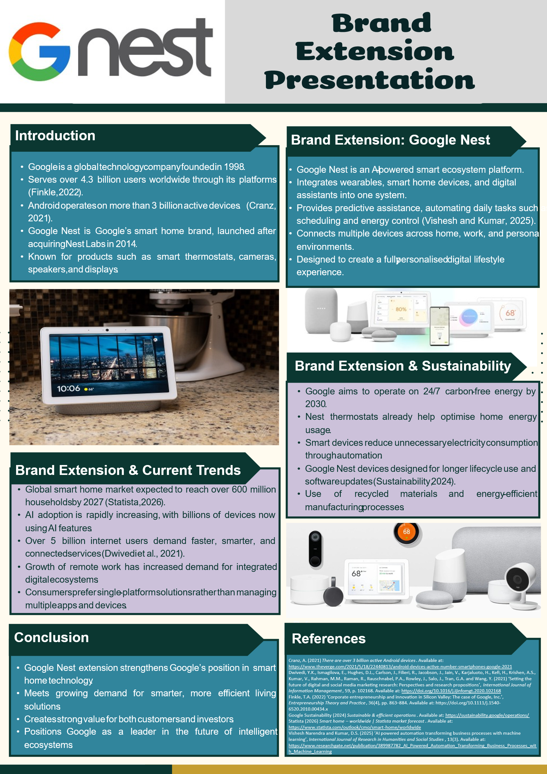

2. Element 2: Develop a Segmentation, Targeting, Differentiation, and Positioning (STDP) Analysis for Google Nest
This section formulates a Segmentation, Targeting, Differentiation, and Positioning (STDP) strategy of the Google Nest brand extension. Being an AI-driven smart ecosystem, it incorporates devices and services, and it needs to be clear how it targets and positions customers to gain competitive edge in the evolving market.

2.1 Market Segmentation
Market segmentation refers to the division of the entire market into smaller segments that share common needs and behaviours. In the case of Google Nest, the geographic, demographic, psychographic, and behavioural factors are used to segment the market.
Table 1: Market Segmentation for Google Nest
Segmentation Type | Segment Characteristics | Description
Geographic | Urban and suburban regions (UK, USA, Europe, Asia) | Target the high internet penetration and smart home adoption cities that are technologically advanced (Rock and Tajudeen, 2026).
Demographic | Age: 25–45; Middle to high income; Professionals and families | People who have spare money and are interested in technological changes in their lifestyles.
Psychographic | Tech-savvy, convenience-oriented, sustainability-conscious | Customers who appreciate innovation, efficiency and eco-friendly solutions.
Behavioural | Early adopters, frequent tech users, brand loyal to Google ecosystem | Customers who use digital platforms frequently and are more inclined to comprehensive technological solutions.
These categories respond to the increasing need to have an interconnected living experience and customized online experience. The urban population is especially applicable since exposure to technological smartness and infrastructure preparedness is greater.

2.2 Targeting Strategy
Targeting is the process of choosing the most appealing segment(s) that are determined during the segmentation process. Google Nest takes a differentiated targeting approach which is supported by urban professionals and modern households as the major target consumers.
The major target market is people between the ages of 25 and 45 years with medium- high incomes and residing in cities. These customers are usually business people, young families, or telecommuters who value convenience, efficiency and easy assimilation of technology in their everyday lives. They are extremely involved in digital ecosystem and are more disposed to smart home technologies.
This is a very appealing segment due to several reasons. To start with, it has a high purchasing power, which allows the use of high-quality smart devices. Second, the trend of working at home is growing, which has increased the need to use smart home systems that are more productive and comfortable (Basarir-Ozel, Turker and Nasir, 2022). Third, this segment is more accepting of innovation and digital change and, therefore, they are early adopters of AI-powered ecosystems, like Google Nest.

2.3 Differentiation Strategy
Differentiation is a term used to refer to the way a brand is differentiated among the competitors within the market. The smart home business is very competitive with major players in the industry including Amazon Alexa and Apple HomeKit who have similar solutions. Google Nest, however, stands out in several aspects.
To start with, Google Nest takes advantage of the high level of artificial intelligence and machine learning to provide highly personalised and predictive experiences. Google, unlike its competitors, has the advantage of having a large data ecosystem, which allows it to be more accurately automated and customised by users.
Secondly, the smooth integration among various devices and platforms brings about a highly competitive edge. Google Nest unites smartphones, wearables, home appliances, and digital services into one ecosystem, eliminating the need to use multiple applications and improving the ease of use (Grigorios, Katsoulis and Fotios Zantalis, 2025).
Third, sustainability is an important element in differentiation. Google has made the pledge to work on carbon-free energy, and integrates energy-saving features in Nest products, including smart thermostats that optimise energy use. This is in line with the current consumer trend of seeking environmentally friendly solutions.
Lastly, a good brand image and the international status of Google also contribute to its competitive edge. Google being a reliable technology partner can use its current customer base to market the use of the Nest ecosystem.

2.4 Positioning Strategy
Positioning is a way of establishing how the brand is perceived in the minds of the consumers in comparison to their competitors. Google Nest is introduced as a smart home ecosystem that is innovative, intelligent, and sustainable and helps to make the everyday life easier and better.
Positioning statement may be stated as follows:
Google Nest is a smart ecosystem that offers continuous, personalised, and sustainable living environments through the implementation of all the elements of digital life in a single smart platform powered by AI.
This stance highlights three fundamental aspects of intelligence (AI-driven automation), integration (connected ecosystem) and sustainability (energy efficiency and environmental responsibility) (Wang, Li and Li, 2025). By offering these qualities, Google Nest can attract new consumers who want to be convenient, innovative, and socially responsible in their consumption.
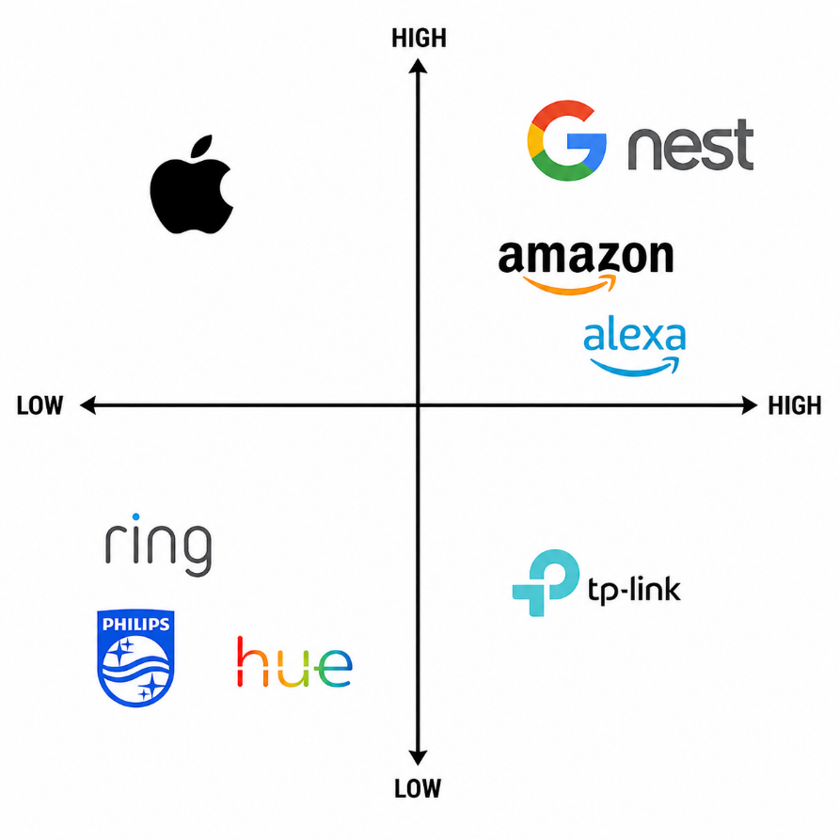
Figure 1: Figure 1: Positioning Map
Source: Author
Moreover, the brand would like to be not only a smart house, but an all-encompassing lifestyle platform that makes life more productive, comfortable, and satisfying (Pasupuleti, 2025). This strategic positioning enables Google Nest to transcend functional benefits to establish a powerful emotional and experiential value to the customers.
Google Nest has a solid segmentation, differentiation, and positioning that make it successful in reaching tech-savvy consumers and establishing a competitive edge in the emerging market of smart home.

3. Element 3: Marketing Mix (7Ps)
The marketing mix (7Ps) offers a systematic way of executing marketing strategy. In the case of Google Nest, the framework helps to position the company as an AI-powered, integrated, and sustainable smart ecosystem. All these aspects are correlated with the brand extension goal of providing convenience, innovation, and improved user experience in the smart home market.
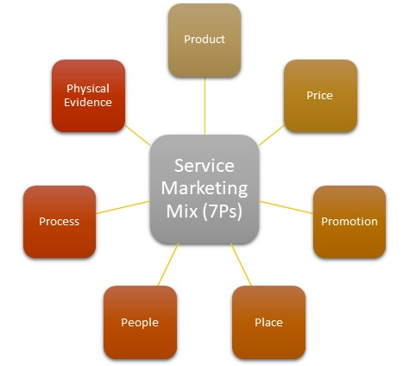
Figure 2: Marketing Mix (7Ps) Framework
Source:(Team, 2025)

3.1 Product (Service Offering)
Google Nest is specialized in providing a smart ecosystem, as opposed to one-off devices. Its product range consists of smart thermostats, cameras, speakers, and displays, all interconnected with the help of Google Assistant and AI-powered automation. This enables easy communication among devices and personalised user experiences.
The product strategy focuses on augmented value, in which customers are not just gaining advantages of physical devices but also software updates, automation, and data-based insights. This is in line with the idea of Kotler that we add value to the core product (Kumar et al., 2026).
The product offering is also sustainable. Smart thermostats and other energy-saving devices allow saving on energy usage, and long-term software support allows products to have longer life cycles. This makes the brand attractive to the environmentally conscious consumers and helps Google achieve its sustainability objectives.

3.2 Price
Google Nest uses a value-based and tiered pricing model, with the Nest Mini, as their entry-level product, costing about £22.99, with their mid-range lineup, such as Nest Hub, retailing between 89.99 and 168. This makes it viable to a broad consumer base.
Premium items, such as the Nest Learning Thermostat, range between £146 and £219 due to its more sophisticated AI and energy-saving options. Security cameras, doorbells and other security gadgets normally cost between 59.99 and 181 based on their features.
Besides, bundle prices may go beyond £400, which stimulates the use of the ecosystem. Recurring revenue and enhanced retention of customers in the long run is created through subscription services that provide up to 60 days of video history.

3.3 Place (Distribution)
Google nest distribution strategy is based on online and offline distribution channels to maximise on the accessibility. Products can be sold via Google store, online stores like Amazon and large retail stores like electronics stores.
The omnichannel distribution is essential because it provides the customers with the opportunity to engage with the brand in various touchpoints. The online channels are convenient and offer a lot of details on the products, whereas the physical stores are informative and allow experience in hand, especially with technology products (Darvidou, 2024).
Collaborations with telecommunications and smart home installers can also boost distribution. Such partnerships make bundled products, like offering Nest products with broadband or home security packages.
Google has a global presence that makes its distribution efficient in international markets helping to scale and penetrate markets.

3.4 Promotion
The marketing mix of Google Nest is based on the principle of online marketing and combined communication channels. Considering the tech-savvy target group, online marketing, including YouTube, social media, and search advertising, have a leading role.
The content marketing especially needs to be highlighted, and the ecosystem should be presented to enhance daily life by showing how it does it via demonstrations and user scenarios. Credibility and reach can be also augmented with the help of influencer marketing and tech reviewers (Tanwar, Chaudhry and Srivastava, 2021).
Google can use its own platforms, i.e. Google Search, YouTube, and Gmail to advertise Nest products. This establishes a competitive edge by not being dependent on outside advertising mediums.
The sustainability and innovation are also highlighted in promotional campaigns which are in line with consumer values. Demand can also be boosted by limited-time deals, product bundles, and seasonal deals. In general, the promotion plan is based on informing and trust-building, as well as showing value to consumers.

3.5 People
Customers are an important part of providing customer experience and brand support. In the case of Google Nest, this consists of customer service teams, technical support staff, retail staff, and engineers.
Professional personnel can guarantee that clients get the right information and support especially when installing the products and troubleshooting. Considering the sophistication of smart home systems, customer service will play a crucial role in lowering the perceived risk and increasing satisfaction (Abel, Emmanuel and Pascal, 2024).
Google has an experienced workforce that helps it to keep innovating and developing new products internally. People engaged in AI and software engineering can help to preserve the competitive efficiency of the Nest ecosystem.
In addition, the brand enjoys effective organisational culture and experience, and this enables it to maintain uniformity in quality of services in the various markets.

3.6 Process
Process is the procedures and systems leading to the service delivery. With Google Nest, it should be simple, practical, and convenient.
The process of installation and set-up is less complex with mobile applications, and the user can connect the devices within a brief period. The automation capabilities enable the devices to save the user preferences and automatically modify the settings.
Continuous software upgrades improve the software performance and security; this assures the customers of their future value. Data privacy and security processes are also vital as consumers are increasingly concerned about how their data is managed (Parry, 2025).
Tactically, a smooth and reliable process enhances customer satisfaction and lowers barrier to adoption. This assists in brand loyalty and word of mouth.

3.7 Physical Evidence
Physical evidence is the physical factors that impact on customer perception. In the case of Google Nest, this is the design of the product, packaging, and the digital interface.
Nest products have minimalistic and modern design, which is the embodiment of innovation and high quality. Plastic-free materials and smooth design add to the perceived value and fit the positioning of the brand.
The packaging is also done in a manner that will be friendly to the environment, which will aid in sustainable development. A positive unboxing experience is enhanced by clear guidelines and professional presentation.
Moreover, the Google Home app user interface is a type of digital physical evidence. The clean and intuitive interface will make the interface easier to use and support the brand in the principle of simplicity and efficiency (Saithong and Yoddee, 2026).
To sum up, Google Nest marketing mix 7Ps relates well with the brand extension strategy. All these components aid in its status as an intelligent, integrated and sustainable ecosystem, which allows the brand to compete effectively in the ever-changing smart home environment.

4. Element 4: Reflection

4.1 Reflection on Brand Development
The Google Nest brand extension taught me a lot in developing a strategic marketing plan. It helped me to gain knowledge about the importance of brand extensions in business development using the existing brand equity. I also realised the need to balance the product concept with the current market trends, especially the increasing trend in the use of AI-based smart home technologies and sustainability.
One of my strengths was that I chose a topical and innovative concept. Google Nest is an indication of a booming industry and technology. I had the opportunity to put theoretical frameworks, like segmentation and marketing mix, into practice, which improved my practical perspective on marketing strategy (Furszyfer, Sovacool and Griffiths, 2021).
However, one of its weaknesses was a lack of critical analysis. I was not as evaluative as I was descriptive at times. I also found it difficult to regularly add an extensive variety of academic sources, which means that I need to enhance the profundity of my research and critical thinking capabilities.

4.2 Reflection on Poster Preparation and Presentation
Preparation and presentation of the poster enabled me to enhance my skills in communication and visual design. The development of a succinctly and aesthetically pleasing poster demanded that I be able to encapsulate important information. I also got to know how to make complex ideas simple and engaging and this is a valuable professional skill.
One of the strengths of this section of the task was that I was able to structure the poster in a clear and focussed way and address the core points, including the brand idea, market tendencies, and sustainability. This made the subject matter easy to understand by the listeners. Additionally, presenting my poster helped me gain confidence in my skills to convey ideas in a limited amount of time (Sousa and Clark, 2019).
Despite these strengths, I observed a couple of weaknesses. The presentation was unable to give me time management skills, and this affected the clarity of some of the explanations. The other thing I learned was that I could become a better verbal presenter, particularly regarding having a continuous flow and reaching the audience better.

4.3 Action Plan for Improvement
To improve my performance in future projects, I will make sure that I practice my critical analysis. It consists of closer work with academic literature and evaluation of a diversity of opinions rather than descriptive (Jaramillo Gómez et al., 2025). I will also aim at using more recent sources to improve the quality of my arguments.
In terms of presentation skills, I will practice to present content in a timely manner so that it can be more understandable and more confident. It is possible to record practice sessions and get feedback on the peers to understand what can be improved. I will also pay attention to the enhancement of my communication style, making it more interactive and engaging.
In general, this assignment has helped me grow personally and professionally since it has improved my thinking skills, research skills, and presentation skills. These are the necessary skills to work in marketing management in the future.

5. Reference List
Abel Uzoka, Emmanuel Cadet and Pascal Ugochukwu Ojukwu (2024) ‘Leveraging AI-Powered chatbots to enhance customer service efficiency and future opportunities in automated support’, Computer Science & IT Research Journal, 5(10), pp.2485–2510. Available at: https://doi.org/10.51594/csitrj.v5i10.1676
Basarir-Ozel, B., Turker, H.B. and Nasir, V.A. (2022) ‘Identifying the Key Drivers and Barriers of Smart Home Adoption: A Thematic Analysis from the Business Perspective’, Sustainability, 14(15), p.9053. Available at: https://doi.org/10.3390/su14159053
Darvidou, K. (2024) ‘Omnichannel Marketing in the Digital Age: Creating Consistent, Personalized and Connected Customer Experiences’, Technium Business and Management, 10, pp.34–54. Available at: https://doi.org/10.47577/business.v10i.11903
Furszyfer Del Rio, D.D., Sovacool, B.K. and Griffiths, S. (2021) ‘Culture, energy and climate sustainability, and smart home technologies: A mixed methods comparison of four countries’, Energy and Climate Change, 2, p.100035. Available at: https://doi.org/10.1016/j.egycc.2021.100035
Grigorios Koulouras, Katsoulis, S. and Fotios Zantalis (2025) ‘Evolution of Bluetooth Technology: BLE in the IoT Ecosystem’, Sensors (Basel, Switzerland), 25(4), p.996. Available at: https://doi.org/10.3390/s25040996
Jaramillo Gómez, D.L., Álvarez Maestre, A.J., Parada Trujillo, A.E., Pérez Fuentes, C.A., Bedoya Ortiz, D.H. and Sanabria Alarcón, R.K. (2025) ‘Determining Factors for the Development of Critical Thinking in Higher Education’, Journal of Intelligence, 13(6), p.59. Available at: https://doi.org/10.3390/jintelligence13060059
Kumar, V.S., Sharma, S., Mathur, S., Virmani, N., Singh, R.K. and Bernadett, K. (2026) ‘Strategic framework to analyze critical success factors of marketing 4.0 operations: evidence from an emerging economy’, International Journal of Innovation Science, pp.1–31. Available at: https://doi.org/10.1108/IJIS-02-2025-0061
Parry, G. (2025) Data Protection and Privacy in Software Development. [online] ResearchGate. Available at: https://doi.org/10.13140/RG.2.2.11804.14728
Pasupuleti, M.K. (2025) The Next Wave of Smart Living: Consumer Trends in AI-Enhanced Home Automation. Available at: https://doi.org/10.62311/nesx/rb410
Rock, L.Y. and Tajudeen, F.P. (2026) ‘Exploring the adoption of IoT-based smart home technology in Malaysia: an empirical study using the Fogg Behavior Model’, Current Psychology, 45(2). Available at: https://doi.org/10.1007/s12144-025-08840-6
Saithong, P. and Yoddee, J. (2026) ‘Integrating user experience and interface design for mental health mobile applications: A prototype development and evaluation approach’, Multidisciplinary Science Journal, 8(9), p.2026553. Available at: https://doi.org/10.31893/multiscience.2026553
Sousa, B.J. and Clark, A.M. (2019) ‘Six Insights to Make Better Academic Conference Posters’, International Journal of Qualitative Methods, 18. Available at: https://doi.org/10.1177/1609406919862370
Tanwar, A.S., Chaudhry, H. and Srivastava, M.K. (2021) ‘Influencer Marketing as a Tool of Digital Consumer Engagement: A Systematic Literature Review’, Indian Journal of Marketing, 51(10), p.27. Available at: https://doi.org/10.17010/ijom/2021/v51/i10/166439
Team, M.S. (2025). Service Mix (7Ps) - Definition, Importance & Example | Marketing | MBA Skool. [online] MBA Skool. Available at: https://www.mbaskool.com/business-concepts/marketing-and-strategy-terms/1870-service-marketing-mix-7-ps.html
Wang, Q., Li, Y. and Li, R. (2025) ‘Integrating artificial intelligence in energy transition: A comprehensive review’, Energy Strategy Reviews, 57, p.101600. Available at: https://doi.org/10.1016/j.esr.2024.101600
‌

